**Appendix**

**Heart Rate Variability Coefficient of Variation During Sleep as a Digital Biomarker That Reflects Behavior and Varies by Age and Sex**

**Running head:** HRV Coefficient of Variation as a Digital Biomarker

Gregory J. Grosicki,1 Jason R. Carter,2 Paul B. Laursen,3,4,5,6 Daniel J Plews,5 Marco Altini,7 Andrew J. Galpin,8

Finnbarr Fielding,1 William von Hippel,1 Christopher Chapman,1 Summer R. Jaskinski,9 Ursula K. Beattie,9 Kristen E. Holmes1

1 Department of Performance Science, WHOOP, Inc., Boston, Massachusetts, United States

2 Robbins College of Health and Human Sciences, Baylor University, Waco, TX, United States

3 Athletica AI, Revelstoke, British Columbia, Canada

4 HIIT Science, Revelstoke, British Columbia, Canada

5 Sports Performance Research Institute New Zealand (SPRINZ), Auckland University of Technology, Auckland, New Zealand

6 Sports Performance and Athlete Development Environments (SPADE), University of Agder, Kristiansand, Norway

7 Department of Human Movement Sciences, Vrije Universiteit Amsterdam, Amsterdam, The Netherlands

8 Human Performance Center, Parker University, Dallas, Texas, United States

9 Department of Data Science, WHOOP, Inc., Boston, Massachusetts, United States

**Address for Correspondence:**

Gregory J. Grosicki, One Kenmore Square, Boston, Massachusetts, United States

email: greg.grosicki@whoop.com

Kristen E. Holmes, One Kenmore Square, Boston, Massachusetts, United States

email: holmes@whoop.com

**Table of Contents**

**Table S1.** HRV-CV percentiles by age and biological sex………………………………………………..……………**3**

**Figure S1.** Within- and between-person effects of alcohol, activity, and sleep on HRV-CV stratified by baseline HRV ……………………………………………………………………………………………………………………...….**4**

**Figure S2.** Within- and between-person effects of variability in alcohol, activity, and sleep on HRV-CV stratified by baseline HRV ………..…………………………………………………………………………………...…………….**5**

**Figure S3.** Unadjustedage trajectories in HRV and HRV-CV stratified by biological sex……………………....…**6**

**Figure S4.** Unadjustedbody mass index trajectories of HRV-CV stratified by biological sex……………………..**7**

|  |  |  |  |  |  |  |
| --- | --- | --- | --- | --- | --- | --- |
| **Table S1.** Sleep-derivedHRV-CV percentiles by age and biological sex | | | | | |  |
| **Percentile (%)** | **20-29 yrs** | **30-39 yrs** | **40-49 yrs** | **50-59 yrs** | **60-69 yrs** | **70-79 yrs** |
| **Females** |  |  |  |  |  |  |
| 90 | 25.8 | 24.0 | 23.6 | 23.3 | 23.7 | 26.2 |
| 80 | 22.0 | 20.8 | 20.3 | 20.2 | 20.5 | 21.9 |
| 70 | 19.7 | 18.9 | 18.6 | 18.6 | 18.8 | 19.1 |
| 60 | 18.1 | 17.3 | 17.2 | 17.2 | 17.4 | 17.7 |
| 50 | 16.6 | 16.1 | 16.0 | 16.3 | 16.3 | 16.4 |
| 40 | 15.2 | 14.9 | 14.8 | 15.1 | 15.1 | 15.3 |
| 30 | 13.7 | 13.8 | 13.7 | 14.1 | 14.2 | 14.4 |
| 20 | 12.3 | 12.5 | 12.6 | 13.2 | 13.2 | 13.0 |
| 10 | 10.4 | 11.0 | 11.1 | 11.8 | 11.8 | 11.6 |
| **Males** |  |  |  |  |  |  |
| 90 | 27.6 | 26.0 | 26.4 | 26.8 | 27.8 | 29.3 |
| 80 | 22.8 | 22.1 | 22.7 | 23.3 | 23.6 | 24.3 |
| 70 | 19.8 | 19.7 | 20.5 | 21.2 | 21.3 | 21.8 |
| 60 | 17.8 | 17.9 | 18.8 | 19.2 | 19.6 | 20.0 |
| 50 | 16.2 | 16.4 | 17.4 | 17.8 | 18.1 | 18.4 |
| 40 | 14.6 | 15.0 | 16.0 | 16.4 | 16.9 | 16.8 |
| 30 | 13.1 | 13.6 | 14.8 | 15.3 | 15.7 | 15.5 |
| 20 | 11.6 | 12.3 | 13.3 | 14.0 | 14.4 | 14.0 |
| 10 | 9.9 | 10.7 | 11.4 | 12.5 | 12.8 | 12.4 |
| HRV-CV was computed as a seven-day rolling coefficient of variation of nocturnal HRV and then averaged per user across 13 weeks. Percentiles (10th-90th) were calculated within each age-sex stratum from these user-level averages using continuous data from 10,561 females and 11,338 males. | | | | | | |

**A)**

**B)**

**C)**

**Figure S1.** Associations between weekly averages of behavioral predictors and HRV-CV from multi-level linear mixed-effects models stratified by sample-median HRV (i.e., High HRV and Low HRV; 43.9 ms). Point estimates represent covariate-adjusted fixed effects from separate linear mixed-effects models predicting HRV-CV from weekly averages of daily alcohol use (number of drinks; A), physical activity (AU; B), sleep duration (hours; C), and sleep consistency (percentage-points; D). Each model controlled for age, sex, and BMI, included random intercepts for participant, and decomposed predictors into between- and within-person effects. Error bars represent 95% confidence intervals.

**D)**

**A)**

***Alcohol CV Model Not Estimated Due to Episodic and Irregular Nature of Alcohol Consumption***

**C)**

**B)**

**Figure S2.** Associations between variability (CV) in behavioral predictors with HRV-CV from multi-level linear mixed-effects models stratified by sample-median HRV (i.e., High HRV and Low HRV; 43.9 ms). Point estimates represent covariate-adjusted fixed effects from separate linear mixed-effects models predicting HRV-CV from the CV of physical activity (A), sleep duration (B), and sleep consistency (C). Each model controlled for age, biological sex, and BMI, included random intercepts for participant, and decomposed predictors into between- and within-person effects. Error bars show 95% confidence intervals. Variability in alcohol use (CV) was not examined due to the episodic and irregular nature of drinking.

**B)**

**A)**

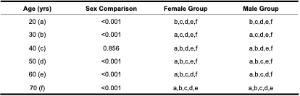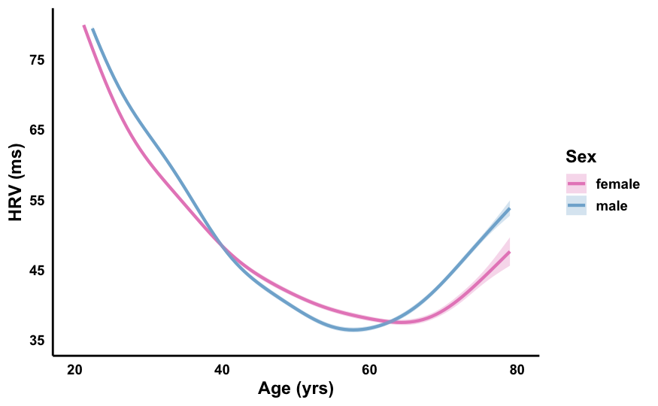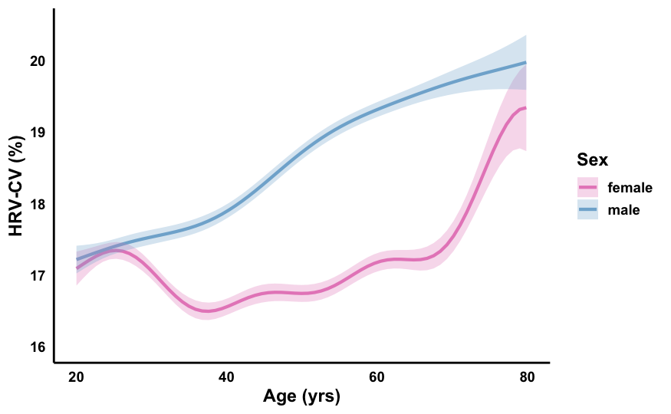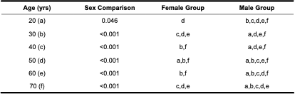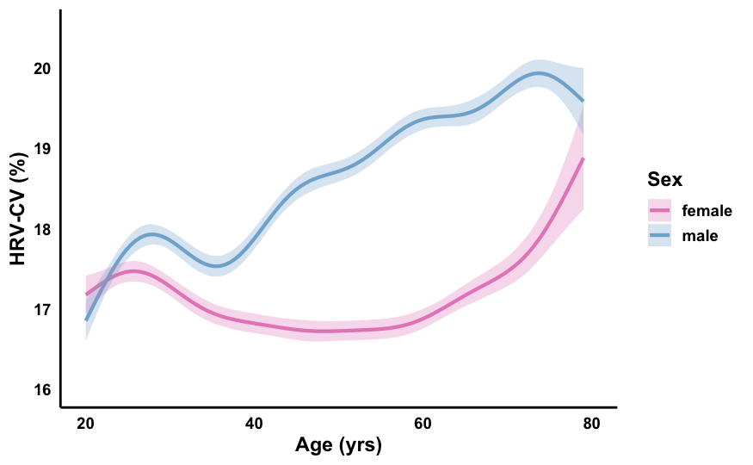

**Figure S3.** Age-related trends in heart rate variability (HRV; A) and HRV coefficient of variation (HRV-CV; B), visualized using generalized additive mixed models that included sex both as a main effect (controlling for baseline differences) and an interaction with smooth terms (sex-specific trends). Figures depict unadjusted models and correspond to models adjusted for behaviors (average and CV) and BMI shown in Figure 5. Shaded areas represent 95% confidence intervals. Post-hoc pairwise comparisons were conducted using estimated marginal means with multivariate t adjustment for multiple comparisons. Comparisons tested for between-sex differences at selected ages as well as within-sex differences across ages. Tables beneath each panel display p-values for between-sex comparisons and groupings based on within-sex age differences. Letters indicate statistically significant differences (P<0.05) from the corresponding labeled age (e.g., ‘a’ = different from age 20).

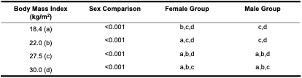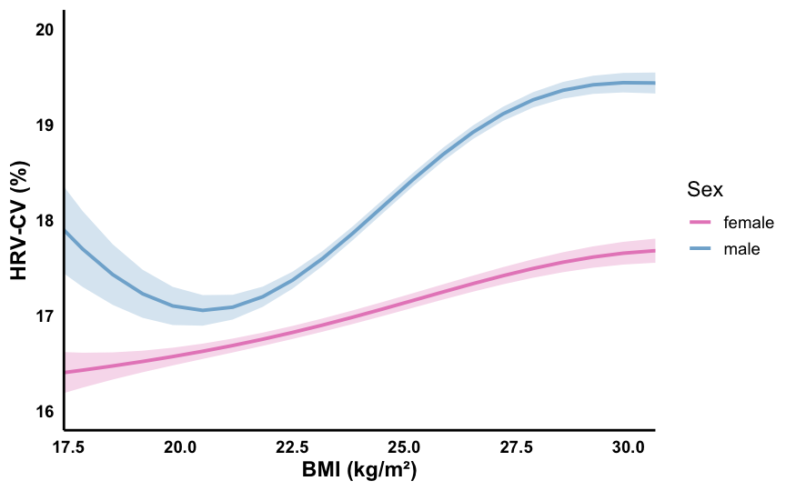

**Figure S4.** Body mass index (BMI) trajectories of HRV-CV visualized using generalized additive mixed models that included sex both as a main effect (controlling for baseline differences) and an interaction with smooth terms (sex-specific trends). Figures depict unadjusted models and correspond to models adjusted for behaviors (average and CV), age, and HRV shown in Figure 6. Shaded areas represent 95% confidence intervals. Post-hoc pairwise comparisons were conducted using estimated marginal means with multivariate t adjustment for multiple comparisons. Comparisons tested for between-sex differences at selected BMI values as well as within-sex differences across BMI values. Tables beneath each panel display p-values for between-sex comparisons and groupings based on within-sex BMI differences. Letters indicate statistically significant differences (P<0.05) from the corresponding labeled BMI (e.g., ‘a’ = different from 18.4 kg/m2).