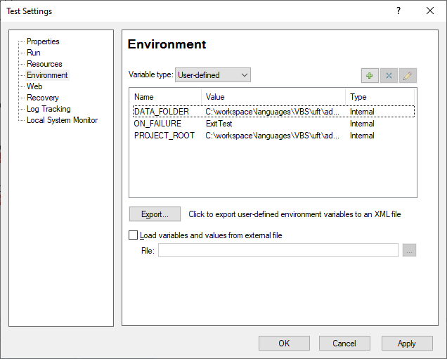

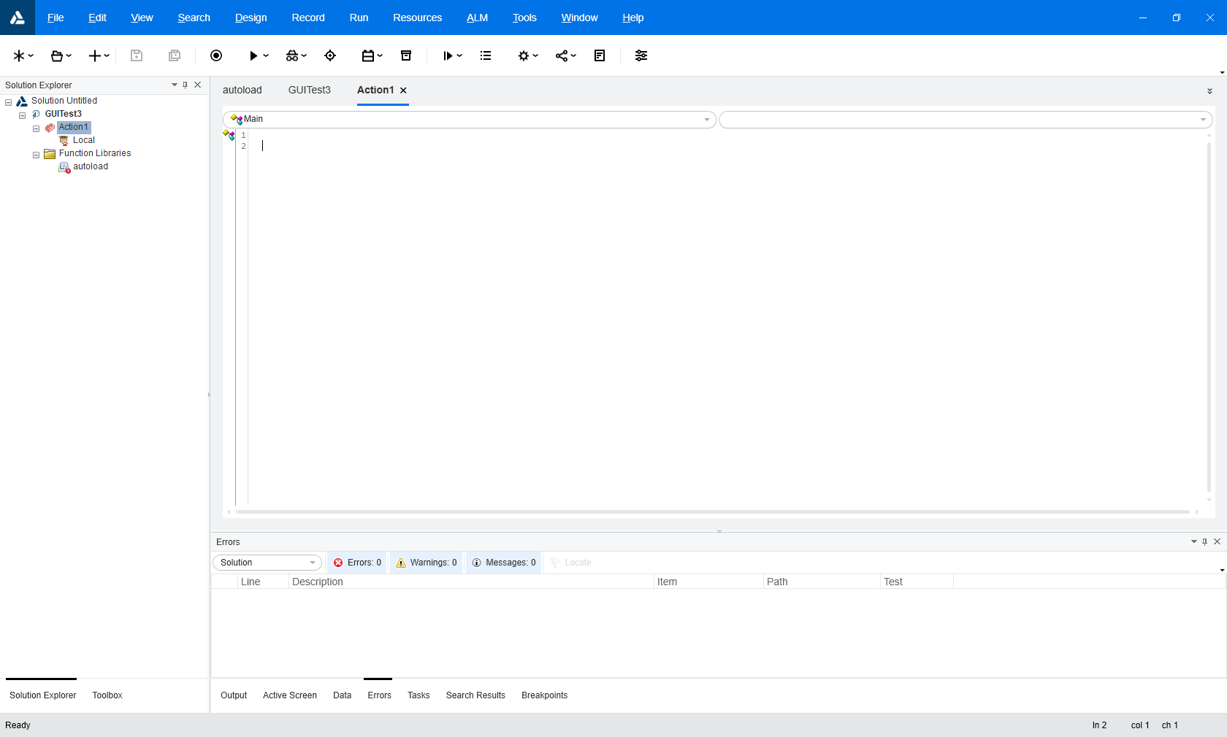

Debugging keywords

Open a new test, set up the DATA_FOLDER

Associate the controller and the keyword class

Set up a local test with the class to test as the only line

Continue testing across multiple variants to ensure you have a viable and correct keyword, document the way to use it