**Problem:** *Delineate a Watershed Using a Topographic Map*

**Statement:**

The topography east of Iowa City 1965 is shown on a USGS 7.5 minute Topo Map (Iowa City East Quadrangle). Note the location of I80 (in red) and Rochester Avenue (red/white dashed line) for orientations.

1. Use this map to delineate the drainage divide (or watershed) of a headwater tributary to the North Branch Ralston Creek. The outlet of the watershed is indicated by the black circle (it is just **upstream** of a confluence).
2. It is common to use a computer tool (e.g., ArcGIS) to delineate watersheds. Use the U.S. Geological Survey’s [StreamStats 3 for Iowa](https://water.usgs.gov/osw/streamstats/iowa.html) to delineate this same watershed. Select Interactive Map and then zoom in to Iowa City to find this section of stream. Use the *Watershed Delineation form a Point* tool to select the (same) basin outlet. After the watershed is delineated (it will take a minute or two), select the *Compute Basin Characteristics* tool (under Delineation Results) and print to a PDF file, and then select the *Compute Flow Statistics* tool and print to a PDF file. Finally, capture an image of the delineated watershed (e.g., using *Snipping Tool* or PrtScn on Windows).

In your solution, include your hand drawn watershed (part a) and the StreamStats 3 (part b), and merge with the PDF files for the basin characteristics and flow statistics.

*Note:* Take a few minutes to compare the two maps. You might see be able to see some parts you missed, but you’ll also see some of the limitations of computer-based methods as well.

**Solution:**

1. Delineate the headwater tributary of North Branch Ralston Creek by hand

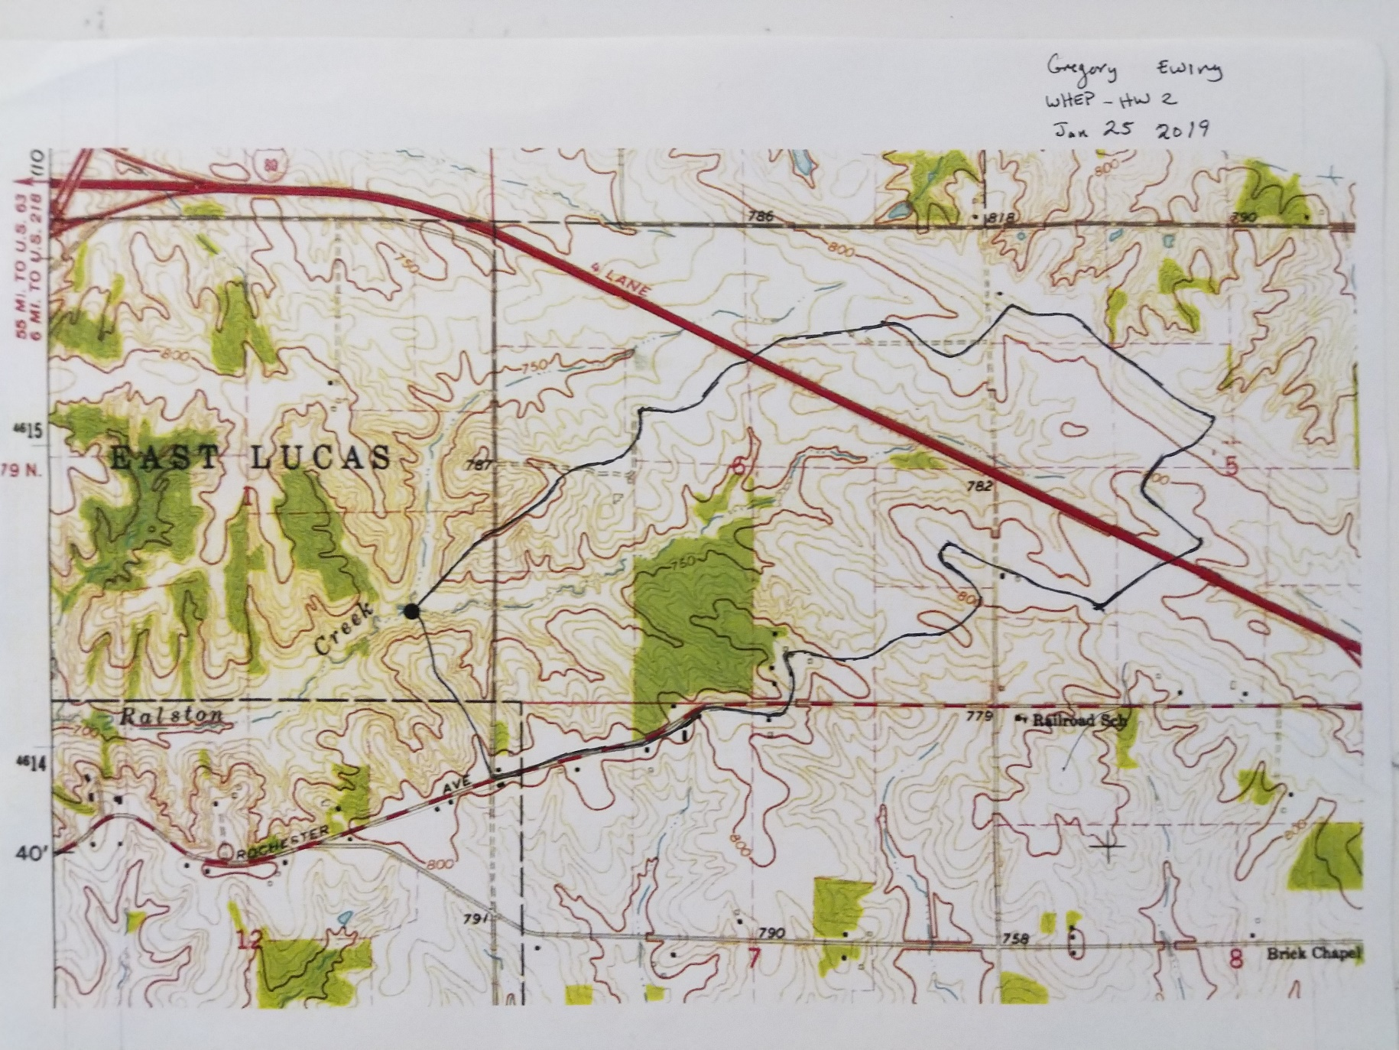

1. Delineate the headwater tributary of North Branch Ralston Creek with StreamStats 3.

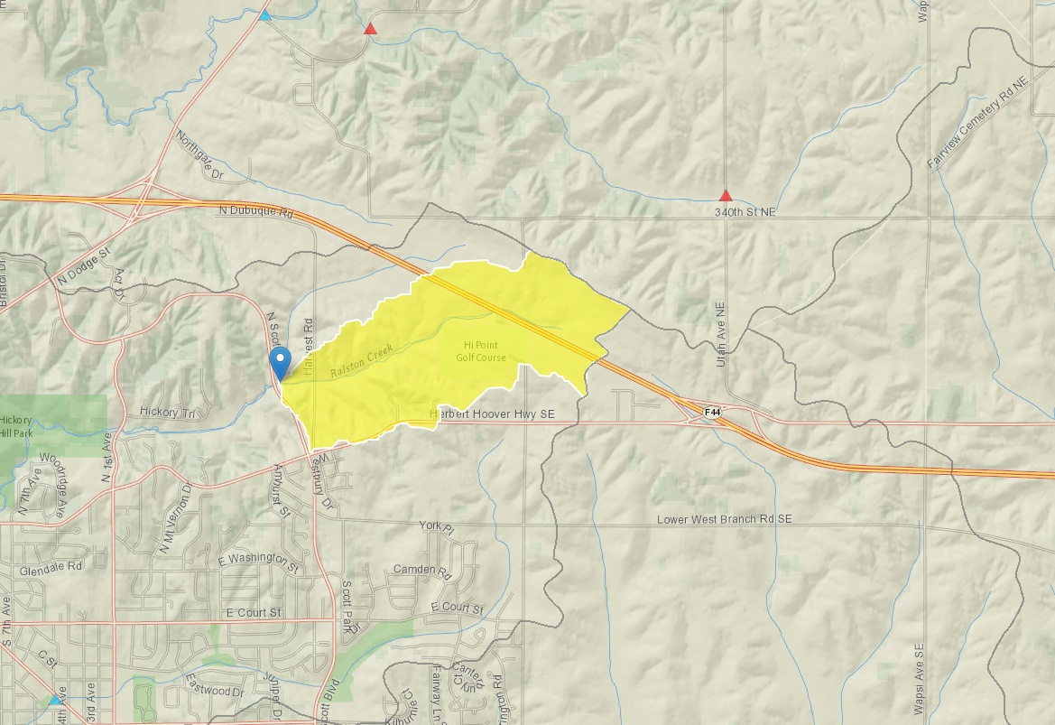

Find attached the streamstats report. The reporting tool allows the basin characteristic report and the flow statistic report to be combined now.