**Problem:** *Coralville Reservoir Operations During the 2008 Flood*

**Statement:**

The 2008 Iowa River flood produced the largest peak discharge in Iowa City (41,100 cfs) since Coralville Reservoir began operations in 1958. The Coralville Reservoir Pool Elevation and Coralville Reservoir outflows for 2008 are shown in the two graphs below.

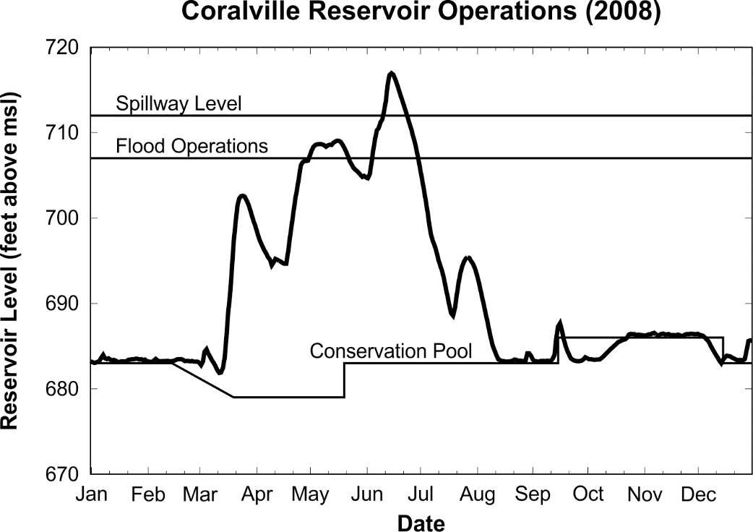

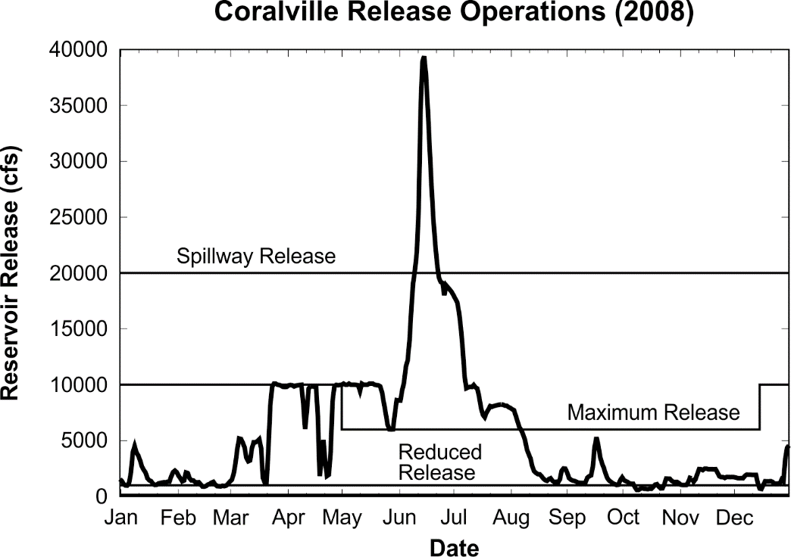

For this problem, classify the reservoir operations in 2008 based on the Coralville Reservoir operating plan. You will need to download the USGS observations for Coralville Reservoir (these are the same data that are shown in the plots).

*Note:* Go to the USGS NWIS web site and download the **daily elevation data** for USGS 05453510 Coralville Lake near Coralville, IA for 2008 (1/1/2008 to 12/31/2008). Go to the USGS NWIS web site and download the **daily flow data** for USGS 05453520 Iowa River below Coralville Dam near Coralville, IA for 2008 (1/1/2008 to 12/31/2008).

*Note:* Use Table C-2 Coralville Lake Regulation Schedules to determine the operating conditions. Please ignore conditions that require data for Lone Tree, Wapello, or Burlington; we will not obtain the data for these sites.

Answer the following:

1. Based on the elevation and flow data, indicate the operating condition (e.g., Condition A-1, B-1, etc) for the first day of each month from March to September (Mar-1, Apr-1, …, Sep-1.

*Note:* Go to the USGS NWIS web site and download the daily Elevation data for USGS 05453510 Coralville Lake near Coralville, IA for 2008 (1/1/2008 to 12/31/2008). Plot the daily elevation data.

Next, add lines showing the conservation pool (variable), and the reference levels for the major flood operations and the spillway elevation. Obtain the conservation pool schedule from Table C-2 Coralville Lake Regulation Schedule (handout) for Schedule A. For the fall pool raise, assume it begins on 15 Sep and holds steady at 686 feet until 15 Dec.

1. Indicate the dates when the reservoir was operating in Condition B-1, B-2, and B-3 (approximate dates).
2. Indicate the dates when the reservoir was operating in Condition C (C-1, C-2, or C-3) in 2008 (give approximate date ranges).

**Solution:**