A CONUS-wide estimator of maximum and largest crown width for FVS-CONUS from legacy Forest Health Monitoring detailed-crown data
Technical report and basis for a manuscript

Aaron R. Weiskittel, Center for Research on Sustainable Forests, University of Maine
Prepared for David W. Marshall and Greg Johnson
Target journals: Forest Ecology and Management or Canadian Journal of Forest Research
22 July 2026

Status. Data ingest, quality control, and the two clade fits are complete, and the David Marshall per-species benchmark is complete and reported here. The final operational library coefficients and the cross-validation coverage and pinball numbers are PENDING FINALIZATION from the softwood form bake-off now running on the cluster, and are marked as such throughout. No final library coefficient or cross-validation number is stated until that run supplies it.

Abstract
Crown width sets crown competition factor and, through it, the density, light interception, growth, and mortality logic of the Forest Vegetation Simulator (FVS). The variant-free FVS-CONUS project needs one defensible continental estimator of maximum crown width (MCW), the near open-grown potential, and largest crown width (LCW), the crown a tree carries under competition, for every species on its list, to replace a patchwork of variant-specific equations, bolted-on maxima, and hand species-group mappings that extrapolate poorly outside their calibration range. We build that estimator from field-measured crown dimensions in the legacy national Forest Health Monitoring (FHM) detailed-crown records, now the FIA Phase 3 sample and the same data Bechtold (2003, 2004) modeled species by species. After quality control the analysis set is 119,513 modeled trees drawn from 127,710 crown-measured trees, spanning 211 species, 32 families, 58 EPA Level III ecoregions, and 33 states.
We read one cloud at two heights. MCW is the τ = 0.95 near open-grown envelope and LCW is the median stand-grown crown, both from a hierarchical Bayesian asymmetric-Laplace quantile regression in brms on cmdstanr. Species are nested in family and crossed with EPA Level III ecoregion as random effects, and four functional-trait fixed slopes (shade tolerance, leaf longevity, wood specific gravity, and maximum attainable height) carry a species-independent equation for data-poor species. The level parameter is estimated on a log link so predictions stay positive. LCW is a bounded Beta ratio of observed crown to predicted MCW, so LCW cannot exceed MCW by construction. A model-free saturation diagnostic split the fit by clade: softwoods took a saturating Mitscherlich form with an estimated asymptote and hardwoods a power form.
The hardwood power fit converged cleanly (population coefficients R-hat 1.01 to 1.06). The softwood Mitscherlich asymptote did not: the entire log-asymptote block reached R-hat as high as 2.1 with effective sample sizes near 5, because the plateau is not identified inside the observed diameter range. A per-species frequentist quantile benchmark that replicates David Marshall’s forms across 88 species with at least 200 trees is the pivotal new evidence. The power exponent is nearly identical across clades, with a softwood median of 0.610 (interquartile range 0.53 to 0.72) and a hardwood median of 0.626 (interquartile range 0.55 to 0.70), both well below one and consistent with David’s Douglas-fir at 0.56. Softwoods therefore follow the same decelerating power as hardwoods and show no distinct in-range saturation, which both explains the non-convergence and questions the clade split. We are resolving the softwood functional form by fitting all three candidates (Mitscherlich, power, and power with a constrained offset) and letting per-clade cross-validation on coverage and pinball loss choose; those results are PENDING. The deliverable is a single fit per clade that returns both operational products, species-dependent and trait-based, for the full CONUS species list, dropping into the FVS-CONUS coefficient slot.

1. Introduction
Crown width is a small measurement that carries a large amount of stand structure. The horizontal spread of a tree’s crown sets how much growing space it occupies, and the sum of those footprints over a stand is crown competition factor, the density measure of Krajicek et al. (1961) that expresses stand occupancy as the fraction of ground the open-grown crowns would cover. Crown competition factor and its relatives feed the density, light interception, diameter and height increment, and mortality logic of the Forest Vegetation Simulator, so an error in the crown-width equation propagates into nearly every projection the model makes. For a growth-and-yield system the crown-width relationship is not a peripheral allometry; it is load-bearing.
Two crown-width quantities matter operationally. Maximum crown width, the crown an open-grown tree of a given diameter can carry, is the near-potential envelope that anchors crown competition factor and the density ceiling. Largest crown width, the crown a tree actually carries in a stand, is the realized quantity that competition compresses below that envelope. FVS carries both, but it carries them as a patchwork. Different geographic variants use different crown-width equations, fitted to different regional samples with different functional forms, and the maximum is often a bolted-on cap rather than an estimated quantity. Species without a local equation are mapped by hand to a surrogate species group. The result works inside each variant’s calibration window and behaves poorly outside it. A linear maximum-crown-width form, for example, keeps widening without bound as diameter grows, so a large tree at the edge of or beyond the fitted range is assigned an implausible crown; David Marshall’s recent refit of the FHM Douglas-fir (Pseudotsuga menziesii (Mirb.) Franco) data makes exactly this point, that the variant equations extrapolate absurdly for large stems.
The variant-free FVS-CONUS project removes the geographic seams and needs a single crown-width estimator that spans the contiguous United States. The requirement is one defensible way to predict MCW and LCW for every species on the FVS-CONUS list, with an honest species mapping and an honest maximum, that behaves sensibly across the full observed diameter range and degrades gracefully for species with little or no crown data. This is the gap the present work fills.
The natural benchmark is Bechtold (2003, 2004), who fit species-by-species ordinary least squares crown-diameter models to this same FHM detailed-crown sample. Our contribution is methodological rather than a new data source: one dataset read at two quantiles instead of two model families, a taxonomy-and-ecoregion hierarchy that returns species-dependent and species-independent predictions from a single fit and retires the hand species-group mapping, a functional-trait layer that carries data-poor species from published traits, and a functional form chosen by a model-free diagnostic rather than assumed. The objectives are, first, to estimate a calibrated MCW envelope and a bounded LCW for the full CONUS species list; second, to determine whether crown width saturates within the observed diameter range and whether softwoods and hardwoods require different functional forms; and third, to fix the softwood form by out-of-sample criteria rather than by in-sample fit alone.

2. Data

2.1 Source and lineage
The crown-width observations come from the legacy national Forest Health Monitoring detailed-crown tree records. FHM established a national grid of permanent detection-monitoring plots in the early 1990s, and under the 1998 Farm Bill that network was folded into the FIA sampling grid in 2000, at which point the former FHM plots became the FIA Phase 3 plots, a one-in-sixteen subset of the Phase 2 grid. The detailed-crown data are therefore a large, spatially extensive sample of field-measured crown dimensions on stand-grown trees, and they are the same records Bechtold (2003, 2004) used, which is why his species-by-species fits are the natural point of comparison.

2.2 Analysis set
After quality control the analysis set is 119,513 modeled trees, drawn from 127,710 crown-measured trees, spanning 211 species, 32 families, 58 EPA Level III ecoregions, and 33 states. We keep standing live trees that carry a real crown measurement, require diameter at breast height (DBH) at or above 5.0 in (12.7 cm) because crown diameters were measured only on trees of that size and larger, require both perpendicular crown diameters to be present and positive, and retain a single record per tree where a stem was remeasured across cycles, matching Bechtold’s rule that avoids autocorrelation from repeated visits. Figure 1 and Figure 2 show the sample density and the species richness across the contiguous United States, and Figure 3 shows the crown-width-on-DBH cloud that the two quantiles read.
Crown width is defined to match the field protocol and the published precedent. Crews measured the horizontal diameter of the widest axis of the crown and the diameter of the axis at ninety degrees to it. Bechtold reduced these two diameters to their arithmetic mean; we reduce them to their geometric mean, the square root of the product, because the geometric mean is the natural summary of a two-axis elliptical footprint and is less sensitive to a single lopsided axis. The two summaries coincide for circular crowns and diverge for asymmetric ones, with the geometric mean at or below the arithmetic mean, and we hold that definitional difference explicit so the Bechtold cross-check can be put on his arithmetic-mean basis rather than absorbing the difference silently. DBH is recorded in inches and crown diameters in feet, the units of the original protocol and of Bechtold’s models, and we fit in those units and report metric equivalents alongside.

2.3 Traits and taxonomy
Species are recorded with the FIA species code, so no separate crosswalk is required. We join each record to the FIA reference species table to recover genus, species, naming authority, and common name in authority-bearing form, for example Picea rubens Sarg., Abies balsamea (L.) Mill., Pinus strobus L., and Pseudotsuga menziesii (Mirb.) Franco, and a genus-to-family lookup populates the taxonomic hierarchy. Four functional traits are joined by species code: shade tolerance as a continuous index, leaf longevity spanning the evergreen-to-deciduous and the conifer longevity gradient, wood specific gravity, and maximum attainable height as a standardized stature index. Continuous traits are standardized after imputation, and the centering and scaling constants are stored so that a prediction for a new species is reproducible from published traits. The softwood-versus-hardwood distinction is joined as well, but it routes each tree to its clade-specific fit rather than entering as a trait slope, because within a clade that contrast is constant and can carry no information.

2.4 Coordinate linkage and confidentiality
Ecoregion enters the model from a spatial join, so each plot needs a coordinate, and the FHM detailed-crown records carry none. We recover approximate public coordinates through the FIA database. The intended bridge, the Phase 3 plot identifier, did not resolve in the shipped extracts, so we adopt an administrative county-representative match: each FHM plot is assigned the median public coordinate of the FIA Phase 3 plots in the same state and county, and the EPA Level III ecoregion is read from a spatial join of that coordinate to the Omernik polygons (Omernik 1987). Two limitations follow and are stated plainly. The public FIA coordinates are themselves fuzzed by up to roughly a kilometer, which is adequate at Level III scale where the polygons are large; and collapsing a county to one representative coordinate misassigns the ecoregion for counties that straddle a boundary and induces pseudo-replication that understates the ecoregion effect’s posterior uncertainty. Only fuzzed public coordinates are used. True FIA plot coordinates are neither used nor released.

3. Methods

3.1 One cloud read at two quantiles
The observations are stand-grown trees, so each record is in effect an observation of largest crown width, the crown a tree carries under competition. Maximum crown width is not a separate dataset but the upper envelope of the same cloud: a tree in a low-density patch that expresses its full crown lies near the top of the crown-width-on-DBH distribution, and a crowded tree lies well below it. We therefore need one relationship read at two heights, the near-maximum for MCW and the central tendency for LCW, and quantile regression is the estimator that reads a single relationship at a chosen height. We fit MCW at the 0.95 quantile and LCW at the median under an asymmetric-Laplace likelihood with the quantile held fixed (Koenker and Bassett 1978; Yu and Moyeed 2001). This dissolves the champion-tree problem: rather than anchor the maximum to one or two registry trees whose spread may not represent open-grown potential, we estimate the upper quantile from the whole cloud, where many thousands of well-expressed trees define the envelope and the estimate carries honest posterior uncertainty. We deliberately do not chase the 0.99 quantile, which is unstable under the asymmetric-Laplace likelihood; 0.95 is the operational anchor for near open-grown maximum.

3.2 Hierarchical structure and the trait-based fallback
Within each clade the coefficients vary by species, with species nested in family as random effects and EPA Level III ecoregion entering as a crossed random intercept. This partial pooling is the mechanism that replaces the hand species-group mapping. A data-rich species such as P. menziesii is estimated almost entirely from its own trees, while a data-poor species is shrunk toward its family and its ecoregion rather than being assigned to a surrogate group by expert choice. Ecoregion enters as a crossed effect so a species can shift its crown-width potential across its range, which carries climate and site without requiring tree height, a quantity the FHM data do not reliably record. The species-independent equation comes from the same fit: within each clade the level parameter is regressed on the four standardized traits, and the intercept plus those trait slopes, evaluated with the random effects set to zero, is the trait-based prediction for a species with little or no crown data. Because the slopes sit on the log-scale level parameter they act multiplicatively on crown width, which keeps the trait response sensible across the wide range of stature in the CONUS list.

3.3 The saturation diagnostic and the clade forms
Before assuming a functional form we asked whether crown width actually saturates with DBH inside the observed range, and whether it saturates the same way for softwoods and hardwoods. A saturating form can return an estimated asymptote only if the cloud bends toward that asymptote somewhere within the data; if the cloud is still climbing at the largest trees, the asymptote sits above the data and the fit reports a prior, not a measurement. A model-free diagnostic tracked the 95th-percentile crown-width envelope across the upper third of the diameter range. The two clades separated cleanly. The softwood envelope flattened, with a slope of about -0.45 ft in⁻¹, so it bends toward a ceiling the observed trees reach. The hardwood envelope kept rising, with a slope near +1.5 ft in⁻¹ and no plateau anywhere in the observed range. We therefore fit softwoods with a saturating Mitscherlich form, crown width equal to an asymptote A times one minus the exponential of a rate b times DBH, with A the estimated maximum crown width; and hardwoods with a power form, crown width equal to a scale a1 times DBH raised to an exponent a2. The split matches the global pattern Katabuchi et al. (2025) reported from the Tallo database, a saturating form in gymnosperms and a power law in angiosperms, reproduced here independently from field-measured widths at the scale of the operational species list. The tension this report resolves is whether that split survives contact with the softwood data in the observed range, which the results address directly.

3.4 Largest crown width as a bounded ratio
Largest crown width cannot physically exceed maximum crown width, and we build that constraint in rather than clamp it afterward. We form the ratio of each observed crown width to its clade-appropriate fitted MCW envelope, a quantity bounded on the interval zero to one, and model that ratio with Beta regression on crown ratio and DBH under the same taxonomic and ecoregion hierarchy. Largest crown width is then predicted MCW times the fitted ratio, so it is bounded above by MCW by construction and cannot produce the above-maximum values a DBH-and-DBH-squared form can generate. Crown ratio is the covariate that explains where a competing tree sits below the open-grown envelope, and it is exactly the variable the FHM data carry. To keep the ratio strictly inside the open interval we floor the fitted envelope at the observed crown before dividing and apply the standard squeeze transform.

3.5 Priors, log link, and computation
We estimate the softwood asymptote and the hardwood scale on the log scale, writing each as the exponential of a log-level parameter so the realized value is positive by construction for every species. This is a deliberate reparameterization, not a cosmetic one. On the natural scale a data-poor species whose family, species, and ecoregion deviations happen to draw low can land at a negative fitted maximum even when the population intercept is positive, which silently drops every tree of that species from the ratio stage and exports a broken coefficient downstream, and it destabilizes warmup because chains that wander toward a nonpositive level are rejected. The log link retires all three failure modes at once. Priors are weakly informative and set on interpretable scales: the log-level intercept carries an informative prior drawn from plausible crown maxima, the hardwood exponent is held positive and below one so the power curve stays monotone and concave, the standardized trait slopes carry modest normal priors, and the random-effect standard deviations carry half-normal priors. We fit the two clade-specific MCW models and the LCW ratio model with brms (Bürkner 2017) on the cmdstanr backend on the Ohio Supercomputer Center Cardinal cluster, with within-chain threading, and assess convergence with the potential scale reduction factor (R-hat target at or below 1.01), bulk and tail effective sample sizes (ESS target above 400), and the absence of divergent transitions.

4. Results

4.1 Convergence: hardwoods converge, the softwood asymptote does not
The two clade fits told opposite stories, and the contrast is itself a result. The hardwood power fit converged cleanly, with population coefficients at R-hat 1.01 to 1.06; only the effective sample sizes lagged the house bar, running 60 to 230 against the target above 400, which a top-up run is closing. The softwood Mitscherlich fit did not converge where it matters. The entire log-asymptote block was unidentified: the log-asymptote intercept reached R-hat 1.21, the trait slopes on the asymptote reached R-hat 1.6 to 2.1 with effective sample sizes of 5 to 7 (leaf longevity 2.10, maximum height 2.01), and the asymptote random-effect standard deviations reached R-hat 1.2 to 2.0. This is not a short-chain problem that more iterations would fix. An effective sample size near 5 with the sampler saturating the tree-depth ceiling is the signature of a parameter the data do not identify. The plateau of the softwood curve is not located inside the observed diameter range, so the asymptote is a prior wearing the costume of an estimate, and anchoring plus tightening it (a normal prior centered at a log-asymptote of about 41 ft) stabilized the sampler only by supplying the information the data withhold.

4.2 The David Marshall benchmark and the exponent parity finding
The pivotal new evidence comes from a per-species frequentist benchmark that replicates David Marshall’s approach directly. For every species with at least 200 crown trees, 88 species in all, we fit David’s four forms, linear, quadratic, power, and power with a free offset, by frequentist quantile regression at τ = 0.95, and read the coefficients. The power exponent is the diagnostic quantity, because a value below one means a decelerating, concave curve and a value at or above one means an accelerating one. The exponent is nearly identical across clades. The softwood median is 0.610 with an interquartile range of 0.53 to 0.72 across 35 species, and the hardwood median is 0.626 with an interquartile range of 0.55 to 0.70 across 53 species (Table 1; Figure 4). Both distributions sit well below one and overlap almost completely, and David’s own Douglas-fir lands at 0.56, squarely inside the softwood cluster. Softwoods, read one species at a time, follow the same decelerating power as hardwoods and show no distinct in-range saturation. That is direct empirical support for what the convergence diagnostics implied: the softwood asymptote does not converge because, inside the range these data cover, the softwood curve is not saturating any more sharply than the hardwood curve. The coefficient cloud in exponent-against-scale space (Figure 5) shows the two clades occupying the same region rather than separating.

4.3 In-sample fit against extrapolation behavior
An in-sample criterion and a behavioral criterion point in different directions, and the difference is the crux of the form choice. By a heuristic AIC computed per species, the flexible polynomials win the in-sample tally: the quadratic is best for 32 of the 88 species, the linear for 29, the power for 15, and the power-with-offset for 12 (Table 2; Figure 7). Read naively, that favors a polynomial. The behavioral criterion overturns it. The linear form extrapolates without bound, assigning ever-wider crowns to large stems, and the quadratic peaks at a finite diameter and then turns downward, predicting crowns that shrink and eventually go negative beyond the fitted range (Figure 6). Neither behavior is acceptable in an operational library that FVS will evaluate at diameters beyond a species’ calibration window. The power form is monotone and concave, rises without turning over, and its exponent below one keeps the rise decelerating, which is the behavior a crown-width envelope should show. We therefore prefer the power form for its extrapolation behavior even where a polynomial edges it out in sample, consistent with Russell and Weiskittel (2010), who reached the same power form for maximum and largest crown width in Maine over the same DBH range.

4.4 The offset
David’s power-with-offset form, crown width equal to a free offset b0 plus a scale times DBH raised to an exponent, fixes the crown at a positive value when DBH is zero. The plain power form passes through the origin by construction, which is biologically tidy but forces the curve low at small diameters. When we let b0 float, its median across species was biggish, about 5.9 ft, and in a number of species it wandered to extreme or ill-determined values as the offset traded off against the scale and exponent (Figure 8). A free offset improves the small-diameter fit but destabilizes the coefficients, exactly the concern David raised. The remedy is not to fix b0 hard but to hold it with a tight prior, which keeps the small-diameter flexibility while damping the wander; that constrained-offset form is one of the three softwood candidates in the bake-off below.

4.5 Stochastic frontier cross-check
As a robustness check on the quantile envelope we are fitting a per-clade Bayesian stochastic frontier, which estimates the boundary of the cloud directly rather than a high quantile of it. The frontier is positioned as a sensitivity analysis, not the workhorse, because the quantile is more robust at small sample sizes, exactly where much of the CONUS species list lives. Its results are PENDING FINALIZATION and will be reported as a cross-check on whether the quantile envelope and the estimated frontier agree on the near-open-grown potential.

5. The softwood form decision and the bake-off
The convergence diagnostics and the benchmark together put the clade split under question. The split was motivated by the saturation diagnostic, which showed a flattening softwood envelope, but the per-species exponents show softwoods decelerating like hardwoods rather than saturating to a distinct plateau within the observed range. Two readings are consistent with the evidence. One is that softwoods genuinely saturate but do so above the largest diameters this stand-grown sample reaches, so the plateau is real but off the top of the cloud. The other is that, over the diameters the data cover, a single decelerating power describes softwoods as well as the Mitscherlich does, and the estimated asymptote is an artifact the data cannot support. These have different consequences for the operational library, so we resolve them empirically rather than by assertion.
The decision is to fit all three softwood candidates and let per-clade cross-validation choose. The candidates are the saturating Mitscherlich with the asymptote anchored by a prior, the plain power form, and the power form with a constrained offset. Hardwoods stay on the power form, which converged and is behaviorally sound. The candidates are scored out of sample by ecoregion-block cross-validation on two criteria: calibration coverage, the fraction of held-out crowns falling below the fitted 0.95 envelope, which should sit near 0.95; and pinball (quantile) loss at τ = 0.95, the proper scoring rule for a quantile prediction. Extrapolation behavior is a screen applied alongside the numeric criteria: a candidate that wins on pinball loss but turns over or runs away outside the fitted range is disqualified for operational use, which is how the power form can be preferred even when a polynomial edges it in sample. The three-way softwood bake-off and the hardwood confirmation are running now; the winning per-clade forms, the final library coefficients, and the coverage and pinball numbers are PENDING FINALIZATION and are not stated here until the run supplies them. A scheduled autopilot promotes the converged fits, builds the clade library, and runs the cross-validation, and will slot the numbers into this report and the manuscript when they land.

6. Discussion
The central empirical finding is that the crown-width exponent is nearly the same in softwoods and hardwoods, both near 0.61 and both well below one. Within the diameter range this continental stand-grown sample covers, conifer and broadleaf crowns decelerate with stem size at almost the same rate, and the sharp gymnosperm-versus-angiosperm shape contrast reported globally does not express itself as a distinct in-range softwood saturation. This does not contradict Katabuchi et al. (2025) so much as locate where their contrast lives. Their saturating gymnosperm form is driven by very large and often open-grown trees in the Tallo compilation, where the conifer plateau is expressed; a Phase 3 sample of stand-grown trees, capped at the diameters ordinary forest inventory reaches, does not include the stems that would bend the softwood curve to its ceiling. The plateau is plausibly real and simply above the top of our cloud, which is the same reading the failed asymptote gives from the other direction. The convergence failure is not a nuisance to be tuned away; it is information about where the data end.
The finding sits comfortably with the regional crown-width literature. Russell and Weiskittel (2010) fit maximum and largest crown width for Maine species with a power form over this diameter range and did not need a hard asymptote, which is the behavior our per-species exponents reproduce continentally. Bechtold (2003, 2004) modeled the same FHM sample species by species with polynomial crown-diameter forms and found them adequate in sample, which our best-form tally echoes, but polynomial forms carry the extrapolation pathologies that an operational continental library cannot tolerate, which is why we prefer the power. The older maximum-crown-width tradition of Paine and Hann (1982) and Hann (1997, 1999) built largely linear open-grown maximum forms for western species; those are serviceable inside their calibration window but are the specific forms that widen without bound outside it, the extrapolation problem FVS-CONUS is trying to retire. Reading these together, the power form is the one that both fits in range and behaves out of range, and the case for a separate saturating softwood form rests entirely on whether the off-the-top-of-the-cloud plateau is worth encoding, which the bake-off will decide.
A deeper question underlies the form choice: is the softwood non-saturation a property of the data or of the environment. If the sample simply lacks the large open-grown conifers that would express the plateau, the flat exponent is a data limitation, and the right response is to infuse open-grown large-tree data (the Tallo database, urban and iTree records) so the likelihood rather than the prior pins the ceiling. If instead the crown-width potential genuinely varies with site and climate in a way that flattens the apparent envelope, the response is to model that variation rather than to force a single asymptote. Our design partitions the two. The EPA Level III ecoregion random effect absorbs discrete regional variation in crown-width potential, and a continuous ClimateNA productivity term (Wang et al. 2016) on the level parameter lets the envelope shift smoothly with productivity, so the ecoregion effect and the productivity slope together separate an environmental gradient in attainable crown width from a mere shortage of large open-grown stems. The sign and magnitude of that productivity slope, and how much regional variation the ecoregion effect carries once productivity is in the model, are PENDING FINALIZATION from the production fits and will bear directly on which reading is correct.
Several limitations temper the results. The county-representative coordinate linkage induces pseudo-replication that understates the ecoregion effect’s posterior uncertainty, so the ecoregion shifts should be read as directions and orderings more than as precisely bounded magnitudes until a one-to-one plot key is located. The stand-grown sample, by construction, thins toward the open-grown envelope at the upper quantile, so the MCW estimate is a near-open-grown envelope inferred from well-expressed stand-grown trees rather than a direct open-grown measurement, and the champion and open-grown checks guard against over-reading it. And the geometric-mean crown-width definition sits at or below Bechtold’s arithmetic mean, which the cross-check reconciles explicitly so the comparison is like for like.

7. Next steps and deliverables
The immediate step is the softwood bake-off. When the three softwood candidates and the hardwood confirmation complete, per-clade cross-validation on coverage and pinball loss, screened for extrapolation behavior, selects the operational softwood form, and the unified clade library is exported with a functional-form and clade column, per-species coefficients, the trait-based species-independent equation, the DBH cap per species, and the LCW ratio parameters. The stochastic frontier sensitivity is then read against the selected envelope, and the Bechtold cross-check is computed on the reconciled arithmetic-mean basis for the overlapping eastern and western species. Two augmentations follow that bear on the softwood-plateau question: infusing open-grown large-tree data from the Tallo database to test whether the softwood ceiling is identifiable once the likelihood sees open-grown stems, and a quantile-regression-forest benchmark to bound what the parametric coefficient library gives up. The deliverables are the operational FVS-CONUS coefficient library, a reproducible archive deposited to Zenodo, and this manuscript for Forest Ecology and Management or the Canadian Journal of Forest Research.
The quantities left PENDING FINALIZATION, to be filled from the production run, are the selected softwood form and its justification from cross-validation; the per-clade fitted coefficients (softwood asymptote and rate, hardwood scale and exponent) with credible intervals; the national calibration coverage overall and by species and ecoregion; the pinball loss by clade and the cross-validation contrast among the softwood candidates; the trait-slope signs and magnitudes on each clade level parameter; the ClimateNA productivity slope and the ecoregion shifts; the stochastic frontier cross-check; and the Bechtold root-mean-squared differences. None of these is stated in this report until the run supplies it.

Tables
Table 1. Power exponent (a2) by clade from the per-species frequentist quantile benchmark (τ = 0.95, species with n ≥ 200). The exponent is nearly identical across clades and both medians sit well below one, indicating a decelerating, concave crown-width curve in each clade and no distinct in-range softwood saturation. For reference, David Marshall’s Douglas-fir (Pseudotsuga menziesii (Mirb.) Franco) exponent is 0.56.
Clade | n species | a2 median | a2 IQR
Softwood (gymnosperm) | 35 | 0.610 | 0.53 to 0.72
Hardwood (angiosperm) | 53 | 0.626 | 0.55 to 0.70

Table 2. Best functional form by species from the per-species benchmark, tallied by heuristic AIC across the 88 species with n ≥ 200. The flexible polynomials win the in-sample tally, but the linear form extrapolates without bound and the quadratic turns over and goes negative beyond the fitted range, so the monotone, concave power form is preferred for operational behavior.
Functional form | Species best (of 88)
Quadratic | 32
Linear | 29
Power | 15
Power with offset | 12

Figures
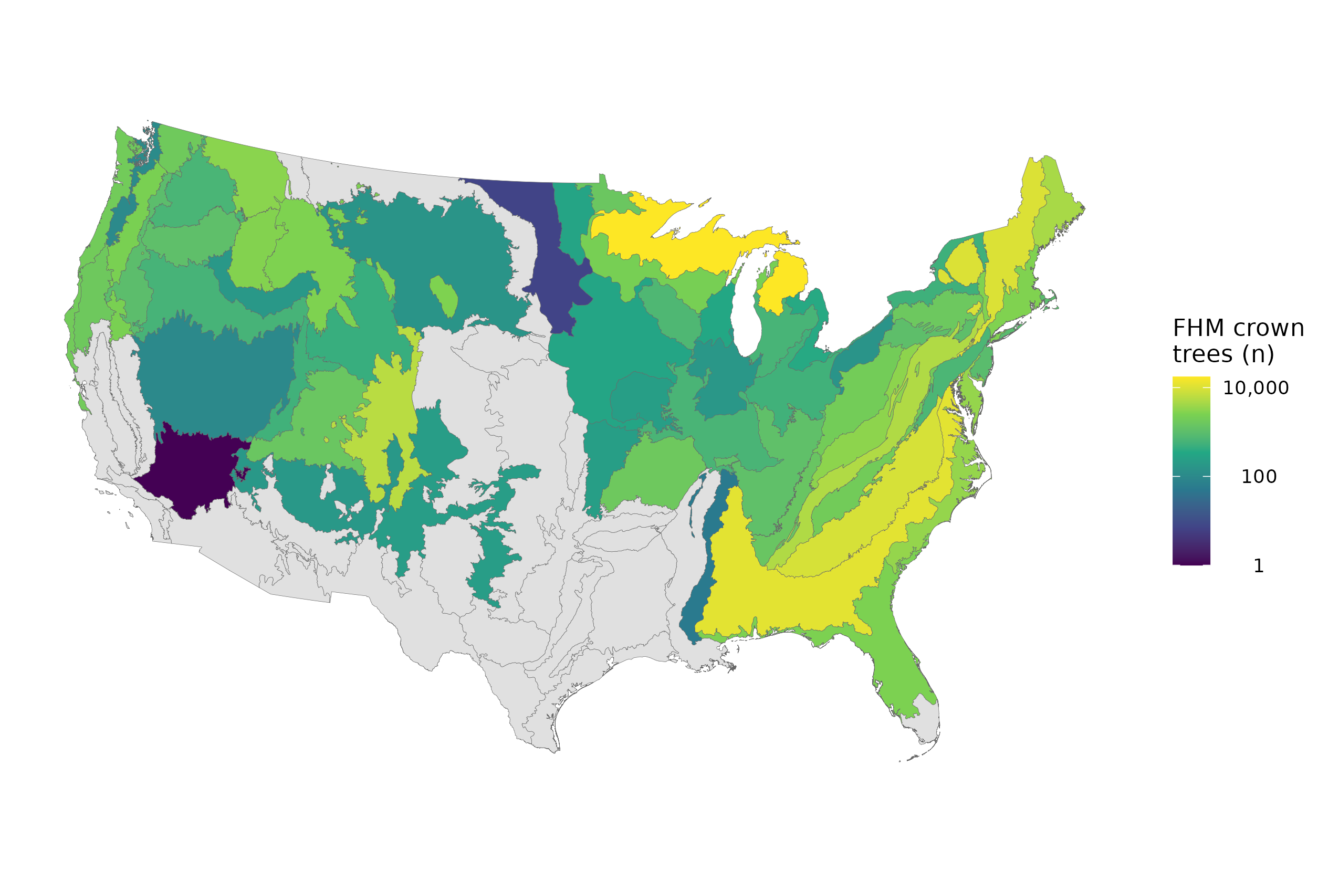
Figure 1. Crown-measured sample density across the contiguous United States from the FHM detailed-crown records, the spatial extent of the 127,710-tree analysis set.
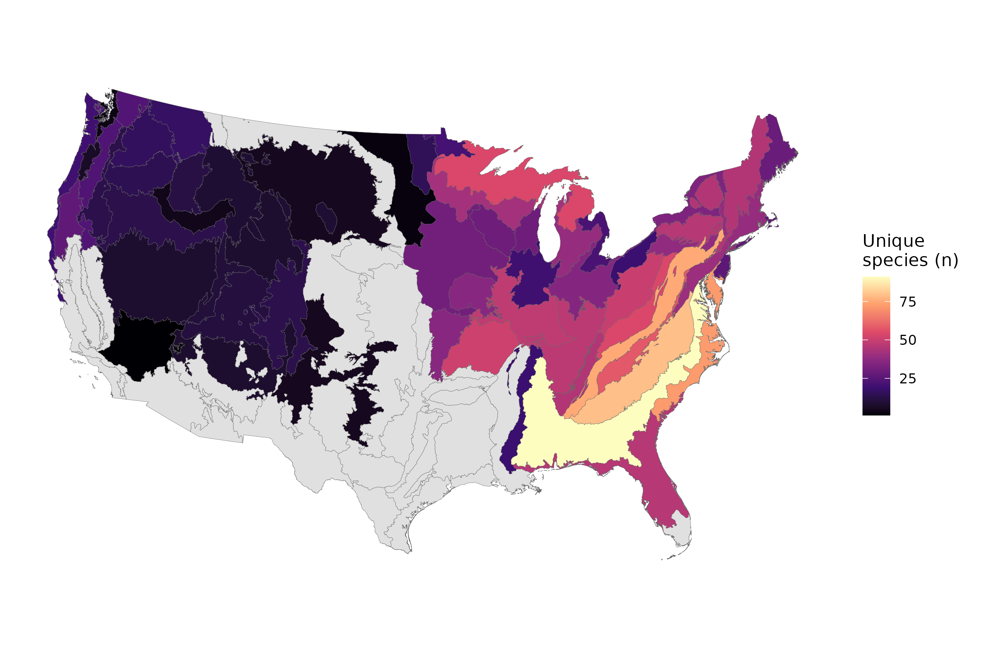
Figure 2. Species richness of the crown-measured sample by area, showing the taxonomic breadth (211 species, 32 families) the hierarchical taxonomy-and-ecoregion structure must span.
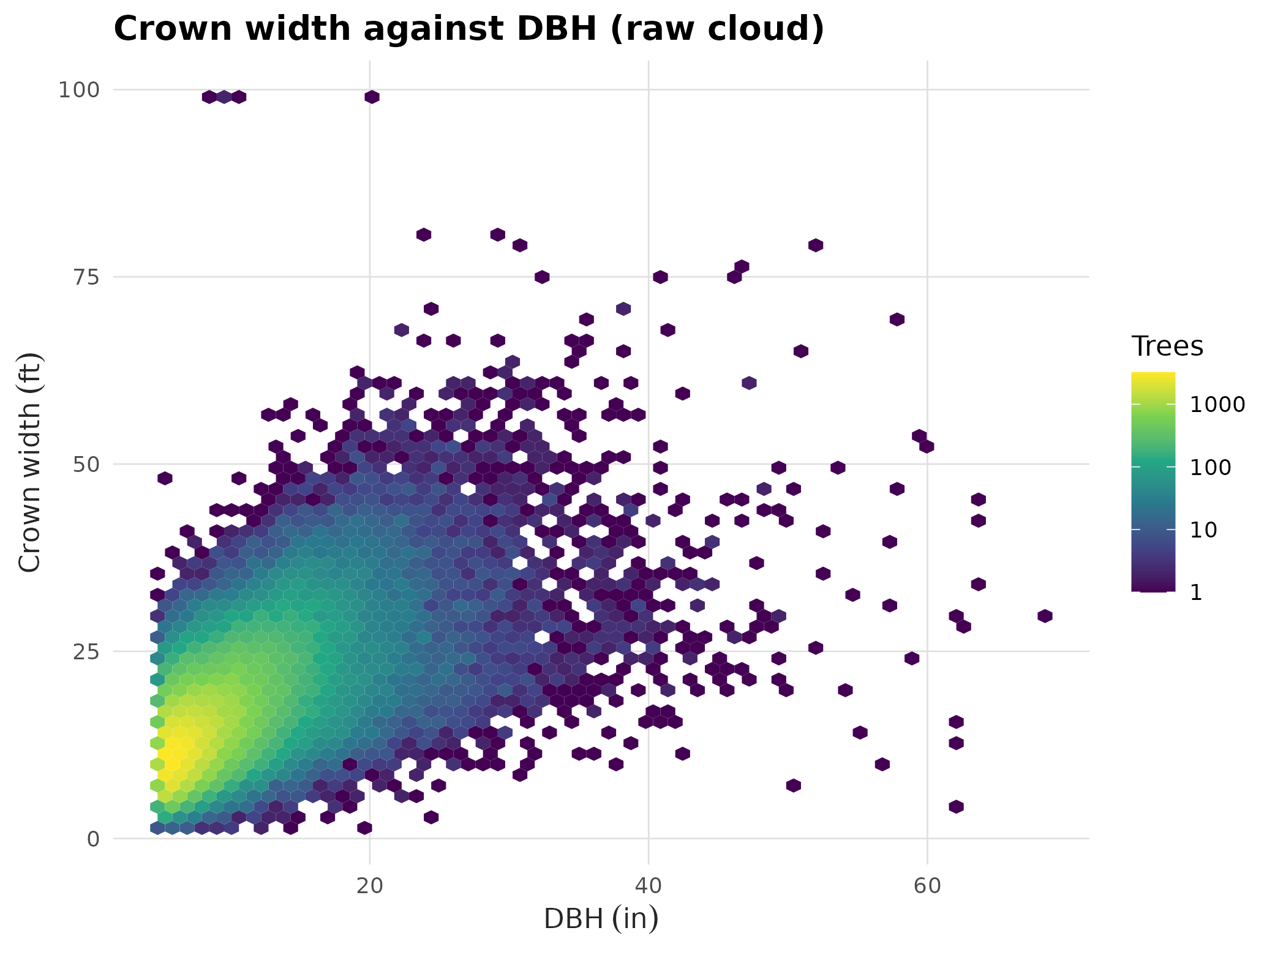
Figure 3. Crown width against DBH for the full analysis set, the single stand-grown cloud read at two quantiles: the τ = 0.95 near-open-grown envelope for MCW and the median for LCW.
The following analysis figures are generated by the parallel benchmarking pipeline into the figures/ directory and are referenced here by filename; they will be embedded when the softwood bake-off finalizes.
Figure 4 (fig_a2_by_clade.png). Distribution of the power exponent a2 by clade from the per-species benchmark, showing the near-complete overlap of the softwood and hardwood distributions, both centered near 0.61 and well below one.
Figure 5 (fig_coef_cloud.png). Per-species coefficient cloud in exponent-against-log-scale space, colored by clade, showing softwoods and hardwoods occupying the same region rather than separating.
Figure 6 (fig_form_extrapolation.png). Extrapolation behavior of the four candidate forms beyond the fitted diameter range: the linear form widens without bound, the quadratic turns over and goes negative, and the power form rises monotonically and decelerates.
Figure 7 (fig_bestform_tally.png). Best-form tally by heuristic AIC across the 88 benchmark species (quadratic 32, linear 29, power 15, power-with-offset 12), the in-sample criterion that the extrapolation screen overrides.
Figure 8 (fig_offset_b0.png). Distribution of the free offset b0 in the power-with-offset form across species (median about 5.9 ft), showing the wander that motivates a constrained prior rather than a free or hard-fixed offset.
Figure 9 (fig_a2_by_region.png). Power exponent a2 by region for wide-ranging species, the empirical read on whether the crown-width exponent shifts with geography and climate.

References
Bechtold, W.A. 2003. Crown-diameter prediction models for 87 species of stand-grown trees in the eastern United States. Southern Journal of Applied Forestry 27(4): 269-278.
Bechtold, W.A. 2004. Largest-crown-width prediction models for 53 species in the western United States. Western Journal of Applied Forestry 19(4): 245-251.
Bürkner, P.-C. 2017. brms: An R package for Bayesian multilevel models using Stan. Journal of Statistical Software 80(1): 1-28.
Hann, D.W. 1997. Equations for predicting the largest crown width of stand-grown trees in western Oregon. Forest Research Laboratory, Oregon State University, Research Contribution 17.
Hann, D.W. 1999. An adjustable predictor of crown profile for stand-grown Douglas-fir trees. Forest Science 45(2): 217-225.
Katabuchi, M., et al. 2025. Global crown-size allometry differs between gymnosperms and angiosperms (Tallo database analysis).
Koenker, R., and Bassett, G. 1978. Regression quantiles. Econometrica 46(1): 33-50.
Krajicek, J.E., Brinkman, K.A., and Gingrich, S.F. 1961. Crown competition: a measure of density. Forest Science 7(1): 35-42.
Omernik, J.M. 1987. Ecoregions of the conterminous United States. Annals of the Association of American Geographers 77(1): 118-125.
Paine, D.P., and Hann, D.W. 1982. Maximum crown-width equations for southwestern Oregon tree species. Forest Research Laboratory, Oregon State University, Research Paper 46.
Russell, M.B., and Weiskittel, A.R. 2010. Maximum and largest crown width equations for 15 tree species in Maine. Northern Journal of Applied Forestry 27(3): 106-112.
Wang, T., Hamann, A., Spittlehouse, D., and Carroll, C. 2016. Locally downscaled and spatially customizable climate data for historical and future periods for North America. PLoS ONE 11(6): e0156720.
Yu, K., and Moyeed, R.A. 2001. Bayesian quantile regression. Statistics and Probability Letters 54(4): 437-447.

