**Peptides containing less than 10 amino acids**

2L2X

2L2Z Drop Duplicate

6FCE

6B34

2N7N

6HVC

6HVB

6BF3

5LFF

2NBC

6VY8

2FRB

2MOA

2IFJ

2MUH

6BEU

|  |  |
| --- | --- |
| **PDB code** | **Reference** |
| 2L2X | **DOI:**[10.1002/anie.201003582](http://dx.doi.org/10.1002/anie.201003582) |
| 2L2Z - DROP Duplicate | **DOI:**[10.1002/anie.201003582](http://dx.doi.org/10.1002/anie.201003582) |
| 6FCE | **DOI:**[10.1021/acs.jmedchem.8b00488](http://dx.doi.org/10.1021/acs.jmedchem.8b00488) |
| 6B34 | **DOI:**[10.1021/acs.jmedchem.7b00953](http://dx.doi.org/10.1021/acs.jmedchem.7b00953) |
| 2N7N | **DOI:**[10.1021/acs.jmedchem.5b01285](http://dx.doi.org/10.1021/acs.jmedchem.5b01285) |
| 6HVC, 6HVB | **DOI:**[10.1021/acs.jmedchem.8b01601](http://dx.doi.org/10.1021/acs.jmedchem.8b01601) |
| 6BF3 | **DOI:**[10.1126/science.aap7577](http://dx.doi.org/10.1126/science.aap7577) |
| 5LFF | **DOI:**[10.1021/acs.jmedchem.6b00695](http://dx.doi.org/10.1021/acs.jmedchem.6b00695) |

**Peptides containing more than 10 amino acids**

|  |  |
| --- | --- |
| **PDB code** | **Reference** |
| 2NBC | **DOI:**[10.1016/j.bbagen.2016.07.027](http://dx.doi.org/10.1016/j.bbagen.2016.07.027) |
| 6VY8 | **DOI:**[10.1002/anie.202003435](http://dx.doi.org/10.1002/anie.202003435) |
| 2FRB | **DOI:**[10.1111/j.1742-4658.2006.05161.x](http://dx.doi.org/10.1111/j.1742-4658.2006.05161.x) |
| 2MOA | **DOI:**[10.1038/nchem.2043](http://dx.doi.org/10.1038/nchem.2043) |
| 2IFJ | **DOI:**[10.1021/bi061969o](http://dx.doi.org/10.1021/bi061969o) |
| 2MUH | **DOI:**[10.1007/s10858-014-9885-4](http://dx.doi.org/10.1007/s10858-014-9885-4) |
| 6BEU | **DOI:**[10.1126/science.aap7577](http://dx.doi.org/10.1126/science.aap7577) |

Example template

#### [2L2X](https://www.rcsb.org/structure/2L2X)

Thiostrepton, oxidized at CA-CB bond of residue 9

**Solvent**: Chloroform-d/Ethanol-d5 (5:1)

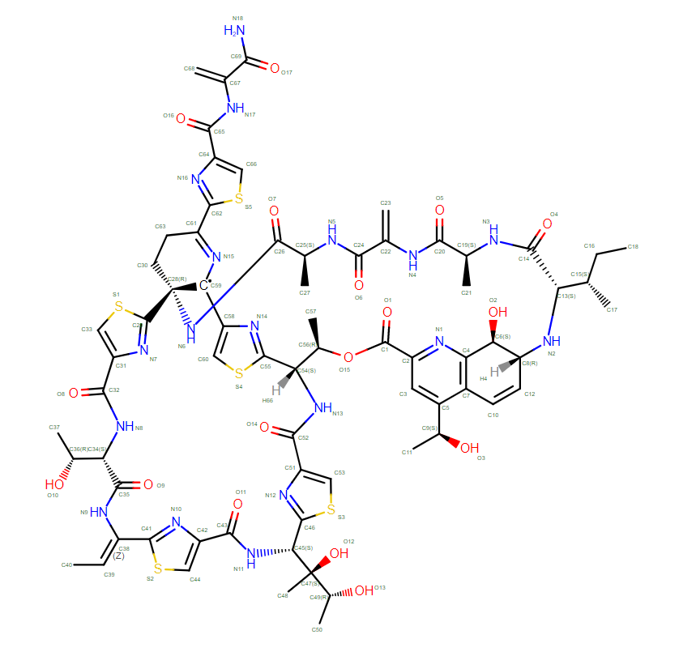

TODO: Check bond orders

#### [2L2Z](https://www.rcsb.org/structure/2L2Z) Drop Duplicate

[THIOPEPTIDE THIOSTREPTON REDUCED AT N-CA BOND OF RESIDUE 14](https://www.rcsb.org/search?q=pdbx_reference_molecule.name:=THIOPEPTIDE%20THIOSTREPTON%20REDUCED%20AT%20N-CA%20BOND%20OF%20RESIDUE%2014)

**Solvent**: Chloroform-d/Ethanol-d5 (5:1)

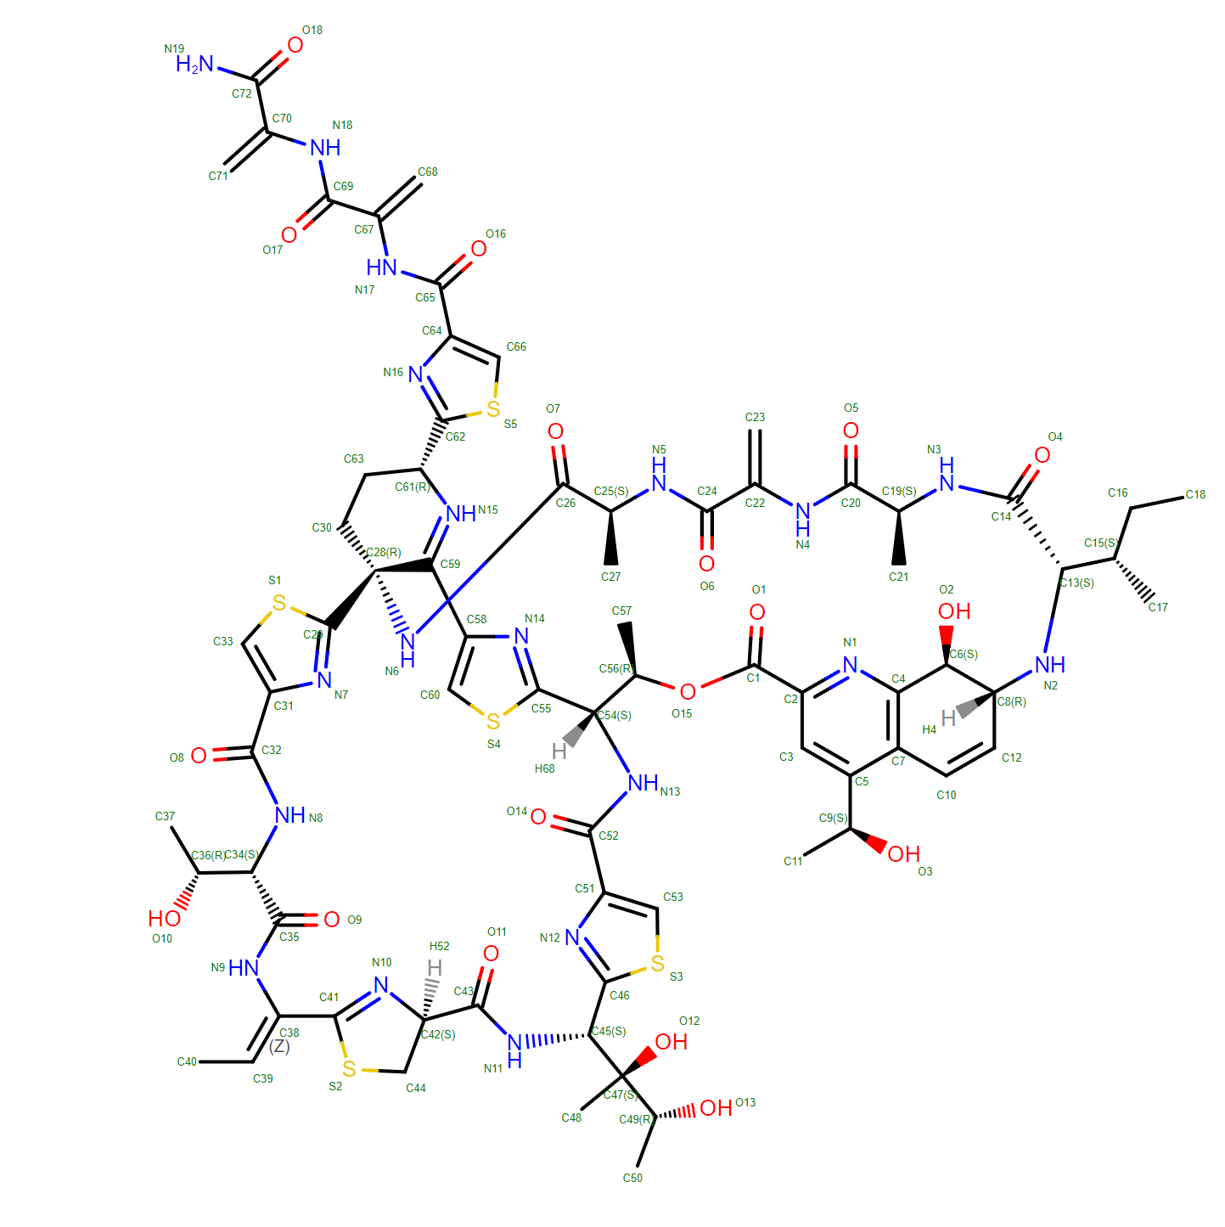

#### [6FCE](https://www.rcsb.org/structure/6FCE)

NMR ensemble of Macrocyclic Peptidomimetic Containing Constrained a,a-dialkylated Amino Acids with Potent and Selective Activity at Human Melanocortin Receptors

ACP-HIS-DPHE-ARG-TRP-ASP-NH2

**Solvent**: 90%H*2*O/10% D*2*O, 200 mM DPC-*d*38

#### [6B34](https://www.rcsb.org/structure/6B34)

NMR ensemble of Tyrocidine A analogue AC3.27

**Solvent**: 50% CD3CN, 50% H2O

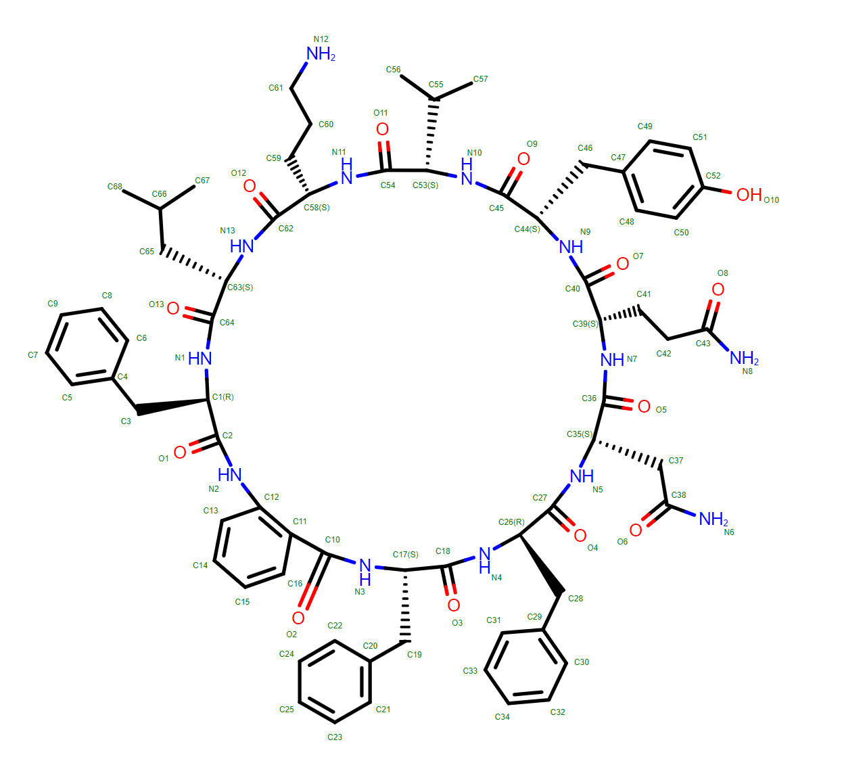

#### [2N7N](https://www.rcsb.org/structure/2N7N)

NMR structure of Peptide PG-989 in DPC micelles

**Solvent**: 90%H*2*O/10% D*2*O pH 5.5, 200 mM DPC-*d*38

>2N7N_1|Chain A|Peptide PG-989|synthetic construct (32630)

XLDPPFRWKX

#### [6HVC](https://www.rcsb.org/structure/6HVC)

NMR structure of Urotensin Peptide Asp-c[Cys-Phe-Trp-(N-Me)Lys-Tyr-Cys]-Val in SDS solution

**Solvent**: 90%H*2*O, 10% D*2*O pH 5.5, 200 mM SDS-*d*25

>6HVC_1|Chain A|Urotensin-2|Homo sapiens (9606)

DCFWXYCV

#### [6HVB](https://www.rcsb.org/structure/6HVB)

NMR structure of Urotensin Peptide Asp-c[Cys-Phe-(N-Me)Trp-Lys-Tyr-Cys]-Val in SDS solution

**Solvent**: 90%H*2*O/10% D*2*O pH 5.5, 200 mM SDS-*d*25

#### [6BF3](https://www.rcsb.org/structure/6BF3)

Solution structure of de novo macrocycle design7.3a

**Solvent**: 90%H*2*O/10% D*2*O pH 5.5, 5% glycerol-*d*8

QDP(DPR)K(2TL)(DAS)

>6BF3_1|Chain A|QDP(DPR)K(2TL)(DAS)|Homo sapiens (9606)

QDPPKTD

#### [5LFF](https://www.rcsb.org/structure/5LFF)

NMR structure of peptide 2 targeting CXCR4

**Solvent**: 90%H*2*O/10% D*2*O pH 5.5, 200 mM SDS-*d*25

ARG-ALA-CYS-ARG-PHE-PHE-CYS

#### [2NBC](https://www.rcsb.org/structure/2NBC)

poneritoxin

>2NBC_1|Chain A|poneritoxin|Anochetus emarginatus (486636)

WCASGCRKKRHGGCSCX

**Solvent**: 95%H*2*O/5% D*2*O, 20mM Sodium Phosphate, pH 6

#### [6VY8](https://www.rcsb.org/structure/6VY8)

NMR solution structure of a triazole bridged trypsin inhibitor based on the framework of SFTI-1

Trypsin inhibitor GLY-ARG-RVJ-THR-LYS-SER-ILE-PRO-PRO-ILE-2AG-PHE-PRO-ASP

**Solvent**: 90%H*2*O/10% D*2*O, pH 3.5

#### [2FRB](https://www.rcsb.org/structure/2FRB)

NMR structure of the alpha-conotoxin GI (ASN4)-benzoylphenylalanine derivative

>2FRB_1|Chain A|Alpha-conotoxin GIA|null

ECCFPACGRHYSC

**Solvent**: 85%H*2*O/15% D*2*O, pH 3.4

#### [2MOA](https://www.rcsb.org/structure/2MOA)

Solution NMR structure of peptide ImI1 (peak 2)

>2MOA_1|Chain A|Alpha-conotoxin ImI|Conus imperialis (35631)

GXASDPRCAWRCX

**Solvent**: 90%H*2*O/10% D*2*O, pH 5.8

#### [2IFJ](https://www.rcsb.org/structure/2IFJ)

Lys6 deamidated variant of ImI conotoxin

>2IFJ_1|Chain A|Alpha-conotoxin ImI|null

GCCSDKRCAWRC

**Solvent**: 90%H*2*O/10% D*2*O, pH 3.0

#### [2MUH](https://www.rcsb.org/structure/2MUH)

High-resolution NMR structure of the protegrin-2 docked to DPC Micelles

>2MUH_1|Chain A|Protegrin-2|Sus scrofa (9823)

RGGRLCYCRRRFCVCV

**Solvent**: 90%H*2*O/10% D*2*O, 50-100mM DPC-*d*38

#### [6BEU](https://www.rcsb.org/structure/6BEU)

Solution structure of de novo macrocycle design14_ss

(DCY)N(DVA)(DPR)DVYC(DPR)(DSG)KY(DVA)(DPR

**Solvent**: 90%H*2*O/10% D*2*O pH 5.5, 5% glycerol-*d*8