**Data Description**

The National Technical University of Athens has developed and operates a multimodal real-time traffic map in the centre of Athens (<http://www.transport.ntua.gr/map/en/>). Data from this application will be used for the short-term forecasting part of the contest. Data are collected from loops on the road at 90 second intervals; part of these data (volume and occupancy) from a key arterial around the city centre (Alexandras Ave) for May of 2000 are included in the data_May.csv file. A supplementary file (data_additional_April.csv) is provided for models needing additional data points for training/developing. Predictions are requested for specific periods of May of 2000.

In the data files, the header row indicates the loop detector IDs. Loop detectors L108, L106, L103 and L101 are in the westbound direction, whereas L102, L104 and L107 in the opposite. Whenever a 255 code is met, an error in measurement was detected. Blank cells indicate missing data. The file contains the letter "x" whenever a prediction is required.

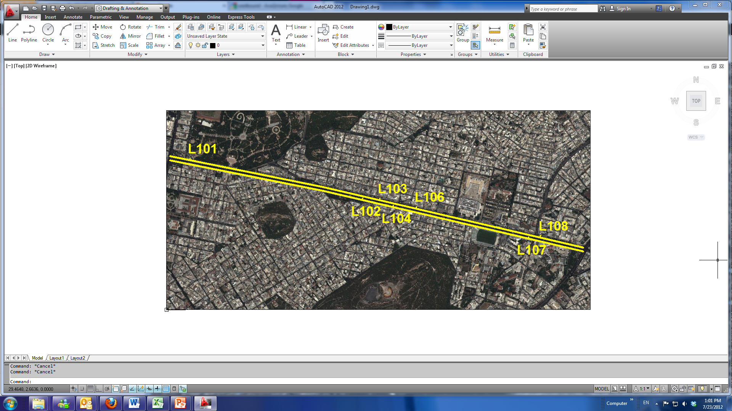

For the prediction, 24 cut-off times have been selected. After those cut-off times, predictions must be made for the next 90 seconds, 15 minutes, 30 minutes, 45 minutes, and 1 hour. To prevent participants from meaningfully using the future to predict the present, data are not revealed again until 30 minutes after the last forecast has been made (or 1.5 hours after the cut-off point).

Participants are required to provide 120 forecasts (5 for each cut-off point) for the 2 routes. The file sampleEntry.csv is an example entry, showing how entries should be formatted.