**PC40 hands on report**

**1D laplace solver**

**Exercise 1: print “hello world” in upc**

For the first exercise, we just had to print hello world with the upc language. The code was already written in the ex_1.upc file.

**Laplace 1D solver: Exercise 2:**

Here, we had to compile and execute a .c file.

To do a test, I also launched the .c file with the classic commands to execute a .upc file, but on one thread. We can clearly see that executing a .c file like this is much slower for some reason (Maybe because the thread has to be initialized).

**Laplace 1D solver: Exercise 3 :**

This is the first exercises where we have to code. First of all, we had to declare the arrays in the shared space.

We also had to change the for and the if statement to make it works with the threads.

We can now execute it :

But as we can see, this is much slower than the .c version of this program. This happened because we are using a for loop with each one of the threads, and we also added an if statement in this loop. On the upcoming exercises, we will try to optimize the code.

Sometimes, the thread 0 prints the result before the other threads could finish. We can add a upc_barrier right before thread 0 starts printing in order to wait for the other ones to finish.

**1D laplace solver : Exercise 4 :**

As said before, the if statement in the for loop in slowing down the execution. So we built a better for loop to get rid of the if statement.



We initialize j with MYTHREAD so it can start on the first element it has to work with. We also now have a for loop without the if in it, which should optimize the program.

We can see that the modifications were useful, the program runs faster just by adding this small change.

**1D laplace solver : exercise 5 :**

In this exercise, we will use the upc_forall loop to make the program faster. In fact, we will use the affinity of each thread, which should increase the time performance. We also had to work with blocksizes.

We don’t have to initialize j on MYTHREAD like said before, because we are here working with affinities, so it would be pointless to do so.

After compiling and launching :

As we can see, the upc_forall loop with the affinity was a uselful tool to get our program to run faster.

**1D laplace solver : exercise 6 :**

To make sure that all the threads finished its array swapping and iteration, we have to add some upc_barrier in it. We simply add them at the end of for loop to make sure that they all finished before moving on.

However, this is now much slower because of the 10000 iteration we are going through each time we enter in the for loop. The 2 upc_barrier could also be slowing down the process.

We don’t need another upc_barrier statement to make sure that thread 0 will start printing before the other ones, because there’s already a upc_barrier at the end of the loop.

This time, the program runs a bit slower than before. This is due to the 10000 iterations as said before.

**1D laplace solver : exercise 7 :**

To solve this exercise, we have to use the function in the upc_collective.h library : upc_all_reduceD( &diffmax, diff, UPC_MAX, THREADS, 1, NULL, UPC_IN_ALLSYNC | UPC_OUT_ALLSYNC );

With this function, we’ll be able to get a value diffmax, which is the max of all the diff values in the local memory of each thread.

We can then run the program:

We can see that the diffmax value converged to 0.000048 at the end of all the iterations.

However, it is now running at a slower rate.

**2D_heat conduction**

**2D_heat conduction: C program**

To start off, we’ll be compiling and running the c version of the program :

As we can see, for N=30 we have a 8,46 µs/iteration, for N=62 we have 32,2 µs/iteration and for N=94 we have 81,2µS/iteration.

In the following exercises, we will try to optimize the program in upc.

**2D_heat conduction : first upc implementation**

In this exercise, we had to convert the c code into a upc code. To do so, we first had to define a blocksize and define the arrays as shared.

We also had to run the iteration a single time. That’s why we are launching the initialisation only if we are using the thread 0.

We changed the for statement in the c file to a upc_forall loop in order to work with the affinity of the thread for a better optimisation.

I also added the bupc_allv_reduce_all function in the bupc_collectivev.h library to get the best value of dTmax out of all the threads after each iteration.

Here, we once again changed a for loop for a upc_forall loop.

to finish it off, we print at the end the time needed to run the program for each thread.

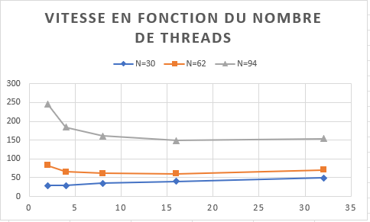

As we can see, the performances of the program went down by a lot. A simple transcription from C to upc is not enough to get a performance boost, it’s even worse than before. This is due to the default work sharing process of the upc as it often access the memory to compute.

However, for N = 30, it is important to use the less amount of thread to keep it efficient. However for N= 62 and 94, the program runs faster the more threads there are until you pass 16 threads. After 16 threads used, the program runs slower.

**2D_heat conduction: better memory use**

In this next exercise, we had to implement a pointer flipping in order not to copy grid_new to grid at the end of each iteration. Thus, we are using a pointer ptr an new_ptr pointing to grid and grid_new. At each iteration, we are swapping the pointers ptr and new_ptr

We first had to add those pointers in the program in order to use them later.

We can then initialize grid and new grid, and then initialize the pointers.

Then we just have to change the computation of in the grid by using the pointers that we created earlier.

To finish the iteration, we are changing the else statement present in the heat_1. We are now swapping the pointers before going into the next iteration.

We are here simulating a copy of grid into new grid, but it’s way faster like this.

With those pointers and pointers flipping, we are reducing by a lot the amount of synchronisation needed in the previous exercises.

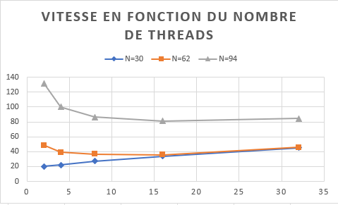

By working with pointers, we can see almost the same progression of curve, but we here lowered all the time/iteration values. The conclusion is the same as the previous exercise: N=30 -> low number of threads, N = 62 and 94 -> 16 threads is optimal.

2D_heat conduction: Performance boost using privatization

It was now asked to get performance boosts by using privatization of the arrays.

First of all, we are now defining 2 new constants which will be helpful later on.



Then we can add the 2 new private pointers and using malloc to allocate the memory of LOCALSIZE, which is the size needed for an array of this size.

We are also now using upc_memget to copy grid and new grind into the private memory - represented by our two new pointers – to initialize them.

We should also break the upc_forall statement into 3 blocks of operation as asked in the exercise. We will use the private pointers during the computation to benefit high performances boosts

After going through the calculation, the program will store the private array into the new_grid array using upc_memput. We are then synchronizing dTmax using the bupc_allv_reduce_all function like before.

To finish the iteration , we swap ptr and new ptr like before, but we also have to swap ptr_priv and new_ptr_priv.

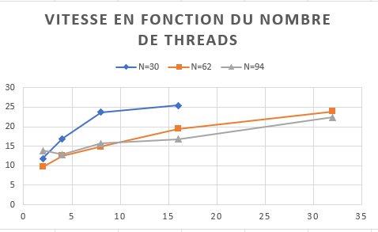

As we can see, the performance boost is huge. However, it seems like adding more and more threads will resolve in a worse performance output, unless for N=94 where 4 threads is the more efficient.

Also, during the launch of the N=30 with 32 threads program, mesoshared crashed multiple times. I couldn’t get the values of it, but it seems like the curve will flatten at around 27 µs.

In comparison with the c code, our upc code is now running faster than the c version, unless for the N=30 where the c code is still faster. For N=62 and N=94, it is now way faster. And for the first time, the most efficient version does not belong to the N=30 but to the N=62 where we went under the 10µs.

**2D_heat conduction: Dynamic problem size**

Here, we had to change the program to specify N at the moment of execution. Since it was too hard for me to adapt heat_4 into heat_5, I started over at the heat_3 for this exercise.

First of all, we are changing the initialize function since we are not using a constant N. we also have to change the array accesses like shown through the whole code.

Also, we are redefining dTmax, ptr and new_ptr with upc_all_alloc as it’s a more practical way to define them here.

We also need to change the computation a bit to adapt with the new accesses of the array. We are also adding this new function, which was given on moodle, and replacing the old bupc_allv_reduce_all for this one.

To finish the iteration, like in heat_3 and 4, we swap ptr and new_ptr.

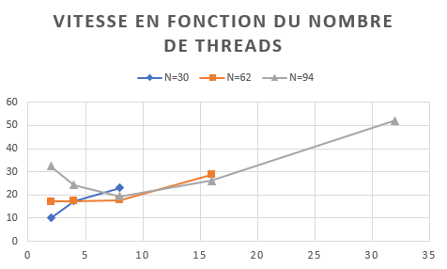

As we went back to heat_3 to do this new exercise, the performances are a bit worst than the heat_4 version, but are still better than the heat_3 version. However, we are using N=30, we should use this version as it’s the fastest for it.

Adding more thread in the N=30 and 62 version is not optimal. For N=94, 8 threads is the most optimal.

**2D_heat Conclusion**

During those 2D_heat exercises, we managed to reduce by a lot the computation time needed throughout multiple optimizations.

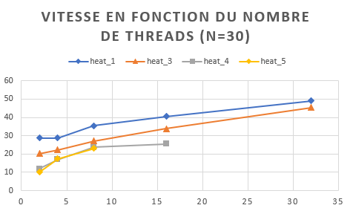

For N=30, we can see that the program needs to keep a low amount of threads for the computation, as the best times were the one with just 2 threads. Also, the code runs faster for each version we ran through.

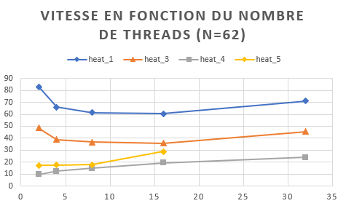

For N=62, heat_4 with the lowest number of threads is the most efficient? For the other versions (except heat_5), 16 threads worked better.

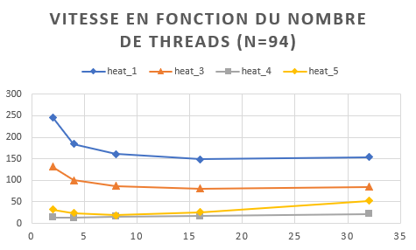

For N=94, the computation time is the biggest out of all the other values of N (<94). The most optimal time for heat_1 and heat_3 is when we are using 16 threads. For heat_5 it is 8 and it’s 4 for the heat_4 version

At the beginning, I thought that the more threads we are using, the best the program will run. However, it’s not really working like that. In fact, it depends on a lot of factors. The computation time could be faster or lower the more threads you work with on certain versions of each code.

**Global conclusion**

Doing those exercises, I learned a lot about the upc programming and I’m now more comfortable with some concepts which were hard to understand at the beginning of the semester.

The 1D laplace solver wasn’t really a big deal since the huge part of the code was already given for each exercise? It was a nice start in the upc world.

While the 1D laplace solver didn’t offered a huge challenge, the 2D_heat conduction part was a hard experience. I had to work a long time on it to understand all the important details and the useful concepts of upc. With a lot of time, internet searches and by speaking with my classmates, I managed to do all the exercises of the 2D_heat conduction.