
CHINESE WUSHU & TAICHI ACADEMY
2827 80th Ave SE Mercer Island WA 98040
(206)749-9513
www.chinesewushutaichi.com

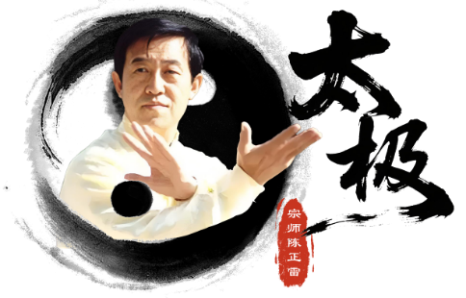
Chinese Wushu & Taichi Academy 30th Anniversary Presents GM Chen Zhenglei’s Chen Tai Chi Seminars July 8th to 12th
GM Chen Zhenglei – China Iconic Tai Chi Grandmaster, Committee Member of China National Wushu Research Institute. Master Chen Bin – Chairman of Henan Province Tai Chi Association. Master Chen Juan – China National Chen Tai Chi Champion. Master Chen Yuanyuan - Chen Tai Chi 12th Direct Line of Descent Inheritor.
July 8th, Wed. evening 7pm-9pm for beginners: Silk Reeling and Chen Tai Chi Qigong by Master Chen Yuanyuan; Four Seasons Health Qigong by Master Chen Juan: 2 hours/ $60
July 9th, Thurs. 9am-12noon and 2pm-5pm for advanced level students or whom already learned Old Frame One: New Frame One applications by GM Chen Zhenglei, assisted by Masters Chen Bin, Chen Juan and Chen Yuanyuan, 6/hours $300
July 10th Fri. 9am-12noon and 2pm-5pm for intermediate above levels students: Push Hands by Master Chen Bin and assisted by Masters Chen Juan and Chen Yuanyuan, 6 hours/$240
July 8th , 9th and 10th classes location：2827 80th Ave SE, Mercer Island WA 98040
July 11th and 12th Sat. and Sun. 9am-12noon and 2pm-5pm for whom already learned 18 forms: Old Frame One by GM Chen Zhenglei and assisted by Master Chen Bin, 12 hours/$360
July 11th and 12th Sat. and Sun. 9am-12noon and 2pm-5pm for advanced level Chen Taichi Sword by Master Chen Juan and Master Chen Yuanyuan, 12 hours/ $360
July 11th and 12th classes (you choose Old Frame One or Chen Sword, one item only) location: Chinatown Community Center, 719 8th Ave S, Seattle, WA 98104
Payment: Tuition must be paid by June 15th, no walk-ins! 10% off before May 15th. Chinese Wushu & Tai Chi Academy students sign up more than two days 15% off before May 15th.
Please mail your Check payable to Chinese Wushu & Taichi Academy LLC and your registration form, available on school website at www.chinesewushutaichi.com to 2827 80th Ave SE, Mercer Island WA, 98004.

