ODT-Testdatei: Style-Registry mit Herkunft
Diese Datei ist ein gezielter Test fuer eine Style-Registry mit Herkunft: styles.xml gegen content.xml / office:automatic-styles.
Erstellt: 23.05.2026 07:07:55

1. Ziel
Der Inspector soll zuerst alle Styles einsammeln und dann beim Lesen von text:p, text:span, table:table-cell und draw:frame den Style-Namen aufloesen.

2. STYLE-REGISTRY Soll-Ausgabe
STYLE-REGISTRY
CommonTitleStyle family=paragraph source=styles.xml
CommonHeadingStyle family=paragraph source=styles.xml
CommonBodyText family=paragraph source=styles.xml
CommonBoldText family=text source=styles.xml
CommonItalicText family=text source=styles.xml
AutoP_CenterBlue family=paragraph source=content.xml/automatic-styles
AutoP_RightRed family=paragraph source=content.xml/automatic-styles
AutoP_CodeBlock family=paragraph source=content.xml/automatic-styles
AutoT_GreenBold family=text source=content.xml/automatic-styles
AutoT_BigItalic family=text source=content.xml/automatic-styles
AutoCell_Header family=table-cell source=content.xml/automatic-styles
AutoCell_Warn family=table-cell source=content.xml/automatic-styles
AutoCell_Ok family=table-cell source=content.xml/automatic-styles
AutoGraphic_Frame family=graphic source=content.xml/automatic-styles

3. Registry als Tabelle
Style | Family | Source | Property-Gruppe | Beispiel-Properties
CommonTitleStyle | paragraph | styles.xml | text-properties | font-size=24pt  font-weight=bold  color=#222222
CommonHeadingStyle | paragraph | styles.xml | text-properties | font-size=16pt  font-weight=bold  color=#003366
CommonBodyText | paragraph | styles.xml | paragraph/text | font-size=11pt  margin-bottom=0.15cm
CommonBoldText | text | styles.xml | text-properties | font-weight=bold
CommonItalicText | text | styles.xml | text-properties | font-style=italic
AutoP_CenterBlue | paragraph | content.xml/automatic-styles | paragraph/text | text-align=center  background=#EEF5FF  font-weight=bold  color=#0044AA
AutoP_RightRed | paragraph | content.xml/automatic-styles | paragraph/text | text-align=end  margin-left=1cm  color=#AA0000
AutoP_CodeBlock | paragraph | content.xml/automatic-styles | paragraph/text | background=#F2F2F2  font-family=Courier New  font-size=9pt
AutoT_GreenBold | text | content.xml/automatic-styles | text-properties | color=#008844  font-weight=bold
AutoT_BigItalic | text | content.xml/automatic-styles | text-properties | font-size=16pt  font-style=italic
AutoCell_Header | table-cell | content.xml/automatic-styles | table-cell-properties | background=#DDDDDD  border=0.05pt solid #666666
AutoCell_Warn | table-cell | content.xml/automatic-styles | table-cell-properties | background=#FFE5E5  border=0.05pt solid #AA0000
AutoCell_Ok | table-cell | content.xml/automatic-styles | table-cell-properties | background=#E5FFE5  border=0.05pt solid #008800
AutoGraphic_Frame | graphic | content.xml/automatic-styles | graphic-properties | border=0.05pt solid #003366  padding=0.05cm

4. Verwendungsstellen im Dokument
CommonBodyText: Dieser Absatz kommt aus styles.xml.
AutoP_CenterBlue: Dieser Absatz kommt aus content.xml automatic-styles.
AutoP_RightRed: Dieser Absatz kommt ebenfalls aus content.xml automatic-styles.
Span-Verwendung: CommonBoldText / CommonItalicText / AutoT_GreenBold / AutoT_BigItalic

5. Table-Cell-Style Test
Zelle | Style | Source
Header | AutoCell_Header | content.xml/automatic-styles
Warnung | AutoCell_Warn | content.xml/automatic-styles
OK | AutoCell_Ok | content.xml/automatic-styles

6. Graphic-Style Test
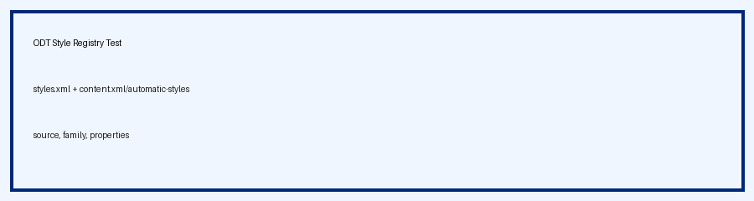

7. Pseudocode fuer Tcl
# 1. styles.xml lesen
collectStyles $stylesDoc styles.xml
# 2. content.xml automatic-styles lesen
collectAutomaticStyles $contentDoc content.xml/automatic-styles
# 3. Registry
dict set registry $name [dict create \
family $family \
source $source \
textProperties $textProps \
paragraphProperties $paragraphProps \
tableCellProperties $cellProps \
graphicProperties $graphicProps]
# 4. Beim Inspect:
set styleName [attr $node text:style-name]
set resolved [dict get $registry $styleName]

8. Fazit
Diese Version macht die Style-Registry explizit sichtbar und testbar.
Wichtig ist die Herkunft: globale Styles aus styles.xml und automatische Styles aus content.xml/office:automatic-styles.

