Project Penny

Make a profitable Twitter clone

Table of Contents

1. Proposal 2

1.1. The Problem 2

1.2. The Solution 2

1.3. The REAL Problem 2

1.4. The Solution to the REAL Problem 2

1.4.1. Features 2

1.4.2. Tactics 3

1.4.3. Strategy 3

1.5. When do we start making MONEY? 3

2. Account Categories 4

2.1. Account levels 4

2.2. Zero Penny account 4

2.3. One Penny account – One penny post 4

2.4. Two Penny account – Two Penny Post 4

2.5. Three Penny account – Three Penny Post 5

2.6. And more Pennies…buy your way into the top spot 5

3. Appendix 5

3.1. Why is this something to try out now? Well look at this: 5

3.2. How many tweets does twitter get? 6

# Proposal

Create a Twitter like platform that has a built in revenue model.

## The Problem

Twitter has a revenue problem. Beyond subscription and advertising there are few methods to create a scalable revenue stream.

How could Twitter generate revenue on a social media platform, commensurate with traffic growth and under their control?

## The Solution

Charge a small fee, a *very* small fee, a **PENNY**, to post a micro-message.

A penny is virtually free, for all intents and purposes it is free, because it certainly feels free.

The revenue stream generated from this penny solution scales linierly with the number of posts and with some additional modifications it can actually grow faster than that, perhaps a lot faster.

And the potential market is humongous; there are currently 300 MILLION tweets on Twitter per DAY! Quite a blue ocean!

## The REAL Problem

Why will people use Penny instead of Twitter?

Anybody that is anybody is on Twitter. This creates a Network Effect that is so complete and perfect, you immediately ask, “How can we crack this nut?”

## The Solution to the REAL Problem

### Features

* **Speech to Text:** Out of the box.
* **Group Chat**: Out of the box. Join a public group, get invited to a private group, read only group posts if you want, post only to the group if you want.
* **Advertising free, algorithm light, Clean UI and Experience:** The underlying bedrock of a revenue stream tied directly to scale means there is no need for any injection of advertisements into the stream in any way. No need to try and match ads to people. The interface is clean, the interaction is pure.  
    
  This Twitter will not be able to do.
* **Rich and freely available APIs:** Because the revenue model is built in we can make available the API to anyone. Almost for any use…let it spread a perfect long tail platform. Whereas Twitter has been known to shut down third party app builders, on the Penny platform we won’t care, anybody can build anything. The micro-charges are built into the platform.   
    
  It is a platform, not just an app.

### Tactics

Focus on **simplicity**. Twitter, for all its “supposed” simplicity is actually a very complicated platform. “Basically, Twitter has become what I call "secret-handshake software" — something that's so complicated that, as in a secret society, only insiders know the rituals that unlock its power.” (Walt Mossburg - [link](http://www.theverge.com/2016/1/27/10836466/walt-mossberg-twitter-is-too-hard-to-use)) Rip out the complexity. Much like what Google does to protect the search experience on the homepage, keep it simple, be rigorous about protecting the simple experience.

Build it from the ground up with the micro-payment machine interwoven into the substrate of the application. This will allow for it to become a platform for micro-blogging and easily transition into a platform for all forms of posts, micro to long-form.

Build it with SEO turned up to “11” from the get go. No need to retro-fit it, build it with that in mind from the start.

Make it with as much feature parity with Twitter as possible…and then add to it and improve it.

### Strategy

Target a niche. - Where is our opportunity: eSports, politics? How about political conservatives…with Facebook being called on the carpet for liberal bias in the trending news stories and Twitter shadow banning conservatives with the Owellian “Trust and Safety Council”. The right side of the political spectrum might be ripe for a competitor in this space.

This will be a marketing play. The message to talk with our customers is a Penny is good, a Penny is what differentiates the quality of our post. If it isn’t worth a penny, then it isn’t worth a posts.

## When do we start making MONEY?

The model is open for tweaking, but on with a simple model the penny per post and additional pennies per premium post starts to really be compelling when we reach a million posts per month. That isn’t very many posts, not really

There will be a multitude of ways to vary the price per post and value returned to the poster per post that can be explored. This will be a machine that can be tweaked.

**Some other examples:**

* Slot on the home page for people to just buy the top spot with the most pennies per post. (Dollars, ten, twenty….a thousand dollar post!? Who knows)
* Friends can pay for your posts if you are witty enough.
* Futures market?
* Political bidding war – zones of conflict?

# Account Categories

## Account levels



## Zero Penny account

Can read all posts.

Can’t Post

## One Penny account – One penny post

Can Post

Can read all posts

Posts can get included in feeds of people following

Posts will not get aggregated to front page or category pages.

## Two Penny account – Two Penny Post

Can Post

Can read all posts

Posts can get included in feeds of people following

Posts get aggregated on category pages.

Posts will not get aggregated to the front page.

## Three Penny account – Three Penny Post

Can Post

Can read all posts

Posts can get included in feeds of people following

Posts get aggregated on category pages.

Posts get aggregated to the front page.

## And more Pennies…buy your way into the top spot

Skies the limit.

There will be a location on the home page for paid placement. Straight up, who wants to buy the top spot. Very intriguing, automatic advertising built in.

# Appendix

## Why is this something to try out now? Well look at this:

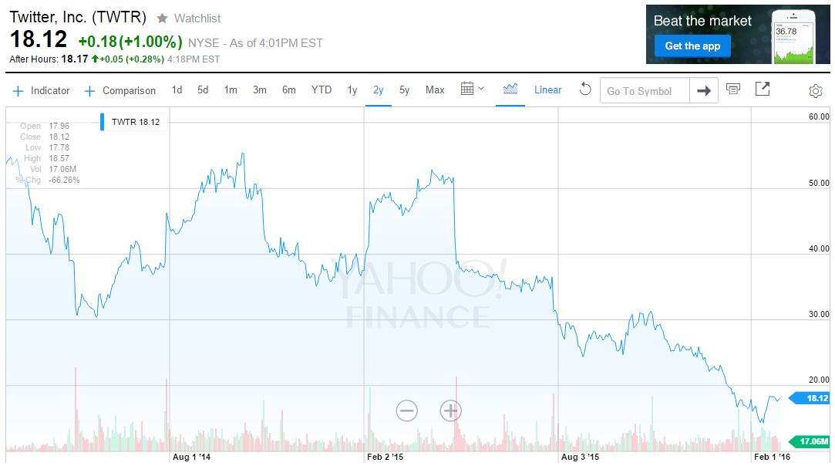

## How many tweets does twitter get?

300,000,000 per day.