HotMan Software

For Hotel management
Version 1.0 beta

Users Manual
TABLE OF CONTENTS
- What is HotMan
- Installing HotMan.
- Starting HotMan.
- Setting up HotMan
- Using HotMan
  - Changing Passwords
  - Registering Guests

WHAT IS HOTMAN?
The HotMan Software, is a powerful tool for managing your hotel business.
- Allows you track your finances by keeping proper accounting records and producing various financial reports.
- Monitor your hotel operations my producing various reports for better decision making by management.

HOTMAN CORE MODULES
- FRONT OFFICE
  - Check in and check out guests.
  - View room status and Guest’s account status
  - Auto-billing
  - Reservations
- FINANCIALS
  - Record cash and credit transactions
  - Generate summary report of transactions by date
  - Void previous transactions
- MAINTENANCE
  - Create users, rooms, room category, department, change shifts, backup and restore utilities.
- UTILITY
  - Audit log
INSTALLING HOTMAN

STARTING HOTMAN
Start a browser and type following url “http://localhost/hotel”.
You will be required to login with a username and password
A default user demo is automatically created while installing Hotman. Use the password password to login. Please make sure you change the default password after login.
We shall see how to create new users and change passwords later in this manual.
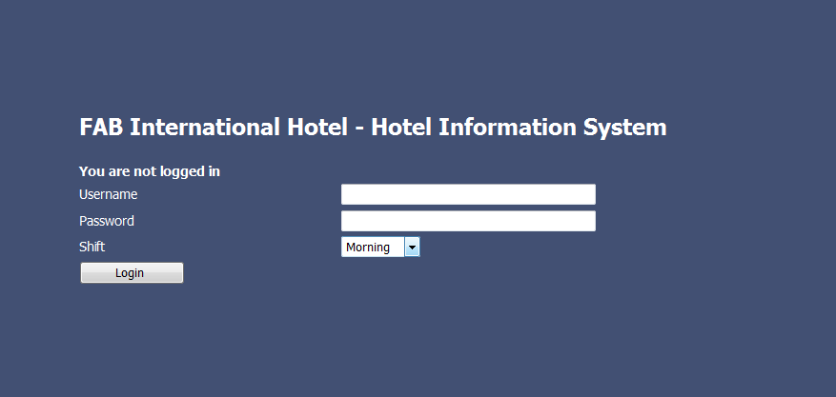
SETTING UP HOTMAN
You need to set up HotMan before you can put it into active day-to-day use. Setting up HotMan for daily use requires adding hotel information, users, room categories, rooms and departments.

SETTING UP HOTEL INFORMATION
You must have been logged in as ‘Manager’.
Go to the Maintenance menu > Hotel Information
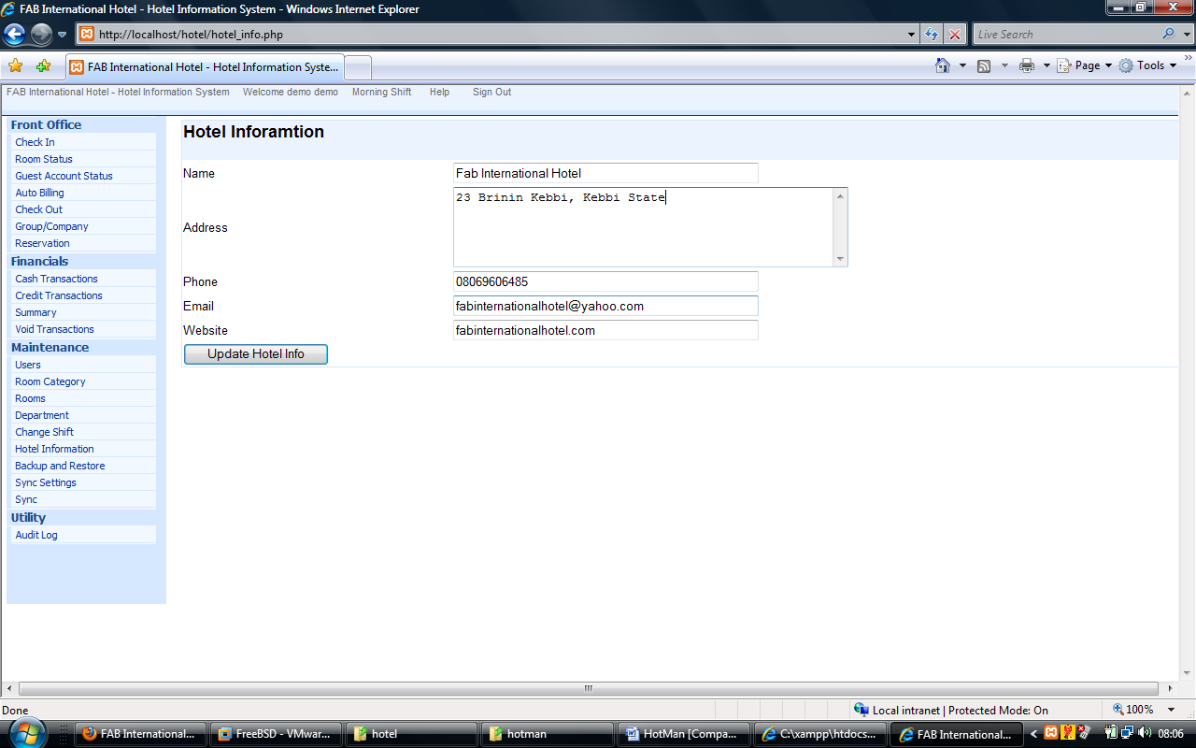
Enter the required information and click ‘Update Hotel Info’
The information provided here will appear at the top of every printed report generated by HotMan.
SETTING UP ROOM CATEGORY
You must have been logged in as ‘Manager’. Go to the Maintenance menu > Room category > Choose Option > Add
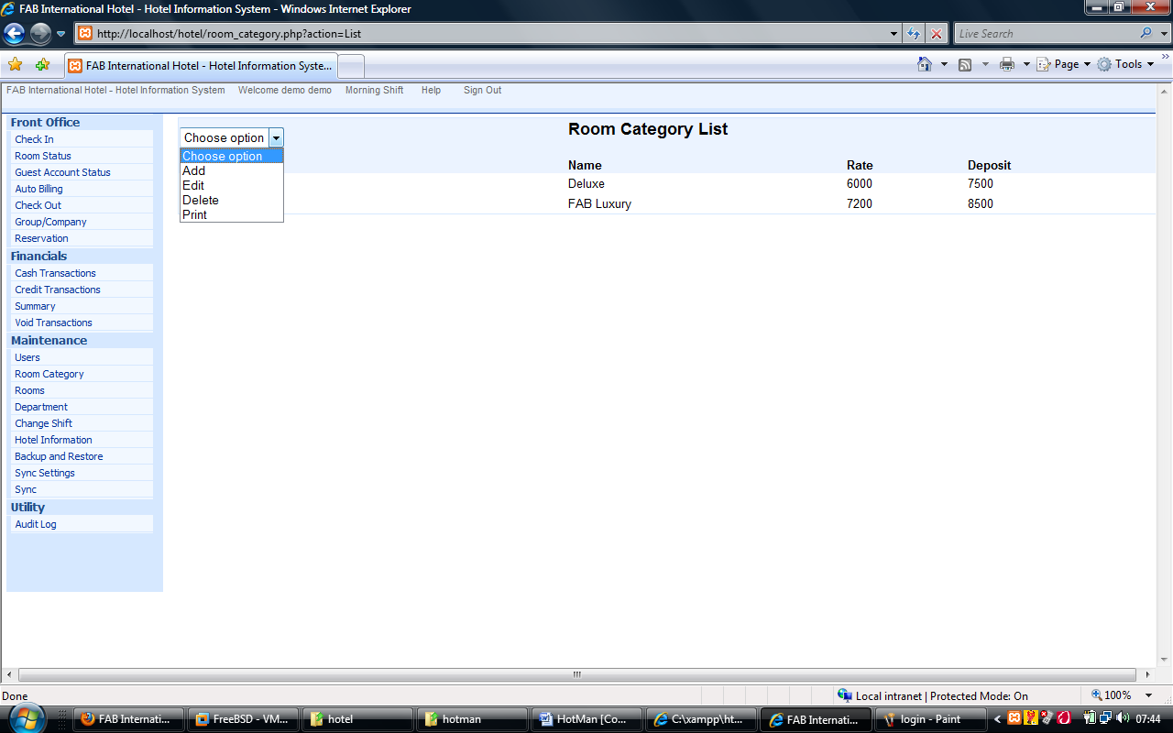
On clicking ‘Add’ a new screen appears where you can enter details and click ‘Add Category’
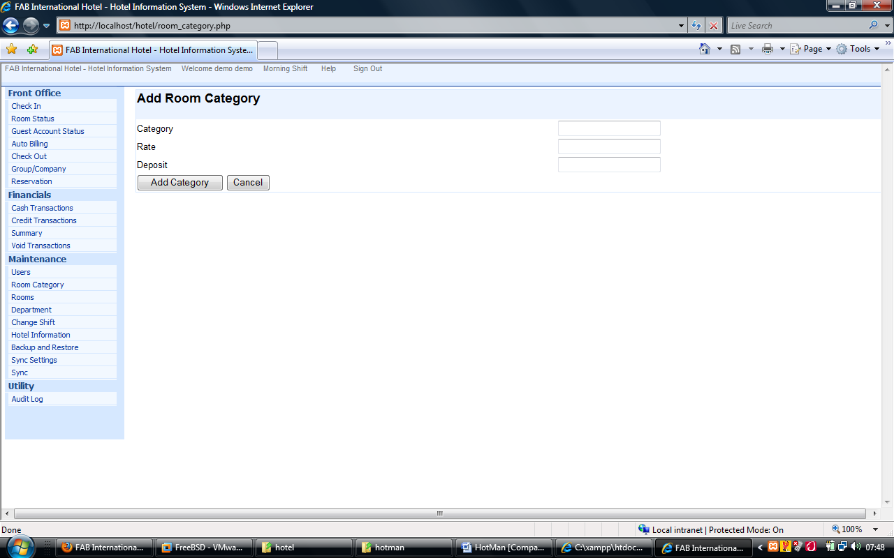

SETTING UP ROOMS
You must have been logged in as ‘Manager’.
Go to the Maintenance menu > Room > Choose Option > Add
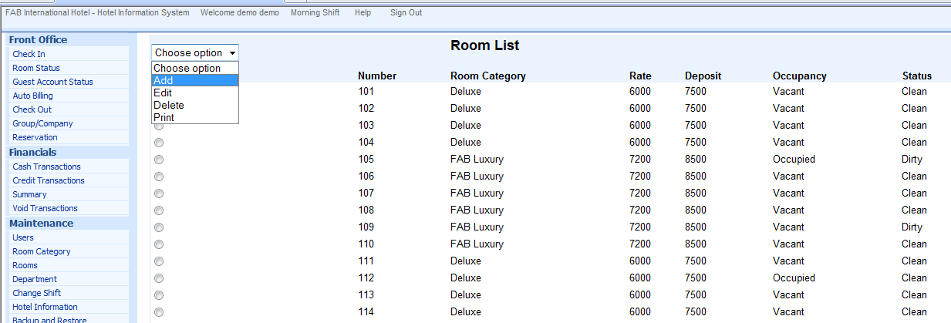

On clicking ‘Add’ a new screen appears where you can enter details and click ‘Add Room’
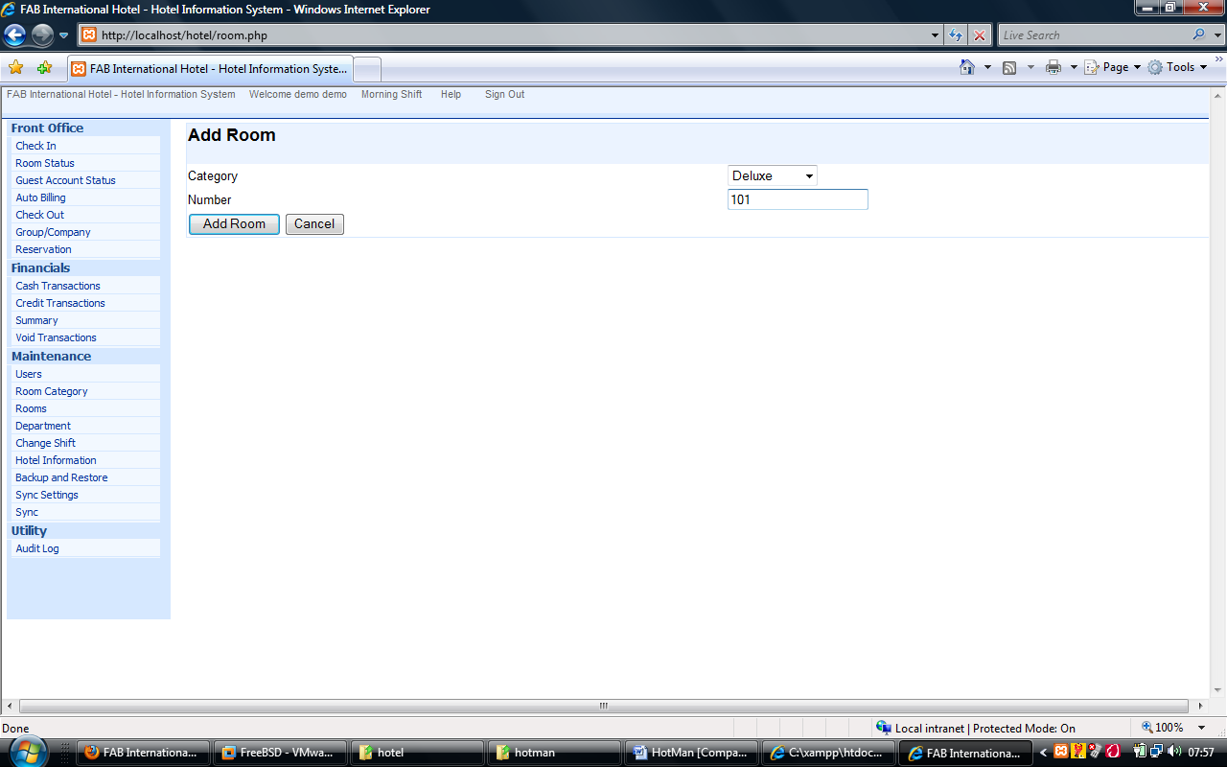
SETTING UP USERS
You must have been logged in as ‘Manager’.
Go to the Maintenance menu > Users > Choose Option > Add
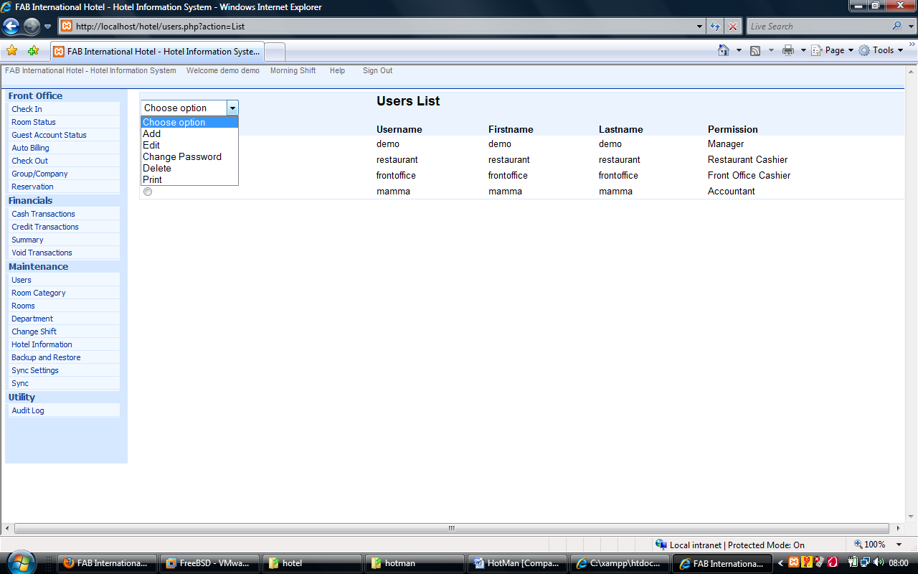

On clicking ‘Add’ a new screen appears where you can enter details and click ‘Add User’
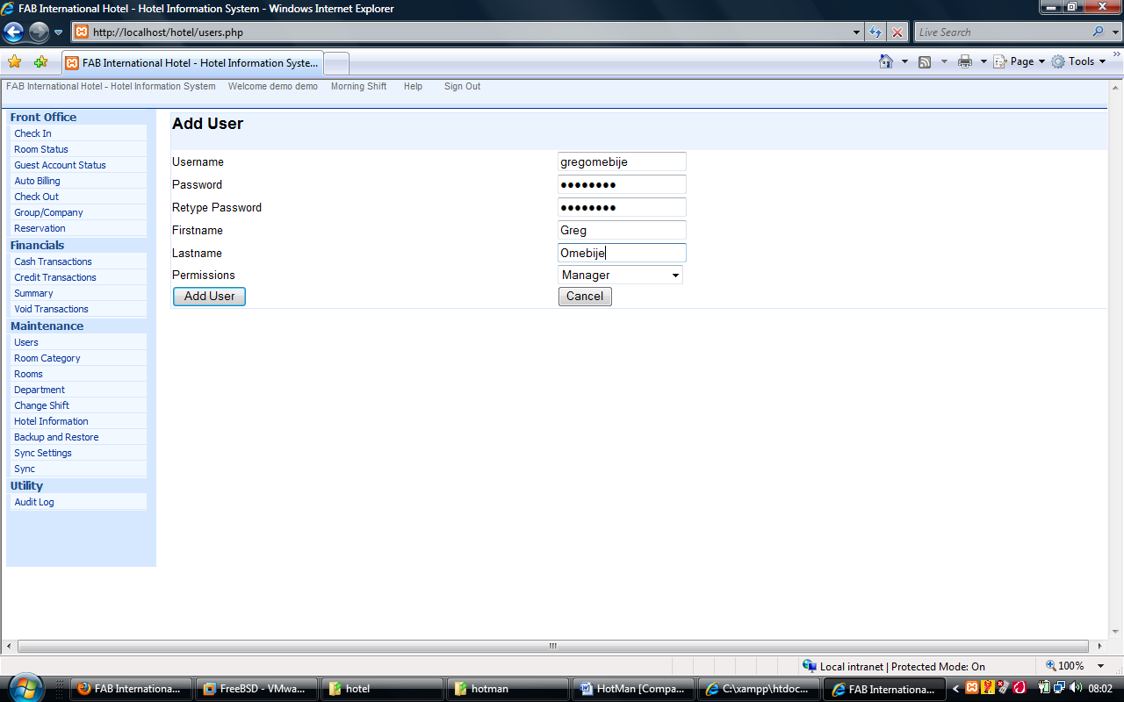
SETTING UP DEPARTMENTS
Departments are useful for grouping various services offered by the Hotel. You can have for example a department called Restaurant that is used by HotMan to record all cash/credit transactions made from the Restaurant. HotMan ships with three default departments: Room, Restaurant, and Laundry. These departments are used by HotMan to categorize transactions concerning Room, Restaurant and or Laundry.
To add extra departments you must have been logged in as a user with ‘Manager’ privileges. Go to the Maintenance menu > Department > Choose Option > Add
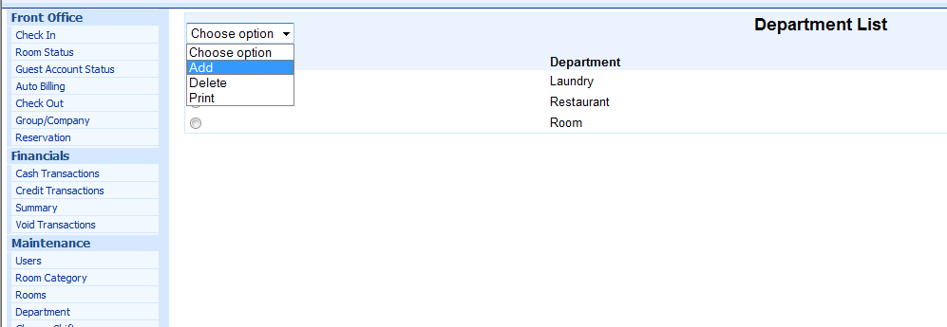

On clicking ‘Add’ a new screen appears where you can enter details and click ‘Add Department’
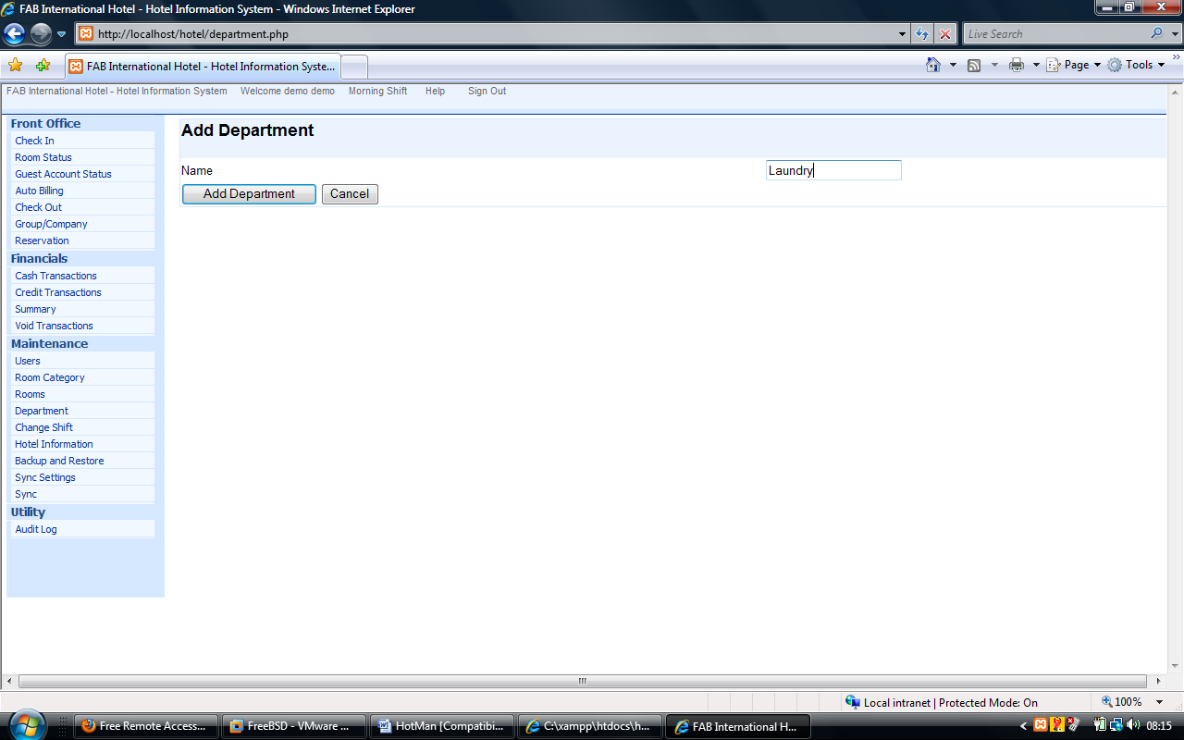

USING HOTMAN
CHANGING PASSWORD
Immediately after installing HotMan, you should login using the demo user and change the demo user password, or better still It is recommended that users should change their password periodically for a higher level of security. A users has the capability of changing his password at anytime. Click ‘Room Records’ then ‘Change Password’.
Diag.
Enter the following information:
- Login name: select from the dropdown list
- Old Password: Key in your current password.
- New Password: Key in the new password.
- Confirm Password: Re-key in you new password.
- Click Save of Cancel.
Companies
Run utilities, File Maintenance, Company to setup the companies that would be invoiced periodically by HotMan.
Diag
Entering a new company details is similar to entering Room Data.

Services Types
Run Utilities, File Maintenance, Services to setup the various service types and their departments. Samples are already provided which would guide you in customizing your service offerings. Simply press the Down Arrow button on the bottom most row to add new records.
Diag.
The next step is to generate listing reports on these basic data you have entered. This is to verify the correctness of your entries. It is very important tht all the data entered are correct!!! To generate the listings access teh Print button on the appropriate maintenance screen.
Using HotMan
Whether it is room reservation booking, guest deposits or any of the numerous transactions possible, it is essential that all transactions are posted into the HotMan System promptly. The recommended approach to using the HotMan system is the online approach. Here there is an immediate and automatic update to the systems databases as transactions occur. An example is a guest making cash deposit at the Front Office Cashier. Online processing requires that this transaction is posted into HotMan which then generates a Cash Receipt while automatically updating the guest’s record.
The other option is the Batch Processing approach where transaction source documents are batched up for entries later in the day. For example manual receipts could be manually filled out and issued, as cash payments are made at the Cashier’s point. These transactions could later be captured into HotMan from the duplicate sheets.
THE FRONT OFFICE
Typically, this is the first point of contact between guests’ and the hotel. In HotMan, the front office refers to the office functions that revolve around the:
- Reception.
- Front Office Cashier
- Reservation Office
RECEPTION
The reception module of HotMan allows you to check in guests as well as carry out a host of guest and room enquiry functions.
TOPICS COVERED
- Registering Guests
- Generation of House List
- Guest Account Status Inquiries .
- Room Transfer
- Viewing Room Status
Registering Guests (Check In)
Typically, a guest fills the registration forms with basic bio data and other relevant details about his stay. These are then promptly posted into HotMan at the reception.
To check in a guest, click on check-in Icon on the toolbar. An electronic form appears. Simply capture the information already filled out by the guest into appropriate boxes.

Diag
Fill as follows:
Designation: Mr. Dr. Alhaji e.t.c.
Sex: M, F
First name: First name
Surname: Surname
Address: Address
Bill To: Self, Company, or Group
Arrival date: Arrival date(Usually today’s date)
Departure Date: Expected departure date
Notification: Comments that could pop up at service points
Comment (Bill): Comment to appear on the final bill
From Profile: Has this guest been here before, simply select name
From Reservation: Does he have a reservation booking?
Save to Profile: In case of repeat visit, no need to retype much.
Click Save to accept or Cancel to abort changes.
Note: Groups that popup in the Bill To box are already registered through the command Process, New Group. In HotMan a group is two or more guests with a joint account.
Diag.
Obtaining House List
Every point on the HotMan network could generate the House List which is a list of all guest currently lodging in the hotel. Simply click on the House List icon (L) to obtain a report like the following:
Diag.
Guest Account Status Enquiries
You can obtain the account status of any Room Guest, detailing every transaction of the guest. You can also obtain summary of very guest in the hotel, showing total deposits, total consumption and balance.
To obtain the account status of the guest in Room 105 for example, click on the Account Status Icon. The following form appears.
Diag.
Select Room from the option buttons and select 105 from the Drop Down box. Click Process to view or print the report. Selecting group or company allows you generate a summary of any group currently in the system or any company whose guests are in the hotel. Selecting summary gives you a listing of all guests in the hotel as well as their account balances.
Diag.
Room Transfer Utility
Situations do occur, when a guest has to swap rooms. It is undesirable to close his current account, and open another for him. All his transactions may then have to be recentered. The Room Transfer routine solves this problem. Simply enter the guest’s current room number, enter the room number of the newly assigned room and pronto! HotMan transfers all his information, including his transactions, to the new room.
Click on Room Transfer Icon on the Toolbar or from the menu.
Diag.
Payable refers to the standard amount in the new room. This could however be changed by clicking the supervisors check box and entering the supervisors password.
VIEWING ROOM STATUS
The Receptionist might desire to obtain a list of vacant Ambassadorial Suites. She simply needs to run Room Status from the Report menu.
Diag.
Filling in the form as above and clicking Process, gives here the desired information.

OBTAINING GUEST STATUS
You could obtain information on Current Occupancy, List of guests who arrived today as well as list of expected checkouts for today by running the command Reports, Guest Status Report.
Diag.
Clicking on Today’s Departures for example could produces the following report.
Diag.
OBTAINING DAILY RETURNS
In some countries (Like Nigeria), It is a requirement by the State Security Servies (SSS) that a list of all guests that slept in a hotel be submitted first thing every morning. A button click on the menu option Reports, Daily Returns is all you need do to obtain this very report.

FRONT OFFICE CASHIER
A guest is checked in through the reception. He wishes to make a deposit of N40,000. He is directed to the Cashier where he pays the money and obtains a Cash Receipt for the transaction.
TOPICS COVERED
- Cash transaction
- Guest checks
- Check out bills
- Cashier shift reports
- Account balance
Cash Transaction (Deposits and Refunds)
Click on the N icon or run Process, Cash Transactions.
Diag.
Fill the electronic form as follows:
- Transaction Type: Select Guest from the Option button if this is a guest related posting. The transaction could however be cash payment for a laundry transaction, where you need to select the Dept Option button. You use Misc option button for any other type of cash deposit.
- Room Number: If a guest deposit, select the room from the Pull-down box.
- Details: Deposit, Additional Deposit, Guest Refund, Final Payment
- Dept: If this transaction is a payment for a service rendered in a department, select the department here. Enter the person paying or other detail in the Detail/Payer box.
- If this transaction is for a miscellaneous cash receipt, fill in details then Guest/Staff box.
- Document Number: This entry, which comes automatically and sequentially represents teh Receipt Number when it is printed out for this transaction.
- Date: The date is also automatic and is the processing date.
- Amount Deposited: How much did the cashier receive?
- Send To: HotMan creates two types of Folios for each guest. The Main folio is for the company that is paying (or the group). The extra folio is for the guest. Oftentimes, a company might give instructions ‘Accommodation and Food Only’. If a guest desires a service outside these two, he could decide that such extras be posted into his extra folio, which he would subsequently make payments against.
- Click on Save to save your entries or Cancel to abort.
- Payment mode. HotMan allows the cashier to rceive payments either in cash, bank cheques or any other acceptable mode of payment.

- On clicking save, a cash receipt is immediately and automatically printed on the printer.

Transaction Entry (Guests Checks)
Guest checks are transaction source documents that need to be posted against a guest account. To manually post a guest check, access the guest’s account sheet by clicking the post transactions icon and entering the room number from the ensuing form.
Diag
Fill as follows:
- Transaction details: Select transaction from the Pull-down
- Bill No: Guest check number
- Amount: Amount on Guest Check
Click Process to save your changes or Cancel to Abort.
ROOM AUTO BILLING
At a specific time, usually at the end of the day everyday, this utility is run to automatically bill all guests today’s Room Charge. Typically it is run once every night though some hotels chose to run Room Autobiling mid day.
Run the menu option: Process, room Autobilling.
Diag.
On clicking process, a charge goes to every occupied room’s account
CHECKING OUT A GUEST
The gust ‘Final Bill’ is similar to the guest account status report. However, this is printed when the guest is checking out. You are required to close a guest’s account, to print the bill. Click the check out icon on the toolbar or from Reports menu.
Diag.
Type in the room number of the guest that is checking out. And click process. You are asked if you wish to close the account. Typically you selct Yes. If any outstanding balance exits, you are notified. You either abort the checkout process to go and take a final payment by the guest or to refund the guest any outstanding balance. It is important that you view the guest account status report prior to running the checkout utility. Here you see at a glance what has to be done; you refund the guest or the guest pays an outstanding balance.
If a balance actually exists but you want to close the account immediately, you are giving a city ledger account entry box to select the account you would like to post this outstanding amount into. You have the option to create a new city ledger account. HotMan requires that an account be nilled (made 0.00) before a checkout is possible.

PRINTING GROUP BILL
Prior to printing a group’s summary bill, every member of the group needs to check out. Run the command Reports, Group Bill. Select the group name from the Pull Down and click process.
CASHIER SHIFT REPORT
This report is printed at the close of a shift. Click on the cashiers shift report icon on the toolbar, a form automatically appears on the screen;
Diag
On clicking process, a report is obtained
Diag.
Transferring or voiding a guest check,
This function, which needs supervisors access level, enables you to:
- Transfer a transaction already posted, perhaps in error, to the appropriate guest’s folio.
- Void or delete a transaction entry froma guest’s account.
These events are logged in the audit trail and can be audited. Run the menu utilities, transfer or void guest check.
Diag.
Enter room number into the room text box. Every transaction of this guest fills the spreadsheet. Right-click on the desired transaction. A short-cut menu appears where you can carry out the specific desired action.
If you select Transfer to another room, you are required to enter the new room number to transfer this transaction to as well as the reason for this .
Note:
- You must select an existing, occupied room as the new room.
- You are not allowed to edit the transaction amount.
I f you selected Void transaction the following appears. Enter the reason for this and click on void to void the transaction.
Room Reservation Management
A prospective guest notifies you of his intention to spend the 4th to 6th of next month in your hotel and wishes to have a room reserved for him. HotMan assits you in recording and monitoring such reservation bookings.
Topics in this section.
- Making reservation bookings
- Viewing expected arrivals
- Cancelling a reservation
Making reservation bookings
This could be of two types:
- Unconfirmed booking
The booking is not firm. It could be cancelled if the guest fails to show up on time. It is simply a log of booking details.
- Confirmed
Here the reservation is fixed. Typically payments are made for a reservation to be confirmed. However, for certain guest of repute, confirmation could be made without prior payments. A guest might forfeit his deposit if he fails to show up.
Run reservation, Unconfirmed booking or confirmed booking.
Diag.
Res No | Reservation Number. It comes automatically and is sequential
Company | Is this a company guest? Or what is his company?
Designation | Mr. Dir. Etc
Firstname
Surname
Telephone
Address
Arrival
Departure
Room Type
Instruction | If from a paying company, this could be ‘ROOM AND FOOD ONLY’ or similar comments
Payment Mode | Is the company paying or is it payment by Cash?

For confirmed booking, run reservation, confirmed booking
Diag.
If any payments have been made, put in the transaction amount in the Deposit made box then enter the receipt number in the Doc. No. Box. This transaction is saved in the City Ledger, with the guest as a Creditor.
VIEWING EXPECTED ARRIVALS
You can obtain a list of all expected guests by clicking on the “Expected arrivals Icon” on the toolbar.
Diag.
You could obtain a list of unconfirmed bookings as well as confirmed bookings. Simply specify the Date Range to cover. Specify Printer or Screen then click Process.
CANCELLING A RESERVATION
From the Reservation menu, select Cancel reservation. A screen appears that allows you specify if you are cancelling an unconfirmed or confirmed booking. You are required to specify the reservation number to cancel.

THE FRONT OFFICE MANAGER
The Front office Manager plays a critical role in the setting up and auditing of HotMan operations.
TOPICS COVERED
- Parameter Setup
- Viewing History Information
- Auditing Functions
Parameter Setup
Most of the data that would be employed in the day-to-day running of the HotMan system are setup in the Manager Module. This include
- Room Data
- Company Data
- Operators of the HotMan system
- Services and transaction types
- Other configuration options
See the topic setting up HotMan for details of these.

VIEWING HISTORY INFORMATION
It may be necessary to get history information of guest visits. This could be as simple as checking to see what dates or how many times a guest visited the hotel last year. It could however, be desirable to reproduce his entire transaction history during a particular visit. HotMan allows you to get this information through facilities in the Front Office Manager’s Module.
To get a listing of periodic guest visits, run: Reports, History, Periodic Guests. The following form appears.
Diag.
You could decide to see all guests that stayed in the hotel between January 1st and June 30th Last year. Simply select All Guests from the option buttons, specify the date range and click Process. If however you desire to see all the visits by Frank James last year, Select Name of Guest option button and type Frank James (or part of the name) into the adjoining TextBox, select desired date range and click process. A spreadsheet type of listing is displayed.
Obtaining History Bill
Locate the desired row in the spreadsheet stated above. Double click on the Bill number to obtain a reprint oh the guest’s transaction.
THE AUDIT TRAIL
The Audit Log is a record of certain critical HotMan events. The Manager could call up this utility at anytime to view the Audit trail which is a report from the Audit Log. Some of the events logged in the Audit Log are:
- Room Transfers
- Room Rebates
- Voiding of Guest Checks
Each transaction logged has the following information tied to it:
- The staff involved
- The time and date of the transaction
- Details of the transaction.
To obtain the Audit trail, Run: Reports, Audit trail
Diag.
You could decide to view all Room Transfers for a specified period, or decide to view all action carried out by a particular staff within the period.

MISCELLANEOUS REPORTS IN MANAGERS MODULE
Room Occupancy Report.
You can obtain occupancy report for any specified period . Run reports, miscellaneous statistics, occupancy report.

Average Room Rate:
Obtain Average Room Rate for any specified period by running reports. Miscellaneous statistics, Average Room Rate.
SOME TIPS ON AUDIT AND CONTROLS
- A guest on checkout is required to have a zero account balance otherwise any outstanding must be sent to a City Ledger account.
- All Discounts, Room Transfers, Voiding of transactions are logged and are viewable through the Audit Trail utility.
- The server PC should be well secured from unauthroized access.
- Workstations should have their Floppy & CD drive disabled
- Regular monitoring of sequence of Guest Checks and receipts
- Regular monitoring of Historical reports to detect anomalies.
HOUSE KEEPING
The house keepers ensure that all rooms are in a state of cleanliness. This department works closely with the Front Office in ensuring that recently checked-out rooms are made clean promptly otherwise it should not be sellable by the Front Office.
The House Keeping function of HotMan assists housekeepers in efficient information management between the Housekeeping Department and other related departments. Some functions of the Housekeeping modules are:
- Production of Room Status Listing
- Production of Allocation Report
- Production of Turndown Report
- Facilities to Update Room status
- Facilities to log faults in rooms.

Obtaining/Updating Room Status
This tells you if a room is Occupied, Vacant, or Unavailable (Out of order). This report gives you a list of every room in the hotel. Click on The R icon on the toolbar to obtain ‘room Status listing’. To update a room status, double click on the particular room number.
Diag.
Make appropriate changes and click Update.
OBTAINING ALLOCATION REPORT
This report lists all room that need cleaning . This comprises Rooms that has just been made vacant by a guest checking out as well as occupied rooms. Click on the ‘Allocation Report Icon’ on the toolbar or From the Reports menu.
Diag.
Status could be D for Vacant and Dirty or O for occupied.
OBTAINING TURNDOWN REPORT.
This report enables you to know on which floors the rooms are located. This also tells you on which particular floor a guest is lodged. Click on the ‘Turn down Report Icon’ on the toolbar or from the Reports Menu.
Diag.

Logging faults
Click on the Add button at the bottom of the screen, to add a new fault. To delete an entry,Click on the Delete. Check box by the side of the entry (the entry would likely have been rectified). Click on the Print button to print a fault list.

FOOD AND BEVERAGE
This module monitores sales at the bar and restaurant. In addition to generating Dockets and Guest Checks, an outlet summary report is generated at the end of each shift.
Topics covered in the F & B module are:
- Setting up stock items/Price List.
- Setting up Table Positions
- Operating an F&B account
- Generating Dockets.
- Closing a bill and printing Guest Check
- Obtaining Outlet summary report
- Obtaining stock movement report

Setting Up Stock Items /Price List
Run the command: Utilities, File Maintenance, Stock Items. Enter your product details in the Grid. Each stock item( Food or Beverage) must fall into a category.
Diag.
To Specify the categories of items in stock, select Utilities, File Maintenance, Categories.
Diag.
The order of the sort column specifies the order in which stock listing reports would be grouped and ordered.

SETTING UP TABLE POSITIONS
Run: Utilities File Maintenance, Table Positiions. Entries in the Grid should tally with the physicall numbering of the tables in the Bar or Restaurant. You might decide to enter table numbers only (4, 5, 6) or detailed to the various positions on a table(4A, 4A, 4B, 5A, 5B etc)
Diag.
In HotMan a position could either be Vacant or Occupied
BEGINNING A SHIFT
Before anything can be allowed on a new shift, the shift must be explicitly started. Click on the ‘Begin New Shift’ icon on the toolbar. The system asks for confirmation before commencing the shfit.

POSTING SALES
The first step in tracking a sale is opening an account. An account could receive as many orders as the guest might make. Each order generates a docket. Click on teh New account icon to open an account.
Diag.
Account No: This comes automatically and runs sequentially
Table: Select Table position from available ones (Vacant)
Waiter: Enter name or waiter
Comment: Any other information relevant for this account.

When the save button is clicked, the following screen appears.
Diag.
On clicking Ok. A Docket is printed out which is taken to the kitchen or to the Dispensing Bar.

CLOSING AN ACCOUNT (Printing Guest Check)
Should the guest request for extras, these are posted into his account by clicking the ‘Generate Order’ icon on the toolbar. Dockets are generated for any orders placed.
To close account and print the final guest check click on the printer icon on the toolbar.
Select the Account number, Specify the guest type. These could be:
C – Cash Guest (Pays Cash for the meal)
S – Signing Guest (Room Guest. Must be in a room)
H- Home use (Complementary or staff)
L – Ledger Guest (Staff. Deduced from salary later)
A – Company (Must already be set up in HotMan)
G – Group Guests (Must already be set up in HotMan)
Enter Discount in percentage of the total Bill.

MAKING DIRECT POSTINGS
HotMan has facilities to post data from manual guest checks, directly into guest accounts as well as into your sales reports. Run Process, Direct Posting. Simply fill in details of the guest checks.

OBTAINING OUTLET SUMMARY REPORT
Click on the outlet summary icon to get a summary and detailed listing of all sales made in this shift. This report is vieweable at all times while a shift is open and is automatically printed when a shift is closed.

OBTAINING STOCK MOVEMENT REPORT
Run Reports, Stock Movement to get a summary of how items moved during this shift. It specifies the following information.

MISCELLANEOUS REPORTS IN THE F&B
Various status reports could be obtained by running the commands under the Reports Menu.
STOCK POSITION/PRICE LIST
View or print a listing of your bar and restaurant items, specifying all or a particular category.
HOME USE.
A Home use Analysis report could be obtained at the end of any specified period to track all food and beverage items issued to any specified staff or by all staff.
ENDING A SHIFT
This is the last activity carried out in a shift. On clicking the ‘End this shift’ icon. And confirming the action, a sales summary report is produced automatically.
MISCELLANEOUS UTILITIES
VOIDING A GUEST CHECK
HotMan allows you void a Guest Check. This facility is not accessible to the cashiers.A supervisory access level is required. Run utilities, void guest check. Specifify the guest check and click void. This information is logged in the Audit TRAIL.
Searching for missing code.
Ocassions might arise where the code for a product is forgotten. Simply run the command utilities, Missing code. Enter Part of the Name of item or/and part of the code to do a search of the goods database.
SEARCHING FOR MISSING CODE
Occassions might arise where hte dode for a product is forgotten. Simply run the command utilities, Missing code. Enter Part of the Name of item/or and part of the code to do search of goods database.
POSTING INWARD STOCK
To Post in items received into the F & B system, simply run the command: ‘Post inward Stock’. Enter items codes, Pressing the down arrow to add a new line.

STORES MODULES
The stores Module offers you the following:
- Store your product data in one efficient location.
- Generate Stock Position at the press of a button.
- Monitory Stock In/Out movements: Bin Card Reports.
- Tracks Cost of Goods issues or received in a specified period.
SETTING UP
THE CATEGORIES FILES
Run the command: Utilities, File Maintenance, Category to specifiy the major categories all your products fall into. A screen appears where you enter/edit categories. Simply overwrite the sample categories or at the last line press the down arrow key to add new categories. The sort column specifies the order in which goods can be listed in reports.

THE PRODUCTS FILE
Run the command: Utilites, File maintenance, Products. Your products are perhaps the most important component of yor organization.
Diag.
To add a new product, click the Add button. Fill ensuing form and save.
ISSUING GOODS
This will by far be the most common operation you will be running. Run teh command. Process, outward stock. Enter the following information.
Diag.
- Select the department receiving goods.
- Enter the transaction date.
- Enter the item codes and quantity issued. Press the down arrow key and enter other items as necessary.
POSTING PURCHASES
Run this routine to update inventory with new purchases. Run teh command process, inward stock.
Diag.
Enter the following information:
- The Goods Received Note (GRN) number
- The transaction date.
- Receiving Department.
- Purchasing Officer
- The Item code.
- The cost price of this purchase.
- The quantity purchased.
RETURN INWARD AND OUTWARD
Run the command: Process, return inward and outward.
Use this facilty to make adjustments when goods already sold are returned to the store or when you return purchased goods to the supplier for any reason. This updats your stock records accordingly.

REPORTS
The MSPlan system has a variety of reports that ill give you accurate knowledge about your inventory. The reports can be found under the menu Reports.
- STOCK POSITIONN REPORT
Gives you your current stock status regarding on-hand quantities, price list and others. This report is grouped by product categories. Run the command: Reports, Stock Position.
- STOCK VALUATION REPORT
Generate a detailed valuation listing of all stock items as well as the total summary value of all stock items. Run the command: Reports, valuation report.
- DEPARTMENTAL ANALYSIS
This report gives you a detailed breakdown of all stock issues within a specified period, grouped by departments receiving. You also obtain an analysis of cost.
- REORDER REPORT
Generate a listing of goods, which have fallen to or below a specified reorder point. A well-run store should not run out-of-stock. Run the command: Reports, Reorder Report.

- BIN CARD REPORT
This report allows you to get details of issues and receipts for a particular item over a specified period.
ACCOUNTS MODULES
TOPICS COVERED
- General Ledger and cash book
- Income Auditor
- Credit Controller
- City Ledger Utility
GENERAL LEDGER
The system is designed to accommodate your Accounting Cycle, which are the basic steps that must be followed (in specific order) for each accounting period.
- Analysize transactions from source documents
- Post these transactions into Journals in Accounts Manager
- Prepare a Trial Balance
- Adjust the General Ledger accounts
- Prepare financial statements.
The system obeys the Double Entry System of transaction posting.
SETTING UP GENERAL LEDGER CHART OF ACCOUNTS.
Setting up your chart of accounts involves two steps:
- Setting up Group Accounts
- Setting up Detailed Accounts
A group account is mapped to one or more detailed accounts. You do not post transactions into group accounts. A detailed account is an entry that can receive a debit or credit posting. For example you could have a group account called Debtors. Ou could then have seven detailed accounts set up your seven customers. In other words, there exists a One-To-Many relationship between the group accounts and detailed accounts.

To setup group accounts, Run: General Ledger, Setup, Chart of Accounts (Group)
Diags.
Click on the Add button at the bottom of the screen to add new Group Accounts. To setup detail accounts, Run: Accounts, Setup, Chart of Accounts (Details)
Diags.
Double-Entry postings are made directly into detailed accounts. Detailed account has unique Account Numbers. The buttons at the btoom of the screen allows you to : Prit a list of your detailed accounts. Add new accounts, Delete accounts or Edit entries.
SETTING UP YOUR PROFIT AND LOSS AND BALANCE SHEET REPORTS
Setting up your profit and loss report involves two steps.
- Specifying in Group Accounts, if a particular entry should appear in the Profit and Loss report. This is done by checking or clearing the check box called P/L (or B/S for Balance Sheet).
- Specifying in Detail Accounts, in the PL Code column, the P/L Group Account under which this particular Detail Account would appear. For Balance sheet enter the B/S code in the Detail Account column called BS CODE
MAKING JOURNAL ENTRIES
Run: Account, Make Journal entries. Your double-entry postings can be carried out in the screen that appears.
Diag.
Examples of Dobule-Entry postings are:
Fill as follows:
Account Header: Select Group Account from the pull-down box
Starting Date: Starting Date
Ending Date: Ending Date
Starting Acct: Starting Account code
Ending Acct: Ending account code
Summary: Summary or detailed report?
Zero Transactions: Omit accounts that received no postings?
Screen: Want screen preview or direct to printer?

3. GL Trial Balance Gives you a trial balance as at a particular date
4. Profit and Loss Account
Gives you your performance within a specified period.
Diag.
- Balance Sheet
Gives you a statement of the financial position of your firm at a particular date.

INCOME AUDITOR
The Income Auditor’s Module accomplishes the following:
- Presents details of total income made periodically
- Monitoring of transaction source documents for discrepancies
- Analysis of sales at the various service points

Generation of Daily Turnover
At any time, he income auditor, can obtain total sales made for the particular day by running the command Accounts, Daily Sales Summary, Specify the date desired. Click Process to obtain the report.
Diag.
VIEWING CASHIER’S SUBMISSIONS
The income auditor’s modules allows the night auditor to obtain a listing of every cashier’s transaction for the day. Simply click on the Cashier’s Submission icon.
CREDIT CONTROLLER
The HotMan credit controller facilty enables teh accountant carryout the following functions:
- Generation of Company invoices and statements
- Generation of summary account balances of all guests.
- Generation of Debtors lists.
GENERATING COMPANY INVOICES
Run Accounts, Company invoice
Certain registered companies send their staff to the hotel. These credit customers are not required to make deposits, or settle teheir accounts on checkout. Periodically, invoices are sent to the companies containing details of all services rendered to the company staff for the period. On checkout, HotMan sends each company guest’s bill into the company’s account. If no specific company’s account. If no specific company code is specified, a list of all customers and their balances as well as suppliers could also be generated.

Enter company account Number and date range to obtain the invoice. Run Accounts, obtain statement of account. Make your selections and click process to obtain company’s statement.
SUMMARY ACCOUNT FOR ALL IN-HOUSE GUESTS
This report gives a listing of all guests in the hotel along side their total deposits; total consumptions and their balances. Accounts with zero balances or who owe the hotel has the balance shown in red. Those with a positive balance are shown in black. Please see reception module under viewering guest account balances for more details.
CITY LEDGER UTILITY
The HotMan city ledger is a database of guests who had outstanding balances on checkout. HotMan requires a guest account to be zeroed on checkout. Thus if he has an outstanding amout to settle ( he owes thehotel), he should pay it up. On the other hand. If he has a refund to collect (the hotelowes him), he should be refunded. There are instances however, where a guest has to physically leave without collecting his refnd or paying up his outstanding debt. In his occasion, the outstanding is sent to the city ledger.
On a subsequent visit by the guest, this outstanding balance would be trasnfered inot his new folio. Run: Utilities, City Ledger.
Diag.
Entries appear here automatically from the guest checkout routine. They could also be manually entered into the city ledger by clicking on the
Add button. Other buttons on this screen do the following:
Print: Obtain a list of city ledger accounts.
Delete: Delete a city ledger account. The balance must be zero.
Refund: give out money from the city ledger account.
Transfer: send money from city ledger account into a guest folio
Take Deposit: Receive money into a city ledger account
Statement: obtain a statement of city ledger account transactions

PAYROLL MODULE
This enables you do the following:
- Compute monthly salaries of staff and Generate Pay slisp and payroll summary reports as well as bank schedule
- Generate service charge report.
SETTING UP
Setting up Staff.
Run Payroll, Setup, Employees
Diag.
Click the add button on the bottom of the screen to add a new staff. A form comes up. Fill as appropriate and save. A new record appears in the spreadsheet.

BEGNNING A NEW MONTH
Run, Payroll, Begin New Month to start a new processing month.
Diag.
This initializes the data files for month’s processing.
You could generate pay slips immediately. However, variations like deductions for the month would not be present. To enter miscellaneous deductions run Payroll, Payroll Update.
Make changes to staff records for the current month only. Simply access the concerned staff row and the appropriate allowance or deduction column and make or edit an entry.
OBTAINING PAY SLIPS
Run Payroll, Generate Pay Slips.
OBTAINING PAYROLL SUMMARY
Run Payroll, Payroll summary to obtain a summary for all staff.
OBTAINING BANK SCHEDULES
Run Payroll, Bank Schedule to obtain a bank schedule.

SERVICE CHARGE PROCESSING
This allows you obtain a service charge schedule for all staff. All staff are required to have a service charge points in the payroll master file.
Run Refresh service charge to start service charge processing. You could generate service charge report right awasy. Run Payroll service charge report.
Diag.
Enter the amount to be split by all staff. Click process to generate the service charge report.
In the even that certain member of staff did not work the full amount of days required for the month in question, run payroll, Update service charge to specifiy a number of days worked for the employee. This automatically leads to a recacluation of all amounts due all e mployees when the service charge report is run.

