## MODELING THE POTENTIAL CONSEQUENCES OF NEW TRANSPORTATION TECHNOLOGIES AND SERVICES USING A FUZZY COGNITIVE MAP BASED MODEL

**Brian Gregor, P.E.** (corresponding author)

Oregon Systems Analytics LLC

PO Box 2211, Salem, OR 97308

Tel: 503-877-0349 Fax: 503-385-0352; Email: gregor@or-analytics.com

**Haizhong Wang, Ph.D., Assistant Professor**

Oregon State University, School of Civil and Construction Engineering

101 Kearney Hall, Oregon State University, Corvallis, OR 97331

Tel: 541-737- 8538 Fax: 541-737-3052; Email: Haizhong.Wang@oregonstate.edu

**Alex Bettinardi, P. E.**

Oregon Department of Transportation

555 13th Street NE, Suite 2, Salem, OR 97301

Tel: 503-986-4104 Fax: 503-986-4174; Email: Alexander.O.BETTINARDI@odot.state.or.us

Word count: 4726 words text + 9 tables/figures x 250 words (each) = 6976 words

**ABSTRACT**

The next several decades look to be times of great flux for transportation. Our transportation systems are likely to be greatly altered by new transportation technologies and services such as intelligent infrastructure, connected vehicles, automated vehicles, and the expansion of demand-responsive transit services. It is important that transportation planners and decision makers consider the potential implications of these emerging technologies and services when making long-range transportation decisions because they could substantially affect the assumptions and analysis used in making those decisions. Unfortunately, most transportation models are not useful for these purposes because they are designed to analyze the effects of incremental changes to transportation systems, not the effects of disruptive changes. This paper describes a new method for modeling the potential consequences of new technologies and services using a variant of the fuzzy cognitive map (FCM) approach, which enables problems involving imprecise and uncertain information to be modeled. Significant modifications to the standard FCM approach were made to address deficiencies found in applying the standard approach. The new approach, named the Fuzzy Systems Dynamics Model (FSDM) retains some basic FCM characteristics, but it deviates substantially in a number of ways as well. It has been found that this produces models having well-behaved dynamics, that can be explained in common-sense terms, be easily configured, run many scenarios quickly, and used to analyze scenarios of disruptive change.

## OBJECTIVES AND MOTIVATIONS

Transportation modelers have developed very sophisticated and complex models of the relationships of different aspects of travel demand to the characteristics of the populations being modeled, the places where they live, and the transportation facilities and services in those places. Although these models are outstanding technical achievements, their complexity substantially limits the domain of transportation policy and planning questions to which they may be applied. The models are built primarily to evaluate the effects of specific transportation system changes and/or land developments, and are very difficult to adapt for broader purposes because of their complexity. Moreover, their complexity and data intensiveness makes them impractical to use for analyzing policy questions having any amount of ambiguity because long model run times and requirements for extensive and detailed inputs severely limit the number of scenarios that may be modeled. Consequently, when these models are used, ambiguity tends to be assumed away and considerations that aren’t addressed are set aside.

Until recently, assuming away ambiguity has been fairly easy to do. Although the urban landscape and transportation system have changed dramatically in past decades, the type, direction and pace of change has been fairly predictable. Urban areas have been spreading outward and single-family development, auto ownership, and vehicle-miles traveled (VMT) have all been increasing. Until recently, it looked like these trends would continue into the future and, although some questioned the wisdom of continuing to accommodate them, there were no apparent limits to their continuation or reasons why they would not continue.

Now however, a number of major changes are occurring that make it unwise to assume away the ambiguity that now surrounds most transportation decisions. VMT growth has stagnated in recent years and VMT per capita has been declining. Although the “Great Recession” undoubtedly contributed to stagnating VMT growth, the longer-term trend in declining VMT per capita suggests that other forces are at work as well such as changing perceptions about the benefits and liabilities of ever increasing automobility. Equally important in disrupting how people think about the future is the awareness of environmental constraints, most notably a constraint on the amount of fossil carbon that can be released into the atmosphere without jeopardizing the future living conditions for hundreds of millions of people. Finally, major changes to transportation technologies and services are occurring that may substantially change travel trends.

The next several decades look to be times of great flux for the transportation system. The combination of intelligent infrastructure, connected vehicles, and autonomous vehicles could substantially reduce accident rates, congestion and driving stress. It might also increase average driving speeds, the distances that people drive, and per capita VMT. Autonomous vehicles might also substantially reduce the operating cost of demand-responsive and fixed-route transit services and might help solve the “last mile” problem, enabling many households to reduce or eliminate car ownership. On the other hand, this might enable more people to travel in single-occupant vehicles who wouldn’t otherwise be able to own or operate one, and might compete with fixed-route transit services for riders.

Transportation decision-makers will be pushed by the public to consider the implications of these potential changes regardless of whether computer models are available to assist in doing so. Lacking computer models to assist them, the decision-makers will rely on their own mental models, political consensus, and perhaps other analysis and expert judgement, to guide them. This would be unfortunate because although computer models are not the be-all and end-all of transportation analysis, they do help maintain logical consistency in the analysis of complex systems. This is arguably the most important role of models, and it is a role that can be carried out even when dealing with decision domains that involve considerable amounts of ambiguity. However it will require different sorts of models than the complex travel demand models that have been developed primarily to analyze transportation projects and other specific transportation system and land use changes.

The objective of this paper is to describe one such method for modeling transportation issues that involve imprecise and uncertain information. The method is a variant of the fuzzy cognitive map (FCM) approach which comes from the field of “soft computing”. Substantial alterations have been made to the standard FCM approach to address deficiencies in using the standard approach for public policy questions. The new approach is named a fuzzy systems dynamics model (FSDM) for reasons that are explained below. A FSDM has been developed to model metropolitan area transportation systems and the potential consequences of new transportation technologies and services. The model and how it works is described and several applications are demonstrated. These results come from research that has been partially funded by the Oregon Department of Transportation (ODOT) in collaboration with Oregon State University (OSU) and Oregon System Analytics (OSA) to develop a fuzzy cognitive map model that can be used to evaluate the potential effects of new transportation technologies and services on transportation systems to assist in prioritizing future research efforts. Earlier results from that research have been published (*1*). The methods and results presented below include significant changes from the earlier published research.

## INTRODUCTION TO FUZZY COGNITIVE MAPS AND THE FUZZY SYSTEMS DYNAMICS MODEL

The approach used in this research is derived from fuzzy cognitive mapping, a modeling approach developed in the field of soft computing (*2*). Fuzzy cognitive maps are models that are structured as directed graphs (digraphs) where each node represents a concept and each edge represents a causal linkage (3). This use of digraphs to express causal relationships is shared by a number of modeling methods such as path modeling (*4*), Bayesian networks (*5-6*), and structural equation modeling (SEM) (*7*).

The inspiration for fuzzy cognitive maps (FCM) came from the cognitive mapping technique used by Axelrod to evaluate systems thinking in political domains (*8*). However, whereas Axelrod’s cognitive maps represented causal effects in simple bipolar terms (+1 vs. -1), FCMs represent causal effects in degrees (e.g. a little, some, a lot). Some FCMs do this using a fuzzy rule-based approach but most follow the approach developed initially by Kosko for representing causal effects as continuous numeric values (*3*).

**Concepts of Fuzzy Cognitive Maps**

FCMs show causal relationships using digraphs. The effect of a causal concept on a receiving concept is represented by an arrow, and the magnitude of effect by a weight (w) as illustrated in Figure 1. Weights are typically in the range of -1 to 1 where positive values are meant to represent causal increases while negative values are meant as causal decreases. The absolute value of the weight indicates the relative strength of the effect where 0 means no effect and 1 means a very strong effect.

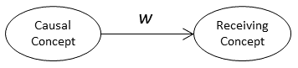

**Figure 1. Simple Two-Node Fuzzy Cognitive Map**

In the standard FCM approach, the value of the receiving concept after a change in a causal concept is equal to the changed causal value multiplied by the weight. If *c* and *c’* are the initial and subsequent values of the causal concept and likewise *r* and *r’* are the initial and subsequent values of the receiving concept, then in the standard FCM the value of *r’* is calculated as follows:

$$r^{'}=w*c^{'}$$

A receiving concept may be affected by more than one causal concept as shown in Figure 2.

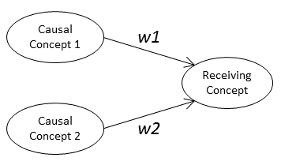

**Figure 2. Fuzzy Cognitive Map with Two Causal Nodes**

The value of the receiving concept *r’* is the sum of the effects of the causal concepts.

$$r^{'}= \sum_{i=1}^{n}{(w_{i}*{c'}_{i})}$$

Concept values in standard FCMs are constrained to the range of 0 to 1 and may be thought of as the proportion of some actual base values. Since the value of *r’* as computed above may exceed 1, the standard FCM uses an “activation function” to scale the result to that range. A variety of activation functions may be used, but most are “S” shaped sigmoid functions like the logistic function shown in Figure 3.

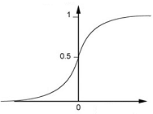

**Figure 3. Logistic Activation Function**

The standard FCM formulation is so similar to the formulation of neural networks that FCMs are often referred to as neural networks with feedback.

Because a FCM can include cycles (e.g. Figure 5) it is necessary to iterate the calculations until the concept values achieve a new stable state or until it is evident that a stable state can’t be achieved.

**New FCM Formulation**

While the approach used by fuzzy cognitive maps of showing causal relationships in directed graphs is useful, the standard mathematical formulation has some limitations when used to model social systems. Most importantly, the mathematics of standard FCMs are not consistent with the meanings most commonly attributed to causal weights. The common view of causality is that a change in the value of a causal concept results in a change in the value of a receiving concept; for example an increase in development density results an increase in fixed-route transit service. This is how weights in FCMs are commonly described. But the FCM mathematics do not represent relationships between changes in concept values. Instead, they represent relationships between the values. For example, in the simple FCM above, the value of the receiving concept is the value of the causal concept times the weight.

This disconnection between meaning and mathematics causes other problems. Negative weights become a significant problem because rather than meaning that an increase in a concept causes a decrease in the concept it affects, they mean that if the value of the causal concept is positive, the value of the affected concept will be negative. This of course is nonsensical since concepts can’t have negative values. This problem may be eliminated in a causal map by changing the meaning of a concept to enable inverting the directionality of the concept (*3*). For example, instead of showing congestion as having a negative relationship to fuel economy (miles per gallon), it could be shown as a positive relationship to fuel diseconomy (gallons per mile). However, changing all negative value to positive values in a complex system model may be challenging.

A new FCM formulation has been developed to overcome this problem. The mathematics of this new FCM have been revised to be consistent with the definition of weights as causal relationships between concepts. Weights in the new FCM are defined as the ratio of the proportional changes of the receiving and causal concepts as follows.

$$w=\frac{\frac{r^{'}-r}{r}}{\frac{c^{'}-c}{c}}$$

Weights as defined above are similar to elasticities. The combined effect of multiple causal concepts, rather than being the sum of the individual effects, is the product of the individual proportional effects. Thus, if we call the proportional change in a causal concept Δ*c*, the value of the proportional change in the receiving concept Δ*r* is calculated as follows:

$$∆r= \prod_{i}^{n}{\left(w_{i}* ∆c_{i}+1\right)-1}$$

A second problem with standard FCM formulation for social system modeling is that it is difficult to attribute a real world meaning to the activation function which is used to constrain concept values to the range of 0 to 1. While this approach may have practical values in making a FCM work, it has no apparent theoretical justifications.

The alternative FCM formulation replaces the activation function with causal and receiving sensitivity functions which modify the effects of a causal weight based on the respective concept values. If *sc* is the causal sensitivity given the value of the causal node and *sr* is the receiving sensitivity given the value of the receiving node, then the change in the receiving node, Δ*r*, due to a change in the causal node, Δ*c*, is calculated as follows:

$$∆r=w* s_{c}* s_{r}* ∆c$$

The forms of the causal and receiving sensitivity functions are shown in Figure 4. It can be seen that these functions are mirror images of one another. The causal sensitivity is 0 when the value of the causal concept is 0 and rises to 1 when the concept is at 50 percent of its maximum value and stays at that level as the concept value increases further. The sensitivity of the receiving node to change is 1 when the value of the concept is less than 50 percent and decreases thereafter, falling to 0 when the receiving concept reaches 100 percent of its maximum. If the starting concept values in a simple two-node system (Figure 1) are small, the combined sensitivity of the system follows an inverted “U” shape as the causal concept is increased to 100 percent of its maximum value.



**Figure 4. Causal and Receiving Sensitivities and Their Joint Effect**

Although these asserted sensitivity functions have not been demonstrated to be correct through empirical evidence or theoretical proof, the forms do make sense. It is expected that the effect of a change in a causal concept on a receiving concept will be small when the causal concept is small and will grow as the causal concept increases. For example, if the number of bicycling trips is very small (say 1% of all trips), increasing their number by 10% would have little effect on the number of automobile trips. However, if the number of bicycling trips is large (say 50% of all trips), then increasing their number by 10% would have a substantial effect on the number of automobile trips. In the case of a receiving concept, it makes sense that it would be most sensitive to change when its value is small and it would become less sensitive at high values. For example, it was easier to increase the market share of cell phones by 50% when they were 10% of the market, than when they had 60% market share.

A final difference between the new method and the standard FCM approach is in how the value of causal concept that is assumed to change in a scenario is changed from its initial value to its final value. In the case of the standard FCM, the causal concept is set to its final value and the model iterates (assuming it has cycles) until a new stable state is achieved (assuming that there is one). In the case of the new method, a causal concept is changed gradually in small increments and the model is iterated to closure with each increment. This is consistent with the nature of weights as elasticities.

The new method has been given the working name of Fuzzy Systems Dynamics Model (FSDM) because like system dynamics models it calculates the change in concepts as the accumulation of small differences as the model iterates. However, unlike system dynamics models the difference calculations use simple elasticities and sensitivity functions, rather than difference equations, and time is not explicit in the FSDM model.

**Comparison of FSDM and Other Methods**

Although there are superficial similarities between FSDM and other modeling methods that used directed graphs, the approaches are very different. Contrasting the FSDM with the method that transportation modelers are most likely to have some familiarity, structural equation modeling (SEM), may be useful to help readers better understand the purpose and methods of the FSDM. The similarity between the FSDM and SEM starts and ends with the use of a directed graph that is asserted by the model developer to represent the structure of a model. However SEM is a multivariate linear regression method which accounts for direct and indirect effects of variables on one another. Simultaneous linear equations are used to estimate the coefficients of the model. SEM models are often used to incorporate latent (unobserved) variables into a model. The primary purpose of SEM is to determine the relative strength of relationships between variables given the asserted model structure. The estimated coefficients, relate the values of variables.

The FSDM method is not a statistical modeling method. Its purpose is to develop logical models to help analyze problem domains where there is significant ambiguity and it is not possible to estimate statistical relationships. The specifications of a FSDM model and the relationships between the concepts being modeled are developed through expert judgement and group processes. This is a method often used in the development of fuzzy cognitive maps and fuzzy logic systems. In the case of the model presented below, the development of the specifications relied on the judgements of the research team supported by a technical advisory committee of transportation analysts and planners from ODOT and Oregon MPOs, and the FHWA.

The FSDM method also differs from SEM with respect to the meaning of the relationships between concepts (variables). In SEM models, as with standard FCMs, the parameters establish the relationship between the values of the connected variables similar to how parameters in multivariate regression models relate the value of the independent variable with those of the dependent variables. In FSDM models, the edge weights are fuzzy elasticities that describe how the change in the value of a causal concept affects the change in the value of the receiving concept. The effects of edge weights are modified by causal and receiving sensitivity functions as described above.

**A FSDM OF METROPOLITAN AREA TRANSPORTATION SYSTEM INTERACTIONS WITH NEW TRANSPORTATION TECHNOLOGIES AND SERVICES**

A cognitive map of the effects of new transportation technologies and services has been built in two components with connections between them. Approaching the problem as two separate components enabled the team to simplify the conceptualization, design and testing of the overall cognitive map. One of the components depicts the relationships between travel behavior and outcomes. This is shown in Figure 5. The concept of behavior as depicted in this graph is broad, representing system behavior. In addition, this cognitive map includes development density and relative roadway capacity because of the importance of those concepts to the understanding of system behavior relationships. All concepts are specified in per capita or proportional terms (e.g. VMT per capita) so that population growth is factored out of the model. In addition, this model assumes no change in real income. The solid black arrows in the graph show positive causal relationships and the red dashed arrows show negative causal relationships. The labels for the arrows indicate the strength of the relationships: VL = very low, L = low, ML = moderately low, M = moderate, MH = moderately high, H = high, VH = very high. The other component is a cognitive map of transportation technologies and services. This portion of the cognitive map and the connections of it to the travel behaviors and outcomes portion are shown in Figure 6.

The meanings of the concepts shown in these figures are described in Table 1.

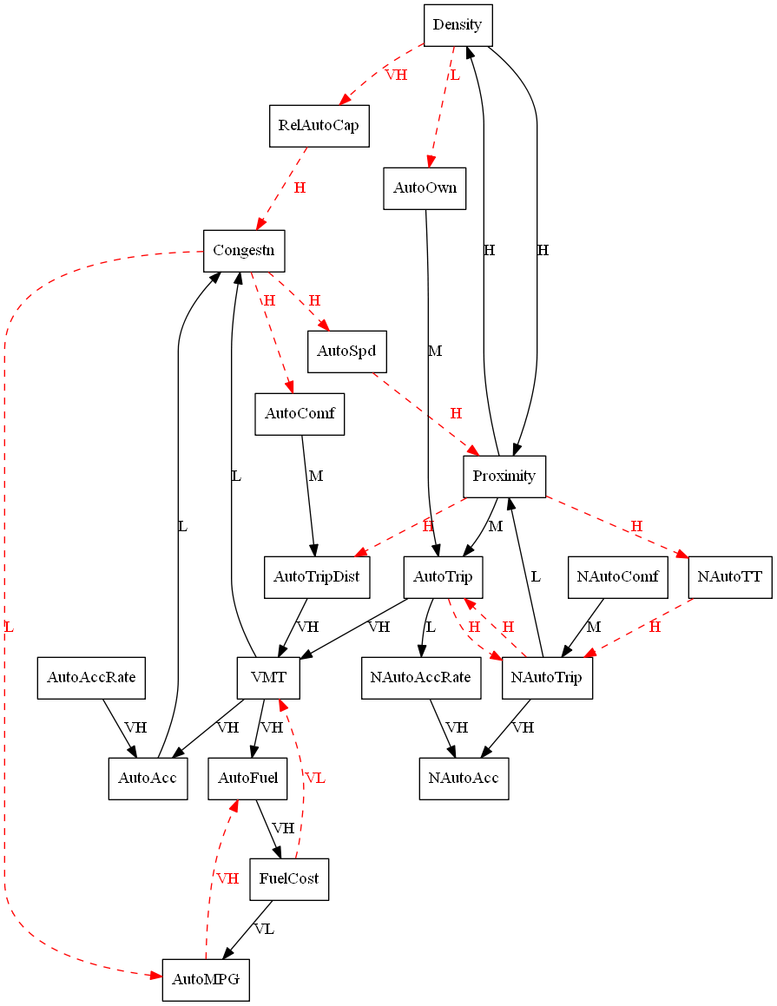

**Figure 5. Travel Behavior and Outcomes Sub-model**

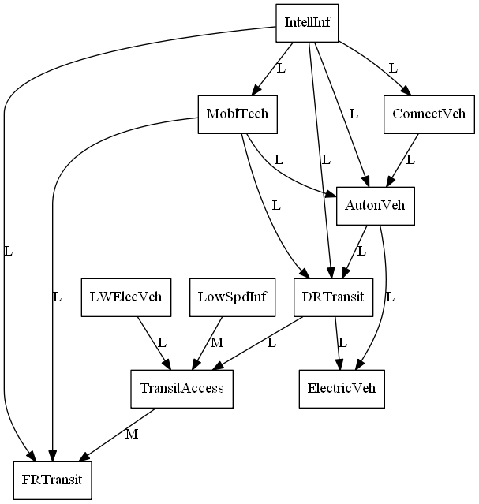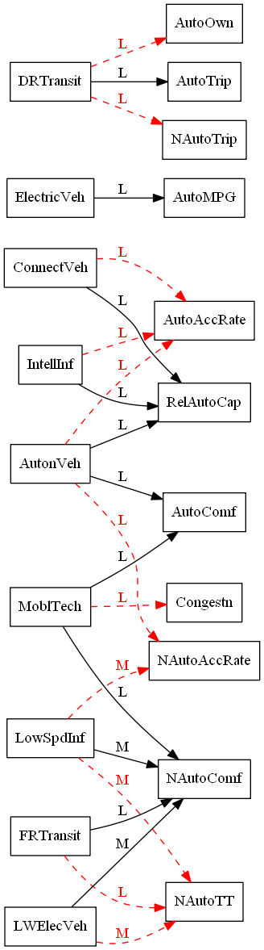

**Figure 6. Transportation Technologies and Services Sub-model and Connections with Travel Behaviors and Outcomes Sub-model**

**Table 1. Description of Model Concepts**



The concepts in the cognitive map were operationalized and data were gathered for as many of the measures as could be found from readily available sources for 93 metropolitan areas in the US. Data sources included the Texas Transportation Institute’s Urban Mobility Study, the US Census Bureau, the FHWA’s Highway Statistics reports, the 2009 National Household Travel Survey (NHTS), and a report by the American Automobile Association on metropolitan traffic fatalities and injuries. These data were used to establish value ranges for the operationalized concepts, values to use for a test area to check model sensitivity, and values to use to compare model results to.

## RESULTS

The FSDM representation of the effects of new transportation technologies and services has been tested with several scenarios for a hypothetical metropolitan area which has characteristics similar to the Portland-Vancouver metropolitan area for the operationalized concepts. The scenarios included:

1. Doubling the population-weighted population density of the metropolitan area;
2. Halving the population-weighted population density of the metropolitan area;
3. Substantially increasing the relative road capacity of the metropolitan area (to be equivalent to that of Houston, TX);
4. Growing autonomous vehicles to be 50% of the vehicle fleet; and,
5. Increasing intelligent infrastructure to cover 80% of the roadway system.

The model appears to respond realistically to the density and relative roadway capacity tests. Figure 7 shows the results of the doubling-density test. It compares the effects of doubling density on congestion (percentage of VMT occurring in congestion), vehicle travel (daily vehicle miles of travel per person), average speed (ratio of congested to uncongested speed), and auto ownership (percentage of households having one or fewer vehicles). Along with the trajectory for the test metropolitan area, the graphs show the values collected for 47 metropolitan areas that are identified in the 2009 NHTS data sets. (Data points for the New York-Newark NY-NJ-CT are not shown because they are outliers relative to the data points for other metropolitan areas.) The directions of change for the test metropolitan area are consistent with expectations and the relative magnitudes of changes are consistent with the observed metropolitan area values. This was also found to be the case for the halving density and increasing relative capacity scenarios.

The results for all of the scenarios are shown in Table 2. The table shows the starting values for the concepts for the test metropolitan area and the percentage changes in the values of the concepts for the five scenarios. The directions and relative magnitudes of the changes all appear to be reasonable. It is very important to note, however, that there are many uncertainties about the magnitudes of the causal effects of new transportation technologies and services. A key purpose of this modeling techniques is that it allows analysts to evaluate the consequences of making different assumptions about these effects. Some assumptions are likely to have greater effect on the outcomes than other assumptions. This will help in the assessment of where research, refinement and better understanding is most needed.



**Figure 7. Comparison of Results of Doubling Density Test with the Values of Selected Concepts for 47 Metropolitan Areas Identified in the 2009 NHTS**

**Table 2. Concept Starting Values and Percentage Changes in Values with Test Scenarios**



## IMPLICATIONS FOR THE PRACTICE OF TRAVEL MODELING

Although more work needs to be done, the results so far demonstrate that the FSDM approach will be useful for analyzing transportation technology and service change scenarios. The travel behavior and outcomes portion of the model can produce models of metropolitan area travel behavior and outcomes that respond sensibly to changes in population density and roadway capacity. Although the transportation technology and services portion of the model, and its connections to the travel behaviors and outcomes needs more work, the preliminary results indicate that the model can be completed and put into practice. Once completed, the model will enable transportation agencies to test out various scenarios of technological and service changes to analyze the potential consequences. Tests can be made of the sensitivity of model results to changes in model parameters. Specifically, the Transportation Planning Analysis Unit of the Oregon Department of Transportation hopes to use the model being refined in this work to better evaluate and prioritize what aspects of future transportation technology and behavior changes have the greatest potential to impact the performance measures, information, and results used in projects and by decision makers. Those future conditions that have the greatest potential to impact project outcomes and decisions would then get further research attention and priority in developing methods to address those conditions in Oregon’s transportation modeling and analysis work.

At a more general level, the FSDM approach is useful for modeling the logical consequences of policies and scenarios in problem domains where information is imprecise and uncertain. The approach produces models that are open to examination and can be explained in a straightforward manner using causal diagrams. Moreover, the strengths of causal relationships are expressed in simple terms. Granted, Figures 5 and 6 are complicated, but the complexity reflects the reality of the transportation system. However, anyone who is willing to spend the time to work through the diagrams will be able to understand the key relationships which drive system behavior and outcomes. The use of this modeling technique will enable transportation modelers and others to develop logical modelers to assist decision-makers when making decisions regarding public policy matters that involve significant amounts of ambiguity.

The mathematics of the model is simple and explainable, and produces sensible model behavior. In addition, this simplicity enables the model to run very quickly. It is possible to run the model on a real time basis and to run thousands of scenarios in a short amount of time. This is very useful for strategic planning applications where the purpose of modeling and analysis is to aid reasoning about decisions that affect and will be affected by future conditions, and not to forecast what the future will be.

Finally, all of the model codes to implement FSDM models and data supporting this research are available under an open-source license. They can be examined, critiqued, and improved upon by all who are interested. They are available at https://github.com/gregorbj/FSDM. This project is actively under development and the repository will be updated with additions. Future extensions will include a graphical user interface that will make it easier for users to create and run FSDM models.

**ACKNOWLEDGEMENTS**

The work described in this paper was partially supported through funding from the Oregon Department of Transportation and the Federal Highway Administration, U.S. Department of Transportation.

## REFERENCES

1. Vogt, R., Wang, H., Gregor, B., & Bettinardi, A. (2015). Potential Changes to Travel Behaviors & Patterns: A Fuzzy Cognitive Map Modeling Approach, Special Issue on “Capturing, measuring and responding to changes that influence travel behavior” in Transportation (Springer), DOI: 10.1007/s11116-015-9657-3.

2. León, M., Rodriguez, C.,  García, M., Bello, R., Vanhoof, K. (2010) Fuzzy Cognitive Maps for Modeling Complex Systems, Chapter [Advances in Artificial Intelligence](http://link.springer.com/book/10.1007/978-3-642-16761-4) Volume 6437 of the series [Lecture Notes in Computer Science](http://link.springer.com/bookseries/558) pp 166-174.

3. Kosko, B. (1986) Fuzzy Cognitive Maps, Int. J. Man-Machine Studies, 24, 65-75.

4. Asher, H. B. (1983). Causal modeling (No. 3). Sage. pp. 36-37.

5. Sedki, K., Louis Bonneau de Beaufort. (2012) Cognitive Maps and Bayesian Networks for Knowledge Representation and Reasoning. 24th International Conference on Tools with Artificial Intelligence, 2012, Greece. pp.1035-1040.

6. Douali, N., Csaba, H., Roo, J., Papageorgiouc, E., Jaulent, M-C. (2014) Diagnosis Support System based on clinical guidelines: comparison between Case-Based Fuzzy Cognitive Maps and Bayesian Networks. computer methods and programs in biomedicine 113, pp. 133–143.

7. Huang, S-C., Lo, S-L., Lin, Y-C. (2013) Application of a fuzzy cognitive map based on a structural equation model for the identification of limitations to the development of wind power, Energy Policy 63 (2013) 851–861.

8. Axelrod, R. (1976) Structure of Decision: The Cognitive Maps of Political Elites, Princeton University Press, Princeton.