appendix

Grigor Dimitrov

September 27, 2016

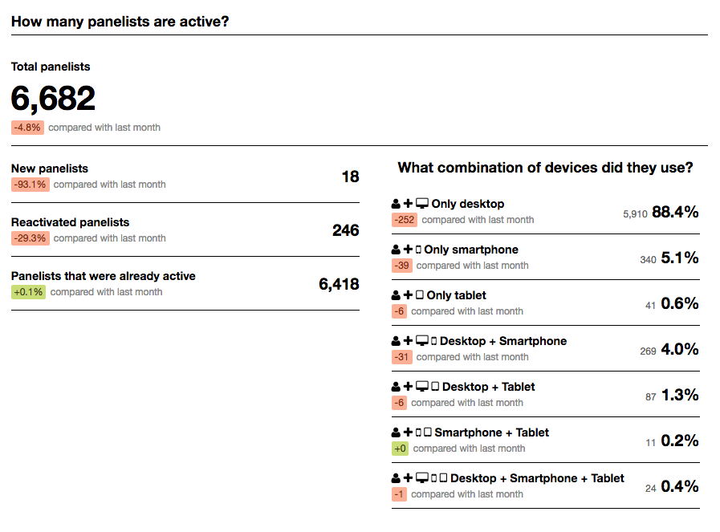

Appendix #1. Panelists

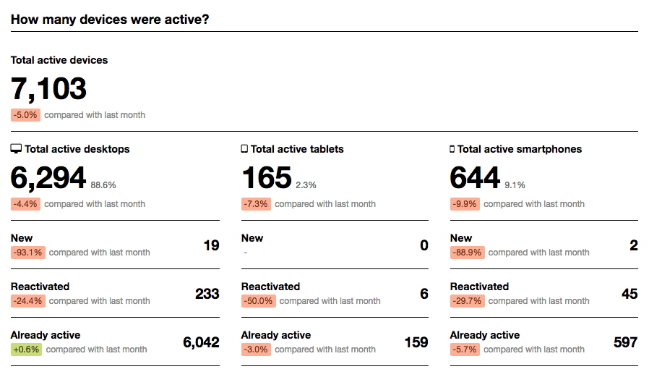

Appendix #2. Devices

## used_at host panelist_id url  
## 1 2016-01-01 00:47:06 telegraaf.nl 2112 telegraaf.nl  
## 2 2016-01-01 00:48:30 telegraaf.nl 2112 telegraaf.nl  
## 3 2016-01-01 00:51:28 telegraaf.nl 2112 telegraaf.nl  
## 4 2016-01-01 00:53:29 telegraaf.nl 2112 telegraaf.nl  
## 5 2016-01-01 01:28:52 telegraaf.nl 2112 telegraaf.nl  
## 6 2016-01-01 02:01:00 telegraaf.nl 2112 telegraaf.nl  
## 7 2016-01-01 02:01:12 twitter.com 2112 twitter.com  
## 8 2016-01-01 02:04:07 twitter.com 2112 twitter.com  
## 9 2016-01-01 02:05:07 twitter.com 2112 twitter.com  
## 10 2016-01-01 02:27:31 twitter.com 2112 twitter.com  
## active_seconds browser_name mmid Class_Travel purchase  
## 1 72 safari 1 0 NA  
## 2 152 safari 1 0 NA  
## 3 0 safari 1 0 NA  
## 4 0 safari 1 0 NA  
## 5 71 safari 2 0 NA  
## 6 11 safari 3 0 NA  
## 7 168 safari 3 0 NA  
## 8 60 safari 3 0 NA  
## 9 0 safari 3 0 NA  
## 10 15 safari 4 0 NA

*Appendix #3 Desktop data*

## app_name host panelist_id device_id scheme url domain  
## 1 ABN AMRO Mobiel Bankieren <NA> 1008505 10093 <NA> <NA> <NA>  
## 2 ABN AMRO Mobiel Bankieren <NA> 1008505 10093 <NA> <NA> <NA>  
## 3 ABN AMRO Mobiel Bankieren <NA> 1008505 10093 <NA> <NA> <NA>  
## 4 ABN AMRO Mobiel Bankieren <NA> 1008505 10093 <NA> <NA> <NA>  
## 5 ABN AMRO Mobiel Bankieren <NA> 1008505 10093 <NA> <NA> <NA>  
## 6 ABN AMRO Mobiel Bankieren <NA> 1008505 10093 <NA> <NA> <NA>  
## 7 ABN AMRO Mobiel Bankieren <NA> 1008505 10093 <NA> <NA> <NA>  
## 8 ABN AMRO Mobiel Bankieren <NA> 1008505 10093 <NA> <NA> <NA>  
## 9 ABN AMRO Mobiel Bankieren <NA> 1008505 10093 <NA> <NA> <NA>  
## 10 ABN AMRO Mobiel Bankieren <NA> 1008505 10093 <NA> <NA> <NA>  
## app_id used_at connection  
## 1 cb46bcba-7258-4b47-8557-de3ff607b456 2016-02-22 13:43:15 wifi  
## 2 cb46bcba-7258-4b47-8557-de3ff607b456 2016-02-03 18:03:34 cellular  
## 3 cb46bcba-7258-4b47-8557-de3ff607b456 2016-01-23 15:38:49 wifi  
## 4 cb46bcba-7258-4b47-8557-de3ff607b456 2016-01-16 15:11:21 wifi  
## 5 cb46bcba-7258-4b47-8557-de3ff607b456 2016-02-03 18:43:44 wifi  
## 6 cb46bcba-7258-4b47-8557-de3ff607b456 2016-01-08 14:15:29 wifi  
## 7 cb46bcba-7258-4b47-8557-de3ff607b456 2016-01-24 10:20:45 wifi  
## 8 cb46bcba-7258-4b47-8557-de3ff607b456 2016-02-03 17:00:56 cellular  
## 9 cb46bcba-7258-4b47-8557-de3ff607b456 2016-01-22 21:34:28 cellular  
## 10 cb46bcba-7258-4b47-8557-de3ff607b456 2016-01-06 07:24:50 wifi  
## duration mmid Class_Travel TravelApp  
## 1 21 799 0 0  
## 2 19 551 0 0  
## 3 34 392 0 0  
## 4 11 283 0 0  
## 5 21 552 0 0  
## 6 23 139 0 0  
## 7 25 396 0 0  
## 8 9 549 0 0  
## 9 45 381 0 0  
## 10 15 98 0 0

*Appendix #4 Mobile data*

A reference to the img/panelists.png.