**Ablage 1**

Ablage 2

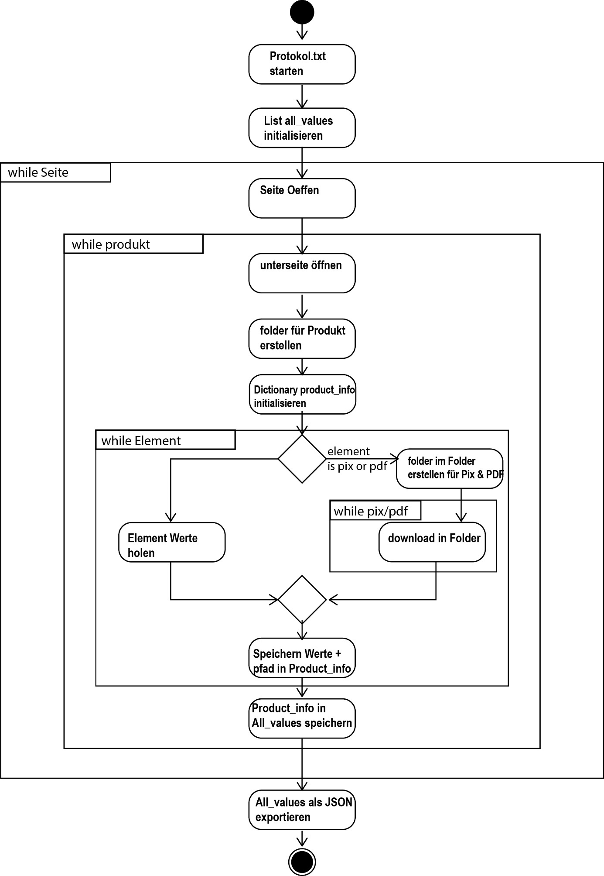

Ablage 3 url

#             _

#            | |

#  _   _ _ __| |___

# | | | | '__| / __|

# | |_| | |  | \__ \

#  \__,_|_|  |_|___/

urls = [f'https://shop.buzil.de/anwendungsbereich/?p={i}&f=' for i in range(1, 14)]

all_values = []

# Open the log file in append mode to avoid overwriting previous logs

with open(log_file_name, 'a') as log_file:

    # Define a custom print function that writes to both console and log file

    def custom_print(\**args*, \*\**kwargs*):

        # Convert the arguments to strings

        messages = [str(arg) for arg in *args*]

        # Concatenate the strings with a space separator

        message = ' '.join(messages)

        print(message, \*\**kwargs*) # Print to console

        log_file.write(message + '\n') # Write to log file

    n = 0

    subpage = 0

    for url in urls:

        n += 1

        custom_print(f'main page {n} from 13')

        custom_print("----------------------------------")

        custom_print("url:", url)

        # Make an HTTP GET request to the website

        response = requests.get(url)

        # Check if the request was successful

        if response.status_code == 200:

            # Parse the HTML content

            soup = BeautifulSoup(response.text, 'html.parser')

            # Find all <div> elements with the specified class

            item = soup.find('div', *class_*='tile-view-phone')

            # todo Loop Produkts

            a_tags = item.find_all('a', *class_*='product--link')

  for a_tag in a_tags:

                subpage += 1

          custom_print('')

            custom_print(f'page {subpage} from 145')

            product_info = {}  # Create a new dictionary for each a_tag

            product_info['a'] = a_tag['href']

            custom_print(f'- found {product_info["a"]}')

            custom_print('')

**ablage 4 log file output:**

main page 1 from 13

----------------------------------

url: https://shop.buzil.de/anwendungsbereich/?p=1&f=

page 1 from 145

- found https://shop.buzil.de/spezial/air-provence-g-565t

page 2 from 145

- found https://shop.buzil.de/kuechen-/lebensmittelhygiene/bistro-g-435

page 3 from 145

- found https://shop.buzil.de/sanitaer/bucasan-clear-g-463

page 4 from 145

- found https://shop.buzil.de/sanitaer/bucasan-fresh-p-920

page 5 from 145

- found https://shop.buzil.de/sanitaer/bucasan-hit-p-921

page 6 from 145

- found https://shop.buzil.de/sanitaer/bucasan-sanibond-g-457

page 7 from 145

- found https://shop.buzil.de/sanitaer/bucasan+-intense-p-922

page 8 from 145

- found https://shop.buzil.de/spezial/buz-air-ambra-g-564

page 9 from 145

- found https://shop.buzil.de/kuechen-/lebensmittelhygiene/buz-calc-ex-g-437

page 10 from 145

- found https://shop.buzil.de/spezial/buz-fresh-magic-g-567

page 11 from 145

- found https://shop.buzil.de/oberflaeche/buz-glass-p-912

page 12 from 145

- found https://shop.buzil.de/kuechen-/lebensmittelhygiene/buz-grillmaster-g-575

main page 2 from 13

----------------------------------

url: https://shop.buzil.de/anwendungsbereich/?p=2&f=  
…

**ablage 5**

# create folder with that name

invalid_chars = ['<', '>', ':', '"', '/', '\\', '|', '?', '*']

# Extract the name from the href

folder_name = os.path.basename(product_info['a'])

# Ersetze ungültige Zeichen durch Unterstriche

for char in invalid_chars:

folder_name = folder_name.replace(char, '_')

# Create a folder with the name from the href

folder_path = os.path.join(os.getcwd(), folder_name)

os.makedirs(folder_path, *exist_ok*=True)

custom_print(f'- - making folder {folder_path}')

**

**ablage7**

# todo linked page

# Make an HTTP GET request to the linked page

response2 = requests.get(a_tag['href'])

# Check if the request was successful

if response2.status_code == 200:

# Parse the HTML content

soup2 = BeautifulSoup(response2.text, 'html.parser')

# Extract all <div> elements with the specified ID

section = soup2.find('div', *id*='contentwrap')

# Create a dictionary to store the data for the current section

#  _     __

# | |   /  |

# | |__ `| |

# | '_ \ | |

# | | | || |_

# |_| |_\___/

# Extract the h1 element within the section

h1_element = section.find('h1')

if h1_element:

           h1_text = h1_element.get_text().strip()

# strip is trimming empty sapce

           product_info['h1'] = h1_text

           custom_print(f'- - FOUND H1')

      else:

           product_info['h1'] = ''

           custom_print(f'+ + h1 is missing ?')

# ----------------------------------------

      # write to all values

      all_values.append(product_info)

…

#    _

#   (_)

#    _ ___  ___  _ __

#   | / __|/ _ \| '_ \

#   | \__ \ (_) | | | |

#   | |___/\___/|_| |_|

#  _/ |

# |__/

# Specify the directory path where the JSON file is located

directory_path = ''

# Specify the file names

json_file_name = f'buzil_{current_datetime}.json'

# Save all_values as a JSON file for each URL

with open(json_file_name, 'w', *encoding*='utf-8') as json_file:

    json.dump(all_values, json_file, *ensure_ascii*=False, *indent*=4)

print("JSON file page created.")

json_file_path = os.path.join(directory_path, json_file_name)

**…**

**Ablage 8 json output**

[

    {

        "a": "https://shop.buzil.de/spezial/air-provence-g-565t",

        "h1": "Air Provence"

    }

]

…

**Ablage 9 Protokoll:**

main page 1 from 13

----------------------------------

url: https://shop.buzil.de/anwendungsbereich/?p=1&f=

page 1 from 145

- found https://shop.buzil.de/spezial/air-provence-g-565t

- - making folder C:\Users\greg\Documents\sites\project\air-provence-g-565t

- - - FOUND H1

Ablage 10 JSON:

[

    {

        "a": "https://shop.buzil.de/spezial/air-provence-g-565t",

        "h1": "Air Provence"

    },

    {

        "a": "https://shop.buzil.de/kuechen-/lebensmittelhygiene/bistro-g-435",

        "h1": "Bistro"

    },

    {

        "a": "https://shop.buzil.de/sanitaer/bucasan-clear-g-463",

        "h1": "Bucasan® Clear"

    },

    {

        "a": "https://shop.buzil.de/sanitaer/bucasan-fresh-p-920",

        "h1": "Bucasan® Fresh"

    },

    {

        "a": "https://shop.buzil.de/sanitaer/bucasan-hit-p-921",

        "h1": "Bucasan® Hit"

    },

**Ablage 11 Protokoll:**

main page 1 from 13

----------------------------------

url: https://shop.buzil.de/anwendungsbereich/?p=1&f=

page 1 from 145

- found https://shop.buzil.de/spezial/air-provence-g-565t

- - making folder C:\Users\greg\Documents\sites\project\air-provence-g-565t

- - - FOUND H1

page 2 from 145

- found https://shop.buzil.de/kuechen-/lebensmittelhygiene/bistro-g-435

- - making folder C:\Users\greg\Documents\sites\project\bistro-g-435

- - - FOUND H1

page 3 from 145

- found https://shop.buzil.de/sanitaer/bucasan-clear-g-463

- - making folder C:\Users\greg\Documents\sites\project\bucasan-clear-g-463

- - - FOUND H1

page 4 from 145

- found https://shop.buzil.de/sanitaer/bucasan-fresh-p-920

- - making folder C:\Users\greg\Documents\sites\project\bucasan-fresh-p-920

- - - FOUND H1

page 5 from 145

- found https://shop.buzil.de/sanitaer/bucasan-hit-p-921

- - making folder C:\Users\greg\Documents\sites\project\bucasan-hit-p-921

- - - FOUND H1

…

**Ablage 12** JSON out put

[

    {

        "a": "https://shop.buzil.de/spezial/air-provence-g-565t",

        "h1": "Air Provence G 565T",

        "image_urls": [

            "https://shop.buzil.de/media/image/0a/1a/ca/2QOLn7huZ4R9dO1_1280x1280.jpg",

            "https://shop.buzil.de/media/image/c8/8b/07/2QOLn7huZ4R9dO1_200x200.jpg",

            "https://shop.buzil.de/media/image/7e/d6/56/2QOLn7huZ4R9dO1.jpg",

            "https://shop.buzil.de/media/image/5d/0e/77/2QOLn7huZ4R9dO1_600x600.jpg",

            "https://shop.buzil.de/media/image/3b/f1/21/2QOLn7huZ4R9dO1_600x600@2x.jpg"

        ],

        "image_local": [

            "air-provence-g-565t/img/2QOLn7huZ4R9dO1_1280x1280.jpg",

            "air-provence-g-565t/img/2QOLn7huZ4R9dO1_200x200.jpg",

            "air-provence-g-565t/img/2QOLn7huZ4R9dO1.jpg",

            "air-provence-g-565t/img/2QOLn7huZ4R9dO1_600x600.jpg",

            "air-provence-g-565t/img/2QOLn7huZ4R9dO1_600x600@2x.jpg"

        ],

        "product_detail_description_section": [

            {

                "header": "Gebrauchsfertiger Raumspray mit Aktiv-Geruchsblocker",

                "content": "In Wohn- und Geschäftsräumen, öffentlichen Einrichtungen wie Krankenhäusern, Altenheimen sowie in der Gastronomie, Sanitär- und WC-Anlagen, Aufenthalts- und Umkleideräumen, Sport- und Wellnessbereichen etc.; für die schnelle und langanhaltende Geruchsvernichtung und Luftverbesserung"

            },

            {

                "header": "Produktvorteile",

                "content": [

                    "Aromatischer Duft, der an frisch geernteten Lavendel erinnert sorgt für eine angenehme Raumatmosphäre",

                    "Neutralisiert schnell unangenehme Gerüche mit Aktiv-Geruchsblocker",

                    "Hinterlässt keine Flecken",

                    "Umweltfreundlicher Zerstäuber ohne Treibgas"

                ]

            }

        ],

**Ablage 13** protokoll

Protokoll:

main page 1 from 13

----------------------------------

url: https://shop.buzil.de/anwendungsbereich/?p=1&f=

page 1 from 145

- found https://shop.buzil.de/spezial/air-provence-g-565t

- - making folder C:\Users\Praktikanten Alpha\Desktop\GegPraktikum\greg_praktikum1\buzil\air-provence-g-565t

- - - FOUND H1

- - - DESCRIPTION-DATA

- - - - downloading description_data: 1

- - - - downloading description_data: 2

- - - ADDITIONAL DATA

- - - - downloading additionail detail: 1

- - - - - downloading additionail detail

- - - - downloading additionail detail: 2

- - - - - downloading additionail detail

- - - HINT

- - - DOWNLOADING PRODUKKT DOWNLOAD TITLE 1

- - - PRODUKT DOWNLOAD CONTENT

- - - - product_download_content found

- - - - - product_download_content li found: 1

- - - - - - product_download li

- - - - - - - downloading text and pdf for Betriebsanweisungen

- - - - - - - - downloading PDF for Betriebsanweisungen

- - - - - product_download_content li found: 2

…

*Ablage 14 Product CSV Import Schema*

Ablage 15

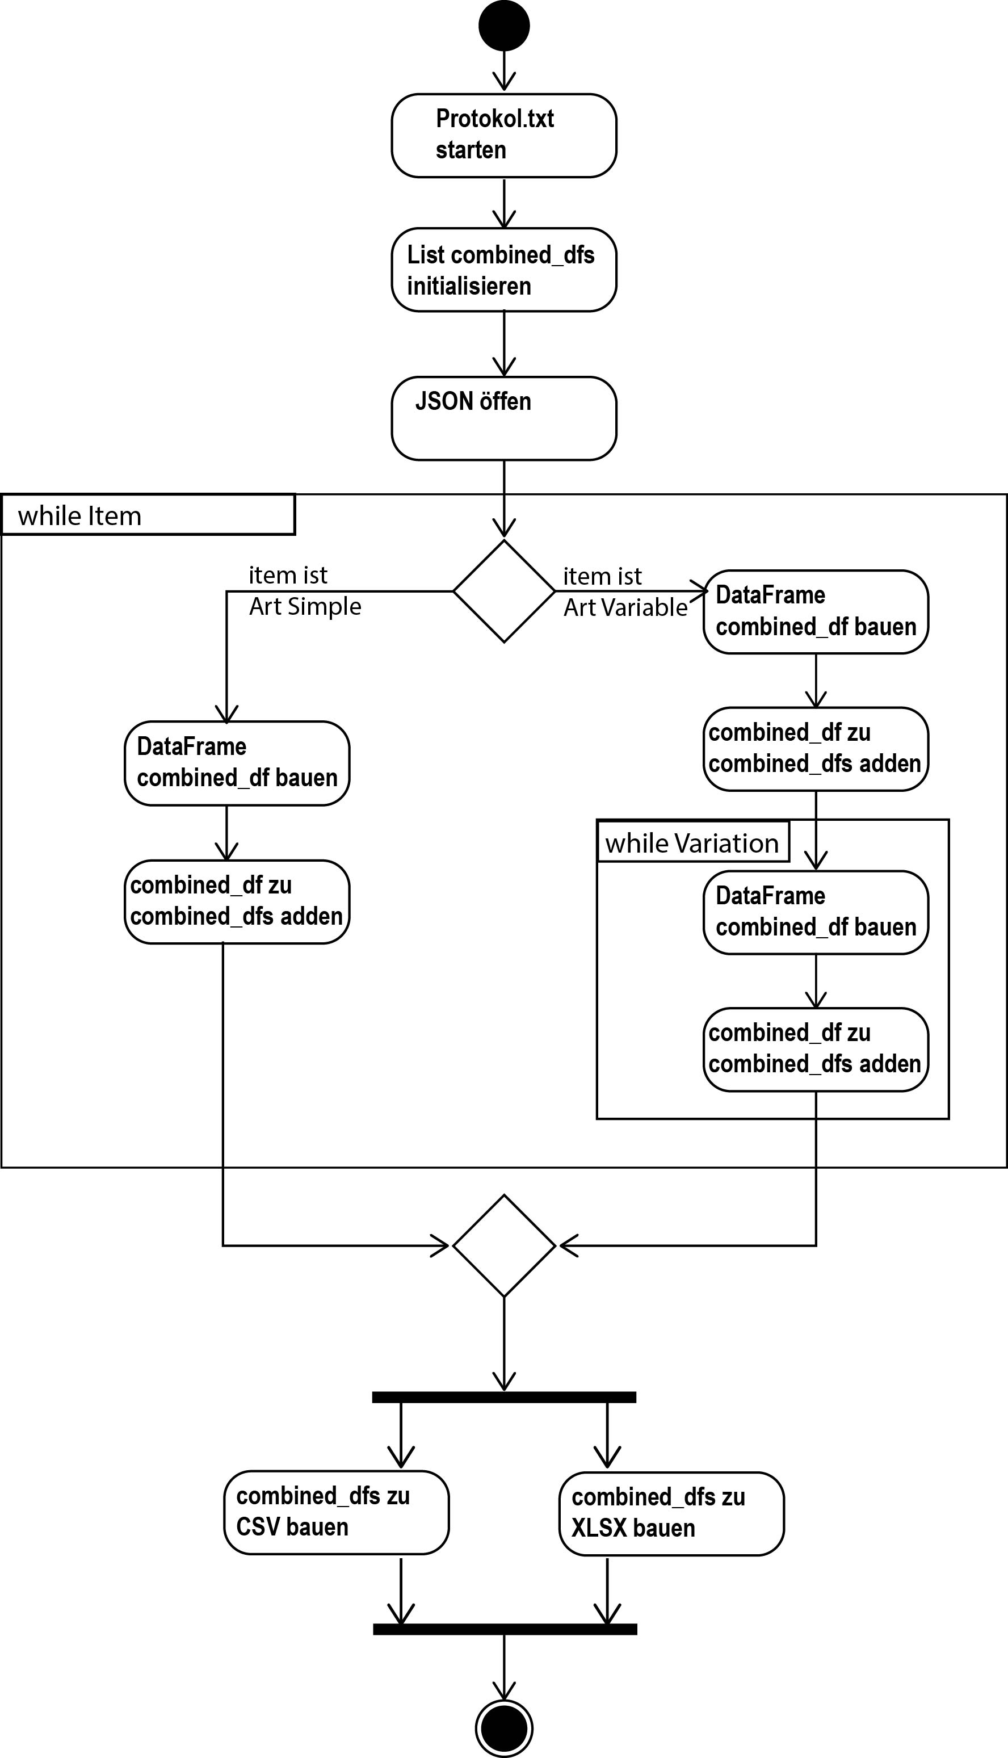

Ablage 16 csv output

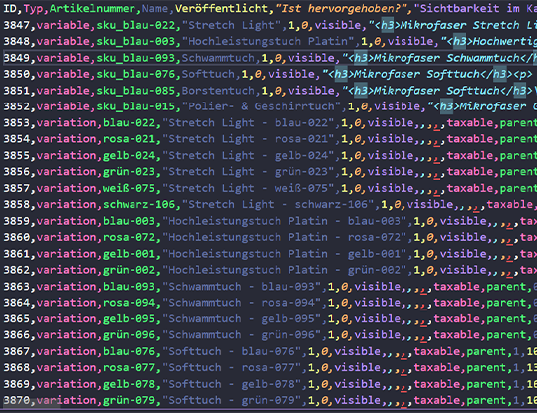

Ablage 17 woocomerce import gui

Ablage 18 woocomerce import gui

Ablage 19 woocomerce import gui

**Ablage 20 xlsx to csv**

import pandas as pd

# this will reformat xlsx to an csv file

# it s well suited for german, and will respect leading zeros for article unumbers

# .__                 __                        __  .__

# |__| ____   _______/  |________ __ __   _____/  |_|__| ____   ____   ______

# |  |/    \ /  ___/\   __\_  __ \  |  \_/ ___\   __\  |/  _ \ /    \ /  ___/

# |  |   |  \\___ \  |  |  |  | \/  |  /\  \___|  | |  (  <_> )   |  \\___ \

# |__|___|  /____  > |__|  |__|  |____/  \___  >__| |__|\____/|___|  /____  >

#         \/     \/                          \/                    \/     \/

# 1 put name of input File xlsx oder ods

# 2 put name of output csv file

# 1 Read the Excel file

df = pd.read_excel('file_name.xlsx', *dtype*=str) # Replace with your file name/path

# Keep only the 'Beschreibung' 'Kurzbeschreibung' columns or column needed

df = df[['Artikelnummer', 'Beschreibung', 'Kurzbeschreibung']]

# 3 Write to a CSV file

df.to_csv('file_name.csv', *index*=False, *encoding*='utf-8')

# Adjust the output file name as needed

**Ablage 21 Woocomerce fehler meldung**

