**Online appendix**

**scripts are available:** [**https://github.com/gregorioCPcG/As-clivagens-do-Brasil-uma-dimens-o-longitudinal**](https://github.com/gregorioCPcG/As-clivagens-do-Brasil-uma-dimens-o-longitudinal)

**Moreno’s Issues Dimensions in Brazil, 1991 and 1997**

|  |  |  |  |  |  |  |
| --- | --- | --- | --- | --- | --- | --- |
|  | 1991 | | | 1997 | | |
|  | PCA | FA | IRT | PCA | FA | IRT |
| **Factor I: Democratic-Authoritarian** | |  |  |  |  |  |
| Political Reform | 0.19 | 0.13 | 0.08 | - | - | - |
| Respect for authority | 0.59 | 0.38 | 0.49 | - | - | - |
| Democracy & eco. performance | - | - | - | 0.83 | 0.76 | 0.81 |
| Democracy& stability | - | - | - | 0.81 | 0.69 | 0.80 |
| Democracy & order | - | - | - | 0.72 | 0.54 | 0.67 |
| Importance of God | 0.41 | 0.18 | 0.14 | 0.12 | 0.11 | 0.14 |
| Abortion | -0.49 | -0.24 | -0.23 | -0.13 | -0.10 | -0.12 |
| National Pride | 0.58 | 0.42 | 0.37 | -0.10 | -0.02 | -0.03 |
| Societal Change | 0.61 | 0.41 | 0.58 | - | - | - |
| Income equality | 0.21 | 0.02 | -0.03 | 0.00 | -0.01 | -0.08 |
| Govt./individual responsibility | - | - | - | -0.07 | -0.06 | -0.10 |
| SS Loadings | 1.56 | 0.59 | 0.80 | 1.91 | 1.38 | 1.79 |
| Proportion Var | 0.22 | 0.08 |  | 0.24 | 0.17 |  |
| **Factor II: Liberal-Fundamentalist** | |  |  |  |  |  |
| Political Reform | - | 0.24 | 0.36 | - | - | - |
| Respect for authority | - | 0.15 | 0.33 | - | - | - |
| Democracy & eco. performance | - | - | - | 0.01 | 0.03 | 0.09 |
| Democracy& stability | - | - | - | -0.01 | 0.03 | 0.13 |
| Democracy & order | - | - | - | 0.12 | 0.14 | 0.03 |
| Importance of God | - | 0.29 | 0.56 | 0.68 | 0.35 | 0.81 |
| Abortion | - | -0.52 | -0.50 | -0.71 | -0.55 | -0.45 |
| National Pride | - | 0.11 | 0.29 | 0.51 | 0.17 | 0.20 |
| Societal Change | - | 0.02 | 0.08 | - | - | - |
| Income equality | - | -0.10 | -0.04 | -0.02 | -0.02 | -0.02 |
| Govt./individual responsibility | - | - | - | -0.01 | -0.03 | -0.02 |
| SS Loadings | - | 0.45 | 0.90 | 1.24 | 0.48 | 0.92 |
| Proportion Var | - | 0.06 |  | 0.16 | 0.06 |  |
| **Factor III: Economic Left-Right** | |  |  |  |  |  |
| Political Reform | -0.59 | - | - | - | - | - |
| Respect for authority | -0.04 | - | - | - | - | - |
| Democracy & eco. performance | - | - | - | -0.09 | -0.14 | -0.04 |
| Democracy& stability | - | - | - | 0.09 | 0.06 | 0.11 |
| Democracy & order | - | - | - | -0.09 | -0.12 | -0.29 |
| Importance of God | -0.28 | - | - | 0.02 | 0.00 | -0.01 |
| Abortion | 0.40 | - | - | 0.01 | 0.02 | 0.32 |
| National Pride | -0.07 | - | - | -0.04 | -0.03 | -0.24 |
| Societal Change | 0.21 | - | - | - | - | - |
| Income equality | 0.71 | - | - | 0.76 | 0.42 | 0.03 |
| Govt./individual responsibility | - | - | - | 0.73 | 0.31 | 0.04 |
| SS Loadings | 1.15 | - | - | 1.15 | 0.31 | 0.26 |
| Proportion Var | 0.16 | - | - | 0.14 | 0.04 |  |

**Extended Moreno’s Issue Unconstrained Dimensions in Brazil, 1991-2018**

|  |  |  |  |  |  |  |  |  |  |  |  |  |  |  |  |
| --- | --- | --- | --- | --- | --- | --- | --- | --- | --- | --- | --- | --- | --- | --- | --- |
|  | 1991 | | | 1997 | | | 2006 | | | 2014 | | | 2018 | | |
|  | PCA | FA | IRT | PCA | FA | IRT | PCA | FA | IRT | PCA | FA | IRT | PCA | FA | IRT |
| **Factor I: Liberal-Conservative (Cultural)** | | | |  |  |  |  |  |  |  |  |  |  |  |  |
| Jobs for men | -0.18 | -0.15 | -0.15 | -0.27 | -0.22 | -0.26 | -0.15 | -0.15 | -0.12 | -0.07 | -0.08 | -0.13 | -0.16 | -0.14 | 0.15 |
| Jobs for own nationality | -0.05 | -0.07 | -0.03 | -0.07 | -0.07 | -0.16 | -0.09 | -0.09 | -0.10 | -0.06 | -0.14 | -0.04 | -0.04 | -0.28 | 0.30 |
| Importance of God | -0.07 | -0.24 | -0.23 | -0.34 | -0.22 | -0.34 | -0.28 | -0.20 | -0.29 | -0.21 | -0.24 | -0.23 | -0.25 | -0.40 | 0.55 |
| Societal change | 0.02 | -0.24 | -0.13 | -0.02 | -0.01 | 0.02 | - | - | - | - | - | - | -0.02 | -0.11 | 0.13 |
| Income equality | 0.17 | 0.07 | 0.08 | 0.03 | 0.04 | 0.01 | 0.04 | -0.02 | -0.01 | -0.04 | -0.03 | -0.05 | 0.10 | -0.12 | 0.11 |
| Private/Public ownership | -0.01 | -0.13 | -0.05 | -0.06 | -0.06 | -0.06 | -0.03 | -0.09 | -0.03 | -0.01 | -0.05 | -0.03 | 0.01 | -0.03 | 0.02 |
| Competition | -0.02 | -0.08 | -0.02 | -0.05 | -0.08 | -0.03 | 0.02 | -0.09 | 0.00 | 0.07 | 0.05 | 0.02 | -0.02 | 0.00 | -.04 |
| Respect for authority | -0.12 | -0.34 | -0.28 | -0.29 | -0.20 | -0.28 | -0.19 | -0.14 | -0.14 | -0.13 | -0.21 | -0.18 | 0.05 | -0.20 | 0.25 |
| Homosexuality | 0.80 | 0.57 | 0.83 | 0.76 | 0.71 | 0.83 | 0.72 | 0.62 | 0.70 | 0.76 | 0.60 | 0.82 | 0.77 | 0.56 | -.66 |
| Prostitution | 0.79 | 0.63 | 0.89 | 0.76 | 0.71 | 0.88 | 0.78 | 0.64 | 0.88 | 0.76 | 0.71 | 0.81 | 0.73 | 0.67 | -.81 |
| Abortion | 0.59 | 0.60 | 0.61 | 0.68 | 0.56 | 0.69 | 0.67 | 0.55 | 0.70 | 0.62 | 0.55 | 0.58 | 0.60 | 0.63 | -.79 |
| Divorce | 0.61 | 0.54 | 0.56 | 0.62 | 0.50 | 0.54 | 0.56 | 0.42 | 0.44 | 0.63 | 0.40 | 0.54 | 0.70 | 0.44 | -.50 |
| Fighting with the police | 0.20 | 0.41 | 0.40 | - | - | - | - | - | - | - | - | - | - | - | - |
| National pride | 0.03 | -0.25 | -0.13 | -0.19 | -0.12 | -0.14 | -0.06 | -0.05 | -0.04 | 0.00 | -0.07 | -0.01 | -0.01 | -0.22 | 0.25 |
| Government more open | -0.03 | -0.07 | -0.11 | - | - | - | - | - | - | - | - | - | - | - | - |
| Political reform | -0.14 | -0.23 | -0.17 | - | - | - | - | - | - | - | - | - | - | - | - |
| Govt. responsibility | 0.01 | -0.08 | -0.00 | 0.03 | 0.01 | 0.02 | 0.16 | 0.04 | 0.11 | 0.14 | 0.08 | 0.04 | 0.14 | 0.08 | -.14 |
| Immigration policy | - | - | - | -0.02 | -0.04 | -0.00 | -0.12 | -0.13 | -0.11 | - | - | - | -0.16 | -0.19 | 0.18 |
| Strong leader | - | - | - | -0.03 | -0.04 | -0.06 | 0.04 | -0.07 | 0.02 | 0.04 | -0.14 | -0.05 | -0.06 | -0.16 | 0.13 |
| Experts | - | - | - | 0.13 | 0.10 | 0.10 | 0.03 | -0.03 | 0.03 | 0.10 | -0.11 | 0.01 | 0.06 | -0.12 | 0.10 |
| Army rule | - | - | - | -0.16 | -0.15 | -0.16 | -0.15 | -0.23 | -0.14 | -0.07 | -0.15 | -0.13 | -0.14 | -0.24 | 0.20 |
| Democratic pol. system | - | - | - | 0.04 | 0.08 | 0.08 | 0.01 | 0.10 | 0.06 | 0.12 | 0.01 | 0.16 | 0.13 | 0.02 | -.04 |
| Order vs freedom | - | - | - | 0.10 | 0.06 | 0.08 | - | - | - | - | - | - | - | - | - |
| Dem. eco. performance | - | - | - | -0.08 | -0.04 | -0.07 | - | - | - | - | - | - | - | - | - |
| Democracy& stability | - | - | - | -0.08 | -0.03 | -0.05 | - | - | - | - | - | - | - | - | - |
| Democracy & order | - | - | - | -0.11 | -0.08 | -0.08 | - | - | - | - | - | - | - | - | - |
| Democracy better | - | - | - | -0.09 | -0.01 | 0.12 | - | - | - | - | - | - | - | - | - |
| SS Loadings | 2.13 | 1.95 | 2.56 | 2.41 | 1.79 | 2.63 | 2.10 | 1.48 | 2.14 | 2.07 | 1.53 | 2.10 | 2.18 | 1.87 | 2.66 |
| Proportion Var | 0.13 | 0.11 |  | 0.10 | 0.07 |  | 0.12 | 0.08 |  | 0.12 | 0.09 |  | 0.11 | 0.10 | 0.14 |
| **Factor II: Economic Left-Right** | | | |  |  |  |  |  |  |  |  |  |  |  |  |
| Jobs for men | 0.12 | - | 0.06 | - | - | - | - | - | - | 0.36 | - | - | 0.33 | - | - |
| Jobs for own nationality | 0.15 | - | 0.11 | - | - | - | - | - | - | 0.07 | - | - | 0.04 | - | - |
| Importance of God | 0.00 | - | -0.01 | - | - | - | - | - | - | -0.13 | - | - | -0.21 | - | - |
| Societal change | 0.06 | - | 0.04 | - | - | - | - | - | - | - | - | - | 0.09 | - | - |
| Income equality | -0.02 | - | -0.04 | - | - | - | - | - | - | 0.43 | - | - | 0.42 | - | - |
| Private/Public ownership | 0.69 | - | 0.60 | - | - | - | - | - | - | 0.41 | - | - | 0.42 | - | - |
| Competition | 0.69 | - | 0.61 | - | - | - | - | - | - | 0.55 | - | - | 0.54 | - | - |
| Respect for authority | 0.11 | - | 0.08 | - | - | - | - | - | - | 0.04 | - | - | 0.00 | - | - |
| Homosexuality | 0.02 | - | 0.01 | - | - | - | - | - | - | -0.05 | - | - | -0.15 | - | - |
| Prostitution | 0.04 | - | 0.01 | - | - | - | - | - | - | 0.01 | - | - | 0.10 | - | - |
| Abortion | -0.10 | - | -0.09 | - | - | - | - | - | - | 0.02 | - | - | 0.13 | - | - |
| Divorce | -0.13 | - | -0.11 | - | - | - | - | - | - | -0.06 | - | - | -0.08 | - | - |
| Fighting with the police | -0.02 | - | 0.01 | - | - | - | - | - | - | - | - | - | - | - | - |
| National pride | -0.01 | - | -0.03 | - | - | - | - | - | - | -0.02 | - | - | -0.01 | - | - |
| Government more open | 0.17 | - | 0.12 | - | - | - | - | - | - | - | - | - | - | - | - |
| Political reform | 0.22 | - | 0.11 | - | - | - | - | - | - | - | - | - | - | - | - |
| Govt. responsibility | 0.71 | - | 0.64 | - | - | - | - | - | - | 0.53 | - | - | 0.57 | - | - |
| Immigration policy | - | - | - | - | - | - | - | - | - | - | - | - | 0.11 | - | - |
| Strong leader | - | - | - | - | - | - | - | - | - | 0.10 | - | - | 0.03 | - | - |
| Experts | - | - | - | - | - | - | - | - | - | -0.08 | - | - | -0.27 | - | - |
| Army rule | - | - | - | - | - | - | - | - | - | 0.43 | - | - | 0.30 | - | - |
| Democratic pol. system | - | - | - | - | - | - | - | - | - | -0.48 | - | - | -0.54 | - | - |
| Order vs freedom | - | - | - | - | - | - | - | - | - | - | - | - | - | - | - |
| Dem. eco. performance | - | - | - | - | - | - | - | - | - | - | - | - | - | - | - |
| Democracy& stability | - | - | - | - | - | - | - | - | - | - | - | - | - | - | - |
| Democracy & order | - | - | - | - | - | - | - | - | - | - | - | - | - | - | - |
| Democracy better | - | - | - | - | - | - | - | - | - | - | - | - | - | - | - |
| SS Loadings | 1.62 | - | 1.21 | - | - | - | - | - | - | 1.54 | - | - | 1.66 | - | - |
| Proportion Var | 0.10 | - |  | - | - | - | - | - | - | 0.09 | - | - | 0.09 | - | - |
| **Factor III: Democratic-Authoritarian** | | | |  |  |  |  |  |  |  |  |  |  |  |  |
| Jobs for men | 0.06 | - | -0.09 | - | - | - | - | - | - | - | - | -0.09 | 0.04 | - | - |
| Jobs for own nationality | 0.04 | - | -0.08 | - | - | - | - | - | - | - | - | 0.40 | 0.41 | - | - |
| Importance of God | 0.45 | - | -0.44 | - | - | - | - | - | - | - | - | 0.70 | 0.56 | - | - |
| Societal change | 0.54 | - | -0.41 | - | - | - | - | - | - | - | - | - | 0.39 | - | - |
| Income equality | 0.08 | - | -0.01 | - | - | - | - | - | - | - | - | -0.06 | 0.35 | - | - |
| Private/Public ownership | 0.04 | - | -0.07 | - | - | - | - | - | - | - | - | 0.04 | 0.11 | - | - |
| Competition | -0.07 | - | 0.04 | - | - | - | - | - | - | - | - | -0.22 | -0.06 | - | - |
| Respect for authority | 0.53 | - | -0.50 | - | - | - | - | - | - | - | - | 0.42 | 0.52 | - | - |
| Homosexuality | -0.04 | - | 0.00 | - | - | - | - | - | - | - | - | 0.04 | -0.02 | - | - |
| Prostitution | -0.13 | - | 0.11 | - | - | - | - | - | - | - | - | -0.24 | -0.22 | - | - |
| Abortion | -0.32 | - | 0.33 | - | - | - | - | - | - | - | - | -0.46 | -0.39 | - | - |
| Divorce | -0.19 | - | 0.19 | - | - | - | - | - | - | - | - | 0.11 | 0.10 | - | - |
| Fighting with the police | -0.60 | - | 0.54 | - | - | - | - | - | - | - | - | - | - | - | - |
| National pride | 0.62 | - | -0.48 | - | - | - | - | - | - | - | - | 0.23 | 0.59 | - | - |
| Government more open | 0.06 | - | -0.18 | - | - | - | - | - | - | - | - | - | - | - | - |
| Political reform | 0.26 | - | -0.24 | - | - | - | - | - | - | - | - | - | - | - | - |
| Govt. responsibility | -0.07 | - | -0.01 | - | - | - | - | - | - | - | - | -0.20 | -0.02 | - | - |
| Immigration policy | - | - | - | - | - | - | - | - | - | - | - | - | 0.22 | - | - |
| Strong leader | - | - | - | - | - | - | - | - | - | - | - | 0.28 | 0.01 | - | - |
| Experts | - | - | - | - | - | - | - | - | - | - | - | 0.38 | 0.11 | - | - |
| Army rule | - | - | - | - | - | - | - | - | - | - | - | 0.06 | 0.15 | - | - |
| Democratic pol. system | - | - | - | - | - | - | - | - | - | - | - | 0.05 | 0.14 | - | - |
| Order vs freedom | - | - | - | - | - | - | - | - | - | - | - | - | - | - | - |
| Dem. eco. performance | - | - | - | - | - | - | - | - | - | - | - | - | - | - | - |
| Democracy& stability | - | - | - | - | - | - | - | - | - | - | - | - | - | - | - |
| Democracy & order | - | - | - | - | - | - | - | - | - | - | - | - | - | - | - |
| Democracy better | - | - | - | - | - | - | - | - | - | - | - | - | - | - | - |
| SS Loadings | 1.78 | - | 1.40 | - | - | - | - | - | - | - | - | 1.49 | 1.70 | - | - |
| Proportion Var | 0.71 | - |  | - | - | - | - | - | - | - | - |  | 0.09 | - | - |
| **Factor IV: Democratic-Authoritarian 2** | | | |  |  |  |  |  |  |  |  |  |  |  |  |
| Jobs for men | - | - | - | -0.11 | -0.07 | -0.05 | - | - | - | - | - | - | - | - | - |
| Jobs for own nationality | - | - | - | -0.10 | -0.03 | -0.00 | - | - | - | - | - | - | - | - | - |
| Importance of God | - | - | - | 0.20 | 0.12 | 0.21 | - | - | - | - | - | - | - | - | - |
| Societal change | - | - | - | -0.11 | -0.07 | -0.09 | - | - | - | - | - | - | - | - | - |
| Income equality | - | - | - | -0.04 | -0.04 | -0.07 | - | - | - | - | - | - | - | - | - |
| Private/Public ownership | - | - | - | -0.03 | -0.01 | -0.01 | - | - | - | - | - | - | - | - | - |
| Competition | - | - | - | -0.06 | -0.03 | 0.00 | - | - | - | - | - | - | - | - | - |
| Respect for authority | - | - | - | 0.00 | -0.01 | -0.04 | - | - | - | - | - | - | - | - | - |
| Homosexuality | - | - | - | -0.02 | -0.06 |  | - | - | - | - | - | - | - | - | - |
| Prostitution | - | - | - | -0.03 | -0.08 | -0.06 | - | - | - | - | - | - | - | - | - |
| Abortion | - | - | - | -0.09 | -0.09 | -0.10 | - | - | - | - | - | - | - | - | - |
| Divorce | - | - | - | 0.11 | 0.06 | 0.06 | - | - | - | - | - | - | - | - | - |
| Fighting with the police | - | - | - | - | - | - | - | - | - | - | - | - | - | - | - |
| National pride | - | - | - | -0.03 | -0.03 | -0.03 | - | - | - | - | - | - | - | - | - |
| Government more open | - | - | - | - | - | - | - | - | - | - | - | - | - | - | - |
| Political reform | - | - | - | - | - | - | - | - | - | - | - | - | - | - | - |
| Govt. responsibility | - | - | - | -0.13 | -0.10 | -0.10 | - | - | - | - | - | - | - | - | - |
| Immigration policy | - | - | - | -0.01 | 0.01 | 0.04 | - | - | - | - | - | - | - | - | - |
| Strong leader | - | - | - | 0.32 | 0.14 | 0.15 | - | - | - | - | - | - | - | - | - |
| Experts | - | - | - | 0.37 | 0.17 | 0.17 | - | - | - | - | - | - | - | - | - |
| Army rule | - | - | - | 0.17 | 0.02 | 0.12 | - | - | - | - | - | - | - | - | - |
| Democratic pol. system | - | - | - | -0.15 | -0.10 | -0.23 | - | - | - | - | - | - | - | - | - |
| Order vs freedom | - | - | - | -0.06 | -0.02 | -0.02 | - | - | - | - | - | - | - | - | - |
| Dem. eco. performance | - | - | - | 0.80 | 0.74 | 0.77 | - | - | - | - | - | - | - | - | - |
| Democracy& stability | - | - | - | 0.77 | 0.68 | 0.79 | - | - | - | - | - | - | - | - | - |
| Democracy & order | - | - | - | 0.65 | 0.49 | 0.61 | - | - | - | - | - | - | - | - | - |
| Democracy better | - | - | - | -0.04 | 0.01 | -0.20 | - | - | - | - | - | - | - | - | - |
| SS Loadings | - | - | - | 2.06 | 1.37 | 1.84 | - | - | - | - | - | - | - | - | - |
| Proportion Var | - | - | - | 0.09 | 0.06 |  | - | - | - | - | - | - | - | - | - |
| **Factor V: Democratic-Authoritarian 3** | | | |  |  |  |  |  |  |  |  |  |  |  |  |
| Jobs for men | - | - | - | 0.37 | 0.23 | -0.30 | 0.41 | - | - | - | - | - | - | - | - |
| Jobs for own nationality | - | - | - | 0.17 | 0.06 | -0.11 | 0.21 | - | - | - | - | - | - | - | - |
| Importance of God | - | - | - | -0.04 | 0.07 | 0.07 | -0.03 | - | - | - | - | - | - | - | - |
| Societal change | - | - | - | 0.14 | 0.07 | -0.09 | - | - | - | - | - | - | - | - | - |
| Income equality | - | - | - | -0.15 | -0.08 | 0.12 | 0.26 | - | - | - | - | - | - | - | - |
| Private/Public ownership | - | - | - | 0.22 | 0.12 | -0.12 | 0.40 | - | - | - | - | - | - | - | - |
| Competition | - | - | - | 0.39 | 0.21 | -0.24 | 0.56 | - | - | - | - | - | - | - | - |
| Respect for authority | - | - | - | 0.11 | 0.12 | -0.19 | 0.08 | - | - | - | - | - | - | - | - |
| Homosexuality | - | - | - | -0.03 | -0.03 | 0.02 | -0.13 | - | - | - | - | - | - | - | - |
| Prostitution | - | - | - | 0.04 | 0.04 | -0.03 | 0.08 | - | - | - | - | - | - | - | - |
| Abortion | - | - | - | -0.06 | -0.10 | 0.16 | -0.01 | - | - | - | - | - | - | - | - |
| Divorce | - | - | - | -0.18 | -0.15 | 0.20 | -0.05 | - | - | - | - | - | - | - | - |
| Fighting with the police | - | - | - | - | - | - | - | - | - | - | - | - | - | - | - |
| National pride | - | - | - | 0.04 | 0.06 | -0.06 | -0.01 | - | - | - | - | - | - | - | - |
| Government more open | - | - | - | - | - | - | - | - | - | - | - | - | - | - | - |
| Political reform | - | - | - | - | - | - | - | - | - | - | - | - | - | - | - |
| Govt. responsibility | - | - | - | 0.09 | 0.03 | 0.03 | 0.37 | - | - | - | - | - | - | - | - |
| Immigration policy | - | - | - | 0.25 | 0.12 | -0.12 | 0.37 | - | - | - | - | - | - | - | - |
| Strong leader | - | - | - | 0.40 | 0.38 | -0.12 | 0.07 | - | - | - | - | - | - | - | - |
| Experts | - | - | - | 0.04 | 0.13 | 0.20 | -0.15 | - | - | - | - | - | - | - | - |
| Army rule | - | - | - | 0.65 | 0.65 | -0.47 | 0.41 | - | - | - | - | - | - | - | - |
| Democratic pol. system | - | - | - | -0.53 | -0.34 | 0.53 | -0.52 | - | - | - | - | - | - | - | - |
| Order vs freedom | - | - | - | -0.05 | -0.07 | 0.07 | - | - | - | - | - | - | - | - | - |
| Dem. eco. performance | - | - | - | 0.04 | 0.17 | -0.06 | - | - | - | - | - | - | - | - | - |
| Democracy& stability | - | - | - | -0.09 | 0.06 | 0.07 | - | - | - | - | - | - | - | - | - |
| Democracy & order | - | - | - | 0.33 | 0.41 | -0.36 | - | - | - | - | - | - | - | - | - |
| Democracy better | - | - | - | -0.57 | -0.36 | 0.22 | - | - | - | - | - | - | - | - | - |
| SS Loadings | - | - | - | 1.84 | 1.24 | 1.06 | 1.53 | - | - | - | - | - | - | - | - |
| Proportion Var | - | - | - | 0.08 | 0.05 |  | 0.08 | - | - | - | - | - | - | - | - |
| **Factor VI: Democratic-Authoritarian 4** | | | |  |  |  |  |  |  |  |  |  |  |  |  |
| Jobs for men | - | - | - | - | - | 0.16 | -0.11 | - | 0.10 | 0.09 | - | - | 0.11 | - | - |
| Jobs for own nationality | - | - | - | - | - | -0.00 | 0.03 | - | 0.13 | 0.40 | - | - | 0.20 | - | - |
| Importance of God | - | - | - | - | - | 0.14 | 0.22 | - | 0.23 | 0.42 | - | - | 0.02 | - | - |
| Societal change | - | - | - | - | - | 0.07 | - | - | - | - | - | - | -0.32 | - | - |
| Income equality | - | - | - | - | - | 0.07 | 0.02 | - | 0.07 | -0.02 | - | - | 0.19 | - | - |
| Private/Public ownership | - | - | - | - | - | 0.07 | 0.04 | - | 0.12 | 0.10 | - | - | -0.08 | - | - |
| Competition | - | - | - | - | - | -0.01 | 0.01 | - | 0.14 | -0.12 | - | - | 0.00 | - | - |
| Respect for authority | - | - | - | - | - | 0.16 | 0.11 | - | 0.16 | 0.46 | - | - | 0.13 | - | - |
| Homosexuality | - | - | - | - | - | -0.04 | 0.09 | - | -0.04 | 0.01 | - | - | -0.02 | - | - |
| Prostitution | - | - | - | - | - | 0.04 | 0.05 | - | 0.04 | -0.14 | - | - | -0.02 | - | - |
| Abortion | - | - | - | - | - | -0.04 | -0.13 | - | -0.12 | -0.27 | - | - | -0.05 | - | - |
| Divorce | - | - | - | - | - | -0.03 | -0.06 | - | -0.10 | 0.12 | - | - | -0.04 | - | - |
| Fighting with the police | - | - | - | - | - | - | - | - | - | - | - | - | - | - | - |
| National pride | - | - | - | - | - | 0.09 | 0.15 | - | 0.10 | 0.27 | - | - | -0.06 | - | - |
| Government more open | - | - | - | - | - | - | - | - | - | - | - | - | - | - | - |
| Political reform | - | - | - | - | - | - | - | - | - | - | - | - | - | - | - |
| Govt. responsibility | - | - | - | - | - | 0.10 | 0.03 | - | 0.08 | -0.05 | - | - | -0.01 | - | - |
| Immigration policy | - | - | - | - | - | 0.02 | -0.07 | - | 0.08 | - | - | - | 0.03 | - | - |
| Strong leader | - | - | - | - | - | 0.72 | 0.75 | - | 0.58 | 0.58 | - | - | 0.73 | - | - |
| Experts | - | - | - | - | - | 0.62 | 0.74 | - | 0.45 | 0.65 | - | - | 0.70 | - | - |
| Army rule | - | - | - | - | - | 0.42 | 0.53 | - | 0.60 | 0.31 | - | - | 0.51 | - | - |
| Democratic pol. system | - | - | - | - | - | 0.13 | -0.01 | - | -0.24 | 0.27 | - | - | 0.08 | - | - |
| Order vs freedom | - | - | - | - | - | -0.04 | - | - | - | - | - | - | - | - | - |
| Dem. eco. performance | - | - | - | - | - | 0.11 | - | - | - | - | - | - | - | - | - |
| Democracy& stability | - | - | - | - | - | 0.08 | - | - | - | - | - | - | - | - | - |
| Democracy & order | - | - | - | - | - | 0.10 | - | - | - | - | - | - | - | - | - |
| Democracy better | - | - | - | - | - | -0.06 | - | - | - | - | - | - | - | - | - |
| SS Loadings | - | - | - | - | - | 1.23 | 1.53 | - | 1.16 | 1.48 | - | - | 1.52 | - | - |
| Proportion Var | - | - | - | - | - |  | 0.08 | - |  | 0.09 | - | - | 0.08 | - | - |

**Confirmatory Factor Analysis, 1991-2018**

**1991**



**1997**



**2006**



**2014**



**2018**



**Fundamentalist Distribution, 1991-2018**

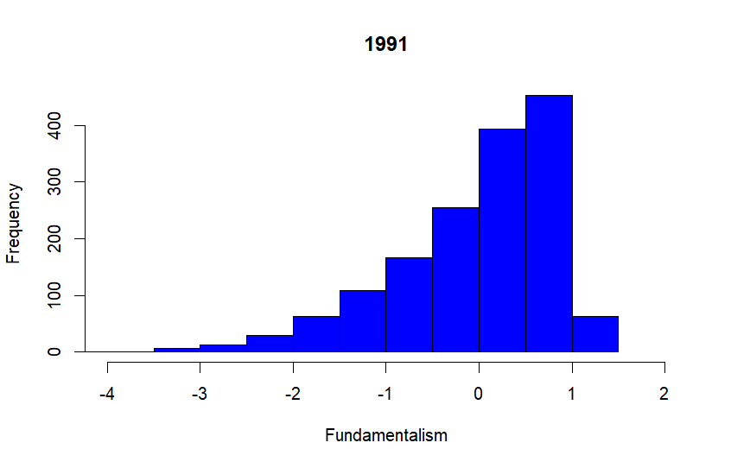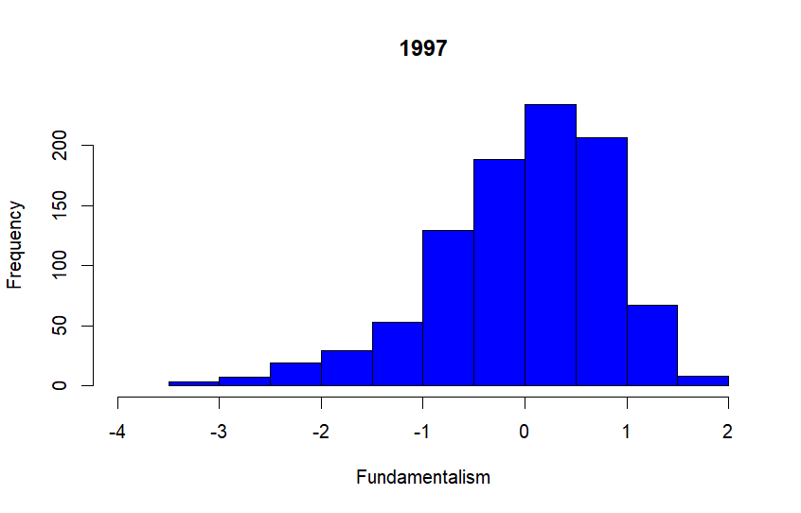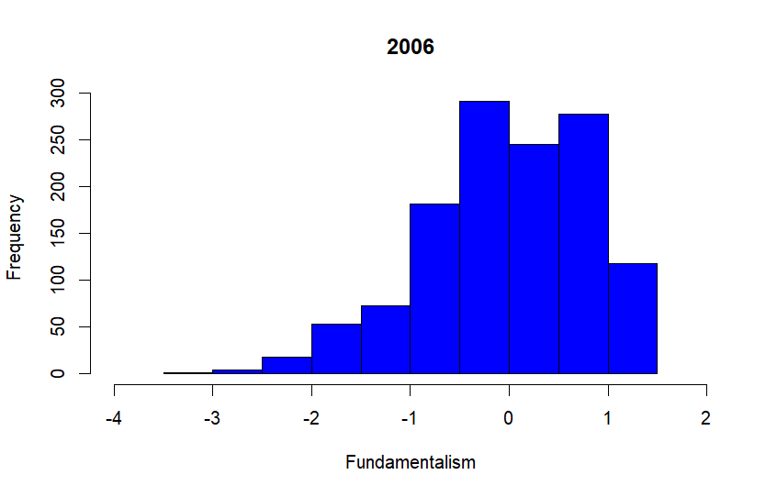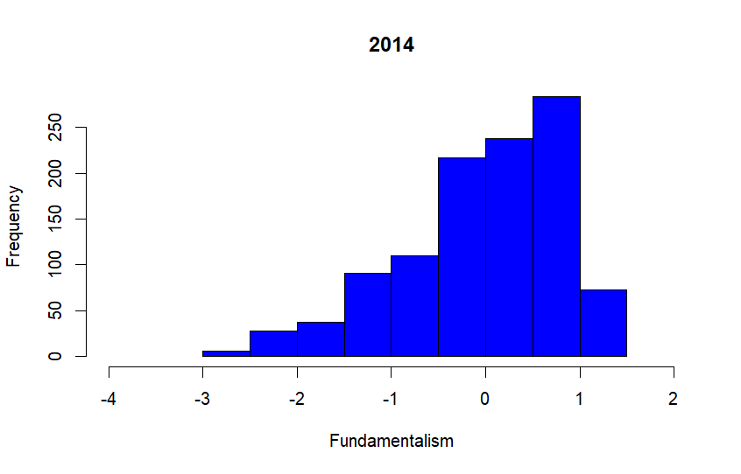

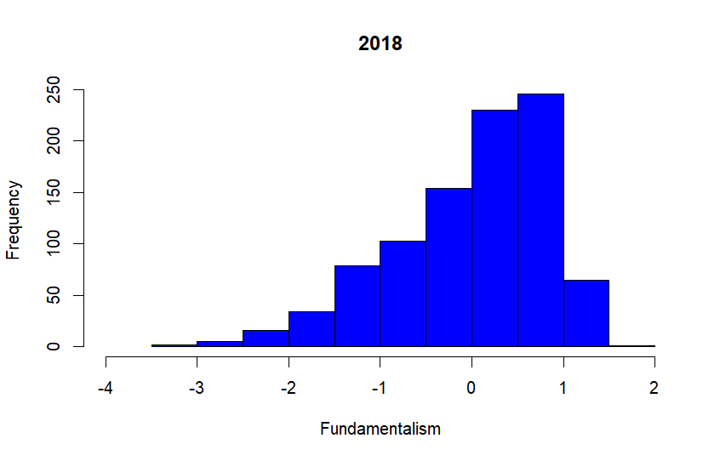

**Merge Factorial Analysis**



Jobs for man (V1), Jobs for own nationality (V2), Importance of God (V3), Income Equality (V4), Private/public ownership (V5), Competition (V6), Respect for authority (V7), Homosexuality (V8), Prostitution (V9), Abortion (V10), Divorce (V11), National Pride (V12), Government responsibility (V13).

**Mean Scores Partys Brazil**

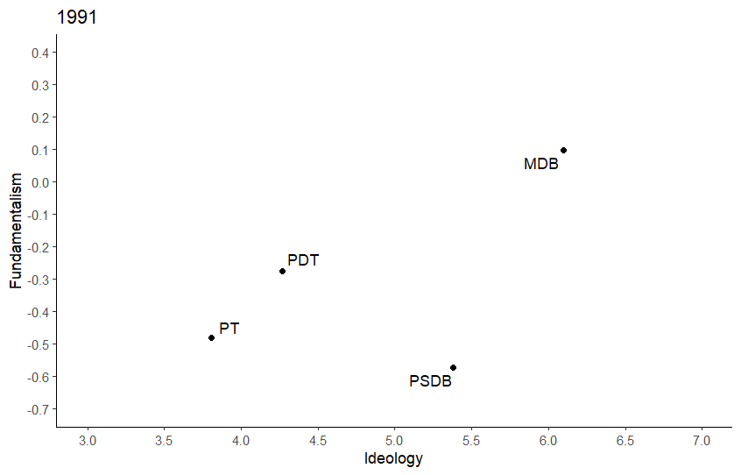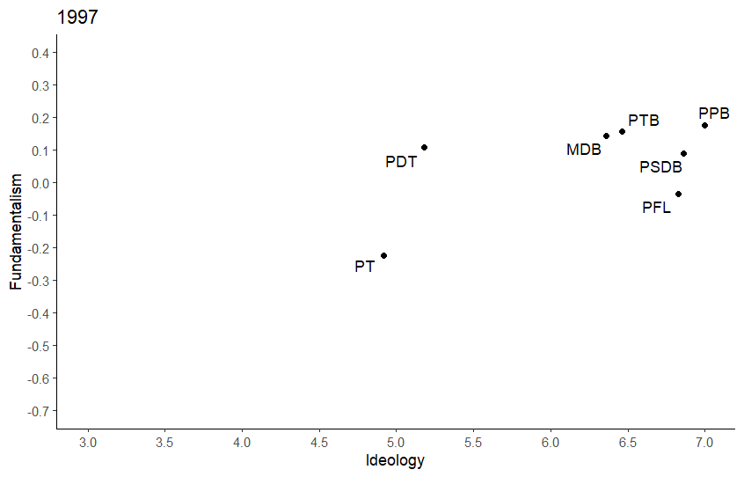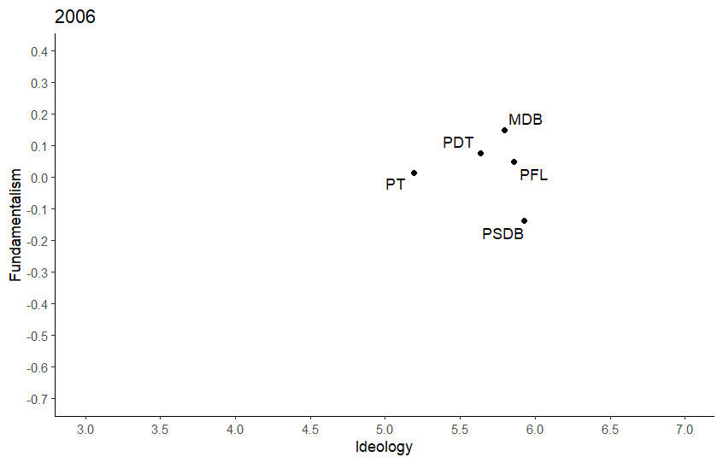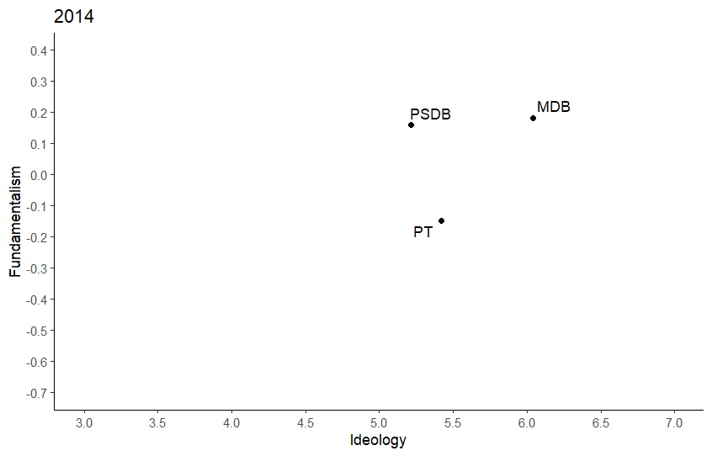

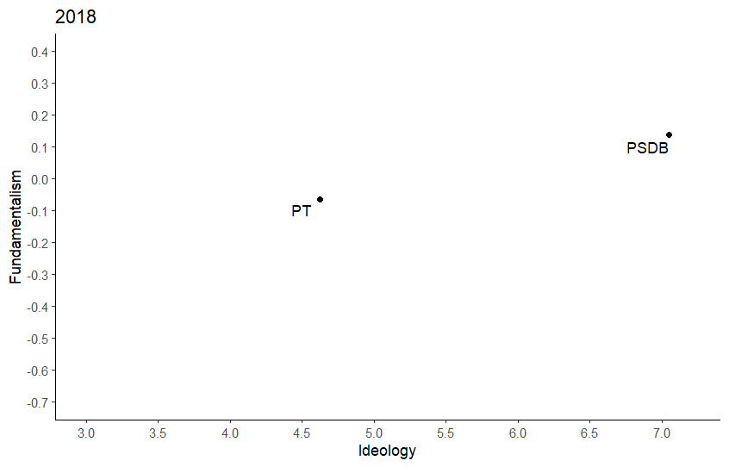

We selected only the cases with more than 30 supporters.

**Full Regression**

