Inhaltsverzeichnis
1 Introduction 3
2 Architecture Model 4
3 Architecture Layers 5
4 Process Flow 5
5 Artifacts per Layer 5
6 Engineering Deliverables 6
7 Product Governance 6
8 Quality / Maturity Model 6
9 Example: DNS Service Implementation 7
10 Accountability and Responsibility 7
11 Governance Model 7
12 Agile Integration 8
13 Definition of Done per Layer 8
14 Conclusion 8
15 List of figures and tables 9

Abbildungsverzeichnis
Abbildung 1: TITEL DER ABBILDUNG 3

Tabellenverzeichnis
Tabelle 1: TITEL DER TABELLE 4

Introduction
Modern platform environments require a clear connection between architecture, product management and engineering implementation. Without a structured approach, platform capabilities are often implemented inconsistently, responsibilities are unclear and engineering teams lack alignment with architectural goals.
This document defines the Platform Architecture to Engineering Delivery Model, which describes how architectural capabilities are translated into platform services and technical implementations.

The objective of this model is to provide:

- a clear architecture structure
- defined responsibilities
- defined artifacts
- a quality / maturity model
- a governance model

The model ensures that platform capabilities move systematically from architecture definition to operational services.
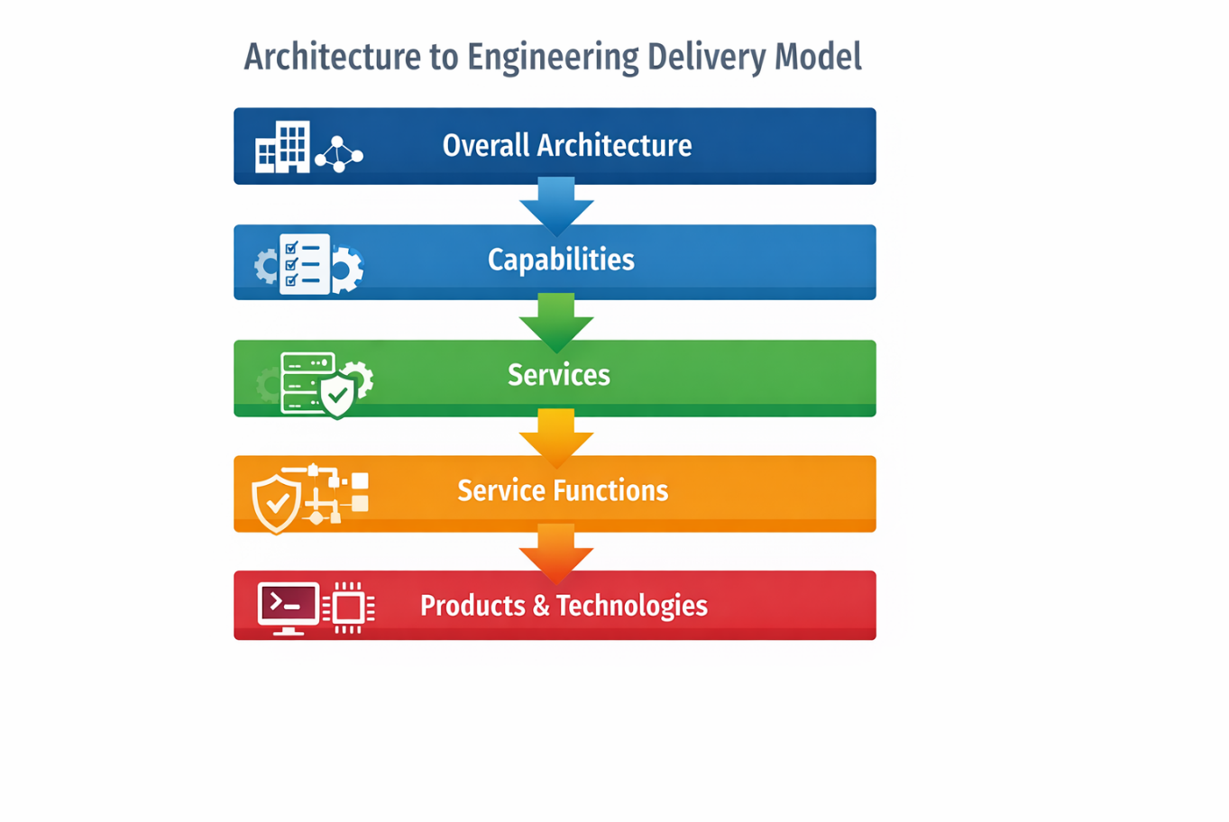
Figure 1 - Architecture to Engineering Delivery Model

Architecture Model
The architecture model follows a layered approach which gradually increases the level of technical detail.

Architecture concepts are translated into capabilities, services and finally into concrete products and technologies.

Overall Architecture
↓
Capability
↓
Service
↓
Service Functions
↓
Product / Technology

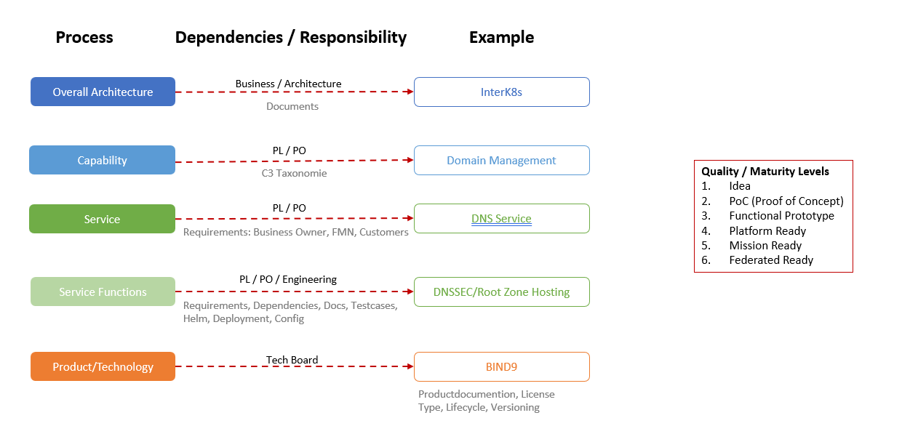
Figure 2 - Architecture Model

Architecture Layers
Layer | Description | Example | Accountability | Responsibility
Overall Architecture | Defines the overall platform architecture and strategic direction | InterK8s Platform | Architecture Board | Architecture Team
Capability | Defines platform capabilities using a taxonomy | Domain Management (C3 Taxonomy) | Product Owner / PL | Architecture + Engineering
Service | Defines services offered to users or systems | DNS Service | Product Owner | Platform Engineering
Service Functions | Defines technical functions of the service | DNSSEC, Root Zone Hosting | Engineering Lead | Engineering
Product / Technology | Defines concrete technology used for implementation | BIND9 | Technology Board | Platform Engineering
Table 1 - Architecutre Layers

Process Flow
The architecture model ensures that engineering implementation follows architectural intent.

Process flow:

Architecture Definition
↓
Capability Definition
↓
Service Definition
↓
Service Engineering
↓
Technology Implementation

This structure provides traceability between architecture decisions and engineering implementation.

Artifacts per Layer
Each architecture layer produces specific artifacts required for engineering implementation.
Layer | Artifact | Description
Capability | Capability Definition (C3 Taxonomy) | Defines capability classification and scope
Service | Service Specification | Defines requirements from Business Owner, FMN and customers
Service Functions | Technical Specification | Defines dependencies, documentation and test cases
Product | Technology Implementation | Helm charts, deployment configuration and operational setup
Table 2 - Artifacts per Layer

Engineering Deliverables
Engineering teams produce several deliverables during service implementation.

Typical engineering artifacts include:
- Requirements documentation
- Dependency documentation
- Architecture documentation
- Test cases
- Helm charts
- Deployment configuration
- CI/CD pipelines
- Monitoring configuration (if required)

Product Governance
For every technology used in the platform, governance information must be documented.
Category | Description
Product | Example: BIND9
License Type | Open Source or Commercial
Lifecycle Status | Supported / Deprecated / End-of-Life
Versioning | Major / Minor / Patch
Table 3 - Product Governance
This information ensures transparency regarding technology lifecycle and operational risks.

Quality / Maturity Model
To evaluate the readiness of platform capabilities and services, a maturity model is used.
Level | Description
Idea | Architecture concept exists
PoC | Proof of concept validating feasibility
Functional Prototype | Working prototype of core functionality
Platform Ready | Integrated with platform standards
Mission Ready | Production ready service
Federated Ready | Reusable across domains
Table 4 - Quality / Maturity
The maturity model provides a structured method to evaluate progress from architecture concept to production-ready service.

Example: DNS Service Implementation
The following example demonstrates how the architecture model works in practice.
Layer | Example | Artifacts
Capability | Domain Management | C3 taxonomy definition
Service | DNS Service | Business requirements from Business Owner, FMN and customers
Service Functions | DNSSEC, Zone Hosting | Requirements, dependencies, documentation, test cases
Product | BIND9 | Helm charts and deployment configuration
Table 5 - DNS Service Example

Accountability and Responsibility
The model distinguishes between accountability and responsibility.

Accountability refers to the role responsible for the outcome and final decisions.
Responsibility refers to the teams performing the implementation work.

Layer | Accountability | Responsibility
Capability | Product Owner | Architecture + Engineering
Service | Product Owner | Engineering Team
Service Functions | Engineering Lead | Engineers
Product | Technology Board | Platform Engineering
Table 6 - Accountability & Responsibility

Governance Model
Architecture and technology decisions are governed through dedicated governance bodies.
Governance Body | Role
Architecture Board | Defines architecture strategy and standards
Technology Board | Approves technology selection
Product Owner | Defines service requirements and priorities
Engineering Teams | Implement and operate platform services
Table 7 – Governance
This governance structure ensures alignment between architecture strategy and engineering implementation.

Agile Integration
The architecture model integrates with agile delivery processes.

Architecture Layer | Agile Equivalent
Architecture | Epic
Capability | Feature
Service | Service Backlog
Service Functions | User Stories
Product Implementation | Engineering Tasks
Table 8 - Agile Integration
This integration ensures that architecture concepts can be implemented within agile development processes.

Definition of Done per Layer
To ensure quality and consistency, each architecture layer has a definition of done.
Layer | Definition of Done
Capability | Capability defined in C3 taxonomy
Service | Service specification and business requirements documented
Service Functions | Dependencies, documentation and test cases completed
Product | Deployment configuration and lifecycle defined
Table 9 - Done per Layer

Conclusion
The Platform Architecture to Engineering Delivery Model provides a structured framework that connects architecture strategy with engineering implementation.

By defining:
- architecture layers
- responsibilities
- artifacts
- governance structures
- maturity levels

the model ensures a consistent and transparent path from architectural concept to production-ready platform services.

List of figures and tables
Figure 1 - Architecture Model 4

Table 1 - Architecutre Layers 5
Table 2 - Artifacts per Layer 5
Table 3 - Product Governance 6
Table 4 - Quality / Maturity 6
Table 5 - DNS Service Example 7
Table 6 - Accountability & Responsibility 7
Table 7 – Governance 7
Table 8 - Agile Integration 8
Table 9 - Done per Layer 8

