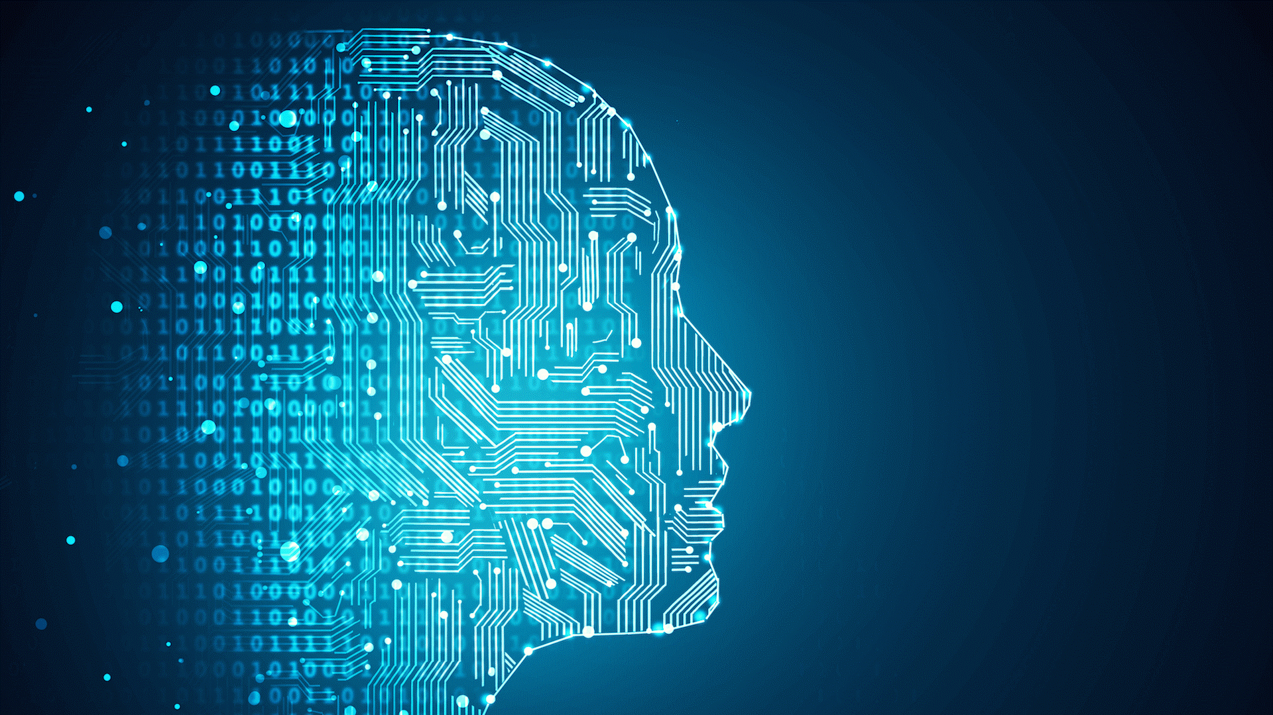

ETUDE DE MARCHE

Compilateur optimisé par Machine Learning

Date : 08/07/2021

GIACINTI Florian

MEURIN Jérémy

Table des matières

Who is interested? 3

Market definition 3

Budget 4

Study of the market trend 4

Regulation 6

Company trend 6

Environment impact 6

Qualitative study 7

Glossary 8

Source 9

# Who is interested?

For the moment, no company has clearly indicated a need that is in line with the precise objective of our project. It is currently a university research project.

Nevertheless, there are already concrete cases that are close to our project. A very recent concrete example is the distribution of “NVIDIA RTX graphics cards” which rely on AI assistance in order to manage light beams very precisely in record time.

The result is a smaller reduction in performance for the same parameters on the various games that use this technology.

# Market definition

Our project is a code optimization to increase the amount of computation possible for the same performance, so we can say that any company doing software development can be interested.

This represents more than 28 000 companies in France in the field of computer science, it is one of the most dynamic sectors. It has been constantly evolving for nearly 10 years with + 4.6% growth in 2019 according to the ACOSS.

(Source: https://syntec-numerique.fr/smacs-chiffres-cles/logiciels-services-informatiques/chiffres-secteur-logiciels-services-2)

The software development sector is also increasing its spending on research and development and is recruiting more and more researchers to improve performance. This part of the sector is growing by 10% since 2018.

We are also targeting the market of embedded system development, this sector is looking for optimization of programs while reducing power consumption, or not to increase it.

Our research program could allow us to optimize the programs in order to meet these two criteria.

# Budget

According to the report in 2018 of the Ministry of Higher Education, Research and Innovation, the research and development sector represents 7.3 billion euros, oriented in several sub-sectors such as the manufacture of electronic components, more efficient means of telecommunications.

On average, 22% of a company's budget is spent on research and development.

For example, the company OVH has produced since 2005, 343 projects of research and development and devote 1.8 billion euros of which 604 million euros of aid from various agencies to these research and development projects.

The optimization includes several sectors such as artificial intelligence, quantum computers but also cyber security. We notice since a few years a sudden increase of the interest of the companies in this sector, of the blaze of the salaries of the researchers in this field.

# Study of the market trend

In the IT sector, there are several segments and supports:

1. Support :

* Server
* Computer
* Phone
* Console
* On-board system

1. Segment :

* Games
* Database
* Embed software
* Information system
* Software

If we look in more detail at the revenue trends during the year 2020 that the segments have demonstrated in 2020 we notice that it is an upward trend, none downward, some evolve faster than others but none down.

If we now study the trend on a larger scale, between the year 2019 and 2010, we observe the same trend.

# Regulation

We will make our concept available on a classic web interface that will produce API calls to our server. There will be no storage of data about the users of the interface.

Only the entries in the interface will be saved so that we can have a history of how our models are trained.

We use AST (Abstract syntax tree) data. There is no data retention so the RGPD (General Regulation on Data Protection) does not apply to this part.

Nevertheless we are going to set up a showcase site which will allow to train the model by providing an AST and which will retain some user data which is still to be defined (name, email etc..). It will be necessary to apply the RGPD in order to be able to store the data and to be able to establish statistics and to take care of the good functioning of the training of the AI.

# Company trend

Companies tend to increase their budgets in different areas of innovation.

* Artificial intelligence
* Cybersecurity
* BlockChain
* Quantum research
* Research and development.

Source :

https://publication.enseignementsup-recherche.gouv.fr/eesr/FR/T755/la_r_d_dans_le_numerique_dans_les_entreprises/

# Environment impact

Computer components consume electricity to operate. The more work they are asked to do the more calculations they are asked to make, the more electricity they must consume quickly and for longer.

The objective of our project is to make less calculations for the same workload. We will therefore reduce the demand for electricity and therefore the impact on the environment.

Let's take two examples, a reduction of 5% of the calculations thanks to our project on a use of 10h of a PS4 type game console and an Arduino board.

A PS4 in games consumes 125 watts per hour on average.

An Arduino board consumes 2.5 watts per hour on average.

If we reduce the calculations by 5% and consider that we use the elements of the two examples for 100h continuously we get the following table.

One Watt produced thanks to nuclear energy generates 0.000023 kg Co2.

|  |  |  |  |  |  |
| --- | --- | --- | --- | --- | --- |
| Exemple | consumption before optimization | Co2 generate | Consumption After optimization | Co2 generate | Co2 saved |
| PS4 | 12500 W | 0.2875 Kg/ Co2 | 11895 W | 0.273 Kg/Co2 | 0.0145 Kg/Co2 |
| Arduino | 250 W | 0.00575 Kg/Co2 | 237.5 | 0 .0055 Kg/Co2 | 0.002 Kg/Co2 |

A reduction in greenhouse gas emissions is possible thanks to our project.

# Qualitative study

To check the quality of our model, we will perform unit tests. We have a goal to verify more than 50% of our code with these tests. This is the code coverage, the higher it is the more it suggests that the code contains undetected bugs.

# Glossary

**IT :** Computer science is a field of scientific, technical and industrial activity concerning the automatic processing of digital information through the execution of computer programs by machines: embedded systems, computers, robots, automata, etc.

# Source

Environment impact:

* <https://forums.futura-sciences.com/electronique/850472-consommation-arduino.html>
* <https://www.monpetitforfait.com/energie/aides/consommation-console-jeux>
* https://www.energuide.be/fr/questions-reponses/quelle-quantite-de-co2-mon-logement-emet-il/68/