WEB@CADEMIE’S INTRANET

Documentation

For web and web mobile developer exam

By Gregory Koenig

TABLE OF CONTENTS

1. Specifications
   1. Project set presentation
      1. Intranet presentation
      2. Objectives of the website
      3. Target market of the website
      4. Quantitative objectives
      5. Perimeter of the project
      6. Description of the actual website
   2. Graphic and ergonomic description
      1. Graphics standards
      2. Design
      3. Models
   3. Functional and technical description
      1. Tree diagram of the website
      2. Functional description
      3. Information relating to contents
      4. Technical requirements
   4. Organization
      1. Expected services provided
      2. Schedule
      3. Monitoring methods
2. Technical design document
3. User guide
4. Appendix
   1. Graphics standards
   2. Mockup
      1. Connection
      2. Dashboard
      3. Profile
      4. Tutorials
         1. Chapters
         2. Videos
         3. Exercises
   3. Clustering
   4. Database
   5. Gantt chart
5. Specifications
   1. Project set presentation
      1. Intranet presentation

Web@cademie is a private, non-profit and tuition-free [computer programming](https://en.wikipedia.org/wiki/Computer_programming) school created and funded by French [IONIS Education Group](https://en.wikipedia.org/wiki/IONIS_Education_Group) with several partners including [Epitech and](https://en.wikipedia.org/wiki/Epitech) Zup de Co association. The school was first opened in Paris in 2010. Headquartered in Le Kremlin-Bicêtre, Paris, the school has branches in [Lyon](https://en.wikipedia.org/wiki/Lyon) and [Strasbourg](https://en.wikipedia.org/wiki/Strasbourg).

The lead role of the intranet is to permit students to have the follow-up of their school. They also will be able to interact with the teaching staff.

* + 1. Objectives of the website

The website is an intranet for Web@cademie. It must implement functionalities like schedule, grades, tutorials, news, etc.

* + 1. Target market of the website

The website is exclusively addressed to the Web@cademie students and their teachers.

* + 1. Quantitative objectives

The website will be daily attended by several hundred students and dozens of teachers and administrative personnel.

* + 1. Perimeter of the project

The website will be available in French and English translations. The structure will be the same for both languages.

The design will be responsive for mobiles.

* + 1. Description of the actual website

Web@cademie uses for the present the intranet of Epitech. It has not his own one. This project will be the first version made from scratch. The actual intranet is neither ergonomic nor responsive.

Later, it will be hosted by the Epitech servers.

Web@cademie provides their own logos.

For now, only myself is allocated to this project. Later, a team will be built, and I will be the project manager.

* 1. Graphic and ergonomic description
     1. Graphics standards

*Cf. Graphics standards in Appendix at page .*

This has been conceived with Adobe XD.

* + 1. Design

The design of the website will be uncluttered, simple and modern. It will be incorporate with flat design and inspired from a template which can be found on <https://freebiesupply.com/adobe-xd-templates/adobe-xd-ui-kit-components/>.

The colors respect those from Web@cademie and their logos.

* + 1. Models

*Cf. Mockup in Appendix at page .*

This has been conceived with Adobe XD.

* 1. Functional and technical description
     1. Tree diagram of the website

*Cf. Clustering in Appendix at page .*

This has been conceived thanks to <https://www.draw.io/>.

* + 1. Functional description

The website must have a secure connection system for students. There is no registration system because only administration is authorized to create accounts. The access to the website is only allowed to Epitech emails.

There should be an administration system for managing the back office and the content of the different sections. It will be automatically generated by the Sonata bundle.

* + 1. Information relating to contents

For the moment, only tutorials section must be developed. It will contain chapters, videos and exercises subsections.

* + 1. Technical requirements

For now, the site will be hosting on GitHub.

For the front end, HTML5 and CSS3 with Bulma will be used. For the back end, it will be PHP 7.2.9 and the Symfony framework, version 3.4.

The website must be compatible with Internet Explorer, Mozilla Firefox, Google Chrome, Opera and Safari.

* 1. Organization
     1. Expected services provided
* Development
* Design
* Database (*cf. Database in Appendix at page* , conceived thanks to <https://www.draw.io/>)
* Maintenance and update
  + 1. Schedule

*Cf. Gantt chart in Appendix at page .*

This has been conceived thanks to <https://www.officetimeline.com/fr>.

The project starts the twenty-fourth of September 2018. The final delivery must be the seventh of October 2018.

The oral defense will be scheduled for the eighteenth of October 2018.

* + 1. Monitoring methods

Agile software development will be used for this project. A project monitoring will be made at the end of each sprint.

1. Technical design document

Installer composer

Création repo GitHub Perso_Project_Webacademie_Intranet

$ git clone git@github.com:gregory-koenig/Perso_project_Webacademie_Intranet.git

<https://symfony.com/doc/3.4/setup.html>

Après avoir essayé d’installer Sonata, perte de temps plein de bugs du coup redéammrer projet de zéro avec easyadmin et fosuser

<https://symfony.com/doc/master/bundles/EasyAdminBundle/index.html>

<https://symfony.com/doc/current/bundles/FOSUserBundle/index.html>

Ajout dans fosuser de firstname, lastname, address

Interdiction aux pages si non connectés et redirection sur login, si ok redirection sur dashboard

Modif + front de la page login de FOSUser

Création entités

Ajout entités dans easyadmin

Jointure entités

Remplissage entités via easyadmin

CSS layout + jQuery

Création page profil

Responsive avec Bulma + Jquery

1. User guide
2. Appendix
   1. Graphics standards

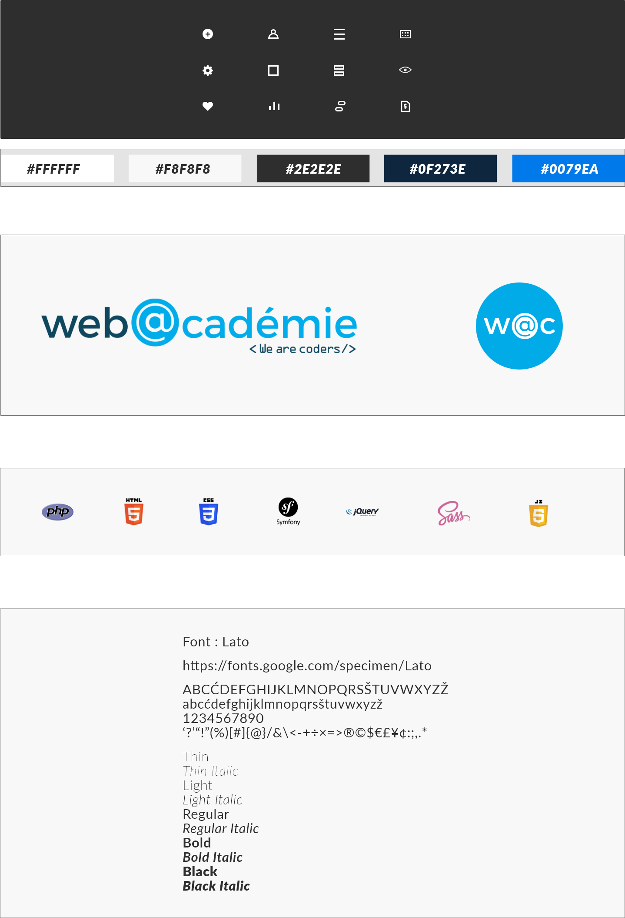

* 1. Mockup
     1. Connection

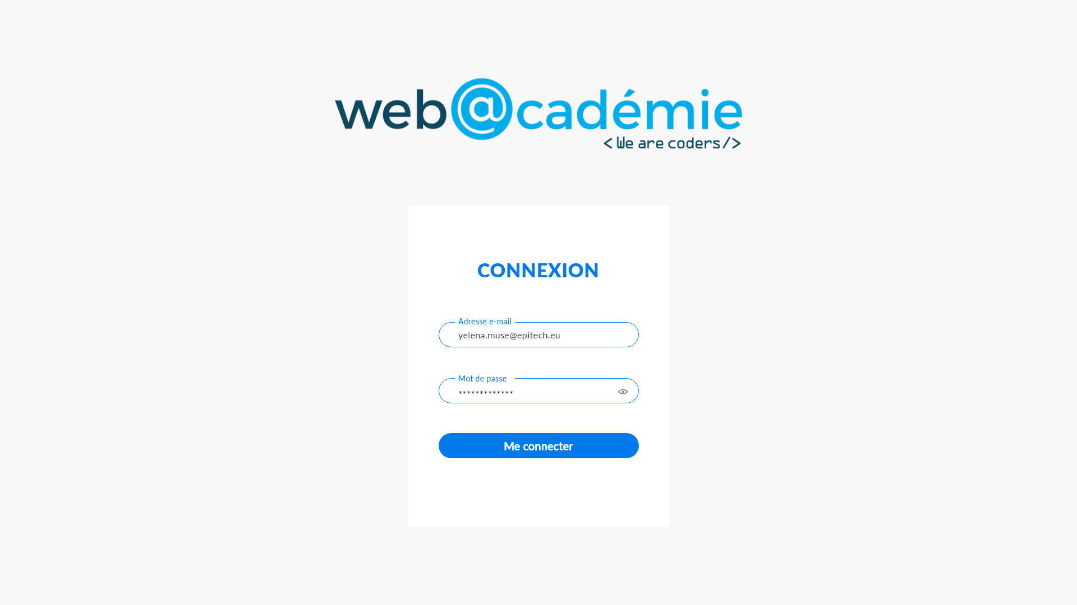

* + 1. Dashboard

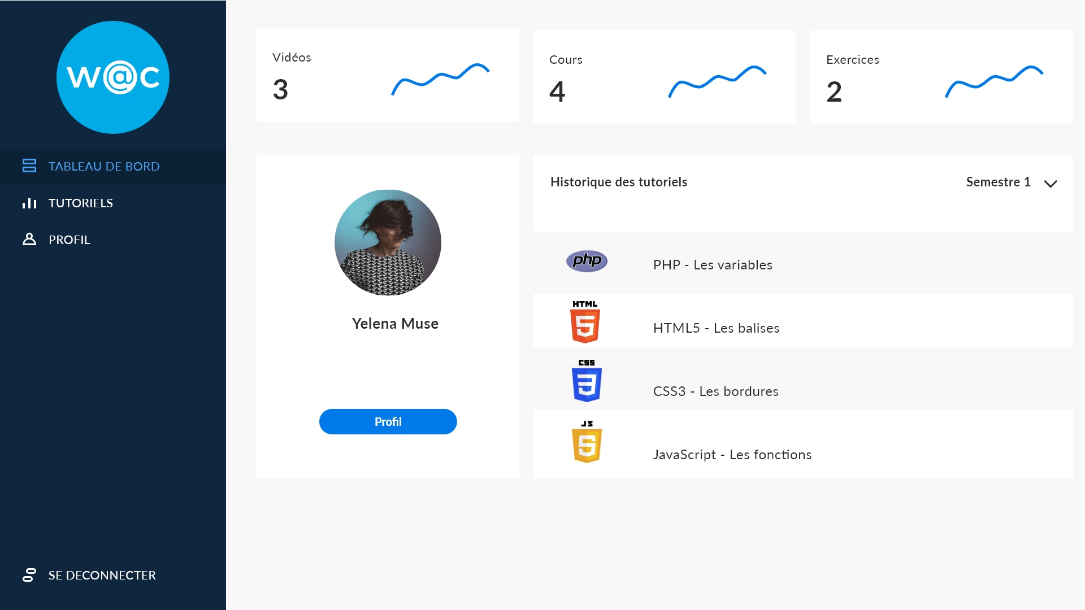

* + 1. Profile

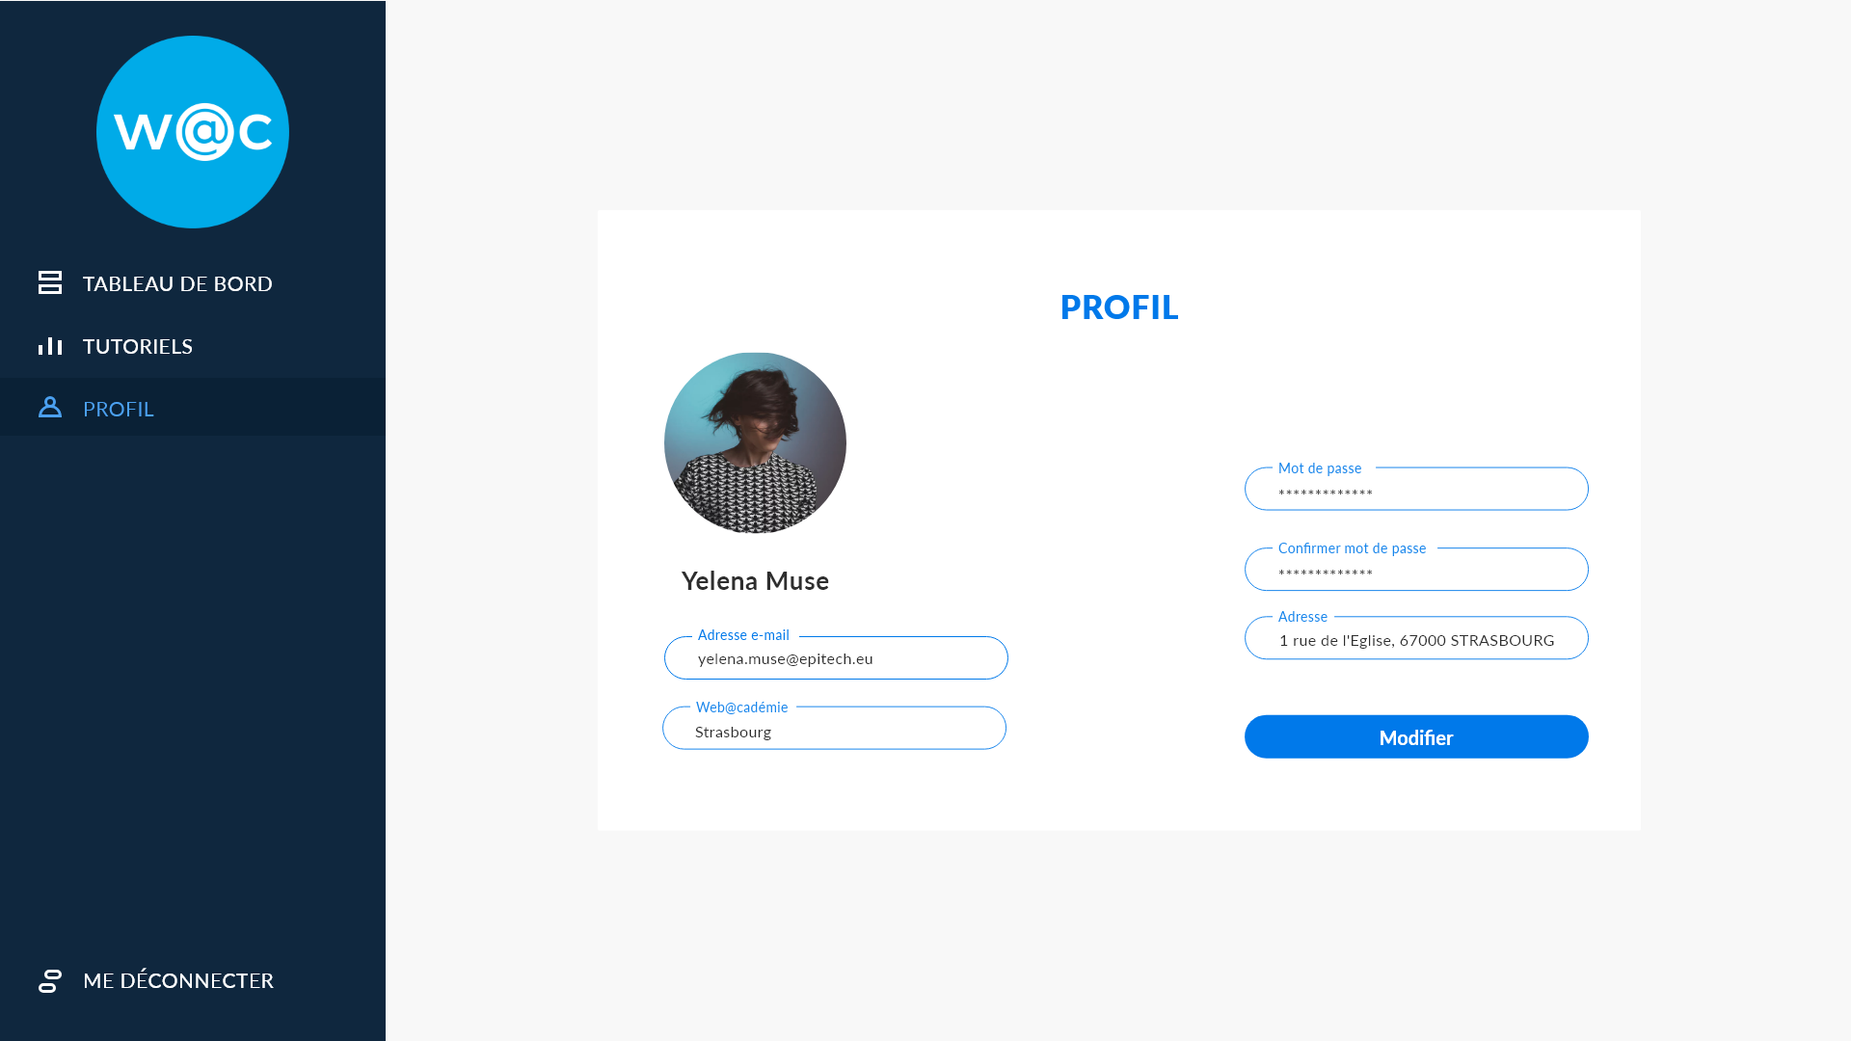

* + 1. Tutorials

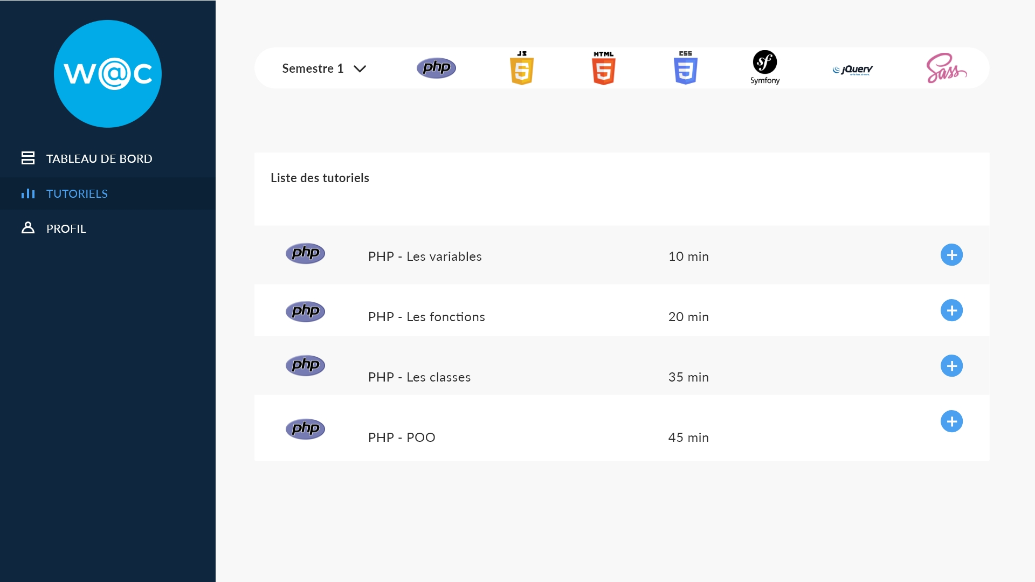

* + - 1. Chapters

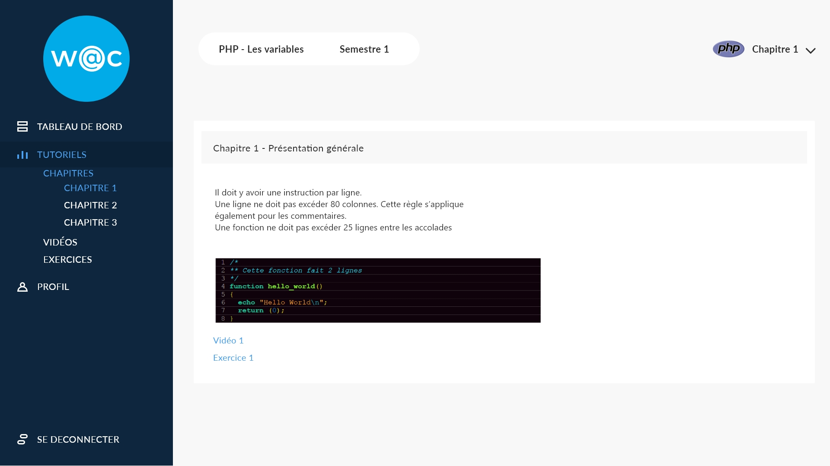

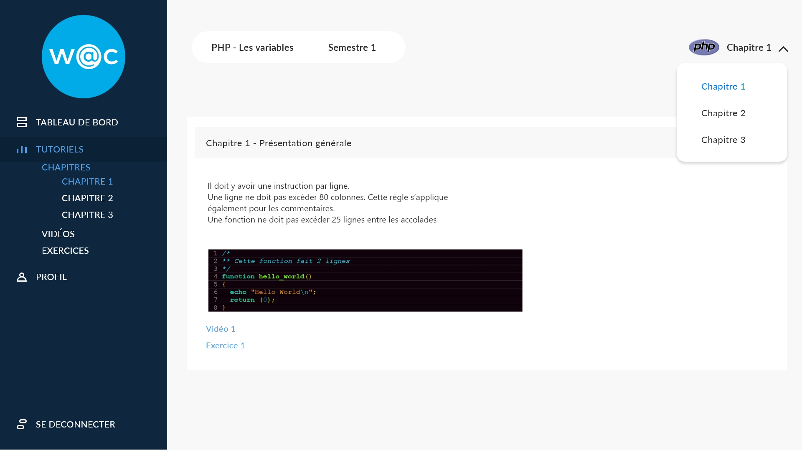

* + - 1. Videos

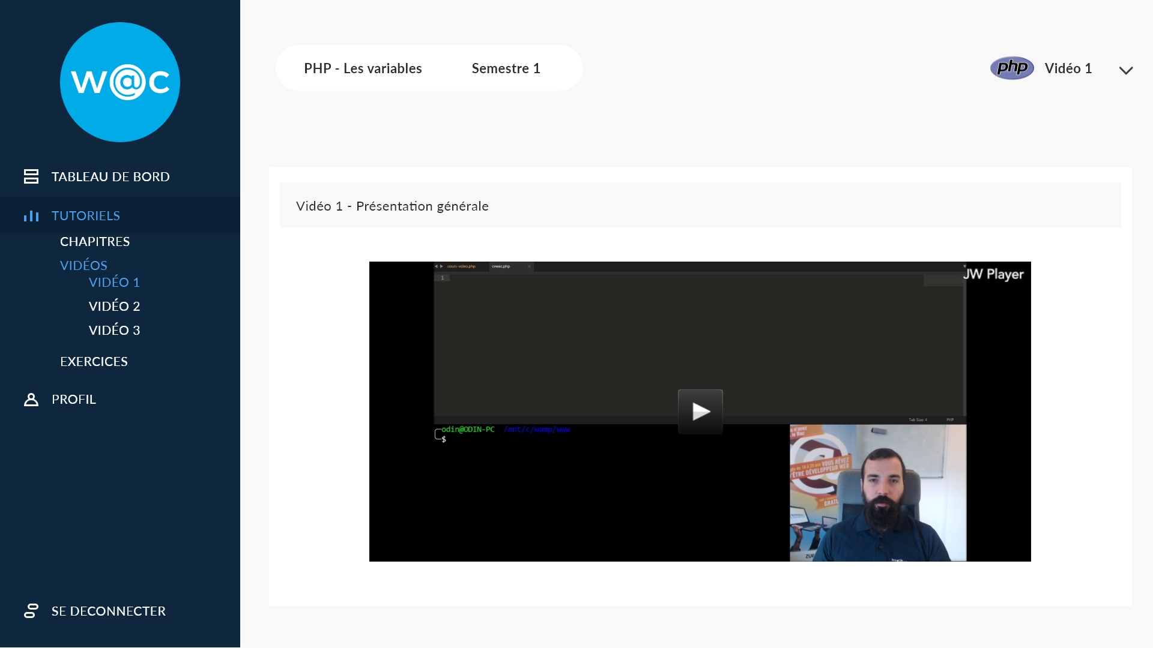

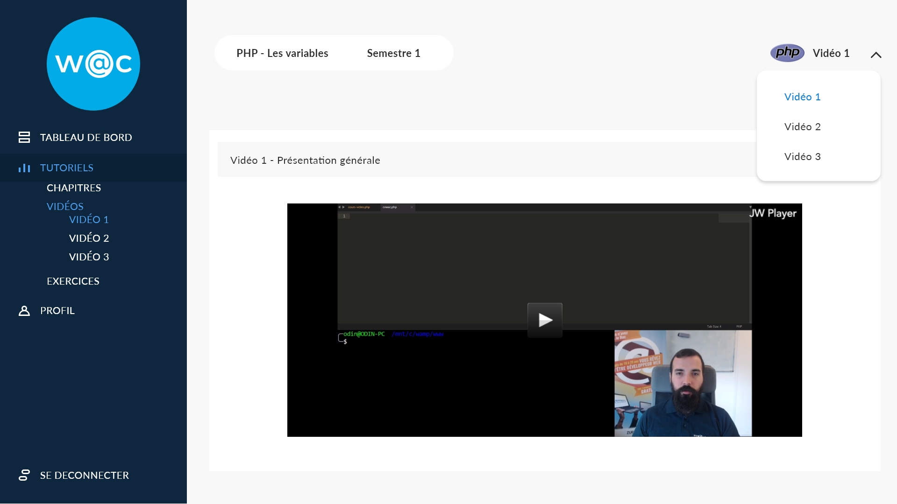

* + - 1. Exercises

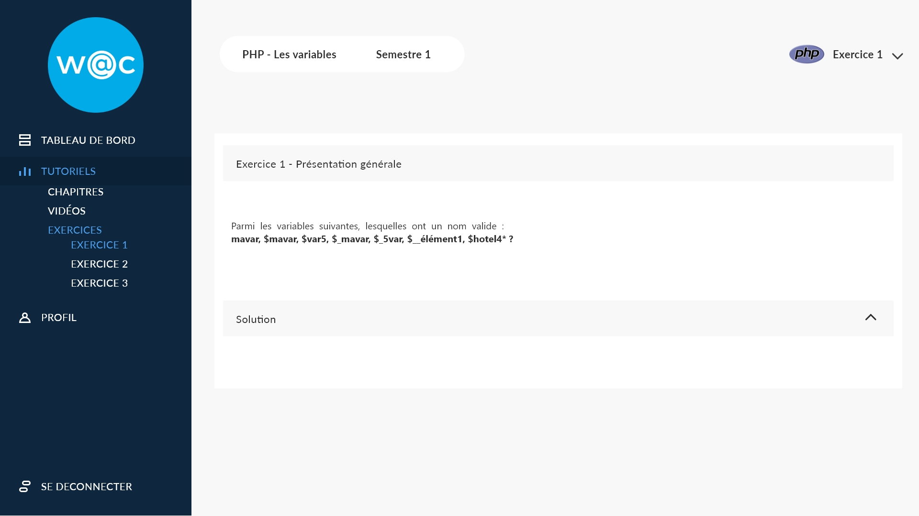

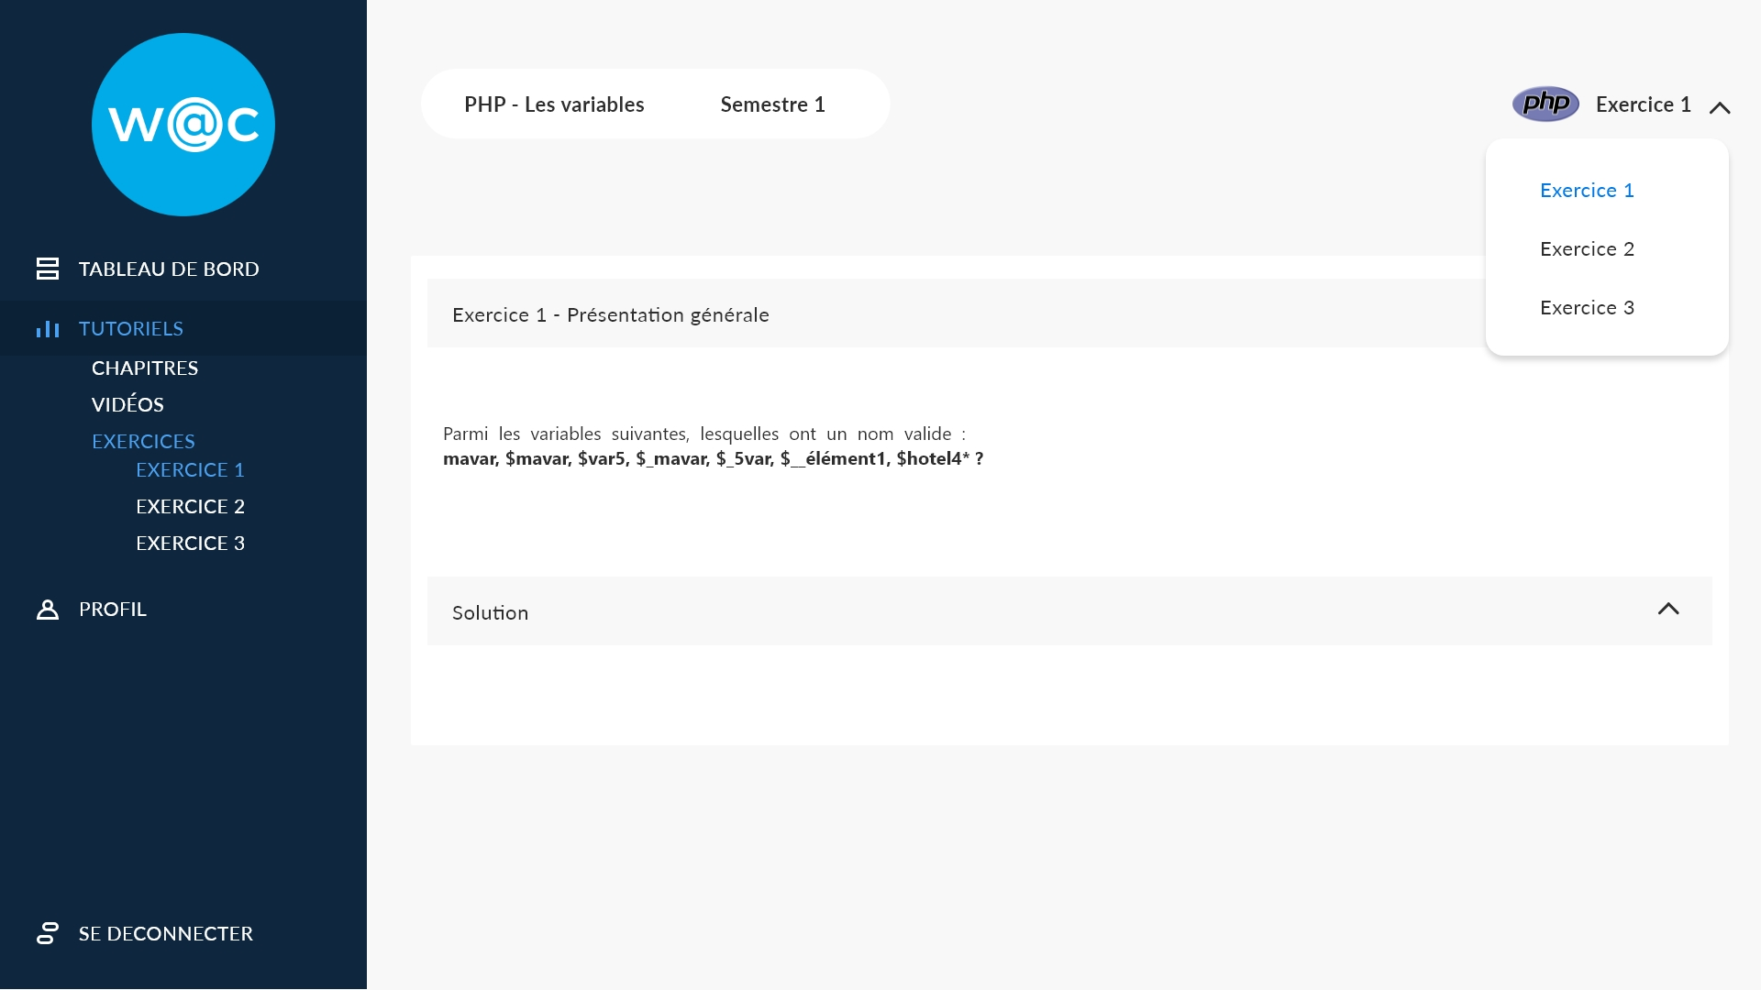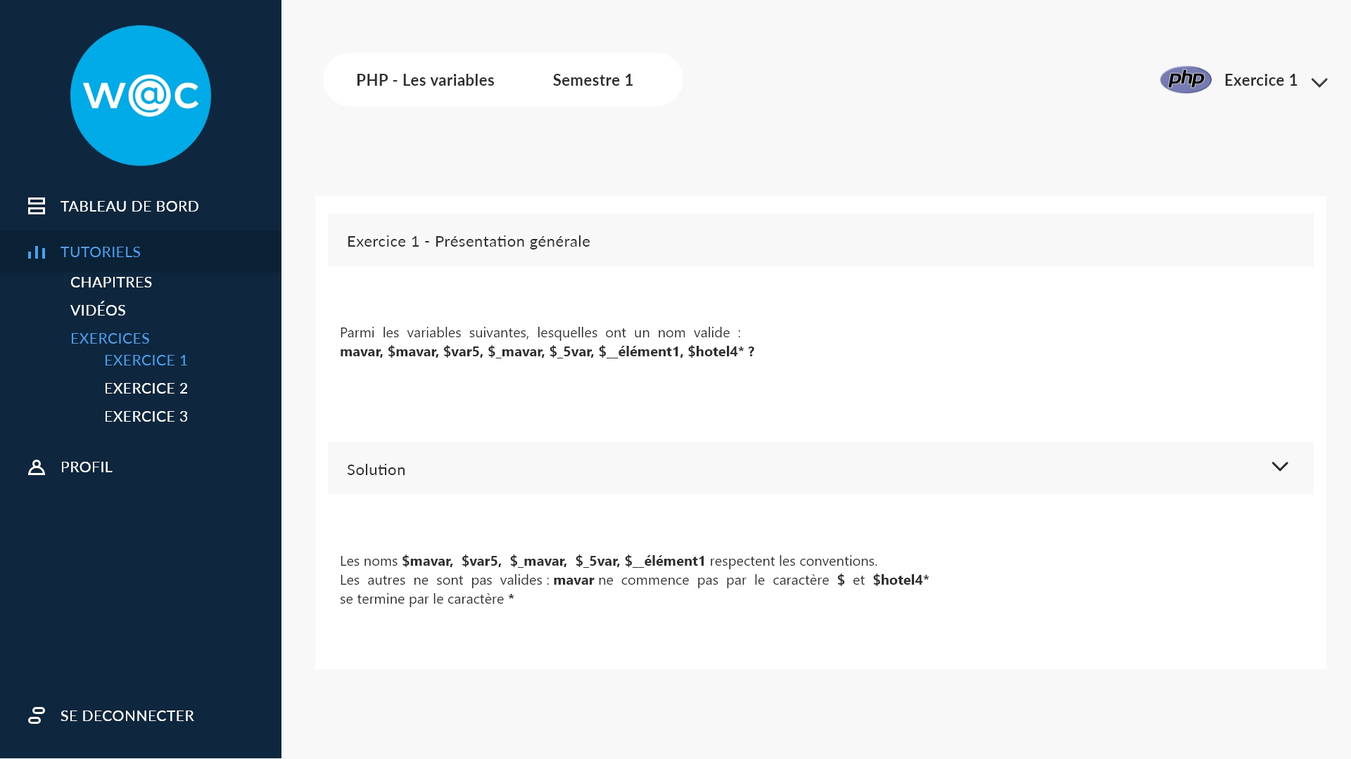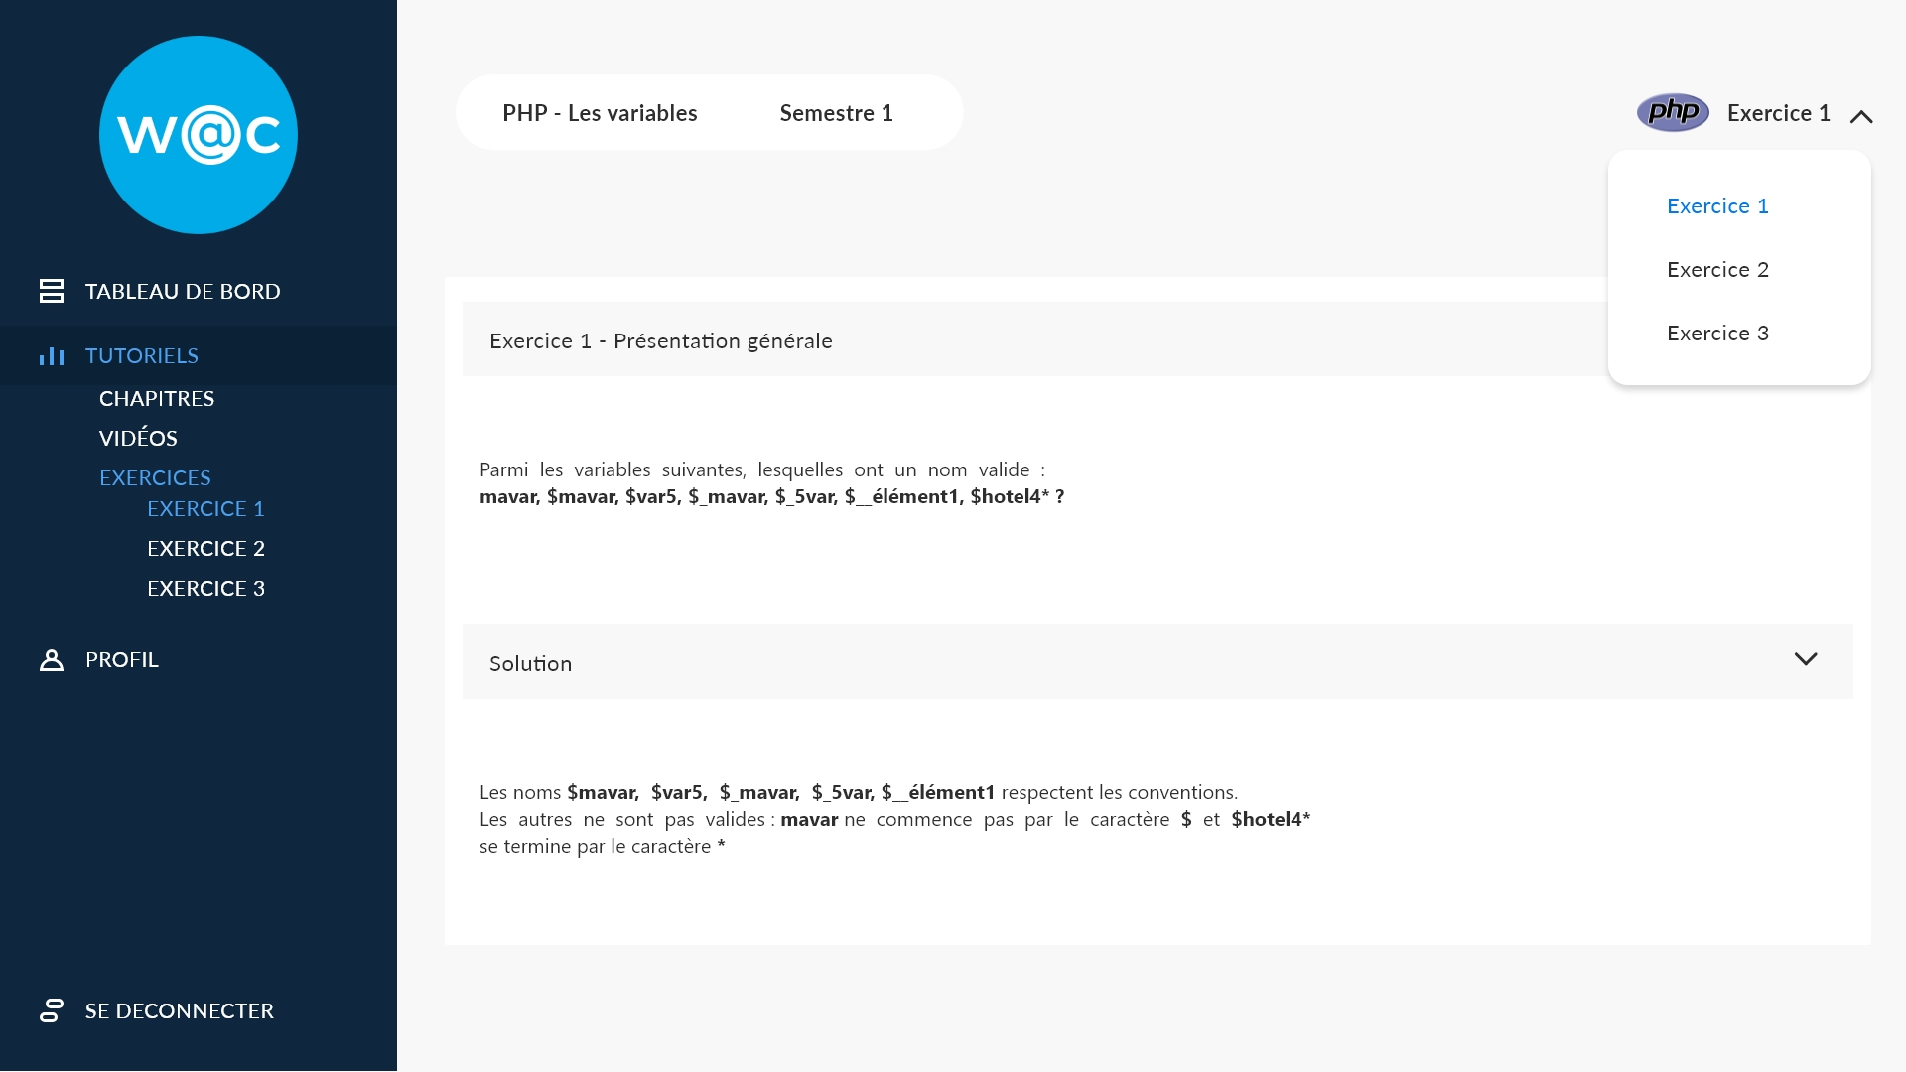

* 1. Clustering

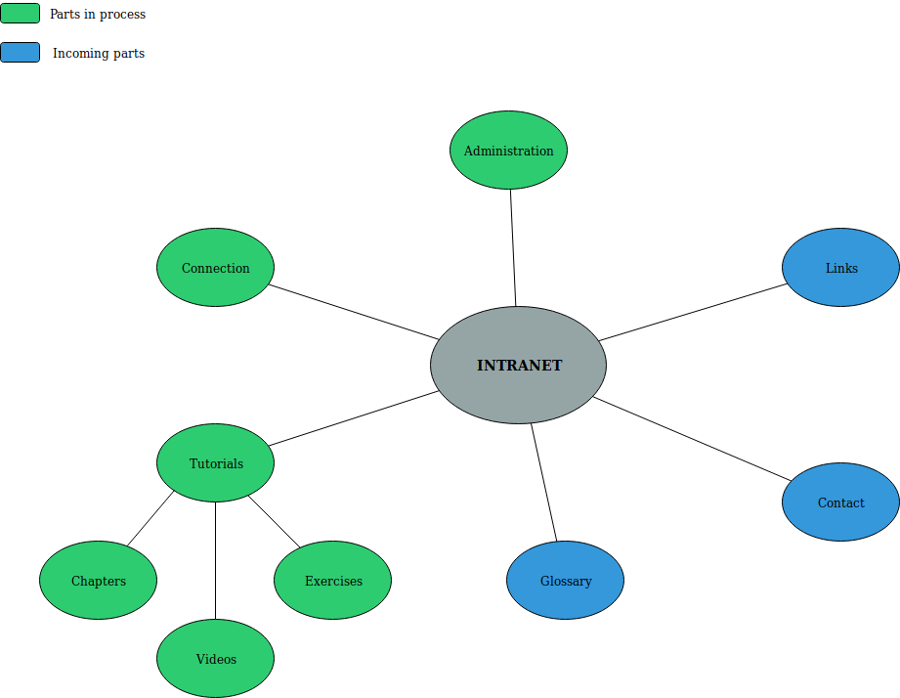

* 1. Database

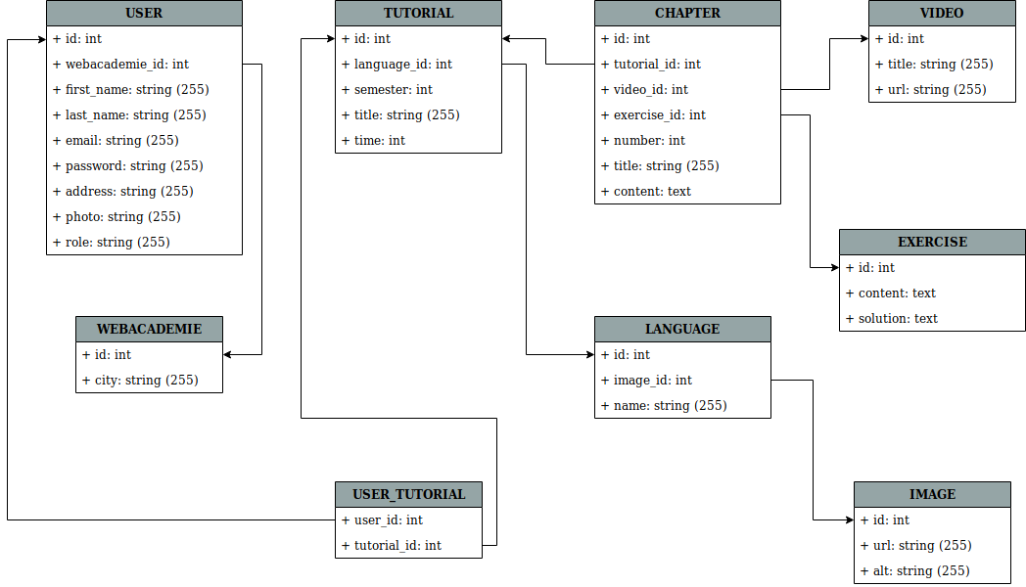

* 1. Gantt chart

