Covid-19 recession & cryptocurrencies

What the 2020 stock market crash has revealed about cryptocurrencies.

Cryptocurrencies are not safe havens.

Well, not all of them. And it is the Covid-19's crisis that has confirmed it.

First of all, let’s define what a safe haven is.

A safe haven is an investment that aims to remain stable in the face of market volatility. They are investments that allow investors to limit their exposure to the risk of loss in the event of a market collapse. This is why an investor must do advanced research in order to consider an investment as a “safe haven”.

The safe haven is therefore a means of fighting against volatility. Thus, this investment must not be correlated to the general market (or negatively correlated, ideally). It should be noted that the stability of safe havens also changes according to periods. A safe haven does not guarantee the absence of loss.

So why aren’t cryptocurrencies a safe haven?

Because, according to the very definition of a safe haven, most cryptocurrencies are positively correlated to the global market. And it is the Covid-19 crisis that has proved it to us.

You don’t need a PhD in mathematics to see a striking correlation between the Dow, the S&P and the Bitcoin.

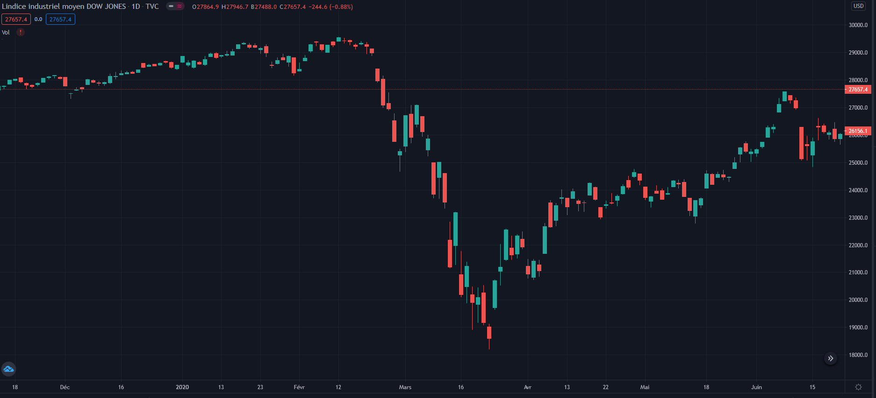

Dow’s crash

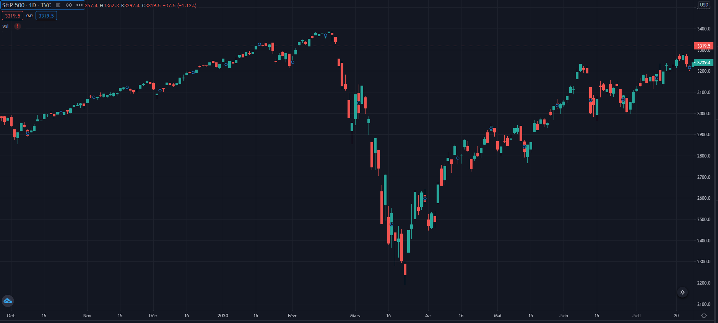

S&P’s crash

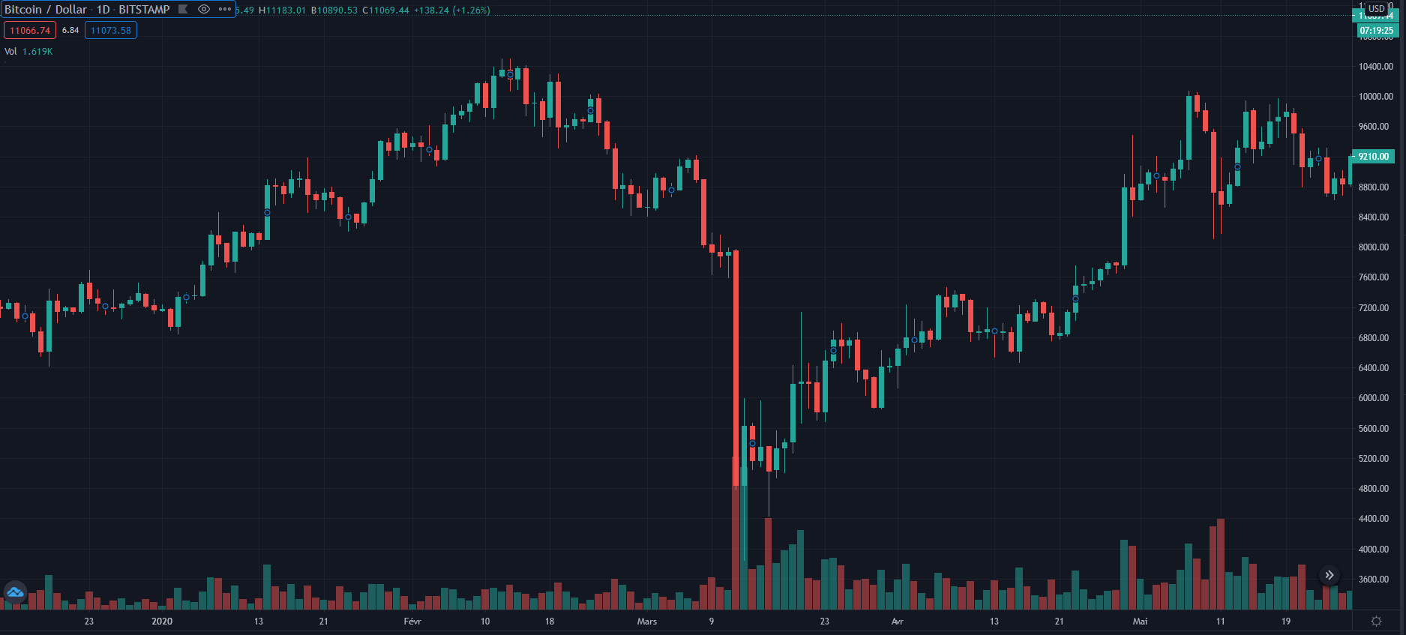

BTC’s crash

The correlation is so visible to the naked eye that it is almost useless to make calculations. And as you know, most cryptocurrencies follow Bitcoin’s trends almost identically.

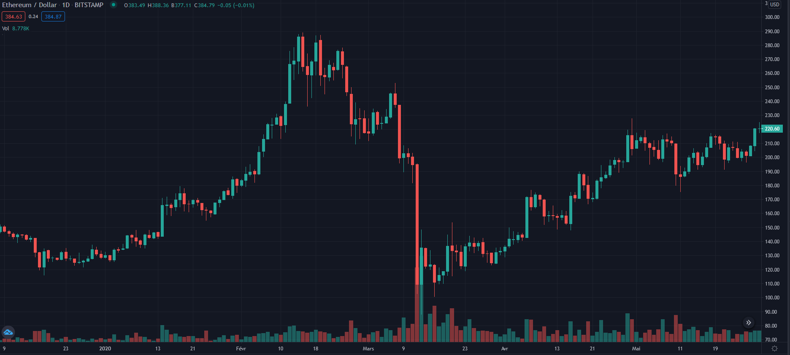 ETH’s crash

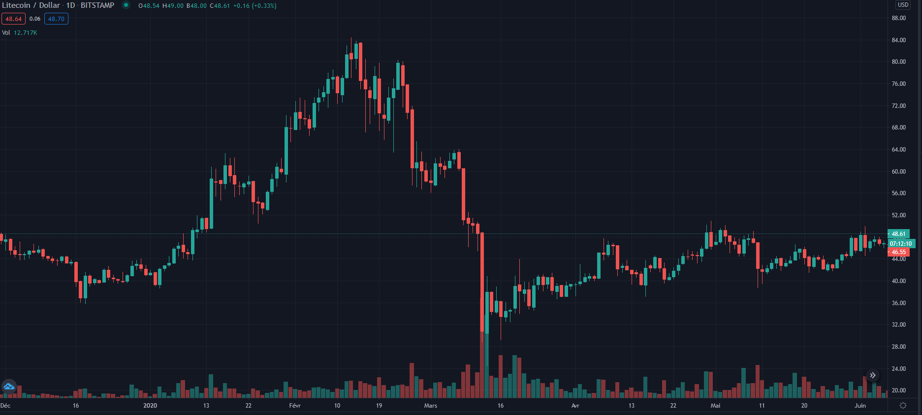 LTC’s crash

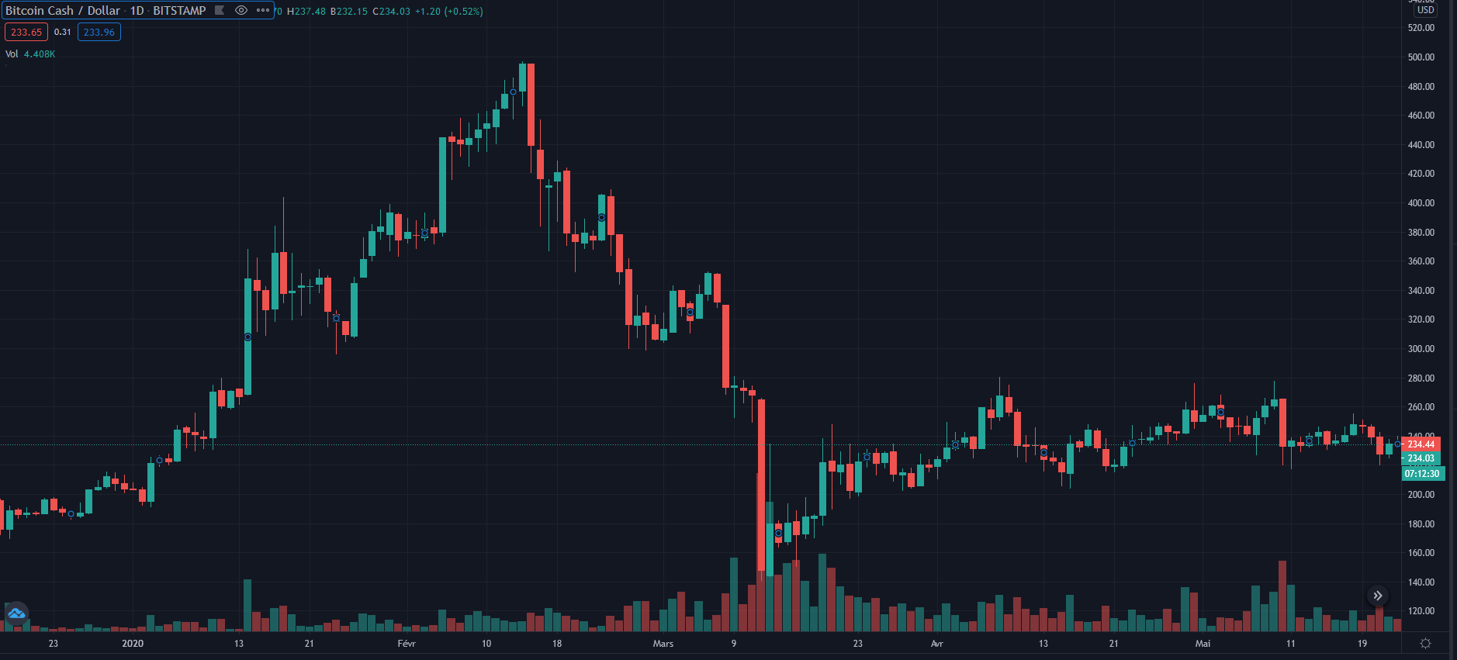 BCH’s crash

I said “most”. Indeed, there are so-called stable coins, which could look like safe havens.

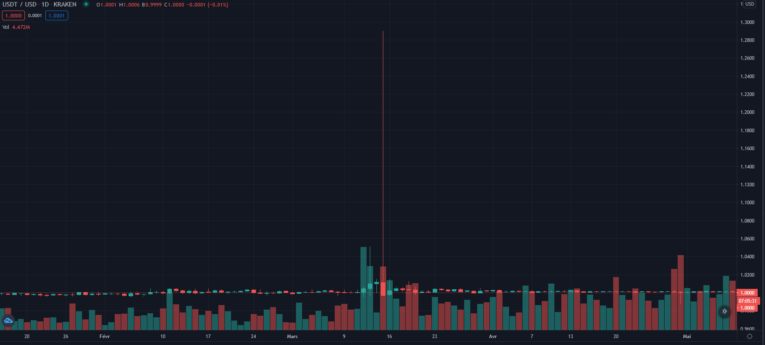 USDT

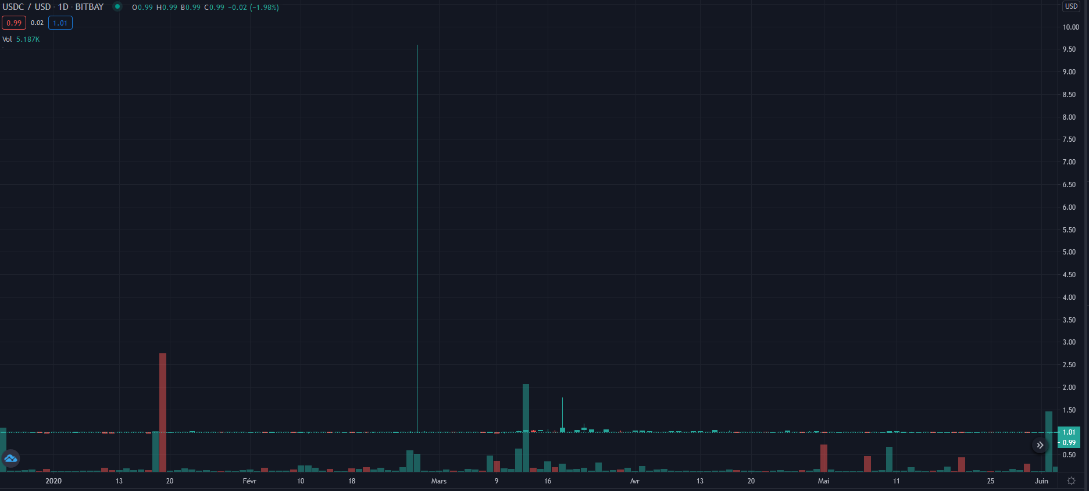 USDC

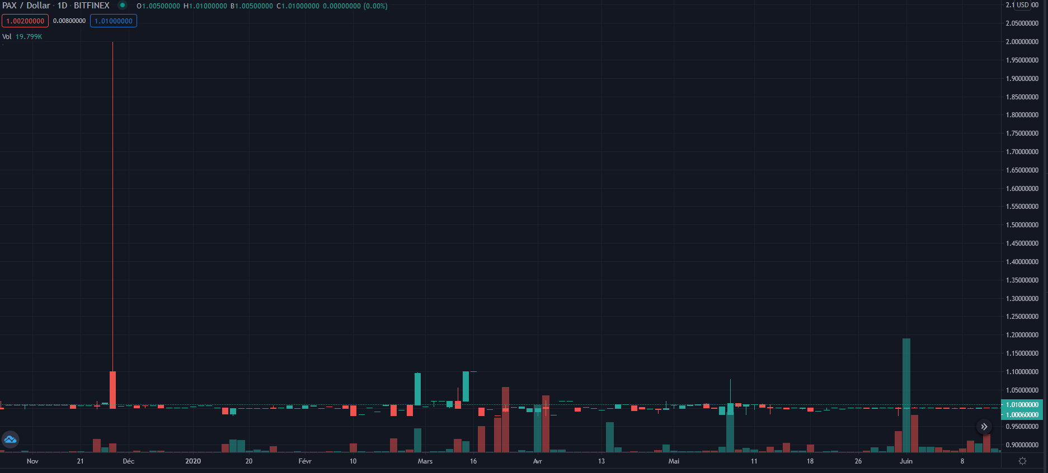

PAX

Stable coins remain stable overall, although fluctuations are noticeable. (I’m only talking about the crisis period).

The step back

If you are an investor and this article surprises you, ask yourself the right questions. Indeed, cryptocurrencies were never intended to be safe havens.

Why?

If we refer to Satoshi Nakamoto’s primary objective, Bitcoin was supposed to provide a decentralized means of exchange, which does not depend on banks or central financial institutions. In the meantime, cryptocurrencies have come a long way:

Satoshi Nakamoto is said to have launched the project, with the aim of decentralizing finance.

Then the anarchists took over and made Bitcoin the currency of reference for the Darknet.

Then the libertarians, who wanted to emancipate themselves from the central institutions in order to give power back to the people.

Then the speculators, who saw in cryptos a way to artificially inflate the rate of currencies with the help of buzz on the internet (legitimate or not, by the way).

Finally, it was the institutions that took up the subject, asking themselves the question: how to regulate all this mess?

Each time a new player takes over, the market loses value.

Why?

Because there is always the hype effect: an actor starts using the technology, then realizes that it doesn’t correspond exactly to his needs, or his needs change, or he discovers drawbacks that make him reluctant to the use of the service. Thus, as hype declines, there are fewer users, and therefore less and less value. Then another actor takes over, and it starts all over again.

We can also add that cryptocurrencies cannot be considered as a safe haven for the following reasons:

Cryptocurrencies lack seniority.

Most of the safe havens have seniority (cash, metals, food). This seniority gives them more trust. However, it is very unlikely that an investor would invest in a safe haven in which he does not have confidence.

Most cryptocurrencies offer a high return on investment.

The return on investment is proportional to the risk, everyone knows this (not only investors). This means that cryptocurrencies present a lot of risk, but as said before, the safe haven’s investment goal is not to make a lot of money, but it’s to protect yourself from market’s instability.

Cryptocurrencies are very volatile.

The basic principle of safe havens is that they must be stable, especially in moving times. However, cryptocurrencies are unstable even in “quiet” periods. Therefore, except for some cryptocurrencies like stable coins, most cryptocurrencies are so volatile that one could consider this investment totally opposite to that of safe havens.