We want a more accurate model to minimize the false positive.

The impact on having higher values of false positive could be dangerous for the company.

Let’s assume that the company make decisions based on the transactions predicted from the model (true positives + false positives):

1. It increases the stock of its products in order to prevent out-of-stock situation that would lead to a customer dissatisfaction;
2. It invests in more performant website in order to avoid crash or session slowness due to more traffic prediction;
3. Let’s think about the voucher approach again !!!!

The decisions could lead to a costs increase that will not be justified by the prediction. Minimizing the false positives reduces the risk of investments that would have a longer full recovery.

**Minimizing the false positives**

The GridSearch results are:

{'n_estimators': 250}

0.9118422167709991

Random Forest with 250 trees.

|  |  |
| --- | --- |
| PageValue | 0.372773 |
| ExitRate | 0.086930 |
| ProductRelated_Duration | 0.083587 |
| Administrative | 0.082638 |
| ProductRelated | 0.077507 |
| Administrative_Duration | 0.066712 |
| BounceRate | 0.062556 |
| Month_Nov | 0.032657 |
| Informational | 0.027552 |
| Informational_Duration | 0.022183 |
| Month_May | 0.015238 |
| Weekend | 0.010876 |
| Month_Mar | 0.010414 |
| VisitorType_Returning_Visitor | 0.008499 |
| VisitorType_New_Visitor | 0.007804 |
| Month_Dec | 0.006607 |
| SpecialDay | 0.005988 |
| Month_Sep | 0.005115 |
| Month_Oct | 0.004528 |
| Month_Jul | 0.003846 |
| Month_Aug | 0.003643 |
| Month_June | 0.001810 |
| Month_Feb | 0.000539 |

Confusion matrix using all the features available:

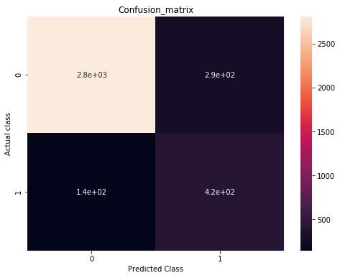

|  |  |
| --- | --- |
| TP: | 425 |
| TN: | 2811 |
| FP: | 294 |
| FN: | 144 |

|  |  |  |  |  |  |  |  |
| --- | --- | --- | --- | --- | --- | --- | --- |
|  | **1 feature** | **2 features** | **3 features** | **4 features** | **5 features** | **6 features** | **7 features** |
| TP: 425 | 345 | 413 | 416 | 395 | 407 | 420 | 419 |
| TN: 2811 | 2854 | 2595 | 2668 | 2729 | 2786 | 2772 | 2794 |
| FP: 294 | 251 | 510 | 437 | 376 | 319 | 333 | 311 |
| FN: 144 | 224 | 156 | 153 | 174 | 162 | 149 | 150 |
|  |  |  |  |  |  |  |  |
| **25,31%** | **39,37%** | **27,42%** | **26,89%** | **30,58%** | **28,47%** | **26,19%** | **26,36%** |

6. Optimizing the usability of the pages with higher values.

This means to analyze more deeply the behaviour of users while visiting that page.

Analysis of sales funnel in order to identify where there is the major loose of users

So for instance: monitoring time on the page, number of page visited per session

Utilize tools of Web Analytics to identify the less valuable elements of the page (such as external links)

That is the best model we can construct with the data available

**PCA Analysis**

[0.15144629 0.10313576]

**0.2545820479700662**

**The amount of variance explained by the first component is 15%; that one explained by the second component is 10%.**

**In total the two first principal components is able to capture only 25.5% of variance of data -> we cannot rely to the representation. There is not a pattern to be identified.**

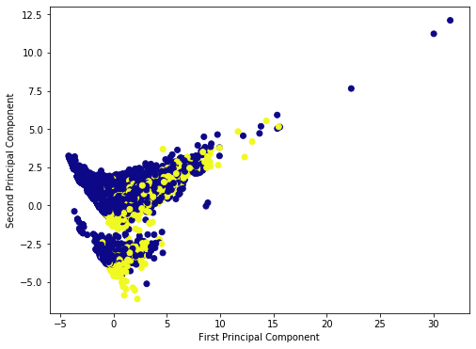

**From the plot we are not able to identify the two different classes so we can consider the PCA failed.**

**We can run the k-means with 2 clusters because we know that we have two groups for variable Y: either the transaction happens or it doesn’t.**

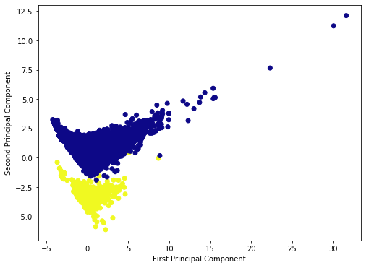

**WE cannot rely on the above visualization because the PCA explains again only 25.5%of data variance.**

**Which is the meaning of elbow plot with these data?? We already know the number of clusters.**

**Elbow Plot:**

|  |  |  |  |
| --- | --- | --- | --- |
| Cluster |  | Delta % cluster |  |
| **1** | **281635,00** |  |  |
| **2** | **255538,87** | -10,21% |  |
| **3** | **232151,19** | -10,07% | -0,14% |
| **4** | **213770,49** | -8,60% | -1,48% |
| **5** | **199773,79** | -7,01% | -1,59% |
| **6** | **189549,00** | -5,39% | -1,61% |
| **7** | **181940,41** | -4,18% | -1,21% |
| **8** | **167720,78** | -8,48% | 4,30% |
| **9** | **159424,41** | -5,20% | -3,27% |
| **10** | **146396,53** | -8,90% | 3,70% |

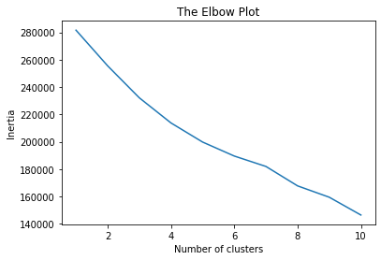

**K-Means Plot with k= 6:**

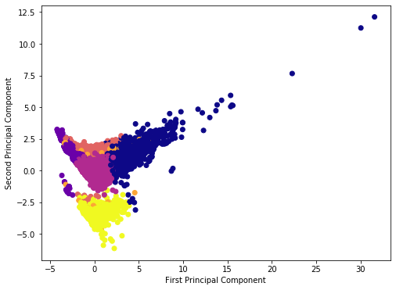

**We know that for this dataset we have only 2 clusters and this is the correct number.**