Project 2 – CRUD

Project Budgeting App

**User Story**

|  |  |  |
| --- | --- | --- |
| MVP | | |
| **As a…** | **I want < >** | **Reason** |
| User | To have an authentication interface | Security (Auth) |
| User | To have a form requesting for my registration details | Registration |
| User | To assign a budget to a main category | Financial planning |
| User | To see a dashboard with all categories | Financial Planning |
| User | To add/delete/edit transactions | Financial Planning |
| User | To add/edit/delete the main categories | Categories for detailed management |
| User | To edit the budgets assigned to the categories (Update) | Financial Planning |
| Ice Box | | |
| As a… | I want < > | Reason |
| User | To click on the individual categories and obtain data visualizations | Data Analysis |
| User | To link up with my partner to have a joint account with shared categories | Financial Planning |
| User | To be able to sign in on Google/Facebook | Security (OAuth) |
| User | To view profile information | Information |
| User | To log out | Exit |
| Completed | | |
| As a… | I want < > | Reason |
|  |  |  |
|  |  |  |

Data Models (Entity Relationship Diagram):

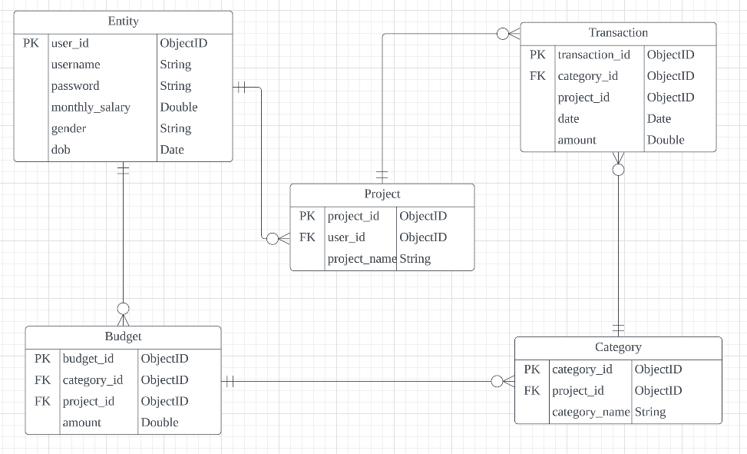

Add Transactions - URL: GET /addtransactions POST (Create)

Add Transactions

Submit

* Project:
* Category:
* Date:
* Amount:

Add Category - URL: GET /category/add POST (Create)

Add Category

* Category:

Submit

Edit Category - URL: GET /category/:id/edit POST (Update)

Edit Category

* Category:

Submit

Edit Transactions - URL: GET /transactions/:id/edit POST (Update)

Edit Transactions

* Project:
* Category:
* Date:
* Amount:

Submit

Transactions - URL: GET /transactions & POST (Delete)

Transactions

Category | Date | Amount | …

XXX | XXX | XXX

Running log of transactions…

Delete

Edit

Category Page- URL: GET /category POST (Delete)

Category

Add

Delete

Edit

* Kitchen
* Living Room
* Dining Area

Delete

Edit

Delete

Edit

Dashboard – GET URL: /dashboard

Budget-Board

Profile (Icebox)

Add/Amend/Del Categories

Transactions

Add Transactions

BUDGET SPENT DELTA

Total $XXXX $XXXX $XXXX

Kitchen $XXXX $XXXX $XXXX

Living Room $XXXX $XXXX $XXXX

…

Login Page – GET/POST URL: /login

Login to Budget-vation!

Username:

Password:

Login

Registration Page – GET/POST URL: /register

Sign-up for Budget-vation!

Username:

Password:

Confirm Password:

Gender:

DOB

Budget

Register

Home – GET URL: /

Tech Stack

Description of project and impetus

Login

Register

Budget-vation