This document shows how to set YARN Fair Scheduler and Impala Resource Pools in a Cloudera Director conf file, so the appropriate YARN and Impala resource pools will be automatically created as part of the cluster installation process.

For this example, assume YARN and Impala Resource Pools are configured like this using CM’s Dynamic Resource Pools dialog:

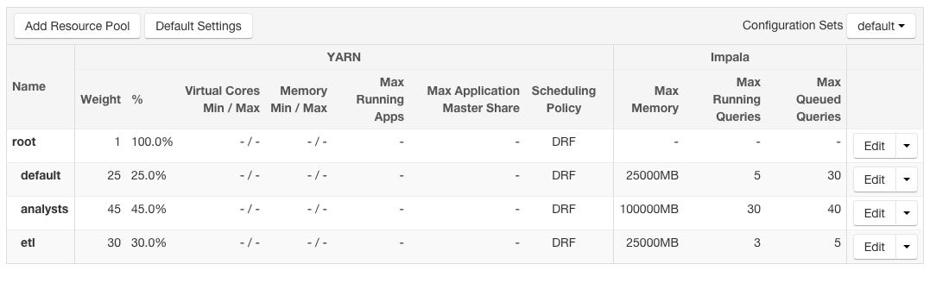

Note there are three pools: default, analysts and etl, each of which has different weights and different Impala max memory, max running and max queued queries.

Assume placement rules are:

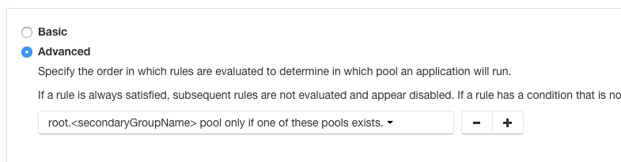

This placement rule dictates that a user’s queries (for both YARN and Impala) should be routed to the pool that matches the name of the user’s secondary group

For this example I will run queries as the user “mark” who we can see belongs to the secondary group “analysts”:

[root@mbrooks ~]# groups mark

mark : mark analysts

Here we see an Impala query for the user mark was correctly routed to the analysts Impala pool:

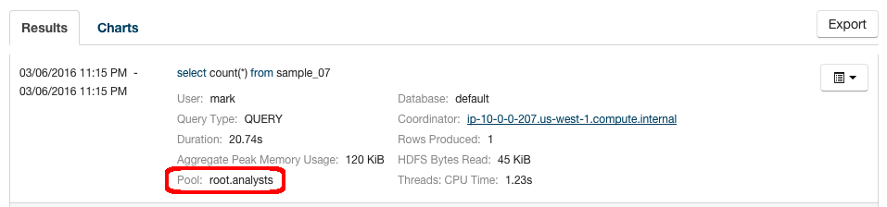

And a Hive query is also correctly placed in the analysts YARN pool:

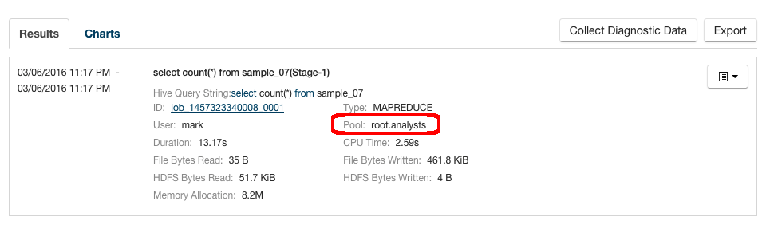

The key to setting the dynamic resource pools in a Director conf file is to capture the generated settings for the “Fair Scheduler Allocations” property in both YARN and Impala configs. These property values are set to reflect the configuration of CM’s Dynamic Resource Pools GUI.

Here is a screenshot from CM of the YARN Fair Scheduler Allocations property that expresses the dynamic resource pools configured in the GUI (the actual text is below):

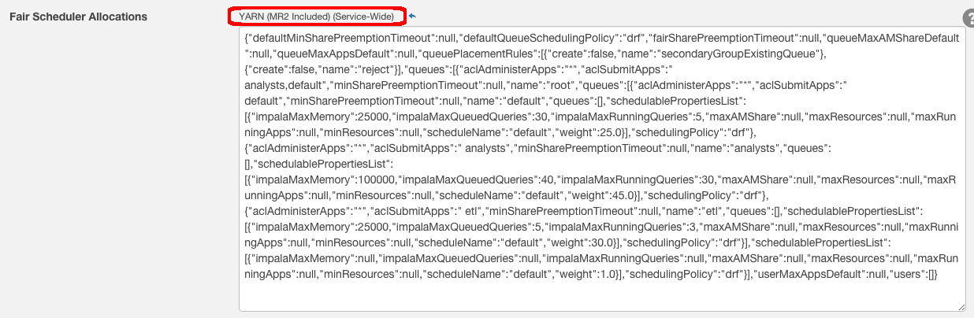

Here is the YARN Fair Scheduler Allocations value:

{"defaultMinSharePreemptionTimeout":null,"defaultQueueSchedulingPolicy":"drf","fairSharePreemptionTimeout":null,"queueMaxAMShareDefault":null,"queueMaxAppsDefault":null,"queuePlacementRules":[{"create":false,"name":"secondaryGroupExistingQueue"},{"create":false,"name":"reject"}],"queues":[{"aclAdministerApps":"*","aclSubmitApps":" analysts,default","minSharePreemptionTimeout":null,"name":"root","queues":[{"aclAdministerApps":"*","aclSubmitApps":" default","minSharePreemptionTimeout":null,"name":"default","queues":[],"schedulablePropertiesList":[{"impalaMaxMemory":25000,"impalaMaxQueuedQueries":30,"impalaMaxRunningQueries":5,"maxAMShare":null,"maxResources":null,"maxRunningApps":null,"minResources":null,"scheduleName":"default","weight":25.0}],"schedulingPolicy":"drf"},{"aclAdministerApps":"*","aclSubmitApps":" analysts","minSharePreemptionTimeout":null,"name":"analysts","queues":[],"schedulablePropertiesList":[{"impalaMaxMemory":100000,"impalaMaxQueuedQueries":40,"impalaMaxRunningQueries":30,"maxAMShare":null,"maxResources":null,"maxRunningApps":null,"minResources":null,"scheduleName":"default","weight":45.0}],"schedulingPolicy":"drf"},{"aclAdministerApps":"*","aclSubmitApps":" etl","minSharePreemptionTimeout":null,"name":"etl","queues":[],"schedulablePropertiesList":[{"impalaMaxMemory":25000,"impalaMaxQueuedQueries":5,"impalaMaxRunningQueries":3,"maxAMShare":null,"maxResources":null,"maxRunningApps":null,"minResources":null,"scheduleName":"default","weight":30.0}],"schedulingPolicy":"drf"}],"schedulablePropertiesList":[{"impalaMaxMemory":null,"impalaMaxQueuedQueries":null,"impalaMaxRunningQueries":null,"maxAMShare":null,"maxResources":null,"maxRunningApps":null,"minResources":null,"scheduleName":"default","weight":1.0}],"schedulingPolicy":"drf"}],"userMaxAppsDefault":null,"users":[]}

A similar value is set for Impala “Fair Scheduler Allocations” property:

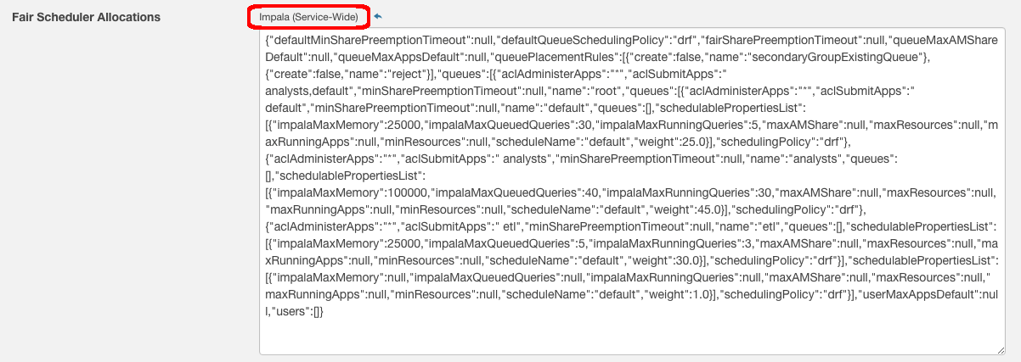

Here is the IMPALA Fair Scheduler Allocations value:

{"defaultMinSharePreemptionTimeout":null,"defaultQueueSchedulingPolicy":"drf","fairSharePreemptionTimeout":null,"queueMaxAMShareDefault":null,"queueMaxAppsDefault":null,"queuePlacementRules":[{"create":false,"name":"secondaryGroupExistingQueue"},{"create":false,"name":"reject"}],"queues":[{"aclAdministerApps":"*","aclSubmitApps":" analysts,default","minSharePreemptionTimeout":null,"name":"root","queues":[{"aclAdministerApps":"*","aclSubmitApps":" default","minSharePreemptionTimeout":null,"name":"default","queues":[],"schedulablePropertiesList":[{"impalaMaxMemory":25000,"impalaMaxQueuedQueries":30,"impalaMaxRunningQueries":5,"maxAMShare":null,"maxResources":null,"maxRunningApps":null,"minResources":null,"scheduleName":"default","weight":25.0}],"schedulingPolicy":"drf"},{"aclAdministerApps":"*","aclSubmitApps":" analysts","minSharePreemptionTimeout":null,"name":"analysts","queues":[],"schedulablePropertiesList":[{"impalaMaxMemory":100000,"impalaMaxQueuedQueries":40,"impalaMaxRunningQueries":30,"maxAMShare":null,"maxResources":null,"maxRunningApps":null,"minResources":null,"scheduleName":"default","weight":45.0}],"schedulingPolicy":"drf"},{"aclAdministerApps":"*","aclSubmitApps":" etl","minSharePreemptionTimeout":null,"name":"etl","queues":[],"schedulablePropertiesList":[{"impalaMaxMemory":25000,"impalaMaxQueuedQueries":5,"impalaMaxRunningQueries":3,"maxAMShare":null,"maxResources":null,"maxRunningApps":null,"minResources":null,"scheduleName":"default","weight":30.0}],"schedulingPolicy":"drf"}],"schedulablePropertiesList":[{"impalaMaxMemory":null,"impalaMaxQueuedQueries":null,"impalaMaxRunningQueries":null,"maxAMShare":null,"maxResources":null,"maxRunningApps":null,"minResources":null,"scheduleName":"default","weight":1.0}],"schedulingPolicy":"drf"}],"userMaxAppsDefault":null,"users":[]}

The values captured from CM (above) can simply be pasted into the Director config files, for both the YARN and IMPALA settings.

The YARN setting has the key “yarn_fs_scheduled_allocations” and the Impala setting has the key “impala_scheduled_allocations”.

Note that two additional Impala properties also need to be set at the service level:

admission_control_enabled: "true"  
 all_admission_control_enabled: "true"

Here is a snippet from a Director conf file that show how these settings are specified (all are service level configs defined at the cluster level):

**cluster** {  
 products {  
 CDH: 5   
 }  
   
 services: [HDFS, YARN, ZOOKEEPER, HIVE, HUE, OOZIE, IMPALA]  
 parcelRepositories: ["http://archive.cloudera.com/cdh5/parcels/5.5/"]  
   
**configs {  
  
 YARN {  
 yarn_fs_scheduled_allocations:** "{\"defaultMinSharePreemptionTimeout\":null,\"defaultQueueSchedulingPolicy\":\"drf\",\"fairSharePreemptionTimeout\":null,\"queueMaxAMShareDefault\":null,\"queueMaxAppsDefault\":null,\"queuePlacementRules\":[{\"create\":false,\"name\":\"secondaryGroupExistingQueue\"},{\"create\":false,\"name\":\"reject\"}],\"queues\":[{\"aclAdministerApps\":\"*\",\"aclSubmitApps\":\" analysts,default\",\"minSharePreemptionTimeout\":null,\"name\":\"root\",\"queues\":[{\"aclAdministerApps\":\"*\",\"aclSubmitApps\":\" default\",\"minSharePreemptionTimeout\":null,\"name\":\"default\",\"queues\":[],\"schedulablePropertiesList\":[{\"impalaMaxMemory\":25000,\"impalaMaxQueuedQueries\":30,\"impalaMaxRunningQueries\":5,\"maxAMShare\":null,\"maxResources\":null,\"maxRunningApps\":null,\"minResources\":null,\"scheduleName\":\"default\",\"weight\":25.0}],\"schedulingPolicy\":\"drf\"},{\"aclAdministerApps\":\"*\",\"aclSubmitApps\":\" analysts\",\"minSharePreemptionTimeout\":null,\"name\":\"analysts\",\"queues\":[],\"schedulablePropertiesList\":[{\"impalaMaxMemory\":100000,\"impalaMaxQueuedQueries\":40,\"impalaMaxRunningQueries\":30,\"maxAMShare\":null,\"maxResources\":null,\"maxRunningApps\":null,\"minResources\":null,\"scheduleName\":\"default\",\"weight\":45.0}],\"schedulingPolicy\":\"drf\"},{\"aclAdministerApps\":\"*\",\"aclSubmitApps\":\" etl\",\"minSharePreemptionTimeout\":null,\"name\":\"etl\",\"queues\":[],\"schedulablePropertiesList\":[{\"impalaMaxMemory\":25000,\"impalaMaxQueuedQueries\":5,\"impalaMaxRunningQueries\":3,\"maxAMShare\":null,\"maxResources\":null,\"maxRunningApps\":null,\"minResources\":null,\"scheduleName\":\"default\",\"weight\":30.0}],\"schedulingPolicy\":\"drf\"}],\"schedulablePropertiesList\":[{\"impalaMaxMemory\":null,\"impalaMaxQueuedQueries\":null,\"impalaMaxRunningQueries\":null,\"maxAMShare\":null,\"maxResources\":null,\"maxRunningApps\":null,\"minResources\":null,\"scheduleName\":\"default\",\"weight\":1.0}],\"schedulingPolicy\":\"drf\"}],\"userMaxAppsDefault\":null,\"users\":[]}"  
 }

**IMPALA {  
 admission_control_enabled: "true"  
 all_admission_control_enabled: "true"  
 impala_scheduled_allocations:** "{\"defaultMinSharePreemptionTimeout\":null,\"defaultQueueSchedulingPolicy\":\"drf\",\"fairSharePreemptionTimeout\":null,\"queueMaxAMShareDefault\":null,\"queueMaxAppsDefault\":null,\"queuePlacementRules\":[{\"create\":false,\"name\":\"secondaryGroupExistingQueue\"},{\"create\":false,\"name\":\"reject\"}],\"queues\":[{\"aclAdministerApps\":\"*\",\"aclSubmitApps\":\" analysts,default\",\"minSharePreemptionTimeout\":null,\"name\":\"root\",\"queues\":[{\"aclAdministerApps\":\"*\",\"aclSubmitApps\":\" default\",\"minSharePreemptionTimeout\":null,\"name\":\"default\",\"queues\":[],\"schedulablePropertiesList\":[{\"impalaMaxMemory\":25000,\"impalaMaxQueuedQueries\":30,\"impalaMaxRunningQueries\":5,\"maxAMShare\":null,\"maxResources\":null,\"maxRunningApps\":null,\"minResources\":null,\"scheduleName\":\"default\",\"weight\":25.0}],\"schedulingPolicy\":\"drf\"},{\"aclAdministerApps\":\"*\",\"aclSubmitApps\":\" analysts\",\"minSharePreemptionTimeout\":null,\"name\":\"analysts\",\"queues\":[],\"schedulablePropertiesList\":[{\"impalaMaxMemory\":100000,\"impalaMaxQueuedQueries\":40,\"impalaMaxRunningQueries\":30,\"maxAMShare\":null,\"maxResources\":null,\"maxRunningApps\":null,\"minResources\":null,\"scheduleName\":\"default\",\"weight\":45.0}],\"schedulingPolicy\":\"drf\"},{\"aclAdministerApps\":\"*\",\"aclSubmitApps\":\" etl\",\"minSharePreemptionTimeout\":null,\"name\":\"etl\",\"queues\":[],\"schedulablePropertiesList\":[{\"impalaMaxMemory\":25000,\"impalaMaxQueuedQueries\":5,\"impalaMaxRunningQueries\":3,\"maxAMShare\":null,\"maxResources\":null,\"maxRunningApps\":null,\"minResources\":null,\"scheduleName\":\"default\",\"weight\":30.0}],\"schedulingPolicy\":\"drf\"}],\"schedulablePropertiesList\":[{\"impalaMaxMemory\":null,\"impalaMaxQueuedQueries\":null,\"impalaMaxRunningQueries\":null,\"maxAMShare\":null,\"maxResources\":null,\"maxRunningApps\":null,\"minResources\":null,\"scheduleName\":\"default\",\"weight\":1.0}],\"schedulingPolicy\":\"drf\"}],\"userMaxAppsDefault\":null,\"users\":[]}"  
 }   
}