1) How to connect to the Node’s webpage via Mobile

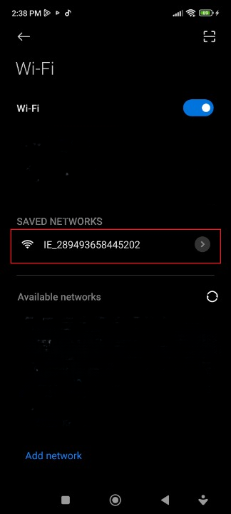

* First step is to scan the WiFi networks from your mobile.
* The WiFi network of the Node has a formatted Hostname constructed by 2 strings. In our example:

Node-name: IE

Node-ID: 289493658445202

* Connect to it , without using a password.
* When you are connected the webpage will appear as auto-popup. (Captive Portal)

Figure 1: All Networks

Here it shows that you’re correctly connected!

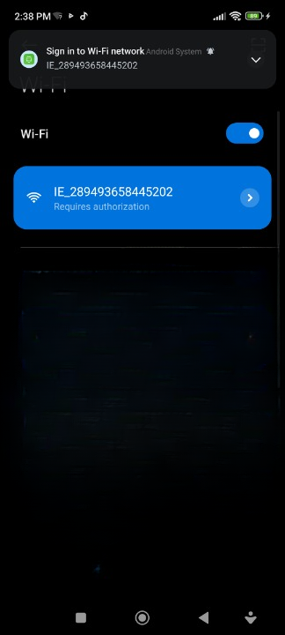

Figure 2: Correctly connected to the Node

Here is the Webpage connected by auto-popup method.

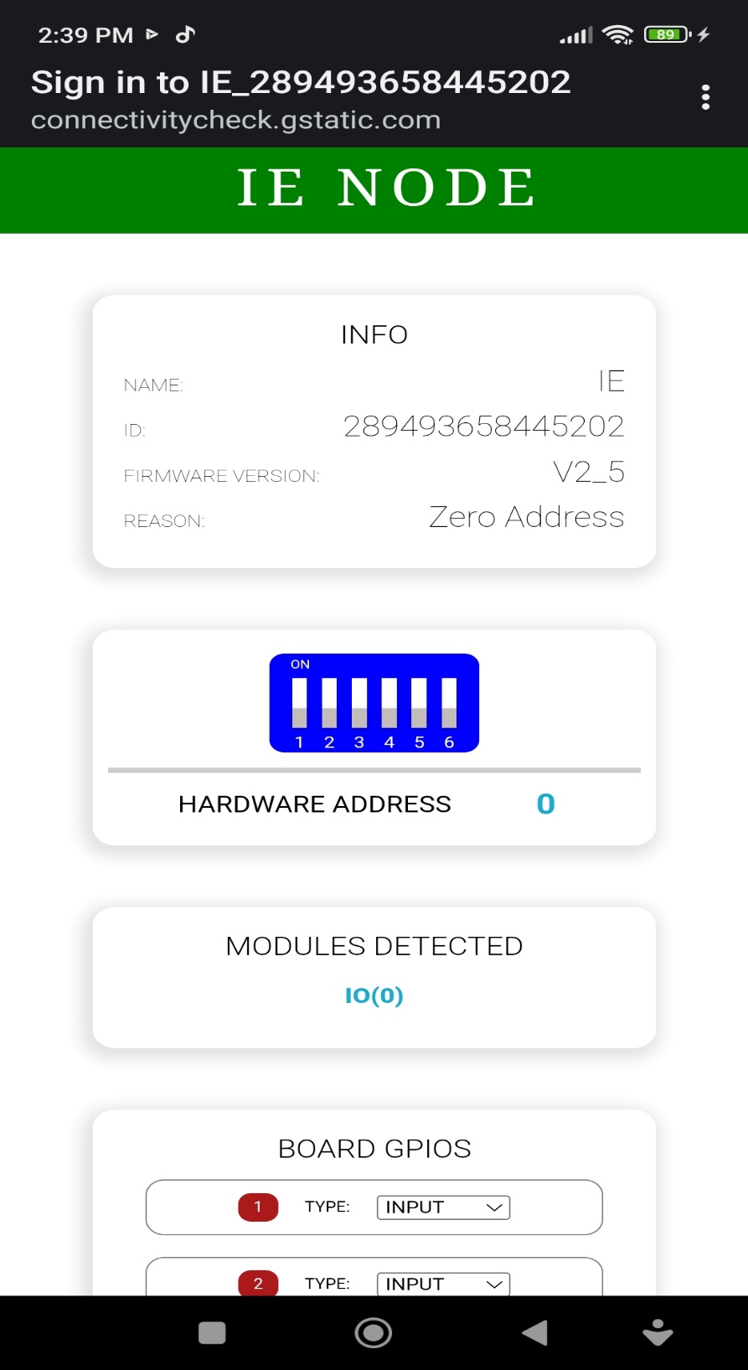

Figure 3: Webpage connected by Auto-Popup method

* 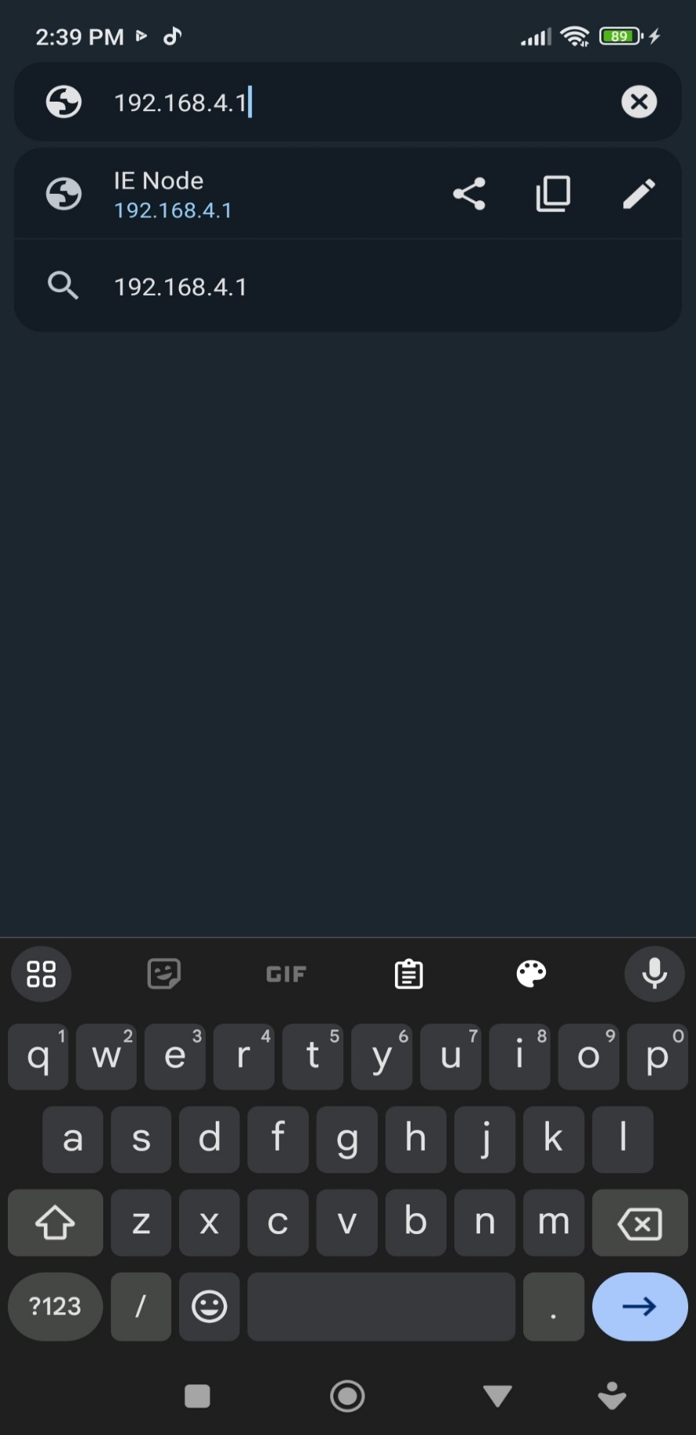IF the Popup function **won’t work.** We will try to connect manually with a Browser (Google Chrome, Mojila Firefox, Microsoft Edge) from your mobile.
* Type in the URL:

<http://192.168.4.1>

* And the webpage will be prompted!

Figure 4: Manually typing URL

Here is the Webpage connected by manual method, typing directly the IP address.

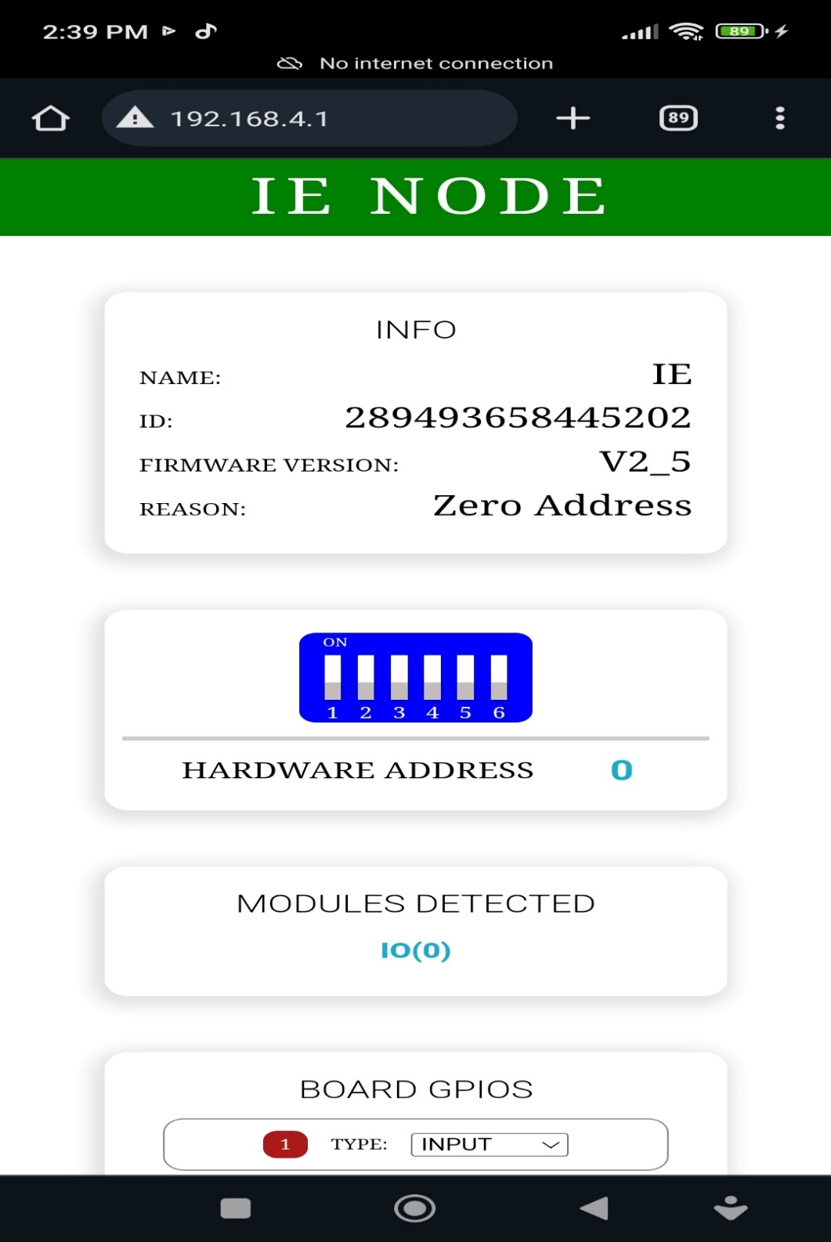

Figure 5: Manually finding the Node’s Webpage via URL

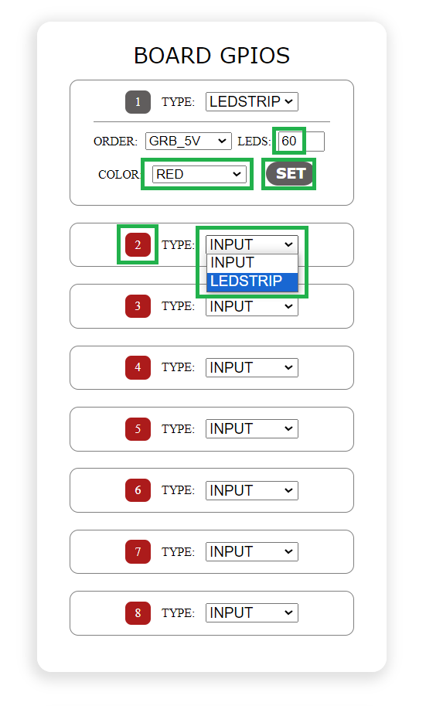2) How to open the Ledstrips of the Node with specific colors (Without using LS-Controller)

1. Choose the GPIO that you want to set the Color.
2. For GPIO:2, select in the Dropdown: LEDSTRIP.
3. Insert the LEDS you want to open, default is 60.
4. Choose the color that you want, default is red.
5. Press SET and the color will open on the number of LEDs you have set!

Figure 6: Open Ledstrip general Instructions

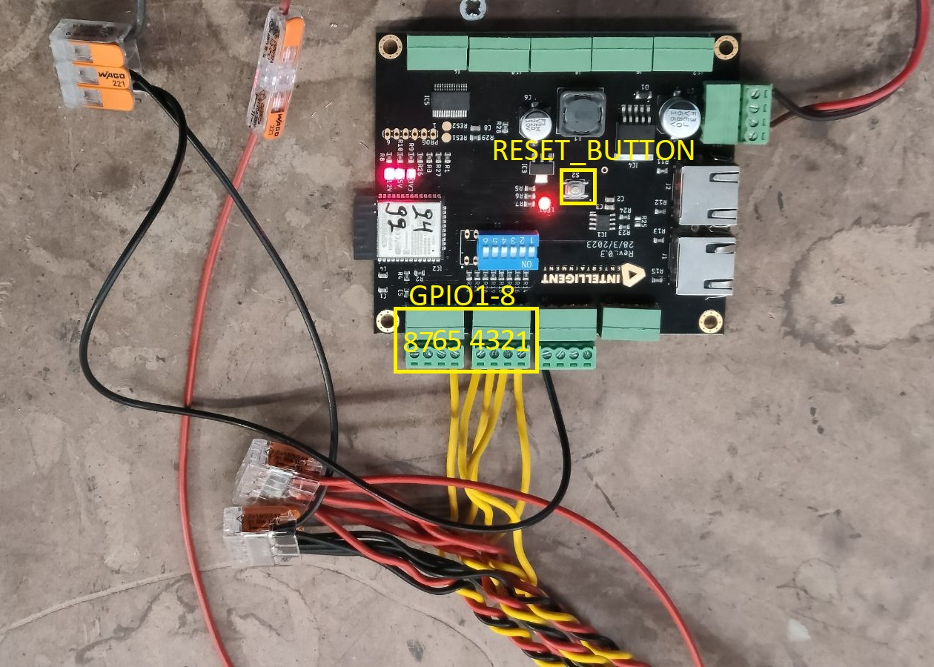

Figure 7: Hardware diagram showing the LEDSTRIPS that connect to GPIO1-8, without using LS-Controller

3) How to open the Ledstrips of the Node with specific colors (with LS-Controller)

Step 1

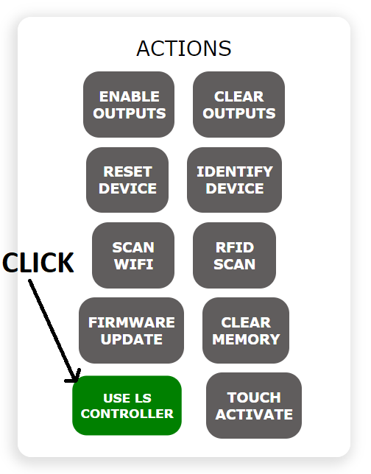

Figure 8: Click ‘USE LS CONTROLLER’

Step 2

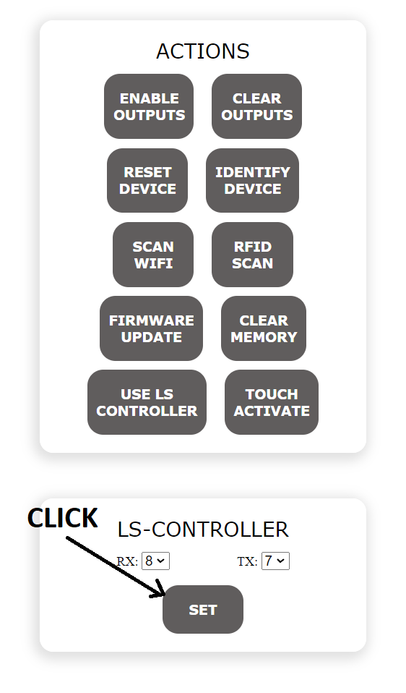

Figure 9: Click ‘SET’, RX is always 8 and TX is always 7

WARNING! Step 1 and Step 2 only needed ONCE!

Step 3

CLICK HERE: Follow <Open Ledstrip general Instructions in Figure 6>

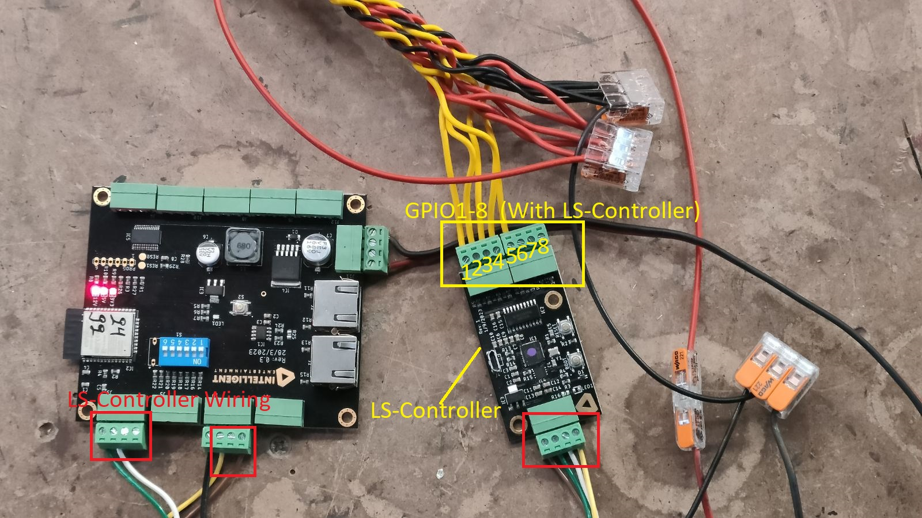

Figure 10: Connect the LEDSTRIPS to LS-Controller (GPIO1-8) now changed wiring position!

4) How to check the RFID-Scanners of the Node

Step 1

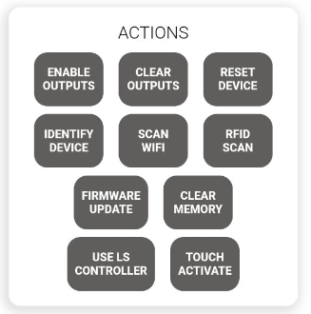

CLICK

Figure 10: Click ‘RFID SCAN’

Step 2 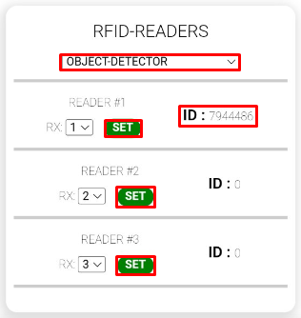

1. Select “OBJECT-DETECTOR”
2. Click SET on each READER
3. “RX” indicates the input where the READER is connected to the node.IN our example the READER #1,#2 and #3 are connected to inputs 1,2 and 3, respectively
4. Now you are ready to scan your RFIDs to the READERS
5. When the RFID is scanned to the READER the ID changes from 0 to a seven digit number

5) How to check the INPUTS of the Node:

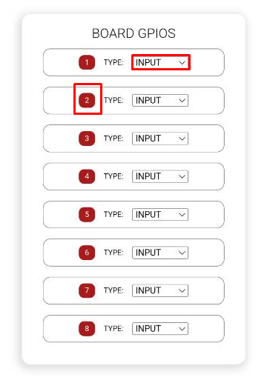

1. Select the INPUT choice in the BOARDS GPIOS section
2. If the color of the input’s number is red, that means that the input is not enabled, in the current example we can see that none of the inputs are enabled
3. If the input is enabled the color of the corresponding input’s number will turn green

6) General instructions

* If you setup to use LS-Controller , and you want to revert it back , to not use it anymore , you need to RESTART the Node by pressing (RESET DEVICE) from the webpage , or manually by the RESET-BUTTON on the PCB.