**1. Introduction**

A client has come to me with seed money to open a piazza shop in the Town of Oyster Bay. The Town of Oyster Bay consists of 20 Cities in Eastern Nassau County, Long Island, NY. The goal is to pick a city, where client can open a pizza shop with the least amount of pizza shops per city population.

**2. Data**

* foursquare – to obtain the number of pizza shops in a city, including latitude and longitude.
* <https://oysterbaytown.com/> - list of all cities within Oyster Bay.
* <https://www.newyork-demographics.com/cities_by_population> - 2021 population estimates by city

**2.2 Data Implementation**

* Get count of pizza shops in each city.
* Get population for each city
* Residents Per shop = (Number of Pizza Shops/Population)

**3. Data Methodology**

* load csv file of population estimates for each city in New York in a dataframe

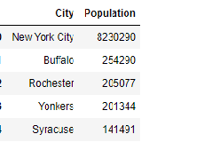

* load csv file of cities in Oyster Bay and get city latitude and longitude for each city.

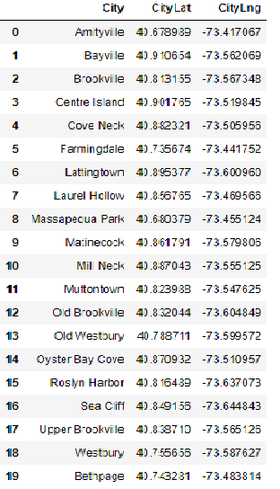

* Loop through each city to get pizza shops utilizing the foursquare API and merge all datasets.

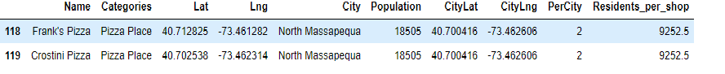

* Create new dataframe group by city, residents_per_shop and number of pizza shops. (See dataframe under results)

**4. Results**

Based on findings, North Massapequa had the lest amount of pizza shops for their population.

North Massapequa has a population of 18,505 with only 2 pizza shops serving their city.

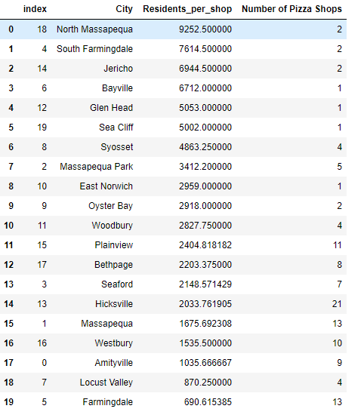

Map of North Massapequa. Blue Markers indicate location of pizza shops.

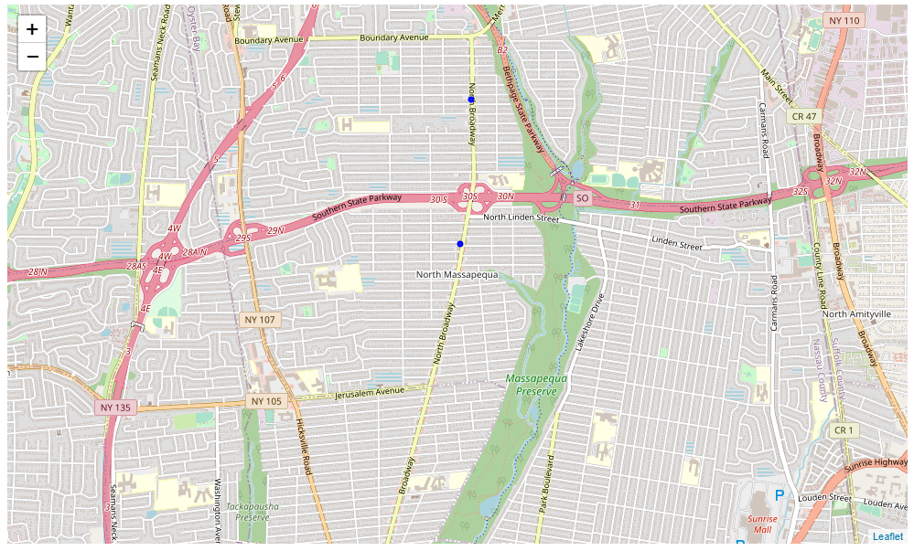

**5. Discussions**

I wanted to include ratings and menu price costs. However, I encountered the following limitations from foursquare API, where I scrapped both variables out of my analysis. Developer addition only allows only 50 premium calls a day, and I was analyzing over 400 pizza shops. In addition, average menu price and ratings were missing from about 60% of the pizza shops. As a results, I just focused on population and number of pizza shops in the city.

**6. Conclusion**

This project narrows down North Massapequa as possible location to open a pizza shop. Additional data analysis would be needed, such as ratings, menu variety and average menu cost of the two other pizza shops in Massapequa.