“SW Engineering CEN 4010 Fall 2014”

# Williamsburg-Housing

Group 30

|  |  |  |
| --- | --- | --- |
| Gregory Prosper |  | gprosper@sfsuswe.com |
| Jevon Cheung |  | jcheun@sfsuswe.com |
| Zainub Baig |  | zbaig@sfsuswe.com |
| Doris Qiu |  | dqiu@sfsuswe.com |
| Nicholas Sankoe |  | nsanko@sfsuswe.com |
| Shukura Smart |  | ssmart@sfsuswe.com |

Milestone 2

October 1, 2014

Revision Table

|  |  |
| --- | --- |
| Revision 0 | N/A |
|  |  |
|  |  |
|  |  |
|  |  |
|  |  |

1.Executive Summary

Williamsburg-Housing is a web accessible online real estate service that makes the real estate business simple. Our service enables a real-estate company to post and maintain their latest information regarding real-estate while simultaneously allowing potential customers around the world to browse and search various listings according to their specifications (city, state, price, etc). Traditionally similar ideas centered around customers browsing through available homes and selecting the options they liked the best. Customers accessing our service will be able to design and customize a personal profile where they can be notified the moment their dream home hits the market.

At its core, Williamsburg-Housing brings real-estate companies and potential customers closer together by making the process less intimidating, more reliable, and most importantly, easier than ever before. The site will collect listing data which it will use to help realtors and clients decide the best possible prices for their assets. Williamsburg-Housing was designed with an intuitive user interface, allowing anyone with basic computer knowledge to navigate the site with confidence in seconds. Our service can be viewed on a variety of devices of all shapes and sizes and is accessible to anyone with a standard internet connection. Williamsburg-Housing is making the interaction between real-estate companies and buyers simpler and easier than ever before.

2. Use Cases: 3-4 main use cases (1-2 paragraphs each requirement or use case)

The website would cater to two types of main users, the first being a ‘**customer**’ the second being a ‘**realtor**’. The names given are generalized and have more options to them than simply to ‘buy’ and to ‘sell’ in this particular case. The ‘customers’ have the option of using the websites accessible capabilities, such as browsing for homes through specific criteria given: city, category, price, zip code, family size etc.

Although at first glance it might appear to be potential home buyers purchasing a home may use this, it could also be the case that ‘customer’s use the ease and accuracy of the website to gain information about homes and their details so they can compare their own listing to it.

It could also be used by ‘customers’ to gain data on average of home pricing in certain areas, or in general, etc. The data collected could be used for future purchasing or selling purposes, when it comes to accurately pricing the house. It could also be used to find information on how many homeowners had a particular house. The customers are not expected to have highly detailed knowledge of website structure or understand anything beyond low level website operations, such as getting on the internet, opening websites, logging into websites or signing up as well as perhaps searching for the information they desire on the websites.

The ‘realtors’ of the website would, ideally, be more committed to the website, and more than likely use the website as it is apparent they would use it: to sell listings which they are given and to look for listing which they wish to produce and sell to clients. They would have their own profile, along with the customers, for which the criteria would be displayed when their specific page is opened. In the case of the realtors, it might display things such as the houses they are currently listing, while for the customer it might display the type of house or price market or location they are looking to buy a home in.

The website, which would be hosted and only accessible through the WWW, would be simplistic in understanding of its use. Customers need not have high level computer operation or coding knowledge to use the website in all of its available functionality.

The realtors would be expected to have some deeper knowledge of computer knowledge in terms of filling out forms properly, and learning the mechanisms for house listings. The website itself will be clean and easy to load, with not much lagging, and shall be simple to load on multiple browsers. It will also be usable on mobile devices, including but not limited to phones and tablets. The website will be accessible through the WWW in any country anywhere that allows amazon in its country. It is only accessible through the WWW.

3.Data Definition/glossary

**Realtor**: the real estate agent working with the potential buyer. They will provide listings from their clientele of available properties to the potential home buyer.

**Customer**: the potential buyer browsing through the listings provided to them by our

system.

**Listings**: a catalog of available houses with the description and pricing of the house.

4.Initial list of functional specs

I. Allow real estate agents to manage website content:

Agents will be able to add, remove, and modify listings.

II. Allow agents to have their own profile:

This profile will only allow realtors to have access to the postings that they made.

One realtor can’t access another realtor’s listings to change or modify them.

III. Potential home buyers can search home database:

Buyers will be able to search for homes within their criteria, based on number of bedrooms,bathrooms, and etc. This function may include set drop down boxes for the potential buyer to choose from.

IV. Potential buyers will be able to make a profile:

Profile will allow customer to receive notifications of new home listings that match their criteria. No one else will have access to potential buyers profile.

V. Customers and Realtors will have limited access:

Customers will not be able to add, delete, or modify any listings on site. Realtors will only be able to modify listings that they posted. If a customer wants their house to be listed by Williamsburg-Housing then they must contact the company for a realtor to list their home.

VI. Site will collect listing data:

Site will collect data on average price listings for particular area(neighborhoods), to help realtors and clients decide best prices for properties. This will be public on the site for all to see.

5.List of non-functional specs

I. Performance Test:

Stress test the site to make sure it’s operational under loads of user input. Have multiple people from the group all at once bombard the server to test the performance on the services under high traffic.

II. Security Requirements for Client:

Security Recruitment must be complex enough to ensure confidential and secure access for user. Password must consist of one capital letter, one number, special character, and at least 8 characters long. Saved email incase user needs to replace password due to be forgotten.

III. Availability and ease of access:

Easy for the user to access their profile on multiple interfaces.

Android/Apple Devices (Mobile Interface). Browsers support: Internet Explorer, Mozilla Firefox, Safari, Google Chrome. Confirm user is using latest form of Browser.

IV. Storage Profile:

Limit Amount of information each profile is allocated or allowed to save on profile to prevent server from being congested with high volume of information from client on each profile causing possible crashes of long load screens.

V. Response Time:

Perform requested action such as uploading, or downloading excel or documented information in a timely manner preventing user frustration with long wait times, and reduce possibility of crashes. Import and export multiple documents to server to test.

VI. Back-Up:

System will perform scheduled backups to ensure all clients information are secured and safe in case of system failure of servers crashing or being reset. Back up to system storage such as a cloud base storage or unto a local computer to prevent user client information lossage. Encrypted backUp files to protect user information.

VII. Maintenance:

Scheduled maintenance on system integration to ensure all functions are at optimal performance and stability. Weekly maintenance around non-work days scheduled such as Saturdays and Sundays. Upgrades to system or browser support.

VIII. Usability:

Targeted to correct client and design to draw in target audience and allow ease of usage and navigation for client.

6.UI Mockups and Storyboards

|  |  |
| --- | --- |
| Home Page | Sign Up Pop Up |
| Sign Up Pop Up | Search Results |
| Listing Details | Realtor Details Pop Up |
| My Listings | Delete Listings Pop Up |
| Add Listing | Edit Listing |

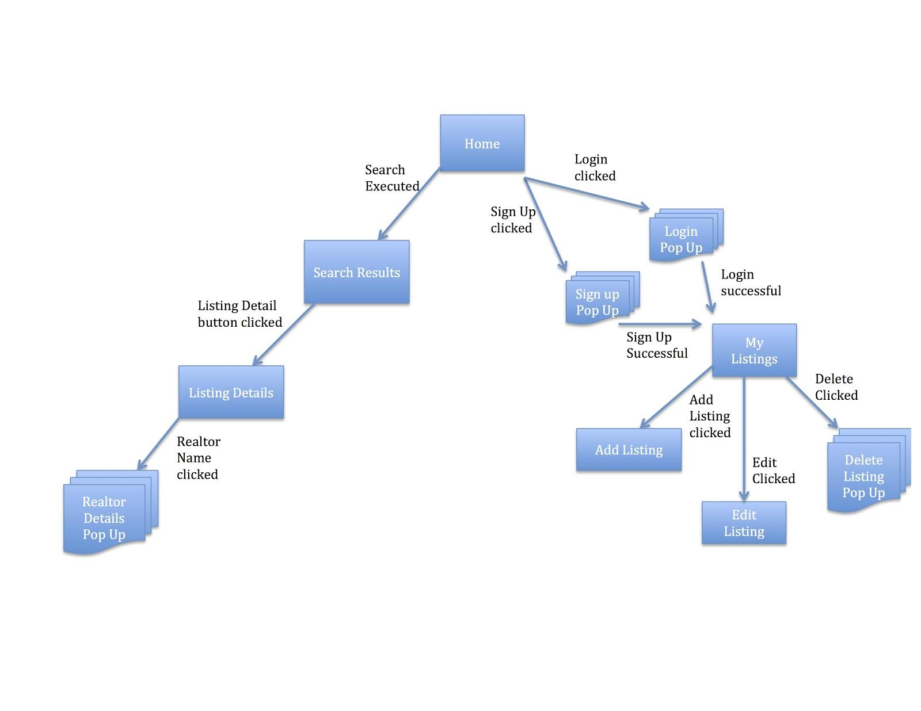

7.High-level system architecture and Database Organization

Front-End

* HTML
* CSS
* JavaScript and JQuery
* Bootstrap

Back-End

* PHP
* MySQL

Supported Browsers

* Most Popular Browsers (ie Firefox, Safari and Google Chrome)
* Mobile Friendly

The website will be hosted on a LAMP server. Netbeans will be used for coding and subversion handling. Bootstrap will be used to quickly build and design the site. PHP and MySQL will be used for database management of Listings. Site is expected to be compatible with all popular browsers and also mobile friendly.

Images that are used will be png, but users should be able to upload any image no matter the format so they will be changed to png. User can upload images of all sizes, but the site will display them at a certain size. All user images will be kept in the database and all website images will be kept on the server.

The database will have a table for realtors which contains realtor information. A Listings Table which contains the postings of each realtor. Regular users can view all listings in Listings Table via the search results, but only realtors can edit the listings that they posted. Realtors won’t be able to edit other realtors postings.

|  |  |
| --- | --- |
| Realtors Table | Listings Table |
| Id | Id |
| First Name | Street |
| Last Name | City |
| Phone | State |
| Email | Beds # |
| Company | Bath # |
| Licence # | Size |
| Username | Price |
| Password | Description |
| Picture (Image) | Type of Home |
|  | Post Date |
|  | Posted by (Realtor Id) |
|  | Image 1 |
|  | Image 2 |
|  | Image 3 |
|  | Image 4 |
|  | Image 5 |

1. High Level UML Diagrams

**Use Case Diagram** 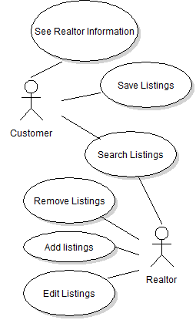

**Class Diagram**

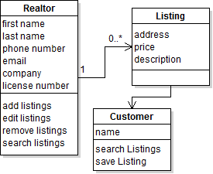

**Object Diagram**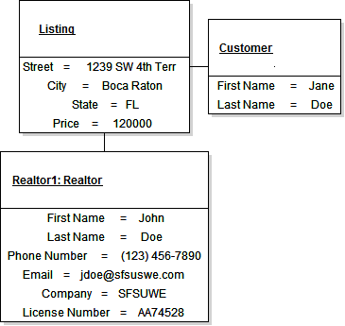

**Sequence Diagram**

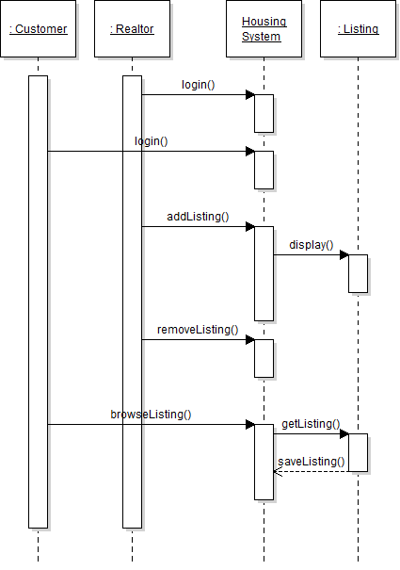

1. Key Risks

SkillsRisks: Our software engineering team is made up of individuals who possess a wide range of talents. Although our team is less experienced in developing applications for the web we still believe we have the skills necessary to deliver a quality product.

Schedule Risks: We believe our team is currently on schedule and prepared to effortlessly meet all current deadlines given the resources at our disposal.

Technical Risks: Our software engineering team has enough experience on it to foresee most major technical challenges. Any unforeseen technical difficulties will be handled on a case by case basis.

Teamwork Risks: Our team is great a constantly communicating via online web services. We believe this has allowed our team to bypass the majority of risks associated with working with a group of people and transform them into an area of strength.

Legal Risks: Most obvious major legal risks have been accounted for. For example, the words “Software Engineering Project, Fall 2014, for demonstration purposes only” must be at the top of the website at all times. We are also very careful to only use media under a creative commons license. We are still in the process of identifying any further legal weaknesses.

1. Team Organization

Gregory Prosper is the product owner. He is the manager and ultimately has the weight of the outcome of the project on his shoulders as a project manager would. He determines what features we focus on at each time, and makes sure to have the product be ‘marketable’ to customers.

Zainub Baig is the scrum master. She oversees how the project is coming along frequently, checking in and making sure things are going along smoothly. Similar to a cheerleader, she tries to motivate and make sure to keep proper goals in sight for the project.  
  
Doris, Nicholas, Shukura and Jevon are apart of the development team, each of them is separately recognizable by their personality and what they bring to this group. Shukura has the intelligence of a good team member, but the calm demeanor to help the scrum master maintain order. Doris is quiet, but a quick to help team member and a good asset to the development team. Jevon is silent as a mouse, and then strikes out to give his excellently done work, as well as provide resources when needed to the group. And Nicholas is a good member for his eagerness to work alongside his cheery demeanor to keep the group in a positive place.

|  |  |
| --- | --- |
|  |  |
|  |  |
|  |  |
|  |  |
|  |  |
|  |  |
|  |  |