**General**

1. The underlying design principle is that the interface should be simple to use.
2. Please use a template similar to - <https://elixir.co.zw>

**Top Nav**

1. The section above the top navigation items should have a contact email “placeholder - [help@judicata.co.zw](mailto:help@judicata.co.zw) and placeholder number 02429948492”
2. The “Get Quote” button should be “Get Help”, and redirect to a form with answers to frequently asked questions, and a contact form with the following fields: Full Name, Email, Phone Number, How can we help? When submitted, there should be a full screen message saying “ Thank You, our support team will call you on the provided details shortly. In the meantime, please see the Get Help section for frequently asked questions”
3. For the logo, use the logo downloadable here:

<https://www.dropbox.com/s/vevq3gf2fc8f80a/Judicata.png?dl=0>

1. The top nav should the following:

* **Home**
* **About** - When clicked “Judicata is a platform developed for the Judicial Services Commission in Zimbabwe in partnership with the International Commission Jurists. The platform aims to strengthen the judicial system, to deal with court backlogs and to increase access to justice, foster judicial transparency utilising technology.
* **About the JSC** - When clicked, it should have the following information - *“The Judicial Service Commission as a policy making body is supported by a Secretariat headed by the Secretary whose responsibility shall, subject to the Commission’s directions, supervise and manage the Commission’s staff, activities, funds and property and perform such other functions on behalf of the Commission as the Commission may assign to him or her. The Secretary is ably supported by two Deputy Secretaries. Administratively there are two main sections each headed by a Deputy Secretary. One section is primarily concerned with court services. Under this section there are registrars of the Superior and Specialised Courts, the Magistracy, the Office of the Master of the High Court and the Legal Research department.The other division offers necessary support services such as finance, administration, human resources, procurement and information services. In line with its policy of decentralising decision making authority, the structure of the Secretariat described above is replicated at provincial level to the extent where this is practicable with the Provincial Magistrate acting as the provincial heads of administration.”*

**Main Banner**

1. The main banner should have three buttons as below:

* **Virtual Cause List** - When clicked, this should present a list of all cases coming up with the following information in a table: Name of Case, Date, Time, Court, View Live Hearing. The user should have the option of downloading the virtual cause list in pdf format.
* **Join Hearing** - This is the platform where someone can join a live hearing as a lawyer, prosecutor or self-representing person and should have the following fields:
* Full Name & Surname
* Select Court - dropdown options, Magistrates Court, Labour Court, High Court, Supreme Court, Constitutional Court
* Designation - dropdown options, Lawyer, Prosecutor, Prisons, Judicial Officer, Self-representing litigant
* Hearing ID or One-Time Link
* Hearing Password

**\* If the user selects “lawyer” above, a pop up should come up asking them to scan the barcode on their PC to verify themselves. This should use a PC or mobile phone camera - You can explore this SDK**

[**https://www.cognex.com/products/barcode-readers/mobile-solutions/cognex-mobile-barcode-sdk?gclid=cjwkcajwyo36braxeiwa24cwgfyu5cjmv4lxaccnkzs0tokkcg5dqzortqfa5lqpmvfz668bedzx0xoc88eqavd_bwe**](https://www.cognex.com/products/barcode-readers/mobile-solutions/cognex-mobile-barcode-sdk?gclid=cjwkcajwyo36braxeiwa24cwgfyu5cjmv4lxaccnkzs0tokkcg5dqzortqfa5lqpmvfz668bedzx0xoc88eqavd_bwe)

* **Watch Hearing** - This allows users to watch live hearings streamed from a custom url or from a YouTube Account. When clicked, this button will present the Virtual Cause List above, with the “View Live Hearing” highlighted in a prominent colour if there is a stream available. When hearing is live, the user will have the option to Share Hearing (to facebook or twitter) and Leave Hearing.

**Courts Section**

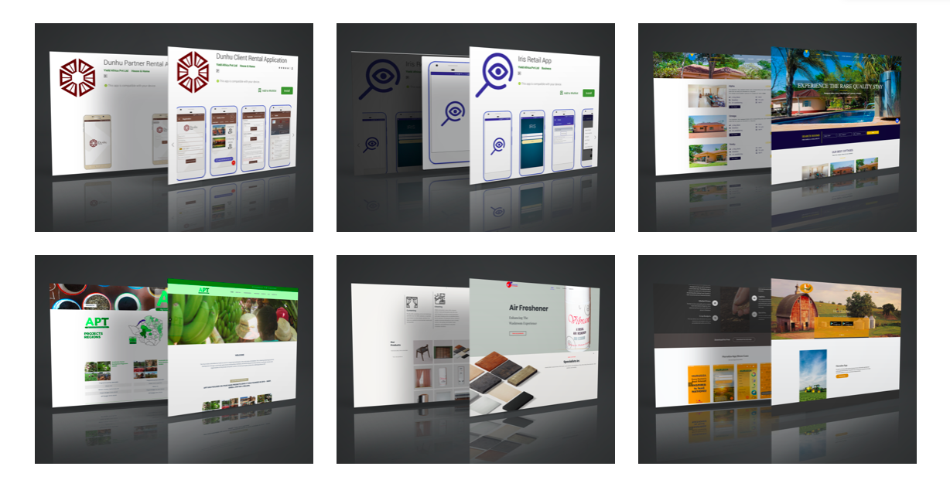

1. This section allows users to log into a hearing or watch a live hearing directly from a “court page” A view like the one above should have the following courts in this order :

* Constitutional Court
* Supreme Court
* High Courts (when clicked, should present a pop-up list with “ High Court Harare, High Court Bulawayo, High Court Mutare, High Court Masvingo”
* Labour Court (When clicked, should present a pop-up with “Labour Court Harare, Labour Court Bulawayo, Labour Court Gweru”
* Administrative Court (when clicked, should present a pop-up list with “ Admin Court Harare, Admin Court Bulawayo
* Magistrates Court (When clicked, should present a pop up with a list of Zimbabwe provinces as follows : Bulawayo, Harare, Manicaland, Mashonaland West, Mashonaland East, Mashonaland Central, Masvingo, Matabeleland North.

**\* On the court page, the user should be able to see the court specific virtual cause list with the following fields - Name of Case, Case Number, Date, Time, Court, View Live Hearing, Join Hearing. The user should have the option of downloading the virtual cause list in pdf format.**

**Admin Panel**

1. The admin panel should have the following four buttons:

* **Virtual Cause List** - This should show the user a virtual cause list with the following details - Name of Case, Date, Time, Court, Start Hearing, View Live Hearing, Edit Info”

**\*There should be an “Add New Cause” button prominently displayed on the virtual cause list page for admins, who may add a cause depending on user permissions.**

**This Add New Case button should have the following fields :**

**Select Matter Type - Dropdown with options - Appeal, Civil Trial, Civil Application, Criminal Trial, Criminal Application, Motion Court, Routine Remand Hearing**

If Appeal is selected then present - Court (dropdown with all courts) Appeal Number, Name of Appellant (can be more than one), Name of Respondent (can be more than one), Date of Virtual Hearing (Selectable from a calendar), Time of hearing (Selectable on a list of dropdown timeslots), Name of Judge/Magistrate. When enter is created, present a Notify Parties” Section - Requires Appellant Email Address, Respondent Email Address and send the following email :

**SUBJECT [IMPORTANT] - NOTICE OF VIRTUAL HEARING [CASE NAME] vs [APPEAL NUMBER]**

Dear [Appellant/Respondent]

PLEASE TAKE NOTICE THAT THE MATTER OF [NAME OF APPELLANT] [NAME OF RESPONDENT] [CASE NUMBER] has been set down for a virtual hearing in the [COURT].

The matter is set for hearing before the learned [JUDGE/MAGISTRATE] on the [DATE], at [TIME], or soon thereafter as the matter may be heard.

***To join by internet enabled phone/tablet or computer:***

To access the hearing, please navigate to [join hearing url] at least 15 minutes before the scheduled time. Your unique login details are as follows:

Meeting ID - XXXXXXXXX

Password - xxxxxxxxxxx

If you are a legal practitioner, please have your practising certificate with you. You will be required to scan it for verification purposes.

***To join by phone:***

Please dial the following number and be prepared to answer the security question

If you have any questions, please contact support on [number] and [email].

**Registrar/Clerk**

[Court]

[Timestamp]

**\*Should present Registrar with a printable copy after being sent - with the inscription “Sent by Registrar/ Clerk of [COURT] on [Timestamp]**

**\*Should also attach a printable copy to emails sent to recipients**

If Civil Trial is selected then present - Court (dropdown with all courts) Case Number, Name of Plaintiff (can be more than one), Name of Defendant (can be more than one), Date of Virtual Hearing (Selectable from a calendar), Time of hearing (Selectable on a list of dropdown timeslots), Name of Judge/Magistrate. When enter is created, present a Notify Parties” Section - Requires Plaintiff Email Address, Defendant Email Address and send the following email :

**SUBJECT [IMPORTANT] - NOTICE OF VIRTUAL HEARING [CASE NAME] [APPEAL NUMBER]**

Dear [Plaintiff/Defendant]

PLEASE TAKE NOTICE THAT THE MATTER OF [NAME OF PLAINTIFF] vs [NAME OF DEFENDANT] [CASE NUMBER] has been set down for a virtual hearing in the [COURT].

The matter is set for hearing before the learned [JUDGE/MAGISTRATE] on the [DATE], at [TIME], or soon thereafter as the matter may be heard.

***To join by internet enabled phone/tablet or computer:***

To access the hearing, please navigate to [join hearing url] at least 15 minutes before the scheduled time. Your unique login details are as follows:

Meeting ID - XXXXXXXXX

Password - xxxxxxxxxxx

If you are a legal practitioner, please have your practising certificate with you. You will be required to scan it for verification purposes.

***To join by phone:***

Please dial the following number and be prepared to answer the security question

If you have any questions, please contact support on [number] and [email].

**Registrar/Clerk**

[Court]

[Timestamp]

**\*Should present Registrar with a printable copy after being sent - with the inscription “Sent by Registrar/ Clerk of [COURT] on [Timestamp]**

**\*Should also attach a printable copy to emails sent to recipients**

If Civil Application is selected then present - Court (dropdown with all courts) Case Number, Name of Applicant (can be more than one), Name of Respondent (can be more than one), Date of Virtual Hearing (Selectable from a calendar), Time of hearing (Selectable on a list of dropdown timeslots), Name of Judge/Magistrate. When enter is created, present a Notify Parties” Section - Requires Applicant Email Address, Respondent Email Address and send the following email :

**SUBJECT [IMPORTANT] - NOTICE OF VIRTUAL HEARING [CASE NAME] [CASE NUMBER]**

Dear [Applicant/Respondent]

PLEASE TAKE NOTICE THAT THE MATTER OF [NAME OF APPLICANT] vs [NAME OF RESPONDENT] [CASE NUMBER] has been set down for a virtual hearing in the [COURT].

The matter is set for hearing before the learned [JUDGE/MAGISTRATE] on the [DATE], at [TIME], or soon thereafter as the matter may be heard.

***To join by internet enabled phone/tablet or computer:***

To access the hearing, please navigate to [join hearing url] at least 15 minutes before the scheduled time. Your unique login details are as follows:

Meeting ID - XXXXXXXXX

Password - xxxxxxxxxxx

If you are a legal practitioner, please have your practising certificate with you. You will be required to scan it for verification purposes.

***To join by phone:***

Please dial the following number and be prepared to answer the security question

If you have any questions, please contact support on [number] and [email].

**Registrar/Clerk**

[Court]

[Timestamp]

**\*Should present Registrar with a printable copy after being sent - with the inscription “Sent by Registrar/ Clerk of [COURT] on [Timestamp]**

**\*Should also attach a printable copy to emails sent to recipients**

If Criminal Trial/Criminal Application is selected then present - Court (dropdown with all courts) Case Number, State (this is fixed for all criminal trials) (**cannot** be more than one), Name of Accused (can be more than one), Date of Virtual Hearing (Selectable from a calendar), Time of hearing (Selectable on a list of dropdown timeslots), Name of Judge/Magistrate.

**\*The criminal trial option must allow the Registrar/Clerk to multi-add cases for a certain day by giving a page like the sketch below:**

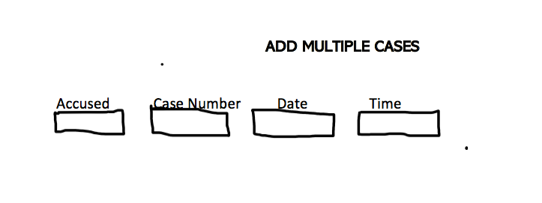

When enter is created, present an option to “print/download master list”, and download all criminal cases in a given day or week. This list must also be capable of being downloaded at a later stage.

Also present, “Notify Parties” - which Requires Prosecutor Email Address, Accused’s Lawyer’s Email Address and send the following email :

**SUBJECT [IMPORTANT] - NOTICE OF VIRTUAL HEARING [CASE NAME] [CASE NUMBER]**

Dear [State/Accused]

PLEASE TAKE NOTICE THAT THE MATTER OF STATE vs [NAME OF ACCUSED] [CASE NUMBER] has been set down for a virtual hearing in the [COURT].

The matter is set for hearing before the learned [JUDGE/MAGISTRATE] on the [DATE], at [TIME], or soon thereafter as the matter may be heard.

***To join by internet enabled phone/tablet or computer:***

To access the hearing, please navigate to [join hearing url] at least 15 minutes before the scheduled time. Your unique login details are as follows:

Meeting ID - XXXXXXXXX

Password - xxxxxxxxxxx

If you are a legal practitioner, please have your practising certificate with you. You will be required to scan it for verification purposes.

***To join by phone:***

Please dial the following number and be prepared to answer the security question

If you have any questions, please contact support on [number] and [email].

**Registrar/Clerk**

[Court]

[Timestamp]

**\*Should present Registrar with a printable copy after being sent - with the inscription “Sent by Registrar/ Clerk of [COURT] on [Timestamp]**

**\*Should also attach a printable copy to emails sent to recipients**

**THIS WORKFLOW, AS IT INVOLVES CRIMINAL CASES MUST GIVE THE REGISTRAR/CLERK OF A PARTICULAR COURT A PRINTABLE MASTER LIST OF ALL CRIMINAL TRIALS OR APPLICATIONS COMING UP IN A GIVEN WEEK OR DAY, TO BE SENT TO DETENTION CENTRES IN ADVANCE.**

* **Start Hearing** - This should present an option for the user to put the following details: Full Name and Password. Once fields are populated, the admin user must be taken into the virtual courtroom where they can have options similar to Zoom : Unmute/Mute, Start Video, Participants (See participants and admit people in the waiting room), Documents (Upload or scan documents), Chat, Share Screen, Start/Pause/Stop Recording, Breakout Rooms.
* **Queries**
* **Recordings**