Burghfield Veterinary Surgery
1 Tarragon Way, Burghfield Common, Reading RG7 3YU
Telephone: 0118 9832465

BITCH SPEY – POST OPERATIVE CARE

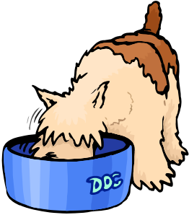
We hope your pet will make a smooth and speedy recovery from her operation. Tonight, she will be recovering from a full general anaesthetic. Please offer a light meal – she may not want to eat much but should be eating by 24 hours time. An easily digestible, highly nutritious diet will be of value in the days following the operation – we can supply a suitable food if necessary.

Her tummy will have a number of stitches. These are due out in 10 days time during a normal appointment slot and at no extra charge. Please discourage her from chewing at the stitches, using a buster collar from us if this is proving difficult. If the wound is interfered with, it will take longer to heal and may become infected so please be vigilant. A dressing may also be placed on the wound and this should be kept on for as long as possible. It shouldn’t need replacing once it is removed unless otherwise instructed.

To give her wound the best chance of healing, you should rest your pet for the first 48 hours post-op and then keep her exercise light until the stitches come out. It is also important to exercise on clean ground only to avoid contamination of the wound.

A few days after the operation, there may be some bruising and/or light leakage of blood stained fluid from the stitch area. This is normal in small quantities but please contact us if either seems excessive.

In order to administer our medications, a small amount of fur from the leg or neck may have been clipped.

Neutering will slow down your pet’s metabolism to some extent. This may result in weight gain. For some dogs, this may be the ideal time to switch from growth food, to adult food or from adult maintenance to light food. Please ask our nurses for advice now, and take advantage of our free weight clinics to monitor this. We recommend at least one weigh-in, six months post-operatively.

Finally, each pet is very different and some are more sensitive to pain than others. All will have been given 24 hour pain relief at the time of the operation however some pets will require more. Please contact us if she seems in pain or if you are worried about any other aspect of her recovery – we are very happy to help!

