Burghfield Veterinary Surgery
1 Tarragon Way, Burghfield Common, Reading RG7 3YU
Telephone: 0118 9832465

DOG CASTRATION – POST OPERATIVE CARE

We hope your pet will make a smooth and speedy recovery from his castration. Tonight your pet will be recovering from his anaesthetic. Please keep him quiet and offer a light meal – he may not want to eat much but should be eating by 24 hours time. We can supply a suitable convalescent food if necessary.

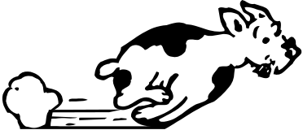
His stitches lie in front of his scrotum. These are due out in 10 days time during a normal appointment slot and at no extra charge. Please discourage him from interfering with the stitches, using a “buster” collar from us if this is proving difficult. If the wound is interfered with, it will take longer to heal and may become infected so please be vigilant and take a buster collar if you suspect there may be problems. Evidence of swelling and/or bruising in this area may be apparent and is normal however, if it appears excessive or he is distressed, please contact us.

Please keep his exercise light and on clean ground to give the wound the best chance of healing.

In order to administer our medications, a small amount of hair from the leg or neck may have been clipped.

Neutering can slow down your pet’s metabolism to some extent. This may result in weight gain. For some dogs, this may be the ideal time to switch from growth food to adult food, or from adult maintenance to light. Please ask our nurses for advice now, and take advantage of our free weight clinics to monitor this. We recommend at least one weigh-in, six months post-operatively.

Finally, each pet is very different and some are more sensitive to pain than others. All will have been given 24 hour pain relief at the time of the operation however some dogs may require more…
… Please contact us if he seems in pain or if you are worried about any other aspect of his recovery – we are very happy to help!

