Burghfield Veterinary Surgery
1 Tarragon Way, Burghfield Common, Reading RG7 3YU
Telephone: 0118 9832465

POST ANAESTHETIC/SEDATION CARE

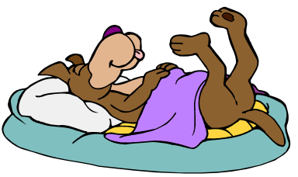
We hope your pet will make a smooth and speedy recovery. Tonight, he/she will be recovering from the anaesthetic. Please offer a light meal later on– they may not want to eat much but should be eating by 24 hours time. An easily digestible, highly nutritious diet will be of value in the days following the anaesthetic – we can supply a suitable food if necessary called i/d.

Don’t be concerned if your pet is sleepy when you get him/her home. It will take 24 hours for all the anaesthetic drugs that we use to be completely out of their system.

Please keep cats indoors for at least 36 hours following their return home.
Please keep a dog’s exercise light for at least 36 hours. Please follow the vet’s advice after this about exercise levels, as it will vary for each individual. If you are unsure just ask.

If your pet has been given medication to go home on, please make ensure you follow the directions carefully. Most medications will start 24 hours after discharge, unless otherwise stated.

In order to administer our medications, a small amount of fur may have been clipped on the leg or the neck.
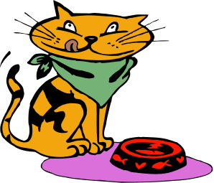
Finally, each pet is very different and some recover better from the anaesthetic than others. Most pets are back to ‘normal’ 24 hours after the anaesthetic. However some individuals may take a few days longer. If necessary your pet would have received pain relief that lasts for 24 hours.

Please do not hesitate to contact us if you are concerned about your pet or if there is any other query regarding their recovery – we are very happy to help.

