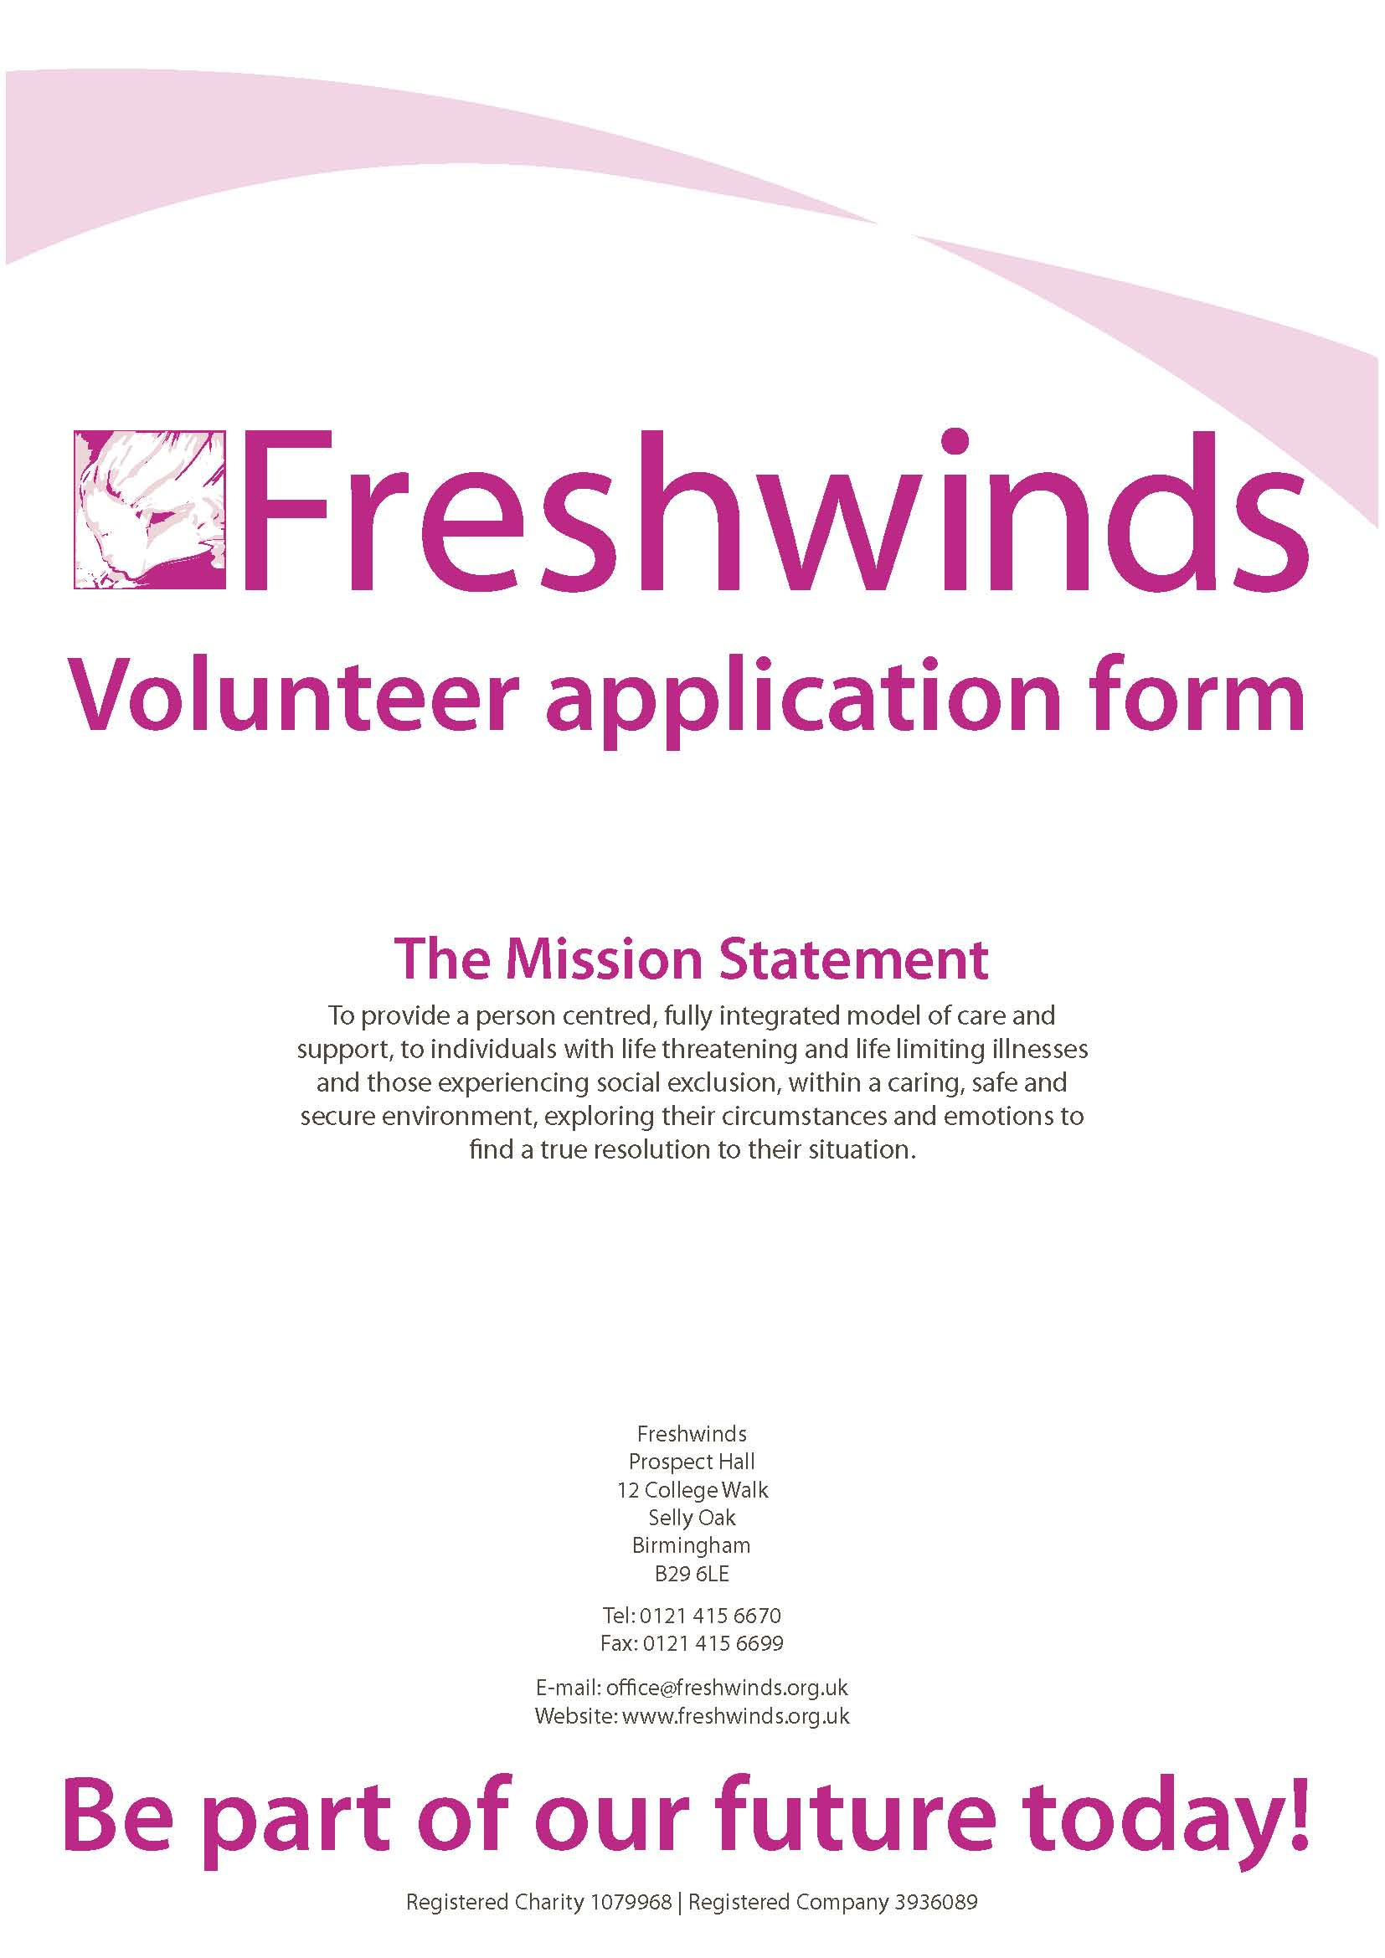

Please complete all sections of this application form to the best of your ability. This should only take about 10 - 15 minutes.

It is important that you provide as much information as possible in order to support your application with us and ensure that we have the necessary information to process it.

Please click text boxes to mark them as checked, they are interactive.

You may wish to copy and paste parts of your CV into this form (education, work experience, etc.) to save time typing things out again.

Once complete, please return to Freshwinds using one of the methods provided below:

Contact | Volunteer Coordinator
Via Email | volunteer@freshwinds.org.uk
Via Post | Freshwinds, Prospect Hall, 12 College Walk, Selly Oak, Birmingham, B29 6LE
Via Fax | 0121 415 6699

If you have any difficulties completing this form, please use the information above to get in touch, or call 0121 415 6670.

Thank you for your interest in volunteering with Freshwinds, and we look forward to receiving your application.

Please continue to the next section.

Volunteer Monitoring
In order to help us monitor the effectiveness of our Equal Opportunities Policy, please complete the following information. Please note that this information is optional, and will not affect your application to volunteer.

Ethnicity
White
British Irish
Other (please specify):
Mixed
White / Black Caribbean White / Black African White / Asian
Other (please specify):
Asian / Asian British
Pakistani Indian Bangladeshi
Other (please specify):
Black / Black British
Caribbean African
Other (please specify):
Other
Other ethnic group (please specify):

Religion
Christian Muslim Sikh Buddhist
Hindu Jewish Agnostic No religion
Other (please specify):

Gender
Female Male Trans Other

Sexual Orientation
Heterosexual Homosexual Bisexual Other

Disability
Do you have a disability?
Yes No
If support or special arrangements are required at interview stage, please provide further details:

Age
Date of Birth:

Personal Details (Required)
Title
Forename(s)
Surname
Address
Postcode
Telephone
Mobile
Email

How did you hear about Freshwinds?

Volunteering
What kind of volunteering would you like to do at Freshwinds?
CEO’s Office  Reception  Marketing  Fundraising  Legal Volunteer  Volunteer Ambassador  Other (please specify): | Freshwinds IT (FIT)  Web Design  Graphic Design  IT Support  Other (please specify):
Integrated Medicine (IM)  Complementary Therapist  Research  Community Heritage Advocate  Other (please specify): | Advice and Welfare (FInDA)  Administration  Advisor  Translating  Other (please specify):
Not Sure
Please specify:

Are you looking for a volunteer position, work experience or a placement with us?
Volunteer Work Experience Placement
For Work Experience / Placement, please specify if known:

Work History & Experience
Please list your ‘Work History’ and/or ‘Volunteer Experiences’ that you think are important to this application.

Qualifications
Please list your ‘Qualifications’ e.g. Training Courses and anything which you think is important to this application. Please also indicate any additional languages that you speak.

Professional Insurance / Membership
Do you have professional insurance/membership (if so please provide details).

Special Skills
Do you have specialist skills, interests or hobbies that you would like to use when volunteering for Freshwinds?

Reason for Application
Why do you want to volunteer with Freshwinds? What is it that particularly attracts you to us?

Support
What support, training or supervision do you think you may need?

Time
How much time would you be able to give for voluntary work at Freshwinds? (e.g. Total hours per day/week/month, particular days/times, etc.)

For all applications, please provide details of two references.
These can be either professional or character references from a professional person. As we prefer to contact referees via email it would be most helpful if you could provide an email address for your referees.

Volunteer therapists will require a minimum of 2 references from people who can comment on relevant and recent aspects of their therapeutic work. Therapists wishing to work with children must provide at least one reference from a person who can comment on their work with children or, if they have not worked with children, comment on their character, attitudes, behaviour etc. towards children.

Referee 1 |  | Referee 2
Title |  | Title
Name |  | Name
Email |  | Email
Address |  | Address
Postcode |  | Postcode
Telephone |  | Telephone
Capacity in which they know you |  | Capacity in which they know you

Confirmation of details
Falsification of information on the form will result in your application not being pursued or your voluntary placement being terminated if you have already begun working with Freshwinds. To ensure the maximum protection to our clients, staff and volunteers of Freshwinds, and in the interests and professionalism of the charity in general, the Trustees and other authorised persons reserve the right to make full confidential enquires regarding personal and other data pertaining to applicants as permitted generally by law and in particular within the parameters of the Rehabilitation of Offenders Act 1974 and Exceptions to the Act, the Data Protection Act 1984, the Trade Union and Labour Regulations (Consolidation Act) 1992, and the Disability Discrimination Act 1995 and other relevant legislation. I confirm that the details in this application form are correct and complete.
Signed: Date:

Please continue to the next section to read about the Disclosure process.

Disclosures
Due to the nature of the work carried out at Freshwinds, particularly in relation to vulnerable adults and children, we may ask you to apply for a criminal record check (called a Disclosure). Disclosures are provided by the Disclosure and Barring Service (DBS), which is an executive agency of the Home Office. The Disclosure service offers organisations a means to check the background of job applicants to ensure that they do not have a history that would make them unsuitable for the posts that they are trying to fill.
Please note that having a criminal record will NOT NECESSARILY bar you from becoming a volunteer. The criminal record will only be taken into consideration if it is relevant to this position.
There are two levels of Disclosure (standard and enhanced). The level of Disclosure you will be asked to apply for will depend on the voluntary work that you do.
Standard
Spent and unspent convictions (under the terms of the Rehabilitation of Offenders Act 1974 (Exceptions) Order 1975), cautions, reprimands and warnings, and an indication if the individual is barred from working with children or vulnerable adults (if relevant to the post)
Enhanced
Provides the same information as standard disclosure; also may contain non-conviction information from local police records if relevant to the position.
Volunteer therapists will require an Enhanced Disclosure as they will be working directly with vulnerable adults and children. All volunteers will be checked against the lists of people not allowed to work with children or vulnerable adults.
Following your interview, if you are offered a volunteer post, you will be given the opportunity to disclose any criminal records to a designated person. If you would like to disclose any criminal records with your application form, instead of waiting for the interview, you can send the information in a separate letter marked ‘private and confidential’ for the attention of Mohammed Al-Rahim (Chief Executive). You may, if you wish, also send supporting information regarding the criminal record that you feel will give us a better understanding of the circumstances and allow us to make a fair decision about its relevance to this position. The information that you give will be kept confidential. Freshwinds is registered and acts in full compliance with the Data Protection Act.
Further information on Disclosure and the DBS can be obtained from:
1) Freshwinds - the following documents are available on request:
a) Applicant’s Guide to the Disclosure and Barring Service
b) Freshwinds policy statement on the recruitment of ex-offenders
c) Freshwinds policy statement on the secure storage, handling, use, retention and disposal of Disclosures and Disclosure information
d) DBS Code of Practice
e) Volunteers wishing to speak to someone in person should contact James Voller on 0121 415 6670
2) The Disclosure and Barring Service (DBS) on 01325 953 795, dbsdispatch@dbs.gsi.gov.uk or https://www.gov.uk/government/organisations/disclosure-and-barring-service
Freshwinds’ policy statement on the recruitment of ex-offenders

- As an organisation using the Disclosure and Barring Service (DBS) to assess applicant’s suitability for positions of trust, Freshwinds complies fully with the DBS Code of Practice and undertakes to treat all applicants for positions fairly. It undertakes not to discriminate unfairly against any subject of a Disclosure on the basis of conviction or other information revealed.
- Freshwinds is committed to the fair treatment of its staff, potential staff or users of its services, regardless of race, gender, religion, sexual orientation, responsibilities for dependants, age, physical/mental disability or offending background.
- We have a written policy on the recruitment of ex-offenders, which is made available to all Disclosure applicants at the outset of the recruitment process.
- We actively promote equality of opportunity for all with the right mix of talent, skills and potential and welcome applications from a wide range of candidates, including those with a criminal record. We select all candidates for interview based on their skills, qualifications and experience.
- A disclosure is only requested after a thorough risk assessment has indicated one is both proportionate and relevant to the position concerned. For those positions where a Disclosure is required, it will be made clear to the applicant during the recruitment process that a Disclosure will be requested in the event of the individual being offered the position.
- Where a Disclosure is to form part of the recruitment process, we encourage all applicants called for an interview to provide details of their criminal record at an early stage in the application process. We request that this information is sent under separate, confidential cover, to a designated person within Freshwinds (please see above) and we guarantee that this information is only to be seen by those who need to see it as part of the recruitment process.
- Unless the nature of the position allows Freshwinds to ask questions about your entire criminal record we only ask about “unspent” convictions as defined in the Rehabilitation of Offenders Act 1974.
- We ensure that all those in Freshwinds who are involved in the recruitment process have been suitably trained to identify and assess the relevance and circumstances of offences. We also ensure that they have received appropriate guidance and training in the relevant legislation relating to the employment of ex-offenders, e.g. the Rehabilitation of Offenders Act 1974.
- At interview, or in a separate discussion, we ensure that an open and measured discussion takes place on the subject of any offences or other matter that might be relevant to the position. Failure to reveal information that is directly relevant to the position sought could lead to withdrawal of an offer of employment.
- We make every subject of a DBS Disclosure aware of the existence of the DBS Code of practice and make a copy available on request.
- We undertake to discuss any matter revealed in a Disclosure with the person seeking the position before withdrawing a conditional offer of employment.
Having a criminal record will not necessarily bar you from working or volunteering with us. This will depend on the nature of the position and the circumstances and background of your offences.

