Self-Service Data Access Request
Software Architecture Document
Spiral 1
Version 0.1

Revision History
Date | Version | Description | Author
20/Dec/2006 | 0.1 | Initial draft | Jereme Kuperman

Table of Contents
1. Introduction 4
1.1 Purpose 4
1.2 Scope 4
1.3 Definitions, Acronyms, and Abbreviations 4
1.4 References 5
2. Architectural Representation 5
3. Architectural Goals and Constraints 6
4. Use Case View 6
4.1 Actors 6
4.1.1 Data Consumer 6
4.2 Use Cases 7
4.3 Use Case Realizations 7
4.3.1 Legend 7
4.3.2 MVC Framework 8
4.3.3 Sitemap 9
4.3.4 Create 10
4.3.5 Preferences 10
4.3.6 Resume/Home 11
4.3.7 Existing 12
4.3.8 Existing Actions 13
4.3.9 Wizard 1 14
4.3.10 Wizard 2 15
4.3.11 Wizard 3 16
4.3.12 Wizard 4 17
4.3.13 Wizard 5 18
4.3.14 Wizard 6 18
5. Development View 19
5.1 Overview 19
5.1.1 Packaging 19
5.1.2 Architectural Layers 20
5.2 Architecturally Significant Design Packages 20
5.2.1 Data Catalog 20
5.2.2 Data Extractor 21
5.2.3 Extract Catalog 21
5.2.4 User Preferences 24
6. Deployment View 25
7. Data View 26
8. Quality 26

Software Architecture Document

Introduction

Purpose
Lockheed Martin has been contracted to provide a Self-Service Data Access Request solution for Air Force Data Services (AFDS) to address two current issues: the staffing workload necessary to service customer data access requests (DARs) and the current backlog of data access requests. The infrastructure enhancement delivered by Self-Service DAR will provide a self-service capability for users who want to request or schedule extracts from the data warehouse.

This document provides a comprehensive architectural overview of the system, using a number of different architectural views to depict different aspects of the system. It is intended to capture and convey the significant architectural decisions which have been made on the system.

Scope
The scope of this Software Architecture Document is the first construction phase of Self-Service Data Access Request (contract number F01620-96-D-0004, Task Order 5495, Mod 10).

Definitions, Acronyms, and Abbreviations
The following terms appearing elsewhere in this document are defined here.
Term |  | Definition
Data Access Request | A request for a Data Extract that has an associated Work Plan that covers extracting the data from the source system(s), bringing it into the Data Warehouse, developing database views to support the required output, developing the extract process to bring the data out of the Data Warehouse and deliver it to the requestor in the desired format at the desired frequency. Note that all steps other than extraction and delivery are optional in implementing a DAR.
Data Consumer | A person who defines data extracts to be executed.
Data Element | An attribute of a Table. Also called a Column.
Data Extract Definition | The grouping of Tables, Data Elements, filter criteria, output format, and delivery destination that implements a Data Access Request.
Data Extract Run | An execution of a Data Extract Definition.
Data Extract Run Result | The file created as a result of a Data Extract Run.
Delivery Destination | Describes how Data Extract Run Results should be delivered to a Data Consumer.
Domain | A categorization that may be used to group Tables. Examples include "maintenance", "personnel", and "supply".
Enterprise Service Bus | A mechanism for integrating enterprise applications in an implementation-independent fashion, at a coarse-grained service level (leveraging the principles of service-oriented architecture) via an event-driven and XML-based messaging engine (the bus). An enterprise service bus frequently is a delivery vehicle for an Enterprise Messaging System.  Specifically, this is Global Combat Support System - Air Force Enterprise Service Bus built on IBM MQSeries and deployed at Wright-Patterson Air Force Base.
Metadata | Any information that describes a particular set of data including format, business name, owner, and update frequency.
Self-Service Data Extract Tool | Part of the overall Self-Service Data Access Request. The tool is used to select and filter data elements, select output format and delivery destination, schedule runs and view existing requests. This tool also allows the user to see all past extract runs, save ‘in process’ definition requests, copy/edit/delete existing data definition requests and provides access to logs and output files.
Self-Service Data Extract Wizard | Exists as a subset of the SS Data Extract Tool. It is the part of the process (wizard) used to create the extract definition. The wizard contains multiple steps to create the data definition: General Extract Information, Data Selection, Filter Criteria, Output format and location, a Summary/submit step, and a Scheduling feature.
Source System | A repository containing information of interest to Data Consumers. Also called a Database. In a Data Warehouse, the Source System generally refers to the origin of the data.
Table | A structured representation of a group of Data Elements.

The following acronyms and abbreviations appearing elsewhere in this document are defined here.
Acronym | Meaning
AFDS | Air Force Data Services
DAR | Data Access Request
ESB | Enterprise Service Bus
ETL | Extract-Transform-Load
GCSS-AF | Global Combat Support System - Air Force
JDBC | Java Database Connectivity
SSDAR | Self Service Data Access Request system
VPN | Virtual Private Network
XML | Extensible Markup Language

References
The following documents were referenced in the development of this document:
- "Self-Service Data Access Request Feature List." Lockheed Martin. 24 Oct 2006. <http://ipewss.iss.lmco.com/sites/Self_Service_DAR/Shared%20Documents/Requirements/S-S DAR Features.xls>.
- "Self-Service Data Access Request Vision Document." Version 0.1. Lockheed Martin. 13 Oct 2006. <http://ipewss.iss.lmco.com/sites/Self_Service_DAR/Shared%20Documents/Requirements/S-S DAR%20Vision.doc>.
- "Self-Service DAR Wire-frames." Roundarch. 15 Dec 2006. <http://ipewss.iss.lmco.com/sites/Self_Service_DAR/Shared%20Documents/Requirements/USAF_SSDAR_Wireframes_(12_12_06)_v1.96.vsd>
- "Self-Service Data Access Request Software Requirements Specification". Version 1.0. Lockheed Martin. 20 Dec 2006. <http://ipewss.iss.lmco.com/sites/Self_Service_DAR/Shared%20Documents/Requirements/S-S%20DAR%20Requirements.doc>
- "Self-Service Data Access Request Web Application Flow Diagrams." Version 0.1. Roundarch. 15 Dec 2006. <http://ipewss.iss.lmco.com/sites/Self_Service_DAR/Shared%20Documents/Design/2006-12-15_webappFlowDiagrams_0.11.vsd>

Architectural Representation
The architecture of a system consists of components, their external properties, and their relationships with one another. Documenting software architecture facilitates communication between stakeholders, documents early decisions about high-level design, and allows reuse of design components and patterns between projects.

The balance of this document examines the Self-Service Data Access Request solution from a variety of perspectives. The views detailed in this document are:
- Use Case View. This view examines the solution from the user's perspective. In this section, users of the system are presented as actors, and functionality of the system is presented as use cases. Also in this section is an examination of the flow of the user interface to be implemented during the Construction phase.
- Development View. This view examines the solution from a developer's perspective, and describes the software components to be built during the Construction phase.
- Deployment View. This view examines the solution as it will be deployed to a production environment, and describes the components to be deployed, as well as their targeted environments.
- Data View. This view examines the solution from database perspective, and provides the schema for any databases required.

In addition to the above views, the architectural and quality goals of the solution are presented, along with constraints or metrics required to meet those goals.

Architectural Goals and Constraints

The architectural goals of this solution are:
- Modifiability to allow the underlying implementation of each component to be altered while minimizing impact to other components.
- Extensibility to allow future development to expand on capability delivered.
- Velocity in terms of iterative and parallel development and incremental deployment.
- Usability, from the perspective of both the content and the method of presentation.

In light of the above goals, the following constraints have been placed on the architecture of the solution:
- The solution will leverage existing infrastructure wherever practical. This includes software, hardware, and business practices.
- The solution will adhere to existing processes, including security and privacy.
- The solution will be accessible through the GCSS-AF portal (BroadVision portal)
- The solution will utilize Web Sphere as an application server.
- The solution will utilize Informatica PowerCenter to run data extracts.
- The solution will utilize Java 2 Enterprise Edition (J2EE) best practices.

Use Case View
This view presents the user's perception of the functionality provided by the Self-Service Data Access Request solution. These use cases are examined in more detail in "Self-Service Data Access Request Software Requirements Specification", and are included here to provide context for the rest of the document.

Actors


Data Consumer
A Data Consumer comes to the solution to request outbound data. He identifies the data elements to be included, how those elements will be filtered, the format of the output, and the delivery mechanism, schedule, and destination.

Use Cases
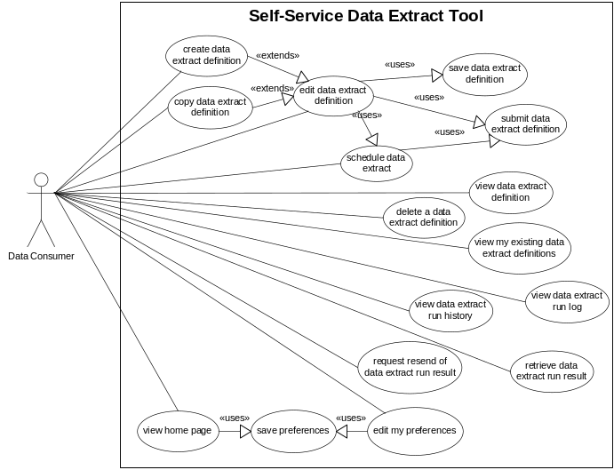

Use Case Realizations

Legend
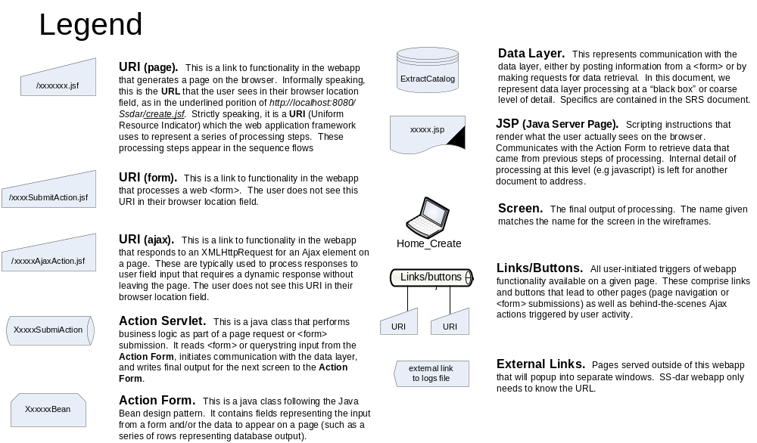

MVC Framework
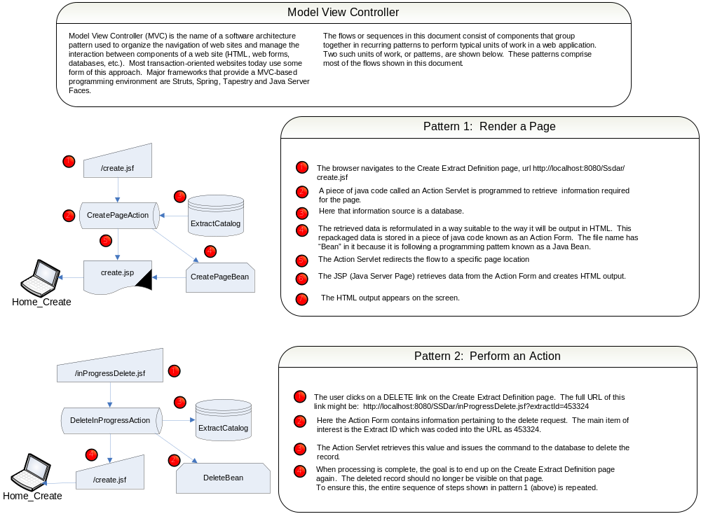

Sitemap
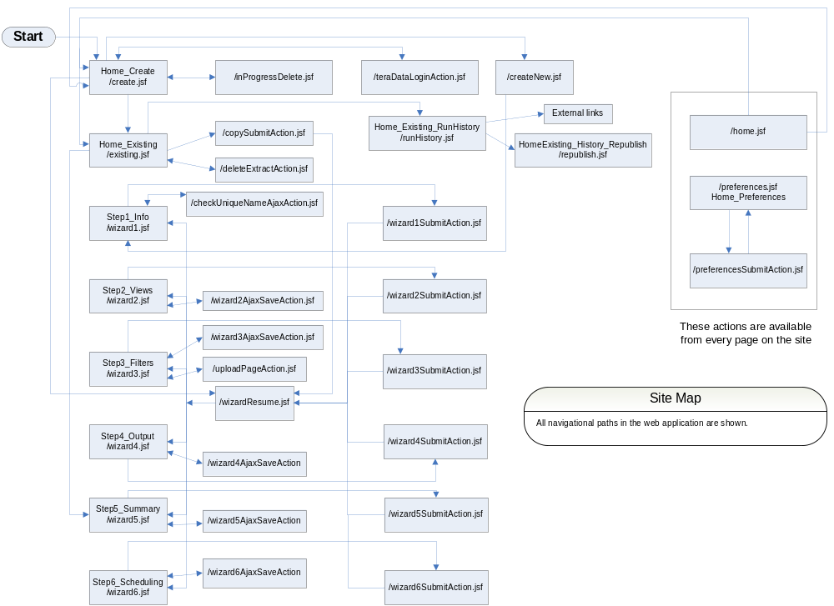

Create
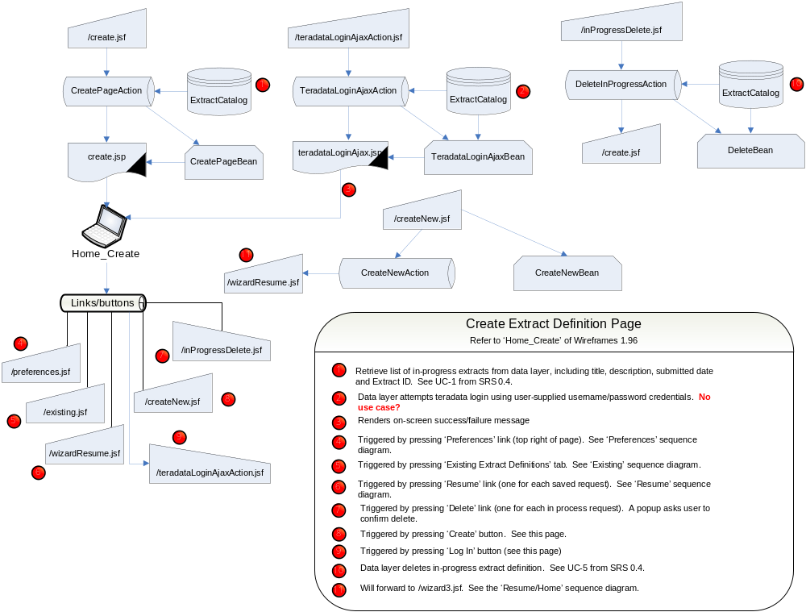

Preferences
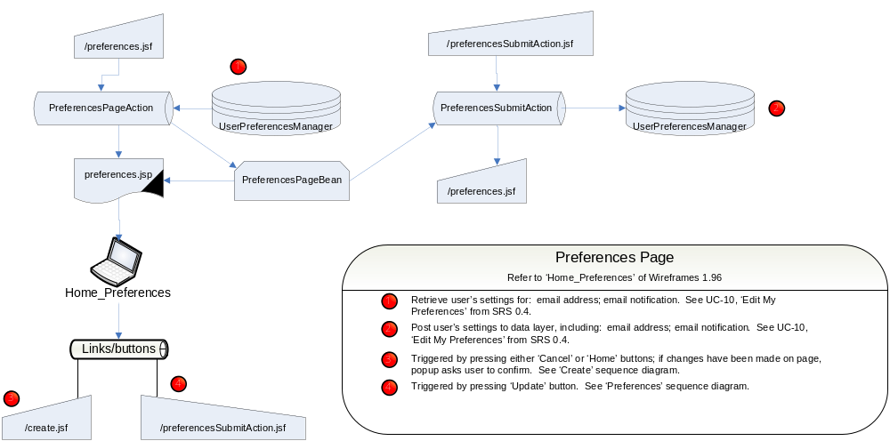

Resume/Home
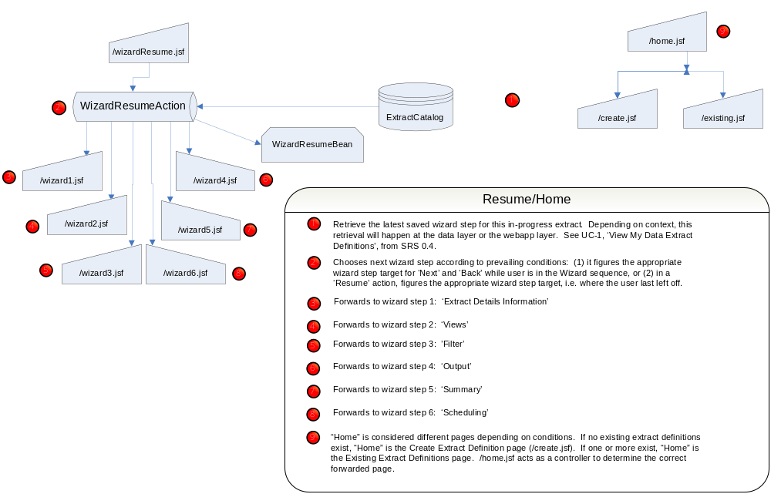

Existing
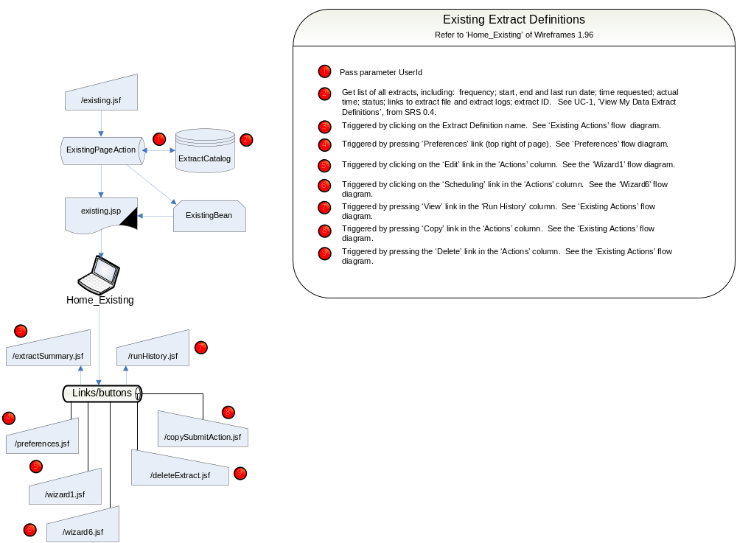

Existing Actions
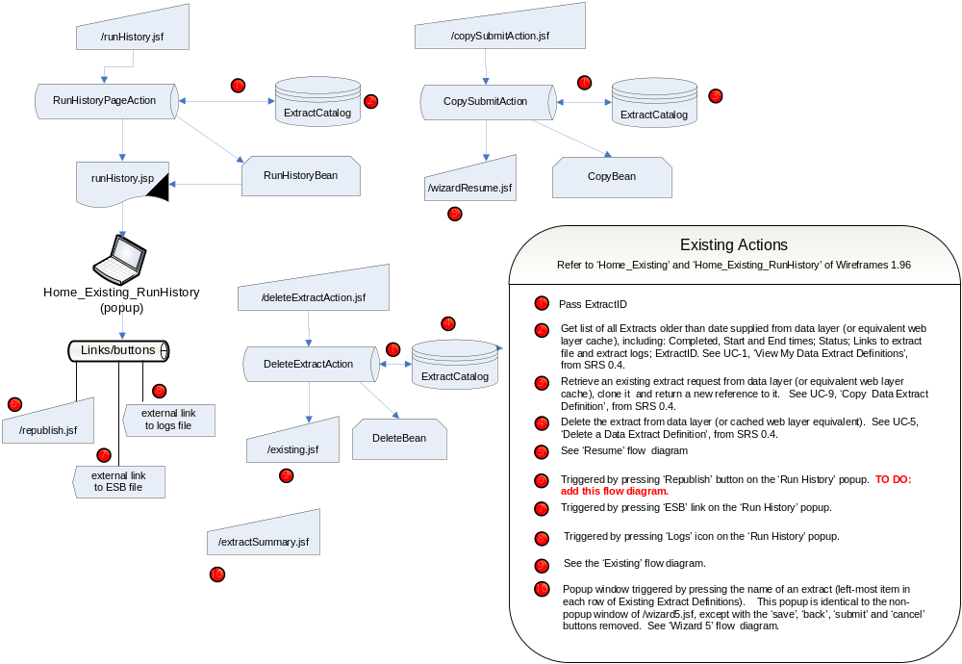

Wizard 1
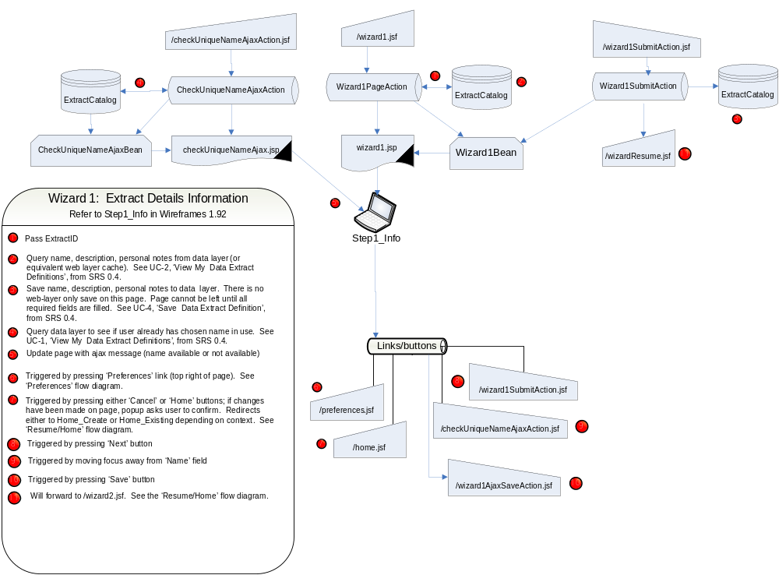

Wizard 2
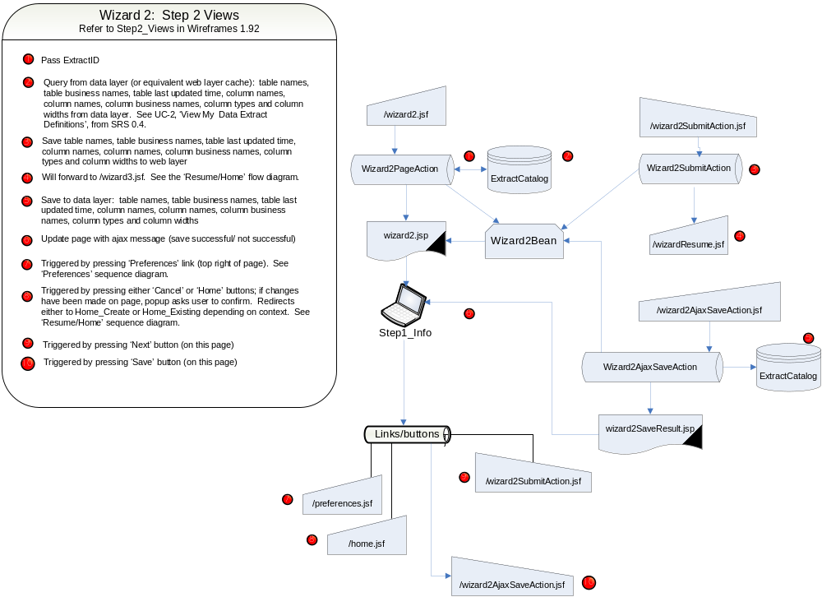

Wizard 3
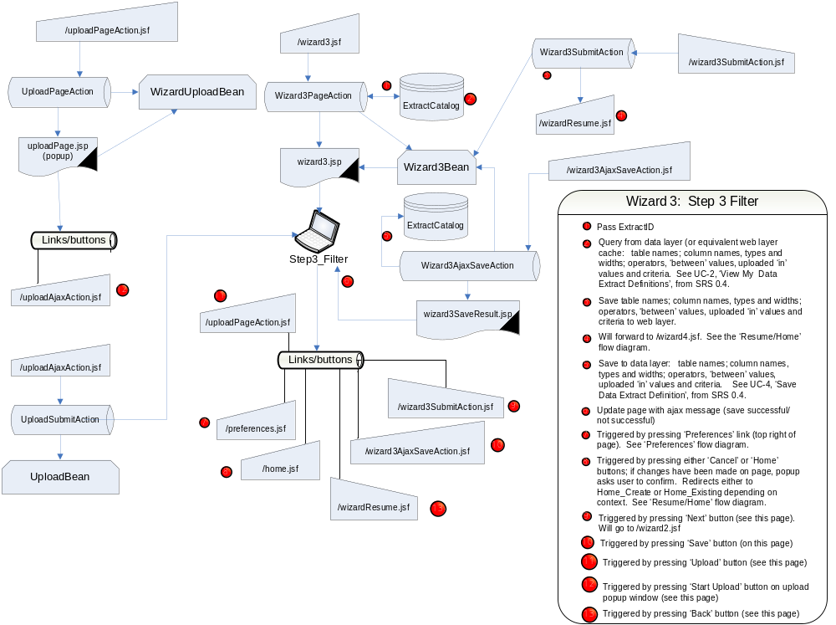

Wizard 4
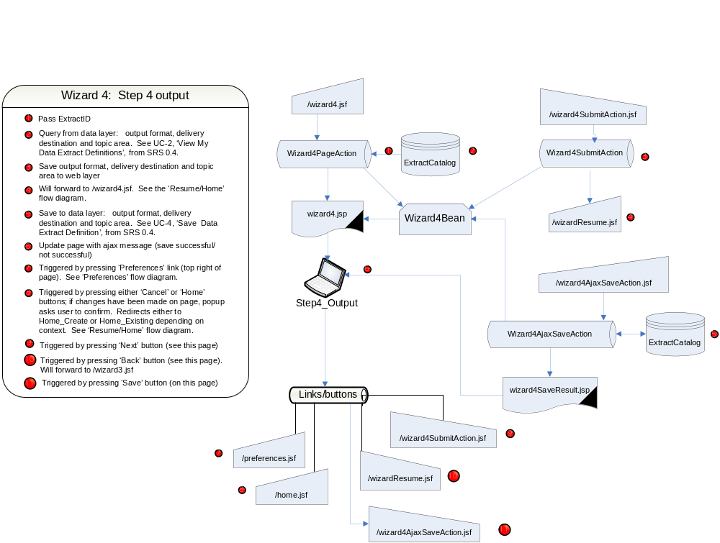

Wizard 5
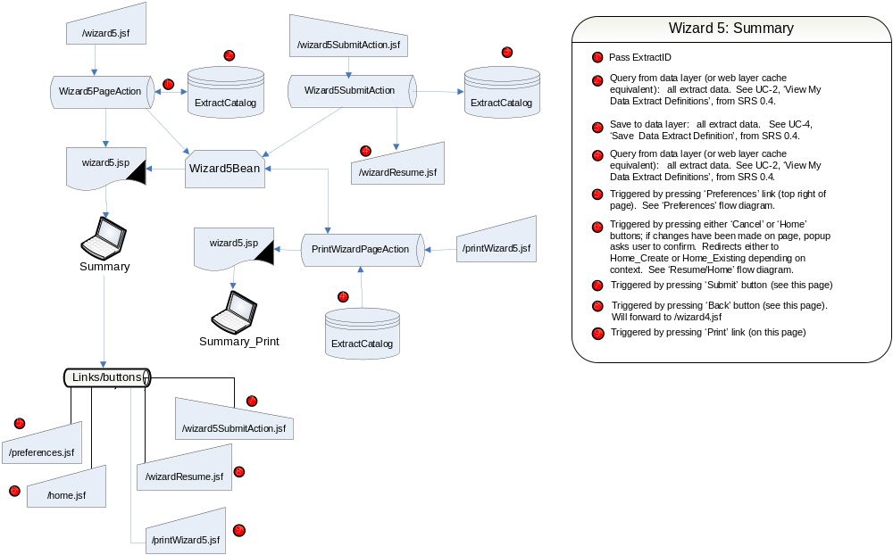

Wizard 6
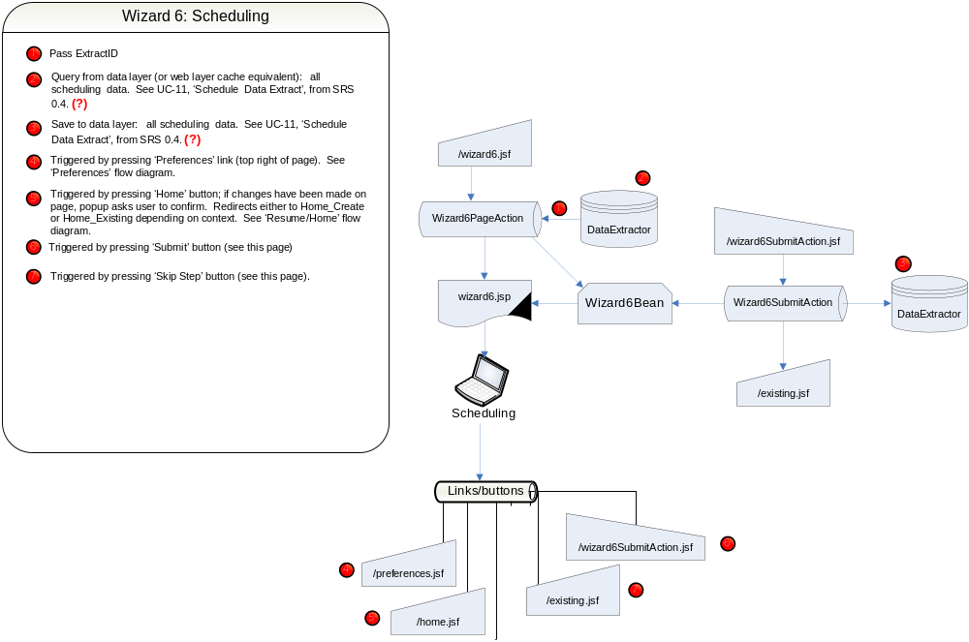

Development View

Overview

Packaging
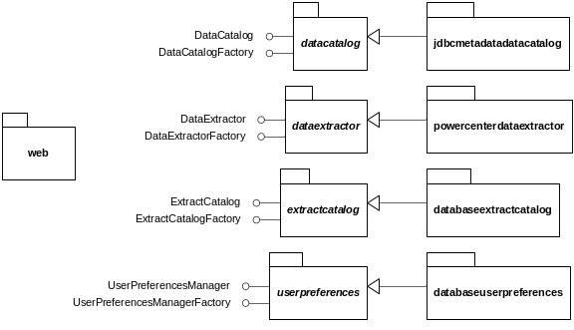
The Self-Service Data Access Request solution will consist of five main packages, each with specific responsibilities. They are:
- Web. Responsible for providing the user interface to the other packages. Ultimately serves as the "glue" that implements the use cases from the Software Requirement Specification.
- Data Catalog. Responsible for providing metadata about tables within the Data Warehouse that may be assembled by users into Data Extracts.
- Data Extractor. Responsible for running Data Extracts and providing access to run history.
- Extract Catalog. Responsible for storing Data Extract Definitions.
- User Preferences. Responsible for storing User Preferences.

The Data Catalog, Data Extractor, Extract Catalog, and User Preferences packages each provide interfaces and associated classes as described in Section 5.2. Each of these abstract packages will require a concrete implementation that provides the required functionality. This approach reduces coupling between packages, and reduces the impact of changes to the implementation of each.

For Spiral 1, these concrete packages will be:
- JDBC Metadata Data Catalog. Provides an implementation of the DataCatalog interface based on using connection metadata provides by the Java Database Connector. This approach lacks business names and descriptions for tables and columns, as well as lineage (source system) information, but leverages prototype code developed during the Elaboration Phase.
- PowerCenter Data Extractor. Provides an implementation of the DataExtractor interface using Informatica PowerCenter 8.1 server to schedule and run Data Extracts as workflows.
- Database Extract Catalog. Provides an implementation of the ExtractCatalog interface using a database for storage of Data Extracts. Object-Relational mapping will be accomplished through the use of Hibernate Core for Java.
- Database User Preferences. Provides an implementation of the UserPreferencesManager interface using a database for storage of User Preferences. Object-Relational mapping will be accomplished through the use of Hibernate Core for Java.

Architectural Layers
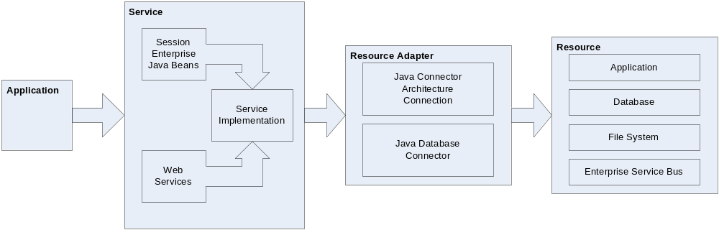
The Self-Service Data Access Request solution is broken down along four main layers, each with distinct responsibilities. These layers and responsibilities are:
- Application Layer. Applications provide users with access to one or more Services to satisfy a business goal.
- Service Layer. Services are reusable processes that may be assembled together to achieve a business goal. From a technical perspective, these may be exposed as Web Services, Enterprise Java Beans, CORBA objects, etc.
- Resource Adapter Layer. Resource Adapters serve two functions: to simplify access to Resources, and to allow that access to be managed.
- Resource Layer. Resources are entities that support delivery of Services. Examples include, but are not limited to, databases, applications, files on file systems, and messaging systems. They are generally shared and finite, so care must be taken not to overburden them.

Architecturally Significant Design Packages
The packages described in this section are interest from an architectural perspective because they define the reusable services that will be made available by the Self-Service Data Access Request system.

Data Catalog
The Data Catalog package is responsible for providing metadata about tables within the Data Warehouse that may be assembled by users into Data Extracts.

Classes
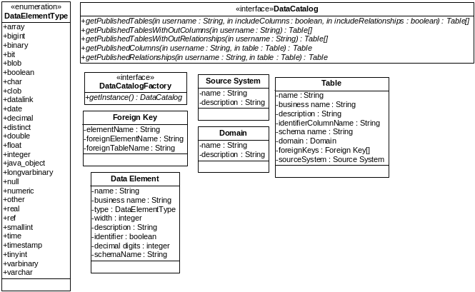
Class Name | Description
Data Catalog | An interface that defines the capabilities exposed by this package. Implementations provide metadata about tables within the Data Warehouse that may be assembled by users into Data Extracts.
Data Catalog Factory | Implementations of this interface provide a common method for creating Data Catalog instances.
Data Element | An attribute of a Table. Also called a Column.
Data Element Type | A list of possible types for Data Elements.
Domain | A categorization that may be used to group Tables. Examples include "maintenance", "supply", and "personnel".
Foreign Key | A relationship from one Table to another via a Data Element.
Source System | A repository containing information of interest to Data Consumers.
Table | A collection of Data Elements within the Data Warehouse. May be associated with a Domain and/or a Source System.

Data Extractor
The Data Extractor package is responsible for running Data Extracts and providing access to run history.

Classes
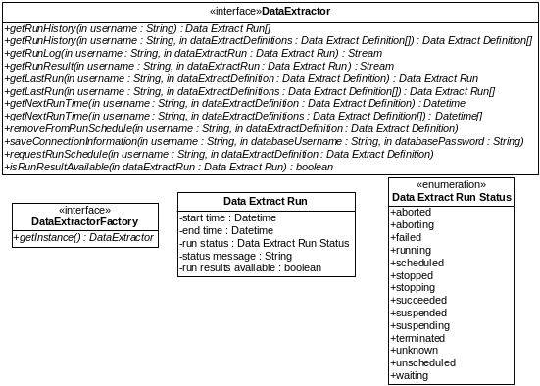
Class Name | Description
Data Extract Run | An execution of a Data Extract.
Data Extract Run Status | A list of possible states for a Data Extract Run.
Data Extractor | An interface that defines the capabilities exposed by this package. Implementations provide the ability to schedule Data Extracts and provide access to run history.
Data Extractor Factory | Implementations of this interface provide a common method for creating Data Extractor instances.

Extract Catalog
The Extract Catalog package is responsible for storing and retrieving Data Extract Definitions.

Classes
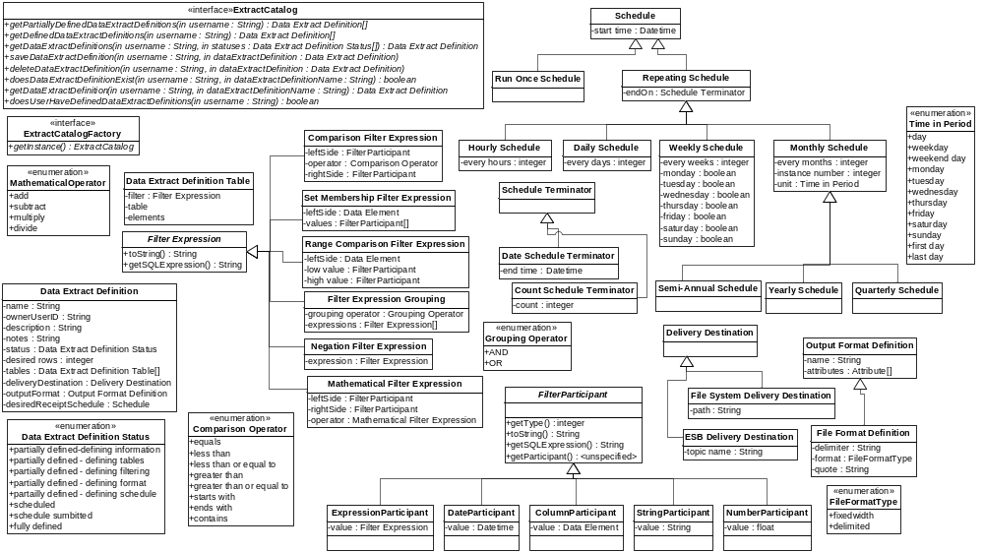
Class Name | Description
Column Participant | A type of Filter Participant that allows Data Elements to be included in Filter Expressions.
Comparison Filter Expression | A type of Filter Expression that compares the value of a Data Element against a constant or another Data Element (e.g., MDS="C005").
Comparison Operator | A list of possible values for the operator attribute of a Comparison Filter Expression.
Count Schedule Terminator | A type of schedule terminator that indicates that the schedule ends after a set number of runs.
Daily Schedule | A repeating activity with a period measured in days.
Data Extract Definition | The grouping of Data Elements, filter criteria, output format, delivery destination, and run schedule that implements a Data Access Request.
Data Extract Definition Status | A list of possible statuses for a Data Extract Definition.
Data Extract Definition Table | A set of Data Elements from a Table with a Filter Expression to be included in a Data Extract Definition.
Date Participant | A type of Filter Participant that allows date and time constants to be included in Filter Expressions.
Date Schedule Terminator | A type of schedule terminator that indicates that the schedule ends after a set date.
Delivery Destination | Describes how Data Extract Run Results should be delivered to a Data Consumer.
ESB Delivery Destination | A class of Delivery Destination that places Data Extract Run Results on the Enterprise Service Bus.
Expression Participant | A type of Filter Participant that allows expressions (e.g., a + b) to participate in Filter Expressions.
Extract Catalog | An interface that defines the capabilities exposed by this package. Implementations provide methods for storing and retrieving Data Extract Definitions.
Extract Catalog Factory | Implementations of this interface provide a common method for creating Extract Catalog instances.
File Format Definition | Describes the format of a "flat" or text file. May be character (tab, space, comma) delimited, or fixed width.
File Format Type | A list of possible formats for a File Format Definition.
File System Delivery Destination | A class of Delivery Destination that places Data Extract Run Results on a file system.
Filter Expression | Describes how rows in a Table should be included or excluded from a Data Extract.
Filter Expression Grouping | A type of Filter Expression that groups multiple Filter Expressions together, either requiring all to be met (AND operator) or only one to be met (OR operator) (e.g., ((MDS="C005") OR (MDS="C130") OR (MDS="F022A")).
Filter Participant | A generalization of "things" that may be included in a Filter Expression.
Grouping Operator | A list of allowable values for how Filter Expressions in a Filter Expression Grouping are combined.
Hourly Schedule | A repeating activity with a period measured in hours.
Mathematical Filter Expression | A type of Filter Expression that joins two Filter Expressions using a Mathematical Operator (e.g., adding two columns together).
Mathematical Operator | A list of allowed operations for Mathematical Filter Expressions.
Monthly Schedule | A repeating activity with a period measured in months.
Negation Filter Expression | A type of Filter Expression that inverts the contained Filter Expression. (e.g., NOT (MDS="C005"))
Number Participant | A type of Filter Participant that allows numeric constants to be included in Filter Expressions.
Output Format Definition | Used to describe the format of the output of a Data Extract. Subtypes include flat files, XML, and database tables.
Quarterly Schedule | A repeating activity with a period measured in quarters (3 months).
Range Comparison Filter Expression | A type of Filter Expression that compares the value of a Data Element with a range of values (e.g., STOCK_ON_HAND BETWEEN 30 AND 90).
Repeating Schedule | An activity that occurs on a regular basis.
Run Once Schedule | A non-repeating activity. When associated with a Table, this schedule indicates that its data is not refreshed regularly. When associated with a Data Extract Definition, this schedule indicates that it will be run one time.
Schedule | Used to indicate how often an activity occurs. Specifically used to indicate how often a Table is updated, and how often a Data Extract should be executed.
Schedule Terminator | Determines when a Repeating Schedule ends.
Semi-Annual Schedule | A repeating activity with a period of 6 months.
Set Membership Filter Expression | A type of Filter Expression that compares the value of a Data Element against a set of values (e.g., MDS IN ("C005",…, "C150")).
String Participant | A type of Filter Participant that allows string constants to be included in Filter Expressions.
Time In Period | A list of possible values used to describe when during the period described by a Monthly Schedule (or its subclasses) a Scheduled event occurs.
Weekly Schedule | A repeating activity with a period measured in weeks.
Yearly Schedule | A repeating activity with a period measured in years.

User Preferences
The User Preferences package is responsible for storing and retrieving User Preferences.

Classes
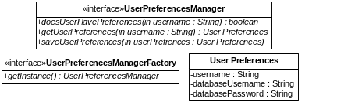
Name | Description
User Preferences | Application settings for the user.
User Preferences Manager | An interface that defines the capabilities exposed by this package. Implementations provide methods for storing and retrieving User Preferences.
User Preferences Manager Factory | Implementations of this interface provide a common method for creating User Preferences Manager instances.

Deployment View
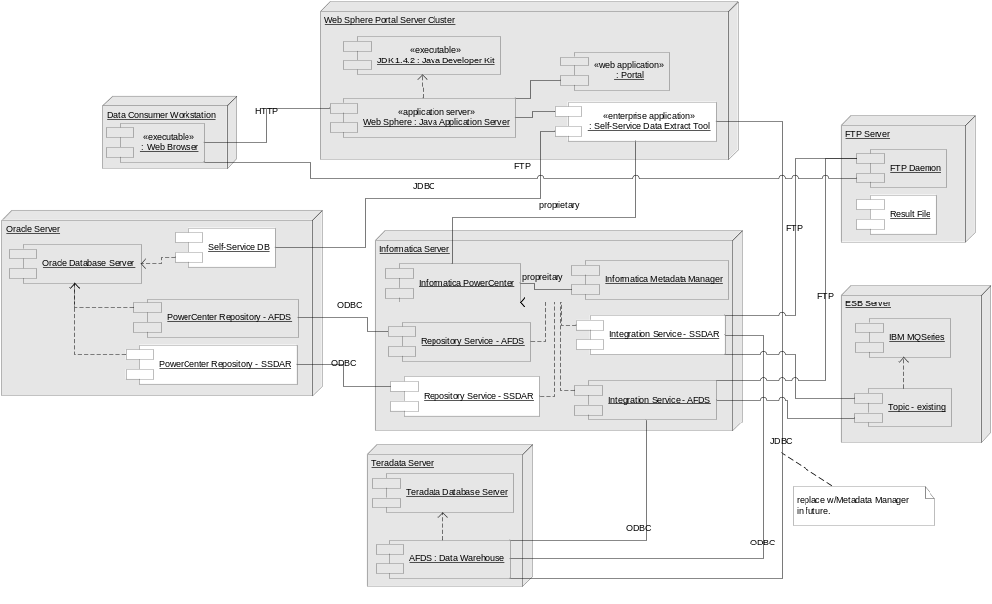
The Self-Service Data Access Request spiral 1 solution will leverage existing software and hardware infrastructure. Specifically, the deployed solution will consist of the following new items (highlighted in the diagram above):
- Self-Service Data Extract Tool. A J2EE Application packaged as an Enterprise Application Archive (EAR) and deployed on the IBM WebSphere Portal Server Cluster.
- Self-Service Database. A database to hold Date Extract Definitions and User Preferences, to be deployed on the shared Oracle server.
- Self-Service Repository Database, Repository Service, and Integration Service. These components will be added to the Informatica PowerCenter landscape to allow the Self-Service Data Access Request solution to be managed independently from the existing Air Force Data Services Informatica ETL processes.
- Result Files will be sent to a central FTP Server for retrieval by the user.

Data View
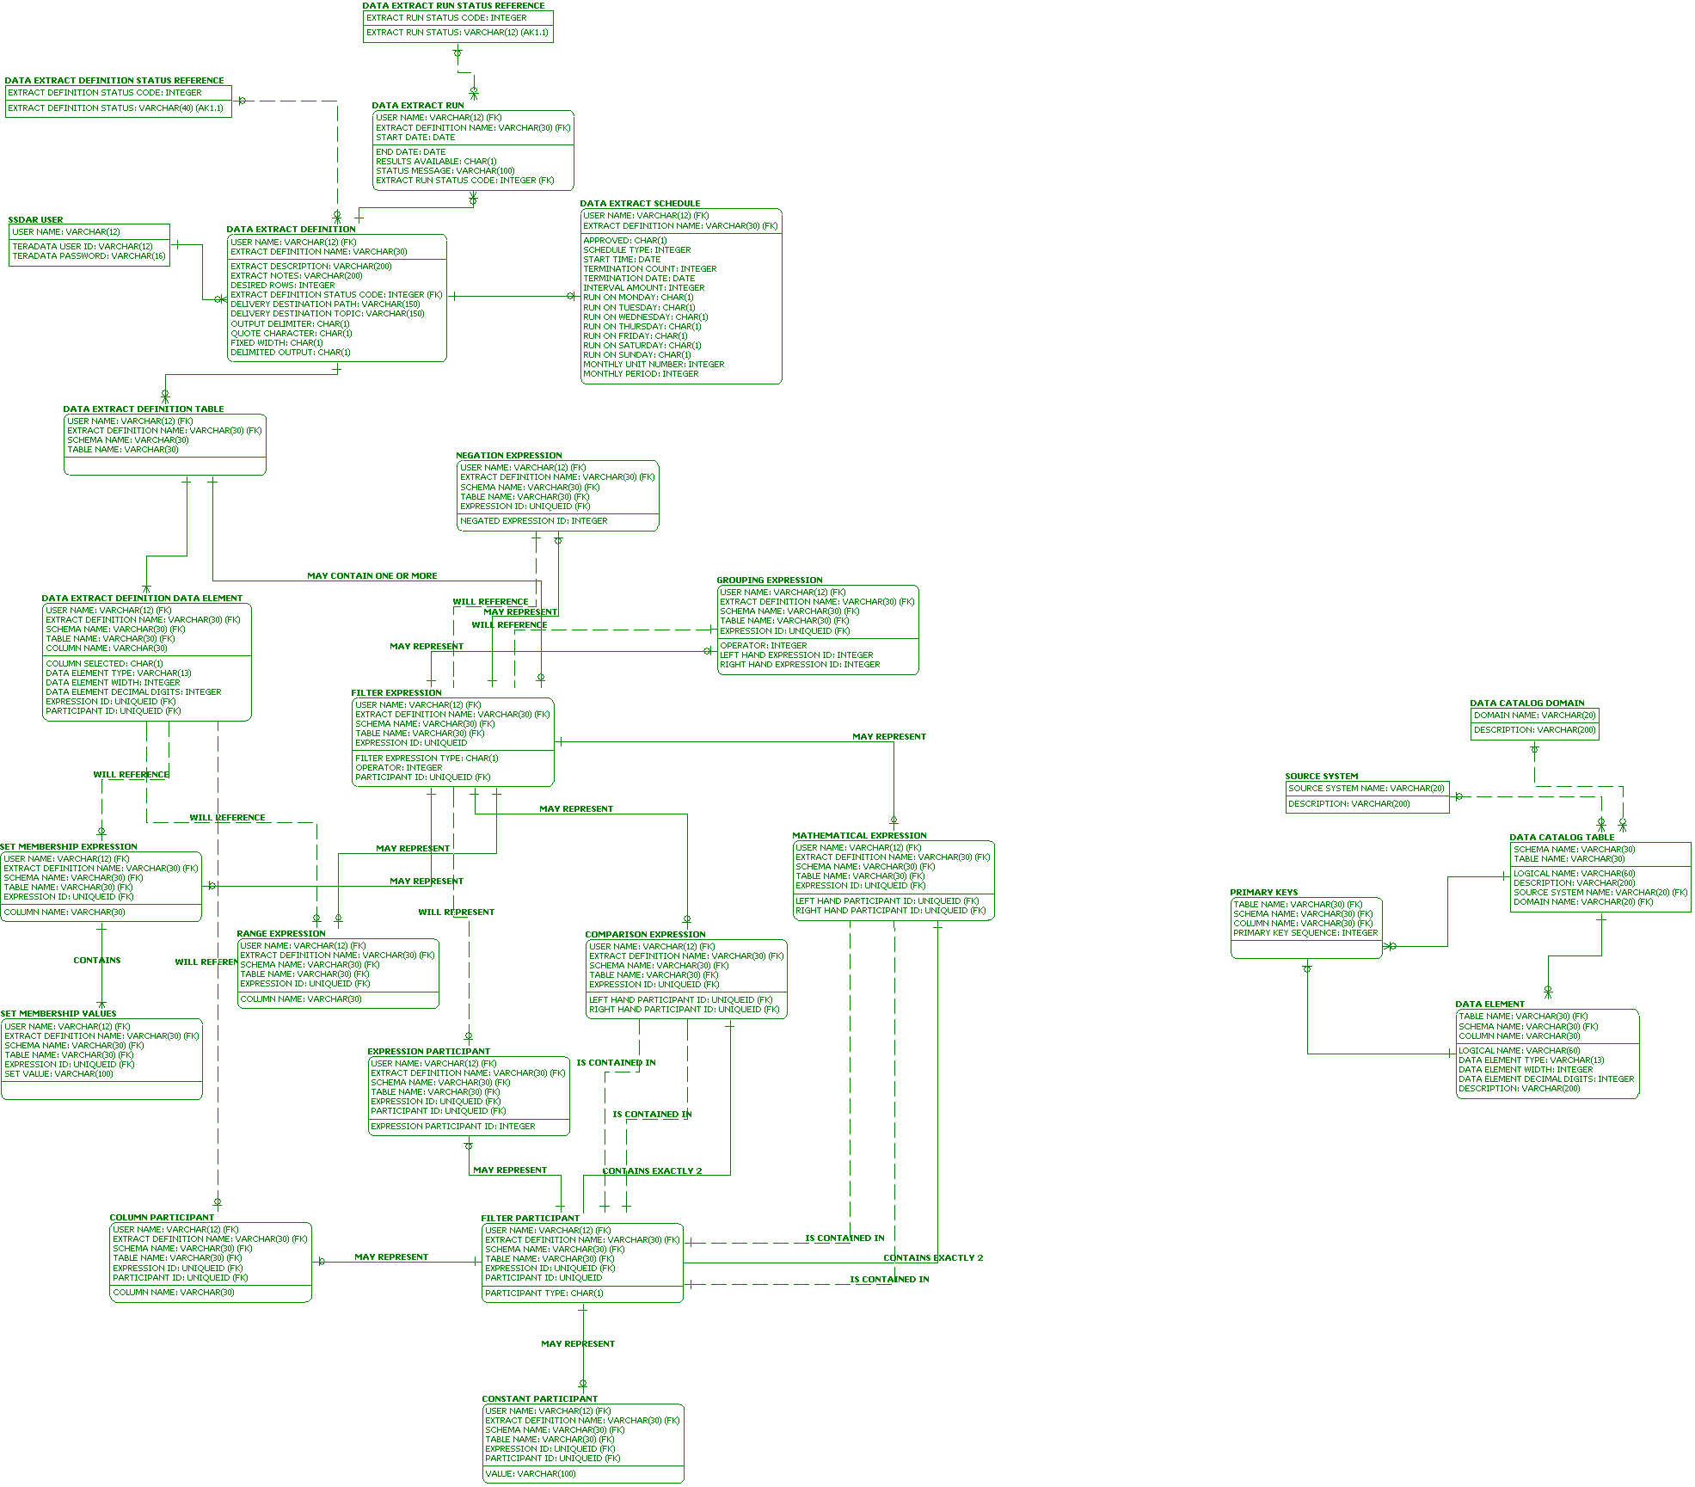
The above diagram presents the data model for the Database User Preferences Manager and the Database Extract Catalog implementations. This schema will be implemented in the Self-Service Database. Object-Relational mapping will be accomplished through the use of Hibernate Core for Java.

It is anticipated that the Self-Service Database will contain several hundred Data Extract Definition records, with each including several dozen tables. This should result in a physical size of less than one Gigabyte.

Quality
Quality of the delivered solution is a key consideration, both from a user's perspective and an architectural perspective. A poor quality solution may meet the user's requirements from a technical perspective but fail to be adopted due to being difficult to use or too complex or slow. Additionally, a poor quality solution may overtax shared resources, which may lead to additional costs (to make more resources available) or reduced customer satisfaction.

As part of the solution delivery plan, the following steps will be taken to ensure the quality of the solution:
- Document, review, and approve user requirements.
- Document, review, and approve solution design.
- Place source code under version control.
- Conduct internal project reviews of deliverables.
- Conduct code walkthroughs.
- Conduct application walkthroughs.
- Develop and run unit tests.
- Develop and conduct training.
- Automate the build, test and deployment process.
- Develop defect detection, tracking and repair plan.
- Develop and execute system test plan.

The success of the above steps will be measured by the following, as appropriate:
- Solution team feedback.
- extended team feedback (sustainment, engineering, etc)
- User feedback.
- Milestone achievement.
- Percentage of classes under test.
- Number, severity, and detection rate of defects.
- Average time to execute a transaction.
- Impact to resources (CPU, storage, network, etc).
- Number of users.
- Number of Data Extracts executed.
- Ongoing regression and QA testing as part of overall enterprise QA Solution
- Reported defects.
- Help desk tickets

