Team ssh

Sukhbir Singh

Greg Schmit

Philip Horwitz

Table of vectors: The first 21 (green) are from the pdf table handout.

|  |  |  |  |  |
| --- | --- | --- | --- | --- |
| a | b | f | expected_y | expected_z |
| 00000000 | 00000000 | 2 | 00000000 | 1 |
| 00000000 | ffffffff | 2 | ffffffff | 0 |
| 00000001 | ffffffff | 2 | 00000000 | 1 |
| 000000ff | 00000001 | 2 | 00000100 | 0 |
| 00000000 | 00000000 | 6 | 00000000 | 1 |
| 00000000 | ffffffff | 6 | 00000001 | 0 |
| 00000001 | 00000001 | 6 | 00000000 | 1 |
| 00000100 | 00000010 | 6 | 000000f0 | 0 |
| 00000000 | 00000000 | 7 | 00000000 | 1 |
| 00000000 | 00000001 | 7 | 00000001 | 0 |
| 00000000 | ffffffff | 7 | 00000000 | 1 |
| 00000001 | 00000000 | 7 | 00000000 | 1 |
| ffffffff | 00000000 | 7 | 00000001 | 0 |
| ffffffff | ffffffff | 0 | ffffffff | 0 |
| ffffffff | 12345678 | 0 | 12345678 | 0 |
| 12345678 | 87654321 | 0 | 02244220 | 0 |
| 00000000 | ffffffff | 0 | 00000000 | 1 |
| ffffffff | ffffffff | 1 | ffffffff | 0 |
| 12345678 | 87654321 | 1 | 97755779 | 0 |
| 00000000 | ffffffff | 1 | ffffffff | 0 |
| 00000000 | 00000000 | 1 | 00000000 | 1 |
| ffffffff | 00000000 | 4 | ffffffff | 0 |
| ffffffff | ffffffff | 4 | 00000000 | 1 |
| 00000000 | ffffffff | 4 | 00000000 | 1 |
| 01010101 | 00000000 | 4 | 01010101 | 0 |
| 00000000 | 00000000 | 5 | ffffffff | 0 |
| ffffffff | ffffffff | 5 | ffffffff | 0 |
| 00000000 | ffffffff | 5 | 00000000 | 1 |
| ffffffff | 00000000 | 5 | ffffffff | 0 |
| 01010101 | 00000000 | 5 | ffffffff | 0 |
| 33333333 | 33333333 | 5 | ffffffff | 0 |

**alu.sv**

module mux2to1_32bit(input wire [31:0] i0, i1, input wire s, output wire [31:0] out);

assign out = s ? i1 : i0;

endmodule

module mux4to1_32bit(input wire [31:0] i0, i1, i2, i3, input wire [1:0] s, output wire [31:0] out);

wire [31:0] m1_out, m2_out;

mux2to1_32bit m1(i0, i1, s[0], m1_out);

mux2to1_32bit m2(i2, i3, s[0], m2_out);

mux2to1_32bit m3(m1_out, m2_out, s[1], out);

endmodule

module adder_32bit(input wire [31:0] a, b, input wire op, output wire [31:0] y);

assign y = op ? a + b + 1 : a + b;

endmodule

module zero_extender(input wire a, output wire [31:0] aex);

assign aex[0] = a;

assign aex[31:1] = 30'b0;

endmodule

module alu(input logic [31:0] a, b, input logic [2:0] f, output logic [31:0] y, output logic zero);

wire [31:0] bb;

wire [31:0] s;

wire cout;

wire [31:0] zeroex;

mux2to1_32bit bbmux(b, ~b, f[2], bb);

adder_32bit adder(a, bb, f[2], s);

zero_extender ze(s[31], zeroex);

mux4to1_32bit ymux(a & bb, a | bb, s, zeroex, f[1:0], y);

assign zero = ~(|y);

endmodule

**Alu.tv**

00000000_00000000_2_00000000_1

00000000_ffffffff_2_ffffffff_0

00000001_ffffffff_2_00000000_1

000000ff_00000001_2_00000100_0

00000000_00000000_6_00000000_1

00000000_ffffffff_6_00000001_0

00000001_00000001_6_00000000_1

00000100_00000010_6_000000f0_0

00000000_00000000_7_00000000_1

00000000_00000001_7_00000001_0

00000000_ffffffff_7_00000000_1

00000001_00000000_7_00000000_1

ffffffff_00000000_7_00000001_0

ffffffff_ffffffff_0_ffffffff_0

ffffffff_12345678_0_12345678_0

12345678_87654321_0_02244220_0

00000000_ffffffff_0_00000000_1

ffffffff_ffffffff_1_ffffffff_0

12345678_87654321_1_97755779_0

00000000_ffffffff_1_ffffffff_0

00000000_00000000_1_00000000_1

ffffffff_00000000_4_ffffffff_0

ffffffff_ffffffff_4_00000000_1

00000000_ffffffff_4_00000000_1

01010101_00000000_4_01010101_0

00000000_00000000_5_ffffffff_0

ffffffff_ffffffff_5_ffffffff_0

00000000_ffffffff_5_00000000_1

ffffffff_00000000_5_ffffffff_0

01010101_00000000_5_ffffffff_0

33333333_33333333_5_ffffffff_0

**Testbench.sv**

`include "ALU.sv"

module testbench();

logic [31:0] a;

logic [31:0] b;

logic [3:0] f;

logic [31:0] y; //actual y value

logic [31:0] expected_y; //expected y value

logic z;

logic [3:0]expected_z;//expected zero value

//change first bracket numbers to reflect size of line

//change second bracket numbers to reflect the number of lines

logic [103:0] testvector[30:0];

integer num; // used for iterating through testvector

ALU dut(a,b,f[2:0],y,z); //please make sure I/Os are in correct order

initial

begin

$readmemh("C:/Modeltech_pe_edu_10.4a/examples/testvector.tv",testvector);

for (num = 0; num <31;num = num + 1)

begin

{a,b,f,expected_y,expected_z} = testvector[num];#10;

//use num + 1 since file lines start at 1

$display("num=%d a=%h b=%h f=%h",num+1,a,b,f);

$display("exp_y=%h y=%h exp_z=%h z=%h",expected_y,y,expected_z,z);

if (expected_y !=y | expected_z != z)

$display("Incorrect y or z line:%d---------------",num+1);

end

end

endmodule

**Display:**

# num= 1 a=00000000 b=00000000 f=2

# exp_y=00000000 y=00000000 exp_z=1 z=1

# num= 2 a=00000000 b=ffffffff f=2

# exp_y=ffffffff y=ffffffff exp_z=0 z=0

# num= 3 a=00000001 b=ffffffff f=2

# exp_y=00000000 y=00000000 exp_z=1 z=1

# num= 4 a=000000ff b=00000001 f=2

# exp_y=00000100 y=00000100 exp_z=0 z=0

# num= 5 a=00000000 b=00000000 f=6

# exp_y=00000000 y=00000000 exp_z=1 z=1

# num= 6 a=00000000 b=ffffffff f=6

# exp_y=00000001 y=00000001 exp_z=0 z=0

# num= 7 a=00000001 b=00000001 f=6

# exp_y=00000000 y=00000000 exp_z=1 z=1

# num= 8 a=00000100 b=00000010 f=6

# exp_y=000000f0 y=000000f0 exp_z=0 z=0

# num= 9 a=00000000 b=00000000 f=7

# exp_y=00000000 y=00000000 exp_z=1 z=1

# num= 10 a=00000000 b=00000001 f=7

# exp_y=00000001 y=00000001 exp_z=0 z=0

# num= 11 a=00000000 b=ffffffff f=7

# exp_y=00000000 y=00000000 exp_z=1 z=1

# num= 12 a=00000001 b=00000000 f=7

# exp_y=00000000 y=00000000 exp_z=1 z=1

# num= 13 a=ffffffff b=00000000 f=7

# exp_y=00000001 y=00000001 exp_z=0 z=0

# num= 14 a=ffffffff b=ffffffff f=0

# exp_y=ffffffff y=ffffffff exp_z=0 z=0

# num= 15 a=ffffffff b=12345678 f=0

# exp_y=12345678 y=12345678 exp_z=0 z=0

# num= 16 a=12345678 b=87654321 f=0

# exp_y=02244220 y=02244220 exp_z=0 z=0

# num= 17 a=00000000 b=ffffffff f=0

# exp_y=00000000 y=00000000 exp_z=1 z=1

# num= 18 a=ffffffff b=ffffffff f=1

# exp_y=ffffffff y=ffffffff exp_z=0 z=0

# num= 19 a=12345678 b=87654321 f=1

# exp_y=97755779 y=97755779 exp_z=0 z=0

# num= 20 a=00000000 b=ffffffff f=1

# exp_y=ffffffff y=ffffffff exp_z=0 z=0

# num= 21 a=00000000 b=00000000 f=1

# exp_y=00000000 y=00000000 exp_z=1 z=1

# num= 22 a=ffffffff b=00000000 f=4

# exp_y=ffffffff y=ffffffff exp_z=0 z=0

# num= 23 a=ffffffff b=ffffffff f=4

# exp_y=00000000 y=00000000 exp_z=1 z=1

# num= 24 a=00000000 b=ffffffff f=4

# exp_y=00000000 y=00000000 exp_z=1 z=1

# num= 25 a=01010101 b=00000000 f=4

# exp_y=01010101 y=01010101 exp_z=0 z=0

# num= 26 a=00000000 b=00000000 f=5

# exp_y=ffffffff y=ffffffff exp_z=0 z=0

# num= 27 a=ffffffff b=ffffffff f=5

# exp_y=ffffffff y=ffffffff exp_z=0 z=0

# num= 28 a=00000000 b=ffffffff f=5

# exp_y=00000000 y=00000000 exp_z=1 z=1

# num= 29 a=ffffffff b=00000000 f=5

# exp_y=ffffffff y=ffffffff exp_z=0 z=0

# num= 30 a=01010101 b=00000000 f=5

# exp_y=ffffffff y=ffffffff exp_z=0 z=0

# num= 31 a=33333333 b=33333333 f=5

# exp_y=ffffffff y=ffffffff exp_z=0 z=0

Wave Forms:

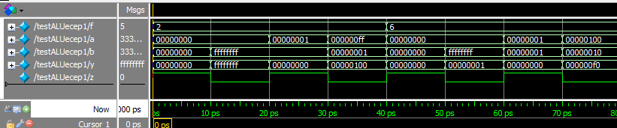

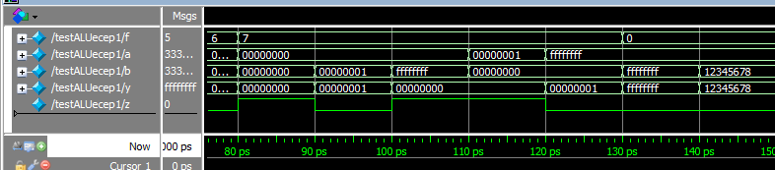

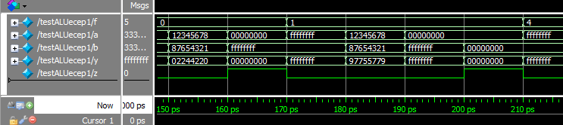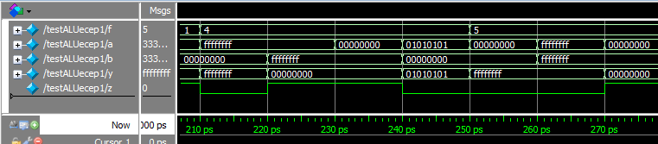

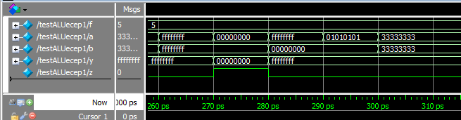

Workload:

The Project took between 12-16 hrs. The most time consuming part has been troubleshooting the code because of syntax errors.