Sukhbir Singh

Greg Schmit

Philip Horwitz

Project 1 part 2

Work Load report:

part1: SQM

This part of the project took a negligible amount of time. We learned that HDL has the power to reduce time needed to implement arithmetic operations.

part2: CA2

This part took between 0.5 to 1 hour to complete. Very simple function, we implemented using muxes.

part3: output analysis / serial1s / s1s / consecutive ones counter

This part several hours (4-6) of brainstorming on one group member's part. However, another group member was familiar with this problem and already had a basic idea of the implementation. Estimated time of writing code and testing is less than 1.5 hours.

part4: Controlled Fault Injector

This part took less than 0.5 hour of brainstorming to figure out. Coding and testing took near 1.5 hours.

part5: Not complete yet

**Modules:**

**------------------------------------------**

`include "ca2.sv"

`include "serial1s.sv"

/*

main s84 module

test vector lines will look like A_B_op_fLoc_fType_Yexpected_Zexpected

*/

module s84(input wire [7:0] A,

input wire [3:0] B,

input wire op,

input wire [2:0] f_loc,

input wire [1:0] f_type,

output wire [7:0] Cout,

output wire [7:0] Y,

output wire [3:0] Z);

wire [7:0] ca2Out;

wire [7:0] sqmOut;

wire [3:0] c1sOut;

ca2 ca2Device(A,B,ca2Out);

sqm sqmDevice(A, B, f_loc, f_type, Cout, sqmOut);

serial1s c1sDevice(Y,c1sOut);

assign Y = op ? ca2Out : sqmOut;

assign Z = c1sOut;

endmodule

/*

sqm module which can compute 'normal'sqm or contain specified faults

*/

module sqm(input wire [7:0] A,

input wire [3:0] B,

input wire [2:0] f_loc,

input wire [1:0] f_type,

output wire [7:0] Cout,

output wire [7:0] out);

//f_loc goes into decoder that produces 8bit string with only one 1

//each bit of C(=Bsqrd) goes into 4to1 mux e.g. (C,0,1,C_not) controlled by f_type

//this 4to1 mux output goes into 2to1 mux containing (C,4to1muxout) controlled by the f_loc_decoder output

wire [7:0] loc;//output of a decoder, used to determine which bit to change.

wire [7:0] m41out; //output of 8 separate 4to1 muxes

wire [7:0] C; // intermediate, equal to B*B

wire [7:0] m21out;// output of 8 separate 2to1 muxes

square multB(B,C);

decoder dec_loc(f_loc,loc);

mux4to1_1bit m41_0(C[0],1'b0,1'b1,~C[0],f_type,m41out[0]);

mux4to1_1bit m41_1(C[1],1'b0,1'b1,~C[1],f_type,m41out[1]);

mux4to1_1bit m41_2(C[2],1'b0,1'b1,~C[2],f_type,m41out[2]);

mux4to1_1bit m41_3(C[3],1'b0,1'b1,~C[3],f_type,m41out[3]);

mux4to1_1bit m41_4(C[4],1'b0,1'b1,~C[4],f_type,m41out[4]);

mux4to1_1bit m41_5(C[5],1'b0,1'b1,~C[5],f_type,m41out[5]);

mux4to1_1bit m41_6(C[6],1'b0,1'b1,~C[6],f_type,m41out[6]);

mux4to1_1bit m41_7(C[7],1'b0,1'b1,~C[7],f_type,m41out[7]);

mux2to1_1bit m21_0(C[0],m41out[0],loc[0],m21out[0]);

mux2to1_1bit m21_1(C[1],m41out[1],loc[1],m21out[1]);

mux2to1_1bit m21_2(C[2],m41out[2],loc[2],m21out[2]);

mux2to1_1bit m21_3(C[3],m41out[3],loc[3],m21out[3]);

mux2to1_1bit m21_4(C[4],m41out[4],loc[4],m21out[4]);

mux2to1_1bit m21_5(C[5],m41out[5],loc[5],m21out[5]);

mux2to1_1bit m21_6(C[6],m41out[6],loc[6],m21out[6]);

mux2to1_1bit m21_7(C[7],m41out[7],loc[7],m21out[7]);

assign Cout = m21out;

assign out = m21out % A;

endmodule

module square(input wire [3:0] B, output wire [7:0] C);

assign C = B*B;

endmodule

module decoder(input wire [2:0] loc, output wire [7:0] out);

assign out[0] = ~loc[0] & ~loc[1] & ~loc[2];

assign out[1] = loc[0] & ~loc[1] & ~loc[2];

assign out[2] = ~loc[0] & loc[1] & ~loc[2];

assign out[3] = loc[0] & loc[1] & ~loc[2];

assign out[4] = ~loc[0] & ~loc[1] & loc[2];

assign out[5] = loc[0] & ~loc[1] & loc[2];

assign out[6] = ~loc[0] & loc[1] & loc[2];

assign out[7] = loc[0] & loc[1] & loc[2];

endmodule

**------------------------------------------------------**

module serial1s(input logic [7:0] a,

output logic [3:0] y);

int count;

int found;

logic [7:0] im[7];

always_comb begin

im[0] = a & (a << 1);

im[1] = im[0] & (im[0] << 1);

im[2] = im[1] & (im[1] << 1);

im[3] = im[2] & (im[2] << 1);

im[4] = im[3] & (im[3] << 1);

im[5] = im[4] & (im[4] << 1);

im[6] = im[5] & (im[5] << 1);

if (a == 0)

y = 0;

else if (im[0] == 0)

y = 1;

else if (im[1] == 0)

y = 2;

else if (im[2] == 0)

y = 3;

else if (im[3] == 0)

y = 4;

else if (im[4] == 0)

y = 5;

else if (im[5] == 0)

y = 6;

else if (im[6] == 0)

y = 7;

else

y = 8;

end

endmodule

**------------------------------------------**

/*

This is the module for a 2to1 mux

Used for 1-bit data paths

*/

module mux2to1_1bit(input wire i0,i1, op , output wire out);

assign out = op ? i1 : i0;

endmodule

/*

This is the module for a 4to1 mux

Used for 1-bit data paths, built with three 2to1 muxes

*/

module mux4to1_1bit(input wire i0,i1,i2,i3,input wire [1:0] op , output wire out);

//intermediate wires for mux2to1 outputs

wire mux1out,mux2out;

//instantiate three 2by1 muxes

mux2to1_1bit mux1(i0,i1,op[0],mux1out);

mux2to1_1bit mux2(i2,i3,op[0],mux2out);

mux2to1_1bit mux3(mux1out,mux2out,op[1],out);//out is final output

endmodule

/*

module for CA2, uses eight 4to1 muxes

*/

module ca2(input wire [7:0] A, input wire [3:0] B, output wire [7:0] Y);

//for the op input into 4to1 mux, we give {A[(i+1) % 8],A[i]} to find Y[i]

mux4to1_1bit m0(B[0],B[1],B[2],B[3],A[1:0],Y[0]); // i = 0 --> (i+1) % 8 = 1

mux4to1_1bit m1(B[0],B[1],B[2],B[3],A[2:1],Y[1]); // i = 1 --> (i+1) % 8 = 2

mux4to1_1bit m2(B[0],B[1],B[2],B[3],A[3:2],Y[2]); // i = 2 --> (i+1) % 8 = 3

mux4to1_1bit m3(B[0],B[1],B[2],B[3],A[4:3],Y[3]); // i = 3 --> (i+1) % 8 = 4

mux4to1_1bit m4(B[0],B[1],B[2],B[3],A[5:4],Y[4]); // i = 4 --> (i+1) % 8 = 5

mux4to1_1bit m5(B[0],B[1],B[2],B[3],A[6:5],Y[5]); // i = 5 --> (i+1) % 8 = 6

mux4to1_1bit m6(B[0],B[1],B[2],B[3],A[7:6],Y[6]); // i = 6 --> (i+1) % 8 = 7

mux4to1_1bit m7(B[0],B[1],B[2],B[3],{A[0],A[7]},Y[7]); // i = 7 --> (i+1) % 8 = 0

endmodule

**------------------------------------------------------**

`include "s84.sv"

module s84_tb();

logic [7:0] A;

logic [3:0] B;

logic op;

logic [2:0] f_loc;

logic [1:0] f_type;

logic [7:0] C,C_expected;

logic [7:0] Y, Y_expected;

logic [3:0] Z, Z_expected;

logic [37:0] testvector [29:0];

s84 s84alu(A, B, op, f_loc, f_type, C, Y, Z);

integer num;

initial

begin

$readmemb("./s84.tv",testvector);

for (num = 0; num<30; num = num + 1)

begin

{A, B, op, f_loc, f_type, C_expected, Y_expected, Z_expected} = testvector[num]; #10;

//$display("num=%d",num+1);

//$display("A=%b B=%b op=%b f_loc=%b f_type=%b C_exp=%b Y_exp=%b Z_exp=%d", A, B, op, f_loc, f_type, C_expected, Y_expected, Z_expected);

//$display("C=%b Y=%d Z=%d",C,Y,Z);

//csv layout

$display("%b,%b,%b,%b,%b,%b,%b,%b", A, B, op, f_loc, f_type, C_expected, Y_expected, Z_expected);

if (C != C_expected)

begin

$display("C does not equal C_exp line num=%d",num+1);

end

if (Y != Y_expected)

begin

$display("Y does not equal Y_exp line num=%d",num+1);

end

if (Z != Z_expected)

begin

$display("Z does not equal Z_exp line num=%d",num+1);

end

end//end for

end

endmodule

**---------------------------------------------------**

Waveforms:

SQM

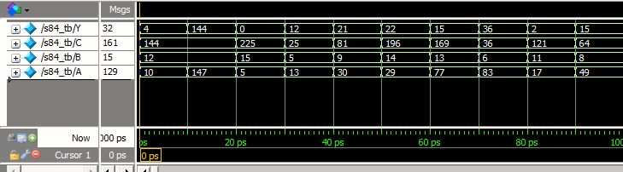

CA2

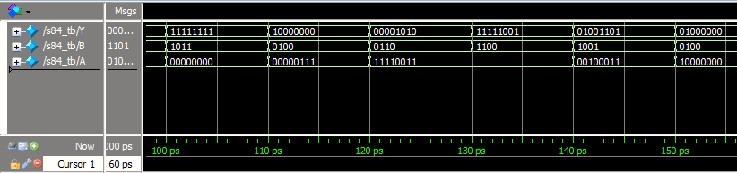

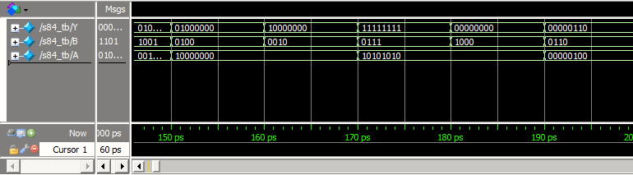

Serial1s

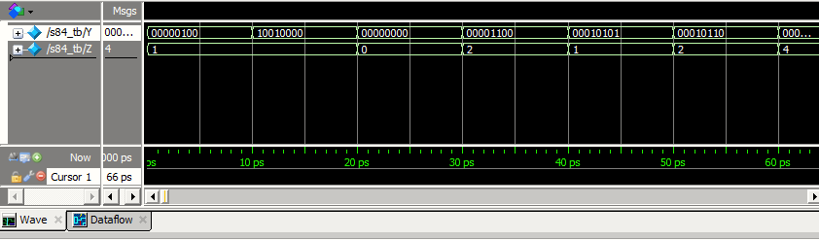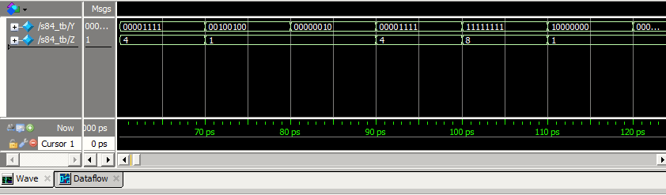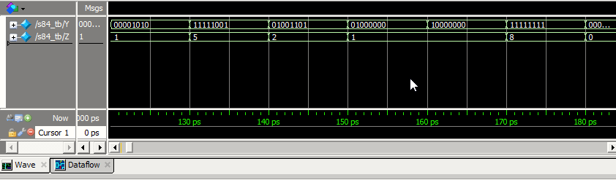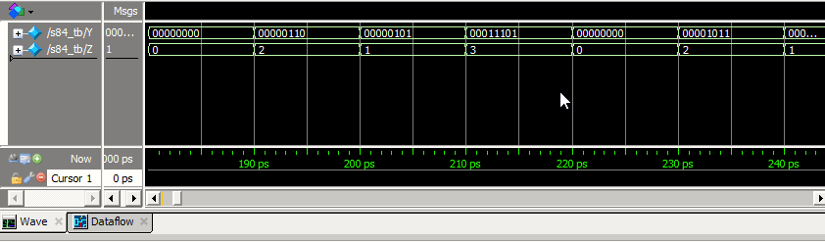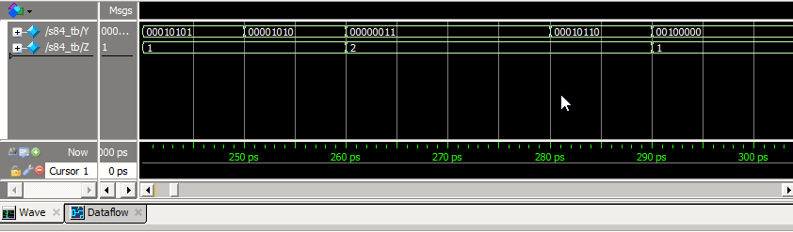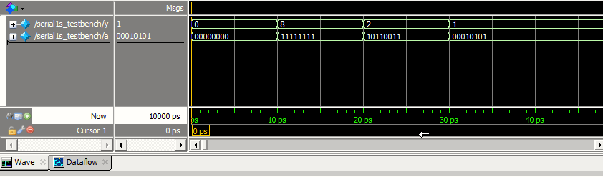

In the last image (above), ‘a’ is ‘Y’ and ‘y’ is Z

CFI

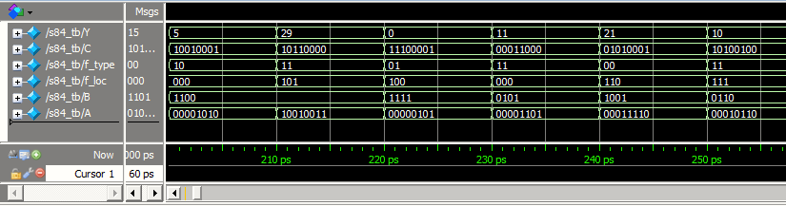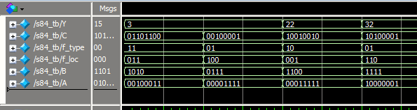

Testvector

A_B_op_fLoc_fType_C_Y_Z

00001010_1100_0_000_00_10010000_00000100_0001

10010011_1100_0_000_00_10010000_10010000_0001

00000101_1111_0_000_00_11100001_00000000_0000

00001101_0101_0_000_00_00011001_00001100_0010

00011110_1001_0_000_00_01010001_00010101_0001

00011101_1110_0_000_00_11000100_00010110_0010

01001101_1101_0_000_00_10101001_00001111_0100

01010011_0110_0_000_00_00100100_00100100_0001

00010001_1011_0_000_00_01111001_00000010_0001

00110001_1000_0_000_00_01000000_00001111_0100

00000000_1011_1_000_00_01111001_11111111_1000

00000111_0100_1_000_00_00010000_10000000_0001

11110011_0110_1_000_00_00100100_00001010_0001

11110011_1100_1_000_00_10010000_11111001_0101

00100011_1001_1_000_00_01010001_01001101_0010

10000000_0100_1_000_00_00010000_01000000_0001

10000000_0010_1_000_00_00000100_10000000_0001

10101010_0111_1_000_00_00110001_11111111_1000

10101010_1000_1_000_00_01000000_00000000_0000

00000100_0110_1_000_00_00100100_00000110_0010

00001010_1100_0_000_10_10010001_00000101_0001

10010011_1100_0_101_11_10110000_00011101_0011

00000101_1111_0_100_01_11100001_00000000_0000

00001101_0101_0_000_11_00011000_00001011_0010

00011110_1001_0_110_00_01010001_00010101_0001

00010110_0110_0_111_11_10100100_00001010_0001

00100011_1010_0_011_11_01101100_00000011_0010

00001111_0111_0_100_01_00100001_00000011_0010

00011111_1100_0_001_10_10010010_00010110_0010

10000001_1111_0_110_01_10100001_00100000_0001

**Designs:**

CA2 below

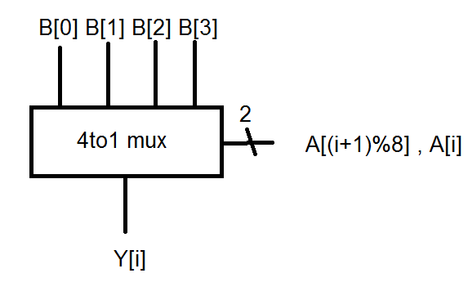

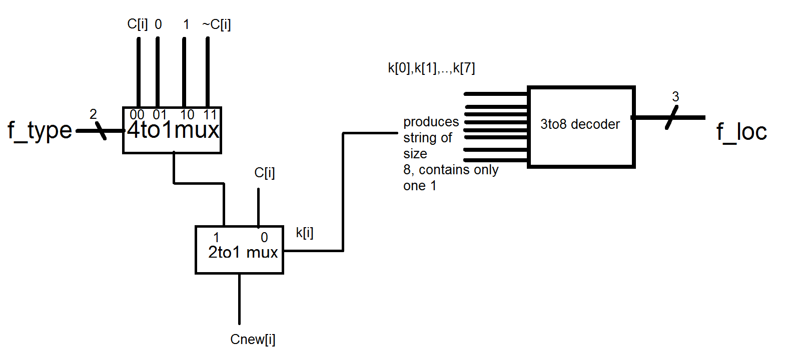CFI below