**BSConsole Purchase Order App Workflow**

Purchase Orders can be created from scratch, or generated by using a line item or an entire order from a previous PO.

**New POs from Scratch**

**Opening Screen**

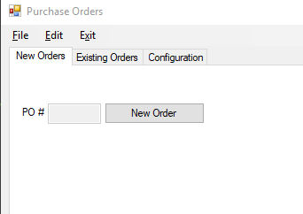

Click NewOrder button to start a PO from scratch

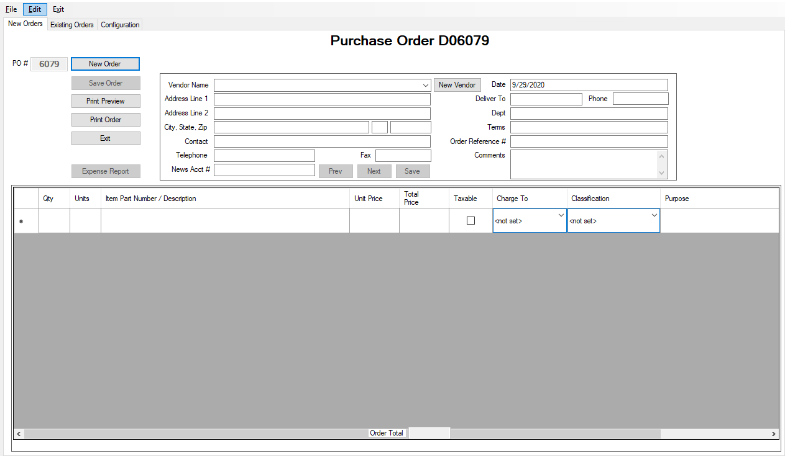

Enter the Vendor from the Vendor drop down (or click the New Vendor button to create a brand new vendor). The Vendor drop down list has many duplicate vendors in it – this is due to backward compatibility with the Access version. In this case the first vendor in a the list of duplicates will be displayed and the Prev/Next buttons will be enabled to allow cycling through the duplicates. If any changes are made to the selected vendor the Save button will be enabled in order to save the changes to the selected vendor record.

Enter each line item on the grid. Total price is automatically calculated for each line and for the entire order. New grid lines will be created each time a previous line is populated with data. You can always delete a line by clicking the left-most column followed by depressing the delete key.

Click the Save Order button to save the order. The Print Preview and Print Order buttons should display/print the completed PO, respectively.

If this order is charged to a personal credit card you can click the Expense Report button (once the order has been saved) to generate a standard expense report.

**POs From a Previous Order**

Click the Existing Orders tab to display all previous PO items. You can check the Filter by Vendor checkbox followed by a vendor selection to limit the PO item list to any specific vendor.

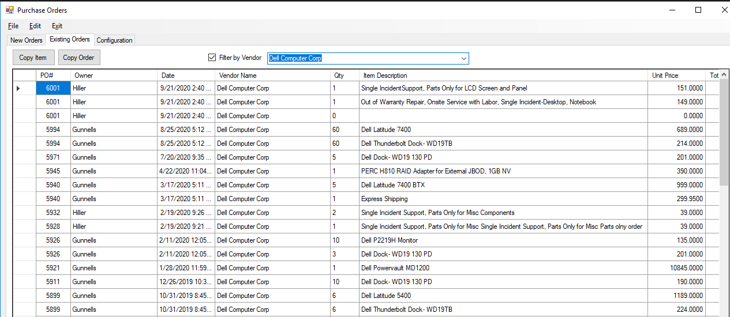

Select any line item in any order and click the Copy Item or Copy Order button to copy either the single line item or the entire order, respectively. A COPIED prompt will highlight and the Apply To New Order button will be rendered. Clicking the Apply To New Order button will paste the previous item/order as a new order and will switch tabs to the New Orders tab.

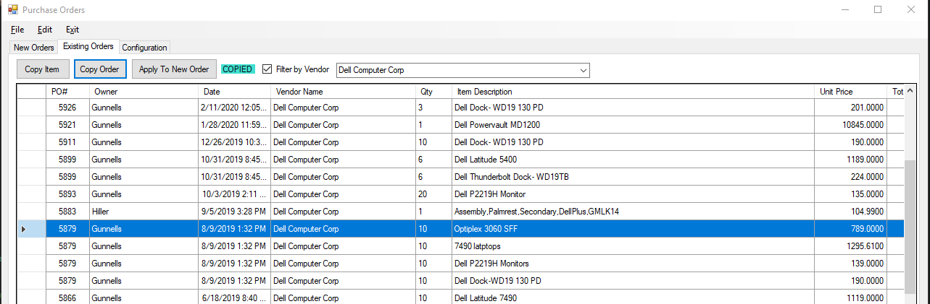

The PO will be assigned a new PO # and can then be edited at will.

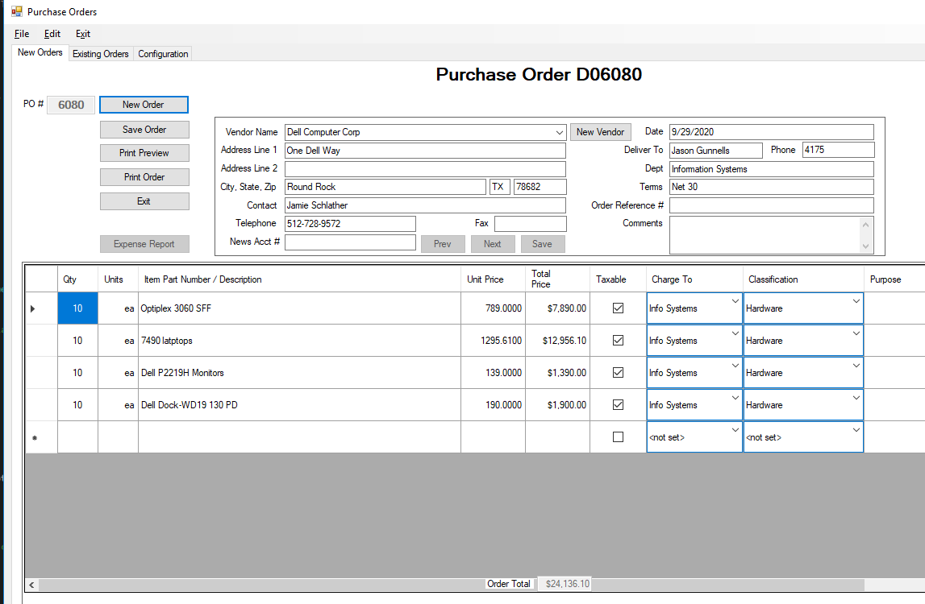

NOTES:

This version is intentionally backward compatible with the Access version. Both will be available until it is determined that the new version is bug-free enough to eliminate.

POs are automatically generated in sequence as soon as a new order is created. Regardless of whether or not the PO is saved, printed or otherwise used, the PO number will **not** be re-used. This is a SQL limitation under the current backward-compatibility limitation with Access.

PO and expense report spreadsheets take a long time to generate. Be patient.

Any column on any grid can be sorted by clicking the column heading. This is especially useful on the Existing Orders tab since some vendors (Dell, CDW) have many orders.

Most controls are enabled only when it is logical to do so. For example, the Save button isn’t enabled if no changes have been made to the PO since the last time it was saved.

The default Existing Orders lookback is 5 years. You can change this by clicking the Configuration tab, changing and saving the value there.

Those who prefer menu items over buttons can (mostly) use the menus to navigate.

The Unit Price column is currently limited to a number with 4 decimal digits. Currency conversion is not displayable (unlike the total Price column) because it is a data entry field. There is probably a (currently unknown) fix for this.

There is currently no user interface for updating departments or classifications. They can be easily updated via the backend (SQL), and a user interface can be added downstream if necessary.