Inferring Hidden Motives: Bayesian Models of Preference Learning in Repeated Dictator Games
Gregory Stanley, Jun Zhang, and Rick Lewis
- Abstract
Cooperation depends on accurately judging who to trust—identifying the strengths of other people's morally-relevant social motives, called social preferences, and refining those beliefs after observing their behavior over time. We propose a Utility Bayesian Model of social preference belief updating in simple economic games, played repeatedly between pairs of participants. This model outperforms non-Bayesian and typological Bayesian alternatives that represent others' preferences as discrete categories rather than continuous parameters. It integrates a seven-parameter utility function that fits the data better than 504 other functional forms, including classic models in experimental economics.
Fitting this model to human data revealed that self-interest outweighs altruism roughly nine to one, though most participants showed reliably positive altruism. Strikingly, aversion to advantageous inequality exceeded aversion to disadvantageous inequality, reversing the canonical Fehr-Schmidt ordering, suggesting that conditional concern for others who are worse off is a stronger motivator than previously recognized. Minority antisocial types (sadistic, competitive, masochistic) appeared at higher rates than prior studies suggest.
Together, these parameter distributions provide a unified psychological coordinate system: a common seven-dimensional space in which any individual's social preferences can be located, enabling cross-study comparisons and justified prior distributions for future models, and offering a quantitative lens on longstanding questions about human nature.
- Introduction
Understanding other people's social preferences is central to cooperation. To decide whom to trust, reciprocate, avoid, forgive, or help, people must infer how others value their own outcomes, the outcomes of others, and inequalities between them. This cognitive problem is difficult because social preferences are hidden and must be inferred from behavior that is often compatible with multiple underlying motives.
This paper focuses on outcome-based social preferences: preferences over final payoff distributions between people, abstracting away from intentions, reciprocity, reputation, self-image, social norms, and strategic reasoning. Those other motives matter, but binary dictator games provide a useful starting point because they strip away much of the interpretive complexity of richer social interaction. In each game, a chooser selects between two payoff allocations for self and other. Because retaliation, negotiation, and within-round strategic reciprocity are structurally absent, choices can be interpreted as evidence about how the chooser values self-payoffs, other-payoffs, and relative payoffs.
Research in behavioral economics and psychology has produced influential models of such preferences, including inequity aversion, ERC, social welfare, warm-glow, and maximin-efficiency models (Fehr & Schmidt, 1999; Bolton & Ockenfels, 2000; Andreoni & Miller, 2002; Charles & Rabin, 2002; Engelmann & Strobel, 2004). These models have clarified stable individual differences in altruism, fairness, self-interest, and inequality aversion. However, two interrelated methodological restrictions limit how well existing models generalize.
The first restriction is that many studies fit models to a narrow portion of the possible payoff landscape. Allocation tasks often use small, hand-selected payoff sets, which can make logically distinct motives behaviorally indistinguishable. For example, standard dictator games are constant-sum and cannot decouple altruism from social comparison. Broader payoff exploration is necessary for distinguishing psychological dimensions that collapse under narrower designs (Andreoni & Miller, 2002; Murphy & Ackermann, 2014).
The second restriction is that researchers typically compare only a small set of inherited utility functions. A model can only recover distinctions it is capable of representing. If the candidate function class omits relevant psychological terms, fitted parameters may absorb multiple motives at once, producing estimates that are stable but conceptually misleading. If a utility function lacks a separate altruism term, concern for others loads onto inequality aversion. If it lacks separate terms for advantageous and disadvantageous inequality, envy-like and guilt-like responses collapse. If self-interest is fixed rather than estimated, unusual but theoretically meaningful patterns such as negative self-weighting cannot be detected. Limited payoff exploration and limited utility-function exploration can each distort inference.
These limitations matter not only for measuring social preferences but also for modeling how people learn them. Cooperation depends on updating beliefs about counterparts: who is generous, who is selfish, who is competitive. Bayesian models are well-suited to this problem because they formalize how uncertain beliefs are updated as evidence accumulates (Camerer & Ho, 1999; Griffiths, Kemp, & Tenenbaum, 2008; Hampton, Bossaerts, & O’Doherty, 2008; Yoshida, Dolan, & Friston, 2008; Fudenberg & Levine, Learning and equilibrium, 2009; Devaine, Hollard, & Daunizeau, 2014). But a model of social-preference learning depends on the utility function embedded in its likelihood term. If that function conflates motives, the learning model inherits the confusion.
A further problem is that researchers often infer beliefs about social preferences from choice data alone. Choices are not pure measures of beliefs: they reflect the chooser's own preferences, strategic incentives, and expectations about others simultaneously. Explicit predictions of a counterpart's choices provide a more direct measure of beliefs, reducing the confound between what a participant wants and what they expect another person to do.
To address these problems, we used repeated binary dictator games in which participants encountered identifiable counterparts over multiple rounds, alternating between chooser and predictor roles. Payoffs for both players were randomly drawn from {1, 2, 3, 4, 5}, spanning all 625 possible binary dictator-game structures defined by that grid. The task isolates outcome-based social preferences from within-round strategic reasoning while covering a broad range of self-regarding, other-regarding, and inequality-sensitive tradeoffs.
The present approach integrates four mutually reinforcing methodological elements.
First, we use randomized binary dictator-game payoffs to sample a broad multidimensional outcome space, allowing utility functions to be evaluated across many different tradeoffs rather than over a small set of hand-picked games.
Second, we compare 505 candidate utility functions varying along psychologically meaningful dimensions: self-interest, altruism, social comparison, asymmetric envy and guilt terms, nonlinear payoff sensitivity, reference dependence, payoff ratios, and min-max forms. The goal is not to ask which canonical model performs best, but to search a wider space of possible utility structures and identify which distinctions are worth preserving after penalizing model complexity.
Third, we elicit explicit predictions of counterpart choices. These predictions provide a more direct behavioral window into participants’ beliefs about others’ preferences than choices alone, while choice data continue to supply estimates of the chooser's own preferences.
Fourth, we formalize social-preference learning with a Utility Bayesian Model. Observers maintain probabilistic beliefs over continuous social-preference parameters, updated after each observed choice via a likelihood term supplied by the utility function and a SoftMax choice rule. Parameter values that make the observed choice more likely gain posterior weight, while values that make it unlikely lose weight. Across repeated meetings, initially uncertain beliefs become more concentrated as evidence accumulates.
Before estimating social-preference distributions on human multiplayer data, we validate the model in two ways. Simulations test whether the pipeline recovers known parameters, whether posteriors converge toward a chooser's true preferences over repeated observations, and whether prior variance and choice stochasticity affect update speed as Bayesian theory predicts. A human-on-bot experiment then pairs participants with artificial choosers governed by fixed, known preference profiles, allowing model predictions to be evaluated against a controlled ground truth.
This integrated design lets us ask several linked questions. Do people update beliefs about others' social preferences in a way better captured by a continuous Bayesian model than by non-Bayesian or discrete typological alternatives? Which utility function best supports such inference across a broad payoff space? What distribution of self-interest, altruism, envy, guilt, and nonlinear payoff sensitivity is revealed when these dimensions are estimated jointly? And what do those distributions imply about the structure of human social motivation?
- Utility Bayesian Model: Formulation and Implementation
  - Motivation and Research Context
The Utility Bayesian Model formalizes the inference problem laid out in the introduction. We describe it here at Marr's (1982) computational level because it specifies the information-processing problem an observer must solve, inferring hidden preferences from ambiguous evidence, without claiming that the brain literally performs the computation this way. Although the model uses explicit probabilistic representations and grid-based approximations for clarity, real observers may approximate the same inference through other mechanisms such as sampling-based heuristics.
This functional-level commitment matters because it positions the model relative to two alternatives. Bayesian models of social inference have consistently outperformed reinforcement-based and heuristic accounts in contexts where latent preferences must be inferred from ambiguous behavior (Camerer & Ho, 1999; Erev & Roth, 1998; Hampton, Bossaerts, & O’Doherty, 2008), and they offer interpretability that more opaque approaches such as neural networks do not. The architecture below makes this interpretability concrete: every component has a psychological meaning.
Next, we detail how our Utility Bayesian Model (UBM) integrates prior beliefs with observed chooser decisions to produce updated posterior beliefs about social preference parameters.
  - Utility Bayesian Model Mechanics: Prior, Likelihood, and Posterior
Observers’ initial beliefs about a chooser’s social preferences are represented by a population prior over a multidimensional parameter space (Gelman, et al., 2003). This prior assumes that social preference parameters are normally distributed in the population—before observing any individual’s choices, one predicts their behavior as if randomly sampled from this population (Lee & Wagenmakers, 2014). We model each preference dimension with a Gaussian (normal) prior distribution characterized by population-level parameters (means, standard deviations, and covariances). Once observations of the chooser’s actual decisions become available, the model updates from these population priors to individual‐level posterior beliefs—although after the first round, we do not impose any specific parametric form on subsequent posteriors.
Specifically, we parameterize social preferences using:
- $V_{ii}$: self-interest, indicating how strongly the chooser values their own payoffs.
- $V_{ij}$: altruism, indicating how strongly the chooser values the recipient’s payoffs.
- $α_{ij}$: envy, capturing negative reactions to disadvantageous inequality.
- $β_{ij}$: guilt, capturing negative reactions to advantageous inequality.
- $γ$: exponent, capturing nonlinear sensitivity to payoff magnitudes and differences.
- $τ$: temperature in the SoftMax function, determining stochasticity in choice behaviors.
Here the chooser is player 𝑖 and the predictor is player 𝑗. 𝑉 indicates value (i.e., $V_{ij}$ reflects how much player 𝑖 values player 𝑗. The envy $α_{ij}$ and guilt $β_{ij}$ symbols are mirror images, highlighting their opposite emotional responses to inequality.
We use μ for mean parameters and σ for standard deviation parameters. For instance μ(𝑉_{𝑖𝑗}) and σ(𝑉_{𝑖𝑗}) are the mean and standard deviation parameters for altruism.
This is an example utility function:
$$U_{i}\left(A\right)=V_{ii}{\left(π_{i}^{A}\right)}^{γ}+V_{ij}{\left(π_{j}^{A}\right)}^{γ}-α_{ij}×{max\left(π_{j}^{A}-π_{i}^{A},0\right)}^{γ}-β_{ij}×{max\left(π_{i}^{A}-π_{j}^{A},0\right)}^{γ}$$
For the utility for player 𝑖 in option A, where $π_{i}^{A}$ is the payoff for player 𝑖 in option A and $π_{j}^{A}$ is the payoff for player 𝑗 in option A.
  - Likelihood Function and SoftMax Choice Rule
After observing a chooser’s decision, we compute the likelihood of this choice given a parameter vector $θ=\left\{V_{ii}, V_{ij}, α_{ij}, β_{ij}, γ, τ\right\}$ through a logit‐type or SoftMax function (Luce, 1959; McFadden, 1974):
$$p\left(choose option A | θ\right)=\frac{e^{{U\left(A, θ\right)}/τ}}{e^{{U\left(A, θ\right)}/τ}+e^{{U\left(B, θ\right)}/τ}}$$
Here τ (temperature parameter) controls how deterministic or stochastic choices are: higher τ yields more random, less deterministic choices, whereas lower τ increases the probability of choosing the option with higher subjective utility. Subjective utility, 𝑈(𝐴, 𝜃), is computed from the parameters 𝜃 by weighting each payoff dimension accordingly. The likelihood then follows from translating these utilities into choice probabilities through the SoftMax rule4F.
  - Grid-Based and Particle Filter Posterior Updating
By default, we used a discrete grid-based approximation method for posterior updating because it is simple and transparent. The multidimensional parameter space is discretized into a finite grid (with resolution defined by 𝑛 bins per dimension). At each grid point, we compute likelihood probabilities, forming a likelihood probability mass function (PMF) over the parameter space. This likelihood PMF is directly comparable to the prior PMF because both are defined over identical parameter grids.
Multiplying the prior and likelihood PMFs point-by-point yields the posterior PMF, representing updated beliefs after observing each choice:
$$p\left(θ | choice\right)∝p\left(choice | θ\right)×p(θ)$$
The posterior PMF subsequently serves as the prior for future belief updates, creating a self-perpetuating Bayesian cycle. This iterative self-updating mechanism ensures that a single set of initial parameters is sufficient to simulate participant responses across multiple games5F.
However, because the number of points in the PMF grids is the number of bins per dimension raised to the number of dimensions ($n^{k}$), full grid-based updating becomes computationally infeasible for higher-dimensional models. Instead, we also switch to using particle filter-based posterior updating, which replaces the full PMF grids with much smaller samples of weighted probability particles.
We verified that the particle filter (PF) reproduces the full grid posterior on synthetic data while varying the number of parameters 𝑘 ∈ [1, 2, 3, … 9] and the ratio of probability particles sampled from the full grid, called the sampling ratio within [0.05, 0.10, 0.15, 0.20, … 0.95]. We simulated 50 artificial choosers paired with 50 artificial predictors across 20 random payoff dictator games, where the predictors used grids of 9 bins per dimension. We provided identical prior parameters to grid-based and PF-based predictors and compared the posteriors recovered from their final round posteriors. In all cases, the correlation exceeded 0.993, demonstrating that the PF faithfully reproduces grid-based updating, typically multiple orders of magnitude faster. We used PF-based updating for the section, “Results: Joint Parameter Distributions in Human-on-human Experiment,” which relied on high-dimensional models and we used grid-based updating in the followings sections: “Simulation Methods and Results”, “Illustrating Belief Updates”, and “Model Validation: Comparing Bayesian and Alternative Cognitive Models”.
  - Optimization and Model Evaluation
Our Utility Bayesian Model follows the sequence of steps participants experience:
- First, predictor-participants predict their chooser-counterparts’ choice.
- Second, they observe the actual choice.
- Finally, they revise their beliefs based on this observation. They use these updated beliefs to make predictions in the next round, or more specifically the next round that they are matched with the same counterpart and assigned the role of predictor.
Crucially, participants' predictions reflect posterior beliefs revised based on choices observed in the previous round. Thus, our model follows the psychologically plausible causal sequence: predict choice → observe choice → update belief, as shown in Figure 1.
Figure 1: Predict, observe, update:
Within each game, players in the predictor role, first predict their counterpart’s choice, second observe their counterpart’s choice, and third update their beliefs about their counterpart’s social preferences. These revised beliefs (posteriors) become the preconceptions (priors) used to make predictions in the next game. Choice observations are an input to the model and predictions are an output of the model.
Our agent function separately maintains stable chooser parameters (used exclusively to generate choices) and dynamically updates predictor parameters (used exclusively for generating predictions). Rather than using predictions or prediction errors, predictor beliefs evolve solely based on observed chooser actions, separating Bayesian updating evidence (chooser actions) from model evaluation criteria (participant predictions).
Model evaluation utilizes the negative log-likelihood (NLL), comparing posterior-generated model predictions against actual participant predictions:
$$NLL\left(θ\right)=-\sum_{t=1}^{T}{ln\left[p\left({observed choice}_{t} | θ\right)\right],}$$
Here, participant parameter vectors (𝜃) directly map to total negative log-likelihood losses, allowing the optimization process to adjust only initial parameters to minimize this cumulative loss across all observations.
For parameter estimation, we first apply simulated annealing (SA), a global optimization method robust to non-differentiable and complex loss functions, initially exploring the parameter space broadly and gradually shifting focus toward regions of lower loss as it "cools" (Kirkpatrick, Gelatt Jr, & Vecchi, 1983). We subsequently refine these parameter estimates using the local optimization algorithm L-BFGS-B (Byrd, Lu, Nocedal, & Zhu, 1995), which efficiently searches for more precise minima using gradient-based methods. Parameters identified by SA serve as starting points for L-BFGS-B, allowing a smooth transition from global exploration to local exploitation. Ultimately, we select the parameter set that yields the lowest NLL across both optimization steps6F.
Figure 2 illustrates the dynamic evolution of beliefs through the Bayesian updating process across sequential games. The likelihood functions (top row), generated from observed choices (middle row), inform the posterior beliefs (bottom row), demonstrating how initial uncertainty progressively sharpens into precise beliefs over successive observations.
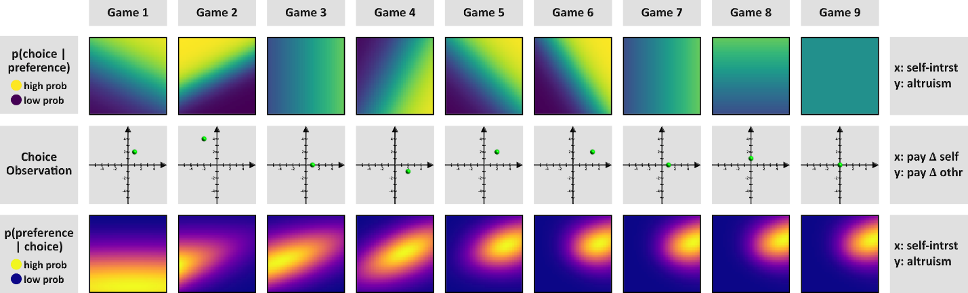
Figure 2: Bayesian belief updating over nine sequential decisions:
Each column illustrates one “game” (choice observation) and how that single observation updates the agent’s preference belief state. Top row: Likelihood of the observed choice given different preference parameters, shown as heatmaps over the 2D preference space (x-axis = self-interest weight, y-axis = altruism weight). Yellow regions indicate high probability of the observed choice under those preference values, and purple regions indicate low probability. Middle row: The choice observation in each game, represented by the green dot in a payoff-difference space (x-axis = Δ payoff to self, y-axis = Δ payoff to other). Bottom row: Posterior distribution of the preference parameters after observing that game’s choice, shown as a probability distribution heatmap (yellow = high posterior density, purple = low). As the games progress from 1 to 9, the posterior distributions become more concentrated, reflecting increasing certainty about the agent’s true preference parameters. This figure demonstrates how Bayesian updating uses each new choice to incrementally refine the belief over the preference model. Interestingly, the likelihood distributions (top row) become sharper in proportion to the distance between the chosen option and the origin of the payoff space (middle row), reflecting the fact that the model treats extreme choices to be more diagnostic of preferences than moderate choices. Indeed, the game 9 choice of (3, 3) vs. (3, 3) is uninformative, resulting in a flat likelihood and thus there is no belief update.
Having articulated our model’s mechanics, notation, and evaluation strategies, we next validate the model with a simulation.
  - Simulation Methods and Results
After presenting the mechanics of the Utility Bayesian Model (UBM), we conducted a simulation designed to (1) verify that our optimizer accurately recovers the “true” social preference parameters specified for each simulated “predictor” bot, (2) confirm that the model’s posterior estimates converge toward the “true” parameter of its “chooser” counterpart over repeated observations, and (3) show that priors with higher variance and lower SoftMax temperatures lead to faster belief updates. This section describes the simulation’s setup, methods, and outcomes.
    - Simulation Setup
We generated 945 simulated dyads by systematically varying parameter values for both predictors and choosers:
- Predictor parameters
  - Self-interest mean μ(𝑉_{𝑖𝑖}): fixed at 1.0
  - Self-interest standard deviation σ(𝑉_{𝑖𝑖}): fixed at 1.0
  - Altruism mean μ(𝑉_{𝑖𝑗}): 7 levels in [-1.0, -0.667, -0.333, 0.0, 0.333, 0.667, 1.0]
  - Altruism standard deviation σ(𝑉_{𝑖𝑗}): 3 levels [0.5, 1.0, 1.5]
  - SoftMax temperature τ: 3 levels [0.5, 1.75, 3.0]
- Chooser parameters
  - Self-interest mean μ(𝑉_{𝑖𝑖}): fixed at 1.0
  - Self-interest standard deviation σ(𝑉_{𝑖𝑖}): fixed at 1.0
  - Altruism mean μ(𝑉_{𝑖𝑗}): 5 levels in [-1.0, -0.5, 0.0, 0.5, 1.0]
  - Altruism standard deviation σ(𝑉_{𝑖𝑗}): fixed at 1.0
  - SoftMax temperature τ: 3 levels [0.5, 1.75, 3.0]
Every possible combination of these levels yielded 7 × 5 × 3 × 3 × 3 = 945 unique bots. Each dyad matched one “predictor” bot to one “chooser” bot. The simulation proceeded for 25 rounds per dyad. On each round:
- A randomized payoff structure from {1, 2, 3, 4, 5} was assigned to the binary choice, simulating the variety of potential payoffs observed in a real experiment.
- The “chooser” bot used its utility function $U_{i}\left(A\right)=V_{ii}\left(π_{i}^{A}-π_{i}^{B}\right)+V_{ij}\left(π_{j}^{A}-π_{j}^{B}\right)$ with its SoftMax temperature τ to probabilistically select one of the two payoff options7F.
- Simultaneously, the “predictor” bot used an analogous function to produce a predicted choice (and so introduced “semi-stochastic” noise when τ ≠ 0).
At the end of 25 rounds, we fitted our Utility Bayesian Model (UBM) at the dyad level—that is, each predictor’s parameter estimates were inferred from those 25 rounds against a single chooser. We focused on μ(𝑉_{𝑖𝑗}), the altruism mean, for most analyses. Although other parameters could also be examined, altruism is arguably the most morally salient to human observers.
    - Goals of the Simulation
- Optimizer Check. We first tested whether the model’s optimization pipeline (simulated annealing followed by L-BFGS-B) recovers a predictor’s true altruism mean, μ(𝑉_{𝑖𝑗}).
- Convergence Toward Chooser Parameter. We verified that across repeated rounds the predictor’s fitted altruism estimates move closer to the chooser’s true altruism (μ(𝑉_{𝑖𝑗})).
- Influence of Prior Variance and Temperature. Finally, we tested the Bayesian model properties that (a) higher prior variance fosters faster belief updating, while (b) lower SoftMax temperature increases update speeds by making each observed choice more “diagnostic” or informative.
    - Simulation Results
1. The Optimizer Accurately Recovers Predictor Parameters
We correlated the true predictor altruism with the fitted predictor altruism across all 945 dyads, obtaining 𝑟 = 0.755, shown in Figure 3. This strong correlation indicates that, even with random payoffs and semi-stochastic agent choices, our optimization procedure reliably estimates the predictor’s underlying parameter. Hence, subsequent references to “fitted priors” can be considered accurate approximations of the predictor’s initial beliefs.
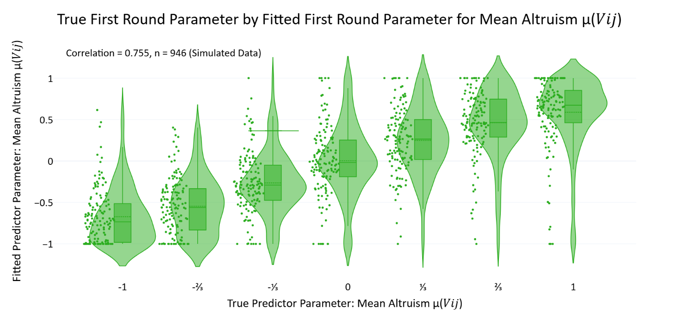
Figure 3: Validation of parameter recovery accuracy for altruism in predictor bots:
Violin plots display distributions of fitted predictor altruism parameter estimates μ(𝑉_{𝑖𝑗}) obtained after the first round of simulated interactions, grouped by the true altruism values programmed into the predictor bots (seven evenly spaced values from -1 to +1). Individual data points (green dots, 𝑛 = 946) represent each simulated dyad. The strong positive correlation (𝑟 = 0.755) confirms that the optimization pipeline reliably recovers the programmed parameters, even with stochastic choices and randomized payoff structures.
2. Predictor Estimates Converge to the Chooser’s True Altruism
Next, we examined whether the predictor estimates align with the chooser’s true parameter over repeated observations. Specifically, we computed the correlation 𝑟[μ(𝑉_{𝑖𝑗})_{𝑡}, μ(𝑉_{𝑖𝑗})_{chooser}] at each round 𝑡. Plotting round‐by‐round correlations revealed 𝑅² = 0.991. In other words, as more rounds are observed, the predictor’s fitted altruism converges toward the chooser’s genuine altruism.
Although the slope may appear modest, the remarkably consistent upward trend shows that the model systematically updates its beliefs in each round. We further subdivided participants based on fitted first‐round altruism variance and temperature (i.e., we took the lowest, middle, and highest third of each dimension) to create a 3 × 3 partition, shown in Table 1. Averaging final‐round correlations in each bin showed that:
- High prior variance groups generally reached correlations of ∼0.85 with the chooser’s altruism by the last three rounds,
- Low prior variance groups showed substantially lower final correlations,
- Temperature (τ) also modulated final accuracy but with somewhat smaller effect than variance.
Table 1: Mean correlation coefficients between true choosers altruism parameters 𝑉_{𝑖𝑗} and predictors mean altruism parameters μ(𝑉_{𝑖𝑗}) in the final round, subdivided by predictor temperature τ and predictor altruism variance σ(𝑉_{𝑖𝑗}).
 | τ ∊ [0.50, 0.78] | τ ∊ [0.78, 1.26] | τ ∊ [1.26, 3.00]
σ(𝑉_{𝑖𝑗}) ∊ [0.50, 0.76] | -0.168705, 𝑛=189 | -0.432427, 𝑛=105 | -0.262768, 𝑛=21_
σ(𝑉_{𝑖𝑗}) ∊ [0.76, 1.56] | 0.480440, 𝑛=88_ | 0.252143, 𝑛=112 | 0.085649, 𝑛=115
σ(𝑉_{𝑖𝑗}) ∊ [1.56, 4.00] | 0.906009, 𝑛=38_ | 0.856050, 𝑛=98_ | 0.791515, 𝑛=180

These findings confirm that the UBM is genuinely Bayesian in its updating: over time, the predictor’s mean altruism estimate converges to match that of the chooser, shown in Figure 4.
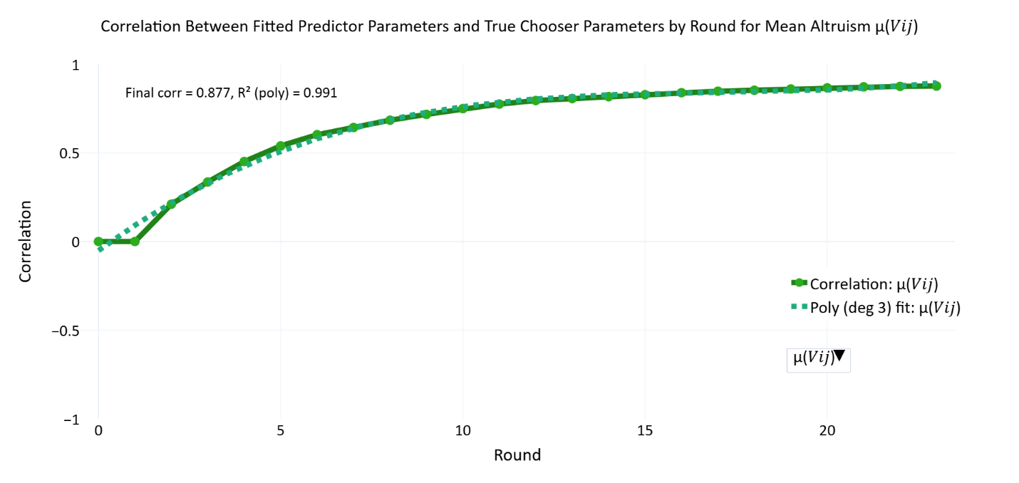
Figure 4: Incremental alignment between inferred and true altruism across rounds:
The solid green line plots the Pearson correlation, by round, between the altruism means fitted for each predictor bot (μ(𝑉_{𝑖𝑗})) and the “ground-truth’’ altruism programmed into its chooser counterpart. The dashed green line gives the least-squares linear fit (slope = 0.023; 𝑅² = 0.991). The trajectory verifies that the Utility Bayesian Model progressively revises beliefs toward the chooser’s true parameter with continued evidence, demonstrating reliable convergence in iterated interactions.
3. Prior Variance and Temperature Affect Belief Update Speed
We quantified belief update speed by identifying the earliest round in which a predictor’s altruism estimate μ(𝑉_{𝑖𝑗}) reached halfway from its initial (round‐0) value to its final (round‐last) value, then normalizing that crossing time by the total number of rounds. Higher values of this speed metric thus indicate a slower approach to the eventual estimate. We regressed this outcome onto: (1) the fitted first‐round standard deviation σ(𝑉_{𝑖𝑗}), representing prior variance in altruism, and (2) the fitted SoftMax temperature τ, representing how “random” or “undiagnostic” each observed choice is assumed to be.
A multiple linear regression (ordinary least squares) was conducted on 𝑛=945 simulated dyads. The model accounted for approximately 13.9% of the variance in update speed (𝑅²=0.139, 𝐹(2, 726)=58.37, 𝑝<.001).
- Prior variance: 𝛽=−0.0677, 𝑡=−10.624, 𝑝<.001. Higher variance in round‐0 altruism corresponded to faster updating (i.e., a lower fraction of total rounds to reach the halfway point). This aligns with Bayesian principles that an uncertain (wide) prior is more responsive to new evidence.
- Temperature: 𝛽=+0.0241, 𝑡=1.665, 𝑝=0.096. Although this positive effect was not statistically significant at conventional 𝛼=0.05, the sign suggests that larger τ may be associated with more protracted updating. In other words, when the model views each choice as relatively uninformative—due to a higher temperature parameter—its beliefs shift more slowly. However, the influence of temperature alone was not strong enough to meet significance in this simulation.
Although the temperature effect did not reach statistical significance, there is some conceptual rationale for believing that very high temperature values could, in certain circumstances, impede accurate learning by treating even meaningful choices as essentially random. Future analyses could explore interactions between extremely high τ and other model parameters (e.g., the chooser’s own temperature), especially in contexts where a single uncharacteristic choice might be over‐or underweighted in belief updating.
Taken together, these findings confirm that prior variance is a primary driver of how rapidly the model adjusts its altruism estimate over the course of repeated observations. A wide prior fosters more flexible belief revision, while lower prior variance slows updating. The partial (though not statistically significant) temperature effect is directionally consistent with the notion that large τ values reduce the model’s ability to glean definitive information from each observed choice.
    - Summary of Simulation Findings
The simulation demonstrates that:
- The optimizer accurately recovers the “true” predictor parameter (𝑟 = 0.755), validating the reliability of fitted priors and posteriors.
- Model posteriors converge systematically toward the chooser’s altruism parameter, with round‐by‐round correlation increasing regularly (𝑅² = 0.958 for a linear fit).
- Higher prior variance consistently yields faster belief updates, and higher temperature tends to lead to slower updates, confirming the model’s Bayesian logic about how priors and likelihood sharpness shape learning.
Together, these points substantiate the practical functioning of our Bayesian approach. The model’s ability to converge on correct parameters, combined with the mechanistic role of variance and temperature, indicates that it is well‐posed to handle noisy, semi‐stochastic decisions. Readers can thus view the subsequent human data analyses with confidence that the same pipeline accurately recovers underlying social preferences in a controlled scenario.
The simulations above validated the computational machinery in isolation. To evaluate the model against human behavior, we first describe the human-on-bot experiment that generated the data used in the following analyses.
- Methods – Experiment 1: Human-on-bot Social Preference Prediction Game Experiment
  - Experimental Design Overview
Participants across all experiments engaged in repeated binary dictator games (bDG), designed to investigate how individuals infer and update beliefs about others' social preferences from observed choices. Each trial involved a chooser ("dictator") selecting between two potential payoff allocations
(Option A vs. Option B). Retaliation, negotiation, or strategic reciprocity within each game was structurally impossible, ensuring that choices reflected pure, outcome-based social preferences0F.
Participants observed these decisions and predicted choosers’ subsequent choices under new payoff scenarios. Predictions were hidden from choosers. Predictions provided a measure of participants' evolving beliefs about the choosers’ underlying social preferences.
We conducted two complementary experiments, a human-on-bot experiment designed primarily for initial model validation, and a subsequent human-on-human experiment offering greater ecological validity and enabling detailed parameter estimation.
We refer to Experiment 1, the Social Preference Prediction Game, as the human-on-bot experiment and Experiment 2, the Iterated Binary Dictator Game experiment, as the human-on-human experiment to highlight one of the most salient differences between them: in the human-on-bot experiment human participants play preprogrammed computerized agents and in the human-on-human experiment, human participants play each other. While there are other differences, both experiments involve repeated interactions in binary dictator games where players predict their counterparts’ choices over varied payoff structures.
  - The Social Preference Prediction Game
The human-on-bot experiment served primarily to validate our Bayesian cognitive model’s ability to accurately describe how participants updated beliefs about chooser preferences. Participants (𝑛 = 83) interacted repeatedly with four identifiable, computer-programmed chooser-agents ("avatars"), each governed by distinct, fixed preference parameters. These preprogrammed preferences provided an objective reference point by which to assess participants’ belief accuracy.
Key Features:
- Controlled Payoff Structures: Each avatar encountered 8 distinct payoff-difference scenarios repeatedly, summarized in Table 2.
- Prediction Elicitation: Participants predicted avatar choices after observing past avatar decisions. Predictions were binary (Option A or Option B).
- Abstract Payoff Presentation: Payoffs appeared as abstract dots rather than numbers1F.
- Constant Matching: Participants repeatedly encountered the same four avatars, identified by consistent icons throughout the experiment.
- No Time Pressure: Participants had unlimited time to respond.
- Two Games Per Trial: Each trial included an observation phase, where participants watch an avatar choose, and a response phase where participants predict the same avatar’s choice in a subsequent binary dictator game, typically with a different payoff structure. Participants submit predictions only during the response phase, without seeing the avatar’s actual choice.
Table 2 summarizes how often each avatar selected each option defined by payoff differences and Figure 5 illustrates the four avatar’s preference profiles based on the regions of the payoff spaces containing their preferred options:
Table 2: Frequency of avatar choices across eight controlled payoff-difference scenarios in the human-on-bot experiment.
Single choice observations were rarely diagnostic of an avatar’s preference profile because different avatars often select the same option. This overlap in choices necessitates gradual belief updating.
Payoff Difference  (π_{𝑖}ᴬ - π_{𝑖}ᴮ, π_{𝑗}ᴬ - π_{𝑗}ᴮ) | Utilitarian | Selfish | Competitive | Masochistic
(-2, 4) | 16 | 0 | 0 | 4
(2, 4) | 16 | 16 | 0 | 0
(4, 2) | 16 | 16 | 16 | 0
(4, -2) | 16 | 16 | 16 | 0
(2, -4) | 0 | 16 | 16 | 0
(-2, -4) | 0 | 0 | 16 | 4
(-4, -2) | 0 | 0 | 0 | 4
(-4, 2) | 0 | 0 | 0 | 4

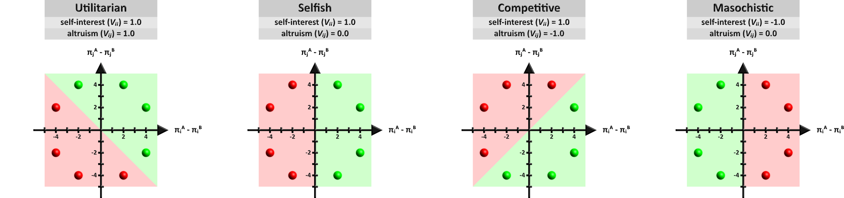
Figure 5: Avatar Preference Profiles:
Participants interacted with four distinct avatars, each characterized by a unique social preference profile: Utilitarian (96 games), Selfish (96 games), Competitive (96 games), and Masochistic (32 games). Avatars' choices were governed by a two-parameter utility function: $U_{i}\left(A\right)=V_{ii}\left(π_{i}^{A}-π_{i}^{B}\right)+V_{ij}\left(π_{j}^{A}-π_{j}^{B}\right)$ where parameters 𝑉_{𝑖𝑖} (self-interest) and 𝑉_{𝑖𝑗} (altruism) systematically varied across avatars, resulting in distinct decision patterns. Green regions in each payoff matrix indicate chosen outcomes, whereas red regions represent non-chosen outcomes. Visually distinct avatars represent each preference profile across the experiment although the avatar appearance to preference profile mapping was randomized across participants.
  - Predicted Belief Trajectories Across Avatar Types
With the experimental design established, we begin by illustrating how the model represents belief trajectories across the four avatar types. Figure 6 illustrates the Utility Bayesian Model’s belief updating behavior. This visualization traces predictor belief trajectories for each of the four avatar types in the human-on-bot experiment—Utilitarian, Selfish, Competitive, and Masochistic—across repeated observations. Each panel shows a separate instantiation of the model’s updating process for different participants, overlaid on a color-coded backdrop indicating regions of the parameter space that would generate the observed choices for each avatar. The green cross in every panel marks the model’s initial prior. All belief trajectories radiate from this single prior because we fitted priors to participants across all their counterpart, rather than dyad by dyad. As decisions unfold, the lines (turquoise, blue, pink, and red) depict the evolving mean beliefs along the self-interest μ(𝑉_{𝑖𝑖}) and altruism μ(𝑉_{𝑖𝑗}) dimensions.
Close inspection of these paths highlights several core features of Bayesian inference. In panels where the priors are set with relatively large variance, the trajectories undergo rapid shifts. By contrast, minimal updating occurs when the priors are narrowly concentrated, as low variance expresses high confidence in beliefs. In such cases, the final beliefs end up near the original prior (green cross), indicating that new observations carry less weight for a model that is strongly peaked from the start.
Additionally, the zig-zag shape of the belief paths reflects the random distribution of payoff structures across trials. Had the bots made identical choices over identical payoffs, the belief trajectories would have been linear. Instead, each new observation nudged the mean estimates in slightly different directions because these variable choice observations can express variable willingness to sacrifice self-interest for the interests of others and vice versa. Despite this variability in payoffs, the avatar-bots choose according to stable social preferences, which is why these choice observations consistently nudge beliefs into one broad direction for each avatar. Unlike humans, these preprogrammed bots never make contradictory or uncharacteristic choices and that is why the beliefs never backtrack. For instance, the masochistic avatars always make choices that reduce their payoffs and so the red lines may zig up or down along the altruism axis, but never rightward along the self-interest axis.
Because the lines show only the model’s mean parameters for each avatar type, they do not capture the standard deviations or covariances that also evolve across trials. Nonetheless, they demonstrate how repeated Bayesian updates gravitate toward true parameters, in this case (1, 1) for Utilitarian, (1, 0) for Selfish, (1, -1) for Competitive, and (-1, 0) for Masochistic avatars.
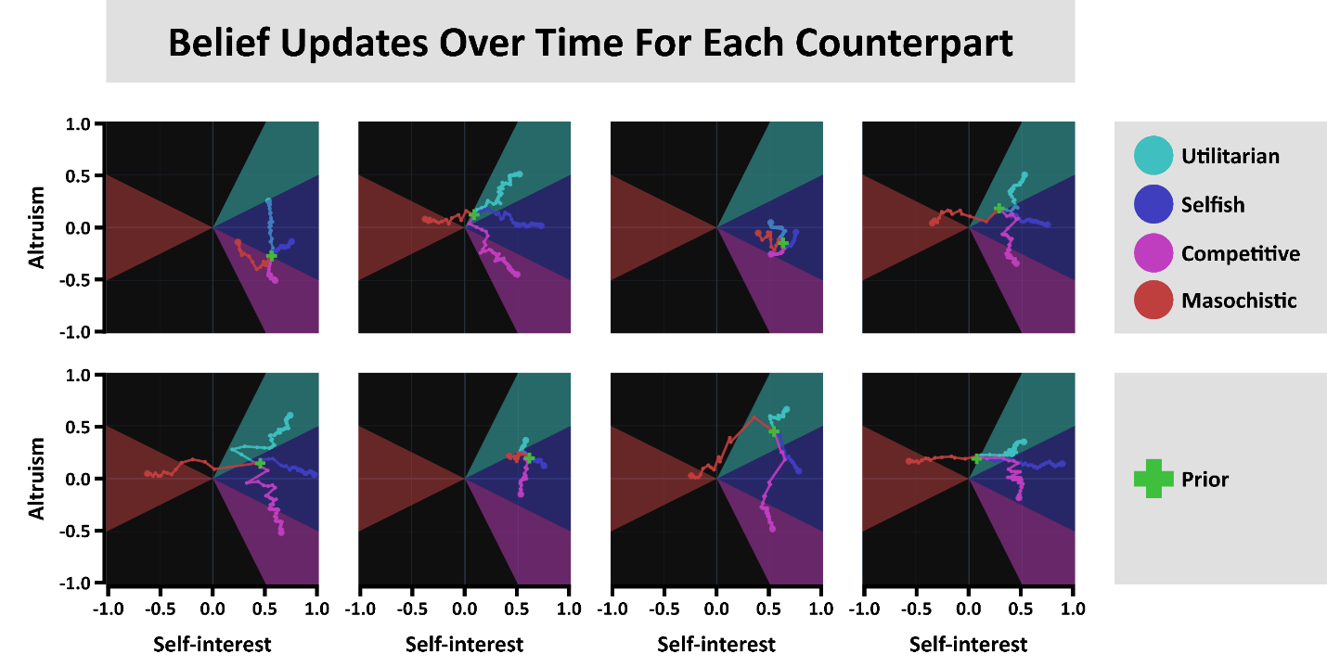
Figure 6: Belief Updates and Convergence Trajectories in 2D Parameter Space:
Each panel shows the evolution of mean beliefs for four avatar types—Utilitarian (1, 1), Selfish (1, 0), Competitive (1, -1), and Masochistic (-1, 0)—in the (𝑉_{𝑖𝑖}, 𝑉_{𝑖𝑗}) plane over repeated observations. The green cross indicates the shared initial prior for all avatars; colored lines trace how the model’s mean parameters shift as it observes each avatar’s choices. Shaded sectors represent the regions of parameter space compatible with each avatar’s behavior. Panels where the prior variance is low (confident priors) exhibit minimal movement, while those with higher variance show large, rapid shifts in response to new data. The zig-zag shapes arise from variability in the payoff structures from trial to trial, illustrating how each observation exerts a distinct directional pull. These convergent trajectories demonstrate the model’s capacity for iterative Bayesian updating in a continuous, two-dimensional representation of social preferences.
- Model Validation: Comparing Bayesian and Alternative Cognitive Models
The simulation results presented earlier verify that our Utility Bayesian Model satisfies several absolute performance criteria, including effective optimization, rational updating behavior, and appropriate sensitivity to prior beliefs and observed choices. While these results confirm the internal coherence and Bayesian quality of the model, they do not demonstrate its superiority over alternative cognitive models in predicting human behavior. To assess relative predictive power, we compared the Utility Bayesian Model against distinct baseline models using data from the human-on-bot experiment.
Because the human-on-bot setup avoids role switching and uses preprogrammed chooser agents, it provided a more controlled environment for model comparison than the human-on-human experiment. We evaluated models via total negative log-likelihood (NLL) calculated from participants’ predictions, with lower NLL indicating higher predictive accuracy. Table 3 reports NLL results across the models.
We first compared the UBM against three non-Bayesian approaches lacking critical features of Bayesian updating. The Stochastic model assigns equal probability to all choices, serving as a minimal baseline (reported NLL is the mean of 1000 runs). The No Learning model was identical to the UBM except priors were effectively frozen by constraining minimum and maximum standard deviation parameters to near zero, preventing meaningful updates from new observations. The No Memory model disregarded priors entirely, making predictions based solely on the immediate past choice, thus requiring no parameter fitting. By contrast, the UBM integrates priors and cumulative evidence dynamically, leveraging both initial assumptions and evolving observations. As shown in Table 3, the UBM achieves substantially lower NLL (5811.11 with a 21×21 grid) than the non-Bayesian baselines (each exceeding 10,000). These results highlight that both cumulative learning and belief integration significantly enhance predictive accuracy.
Next, we tested the Utility Bayesian Model against three models that represent others as falling into discrete preference types, rather than representing the social preferences of others as parameters on continuous dimensions, which is more like our approach. However, because our model approximates a continuous hypothesis space with a discrete grid, it is more accurate to say that we test models that vary in their level of resolution, with discrete (typological) approaches at the low end and continuous approaches at the high end of a spectrum of resolution. By representing beliefs via a dense grid, our Utility Bayesian Model uses a higher resolution than the typological models tested here but does not reach the resolution of a fully continuous model.
  - Discrete versus Continuous Bayesian Models
A critical question in social preference research concerns whether human moral cognition and inferences about others are best represented as discrete types or continuous parameters. Historically, discrete categorization frameworks have been influential in psychology and economics due to their intuitive appeal and interpretative simplicity. For example, early approaches to social value orientation (SVO) classified individuals into distinct categories—such as “prosocial,” “individualistic,” and “competitive”—to succinctly describe cooperative tendencies in social dilemmas (Van Lange, Joireman, Parks, & Dijk, 2013; Balliet, Parks, & Joireman, 2009). Similarly, in contexts like public goods games, researchers have identified meaningful discrete clusters, notably “conditional cooperators” and “free riders” (Fischbacher & Gächter, 2010), demonstrating practical explanatory value.
However, accumulating empirical evidence increasingly suggests that discrete categorization—while convenient—may substantially oversimplify the underlying psychological reality. Andreoni and Miller (2002), in a seminal revealed-preference study, demonstrated that altruistic behavior exhibits nuanced variation along a continuous spectrum rather than fitting neatly into distinct categories. This continuous variability in social preferences was further supported by Fisman, Kariv, and Markovits (2007), who documented extensive heterogeneity in generosity and social concern across a broad, continuous payoff space. Moreover, Murphy, Ackermann, and Handgraaf (2011) explicitly introduced a continuous measurement method—the “SVO Slider”—highlighting significant and meaningful variability in social preferences that discrete typologies fail to capture fully.
Parallel debates exist regarding people's beliefs about others' social preferences. While discrete mental categories, such as labeling individuals as “good” or “bad,” offer efficient cognitive heuristics (Cosmides, Barrett, & Tooby, 2010; Krupp, Debruine, & Barclay, 2008), more recent evidence shows that human belief updating often transcends these initial simplifications. However, the question of whether social-preference inferences specifically are best represented as discrete categories or continuous distributions remains unresolved.
A growing body of work indicates that, even when researchers start from discrete typologies, people’s beliefs about others shift in graded, probabilistic ways as evidence accrues. For instance, subjects invert partners’ actions to update a continuous posterior over preference weights (Jern, Lucas, & Kemp, 2017), show type-dependent belief revision across repeated dictator tasks (Iriberri & Rey-Biel, 2013), and can be captured by hierarchical Bayesian models that treat both preferences and beliefs as continuous latent variables (Aksoy & Weesie, 2014). Yet these prior studies tested only a small, predetermined set of discrete models or did not systematically examine continuous-versus-discrete representations specifically within the domain of social preferences.
Following this reasoning, we compared our relatively high-resolution Utility Bayesian Model to several discrete topological Bayesian models8F. In this analysis, discrete models included the Good versus Evil model (categorizing altruism parameters as positive or negative), the Canonical Social Value Orientation (SVO) model (utilizing familiar categories like altruistic, selfish, and competitive), and the Perfect Oracle model, which starts with a perfectly calibrated prior matching the experiment’s actual distribution of avatar types. This “oracle” thus knows in advance exactly what fraction of encounters will feature selfish, competitive, or utilitarian counterparts, giving it the best possible starting guess in principle. Rather than fitting parameters, these models used fixed priors as shown in Figure 7. Despite its theoretically optimal prior, the Perfect Oracle yielded poor predictive performance (NLL = 17381.06), indicating that participants did not rely on perfect population knowledge from the outset. Likewise, Good versus Evil and Canonical SVO models underperformed substantially, each producing NLL values exceeding 14,000. These comparisons suggest that at least these discrete categorizations inadequately capture nuanced and dynamic human belief updating. The Utility Bayesian Model’s superior performance supports representing social preferences at higher resolutions and refining them continuously over time.
Table 3: Model Comparison by Total Negative Log-Likelihood.
Loss values represent the sum of negative log-likelihoods (NLL) across all participants in the human-on-bot experiment. The “High-Resolution Bayesian” model (leftmost bar) shows the lowest NLL of 5811, outperforming all discrete and non-Bayesian alternatives.
Model Name | Bayesian | Parameterization | Loss (Total NNL)
Perfect Oracle | True | Discrete | 17381.055
Canonical SVO | True | Discrete | 16904.924
Good versus Evil | True | Discrete | 14639.593
Stochastic | False | Neither | 13272.419
No Memory | False | Continuous | 12057.898
No Learning | False | Continuous | 10683.986
Utility Bayesian | True | Continuous | 5811.111

These comparisons favor a Bayesian updating process with nuanced social preference beliefs and belief updating. Nonetheless, there remain infinitely many ways to partition continuous hypothesis spaces, and our discrete models thus far are a minute subset of what is possible. We next examine a broader range of models with discrete hypothesis spaces, testing whether any such model can surpass the predictive performance of our comparatively high-resolution framework.
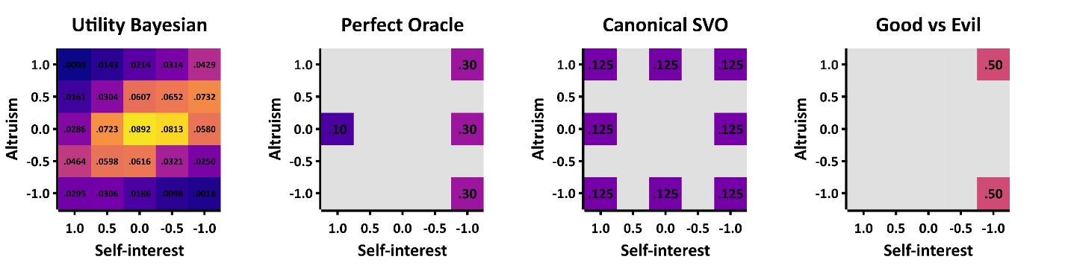
Figure 7: Illustrating Different Resolutions of Social Preference Hypothesis Spaces:
Each square shows a 5×5 parameter grid for 𝑉_{𝑖𝑖} and 𝑉_{𝑖𝑗} ranging from −1 to +1. The color in each cell corresponds to the prior probability assigned to that cell. The leftmost square depicts our high-resolution Utility Bayesian Model (here, 5 bins per dimension) with probabilities spread across all 25 cells. Panels B–D display lower-resolution “discrete” models—Perfect Oracle, Canonical SVO, and Good vs. Evil—where only a handful of cells carry nonzero probability (colored), effectively treating the rest as impossible (dark/empty). This demonstrates how simple discrete models can be seen as special cases of the higher-resolution approach, with fewer “bins” (or types) in their hypothesis space. In practice, our “high-resolution” approach uses finer grids (like 21×21) to approximate “continuous” preferences but we also used a 5×5 grid when comparing the UBM to typological models that represent types in somewhere in the 5×5 parameter space so that they UBM would be more comparable to the typological models. Note: The distinction between continuous and discrete Bayesian models pertains to their hypothesis spaces, not how probabilities are updated. Both continuous (UBM) and discrete (typological) models update probabilities continuously (gradually rather than stepwise), but only typological models explicitly forbid certain regions of the parameter space.
  - Searching The Space of Typological Bayesian Models
We next conducted a more extensive search through a broad range of discrete models to test whether any alternative partitioning of the social preference space could rival our Utility Bayesian Model. The logic behind these additional comparisons was that each “discrete” hypothesis space can be thought of as a lower-resolution special case of our grid-based, high-resolution approach, where only a handful of parameter “bins” receive nonzero prior probability. To construct these lower-resolution hypothesis spaces, we discretized the two-dimensional parameter space (𝑉_{𝑖𝑖}, 𝑉_{𝑖𝑗}) into a 5 by 5 grid with equally spaced points between −1 and +1 on each dimension. We then generated discrete models by choosing different subsets of these points—ranging from three to six preference “types”—and fitting the prior probabilities over those types to the data. Specifically, we evaluated every combination of three and four types in that 25-point grid ($\left({25 \atop 3}\right)=2300$ combinations and $\left({25 \atop 4}\right)=12,650$ combinations), and we drew a random sample of subsets for five and six types due to computational constraints. For each discrete model, we optimized the prior distribution and calculated total negative log-likelihood (NLL) values based on participants' predictions. We optimized the prior distribution to the entire population for all the models and then fitted the prior distribution participant by participant for the model with the best fit at the population level. Individual-level fitting for every model would have been computationally intractable.
Despite this extensive search, none of the typological models approached the predictive accuracy achieved by our Utility Bayesian Model. The best-performing discrete model had a minimum total NLL slightly above 8,500 at the population level, which improved marginally to approximately 8,470 when priors were individualized per participant. While these adjustments did yield incremental improvements, the overarching result remained robust: typological models omitting large regions (bins) of the hypothesis space failed to capture participants' predictions as effectively as the more granular Utility Bayesian Model (UBM). This suggests that representing social preferences with only a few discrete types overlooks the nuanced, high-resolution inference processes participants actually employed.
Our exhaustive combinational approach inherently included many models with low face validity or minimal differentiation. Nevertheless, systematically evaluating over 15,000 discrete typological models against a continuous Bayesian approach allowed us to present uniquely conclusive evidence supporting quasi-continuous belief representation. This comprehensive evaluation thus constitutes a novel methodological contribution—arguably the largest and most rigorous discrete-versus-continuous Bayesian model comparison within social preference research to date9F. Previous studies comparing continuous and discrete representations typically contrast only a handful of predefined models.
Nonetheless, several directions remain open for future research. First, our analysis is a functional-level description (Marr, 1982), characterizing input-output relationships (choices and predictions) without specifying the cognitive algorithms observers employ. Future studies could explore underlying cognitive or neural processes—for example, determining whether humans approximate Bayesian inference through heuristic algorithms (e.g., sampling-based approximations or particle filters).
Second, our conclusions about discrete versus continuous representations depend on the two parameters (self-interest and altruism) and the utility function we used. While we expect that similar outcomes would generalize to alternative dimensions (e.g., envy and guilt), future empirical work is needed to confirm whether continuous Bayesian inference consistently outperforms discrete typological models across other social preference domains.
Finally, the experimental context provided participants with clear, repeated feedback, which likely facilitated fine-grained belief representation and updating. Future research may address whether participants maintain such granular representations in more information-poor or cognitively demanding environments, or if simpler typological representations would prove more adaptive under these conditions.
The analyses to this point provided evidence that the model can be trusted. Simulations confirmed that the optimizer recovers known parameters, that posterior beliefs converge on a chooser's true preferences across repeated observations, and that update speed responds to prior variance and choice temperature as Bayesian theory predicts. Applied to human-on-bot data, the Utility Bayesian Model outperformed non-Bayesian alternatives, showing that integrating prior beliefs with incoming evidence beats relying on either alone, and outperformed typological Bayesian models that categorize others into discrete types rather than tracking continuous parameters. What remains is to apply this validated framework to what it was built for: real interactions between real people, whose preferences are unknown, variable, and worth measuring. We begin by describing the human-on-human experiment that generated the data for everything that follows.
- Methods – Experiment 2: Human-on-human Iterated Binary Dictator Game Experiment
The human-on-human experiment (𝑛 = 73) shifts from the control of preprogrammed agents to a relatively ecologically valid context—due to actual human interactions, role switching, and more varied payoff structures. Participants alternated between chooser and predictor roles, repeatedly encountering one another across multiple rounds. Participants played simultaneously in groups of 4 to 8 players.
Key Features:
- Randomized Payoff Structures: Payoffs for both chooser and recipient positions were fully randomized within {1, 2, 3, 4, 5}, yielding a comprehensive space of 625 unique payoff combinations.
- Numeric Payoff Presentation: Payoffs were shown as integers rather than abstract dots.
- Probabilistic Matching: Participants received explicit information about the probability of re-encountering each counterpart. We acknowledge this manipulation to be transparent, although future research will be needed to test the effect of matching probabilities on cooperation rates.
- Private Predictions: As with the human-on-bot experiment, predictions were private, never exposed to counterparts, to eliminate the confound of strategic signaling.
- Audiovisual Feedback: Participants received immediate audiovisual confirmation after each submission, represented by colored arrows clearly indicating chosen and predicted options, enhancing participant engagement and data reliability.
- Time Pressure: Predictions and choices were required within eight seconds per response, simulating realistic decision-making constraints. Time pressure is necessary in synchronous human-on-human multiplayer experiments to prevent slower participants from slowing down everyone else, which is why the human-on-human experiment involved time pressure but the human-on-bot experiment did not.
Table 4 contrasts procedural details between experiments:
Table 4: Contrasts between human-on-bot and human-on-human experiments highlighting complementary purposes and methodological variations.
Dimension | Human-on-bot Experiment | Human-on-human Experiment
Purpose | Model validation | Parameter estimation
Participants | Human predictors; artificial choosers | Humans as predictors and choosers
Payoff Structure | Controlled (8 unique payoff structures) | Randomized (625 payoff structures)
Matching Procedure | Constant, identifiable avatars | Probabilistic human matching
Payoff Presentation | Abstract dots | Numeric integers
Response Types | Predictions only | Predictions and choices
Data per Participant | 160 responses | ~120 responses
Time Pressure | None | 8 seconds per response
Platform URLs | m3labexperiment.com | moralitygame.com

  - Participants, Recruitment, and Procedure
Participants were undergraduate students recruited via standard university participant pools and compensated through course credits. Comprehension checks and attention-validation trials ensured data quality. Experiments were conducted remotely via standardized web platforms. Figure 8 shows the user-interface.

Procedural Controls Across Experiments:
- Payoff Order Randomization: All payoff presentations and orderings were randomized and counterbalanced, mitigating order effects.
- Neutral Instructions: Instructions were carefully neutral, explicitly avoiding normative or evaluative language.
- Performance Feedback: Participants in the human-on-bot experiment received no accuracy feedback regarding their predictions or counterparts' subsequent choices2F, while predictor-participants in the human-on-human feedback saw their counterparts’ choices after submitting predictions.
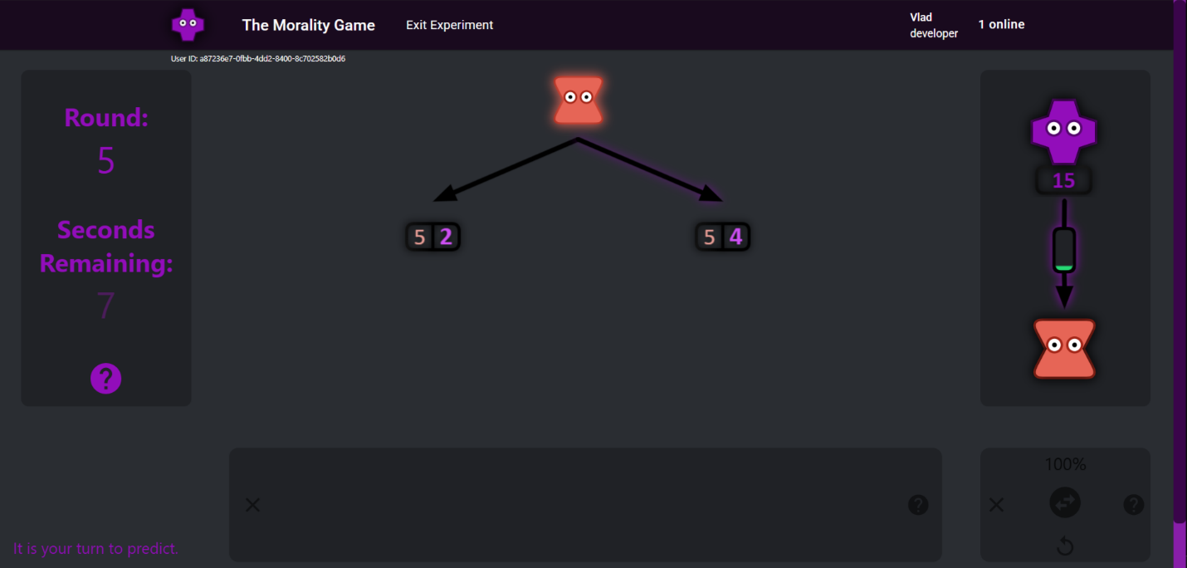
Figure 8: Human-on-human Experiment Stimuli:
This screenshot illustrates the user interface from the perspective of a participant in the predictor role during round 5, with 7 seconds remaining to submit a response. The predictor (purple avatar) must predict whether their counterpart (chooser; orange avatar) will select the left or right option. The chooser's payoff is fixed at 5 points for either choice, whereas the predictor's payoff differs between options: 2 payoffs left and 5 payoffs right. Participants select options and submit predictions via mouse, touchscreen, or keyboard. The faint purple shadow around the right arrow indicates a pre-selected prediction. Upon submission (via click, tap, or spacebar), this shadow intensifies, providing visual feedback. At this point, the arrow's interior turns orange if the chooser already chose or will turn orange when the chooser submits their choice. The right-side panel displays the predictor's cumulative payoff (15 points) and includes a thermometer icon, where the green mercury level indicates the relatively low probability of these participants being rematched in subsequent rounds. Participants understand the matching procedure and can hover the cursor over the thermometer icon to discover the exact probability, which is not revealed by default to avoid visual clutter on the user-interface.

- Information Criterion Analysis: Determining Optimal Utility Structures
The Information Criterion (IC) analysis below uses the human-on-human data from Experiment 2 to identify the utility function that should occupy the UBM's likelihood term for the population analyses. The validation work in Experiment 1 used a two-parameter UBM (self-interest and altruism) to verify that a continuous Bayesian framework outperforms typological alternatives. Here the IC analysis extends the framework by selecting a higher-dimensional utility function from a wider space of candidates, which the population analyses in the following section then use to estimate the full distribution of social preferences. The breadth of Experiment 2's randomized payoff space is what makes this comparison possible: it discriminates among utility forms in ways that hand-selected payoffs cannot. The utility function determines which psychological distinctions the model can represent, such as whether altruism and social comparison are separable, whether envy and guilt are treated as symmetric, and whether self-interest is estimated or fixed. To identify the best functional form, we performed an IC model comparison across 505 candidate utility functions.
  - Motivation and Theoretical Justification of Utility Form Variations
Our modeling effort aims to characterize how observers infer and update beliefs about others' social preferences, specifically focusing on outcome-based social preferences. Outcome-based preferences refer to preferences that depend exclusively on final distributions of payoffs, without considering non-outcome elements such as intentions, fairness norms, reciprocity, or responsibility attribution (Falk & Fischbacher, 2006). Non-outcome-based social preferences are important but outside the scope of this study.
We explored a space of utility functions inspired by influential theoretical frameworks and empirical findings. Each variation captures a psychological mechanism hypothesized to influence how individuals represent and evaluate social outcomes.
The following 14 binary utility settings determine each model’s functional form. If a setting is set to ‘true’, then it is turned on and it is turned off otherwise. For example, if and only if the setting called ‘conditional welfare mode’ is set to ‘true’, then the utility function will have a conditional welfare form.

(1) Conditional Welfare Mode
Conditional welfare mode captures the tendency to weigh payoffs differently depending on relative social standing—whether one's payoff is ahead (advantageous) or behind (disadvantageous) of others, a concept called conditional welfare (Rabin, 1992).
Example:
$$U_{i}\left(A\right)=\left\{\begin{aligned}V_{ii}\left(π_{i}^{A}-π_{i}^{B}\right)+V_{ij}\left(π_{j}^{A}-π_{j}^{B}\right), &if π_{i}^{A}≥π_{j}^{A} \\ Ʌ_{ii}\left(π_{i}^{A}-π_{i}^{B}\right)+Ʌ_{ij}\left(π_{j}^{A}-π_{j}^{B}\right), &if π_{i}^{A}<π_{j}^{A}\end{aligned}\right.$$

(2) Reference-Dependent Altruism
Reference-dependent altruism introduces the idea that altruistic preferences differ depending on whether the recipient's payoff is above or below a neutral reference point (𝑅 = 3), chosen as the middle payoff in {1, 2, 3, 4, 5}. This aligns with insights from reference-dependent models (Cox, Friedman, & Gjerstad, 2007). This utility setting only applies to conditional welfare models.
Example:
$$U_{i}\left(A\right)=V_{ii}\left(π_{i}^{A}-π_{i}^{B}\right)+\left\{\begin{aligned}V_{ij}\left(π_{j}^{A}-π_{j}^{B}\right), &if π_{i}^{A}≥R \\ Ʌ_{ij}\left(π_{j}^{A}-π_{j}^{B}\right), &if π_{i}^{A}<R\end{aligned}\right.$$

(3) Min-Max Preferences (Rawlsian and Leontief Forms)
Min-max functional forms model fairness considerations that focus on maximizing minimum payoffs, consistent with a desire for equality or fairness as famously advocated by Rawls (1971) and formalized in production economics by Leontief (1941). These forms differ in the placement of preference weights (e.g., self-interest and altruism parameters) relative to the min operator. The Rawlsian form applies a single altruism parameter externally, capturing the principle of maximizing the payoff of the worst-off individual without modulating individual contributions separately. However, the Leontief form incorporates separate parameters internally within the min operator, reflecting an agent-specific weighted consideration of everyone’s outcome. Although neither Rawls nor Leontief originally proposed using the max operator, for completeness and symmetry, we tested both min and max variants.
Rawlsian (external weighting) example:
$$U_{i}\left(A\right)=V_{ij}×{min\left(π_{i}^{A},π_{j}^{A}\right)}^{γ}$$
Leontief (internal weighting) example:
$$U_{i}\left(A\right)=min\left(V_{ii}{\left(π_{i}^{A}\right)}^{γ},V_{ij}{\left(π_{j}^{A}\right)}^{γ}\right)$$

(4 & 5) Use of Exponential Parameters and Single versus Individual Exponents per Term
Exponential parameters model nonlinear subjective utilities, aligning with diminishing marginal utility and Prospect Theory (Kahneman & Tversky, 1979). We explored whether a single exponent across all terms suffices or distinct exponents per term are necessary, reflecting varied nonlinear evaluations for self-interest, altruism, and social comparison.
Single exponent example:
$$U_{i}\left(A\right)=V_{ii}{\left(π_{i}^{A}-π_{i}^{B}\right)}^{γ}+V_{ij}{\left(π_{j}^{A}-π_{j}^{B}\right)}^{γ}-α_{ij}{\left(π_{i}^{A}-π_{j}^{A}\right)}^{γ}$$
Individual exponents example:
$$U_{i}\left(A\right)=V_{ii}{\left(π_{i}^{A}-π_{i}^{B}\right)}^{γ_{1}}+V_{ij}{\left(π_{j}^{A}-π_{j}^{B}\right)}^{γ_{2}}-α_{ij}{\left(π_{i}^{A}-π_{j}^{A}\right)}^{γ_{3}}$$

(6) Apply Exponents Directly to Payoffs
When utility functions have exponents and include payoff differences or payoff ratios, the exponents can be applied to the payoffs before or after these transformations. The two placements encode different kinds of nonlinear sensitivity. Assuming γ < 1, curving each payoff before comparison makes a fixed payoff difference feel smaller as both payoffs get larger (Ottone & Ponzano, 2005), while curving the difference itself makes sensitivity diminish with the size of the payoff difference (or ratio) per se, even at the same absolute payoff sizes, which in a social comparison term is akin to inequality aversion with diminishing sensitivity (Hill & Neilson, 2007).
Example of exponents applied inside the payoff difference:
$$U_{i}\left(A\right)=…α_{ij}\left({\left(π_{i}^{A}\right)}^{γ}-{\left(π_{j}^{A}\right)}^{γ}\right)$$
Example of exponents applied outside the payoff difference:
$$U_{i}\left(A\right)=…α_{ij}{\left(π_{i}^{A}-π_{j}^{A}\right)}^{γ}$$

(7 & 8) Single Payoffs and Payoff Ratios instead of Differences
Computing utilities from single payoffs may be cognitively simpler than computing utilities from differences (Camerer C. F., 2003) and models the payoff-utility relation as absolute, not relative. Additionally, computing utilities from payoff ratios, not payoff differences, means that a payoff difference becomes less salient as the payoffs grow larger, aligning with nonlinear marginal utility and proportional fairness perspectives (Bolton & Ockenfels, 2000). Note that the social comparison term always uses payoff differences.
Single payoff example:
$$U_{i}\left(A\right)=V_{ii}{\left(π_{i}^{A}\right)}^{γ}+V_{ij}{\left(π_{j}^{A}\right)}^{γ}$$
Payoff ratio example:
$$U_{i}\left(A\right)=V_{ii}{\left(\frac{π_{i}^{A}}{π_{i}^{A}+π_{i}^{B}}-\frac{1}{2}\right)}^{γ}+V_{ij}{\left(\frac{π_{j}^{A}}{π_{j}^{A}+π_{j}^{B}}-\frac{1}{2}\right)}^{γ}$$

(9) Reference-Dependent Utility
Inspired by Prospect Theory, reference-dependent utility evaluates outcomes against a neutral reference point, allowing for modeling of asymmetric perceptions of outcomes as gains or losses (Kahneman & Tversky, 1979).
Ideally, identifying reference-dependent preferences requires outcomes that span true gains and losses relative to a meaningful neutral (often zero or a status-quo allocation). However, because our experimental payoffs were restricted to positive values {1, 2, 3, 4, 5}, we set an artificial reference point at the midpoint of this range (𝑅=3). Conceptually, this is akin to rescaling outcomes around an average midpoint ({-2, -1, 0, 1, 2}), but it is fundamentally different from genuine loss framing around zero or another psychologically meaningful reference.
Example:
$$U_{i}\left(A\right)=V_{ii}{\left(π_{i}^{A}-R\right)}^{γ}+V_{ij}{\left(π_{j}^{A}-R\right)}^{γ}$$

(10) Negativity Parameters (Loss Aversion)
Negativity parameters model distinct sensitivity to negative deviations (losses) relative to positive deviations (gains) from the reference point, capturing the well-documented psychological phenomenon of loss aversion (Kahneman & Tversky, 1979).
As noted in the previous section, our lack of negative payoffs prevent participants from experiencing absolute losses. Instead, in this study, negativity parameters only weight relative losses—losses compared to the alternative payoff or the reference point payoff of 3.
Example:
$$U_{i}\left(A\right)=V_{ii}×max{\left(π_{i}^{A}-π_{i}^{B},0\right)}^{γ}+Ʌ_{ii}{×max\left(π_{i}^{B}-π_{i}^{A},0\right)}^{γ}$$

(11) Negativity in Social Comparison (Envy/Guilt)
Separate negativity parameters within social comparison terms reflect differentiated psychological responses to advantageous versus disadvantageous inequalities, consistent with inequity aversion theories (Fehr & Schmidt, 1999). Here $α_{ij}$ is envy towards disadvantageous inequality and $β_{ij}$ is guilt towards advantageous inequality.
Example:
$$U_{i}\left(A\right)=…-α_{ij}×{max\left(π_{j}^{A}-π_{i}^{A},0\right)}^{γ}-β_{ij}×{max\left(π_{i}^{A}-π_{j}^{A},0\right)}^{γ}$$

(12) Variable versus Fixed Self-Interest Parameter
We assessed whether self-interest varies across individuals or is universally fixed at 1, simplifying individual heterogeneity assumptions and following common practice (Andreoni & Miller, 2002).
Variable example:
$$U_{i}\left(A\right)=V_{ii}{\left(π_{i}^{A}-π_{i}^{B}\right)}^{γ}+…$$
Fixed example:
$$U_{i}\left(A\right)={\left(π_{i}^{A}-π_{i}^{B}\right)}^{γ}+…$$

(13 & 14) Inclusion of Altruism and Social Comparison Terms
Finally, we explicitly tested the necessity of including altruism and social comparison terms, frequently identified as critical to social behavior (Fehr & Schmidt, 1999; Bolton & Ockenfels, 2000).
These systematic explorations resulted in 505 distinct utility forms. We searched for the best fitting utility form, defined as minimizing the information criterion score, to ensure a robust foundation for our Bayesian cognitive modeling.
  - Methodological Approach
We performed an Information Criterion (IC) analysis to select the optimal utility function among 505 systematically generated alternatives. Using Akaike Information Criterion (AIC) and Bayesian Information Criterion (BIC), we balanced model fit against complexity (Anderson & Burnham, 2002; Akaike, 1973; Schwarz, 1978). For computational feasibility, we conducted this analysis using a static (no updating) version of our cognitive model. Although a fully dynamic Bayesian approach would have been theoretically ideal, the computational demands of fitting individual-level Bayesian belief updating parameters across 73 participants and 505 utility functions proved prohibitive10F.
The total negative log-likelihood (NLL) summed across all participant choices and predictions served as the basis for IC calculations:
$$AIC=2k+2×NLL$$
$$BIC=k×ln\left(n\right)+2×NLL$$
where 𝑘 is the number of free parameters and is the total number of data points.
  - Pairwise Comparison Analysis
Beyond identifying the single best utility form, it is valuable to learn general principles about which design features consistently help or hinder model fit. Such principles can guide researchers who wish to extend this framework to richer settings—e.g., games with more players, strategic reasoning, or belief-based preferences. Because our set of candidate models spans 505 functional forms that differ along 14 Boolean design dimensions, we summarize the average directional contribution of each dimension by averaging the difference in BIC between pairs of models that are identical except for one switched setting.
Table 5 summarizes the results of this pairwise comparison analysis:
Table 5: Pairwise BIC contrasts for each Boolean utility setting:
$∆BIC=BIC\left(setting off\right)-BIC\left(setting on\right).$ Negative values indicate that turning the setting on improves fit on average. “Relation” denotes whether the compared pairs are nested (parent/child), siblings (same k), or neither. Because some settings are only defined with subsets of the model space, the number of eligible pairs differs by row.
Utility Setting | Relation | N Pairs | Mean ΔBIC | Med ΔBIC | Effect on Fit
Use Exponential Parameters | Nested | 118 | -967.38 | -950.51 | Strongly improves
Include Altruism Term | Nested | 158 | -433.46 | -430.77 | Strongly improves
Envy/Guilt in Social Comparison | Nested | 81 | -355.13 | -232.91 | Moderately improves
Include Social Comparison | Nested | 63 | -244.63 | -277.6 | Moderately improves
General Negativity Parameters | Nested | 92 | -51.91 | 1.84 | Slightly improves
Single Exponential Parameter | Nested | 140 | 77.97 | 22.87 | Slightly worsens
Fix Self-Interest Parameter | Nested | 118 | 219.44 | 44.58 | Moderately worsens
Single Payoffs (not differences) | Siblings | 48 | -8.18 | 15.31 | Neutral effect
Reference-Dependent Altruism | Siblings | 37 | 21.42 | 4.92 | Slightly worsens
Reference-Dependent Utility | Siblings | 214 | 313.00 | 358.57 | Moderately worsens
Apply Exponents to Payoffs | Siblings | 164 | 565.27 | 819.96 | Strongly worsens
Payoff Ratios (not differences) | Siblings | 214 | 1548.36 | 1566.04 | Strongly worsens
Conditional Welfare Form | None | 37 | -162.27 | -87.02 | Moderately improves
Min-Max Rawlsian/Leontief | None | 23 | 701.22 | 701.33 | Strongly worsens

Provisional Principles and Recommendations:
Strongly recommended:
- Include exponential parameters and an altruism term.
- Exclude exponents directly on payoffs, payoff ratios, and min-max forms.
Recommended:
- Include a social comparison term, ideally split into sides for disadvantageous (envy) and advantageous (guilt) inequality.
- Allow self-interest to vary, rather than fixing it to one,
- Avoid reference points based on the midpoint payoff (𝑅=3).
- Single payoffs and payoff differences perform about equally well.
- Caution advised: The neutral or weak effects of models that include negativity parameters or use 𝑅 = 3 as a reference point likely reflect our payoff space lacking true losses. These forms might behave differently when outcomes can fall below zero.
These recommendations are provisional. They represent averages across all 505 utility functions rather than the subset of best-fitting ones and ignore potential interactions between settings. Some features that look harmful in aggregate can become beneficial in restricted contexts. For example, “apply exponents to payoffs” worsened fit on average (ΔBIC ≈ +565), but when models using payoff ratios, min-max, and conditional-welfare forms are excluded, the same setting improves fit (mean ΔBIC ≈ -225). Thus, this pairwise analysis should be read as a first-pass, rather than a final verdict. It is a way to identify promising ingredients for future models and to flag areas where richer interaction analyses could reveal context-specific advantages of functional forms.
  - Optimal Utility Functions and Nesting
Our top-performing utility functions were determined by ranking BIC scores, as BIC penalizes model complexity more strongly than AIC. Figure 9 shows the ΔBIC scores for all 505 models and Table 6 shows the top-performing models by 𝑘 parameters.
The optimal utility function is expressed as:
$$U_{i}\left(A\right)=V_{ii}{\left(π_{i}^{A}-π_{i}^{B}\right)}^{γ_{1}}+V_{ij}{\left(π_{j}^{A}-π_{j}^{B}\right)}^{γ_{2}}-α_{ij}×{max\left(π_{j}^{A}-π_{i}^{A},0\right)}^{γ_{3}}-β_{ij}×{max\left(π_{i}^{A}-π_{j}^{A},0\right)}^{γ_{3}}$$
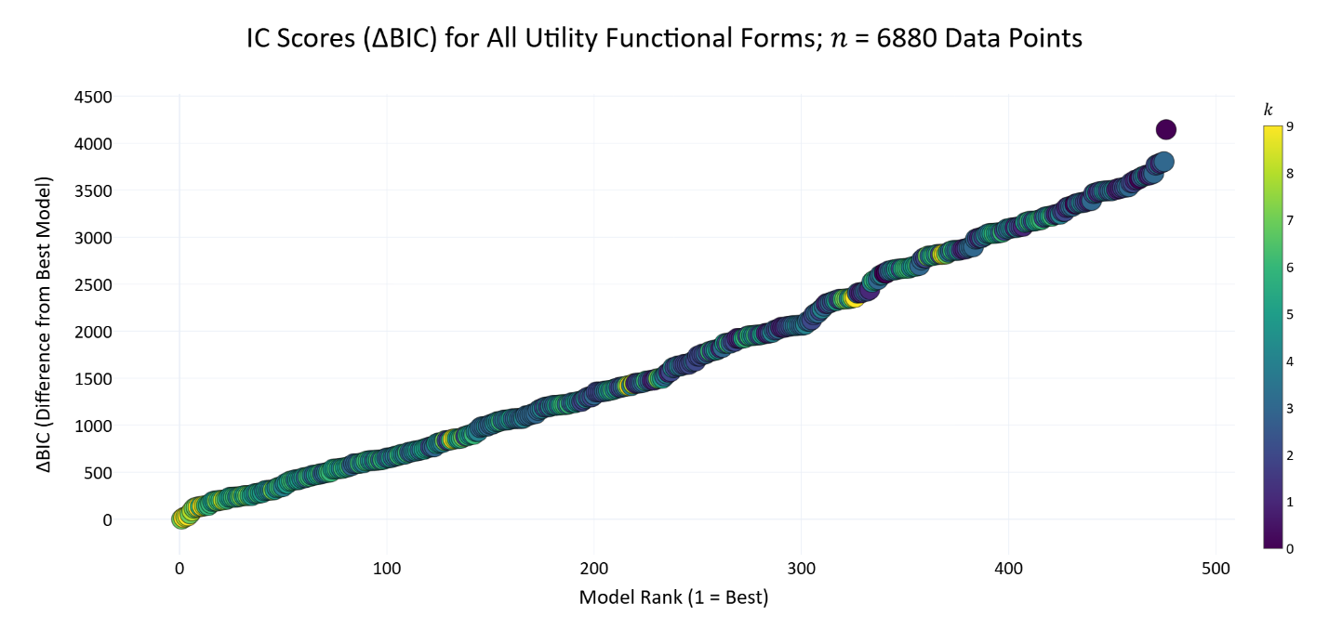
Figure 9: All 505 ΔBIC Scores Per Functional Form from Least to Greatest:
This plot shows ΔBIC for all 505 models from least to greatest, where ΔBIC is the difference between the minimum BIC score and the model's BIC score. Each point is one model. Models are colored by number of parameters (𝑘).
Table 6: Information Criterion Scores and Functional Forms for Top-Performing Utility Functions by Parameter Count.
This table presents the nine best-fitting utility functions from our set of 505 candidate models, organized by the number of free parameters (𝑘). Utility functions are ranked within each 𝑘 on the basis of their Bayesian Information Criterion (BIC), a metric that balances model fit (measured by summed negative log-likelihood) against complexity. The ΔBIC column reports the BIC difference from the best-fitting model across all 505 (the 𝑘 = 5 model with ΔBIC = 0). ΔBIC values greater than 10 indicate significantly worse model performance.
Binary indicators (0/1) in columns S1–S14 denote the inclusion of 14 theoretically motivated utility settings, such as reference dependence, exponent structure, and social comparison terms (see legend below). While the top-performing model includes seven parameters—self-interest, altruism, envy, guilt, and exponents for each term—the broader comparison highlights which features tend to improve fit as model complexity increases.
The equations in the lower panel correspond to the models listed in the upper panel, matched by their 𝑘 values. Due to formatting constraints, the top and bottom halves are separated but aligned row-wise by 𝑘.
While we recommend using the top performing model (𝑘=7), this table allows modelers to select the best utility functions based on the number of parameters they prefer to use, and it reveals general insights into the types of models that tend to fit the data best.
𝑘 | Loss | AIC | BIC | ΔBIC | S_{1_} | S_{2_} | S_{3_} | S_{4_} | S_{5_} | S_{6_} | S_{7_} | S_{8_} | S_{9_} | S₁₀ | S₁₁ | S₁₂ | S₁₃ | S₁₄
1 | 3274.05 | 6550.1 | 6556.94 | 1443.94 | 0 | 0 | 0 | 1 | 1 | 1 | 0 | 0 | 0 | 0 | 0 | 1 | 0 | 0
2 | 2932.19 | 5868.39 | 5882.06 | 769.06 | 0 | 0 | 0 | 1 | 1 | 1 | 0 | 0 | 0 | 0 | 0 | 1 | 0 | 1
3 | 2764.46 | 5534.92 | 5555.43 | 442.43 | 0 | 0 | 0 | 1 | 1 | 1 | 0 | 0 | 1 | 0 | 1 | 1 | 1 | 0
4 | 2657.34 | 5322.68 | 5350.02 | 237.02 | 0 | 0 | 0 | 1 | 1 | 1 | 0 | 0 | 0 | 0 | 0 | 0 | 1 | 1
5 | 2628.47 | 5266.94 | 5301.12 | 188.13 | 0 | 0 | 0 | 1 | 1 | 0 | 1 | 0 | 0 | 0 | 1 | 0 | 1 | 1
6 | 2597.37 | 5206.74 | 5247.75 | 134.76 | 0 | 0 | 0 | 1 | 0 | 0 | 0 | 0 | 0 | 0 | 1 | 1 | 1 | 1
7 | 2525.57 | 5065.14 | 5113 | 0.00 | 0 | 0 | 0 | 1 | 0 | 0 | 0 | 0 | 0 | 0 | 1 | 0 | 1 | 1
8 | 2534.47 | 5084.93 | 5139.62 | 26.63 | 0 | 0 | 0 | 1 | 0 | 0 | 0 | 0 | 0 | 1 | 1 | 1 | 1 | 1
9 | 2525.24 | 5068.48 | 5130.01 | 17.01 | 0 | 0 | 0 | 1 | 0 | 0 | 0 | 0 | 0 | 1 | 1 | 0 | 1 | 1
Column Names:
𝑘: Number of parameters.
loss: Summed Negative Log-Likelihood across all participant responses.
AIC/BIC: Information Criteria balancing fit and complexity (lower values indicate superior models).
ΔBIC: Difference in BIC relative to the best (lowest) scoring model (ΔBIC > 10 considered decisive).
S1 through S14: Utility Settings (1 = true, 0 = false) corresponding to the enumerated settings:
- Conditional welfare mode
- Reference-dependent altruism
- Rawlsian and Leontief min-max
- Use of exponential parameters
- Single versus individual exponents
- Apply exponents directly to payoffs
- Single payoffs (instead of differences)
- Payoff ratios (instead of differences)
- Reference-dependent utility (𝑅 = 3)
- Negativity parameters (loss aversion)
- Negativity within social comparison (envy/guilt)
- Variable versus fixed self-interest parameter
- Inclusion of social comparison
- Inclusion of altruism
𝑘 | Equation
1 | $$U_{i}\left(A\right)={\left(π_{i}^{A}\right)}^{γ}-{\left(π_{i}^{B}\right)}^{γ}$$
2 | $$U_{i}\left(A\right)={\left(π_{i}^{A}\right)}^{γ}-{\left(π_{i}^{B}\right)}^{γ}+V_{ij}\left({\left(π_{j}^{A}\right)}^{γ}-{\left(π_{j}^{B}\right)}^{γ}\right)$$
3 | $$U_{i}\left(A\right)={\left(π_{i}^{A}\right)}^{γ}-{\left(R\right)}^{γ}-α_{ij}×max\left({\left(π_{j}^{A}\right)}^{γ}-{\left(π_{i}^{A}\right)}^{γ},0\right)-β_{ij}×max\left({\left(π_{i}^{A}\right)}^{γ}-{\left(π_{j}^{A}\right)}^{γ},0\right)$$
4 | $$U_{i}\left(A\right)=V_{ii}\left({\left(π_{i}^{A}\right)}^{γ}-{\left(π_{i}^{B}\right)}^{γ}\right)+V_{ij}\left({\left(π_{j}^{A}\right)}^{γ}-{\left(π_{j}^{B}\right)}^{γ}\right)-α_{ij}\left[max\left({\left(π_{j}^{A}\right)}^{γ}-{\left(π_{i}^{A}\right)}^{γ},0\right)+max\left({\left(π_{i}^{A}\right)}^{γ}-{\left(π_{j}^{A}\right)}^{γ},0\right)\right]$$
5 | $$U_{i}\left(A\right)=V_{ii}{\left(π_{i}^{A}\right)}^{γ}+V_{ij}{\left(π_{j}^{A}\right)}^{γ}-α_{ij}×{max\left(π_{j}^{A}-π_{i}^{A},0\right)}^{γ}-β_{ij}×{max\left(π_{i}^{A}-π_{j}^{A},0\right)}^{γ}$$
6 | $$U_{i}\left(A\right)={\left(π_{i}^{A}-π_{i}^{B}\right)}^{γ_{1}}+V_{ij}{\left(π_{j}^{A}-π_{j}^{B}\right)}^{γ_{2}}-α_{ij}×{max\left(π_{j}^{A}-π_{i}^{A},0\right)}^{γ_{3}}-β_{ij}×{max\left(π_{i}^{A}-π_{j}^{A},0\right)}^{γ_{3}}$$
7 | $$U_{i}\left(A\right)=V_{ii}{\left(π_{i}^{A}-π_{i}^{B}\right)}^{γ_{1}}+V_{ij}{\left(π_{j}^{A}-π_{j}^{B}\right)}^{γ_{2}}-α_{ij}×{max\left(π_{j}^{A}-π_{i}^{A},0\right)}^{γ_{3}}-β_{ij}×{max\left(π_{i}^{A}-π_{j}^{A},0\right)}^{γ_{3}}$$
8 | $$U_{i}\left(A\right)=max{\left(π_{i}^{A}-π_{i}^{B},0\right)}^{γ_{1}}+Ʌ_{ii}×{max\left(π_{i}^{B}-π_{i}^{A},0\right)}^{γ_{1}}+V_{ij}{×max\left(π_{j}^{A}-π_{j}^{B},0\right)}^{γ_{2}}+Ʌ_{ij}×{max\left(π_{j}^{B}-π_{j}^{A},0\right)}^{γ_{2}}-α_{ij}×{max\left(π_{j}^{A}-π_{i}^{A},0\right)}^{γ_{3}}-β_{ij}×{max\left(π_{i}^{A}-π_{j}^{A},0\right)}^{γ_{3}}$$
9 | $$U_{i}\left(A\right)=V_{ii}×max{\left(π_{i}^{A}-π_{i}^{B},0\right)}^{γ_{1}}+Ʌ_{ii}×{max\left(π_{i}^{B}-π_{i}^{A},0\right)}^{γ_{1}}+V_{ij}{×max\left(π_{j}^{A}-π_{j}^{B},0\right)}^{γ_{2}}+Ʌ_{ij}×{max\left(π_{j}^{B}-π_{j}^{A},0\right)}^{γ_{2}}-α_{ij}×{max\left(π_{j}^{A}-π_{i}^{A},0\right)}^{γ_{3}}-β_{ij}×{max\left(π_{i}^{A}-π_{j}^{A},0\right)}^{γ_{3}}$$
Where:
- $U_{i}\left(A\right)$is the utility for player 𝑖 in option 𝐴.
- $π_{j}^{B}$ is the payoff for player 𝑗 in option 𝐵, where $π∈\left[1, 5\right]$.
- 𝑅 is a reference point of 3—the middle payoff in {1, 2, 3, 4, 5}.
- $V_{ii}$ is the self-interest parameter—the amount that player 𝑖 values player 𝑖.
- $V_{ij}$ is the altruism parameter—the amount that player 𝑖 values player 𝑗.
- $α_{ij}$ is the social comparison parameter activated by disadvantageous inequality.
- $β_{ij}$ is the social comparison parameter activated by advantageous inequality.
- $Ʌ_{ii}$ and $Ʌ_{ij}$ are the negativity versions of the self-interest and altruism parameters.
- 𝛾 is the exponent parameter, which may or may not be unique to each term.

An important methodological caveat is that our IC analysis fits utility functions at the population level, potentially masking individual differences in preferences and future research may benefit from individual-level modeling to fully capture participant diversity.
  - Robustness Analysis of Model Selection
To ensure that our information criterion (IC) results were robust to the inherently stochastic nature of the optimization process, we conducted a robustness analysis based on repeated iterations of the fitting process. Each iteration attempted to discover better (lower) negative log-likelihood (NLL) losses for each candidate utility function, starting from different randomized initial parameter estimates.
We tracked two complementary metrics:
- Sum of Δ Minimum Loss: This metric quantifies the incremental improvement in model fits across iterations. For each model, we recorded the minimum loss discovered up to each iteration. After every iteration, we calculated how much lower the new minimum loss (if found) was compared to the best minimum loss identified in all previous iterations. Summing these differences across all models yielded a total improvement measure for that iteration. We chose this as our primary robustness metric because diminishing returns in this metric reflect when further iterations no longer substantively improve the stability of our results.
- Ordinal Rank Changes: As a complementary metric, we examined how models' ranks by BIC changed between iterations. Trust in the results of our IC analysis depends on the stability of BIC rank ordering of models across repeated analyses. We measured this by the sum of the absolute differences in rank for all models between consecutive iterations. The results from this metric corroborate those observed with the sum of Δ minimum loss.
We terminated the analysis once the sum of Δ minimum loss improvements fell below a pre-specified threshold (e.g., 10) for two consecutive rounds because this indicates convergence. The sum of Δ minimum loss decreased substantially within the first few iterations and remained below our threshold by iteration 11, triggering the stopping criterion. This convergence provides confidence that our IC-based selection of the optimal utility function is stable and reproducible. Figure 10 illustrates these robustness metrics across iterations.
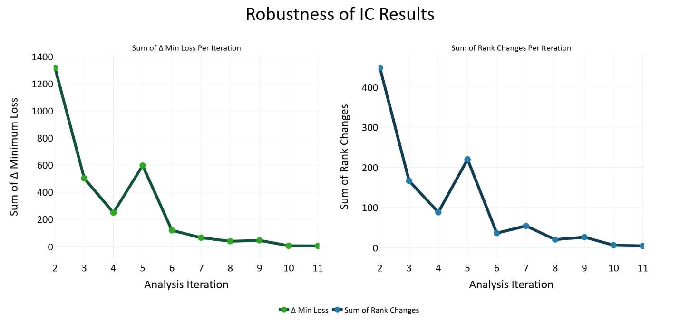
Figure 10: Robustness Analysis of Information Criterion (IC) Results:
The left panel illustrates the sum of Δ minimum loss (negative log-likelihood) discovered across iterations of model fitting, indicating incremental improvements in model fit. Iterations were stopped once the sum of incremental improvements approached minimal practical significance (indicating stability). The right panel shows the sum of ordinal rank changes (by Bayesian Information Criterion; BIC) between consecutive iterations, corroborating the stability suggested by the diminishing returns observed in the sum of Δ minimum loss metric.
  - Nested Models
Many of our utility functions are nested: a child model is a special case of a more flexible parent model, obtained by fixing one or more special parameters, such as setting added exponents to one. For example, Table 7 below presents a small family of nested models. Under identical parameter bounds, a correctly optimized parent must achieve a negative log‑likelihood (NLL) that is less than or equal to its child. Any case where a fitted parent’s best NLL is worse than its child’s is a nesting violation. Our goal is to prevent such violations that arise from optimization artifacts.
Table 7: Example nested family:
Each utility function is a parent of the model in the row below it. 𝑘 = number of free parameters. The special parameters column shows the values these parameters must be set to for the parent to function as the child model in the row below.
𝑘 | Utility Function | Special Parameters
4 | $$U_{i}\left(A\right)=V_{ii}{\left(π_{i}^{A}\right)}^{γ_{1}}+V_{ij}{\left(π_{j}^{A}\right)}^{γ_{2}}$$ | $$γ_{1}=γ_{2}$$
3 | $$U_{i}\left(A\right)=V_{ii}{\left(π_{i}^{A}\right)}^{γ}+V_{ij}{\left(π_{j}^{A}\right)}^{γ}$$ | $$γ=1$$
2 | $$U_{i}\left(A\right)=V_{ii}\left(π_{i}^{A}\right)+V_{ij}\left(π_{j}^{A}\right)$$ | $$V_{ij}=0$$
1 | $$U_{i}\left(A\right)=V_{ii}\left(π_{i}^{A}\right)$$ | $$V_{ii}=1$$
0 | $$U_{i}\left(A\right)=π_{i}^{A}$$

    - Nesting Network and Verification
We formalized a nesting network over all 505 models:
Parent-child relationship: A model is a parent of a child if (1) the parent contains all the parameter of the child, plus at least one additional parameter, (2) exactly one Boolean utility setting differs, and (3) at the child-anchor (the special parameter values), the parent and child produce identical utilities on all possible 625 (54) payoff structures in our dataset. We verified these criteria for all child-parent pairs.
Sibling relationship: Two models are siblings if they have the same number of free parameters and differ in exactly one Boolean utility setting (no strict nesting).
Table 8 below, shows the type of relationship produced between a pair of models when only one boolean utility setting differs between them.
Table 8: Boolean Utility Setting Flips and the Relationships They Produce.
Utility Setting Flip | Relationship
Place exponents on each term | child-parent
Use the same exponent for all terms | child-parent
Include negativity (loss aversion) parameters | child-parent
Include guilt in the social comparison term | child-parent
Fix self-interest parameter to one | child-parent
Include an altruism term | child-parent
Include a social comparison term | child-parent
Use single payoffs, not payoff differences | sibling-sibling
Compute payoff ratios, not payoff differences | sibling-sibling
Apply exponents directly to payoffs | sibling-sibling
Reference-dependent utility (𝑅=3) | sibling-sibling
Reference-dependent altruism | sibling-sibling
Conditional welfare form | None
Min-max Rawlsian-Leontief form | None

    - Parent-Fair L2 Regularization
Many of our models are quasi–scale‑invariant in their weights (e.g., 𝑉_{𝑖𝑖}, 𝑉_{𝑖𝑗},…): multiplying all social preference weights by a constant can leave choice predictions nearly unchanged for a fixed SoftMax temperature. This creates flat directions in the loss surface that can cause gradient‑based local optimizers (especially L‑BFGS‑B) to stop early or wander.
A small L2 penalty adds gentle curvature in these flat directions, stabilizing the search and making local refinement reliable. We keep the weight small. It is used only to help the optimizer, not to change which model wins.
A naïve L2 penalty can bias against parents (they have more free parameters), which could itself produce nesting violations. We therefore design the penalty to be parent‑fair: When a parent is set to the child‑anchor (i.e., the special parameters that collapse it to the child) and the shared parameters match, the parent and child incur the same penalty. So parents are penalized more only when they deviate away from the anchor that makes them behave like their children.
$$Loss=\sum{NLL}+\sum{λ}\left\{\begin{aligned}{\left(w_{+}\right)}^{2} \\ {\left(\frac{\left|w_{+}\right|+\left|w_{-}\right|}{2}\right)}^{2} \\ {\left(\frac{γ_{1}+γ_{2}+…+γ_{n}}{n}-1\right)}^{2}\end{aligned}\right.$$
where:
- λ is the penalty weight, typically 0.05,
- 𝑤₊ are social preference weights: μ(𝑉_{𝑖𝑗}) or μ(𝛼_{𝑖𝑗}),
- 𝑤₊ are positivity weights, while 𝑤– are negativity weights: μ(Λ_{𝑖𝑖}), μ(Λ_{𝑖𝑗}), or μ(𝛽_{𝑖𝑗}),
- γ are exponent parameters on one of the three social preference terms,
- Note: self-interest is penalized as ${\left(μ\left(V_{ii}\right)-1\right)}^{2}$.
Equation 1: Penalty Function:
We add a L2 penalty term to stabilize optimization. To not contribute to nesting violations, the penalty is identical for child and parent models if both models use identical parameters and the additional parent parameter(s) are set to the special points that make the parent behave like its child. The social preference weights for altruism and envy are only penalized when they are non-zero, while the self-interest weight is only penalized when it deviates from one. When positivity parameters are paired with negativity parameters: μ(𝑉_{𝑖𝑖}) with μ(Λ_{𝑖𝑖}), μ(𝑉_{𝑖𝑗}) with μ(Λ_{𝑖𝑗}), and μ(𝛼_{𝑖𝑗}) with μ(𝛽_{𝑖𝑗}), we penalize the mean of the absolute values of each pair because if a parent model differs from its child only by the exclusion versus inclusion of these negativity parameters, the child and parent are penalized the same when the positivity and negativity parameters are the same. Exponents are penalized as the mean of all exponents minus one because exponents set to one make the parent equivalent to a child without exponents.
    - Optimization Schedule
To avoid nesting violations, we first fit child models and pass their best fitting parameters to their parents as an initial point for optimization, called a warm start. This helps move the optimizer out of local minima in high-dimensional parent parameter spaces. However, warm starts can create path dependence, where a child stuck in a local minima could propagate this suboptimal initialization up the model hierarchy. To mitigate this problem, we fit the models iteratively, using the same iterations within the robustness analysis, where the system progresses from exploration to exploitation. The first four iterations, all models are optimized with simulated annealing, followed by L-BGFS-B, without the help of warm starts. In the next four iterations, children provide their best-fitting parameters to their parents as warm starts but the parents select the child to take the parameters from at random, meaning that parents do not always select their best-fitting child. In the final iterations, parents always exploit the best-fitting parameters of their best-fitting child model.
All model ranking (AIC/BIC) is computed from the best raw NLL attained by each model across all passes. The schedule above eliminated all but trivial (floating‑point) nesting violations in practice.
Overall, these analyses justify our selection of the optimal seven-parameter utility form as a model for observers' outcome-based social preferences.
  - Does the population need more than one utility architecture?
The IC analysis identifies the single best-fitting utility architecture for the population, but population-level model selection leaves one further question open: are all participants well described by that single architecture, or do meaningful subgroups need different ones? This matters because the parameter distributions reported in the next section presume that individuals differ from one another primarily in parameter values within a common utility space. To test that presumption, we conducted an architecture-set analysis. For each M, we selected the set of M architectures that minimized total BIC when each participant was assigned to the architecture in the set that fit them best. We then computed A(M), the fraction of the fully individualized advantage captured by that M-architecture set, where M = 1 corresponds to the single IC-winning architecture and the upper bound corresponds to giving every participant their own best-fitting architecture.
The single-architecture solution already captures the overwhelming majority of explainable structure. On an absolute scale, the IC-winning architecture alone closes 95.4% of the gap between chance prediction and the fully individualized ceiling. Adding a second architecture raises this to 98.1%, and M = 3, 4, and 5 raise it to 99.0%, 99.3%, and 99.5% respectively (Table 9). Most of the explainable structure is therefore carried by the single winning architecture, though a small set of architectures can improve fit for participants whose choices are better described by alternative forms.
On the relative A(M) scale, the first additional architecture produced the largest gain: M = 2 captured 58.3% of the remaining individualization advantage. The M = 2 set splits participants almost evenly between the IC winner and a second, structurally distinct architecture. The IC winner is a difference-based form: utility is computed from option-to-option differences in self-payoff, other-payoff, and inequality terms, each with its own exponent. The second architecture is reference-dependent: utility is computed from gains and losses around the midpoint payoff of 3, with a shared exponent and additional loss-aversion parameters distinguishing payoffs below the reference from payoffs above it (full equations in Table 13). The two forms encode different psychological accounts of how the same choices get evaluated, and 37 of 73 participants are better described by the second form than by the population winner.
These two architectures are also behaviorally distinct in our payoff space, with an Average Model Policy Distance (AMPD) of 0.128, approximately the 90th percentile of pairwise distances across the full candidate set. The split therefore reflects more than a symbolic difference between near-duplicate equations.
The compression curve does not yield a single unambiguous stopping point. Maximum curvature and meta-BIC select M = 3, the cumulative-gain criterion selects M = 4, the Kneedle elbow (Satopaa, Albrecht, Irwin, & Raghavan, 2011) selects M = 5, and the 1% marginal-gain rule selects M = 8. We do not interpret the disagreement as identifying a uniquely correct number of utility architectures. It quantifies a tradeoff. For population-level description, the seven-parameter IC winner is a compact and defensible default. For applications requiring more individualized prediction, M = 2 or M = 3 captures most of the additional benefit, while M = 5 provides higher resolution at the cost of parsimony.
We therefore use the seven-parameter IC winner as the primary coordinate system for the population analyses that follow, while treating the architecture-set analysis as a calibration of that choice. The single architecture is not perfect for every participant, but it captures the overwhelming majority of explainable structure. The multi-architecture sets in Table 13 remain available as principled extensions for researchers who wish to trade parsimony for individual-level precision.
Table 9: Utility architectures selected at each M from 1 to 5.
Each row of the upper panel is one architecture in the M-set. H(M) is the fraction of the explainable improvement from chance to the fully individualized ceiling captured by the M-architecture set as a whole. A(M) is the fraction of the fully individualized advantage captured (A(1) = 0 by definition). k gives the number of free parameters; n gives the number of participants whose choices are best fit by that architecture under the M-set assignment; mean BIC gives the average individual BIC across those participants. The lower panel gives the equations corresponding to each architecture label. Researchers wishing to trade parsimony for individual-level precision can read M-set membership directly off this table.
𝑀 | 𝐻(𝑀) | 𝐴(𝑀) | Mean BIC | 𝑘 | 𝑵 | Label
1 | 0.954 | 0.000 | 131.7 | 7 | 73 | A
2 | 0.981 | 0.583 | 142.0 | 7 | 36 | A
2 | 0.981 | 0.583 | 118.3 | 7 | 37 | B
3 | 0.990 | 0.774 | 131.1 | 7 | 31 | A
3 | 0.990 | 0.774 | 86.9 | 7 | 19 | C
3 | 0.990 | 0.774 | 180.9 | 9 | 23 | D
4 | 0.993 | 0.843 | 133.7 | 7 | 27 | A
4 | 0.993 | 0.843 | 84.1 | 7 | 11 | C
4 | 0.993 | 0.843 | 191.0 | 9 | 19 | D
4 | 0.993 | 0.843 | 117.7 | 9 | 16 | E
5 | 0.995 | 0.898 | 134.3 | 7 | 26 | A
5 | 0.995 | 0.898 | 86.0 | 7 | 9 | C
5 | 0.995 | 0.898 | 191.0 | 9 | 19 | D
5 | 0.995 | 0.898 | 115.6 | 9 | 15 | E
5 | 0.995 | 0.898 | 79.7 | 5 | 4 | F
Label | Equation
A | Uᵢ(A) = Vᵢᵢ(πᵢᴬ − πᵢᴮ)^γ₁ + Vᵢⱼ(πⱼᴬ − πⱼᴮ)^γ₂ − αᵢⱼ × max(πⱼᴬ − πᵢᴬ, 0)^γ₃ − βᵢⱼ × max(πᵢᴬ − πⱼᴬ, 0)^γ₃
B | Uᵢ(A) = Vᵢᵢ × max(πᵢᴬ^γ₁ − 3^γ₁, 0) − λᵢᵢ × max(3^γ₁ − πᵢᴬ^γ₁, 0) + Vᵢⱼ × max(πⱼᴬ^γ₁ − 3^γ₁, 0) − λᵢⱼ × max(3^γ₁ − πⱼᴬ^γ₁, 0) − αᵢⱼ × max(πⱼᴬ^γ₁ − πᵢᴬ^γ₁, 0) − βᵢⱼ × max(πᵢᴬ^γ₁ − πⱼᴬ^γ₁, 0)
C | Uᵢ(A) = Vᵢᵢ(πᵢᴬ^γ₁ − πᵢᴮ^γ₁) + Vᵢⱼ(πⱼᴬ^γ₂ − πⱼᴮ^γ₂) − αᵢⱼ × max(πⱼᴬ^γ₃ − πᵢᴬ^γ₃, 0) − βᵢⱼ × max(πᵢᴬ^γ₃ − πⱼᴬ^γ₃, 0)
D | Uᵢ(A) = Vᵢᵢ × max(πᵢᴬ − 3, 0)^γ₁ − λᵢᵢ × max(3 − πᵢᴬ, 0)^γ₁ + Vᵢⱼ × max(πⱼᴬ − 3, 0)^γ₂ − λᵢⱼ × max(3 − πⱼᴬ, 0)^γ₂ − αᵢⱼ × max(πⱼᴬ − πᵢᴬ, 0)^γ₃ − βᵢⱼ × max(πᵢᴬ − πⱼᴬ, 0)^γ
E | Uᵢ(A) = Vᵢᵢ × max(πᵢᴬ^γ₁ − 3^γ₁, 0) − λᵢᵢ × max(3^γ₁ − πᵢᴬ^γ₁, 0) + Vᵢⱼ × max(πⱼᴬ^γ₂ − 3^γ₂, 0) − λᵢⱼ × max(3^γ₂ − πⱼᴬ^γ₂, 0) − αᵢⱼ × max(πⱼᴬ^γ₃ − πᵢᴬ^γ₃, 0) − βᵢⱼ × max(πᵢᴬ^γ₃ − πⱼᴬ^γ₃, 0)
F | Uᵢ(A) = Vᵢᵢ × (πᵢᴬ^γ₁ − πᵢᴮ^γ₁) + Vᵢⱼ × (πⱼᴬ^γ₁ − πⱼᴮ^γ₁) if πᵢᴬ^γ₁ ≥ 3, else λᵢᵢ × (πᵢᴬ^γ₁ − πᵢᴮ^γ₁) + λᵢⱼ × (πⱼᴬ^γ₁ − πⱼᴮ^γ₁)
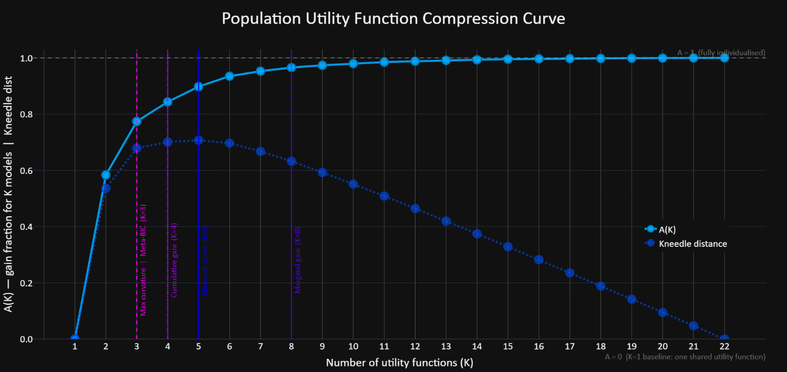
Figure 11: Population Utility Function Compression Curve.
For each value of M, the analysis selected the best set of M utility architectures and assigned each participant to the architecture in that set that minimized their BIC. The solid blue curve shows A(M), the fraction of the fully individualized advantage recovered by an M-architecture set. A(M) = 0 is the baseline in which all participants use the single population-winning architecture; A(M) = 1 is the fully individualized ceiling, in which every participant uses their own best-fitting architecture. The curve rises sharply from M = 1 to M = 2 and then gradually plateaus. The dotted dark-blue curve plots Kneedle distance (Satopaa, Albrecht, Irwin, & Raghavan, 2011), the vertical distance from each point on the compression curve to the straight line connecting its endpoints, after both axes have been normalized. The largest Kneedle distance, marking the curve's elbow, occurs at M = 5. Vertical lines indicate four stopping criteria that disagree among themselves: maximum curvature and meta-BIC select M = 3, cumulative gain selects M = 4, Kneedle selects M = 5, and the 1% marginal-gain rule selects M = 8. The figure therefore quantifies a fit-parsimony tradeoff rather than identifying a uniquely correct number of architectures. Labels on the first five markers show H(M), the fraction of explainable improvement from chance to the fully individualized ceiling captured by each set: H(1) = 0.954, H(2) = 0.981, H(3) = 0.990, H(4) = 0.993, H(5) = 0.995.
- Results: Joint Parameter Distributions in Human-on-human Experiment
Having identified the optimal seven-parameter utility function from our Information Criterion (IC) analysis, we now report the resulting social preference parameters from the human-on-human experiment. This experiment allowed participants to alternate between chooser and predictor roles, providing data to distinguish between genuine social preferences (chooser parameters) and beliefs about others' social preferences (predictor parameters). Moreover, the use of randomized payoff structures facilitated robust analysis across a multidimensional preference space, enabling meaningful exploration of trade-offs between parameters like self-interest, altruism, envy, guilt, and nonlinear payoff sensitivity.
  - Population-Level Distributions of Social Preference Parameters
    - Self-Interest and Altruism
Participants predominantly exhibited positive self-interest and altruism parameters, with self-interest generally outweighing altruism. Population-level means and standard deviations of chooser parameters were: self-interest [μ(𝑉_{𝑖𝑖}) = 0.67841, σ(𝑉_{𝑖𝑖}) = 0.36920] and altruism [μ(𝑉_{𝑖𝑗}) = 0.04689, σ(𝑉_{𝑖𝑗}) = 0.26501]. Predictors' initial priors showed a similar but exaggerated pattern [μ(𝑉_{𝑖𝑖}) = 0.45530, σ(𝑉_{𝑖𝑖}) = 0.45071; μ(𝑉_{𝑖𝑗}) = 0.14819, σ(𝑉_{𝑖𝑗}) = 0.47929], reflecting participants' accurate belief that self-interest dominates altruism, though they slightly overestimated this dominance.
Additionally, 50.68% of choosers exhibited negative altruism parameters, indicating sadistic or spiteful preferences, and 10.96% of choosers exhibited negative self-interest parameters, indicating masochistic or self-sacrificing behaviors.
After excluding these sadistic and masochistic participants, we computed the ratios between their self-interest and altruism parameters (𝑉_{𝑖𝑖} / 𝑉_{𝑖𝑗}). The average ratio between self-interest and altruism was 8.974 [𝑉_{𝑖𝑖} / (𝑉_{𝑖𝑖} +𝑉_{𝑖𝑗}): mean = 0.755, SD = 0.154, 𝑛 = 30]. This result indicates that, on average, choosers weighted their own payoff roughly nine times more than their counterparts' payoffs.
    - Asymmetric Social Comparison: Envy Versus Guilt
At the population level, choosers’ guilt parameters were larger than their envy parameters ([μ(𝛽_{𝑖𝑗}) = 0.25591, σ(𝛽_{𝑖𝑗}) = 0.40912] vs. [μ(𝛼_{𝑖𝑗}) = 0.01541, σ(𝛼_{𝑖𝑗}) = 0.35149]), and 68.49% of choosers had 𝛽_{𝑖𝑗} > 𝛼_{𝑖𝑗}. Predictors’ priors were: ([μ(𝛽_{𝑖𝑗}) = −0.03515, σ(𝛽_{𝑖𝑗}) = 0.55385] vs. [μ(𝛼_{𝑖𝑗}) = 0.20265, σ(𝛼_{𝑖𝑗}) = 0.54697]; 42.47% with 𝛽_{𝑖𝑗} > 𝛼_{𝑖𝑗}).
Figure 11 shows how the distributions of these parameter ratios in the participant population.
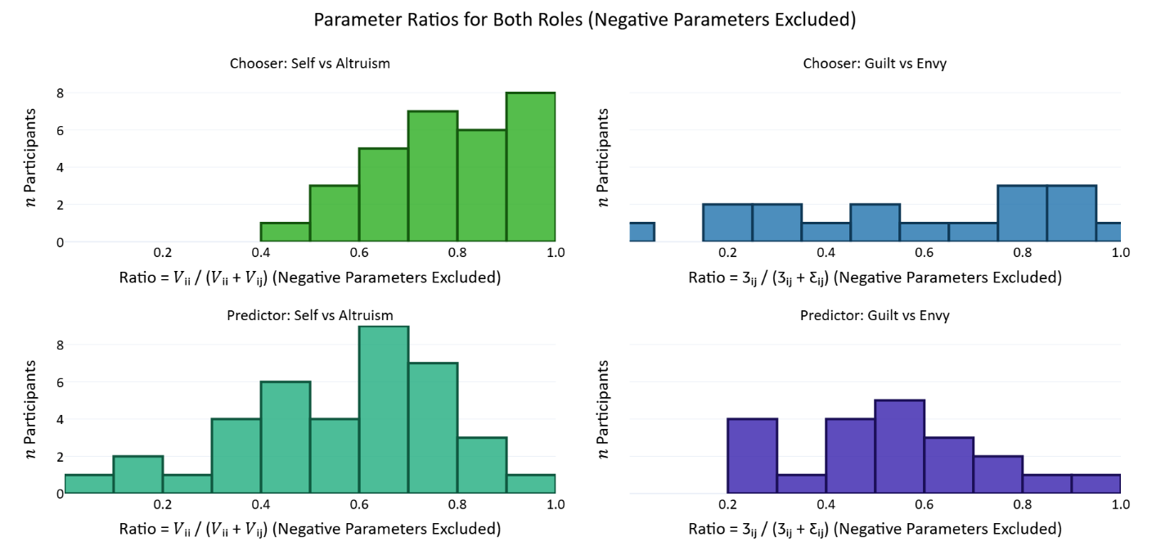
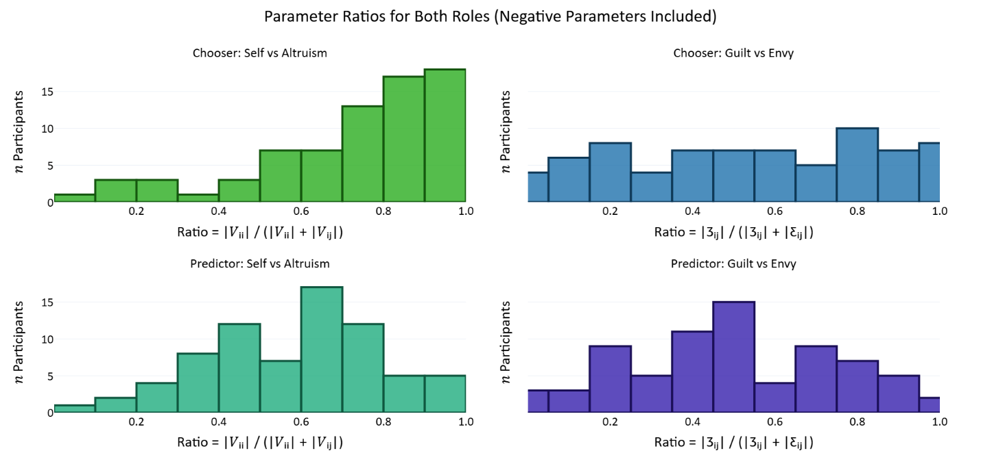
Figure 12: Histograms of Social Preference Parameter Ratios:
For each participant, we computed the ratios of some of their parameters and report the distribution of these ratios in the population. Histograms in the top panel report the distributions only of the subset of participants where both parameters in the ratio were positive (𝑛 participants ∈ [0, 9]), while histograms in the bottom panel report distributions of the ratios of the absolute values of parameters (𝑛 participants ∈ [0, 19]). Within each panel, the top histograms report chooser parameter ratios and the bottom histograms report predictor parameters. Also, the left histograms report ratios between self-interest and altruism, while the right histograms report ratios between guild and envy.
Panels (A) and (B) show distributions of chooser and predictor self-interest/altruism ratios, respectively; panels (C) and (D) display distributions of chooser and predictor envy/guilt ratios. Vertical dashed lines indicate mean ratios, emphasizing the asymmetrical prioritization of self-interest over altruism, and envy over guilt.
    - Nonlinear Payoff Sensitivity
With the seven-parameter model, exponent parameters differ by term. For choosers, μ(𝛾₁)= 0.82552 (σ(𝛾₁) = 0.72610) for self-interest, μ(𝛾₂)=1.33617 (σ(𝛾₂) = 0.67218) for altruism, and μ(𝛾₃)=1.37846 (σ(𝛾₃) = 0.69538). For predictor priors, μ(𝛾₁)= 1.08456 (σ(𝛾₁) = 0.056325) for self-interest, μ(𝛾₂)=0.85037 (σ(𝛾₂) = 0.48445) for altruism, and μ(𝛾₃)= 0.94475 (σ(𝛾₃) = 0.59211).
    - Clarification on Parameter Reporting
Individual-level mean parameters reflect each participant's central social preference tendencies, whereas individual-level standard deviation parameters (used only in predictors' priors) reflect uncertainty about others' preferences. Population-level statistics reported here include the mean and standard deviation across these individual-level mean parameters.
Additionally, choices were likely influenced by the expectation that players would be matched in subsequent rounds, depending on the round number and matching probabilities. Knowledge of these time horizons likely altered the calculation of social preferences. For instance, many choosers may have acted more cooperatively than if they expected to never meet their counterpart again, making these repeated games less of a pure index of altruism than one-shot dictator games.
Figure 12 and Table 9 summarize the distribution of individual-level mean parameters in the population.
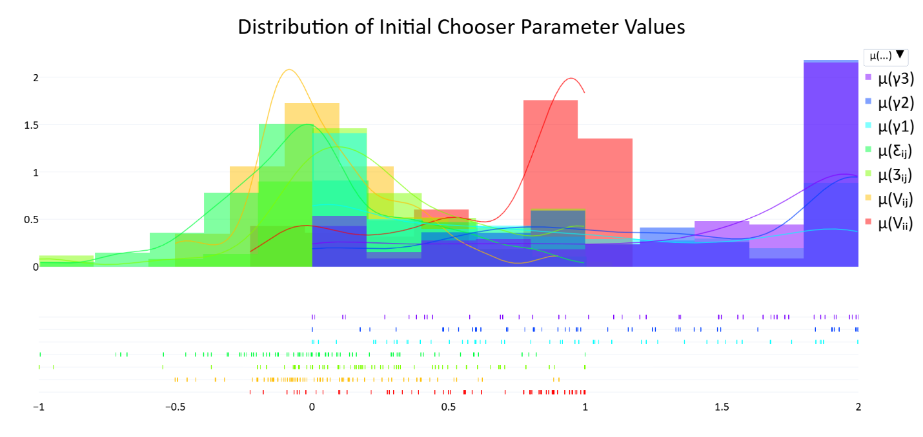
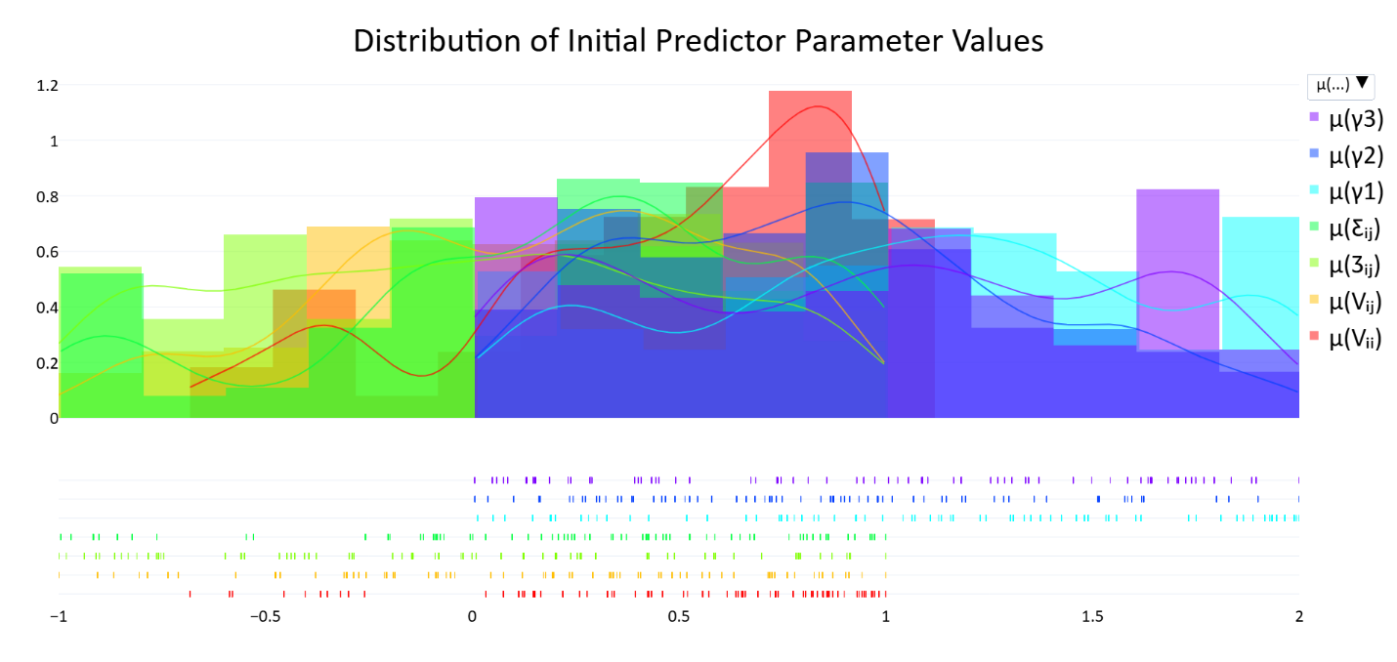
Figure 13: Population-level Distributions of Social Preference Parameters:
Panels display distributions for chooser and predictor parameters (self-interest [𝑉_{𝑖𝑖}], altruism [𝑉_{𝑖𝑗}], envy [𝛼_{𝑖𝑗}], guilt [𝛽_{𝑖𝑗}], exponents over the self-interest, altruism, and social comparison terms [𝛾₁, 𝛾₂, 𝛾₃]). Upper histograms show chooser parameters; lower histograms show initial predictor parameters (priors).

Table 10: Population-level averages of individual mean chooser and predictor social preference parameters.
Population Average Chooser and Predictor Parameter Values – Means and Standard Deviations
 | Chooser Parameters; 𝑛 = 73 |  | Predictor Parameters; 𝑛 = 73
Parameter | Mean | Std Dev | Mean | Std Dev
Self-interest 𝑉_{𝑖𝑖} | 0.67861 | 0.36920 | 0.45530 | 0.45017
Altruism 𝑉_{𝑖𝑗} | 0.04689 | 0.26501 | 0.14819 | 0.47929
Envy 𝛼_{𝑖𝑗} | 0.01541 | 0.35149 | 0.20265 | 0.54697
Guilt 𝛽_{𝑖𝑗} | 0.25591 | 0.40912 | −0.03515 | 0.55385
Exponent 𝛾₁ | 0.82552 | 0.72610 | 1.08456 | 0.56325
Exponent 𝛾₂ | 1.33617 | 0.67218 | 0.85037 | 0.48445
Exponent 𝛾₃ | 1.37846 | 0.69538 | 0.94475 | 0.59211
Temperature 𝜏 | 0.97034 | 0.71975 | 1.95989 | 0.62519

    - Correlations Among Social Preference Parameters
Chooser (within‑role). Several theoretically coherent relationships emerged (see Table 10). Self‑interest was strongly negatively associated with 𝛾₁ (𝑟 = −0.445, Holm‑corrected 𝑝_{h} = .0021), indicating that higher weighting of self‑interest co‑occurred with more concave scaling of one’s own payoff differences. Altruism positively correlated with envy (𝑟 = 0.457, 𝑝_{h} = .0013). Among the exponents, we observed negative associations between 𝛾₁–𝛾₃ (𝑟 = −0.409, 𝑝_{h} = .0081) and 𝛾₂–𝛾₃ (𝑟 = −0.475, 𝑝_{h} = .0006). The self-interest exponent 𝛾₁ was negatively correlated with temperature 𝜏 (𝑟 = −0.389, 𝑝_{h} = .0160). All other entries were non‑significant after Holm correction.
Predictor (within‑role). The only robust association after Holm correction was a negative correlation between the altruism exponent 𝛾₂ and temperature 𝜏 (𝑟 = −0.407, 𝑝_{h} = .0099).
Table 11: Pearson correlations coefficients among chooser parameters (upper table) and among predictor parameters (lower table), (𝑛 = 73).
Parameters were normalized so that their absolute values summed to 1 before computing the correlations. Note that these are within-role parameter correlations.
Chooser Parameter Correlations
 | μ(𝑉_{𝑖𝑖}) |  | μ(𝑉_{𝑖𝑗}) | μ(𝛼_{𝑖𝑗}) | μ(𝛽_{𝑖𝑗}) | μ(𝛾₁) | μ(𝛾₂) | μ(𝛾₃) | 𝜏
μ(𝑉_{𝑖𝑖})
μ(𝑉_{𝑖𝑗}) | 0.183
μ(𝛼_{𝑖𝑗}) | 0.081 |  | 0.457**
μ(𝛽_{𝑖𝑗}) | -0.069 |  | -0.183 | -0.262*
μ(𝛾₁) | -0.445** |  | 0.010 | 0.116 | 0.064
μ(𝛾₂) | 0.022 |  | -0.244* | -0.242* | 0.096 | -0.256*
μ(𝛾₃) | 0.256* |  | -0.050 | 0.050 | -0.246* | -0.409** | -0.479**
𝜏 | -0.135 |  | -0.093 | -0.091 | -0.188 | -0.389** | -0.177 | 0.039 | ---
Predictor Parameter Correlations
 | μ(𝑉_{𝑖𝑖}) |  | μ(𝑉_{𝑖𝑗}) | μ(𝛼_{𝑖𝑗}) | μ(𝛽_{𝑖𝑗}) | μ(𝛾₁) | μ(𝛾₂) | μ(𝛾₃) | 𝜏
μ(𝑉_{𝑖𝑖})
μ(𝑉_{𝑖𝑗}) | -0.049
μ(𝛼_{𝑖𝑗}) | 0.037 |  | -0.115
μ(𝛽_{𝑖𝑗}) | 0.028 |  | -0.190 | -0.052
μ(𝛾₁) | 0.090 |  | -0.077 | 0.036 | 0.224
μ(𝛾₂) | 0.011 |  | 0.108 | -0.110 | -0.250* | -0.066
μ(𝛾₃) | -0.087 |  | -0.006 | 0.168 | 0.153 | -0.225 | -0.333**
𝜏 | -0.232* |  | -0.077 | -0.057 | 0.156 | -0.334** | -0.407** | -0.055 | ---
*𝑝 < .05, **𝑝 < .01

    - Cross-Role Consistency in Preferences
Because participants alternated between chooser and predictor roles, we examined cross-role consistency to assess preference projection (see Table 11). All cross-role correlations were small and non-significant after Holm correction. The results therefore provide no support for the consensus-effect hypothesis that observers project their own preferences onto others (Ross, Greene, & House, 1977; Engelmann & Strobel, 2000).
Table 12: Cross-role Parameter Correlations.
Correlation between chooser and predictor parameters (𝑛 = 73), illustrating the degree of preference projection. The bottom row reports 𝑝 values.
Correlation Between Chooser and Predictor Parameters
 | μ(𝑉_{𝑖𝑖}) | μ(𝑉_{𝑖𝑗}) | μ(𝛼_{𝑖𝑗}) | μ(𝛽_{𝑖𝑗}) | μ(𝛾₁) | μ(𝛾₂) | μ(𝛾₃) | 𝜏
𝑟 | 0.062 | 0.032 | 0.081 | -0.070 | 0.204 | -0.029 | -0.043 | -0.092
𝑝 | 0.605 | 0.791 | 0.494 | 0.554 | 0.084 | 0.810 | 0.721 | 0.440

- Discussion and Conclusion
To cooperate, people need to infer others' hidden motives from their actions and update those beliefs over time. This paper modeled that process with a Utility Bayesian Model: an observer maintaining continuous probabilistic beliefs over a counterpart's social preferences, reweighting the parameter space against the likelihood of each observed choice. A Bayesian learning model is only as good as the utility function inside it, and a utility function is only as good as the payoff space it was fit to. Generalizing requires testing a broad range of candidate utility forms across a broad range of payoff structures, not a handful of models across many structures and not many models across a handful of structures.
When we did that, the parameters that prior work routinely collapses turned out to be empirically separable and psychologically distinct. The seven-parameter winner beat the next-best model by 17 BIC points and beat the canonical low-dimensional alternatives by hundreds. The parameters those simpler models collapse (altruism with social comparison, envy with guilt, fixed with variable self-interest, shared with term-specific exponents) carry different psychological readings, and once each was given its own term, three findings emerged that change the picture: guilt outweighs envy, social exponents are super-linear rather than concave, and antisocial preferences are more common than previous estimates suggest. Estimating all seven parameters jointly also places every participant in the same psychological space, which makes results commensurable across studies in a way they previously were not.
  - Validation and the case for continuous representations
The Utility Bayesian Model represents an observer's beliefs about a counterpart's social preferences as a probability distribution over a continuous parameter space, reweighted after each observed choice by the likelihood of that choice under candidate parameter values. Before fitting it to human-on-human data in Experiment 2, we validated the framework in two ways. Simulations confirmed that the machinery does what it claims: the optimizer recovers known parameters, posteriors converge toward a chooser's true preferences with repeated observations, and update speed responds to prior variance and choice stochasticity in the way Bayesian theory predicts. Experiment 1, the human-on-bot experiment, then evaluated the model against a controlled ground truth by pairing participants with artificial agents whose preferences were fixed in advance. Across both checks, the continuous UBM outperformed non-Bayesian alternatives and several thousand typological Bayesian models that partitioned the preference space into discrete types.
That comparison is informative in its own right. It asks whether observers' hypothesis spaces are best represented as a fine-grained continuum or as a small discrete set of types. At least within the domain we tested, the answer is the continuum. Social cognition here looks less like sorting people into a few categories and more like positioning them in a graded space, updatable at fine resolution. Whether this generalizes beyond outcome-based preferences in binary dictator games is an open question, but the present results give continuous representations a stronger empirical footing than they previously had.
  - The cost of inherited simplicity
Outcome-based social preferences have largely been modeled with a handful of canonical utility forms developed between 1992 and 2004: inequity aversion (Fehr & Schmidt, 1999), ERC (Bolton & Ockenfels, 2000), CES warm-glow altruism (Andreoni & Miller, 2002), social welfare (Charness & Rabin, 2002), and maximin-efficiency (Engelmann & Strobel, 2004). Subsequent innovation moved largely toward non-outcome-based motives such as reciprocity and self-image, leaving these foundational outcome-based kernels mostly untouched (Capraro, Halpern, & Perc, 2024; Fehr & Charness, 2025), and recent empirical work continues to rely on the same canonical frameworks or on even simpler two-dimensional schemes (Kerschbamer, 2015; Bakker & Dijkstra, 2021; Nunnari & Pozzi, 2022; Liu & Lange, 2023; Mizuno & Shimizu, 2024; Wang et al., 2025). At the same time, these forms have typically been fit to small, hand-selected payoff sets, frequently constant-sum, which left most of the relevant tradeoff space unsampled. Habits in model choice and habits in design choice reinforced each other: narrow payoff spaces could not discriminate among richer utility forms, so richer utility forms were not developed, so payoff spaces continued to be designed for the models already in use. The result is a literature that rests heavily on a small inheritance from the late 1990s and early 2000s, rarely tested against the wider space of candidates those original models came from.
Our IC analysis estimates the cost of this inheritance directly. Table 12 shows the BIC penalty incurred by collapsing each parameter the seven-parameter winner separates out. Removing the altruism term costs roughly 442 BIC points and conflates altruism with social comparison. Symmetrizing social comparison costs about 233 points and collapses envy and guilt into a single inequality term. Forcing a single exponent across terms costs about 193 points and obscures whether nonlinearity is operating on self-payoffs, other-payoffs, or inequality. Fixing self-interest to one costs about 135 points and precludes detection of masochism. Each of these gaps exceeds by an order of magnitude or more the conventional ΔBIC threshold of 10 for decisive model comparison (Schwarz, 1978; Anderson & Burnham, 2002). The parameters that simpler models discard are not statistical decoration. They correspond to distinctions the data require us to make.
Table 13: Costs of simplifying the winning seven-parameter model:
The seven-parameter BIC-minimizing model has four child models. This table shows the costs of reducing the winning model to these children in added BIC and theoretically.
Simplification | +ΔBIC | Theoretical Cost
Remove altruism | ~442 | Conflates altruism with social comparison
Symmetrize social comparison | ~233 | Conflates envy and guilt
Force a single exponent | ~193 | Loses specificity
Fix self-interest to one | ~135 | Precludes masochism

The numerical penalties also correspond to specific psychological confusions. Combining altruism with social comparison forces a model to misclassify a participant who genuinely enjoys hurting others as merely 'extremely competitive,' or a participant who enjoys being superior to others as 'sadistic'. Combining envy with guilt obscures the documented asymmetry of inequality aversion, which prior work has shown to be substantial in either direction (Fehr & Schmidt, 1999; Kerschbamer, 2015; Nunnari & Pozzi, 2022; Capraro, Halpern, & Perc, 2024). Fixing self-interest to one precludes detection of masochism, which our data show at non-trivial frequencies. Lower-dimensional models remain useful when the penalty for complexity is severe (Experiment 1, where higher-dimensional payoff exploration was infeasible, is one such case), but in any setting that can sustain richer estimation, the additional parameters earn their place.
  - What the broader search revealed
Four results from the population parameter distributions deserve emphasis, because in each case the broader search either sharpens a familiar finding or contradicts one.
Antisocial preferences are more common than prior work has suggested. The seven-parameter model identified negative altruism (sadism), negative guilt (competitiveness), and negative self-interest (masochism) at frequencies substantially above what earlier studies report. These types are not artifacts of fitting noise: their behavioral signatures appear clearly across many trials, and they survive the regularization scheme designed to prevent parent models from absorbing spurious additional fit. Some portion of the elevated sadism and competitiveness estimates may reflect strategic punishment in the context of expected repeated interaction (Abbink & Sadrieh, 2009; Herrmann & Orzen, 2008). But the consistent appearance of these types across analyses, including masochism, which has no obvious strategic rationale, suggests that prior estimates of antisocial preferences have been depressed by utility forms that lacked the parameters needed to detect them.
Social exponents on altruism and social comparison are super-linear. Self-payoff curvature was near-linear and slightly concave (μ(γ₁) ≈ 0.83), in line with diminishing marginal utility. But the exponents on the altruism and social-comparison terms came out greater than one (μ(γ₂) ≈ 1.34; μ(γ₃) ≈ 1.38), meaning people respond more intensely to larger other-payoffs and larger inequalities than to smaller ones. This pattern contradicts the standard assumption that all subjective magnitudes obey diminishing marginal utility (Kahneman & Tversky, 1979; Andreoni & Miller, 2002; Gossen, 1854; Marshall, 1920). It is the kind of finding that becomes visible only when each term gets its own exponent, which is why a search restricted to canonical forms could not have surfaced it. The right interpretation is still open: super-linearity may reflect threshold sensitivity, escalating moral salience of large inequalities, or a non-utility cognitive process such as attention that the exponent term is partly absorbing. Each is testable.
Self-interest dominates, but altruism is genuine and positive for most people. Among choosers with non-antisocial preferences, self-interest weighed roughly nine times more heavily than altruism (Vᵢᵢ/Vᵢⱼ ratio ≈ 8.97 averaged across participants), and most participants showed reliably positive altruism. The broad direction is familiar: dictator-game allocations across populations average roughly 20% of the endowment given away (Engel, 2011; Falk et al., 2018), which is consistent with positive-but-modest altruism. The agreement is only approximate, however, since standard dictator-game giving is not itself a clean measure of altruism: linear two-term utility functions of the kind discussed above predict extreme allocations rather than the interior splits observed in real data, so any inference from observed giving to underlying altruism depends on what other parameters the utility form does (or does not) include. Our binary-dictator design with varied payoffs avoids that confound by isolating altruism from social comparison without requiring exponents or inequality-aversion terms to recover interior choices. What changes here, then, is that the altruism estimate is no longer absorbing the work of unmodeled terms. With altruism and social comparison separately identified, the nine-to-one ratio between self-interest and altruism sits in a parameter space where each term has a clean psychological reading. That separation matters for what follows. With self-interest this strong relative to altruism, the motivational pull most often credited to altruism, namely caring about whether the other person comes out ahead or behind, has to be located somewhere else in the model. The guilt finding below tells us where it goes.
Guilt outweighs envy, reversing the canonical Fehr-Schmidt ordering. At the population level, μ(β) ≈ 0.26 exceeded μ(α) ≈ 0.015, and about 69% of choosers had β > α. This contrasts with most of the inequality-aversion literature (Fehr & Schmidt, 1999; Loewenstein, Thompson, & Bazerman, 1989; Nunnari & Pozzi, 2022). Part of that earlier ordering may itself be a methodological artifact. Earlier studies typically combined narrow payoff designs (constant-sum, or otherwise unable to separate altruism from social comparison) with utility forms that omitted altruism or constrained α ≥ β, both of which inflate α relative to β. So part of the canonical ordering reflects designs that prevent guilt from emerging even when present in the data.
Because the reversal is so unexpected, we verified independently that it is not an artifact of the seven-parameter model's flexibility. We constructed two minimal Fehr-Schmidt-style agents, linear utilities with no exponents and no reference dependence, identical in every respect except their inequality-aversion ratios: an envious agent with 𝛼 = 0.75 and 𝛽 = 0.25, and a guilt-heavy agent with 𝛼 = 0.25 and 𝛽 = 0.75. We then scored each agent against all participants' observed choices across a grid of self-interest (Vᵢᵢ) and altruism (Vᵢⱼ) weights (Figure 13). Stripping the utility form down to its canonical inequality-aversion ingredients puts the comparison on the same footing as the original Fehr-Schmidt framework. Which agent fits better turns out to depend on where in (Vᵢᵢ, Vᵢⱼ) space the scoring is done. The guilt-heavy agent wins throughout the high-Vᵢᵢ, low-Vᵢⱼ region, exactly where our population is concentrated (μ(Vᵢᵢ) ≈ 0.68, μ(Vᵢⱼ) ≈ 0.047). The envious agent dominates only in the opposite corner, where altruism is large relative to self-interest.
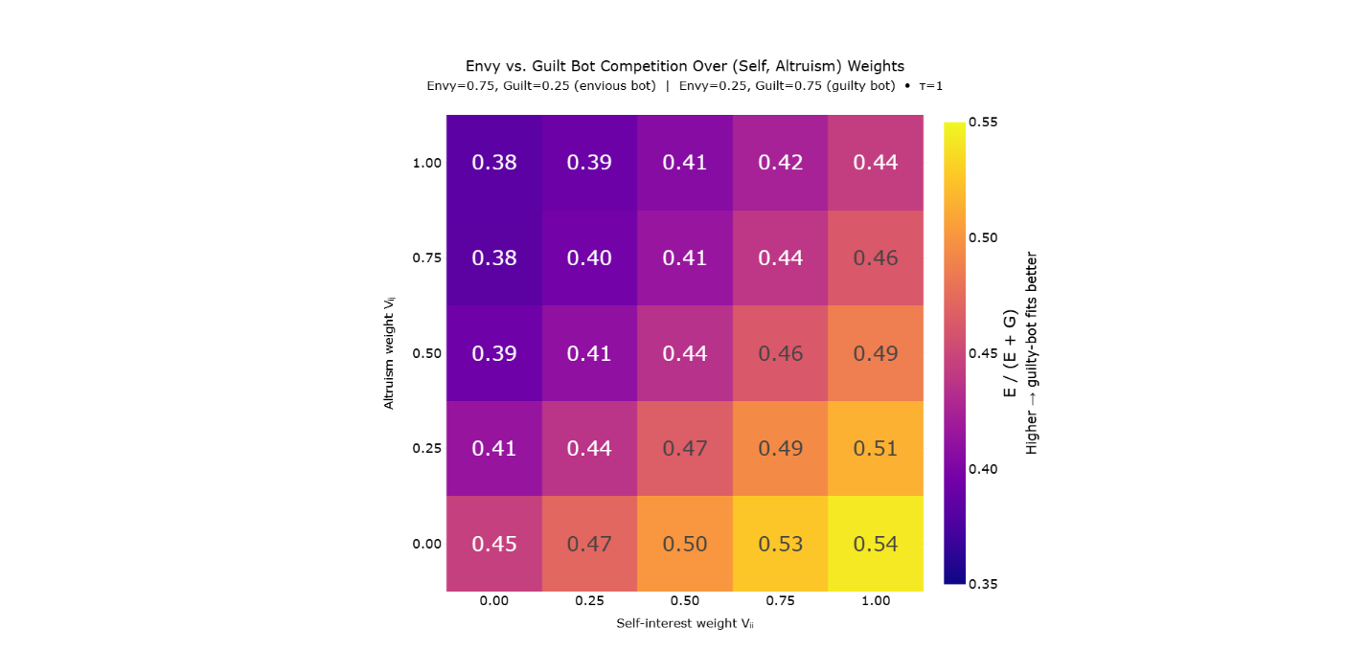
Figure 14: Model Comparison Between Envious (𝛼_{𝑖𝑗} > 𝛽_{𝑖𝑗}) and Guilt-Weighted (𝛽_{𝑖𝑗} > 𝛼_{𝑖𝑗}) Agents Across (V_{𝑖𝑖}, V_{𝑖𝑗}) grid:
Cells show the proportion of NLL attributable to the guilt-heavy agent relative to the total error from both agents; values above 0.5 indicate better fit by the guilt-heavy agent. The guilt-heavy agent fits human behavior more closely when self-interest is high and altruism is low, the region where most participants' fitted parameters lie. The envious agent dominates only when self-interest is low and altruism is high.
The mechanism becomes interpretable in light of the previous finding. When self-interest is strong and altruism is weak, the motivational role usually carried by altruism, increasing the other person's payoff, has to be carried by something else, because most people are still doing it. Guilt steps in: aversion to advantageous inequality picks up the slack and produces the same kind of choices that strong altruism would produce, but conditional on the other person being worse off. The pattern can be read in the other direction too. When Vᵢᵢ is large, α contributes little additional explanatory value because most of the envy-active contrasts are already explained by self-interest alone. When Vᵢⱼ is large, β loses its job because unconditional altruism already curbs advantageous inequality. So the relative strength of α and β depends on the balance of self- and other-directed motives, and in our population that balance favors β.
What Fehr and Schmidt called guilt may therefore be better understood as conditional altruism: a willingness to raise others up to one's own level, without going beyond it. The practical implication matters. Cooperative behavior does not require a population with strong unconditional altruism. It can be sustained when the trigger is a concrete disparity rather than an abstract concern for others' welfare. A population that looks modestly altruistic by standard dictator-game measures can still be reliably motivated to close gaps, which is the more common shape of real-world helping.
  - A shared coordinate system
Because the seven parameters are estimated jointly and refer to the same underlying utility space, every participant in this study occupies a point in the same seven-dimensional system, and that system can in principle be extended to other studies that adopt the same parameterization. This matters because prior work has reported social-preference parameters in isolated pairs or within two-dimensional SVO frameworks (Messick & McClintock, 1968; Van Lange, 1999; Murphy, Ackermann, & Handgraaf, 2011), and the resulting estimates are difficult to combine. Two studies that each report an 'altruism' parameter may not be measuring the same thing if one uses a model that includes social comparison and the other does not, because the absent term forces its psychological work onto whichever term is available to absorb it. The pieces do not fit together, not because the underlying construct is incoherent, but because the parameter spaces are incommensurable.
A common parameter space changes this. Cross-study comparisons become meaningful, meta-analyses become possible, and future Bayesian models can use accumulated empirical distributions to set informed priors instead of starting from uniform every time. Each subsequent study that fits the same parameterization adds to a growing public stock of priors that the next study can draw on.
  - Future directions
Future studies should expand this research to paid participants across many cultures (Henrich, Heine, & Norenzayan, 2010), and should include negative payoffs. The utility settings that make payoffs reference-point dependent and that include negativity parameters similar to loss aversion underperformed in our IC analysis, but those are precisely the terms most likely to matter once payoffs can fall below the reference point. Our results should not be read as strong evidence against either kind of structure.
Beyond such expansions in sample and design, the framework rests on two complementary commitments: invertibility and generalizability. The first means that any forward model expressing choice probabilities as a function of candidate parameter values can be turned into an inference engine for those parameters. While the UBM here inverted a simple utility function that represented outcome-based social preferences within a choice probability function, much more sophisticated forward models can be inverted also. Once inverted, a model of reciprocity becomes a model of inferring others' propensities to reciprocate. Once inverted, a model of limited strategic reasoning depth becomes a model of inferring the reasoning depth of others. Once inverted, a model of attributions of moral responsibility becomes a model of inferring how others attribute moral responsibility. Such complexities, once inverted, allow the framework to generalize to the full space of games and to capture a greater richness of moral psychology, including how we come to learn the moral psychology of others.
As one example among many, the UBM can be combined with a model of higher-order Theory of Mind reasoning so that the resulting model handles multi-step games with multiple choosers. The winning seven-parameter utility function would be retained, with priors informed by distributions accumulated from work such as the present study, but in place of literal payoffs it would consume expected payoffs forecasted via recursive simulation of the future choices of self and others, that is, by recursive Theory of Mind. That recursion is bounded because thinking about what others are thinking is cognitively costly and degrades with depth (Hedden & Zhang, 2002; Stanley, 2026), so the forward model would introduce a reasoning-depth parameter k governing how many recursive levels the chooser simulates before falling back on a non-mentalistic default at further-out nodes, such as treating downstream choices as if they were governed by baseline probabilities rather than by explicit forecasts of others' decisions.
Inverting this more sophisticated forward model would do something the original UBM cannot. Even reasoning-depth parameters can be inferred from observed choices when those choices depend on recursive mentalizing, recovered alongside the social-preference parameters. Two observers can hold identical social preferences but reason to different depths, a possibility long recognized in level-k frameworks of strategic reasoning (Stahl & Wilson, 1995; Nagel, 1995) but not previously integrable with continuous Bayesian models of preference learning, and their choices in sequential games differ in characteristic ways; observed choices therefore identify both. Combining the UBM with Theory of Mind in this way also lets observers forecast their own future belief updates. Consider a multi-step trust game in which player A currently values player B highly. Player B may betray; player A may later choose to punish or reward. Player A, currently inclined to reward, can nevertheless anticipate that following a betrayal their valuation of player B will be revised downward and they will choose to punish. Inverting a model of recursive belief updating produces this form of forecasting one's own learning and is essential for explaining cooperation in settings where today's choices depend on anticipating reactions to tomorrow's outcomes.
The same principle generalizes. A forward model that conditions utility on what each agent believes the others believe yields, on inversion, a model of inferring belief-based preferences such as guilt aversion and the desire to meet others' expectations (Charness & Dufwenberg, 2006; Battigalli & Dufwenberg, 2009, 2022). A forward model that incorporates causal contribution and foreseeability into the evaluation of agents yields, on inversion, a model of inferring how each observer attributes moral responsibility (Cushman, Young, & Hauser, 2006; Young & Saxe, 2009). A forward model that lets the chooser's utility depend on what they believe others see them choosing yields, on inversion, a model of inferring sensitivity to self- and social-image concerns (Dana, Weber, & Kuang, 2007; Andreoni & Bernheim, 2009). A forward model that conditions current utility on the history of interaction within a dyad yields, on inversion, a model of inferring individual differences in reciprocity and the rate at which preferences themselves drift over relationships.
Generalizability is the framework's second commitment, and randomizing payoffs across a fully crossed space, as we did here, was only its first step. The argument that motivated it, that models calibrated to a narrow slice of situational variation can only speak to that slice, extends naturally beyond payoffs to the structure of games themselves. Future work should fit forward models like the UBM to broader spaces: games that vary not only payoffs but branching factor, depth, node types, the presence of chance, the distribution of choosers across the tree, knowledge asymmetries between agents, and the cross-game histories that link encounters. Expanding the model and expanding the games it handles are two sides of the same project. Game trees can encode promises, threats, asymmetric knowledge, choices under uncertainty, and the temporal structure of relationships, but a model captures these only insofar as its forward representations are sophisticated enough to reason over them. Once inverted, a forward model rich enough to navigate the full space of such games becomes an inference engine for the social and moral parameters that drive human behavior across the situations game trees encode.
  - Conclusion
Social preferences have been studied for decades, but mostly through narrow keyholes: a handful of utility forms, in a handful of games, over a handful of payoff structures. What those keyholes showed was real, but partial. When we opened the door, the view cohered: more parameters were worth their complexity costs, the distinctions that simpler models erase turned out to matter, and the findings that emerged were both more surprising and more unified than the inherited picture suggested. The framework introduced here opens a larger space in which questions about human social motivation can be asked more precisely, answered more reliably, and compared more meaningfully across studies. The map is not complete. But researchers can now work from the same one.

References
Abbink, K., & Sadrieh, A. (2009). The pleasure of being nasty. Economics letters, 105(3), 306-308.
Akaike, H. (1973). Maximum likelihood identification of Gaussian autoregressive moving average models. Biometrika, 60(2), 255-265.
Aksoy, O., & Weesie, J. (2014). Hierarchical Bayesian analysis of outcome-and process-based social preferences and beliefs in Dictator Games and sequential Prisoner’s Dilemmas. Social Science Research, 45, 98-116.
Anderson, D. R., & Burnham, K. P. (2002). Avoiding pitfalls when using information-theoretic methods. The Journal of wildlife management, 912-918.
Andreoni, J., & Bernheim, B. D. (2009). Social image and the 50–50 norm: A theoretical and experimental analysis of audience effects. Econometrica, 77(5), 1607-1636.
Andreoni, J., & Miller, J. (2002). Giving According to GARP; An Experimental Test of the Consistency of Preferences in Altruism. Econometrica, 70(2), 737-753.
Bakker, D. M., & Dijkstra, J. (2021). Comparing the slider measure of social value orientation with its main alternatives. Social Psychology Quarterly, 84(3), 235-245.
Balliet, D., Parks, C., & Joireman, J. (2009). Social value orientation and cooperation in social dilemmas: A meta-analysis. Group Processes & Intergroup Relations, 12(4), 533-547.
Battigalli, P., & Dufwenberg, M. (2009). Dynamic psychological games. Journal of Economic Theory, 144(1), 1-35.
Battigalli, P., & Dufwenberg, M. (2022). Belief-dependent motivations and psychological game theory. Journal of Economic Literature, 60(3), 833-882.
Bolton, G. E., & Ockenfels, A. (2000). ERC: A Theory of Equity, Reciprocity, and Competition. American Economic Review, 90(1), 166–193.
Byrd, R. H., Lu, P., Nocedal, J., & Zhu, C. (1995). A limited memory algorithm for bound constrained optimization. SIAM Journal on scientific computing, 6(5), 1190-1208.
Camerer, C. F. (2003). Behavioral Game Theory: Experiments in Strategic Interaction. Princeton: Princeton University Press.
Camerer, C. F., Ho, T.-H., & Chong, J.-K. (2004). A Cognitive Hierarchy Model of Games. The Quarterly Journal of Economics, 861-898.
Camerer, C., & Ho, T. H. (1999). Experience-weighted attraction learning in normal form games. Econometrica, 67(4), 827-874.
Capraro, V., Halpern, J. Y., & Perc, M. (2024). From outcome-based to language-based preferences. Journal of Economic Literature, 62(1), 115-154.
Charles, G., & Rabin, M. (2002). Understanding social preferences with simple tests. The Quarterly Journal of Economics, 117(3), 817-869.
Charness, G., & Dufwenberg, M. (2006). Promises and partnership. Econometrica, 74(6), 1579-1601.
Cosmides, L., Barrett, H. C., & Tooby, J. (2010). Adaptive specializations, social exchange, and the evolution of human intelligence. Proceedings of the National Academy of Sciences, 107(supplement_2), 9007-9014.
Cox, J. C., Friedman, D., & Gjerstad, S. (2007). A tractable model of reciprocity and fairness. Games and Economic Behavior, 59(1), 17-45.
Cushman, F., Young, L., & Hauser, M. (2006). The role of conscious reasoning and intuition in moral judgment: Testing three principles of harm. Psychological science, 17(12), 1082-1089.
Dafoe, A., Hughes, E., Bachrach, Y., Collins, T., McKee, K. R., Leibo, J. Z., & Graepel, T. (2020). Open problems in cooperative AI. arXiv preprint, arXiv:2012.08630.
Dana, J., Weber, R. A., & Kuang, J. X. (2007). Exploiting moral wiggle room: Experiments deomonstrating an illusory preference for fairness. Economic Theory, 33, 67-80.
David A. Pizarro, E. U. (2003). Causal deviance and the attribution of moral responsibility. Journal of Experimental Social Psychology, 1-8.
Devaine, M., Hollard, G., & Daunizeau, J. (2014). The Social Bayesian Brain: Does Mentalizing Make a Difference When We Learn? PLoS Computational Biology, 10(12), e1003992.
Engel, C. (2011). Dictator Games: A Meta Study. Experimental Economics, 583–610.
Engelmann, D., & Strobel, M. (2004). Inequality aversion, efficiency, and maximin preferences in simple distribution experiments. American economic review, 94(4), 857-869.
Erev, I., & Roth, A. E. (1998). Predicting how people play games: Reinforcement learning in experimental games with unique, mixed strategy equilibria. American economic review, 848-881.
Falk, A., & Fischbacher, U. (2006). A theory of reciprocity. Games and economic behavior, 54(2), 293-315.
Falk, A., Becker, A., Dohmen, T., Enke, B., Huffman, D., & Sunde, U. (2018). Global evidence on economic preferences. The quarterly journal of economics, 133(4), 1645-1692.
Fehr, E., & Charness, G. (2025). Social preferences: Fundamental characteristics and economic consequences. Journal of Economic Literature, 63(2), 440–514.
Fehr, E., & Schmidt, K. M. (1999). A Theory of Fairness, Competition, and Cooperation. Quarterly Journal of Economics, 114(3), 817-868.
Fischbacher, U., & Gächter, S. (2010). Social preferences, beliefs, and the dynamics of free riding in public goods experiments. American economic review, 100(1), 541-556.
Fisman, R., Kariv, S., & Markovits, D. (2007). Individual preferences for giving. American Economic, 97(5), 1858-1876.
Fudenberg, D., & Levine, D. K. (1998). The theory of learning in games (Vol. 2). Cambrige, MA: MIT press.
Fudenberg, D., & Levine, D. K. (2009). Learning and equilibrium. Annu. Rev. Econ, 1(1), 385-420.
Gelman, A., Carlin, J. B., Stern, H. S., Dunson, D. B., Vehtari, A., & Rubin, D. B. (2003). Bayesian Data Analysis. New York, NY: Chapman & Hall.
Gershman, S. J., Daw, N. D., Rabinovich, M. I., Friston, K. J., & Varona, P. (2012). Perception, action and utility: The tangled skein. Principles of brain dynamics: Global state interactions, 293-312.
Gossen, H. H. (1854). The Laws of Human Relations and the Rules of Human Action Derived Therefrom. Verlag von R. L. Prager.
Griffiths, T. L., Kemp, C., & Tenenbaum, J. B. (2008). Bayesian Models of Cognition. In S. R., The Cambridge Handbook of Computational Psychology (pp. 59-100). Cambridge, MA: Cambridge University Press.
Hampton, A. N., Bossaerts, P., & O’Doherty, J. P. (2008). Neural correlates of mentalizing-related computations during strategic interactions in humans. Proceedings of the National Academy of Sciences, 105(18), 6741–6746.
Henrich, J., Heine, S. J., & Norenzayan, A. (2010). The weirdest people in the world? . Behavioral and brain sciences, 33(2-3), 61-83.
Herrmann, B., & Orzen, H. (2008). The appearance of homo rivalis: Social preferences and the nature of rent seeking. CeDEx discussion paper series, 1-44.
Hill, S. A., & Neilson, W. (2007). Inequality aversion and diminishing sensitivity. Journal of Economic Psychology, 28(2), 143-153.
Iriberri, N., & Rey-Biel, P. (2013). Elicited beliefs and social information in modified dictator games: What do dictators believe other dictators do? Quantitative Economics, 4(3), 515-547.
Jern, A., Lucas, C. G., & Kemp, C. (2017). People learn other people’s preferences through inverse decision-making. Cognition, 168, 46-64.
Kahneman, D., & Tversky, A. (1979). Prospect theory: An analysis of decision under risk. Econometrica, 47(2), 263-292.
Kerschbamer, R. (2015). The geometry of distributional preferences and a non-parametric identification approach: The Equality Equivalence Test. European economic review, 76, 85-103.
Kerschbamer, R. (2015). The geometry of distributional preferences and a non-parametric identification approach: The Equality Equivalence Test. European economic review, 76, 85-103.
Kirkpatrick, S., Gelatt Jr, C. D., & Vecchi, M. P. (1983). Optimization by simulated annealing. Science, 220(4598), 671-680.
Krupp, D. B., Debruine, L. M., & Barclay, P. (2008). A cue of kinship promotes cooperation for the public good. Evolution and Human Behavior, 29(1), 49-55.
Lee, M. D., & Wagenmakers, E.-J. (2014). Bayesian cognitive modeling: A practical course. Cambridge, England: Cambridge University Press.
Leontief, W. W. (1941). The Structure of American Economy, 1919–1929: An Empirical Application of Equilibrium Analysis. Harvard University Press.
Liu, Y. B., & Lange, P. A. (2023). The development of social value orientation: Attachment styles, number of siblings, age, and a comparison of measures. European Journal of Personality, 37(4), 402-417.
Loewenstein, G. F., Thompson, L., & Bazerman, M. H. (1989). Social utility and decision making in interpersonal contexts. Journal of Personality and Social psychology, 57(3), 426.
Luce, R. D. (1959). Individual Choice Behavior: A Theoretical Analysis. Mlneola, New York: Dover Publications, Inc.
Marr, D. (1982). Vision: A computational investigation into the human representation and processing of visual information.
Marshall, A. (1920). Principles of Economics (8th ed.). Macmillan and Co.
McFadden, D. (1974). Conditional Logit Analysis of Qualitative Choice Behavior. Frontiers in Econometrics, 105–142.
Messick, D. M., & McClintock, C. G. (1968). Motivational bases of choice in experimental games. Journal of experimental social psychology, 4(1), 1-25.
Mizuno, K., & Shimizu, H. (2024). Measuring social value orientation by model-based scoring. Behaviormetrika, 51(1), 211-236.
Murphy, R. O., & Ackermann, K. A. (2014). Social value orientation: Theoretical and measurement issues in the study of social preferences. Personality and Social Psychology Review, 18(1), 13-41.
Murphy, R. O., Ackermann, K. A., & Handgraaf, M. J. (2011). Measuring Social Value Orientation. Judgment and Decision Making, 6(8), 771-781.
Nagel, R. (1995). Unraveling in Guessing Games: An Experimental Study. The American Economic Review, 85(5), 1313-1326.
Nunnari, S., & Pozzi, M. (2022). Meta-analysis of inequality aversion estimates (No. 9851). CESifo Working Paper.
Ottone, S., & Ponzano, F. (2005). An extension to the model of inequity aversion by Fehr and Schmidt. POLIS department's Working Papers, 51.
Rabin, M. (1992). Incorporating fairness into game theory and economics. University of California at Berkeley, Department of Economics, 1281-1302.
Rand, D. G., & Nowak, M. A. (2013). Human cooperation. Trends in cognitive sciences, 17(8), 413-425.
Rawls, J. (1971). An egalitarian theory of justice. Philosophical Ethics: An Introduction to Moral Philosophy, 365-370.
Ross, L., Greene, D., & House, P. (1977). The “false consensus effect”: An egocentric bias in social perception and attribution processes. Journal of experimental social psychology, 13(3), 279-301.
Russell, S. J. (2019). Human Compatible: Artificial Intelligence and the Problem of Control. United States: Viking.
Schwarz, G. (1978). Estimating the dimension of a model. The annals of statistics, 461-464.
Stahl, D. O., & Wilson, P. W. (1995). On players′ models of other players: Theory and experimental evidence. Games and Economic Behavior, 10(1), 218-254.
Van Lange, P. A. (1999). The pursuit of joint outcomes and equality in outcomes: An integrative model of social value orientation. Journal of personality and social psychology, 77(2), 337.
Van Lange, P. A., Joireman, J., Parks, C. D., & Dijk, E. V. (2013). The psychology of social dilemmas: A review. Organizational Behavior and Human Decision Processes, 120, 125-141.
Wang, Q.-H., Wei, Z.-H., Chen, W.-N., Na, Y., Gou, H.-M., & Liu, H.-Z. (2025). The impact of inequality on social value orientation: an eye-tracking study. Frontiers in Psychology, 16, 1521101.
Yoshida, W., Dolan, R. J., & Friston, K. J. (2008). Game Theory of Mind. PLoS Computational Biology, 4(12), e1000254.
Young, L., & Saxe, R. (2009). Innocent intentions: A correlation between forgiveness for accidental harm and neural activity. Neuropsychologia, 47(10), 2065-2072.

The gaussian prior is truncated within parameter bounds for the mean parameters, which is between -1 and 1 for self-interest, altruism, envy, and guilt and is 0.02 – 2 for the exponent and 0.02 – 4 for temperature.
Throughout this paper, the Utility Bayesian Model submits responses using a SoftMax temperature parameter set arbitrarily at 1.5. This response temperature controls the stochasticity of simulated choices and predictions, setting a theoretical minimum achievable loss. By contrast, the likelihood function employs a separate SoftMax temperature parameter (𝜏) fitted individually to participants. This parameter reflects participants' beliefs regarding chooser randomness, directly influencing the Bayesian updating of beliefs. Despite both using SoftMax functions, these two temperatures serve fundamentally different purposes: the response temperature standardizes model-generated predictions, while the likelihood temperature characterizes participants’ inferred uncertainty about chooser behavior.
Updates were skipped whenever participants failed to respond within the allotted time, mitigating potential contamination from inattentive responses.
We implemented a nonlinear penalty on parameter values during the estimation process, calculated by squaring each mean parameter, multiplying by a penalty weight of 0.05, and adding these values to the loss function. This penalty was essential because most utility functions exhibit scale invariance in their parameters, meaning infinitely many parameter sets differing by a constant multiplier could produce identical predicted behavior (e.g., parameters {.1, .2, .4} versus {.2, .4, .8}). Without this penalty, the L-BFGS-B optimization algorithm frequently failed to converge to stable solutions, terminating prematurely. The penalty itself was subtracted from the final reported loss values, thereby minimally impacting the primary analyses or conclusions. Nonetheless, this method slightly biases parameter estimates toward zero, marginally compressing extreme parameter values and subtly affecting the shape of parameter distributions.
Temperature parameters (τ) are fitted individually although they remain stable across all rounds (they do not themselves update), reflecting a constant assumption regarding how diagnostic each choice is of the counterpart’s preferences.
Future research is needed to analyze social preferences, like reciprocity, that occur between games.
Using dots instead of numbers allows the method to be more easily adapted to studies involving nonhuman animals and non-literate populations. Payoffs were switched back to numbers on the Morality Game (human-human experiment) to avoid crowding the user-interface.
To ensure a fair comparison between the typological models and our Utility Bayesian Model (UBM), we conducted two separate analyses: one where the UBM used a high-resolution 21×21 grid to approximate fully continuous preferences, and another using a coarser 5×5 grid matching the discrete models' resolution. Results were substantively similar, confirming that the superior performance of the UBM was not merely due to higher resolution. The typological models were thus evaluated against a comparable-resolution continuous model.
We acknowledge that we could have tested discrete models with types (bins) at irregular intervals within the parameter space, but we expect that any improvements to model fit would be marginal and not worth the computation expense.
Although another related experiment explored 234 payoff structures in a separate sub-study within the human-bot paradigm (456 participants), these data are reserved for potential supplementary analyses (e.g., Bayesian prior estimation). We clarify this briefly here to avoid confusion and clearly delineate it from our core human-bot and human-human datasets.
This feedback was withheld in the human-bot experiment to avoid imposing the researcher’s model upon the participants. Instead, we were interested in investigating the moral schemas that participants would spontaneously apply to the games.
Utility functions were fit separately to chooser and predictor decisions. Chooser parameters directly express pure social preferences without incorporating belief updates and thus are inherently non-Bayesian. Predictor parameters, by contrast, reflect beliefs about the chooser’s preferences and ideally would employ dynamic Bayesian updating. Here, for computational tractability, we evaluated both chooser and predictor parameters using a static model.
This pairwise comparison analysis is preferable to running a regression, which would have been misleading due to utility settings that are logically interdependent (creating multicollinearity).
Self-interest is penalized as ${\left(μ\left(V_{ii}\right)-1\right)}^{2}$ because the relevant Boolean utility setting determines if the utility function fixes the self-interest parameter to one, meaning that a child model could look like $U_{i}\left(A\right)=π_{i}^{A}+…$ while the parent could look like $U_{i}\left(A\right)=V_{ii}\left(π_{i}^{A}\right)+…$. By contrast, the other relevant utility settings determine if altruism terms or social comparison terms should be included at all, which is why the penalty for altruism and social comparison should bias those parameters towards zero, not one.
We use only local refinement in the warm‑start steps because standard simulated/dual annealing APIs do not accept an explicit initial guess.
Consider a linear utility function over two payoffs $π_{i}^{A}$, and $π_{j}^{A}$, such as $U_{i}\left(A\right)=V_{ii}\left(π_{i}^{A}\right)+V_{ij}\left(π_{j}^{A}\right)$. Adding a symmetric social-comparison term, $-α_{ij}\left(π_{i}^{A}-π_{j}^{A}\right)$, does not add a genuinely independent parameter. Distributing the term gives $U_{i}\left(A\right)=\left(V_{ii}-α_{ij}\right)π_{i}^{A}+\left(V_{ij}+α_{ij}\right)π_{j}^{A}$, so any value of 𝛼_{𝑖𝑗} can be exactly offset by rescaling 𝑉_{𝑖𝑖} and 𝑉_{𝑖𝑗}; the symmetric social-comparison parameter is therefore unidentified in a linear two-term utility. This redundancy is what makes the asymmetric decomposition into envy ($α_{ij}$, active when$π_{i}^{A}<π_{j}^{A}$) and guilt ($β_{ij}$, active when $π_{i}^{A}>π_{j}^{A}$) substantive rather than cosmetic. Once the social-comparison term is split asymmetrically, no rescaling of 𝑉_{𝑖𝑖} and 𝑉_{𝑖𝑗} recovers it, and 𝛼_{𝑖𝑗} and 𝛽_{𝑖𝑗} become independently identified.
Additions such as Kerschbamer’s Equality-Equivalence Test (2015), Cappelen et al.’s (2007) fairness ideals, moral wiggle room, merit biases, stake effects, or reference dependence represent important elaborations but do not substantially alter this overall historical narrative
The altruism-social comparison distinction is roughly analogous to the division between the morality of harm and the morality of fairness in moral foundations theory (Haidt, 2007), although there are many forms of fairness, such as outcome equality, procedural fairness, and reciprocity.
A linear two-term utility function such as $U_{i}\left(A\right)=V_{ii}\left(π_{i}^{A}\right)+V_{ij}\left(π_{j}^{A}\right)$ always prefers one extreme allocation: keep everything or give everything. Standard dictator-game data show interior splits only after the utility is modified, either by adding a social-comparison penalty (e.g., $-Ƹ_{ij}\left(π_{i}^{A}-π_{j}^{A}\right)$) or by raising each pay-off to a concave exponent $U_{i}\left(A\right)=V_{ii}{\left(π_{i}^{A}\right)}^{γ}+V_{ij}{\left(π_{j}^{A}\right)}^{γ}$. Note also that utilities alone do not produce choices; they must be embedded in a choice-probability rule such as a softmax.
Although our seven-parameter winning utility function does include exponents, the point here is that exponents are not necessary to quantify altruism in binary dictator games with varied payoff structures. The varied payoff space alone is enough to produce interior choices that distinguish altruism from social comparison.

