Inferring Hidden Motives: Bayesian Models of Preference Learning in Repeated Dictator Games
Gregory Stanley, Jun Zhang, Rick Lewis
- Abstract
Human cooperation depends on how accurately we infer others’ motives—how much they value fairness, generosity, or self-interest from the choices they make. We model that process in binary dictator games, which isolate moral trade-offs between self and other stripped of strategic complexity. Participants observed others’ allocation decisions and predicted their future behavior while playing through an exhaustive, randomized payoff space implemented on The Morality Game platform.
We formalize social-preference learning as Bayesian belief updating over continuous parameters such as self-interest, altruism, envy, and guilt. The resulting Utility Bayesian Model (UBM) outperformed non-Bayesian alternatives and Bayesian models that categorize others into discrete social types. Because Bayesian updating requires a utility function in its likelihood term, we conducted the largest utility-function comparison to date—476 candidate forms differing in psychologically meaningful properties (e.g., payoff exponents, reference dependence, payoff ratios, and envy–guilt asymmetries). Exploring this joint space of payoffs and models allowed us to identify the function that unifies prior theories and generalizes across payoff conditions.
Parameter estimation revealed strong self-interest, weak unconditional altruism, and a surprising reversal of the canonical inequality-aversion asymmetry: advantageous-inequality aversion exceeded disadvantageous-inequality aversion. Altruism and social-comparison motives were largely independent, revealing diverse moral phenotypes from cooperative to competitive or sadistic. Together, these findings provide a computational framework and a map of social motives, clarifying how humans learn whom to trust and offering quantitative foundations for promoting cooperation in social and artificial systems.
- Introduction
Understanding the social preferences of others—how much they weigh their own payoffs relative to those of others, their sensitivity to inequalities, and their emotional reactions such as envy or guilt, is foundational to navigating human social interactions. Decisions about trust, reciprocity, cooperation, and resource allocation hinge upon individuals’ abilities to accurately infer the social preferences that guide the choices of others. Errors in these inferences can be costly, leading to misallocated resources, missed opportunities for cooperation, exploitation, or broken relationships. Despite its importance, our understanding of how people form, update, and refine their beliefs about others’ social preferences remains incomplete, fragmented, and methodologically constrained. Specifically, existing studies typically explore limited payoff scenarios, rely on simplified low-dimensional utility forms, and rarely measure explicit belief updating—limitations that collectively restrict our ability to accurately and comprehensively characterize social preferences and beliefs about them.
To address these gaps, Experiments 1 and 2 integrate four mutually reinforcing methodological elements: (a) randomized payoffs spanning a broad multidimensional space; (b) a near comprehensive comparison of 476 candidate utility functions; (c) explicit elicitation of predictions to measure beliefs to avoid confounds associated with inferring beliefs solely from choice data; and (d) Bayesian cognitive modeling of social preference belief updating in iterated binary dictator games. While each of these methodological components is rare individually, their integration is novel and mutually reinforcing: the randomized payoffs ensure that the optimal utility function applies broadly rather than narrowly; explicit prediction elicitation provides unconfounded data for fitting the Bayesian model; and identifying the best-fitting utility function is crucial for accurately parameterizing the Bayesian cognitive model.
Over the last three decades, a significant body of research has employed various economic games to probe social preferences, such as dictator, ultimatum, trust, and public goods games. Canonical models like Fehr and Schmidt’s (1999) inequality aversion, Bolton and Ockenfels’s (2000) ERC model, and Charness and Rabin’s (2002) model of fairness and reciprocity have proposed specific parameterizations of other-regarding preferences that explain stable individual differences in prosociality, altruism, and fairness. Although these models are clear, helpful, and well-supported, they are incomplete descriptions of social preferences.
One prominent limitation is that many studies have restricted themselves to narrow, payoff spaces in a small number of games (Andreoni & Miller, 2002; Fehr & Schmidt, 1999). Typically, standard dictator games (DGs) or ultimatum games (UGs) use small, predetermined payoff sets, that do not expose or elicit the full landscape of possible preference patterns. Consequently, past studies often yield insights that fail to generalize outside these places. Murphy and Ackermann (2014) emphasized the importance of mapping a broader payoff landscape to reveal nuanced preferences (such as spite), yet even their relatively expansive exploration was limited to continuous dictator games. Thus, randomized binary dictator game payoff structures enable comprehensive exploration of the space of distributional social preference—an approach introduced for the first time in this study.
Limiting our understanding still, prior studies have only sampled a handful of utility functions out of a combinatorially explosive space of functional forms. Typically, these studies choose amongst about six candidate models a priori (Fehr & Schmidt, 1999; Engelmann & Strobel, 2004; Murphy & Ackermann, 2014). Few studies have conducted extensive quantitative model comparisons across a large, systematically structured set of candidate functional forms. For instance, Andreoni and Miller (2002) compared linear altruism models to alternative forms, yet their exploration did not vary negative biases, reference dependence, conditional welfare, payoff sensitivity and a host of plausibly relevant factors. Thus, it remains uncertain whether canonical models are the best available approximations of human social preferences, or simply convenient and widely adopted assumptions.
These methodological limitations impede scientific understanding of social preferences. Additionally, they hinder understanding of how beliefs about others' social preferences form and evolve. When studied, such beliefs are typically inferred from choice data, but when a participant chooses, they are motivated by their morality, their strategy, and their beliefs about the morality or social preferences of their counterpart(s). These confounds are irrelevant when participants explicitly predict counterparts’ choices, and that is why we collected prediction data.
Thus, despite significant advances, existing research has (1) explored a limited space of payoff structures, (2) explored a limited space of utility functions, (3) cannot separate beliefs about social preferences from social preferences themselves, via choice data alone.
This research addresses these gaps by being the first to integrate four interlocking methodological elements. First, we employ binary dictator games with randomized payoffs, spanning an extensive, multidimensional payoff space. Binary dictator games are simple enough to isolate social preferences from strategic considerations, yet flexible enough to host a vast, multidimensional space of payoffs that can evoke social psychological mechanisms left confounded or unexplored by games like the standard dictator game, which, for instance, cannot decouple altruism from social comparison.
Second, we record participants' prediction of their counterparts’ choices across repeated meetings to measure how they update beliefs based on evidence. While we record choice data also, we only measure only one data type per round to avoid confounds.
Third, we model participants as Bayesian learners, integrating the implications of choice observations with preconceptions about the social preferences of their chooser-counterparts. We fit this Bayesian model to prediction data.
Finally, we conduct the largest to date Information Criterion (IC) analysis (AIC/BIC) of candidate utility functional forms, comparing 476 variants to identify the optimal utility function that individuals use in forming beliefs about others’ social preferences. This method ensures that our chosen utility function only excludes plausibly relevant psychological mechanisms, like self-interest, altruism, envy, guilt, nonlinear payoff sensitivity, and novel forms like reference dependence, payoff ratios, and min-max (Rawlsian/Leontief) forms, if they do not improve model fit or are worth the added model complexity.
Thus, this research integrates multiple methodological innovations—systematically randomized payoffs, explicit predictions, Bayesian modeling, and a comprehensive IC utility form analysis—to address holes in the scientific understanding of social preferences and beliefs about them. Individually, each innovation resolves distinct methodological limitations; collectively, they form an integrated framework for exploring social preference inference and belief updating.
Indeed, we did so via two experiments. First, we conducted a controlled human-bot experiment, where participants made predictions about known, algorithmically determined chooser preferences. Since these artificial choosers had fixed social preferences, this initial step allowed objective validation of our Bayesian model’s accuracy in predicting belief updating without confounding factors. Second, after establishing this objective validation, we applied the validated model to a human-human experiment, where participants repeatedly interacted across randomized payoff structures within a large, multidimensional payoff space (payoffs randomly selected from {1, 2, 3, 4, 5}). Participants explicitly observed the probabilities of future re-matching with identifiable counterparts, ensuring realistic conditions for examining continuous, dynamic belief updating over multiple rounds.
Crucially, our comprehensive information criterion analysis compared 476 candidate utility functional forms using Information Criteria (AIC/BIC), evaluating distinct parameters for self-interest, altruism, envy, guilt, nonlinear payoff sensitivity (exponential weighting), reference dependence, and negativity parameters. The analysis identified an optimal seven-parameter utility model. This optimal model distinctly separates altruism (direct positive valuation of others' payoffs) from social comparison (sensitivity to payoff inequalities), further differentiating between envy (negative response to disadvantageous inequality) and guilt (negative response to advantageous inequality). It also employs single payoffs rather than payoff differences (except for social comparison terms, which inherently require relative comparisons) and includes a nonlinear exponent term uniformly applied across parameters, capturing participants' amplified sensitivity to larger payoffs or inequalities.
Empirical parameter estimates from our human-human experiment provide clear psychological insights: participants positively valued their own payoffs approximately three times more strongly than those of their counterparts (mean ratio = 3.05). Despite this self-interested bias, altruism parameters were consistently positive for most participants, indicating that the majority genuinely preferred better outcomes for others, all else being equal—an encouraging foundation for cooperative interactions.
However, significant heterogeneity emerged: approximately 27% of participants displayed negative altruism parameters (indicating sadistic or spiteful preferences), and roughly 16% exhibited negative self-interest parameters (masochistic or self-sacrificing behaviors). Additionally, 27% exhibited negative envy parameters (competitive preferences), demonstrating a distinct preference for achieving superior payoffs relative to others. Importantly, these competitive preferences were orthogonal to sadism, highlighting that individuals can simultaneously desire superior outcomes and still prefer that others fare positively rather than negatively. These results move beyond traditional two-dimensional social value orientation frameworks, emphasizing the need for nuanced, multi-parameter approaches in modeling human social preferences.
Moreover, our Bayesian cognitive modeling approach demonstrated superior predictive accuracy compared to alternative discrete Bayesian and non-Bayesian models, reinforcing the empirical validity and cognitive plausibility of continuous belief updating processes. This result aligns with psychological research indicating that people update their beliefs gradually rather than categorizing others into rigid types (Murphy & Ackermann, 2014).
Collectively, these methodological innovations are indispensable for addressing critical limitations in prior research, jointly enabling a comprehensive characterization of how people infer and update beliefs about social preferences. Each component individually provides distinct benefits, yet together they form a rigorous foundation for accurately understanding cognitive mechanisms underlying social inference.
In the subsequent sections, we detail experimental methods, Bayesian modeling specifics, model comparisons, and comprehensive empirical results. This integrated methodological framework not only clarifies fundamental psychological processes underlying social preference inference but also establishes a robust platform for future investigations into human social cognition.
  - Disclaimers and Methodological Limitations
We acknowledge several limitations to this study upfront, with further elaboration provided in later sections. First, our sample consisted of unpaid undergraduate participants from WEIRD (Western, Educated, Industrialized, Rich, and Democratic) backgrounds, potentially constraining the generalizability of our findings (Henrich, Heine, & Norenzayan, 2010). Second, our payoff structures did not include negative values, restricting the investigation of social preferences involving loss scenarios. Third, computational constraints necessitated using a simplified, non-updating variant of our Bayesian model in Information Criterion (IC) analyses, potentially affecting the generalizability of the identified utility function. Finally, the current model did not capture dynamic evolution of social preferences or interactions between chooser and predictor parameters—important considerations that present clear avenues for exciting future research.
- Main Contributions
  - Methodological Contributions
- First to integrate four mutually reinforcing methodological elements: extensive payoff randomization, broad utility function comparison, explicit prediction elicitation, and Bayesian belief updating. This integration provides a framework for isolating and analyzing beliefs about social preferences from strategic considerations.
- Conducted a model comparison of 476 distinct utility functions across multiple theoretical dimensions (e.g., reference dependence, single payoffs vs payoff differences), identifying an empirically optimal functional form.
    - Theoretical and Psychological Contributions
- Established a seven-parameter utility function—self-interest, altruism, envy, guilt, and nonlinear payoff sensitivity—as optimal for predicting social decisions and beliefs. This framework decouples altruism from social comparison, which are conflated in traditional two-dimensional Social Value Orientation models. By independently quantifying these distinct psychological motivations, the seven-parameter model improves explanatory accuracy and prevents conceptual confusion.
- Reported distributions of social preference parameters in the population. This is useful to modelers, who can input mean and standard deviation parameters into their models. Additionally, by quantifying the relative strengths of all seven preferences simultaneously, this approach provides a unified and comparable psychological “coordinate system.” This represents a novel contribution, as prior studies typically use lower-dimensional utility frameworks (often two-dimensional) or report parameters in isolated pairs, making cross-study comparisons incommensurable. Establishing this common framework enables meta-analyses, theoretical integration, and more comprehensive characterizations of human social behavior. Beyond computational applications, knowing these relative strengths offers philosophical insight into fundamental questions about human nature, such as the strength of altruism and prevalence of antisocial motives.
- Identified negative minority subpopulations, including individuals with negative altruism (sadists), negative self-interest (masochists), and competitive types (negative guilt), to be more prevalent than previously reported.
- Documented that most individuals exhibit positive altruism, albeit weighted less than self-interest, offering cautious optimism for promoting cooperative behavior.
- Although unconditional altruism (valuing others’ payoffs regardless of one’s own) was modest on average, participants showed strong advantageous-inequality aversion: a preference for raising others up to one’s own level but not beyond it. This indicates that, after self-interest, the next most influential motive is a form of conditional altruism expressed when others are worse off. Such conditional concern can generate helping behavior even when unconditional altruism is weak. Notably, this pattern reverses the common finding that disadvantageous-inequality aversion exceeds advantageous-inequality aversion.
- Demonstrated the cognitive validity and superior predictive accuracy of (quasi-) continuous Bayesian belief updating models over models that categorize people into discrete types. While prior work has compared continuous and discrete models on smaller scales, the exhaustive comparison of thousands of typological models against a continuous Bayesian model, is unprecedented in scale.
  - Methods
    - Experimental Design Overview
Participants across all experiments engaged in repeated binary dictator games (bDG), designed to investigate how individuals infer and update beliefs about others' social preferences from observed choices. Each trial involved a chooser ("dictator") selecting between two potential payoff allocations
(Option A vs. Option B). Retaliation, negotiation, or strategic reciprocity within each game was structurally impossible, ensuring that choices reflected pure, outcome-based social preferences0F.
Participants observed these decisions and predicted choosers’ subsequent choices under new payoff scenarios. Predictions were hidden from choosers. Predictions provided a measure of participants' evolving beliefs about the choosers’ underlying social preferences.
We conducted two complementary experiments, a human-bot experiment designed primarily for initial model validation, and a subsequent human-human experiment offering greater ecological validity and enabling detailed parameter estimation.
We refer to Experiment 1, the Social Preference Prediction Game, as the human-bot experiment and Experiment 2, the Iterated Binary Dictator Game experiment, as the human-human experiment to highlight one of the most salient differences between them: in the human-bot experiment human participants play preprogrammed computerized agents and in the human-human experiment, human participants play each other. While there are other differences, both experiments involve repeated interactions in binary dictator games where players predict their counterparts’ choices over varied payoff structures.
    - Experiment Descriptions

Human-Bot Social Preference Prediction Game Experiment
The human-bot experiment served primarily to validate our Bayesian cognitive model’s ability to accurately describe how participants updated beliefs about chooser preferences. Participants (𝑛 = 83) interacted repeatedly with four identifiable, computer-programmed chooser-agents ("avatars"), each governed by distinct, fixed preference parameters. These preprogrammed preferences provided an objective reference point by which to assess participants’ belief accuracy.
Key Features:
- Controlled Payoff Structures: Each avatar encountered 8 distinct payoff-difference scenarios repeatedly, summarized in Table 1.
- Prediction Elicitation: Participants predicted avatar choices after observing past avatar decisions. Predictions were binary (Option A or Option B).
- Abstract Payoff Presentation: Payoffs appeared as abstract dots rather than numbers1F.
- Constant Matching: Participants repeatedly encountered the same four avatars, identified by consistent icons throughout the experiment.
- No Time Pressure: Participants had unlimited time to respond.
- Two Games Per Trial: Each trial included an observation phase, where participants watch an avatar choose, and a response phase where participants predict the same avatar’s choice in a subsequent binary dictator game, typically with a different payoff structure. Participants submit predictions only during the response phase, without seeing the avatar’s actual choice.
Table 1 summarizes how often each avatar selected each option defined by payoff differences and Figure 1 illustrates the four avatar’s preference profiles based on the regions of the payoff spaces containing their preferred options:
Table 1: Frequency of avatar choices across eight controlled payoff-difference scenarios in the human-bot experiment.
Single choice observations were rarely diagnostic of an avatar’s preference profile because different avatars often select the same option. This overlap in choices necessitates gradual belief updating.
Payoff Difference  (π_{𝑖}ᴬ - π_{𝑖}ᴮ, π_{𝑗}ᴬ - π_{𝑗}ᴮ) | Utilitarian | Selfish | Competitive | Masochistic
(-2, 4) | 16 | 0 | 0 | 4
(2, 4) | 16 | 16 | 0 | 0
(4, 2) | 16 | 16 | 16 | 0
(4, -2) | 16 | 16 | 16 | 0
(2, -4) | 0 | 16 | 16 | 0
(-2, -4) | 0 | 0 | 16 | 4
(-4, -2) | 0 | 0 | 0 | 4
(-4, 2) | 0 | 0 | 0 | 4

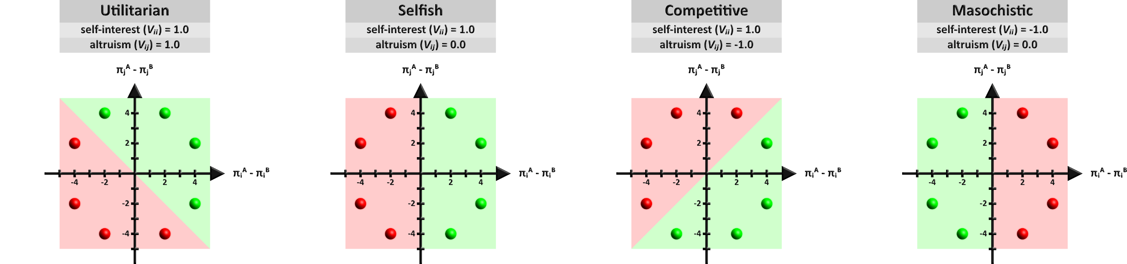
Figure 1: Avatar Preference Profiles:
Participants interacted with four distinct avatars, each characterized by a unique social preference profile: Utilitarian (96 games), Selfish (96 games), Competitive (96 games), and Masochistic (32 games). Avatars' choices were governed by a two-parameter utility function: $U_{i}\left(A\right)=V_{ii}\left(π_{i}^{A}-π_{i}^{B}\right)+V_{ij}\left(π_{j}^{A}-π_{j}^{B}\right)$ where parameters 𝑉_{𝑖𝑖} (self-interest) and 𝑉_{𝑖𝑗} (altruism) systematically varied across avatars, resulting in distinct decision patterns. Green regions in each payoff matrix indicate chosen outcomes, whereas red regions represent non-chosen outcomes. Visually distinct avatars represent each preference profile across the experiment although the avatar appearance to preference profile mapping was randomized across participants.

Human-Human Iterated Binary Dictator Game Experiment
The human-human experiment (𝑛 = 73) shifts from the control of preprogrammed agents to a relatively ecologically valid context—due to actual human interactions, role switching, and more varied payoff structures. Participants alternated between chooser and predictor roles, repeatedly encountering one another across multiple rounds. Participants played simultaneously in groups of 4 to 8 players.
Key Features:
- Randomized Payoff Structures: Payoffs for both chooser and recipient positions were fully randomized within {1, 2, 3, 4, 5}, yielding a comprehensive space of 625 unique payoff combinations.
- Numeric Payoff Presentation: Payoffs were shown as integers rather than abstract dots.
- Probabilistic Matching: Participants received explicit information about the probability of re-encountering each counterpart. We acknowledge this manipulation to be transparent, although future research will be needed to test the effect of matching probabilities on cooperation rates.
- Private Predictions: As with the human-bot experiment, predictions were private, never exposed to counterparts, to eliminate the confound of strategic signaling.
- Audiovisual Feedback: Participants received immediate audiovisual confirmation after each submission, represented by colored arrows clearly indicating chosen and predicted options, enhancing participant engagement and data reliability.
- Time Pressure: Predictions and choices were required within 8 seconds per response, simulating realistic decision-making constraints. Time pressure is necessary in synchronous human-human multiplayer experiments to prevent slower participants from slowing down everyone else, which is why the human-human experiment involved time pressure but the human-bot experiment did not.
Table 2 contrasts procedural details between experiments:
Table 2: Contrasts between human-bot and human-human experiments highlighting complementary purposes and methodological variations.
Dimension | Human-Bot Experiment | Human-Human Experiment
Purpose | Model validation | Parameter estimation
Participants | Human predictors; artificial choosers | Humans as predictors and choosers
Payoff Structure | Controlled (8 unique payoff structures) | Randomized (625 payoff structures)
Matching Procedure | Constant, identifiable avatars | Probabilistic human matching
Payoff Presentation | Abstract dots | Numeric integers
Response Types | Predictions only | Predictions and choices
Data per Participant | 160 responses | ~120 responses
Time Pressure | None | 8 seconds per response
Platform URLs | m3labexperiment.com | moralitygame.com

    - Participants, Recruitment, and Procedure
Participants were undergraduate students recruited via standard university participant pools and compensated through course credits. Comprehension checks and attention-validation trials ensured data quality. Experiments were conducted remotely via standardized web platforms. Figure 2 shows the user-interface.

Procedural Controls Across Experiments:
- Payoff Order Randomization: All payoff presentations and orderings were randomized and counterbalanced, mitigating order effects.
- Neutral Instructions: Instructions were carefully neutral, explicitly avoiding normative or evaluative language.
- Performance Feedback: Participants in the human-bot experiment received no accuracy feedback regarding their predictions or counterparts' subsequent choices2F, while predictor-participants in the human-human feedback saw their counterparts’ choices after submitting predictions.

Figure 2: Human-Human Experiment Stimuli:
This screenshot illustrates the user interface from the perspective of a participant in the predictor role during round 5, with 7 seconds remaining to submit a response. The predictor (purple avatar) must predict whether their counterpart (chooser; orange avatar) will select the left or right option. The chooser's payoff is fixed at 5 points for either choice, whereas the predictor's payoff differs between options: 2 payoffs left and 5 payoffs right. Participants select options and submit predictions via mouse, touchscreen, or keyboard. The faint purple shadow around the right arrow indicates a pre-selected prediction. Upon submission (via click, tap, or spacebar), this shadow intensifies, providing visual feedback. At this point, the arrow's interior turns orange if the chooser already chose or will turn orange when the chooser submits their choice. The right-side panel displays the predictor's cumulative payoff (15 points) and includes a thermometer icon, where the green mercury level indicates the relatively low probability of these participants being rematched in subsequent rounds. Participants understand the matching procedure and can hover the cursor over the thermometer icon to discover the exact probability, which is not revealed by default to avoid visual clutter on the user-interface.

Brief Note on Additional Data
Although another related experiment explored 234 payoff structures in a separate sub-study within the human-bot paradigm (456 participants), these data are reserved for potential supplementary analyses (e.g., Bayesian prior estimation). We clarify this briefly here to avoid confusion and clearly delineate it from our core human-bot and human-human datasets.
  - Utility Bayesian Model: Formulation and Implementation
    - Motivation and Research Context
The primary goal of our study is to provide a precise and psychologically plausible cognitive model of how people infer and dynamically update their beliefs about others’ hidden social preferences from observed decisions. Humans routinely face ambiguous social signals—actions that may reflect multiple underlying motivations—and they must integrate this uncertainty to form reliable predictions of future behavior. Prior empirical evidence demonstrates that people indeed combine prior expectations with observed behaviors to refine their beliefs about others’ intentions, preferences, or trustworthiness (Devaine, Hollard, & Daunizeau, 2014; Yoshida, Dolan, & Friston, 2008). Bayesian models, which formally represent uncertainty as probabilistic distributions updated through observations, are especially well-suited to capturing this gradual inference process (Camerer & Ho, 1999; Fudenberg & Levine, 2009; Hampton, Bossaerts, & O’Doherty, 2008; Griffiths, Kemp, & Tenenbaum, 2008).
Within repeated binary dictator games, observing a single choice—such as a decision benefiting oneself over another person—rarely provides unequivocal insight into underlying motives. For instance, selecting a self-beneficial option may equally reflect strong self-interest, modest altruism, or nuanced inequality aversion. Bayesian inference naturally addresses this challenge by simultaneously modeling multiple competing hypotheses (social preference parameters) and updating their relative plausibility each time a new choice is observed (Yoshida, Dolan, & Friston, 2008). Over repeated observations, Bayesian inference allows initially uncertain beliefs to sharpen gradually into precise and reliable predictions.
Bayesian modeling aligns closely with empirically documented cognitive processes in social decision-making contexts and provides interpretability by explicitly modeling the belief-updating process. This interpretability contrasts favorably with less transparent modeling approaches (e.g., neural network models), whose predictions are often difficult to understand. Furthermore, Bayesian inference models have consistently outperformed alternative, less cognitively grounded models—such as purely reinforcement-based or heuristic models—particularly in contexts where accurately inferring latent social preferences from ambiguous behavioral cues is essential (Camerer & Ho, 1999; Erev & Roth, 1998; Hampton, Bossaerts, & O’Doherty, 2008). By explicitly modeling belief updating as a core cognitive process rather than treating beliefs as incidental by-products of predicting choices, our Bayesian approach facilitates deeper insights into the underlying cognitive mechanisms.
Although our current experiment involves simple one-step dictator games that do not require modeling deeper strategic reasoning (such as level-𝑘 or recursive theory-of-mind (Stahl & Wilson, 1995; Nagel, 1995)) extending our Bayesian model to incorporate such reasoning represents a natural and valuable future direction. To clarify, our current model addresses only first-level Theory of Mind but could be extended to incorporate deeper recursive reasoning applicable to multi-step games.
Crucially, our Utility Bayesian Model describes the information-processing problem the brain must solve—inferring hidden preferences from ambiguous evidence—without making claims about the actual neural implementation. Although our model employs explicit probabilistic computations and grid-based approximations for clarity and computational convenience, we do not suggest the that brain literally performs identical computations. Rather, we offer a functional-level description outlining the problem of social preference inference and belief updating.
Next, we detail how our Utility-Bayes Model (UBM) integrates prior beliefs with observed chooser decisions to produce updated posterior beliefs about social preference parameters.
    - Utility Bayesian Model Mechanics: Prior, Likelihood, and Posterior
Observers’ initial beliefs about a chooser’s social preferences are represented by a population prior over a multidimensional parameter space (Gelman, et al., 2003). This prior assumes that social preference parameters are normally distributed in the population—before observing any individual’s choices, one predicts their behavior as if randomly sampled from this population (Lee & Wagenmakers, 2014). We model each preference dimension with a Gaussian (normal) prior distribution characterized by population-level parameters (means, standard deviations, and covariances). Once observations of the chooser’s actual decisions become available, the model updates from these population priors to individual‐level posterior beliefs—although after the first round, we do not impose any specific parametric form on subsequent posteriors.
Specifically, we parameterize social preferences using:
- $V_{ii}$: self-interest, indicating how strongly the chooser values their own payoffs.
- $V_{ij}$: altruism, indicating how strongly the chooser values the recipient’s payoffs.
- $Ƹ_{ij}$: envy, capturing negative reactions to disadvantageous inequality.
- $Ʒ_{ij}$: guilt, capturing negative reactions to advantageous inequality.
- $γ$: exponent, capturing nonlinear sensitivity to payoff magnitudes and differences.
- $τ$: temperature in the SoftMax function, determining stochasticity in choice behaviors.
Here the chooser is player 𝑖 and the predictor is player 𝑗. 𝑉 indicates value (i.e., $V_{ij}$ reflects how much player 𝑖 values player 𝑗. The envy $Ƹ_{ij}$ and guilt $Ʒ_{ij}$ symbols are mirror images, highlighting their opposite emotional responses to inequality.
We use μ for mean parameters and σ for standard deviation parameters. For instance μ(𝑉_{𝑖𝑗}) and σ(𝑉_{𝑖𝑗}) are the mean and standard deviation parameters for altruism.
This is an example utility function:
$$U_{i}\left(A\right)=V_{ii}{\left(π_{i}^{A}\right)}^{γ}+V_{ij}{\left(π_{j}^{A}\right)}^{γ}-Ƹ_{ij}×{max\left(π_{j}^{A}-π_{i}^{A},0\right)}^{γ}-Ʒ_{ij}×{max\left(π_{i}^{A}-π_{j}^{A},0\right)}^{γ}$$
For the utility for player 𝑖 in option A, where $π_{i}^{A}$ is the payoff for player 𝑖 in option A and $π_{j}^{A}$ is the payoff for player 𝑗 in option A.
    - Likelihood Function and SoftMax Choice Rule
After observing a chooser’s decision, we compute the likelihood of this choice given a parameter vector $θ=\left\{V_{ii}, V_{ij}, Ƹ_{ij}, Ʒ_{ij}, γ, τ\right\}$ through a logit‐type or SoftMax function (Luce, 1959; McFadden, 1974):
$$p\left(choose option A | θ\right)=\frac{e^{{U\left(A, θ\right)}/τ}}{e^{{U\left(A, θ\right)}/τ}+e^{{U\left(B, θ\right)}/τ}}$$
Here τ (temperature parameter) controls how deterministic or stochastic choices are: higher τ yields more random, less deterministic choices, whereas lower τ increases the probability of choosing the option with higher subjective utility. Subjective utility, 𝑈(𝐴, 𝜃), is computed from the parameters 𝜃 by weighting each payoff dimension accordingly. The likelihood then follows from translating these utilities into choice probabilities through the SoftMax rule4F.
    - Grid-Based and Particle Filter Posterior Updating
By default, we used a discrete grid-based approximation method for posterior updating because it is simple and transparent. The multidimensional parameter space is discretized into a finite grid (with resolution defined by 𝑛 bins per dimension). At each grid point, we compute likelihood probabilities, forming a likelihood probability mass function (PMF) over the parameter space. This likelihood PMF is directly comparable to the prior PMF because both are defined over identical parameter grids.
Multiplying the prior and likelihood PMFs point-by-point yields the posterior PMF, representing updated beliefs after observing each choice:
$$p\left(θ | choice\right)∝p\left(choice | θ\right)×p(θ)$$
The posterior PMF subsequently serves as the prior for future belief updates, creating a self-perpetuating Bayesian cycle. This iterative self-updating mechanism ensures that a single set of initial parameters is sufficient to simulate participant responses across multiple games5F.
However, because the number of points in the PMF grids is the number of bins per dimension raised to the number of dimensions ($n^{k}$), full grid-based updating becomes computationally infeasible for higher-dimensional models. Instead, we also switch to using particle filter-based posterior updating, which replaces the full PMF grids with much smaller samples of weighted probability particles.
We verified that the particle filter (PF) reproduces the full grid posterior on synthetic data while varying the number of parameters 𝑘 ∈ [1, 2, 3, … 9] and the ratio of probability particles sampled from the full grid, called the sampling ratio within [0.05, 0.10, 0.15, 0.20, … 0.95]. We simulated 50 artificial choosers paired with 50 artificial predictors across 20 random payoff dictator games, where the predictors used grids of 9 bins per dimension. We provided identical prior parameters to grid-based and PF-based predictors and compared the posteriors recovered from their final round posteriors. In all cases, the correlation exceeded 0.993, demonstrating that the PF faithfully reproduces grid-based updating, typically multiple orders of magnitude faster. We used PF-based updating for the section, “Results: Joint Parameter Distributions in Human-Human Experiment,” which relied on high-dimensional models and we used grid-based updating in the followings sections: “Simulation Methods and Results”, “Illustrating Belief Updates”, and “Model Validation: Comparing Bayesian and Alternative Cognitive Models”.
    - Optimization and Model Evaluation
Our Utility Bayesian model follows the sequence of steps participants experience:
- First, predictor-participants predict their chooser-counterparts’ choice.
- Second, they observe the actual choice.
- Finally, they revise their beliefs based on this observation. They use these updated beliefs to make predictions in the next round, or more specifically the next round that they are matched with the same counterpart and assigned the role of predictor.
Crucially, participants' predictions reflect posterior beliefs revised based on choices observed in the previous round. Thus, our model follows the psychologically plausible causal sequence: predict choice → observe choice → update belief, as shown in Figure 3.
Figure 3: Predict, observe, update:
Within each game, players in the predictor role, first predict their counterpart’s choice, second observe their counterpart’s choice, and third update their beliefs about their counterpart’s social preferences. These revised beliefs (posteriors) become the preconceptions (priors) used to make predictions in the next game. Choice observations are an input to the model and predictions are an output of the model.
Our agent function separately maintains stable chooser parameters (used exclusively to generate choices) and dynamically updates predictor parameters (used exclusively for generating predictions). Rather than using predictions or prediction errors, predictor beliefs evolve solely based on observed chooser actions, separating Bayesian updating evidence (chooser actions) from model evaluation criteria (participant predictions).
Model evaluation utilizes the negative log-likelihood (NLL), comparing posterior-generated model predictions against actual participant predictions:
$$NLL\left(θ\right)=-\sum_{t=1}^{T}{ln\left[p\left({observed choice}_{t} | θ\right)\right],}$$
Here, participant parameter vectors (𝜃) directly map to total negative log-likelihood losses, allowing the optimization process to adjust only initial parameters to minimize this cumulative loss across all observations.
For parameter estimation, we first apply simulated annealing (SA), a global optimization method robust to non-differentiable and complex loss functions, initially exploring the parameter space broadly and gradually shifting focus toward regions of lower loss as it "cools" (Kirkpatrick, Gelatt Jr, & Vecchi, 1983). We subsequently refine these parameter estimates using the local optimization algorithm L-BFGS-B (Byrd, Lu, Nocedal, & Zhu, 1995), which efficiently searches for more precise minima using gradient-based methods. Parameters identified by SA serve as starting points for L-BFGS-B, allowing a smooth transition from global exploration to local exploitation. Ultimately, we select the parameter set that yields the lowest NLL across both optimization steps6F.
Figure 4 illustrates the dynamic evolution of beliefs through the Bayesian updating process across sequential games. The likelihood functions (top row), generated from observed choices (middle row), inform the posterior beliefs (bottom row), demonstrating how initial uncertainty progressively sharpens into precise beliefs over successive observations.
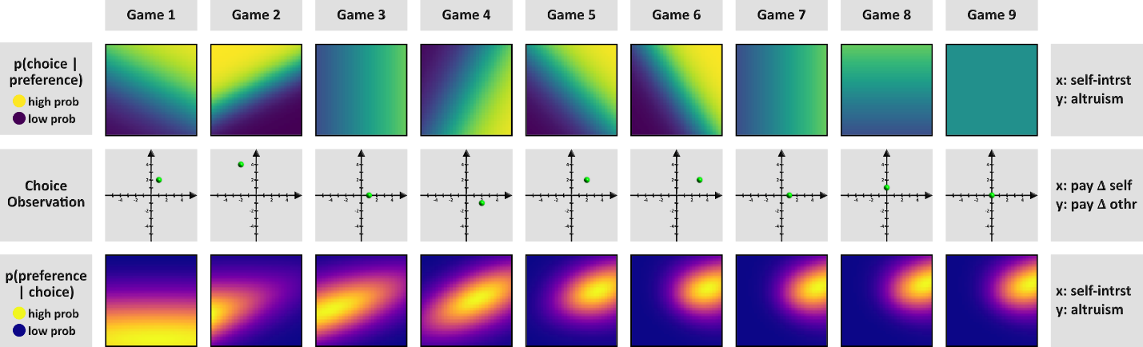
Figure 4: Bayesian belief updating over nine sequential decisions:
Each column illustrates one “game” (choice observation) and how that single observation updates the agent’s preference belief state. Top row: Likelihood of the observed choice given different preference parameters, shown as heatmaps over the 2D preference space (x-axis = self-interest weight, y-axis = altruism weight). Yellow regions indicate high probability of the observed choice under those preference values, and purple regions indicate low probability. Middle row: The choice observation in each game, represented by the green dot in a payoff-difference space (x-axis = Δ payoff to self, y-axis = Δ payoff to other). Bottom row: Posterior distribution of the preference parameters after observing that game’s choice, shown as a probability distribution heatmap (yellow = high posterior density, purple = low). As the games progress from 1 to 9, the posterior distributions become more concentrated, reflecting increasing certainty about the agent’s true preference parameters. This figure demonstrates how Bayesian updating uses each new choice to incrementally refine the belief over the preference model. Interestingly, the likelihood distributions (top row) become sharper in proportion to the distance between the chosen option and the origin of the payoff space (middle row), reflecting the fact that the model treats extreme choices to be more diagnostic of preferences than moderate choices. Indeed, the game 9 choice of (3, 3) vs. (3, 3) is uninformative, resulting in a flat likelihood and thus there is no belief update.
Having articulated our model’s mechanics, notation, and evaluation strategies, we next validate the model with a simulation.
    - Simulation Methods and Results
After presenting the mechanics of the Utility Bayesian Model (UBM), we conducted a simulation designed to (1) verify that our optimizer accurately recovers the “true” social preference parameters specified for each simulated “predictor” bot, (2) confirm that the model’s posterior estimates converge toward the “true” parameter of its “chooser” counterpart over repeated observations, and (3) show that priors with higher variance and lower SoftMax temperatures lead to faster belief updates. This section describes the simulation’s setup, methods, and outcomes.

Simulation Setup
We generated 945 simulated dyads by systematically varying parameter values for both predictors and choosers:
- Predictor parameters
  - Self-interest mean μ(𝑉_{𝑖𝑖}): fixed at 1.0
  - Self-interest standard deviation σ(𝑉_{𝑖𝑖}): fixed at 1.0
  - Altruism mean μ(𝑉_{𝑖𝑗}): 7 levels in [-1.0, -0.667, -0.333, 0.0, 0.333, 0.667, 1.0]
  - Altruism standard deviation σ(𝑉_{𝑖𝑗}): 3 levels [0.5, 1.0, 1.5]
  - SoftMax temperature τ: 3 levels [0.5, 1.75, 3.0]
- Chooser parameters
  - Self-interest mean μ(𝑉_{𝑖𝑖}): fixed at 1.0
  - Self-interest standard deviation σ(𝑉_{𝑖𝑖}): fixed at 1.0
  - Altruism mean μ(𝑉_{𝑖𝑗}): 5 levels in [-1.0, -0.5, 0.0, 0.5, 1.0]
  - Altruism standard deviation σ(𝑉_{𝑖𝑗}): fixed at 1.0
  - SoftMax temperature τ: 3 levels [0.5, 1.75, 3.0]
Every possible combination of these levels yielded 7 × 5 × 3 × 3 × 3 = 945 unique bots. Each dyad matched one “predictor” bot to one “chooser” bot. The simulation proceeded for 25 rounds per dyad. On each round:
- A randomized payoff structure from {1, 2, 3, 4, 5} was assigned to the binary choice, simulating the variety of potential payoffs observed in a real experiment.
- The “chooser” bot used its utility function $U_{i}\left(A\right)=V_{ii}\left(π_{i}^{A}-π_{i}^{B}\right)+V_{ij}\left(π_{j}^{A}-π_{j}^{B}\right)$ with its SoftMax temperature τ to probabilistically select one of the two payoff options7F.
- Simultaneously, the “predictor” bot used an analogous function to produce a predicted choice (and so introduced “semi-stochastic” noise when τ ≠ 0).
At the end of 25 rounds, we fitted our Utility Bayesian Model (UBM) at the dyad level—that is, each predictor’s parameter estimates were inferred from those 25 rounds against a single chooser. We focused on μ(𝑉_{𝑖𝑗}), the altruism mean, for most analyses. Although other parameters could also be examined, altruism is arguably the most morally salient to human observers.

Goals of the Simulation
- Optimizer Check. We first tested whether the model’s optimization pipeline (simulated annealing followed by L-BFGS-B) recovers a predictor’s true altruism mean, μ(𝑉_{𝑖𝑗}).
- Convergence Toward Chooser Parameter. We verified that across repeated rounds the predictor’s fitted altruism estimates move closer to the chooser’s true altruism (μ(𝑉_{𝑖𝑗})).
- Influence of Prior Variance and Temperature. Finally, we tested the Bayesian model properties that (a) higher prior variance fosters faster belief updating, while (b) lower SoftMax temperature increases update speeds by making each observed choice more “diagnostic” or informative.

Simulation Results
1. The Optimizer Accurately Recovers Predictor Parameters
We correlated the true predictor altruism with the fitted predictor altruism across all 945 dyads, obtaining 𝑟 = 0.755, shown in Figure 5. This strong correlation indicates that, even with random payoffs and semi-stochastic agent choices, our optimization procedure reliably estimates the predictor’s underlying parameter. Hence, subsequent references to “fitted priors” can be considered accurate approximations of the predictor’s initial beliefs.
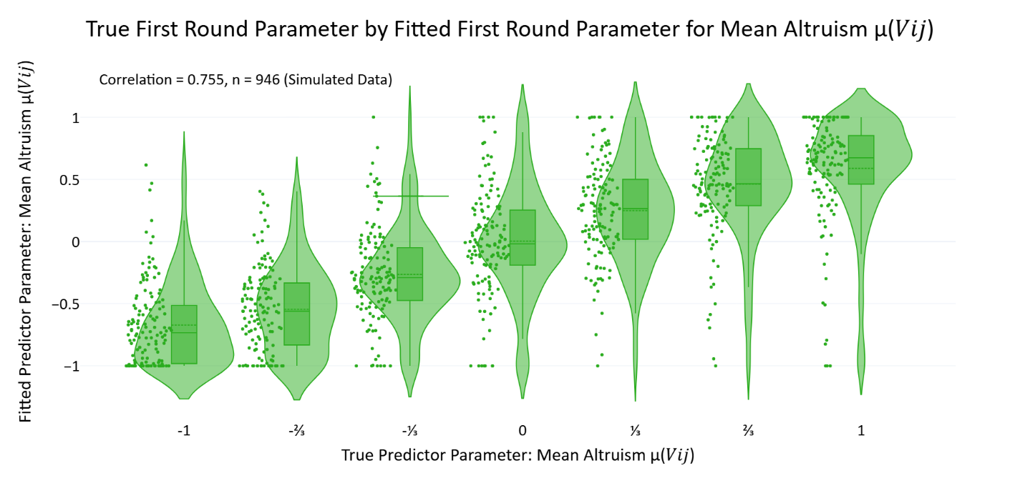
Figure 5: Validation of parameter recovery accuracy for altruism in predictor bots:
Violin plots display distributions of fitted predictor altruism parameter estimates μ(𝑉_{𝑖𝑗}) obtained after the first round of simulated interactions, grouped by the true altruism values programmed into the predictor bots (seven evenly spaced values from -1 to +1). Individual data points (green dots, 𝑛 = 946) represent each simulated dyad. The strong positive correlation (𝑟 = 0.755) confirms that the optimization pipeline reliably recovers the programmed parameters, even with stochastic choices and randomized payoff structures.
2. Predictor Estimates Converge to the Chooser’s True Altruism
Next, we examined whether the predictor estimates align with the chooser’s true parameter over repeated observations. Specifically, we computed the correlation 𝑟[μ(𝑉_{𝑖𝑗})_{𝑡}, μ(𝑉_{𝑖𝑗})_{chooser}] at each round 𝑡. Plotting round‐by‐round correlations revealed a near‐linear increase with a slope of 0.024 and 𝑅² = 0.958. In other words, as more rounds are observed, the predictor’s fitted altruism steadily converges toward the chooser’s genuine altruism.
Although the slope may appear modest, the remarkably consistent upward trend shows that the model systematically updates its beliefs in each round. We further subdivided participants based on fitted first‐round altruism variance and temperature (i.e., we took the lowest, middle, and highest third of each dimension) to create a 3 × 3 partition, shown in Table 3. Averaging final‐round correlations in each bin showed that:
- High prior variance groups generally reached correlations of ∼0.85 with the chooser’s altruism by the last three rounds,
- Low prior variance groups showed substantially lower final correlations,
- Temperature (τ) also modulated final accuracy but with somewhat smaller effect than variance.
Table 3: Mean correlation coefficients between true choosers altruism parameters 𝑉_{𝑖𝑗} and predictors mean altruism parameters μ(𝑉_{𝑖𝑗}) in the final round, subdivided by predictor temperature τ and predictor altruism variance σ(𝑉_{𝑖𝑗}).
 | τ ∊ [0.50, 0.78] | τ ∊ [0.78, 1.26] | τ ∊ [1.26, 3.00]
σ(𝑉_{𝑖𝑗}) ∊ [0.50, 0.76] | -0.168705, 𝑛=189 | -0.432427, 𝑛=105 | -0.262768, 𝑛=21_
σ(𝑉_{𝑖𝑗}) ∊ [0.76, 1.56] | 0.480440, 𝑛=88_ | 0.252143, 𝑛=112 | 0.085649, 𝑛=115
σ(𝑉_{𝑖𝑗}) ∊ [1.56, 4.00] | 0.906009, 𝑛=38_ | 0.856050, 𝑛=98_ | 0.791515, 𝑛=180

These findings confirm that the UBM is genuinely Bayesian in its updating: over time, the predictor’s mean altruism estimate converges to match that of the chooser, shown in Figure 6.
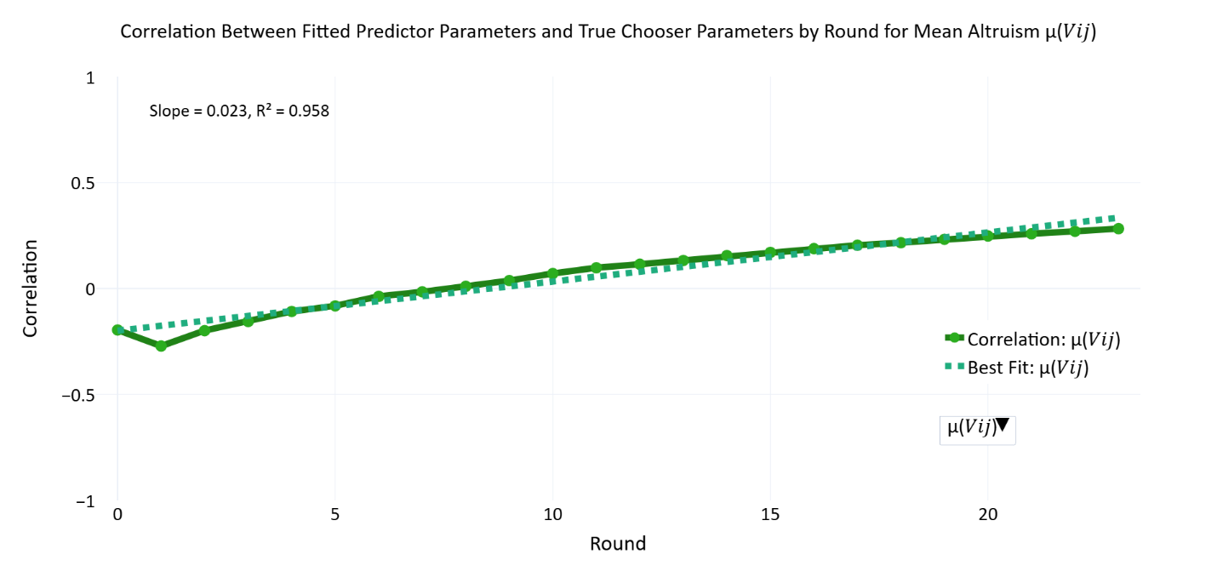
Figure 6: Incremental alignment between inferred and true altruism across rounds:
The solid green line plots the Pearson correlation, by round, between the altruism means fitted for each predictor bot (μ(𝑉_{𝑖𝑗})) and the “ground-truth’’ altruism programmed into its chooser counterpart. The dashed green line gives the least-squares linear fit (slope = 0.023; 𝑅² = 0.958). The relation climbs monotonically reaching ≈ 0.30 by round 23. The trajectory verifies that the Utility-Bayesian Model progressively revises beliefs toward the chooser’s true parameter with continued evidence, demonstrating reliable convergence in iterated interactions.
3. Prior Variance and Temperature Affect Belief Update Speed
We quantified belief update speed by identifying the earliest round in which a predictor’s altruism estimate μ(𝑉_{𝑖𝑗}) reached halfway from its initial (round‐0) value to its final (round‐last) value, then normalizing that crossing time by the total number of rounds. Higher values of this speed metric thus indicate a slower approach to the eventual estimate. We regressed this outcome onto: (1) the fitted first‐round standard deviation σ(𝑉_{𝑖𝑗}), representing prior variance in altruism, and (2) the fitted SoftMax temperature τ, representing how “random” or “undiagnostic” each observed choice is assumed to be.
A multiple linear regression (ordinary least squares) was conducted on 𝑛=945 simulated dyads. The model accounted for approximately 13.9% of the variance in update speed (𝑅²=0.139, 𝐹(2, 726)=58.37, 𝑝<.001).
- Prior variance: 𝛽=−0.0677, 𝑡=−10.624, 𝑝<.001. Higher variance in round‐0 altruism corresponded to faster updating (i.e., a lower fraction of total rounds to reach the halfway point). This aligns with Bayesian principles that an uncertain (wide) prior is more responsive to new evidence.
- Temperature: 𝛽=+0.0241, 𝑡=1.665, 𝑝=0.096. Although this positive effect was not statistically significant at conventional 𝛼=0.05, the sign suggests that larger τ may be associated with more protracted updating. In other words, when the model views each choice as relatively uninformative—due to a higher temperature parameter—its beliefs shift more slowly. However, the influence of temperature alone was not strong enough to meet significance in this simulation.
Although the temperature effect did not reach statistical significance, there is some conceptual rationale for believing that very high temperature values could, in certain circumstances, impede accurate learning by treating even meaningful choices as essentially random. Future analyses could explore interactions between extremely high τ and other model parameters (e.g., the chooser’s own temperature), especially in contexts where a single uncharacteristic choice might be over‐or underweighted in belief updating.
Taken together, these findings confirm that prior variance is a primary driver of how rapidly the model adjusts its altruism estimate over the course of repeated observations. A wide prior fosters more flexible belief revision, while lower prior variance slows updating. The partial (though not statistically significant) temperature effect is directionally consistent with the notion that large τ values reduce the model’s ability to glean definitive information from each observed choice.

Summary of Simulation Findings
The simulation demonstrates that:
- The optimizer accurately recovers the “true” predictor parameter (𝑟 = 0.755), validating the reliability of fitted priors and posteriors.
- Model posteriors converge systematically toward the chooser’s altruism parameter, with round‐by‐round correlation increasing regularly (𝑅² = 0.958 for a linear fit).
- Higher prior variance consistently yields faster belief updates, and higher temperature tends to lead to slower updates, confirming the model’s Bayesian logic about how priors and likelihood sharpness shape learning.
Together, these points substantiate the practical functioning of our Bayesian approach. The model’s ability to converge on correct parameters, combined with the mechanistic role of variance and temperature, indicates that it is well‐posed to handle noisy, semi‐stochastic decisions. Readers can thus view the subsequent human data analyses with confidence that the same pipeline accurately recovers underlying social preferences in a controlled scenario.
The following section illustrates how the model represents belief updates, which are important to understand before proceeding to our model comparison analysis.
    - Illustrating Belief Updates
Figure 7 further illustrates the Utility Bayesian model’s belief updating behavior. This visualization traces predictor belief trajectories for each of the four avatar types in the human-bot experiment—Utilitarian, Selfish, Competitive, and Masochistic—across repeated observations. Each panel shows a separate instantiation of the model’s updating process for different participants, overlaid on a color-coded backdrop indicating regions of the parameter space that would generate the observed choices for each avatar. The green cross in every panel marks the model’s initial prior. All belief trajectories radiate from this single prior because we fitted priors to participants across all their counterpart, rather than dyad by dyad. As decisions unfold, the lines (turquoise, blue, pink, and red) depict the evolving mean beliefs along the self-interest μ(𝑉_{𝑖𝑖}) and altruism μ(𝑉_{𝑖𝑗}) dimensions.
Close inspection of these paths highlights several core features of Bayesian inference. In panels where the priors are set with relatively large variance, the trajectories undergo rapid shifts. By contrast, minimal updating occurs when the priors are narrowly concentrated, as low variance expresses high confidence in beliefs. In such cases, the final beliefs end up near the original prior (green cross), indicating that new observations carry less weight for a model that is strongly peaked from the start.
Additionally, the zig-zag shape of the belief paths reflects the random distribution of payoff structures across trials. Had the bots made identical choices over identical payoffs, the belief trajectories would have been linear. Instead, each new observation nudged the mean estimates in slightly different directions because these variable choice observations can express variable willingness to sacrifice self-interest for the interests of others and vice versa. Despite this variability in payoffs, the avatar-bots choose according to stable social preferences, which is why these choice observations consistently nudge beliefs into one broad direction for each avatar. Unlike humans, these preprogrammed bots never make contradictory or uncharacteristic choices and that is why the beliefs never backtrack. For instance, the masochistic avatars always make choices that reduce their payoffs and so the red lines may zig up or down along the altruism axis, but never rightward along the self-interest axis.
Because the lines show only the model’s mean parameters for each avatar type, they do not capture the standard deviations or covariances that also evolve across trials. Nonetheless, they demonstrate how repeated Bayesian updates gravitate toward true parameters, in this case (1, 1) for Utilitarian, (1, 0) for Selfish, (1, -1) for Competitive, and (-1, 0) for Masochistic avatars.
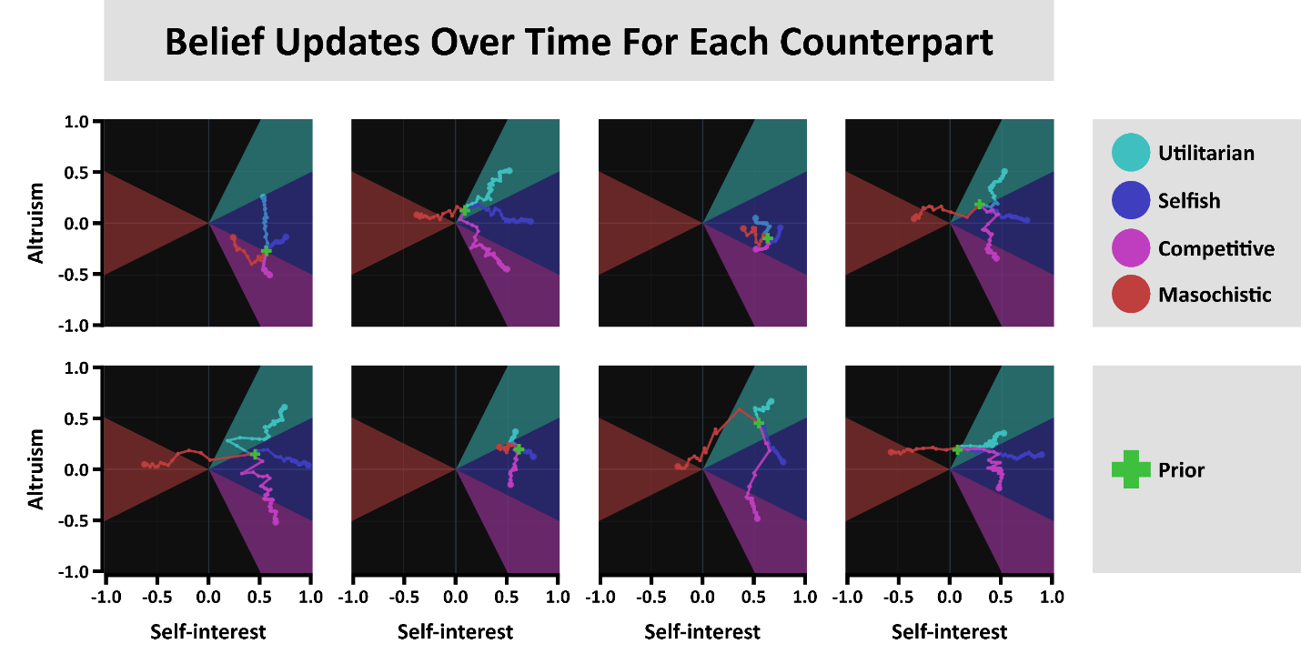
Figure 7: Belief Updates and Convergence Trajectories in 2D Parameter Space:
Each panel shows the evolution of mean beliefs for four avatar types—Utilitarian (1, 1), Selfish (1, 0), Competitive (1, -1), and Masochistic (-1, 0)—in the (𝑉_{𝑖𝑖}, 𝑉_{𝑖𝑗}) plane over repeated observations. The green cross indicates the shared initial prior for all avatars; colored lines trace how the model’s mean parameters shift as it observes each avatar’s choices. Shaded sectors represent the regions of parameter space compatible with each avatar’s behavior. Panels where the prior variance is low (confident priors) exhibit minimal movement, while those with higher variance show large, rapid shifts in response to new data. The zig-zag shapes arise from variability in the payoff structures from trial to trial, illustrating how each observation exerts a distinct directional pull. These convergent trajectories demonstrate the model’s capacity for iterative Bayesian updating in a continuous, two-dimensional representation of social preferences.
    - Model Validation: Comparing Bayesian and Alternative Cognitive Models
The simulation results presented earlier verify that our Utility-Based Bayesian (Utility-Bayes) model satisfies several absolute performance criteria, including effective optimization, rational updating behavior, and appropriate sensitivity to prior beliefs and observed choices. While these results confirm the internal coherence and Bayesian quality of the model, they do not demonstrate its superiority over alternative cognitive models in predicting human behavior. To assess relative predictive power, we compared the Utility-Bayes model against distinct baseline models using data from the human-bot experiment.
Because the human-bot setup avoids role switching and uses preprogrammed chooser agents, it provided a more controlled environment for model comparison than the human-human experiment. We evaluated models via total negative log-likelihood (NLL) calculated from participants’ predictions, with lower NLL indicating higher predictive accuracy. Table 4 reports NLL results across the models.
We first compared Utility Bayesian against three non-Bayesian approaches lacking critical features of Bayesian updating. The Stochastic model assigns equal probability to all choices, serving as a minimal baseline (reported NLL is the mean of 1000 runs). The No Learning model was identical to Utility-Bayes except priors were effectively frozen by constraining minimum and maximum standard deviation parameters to near zero, preventing meaningful updates from new observations. The No Memory model disregarded priors entirely, making predictions based solely on the immediate past choice, thus requiring no parameter fitting. By contrast, Utility-Bayes integrates priors and cumulative evidence dynamically, leveraging both initial assumptions and evolving observations. As shown in Table 4, Utility-Bayes achieves substantially lower NLL (5811.11 with a 21×21 grid) than the non-Bayesian baselines (each exceeding 10,000). These results highlight that both cumulative learning and belief integration significantly enhance predictive accuracy.
Next, we tested the Utility Bayesian model against three models that represent others as falling into discrete preference types, rather than representing the social preferences of others as parameters on continuous dimensions, which is more like our approach. However, because our model approximates a continuous hypothesis space with a discrete grid, it is more accurate to say that we test models that vary in their level of resolution, with discrete (typological) approaches at the low end and continuous approaches at the high end of a spectrum of resolution. By representing beliefs via a dense grid, our Utility Bayesian model uses a higher resolution than the typological models tested here but does not reach the resolution of a fully continuous model.

Discrete versus Continuous Bayesian Models
A critical question in social preference research concerns whether human moral cognition and inferences about others are best represented as discrete types or continuous parameters. Historically, discrete categorization frameworks have been influential in psychology and economics due to their intuitive appeal and interpretative simplicity. For example, early approaches to social value orientation (SVO) classified individuals into distinct categories—such as “prosocial,” “individualistic,” and “competitive”—to succinctly describe cooperative tendencies in social dilemmas (Van Lange, Joireman, Parks, & Dijk, 2013; Balliet, Parks, & Joireman, 2009). Similarly, in contexts like public goods games, researchers have identified meaningful discrete clusters, notably “conditional cooperators” and “free riders” (Fischbacher & Gächter, 2010), demonstrating practical explanatory value.
However, accumulating empirical evidence increasingly suggests that discrete categorization—while convenient—may substantially oversimplify the underlying psychological reality. Andreoni and Miller (2002), in a seminal revealed-preference study, demonstrated that altruistic behavior exhibits nuanced variation along a continuous spectrum rather than fitting neatly into distinct categories. This continuous variability in social preferences was further supported by Fisman, Kariv, and Markovits (2007), who documented extensive heterogeneity in generosity and social concern across a broad, continuous payoff space. Moreover, Murphy, Ackermann, and Handgraaf (2011) explicitly introduced a continuous measurement method—the “SVO Slider”—highlighting significant and meaningful variability in social preferences that discrete typologies fail to capture fully.
Parallel debates exist regarding people's beliefs about others' social preferences. While discrete mental categories, such as labeling individuals as “good” or “bad,” offer efficient cognitive heuristics (Cosmides, Barrett, & Tooby, 2010; Krupp, Debruine, & Barclay, 2008), more recent evidence shows that human belief updating often transcends these initial simplifications. However, the question of whether social-preference inferences specifically are best represented as discrete categories or continuous distributions remains unresolved.
A growing body of work indicates that, even when researchers start from discrete typologies, people’s beliefs about others shift in graded, probabilistic ways as evidence accrues. For instance, subjects invert partners’ actions to update a continuous posterior over preference weights (Jern, Lucas, & Kemp, 2017), show type-dependent belief revision across repeated dictator tasks (Iriberri & Rey-Biel, 2013), and can be captured by hierarchical Bayesian models that treat both preferences and beliefs as continuous latent variables (Aksoy & Weesie, 2014). Yet these prior studies tested only a small, predetermined set of discrete models or did not systematically examine continuous-versus-discrete representations specifically within the domain of social preferences.
Following this reasoning, we compared our relatively high-resolution Utility-Bayes model to several discrete Bayesian models of social preference belief updating. In these discrete variants, we treated participants’ social preferences as belonging to one of a few distinct “types” and specified uniform priors across those types. The Good versus Evil model, for instance, divides the population into two bins according to whether an agent’s altruism parameter is positive or negative, and the Canonical Social Value Orientation (SVO) model draws on well-known categories such as altruistic, selfish, and competitive. We also included a Perfect Oracle model, which starts with a perfectly calibrated prior matching the experiment’s actual distribution of avatar types. This “oracle” thus knows in advance exactly what fraction of encounters will feature selfish, competitive, or utilitarian counterparts, giving it the best possible starting guess in principle. Yet despite these theoretically favorable conditions, the Perfect Oracle model exhibits a relatively poor fit (NLL = 17381.06), suggesting that participants do not behave like omniscient observers who know the population composition from the outset.
Following this reasoning, we compared our relatively high-resolution Utility-Bayes model to several discrete topological Bayesian models8F. In this analysis, discrete models included the Good versus Evil model (categorizing altruism parameters as positive or negative), the Canonical Social Value Orientation (SVO) model (utilizing familiar categories like altruistic, selfish, and competitive), and the Perfect Oracle model (with an optimally informed initial prior matching the actual avatar distribution within the experiment). Rather than fitting parameters, these models used fixed priors as shown in Figure 8. Despite its theoretically optimal prior, the Perfect Oracle yielded poor predictive performance (NLL = 17381.06), indicating that participants did not rely on perfect population knowledge from the outset. Likewise, Good versus Evil and Canonical SVO models underperformed substantially, each producing NLL values exceeding 14,000. These comparisons suggest that at least these discrete categorizations inadequately capture nuanced and dynamic human belief updating. The Utility-Bayes model’s superior performance supports representing social preferences at higher resolutions and continuously refining these representations over time.
Table 4: Model Comparison by Total Negative Log-Likelihood.
Loss values represent the sum of negative log-likelihoods (NLL) across all participants in the human-bot experiment. The “High-Resolution Bayesian” model (leftmost bar) shows the lowest NLL of 5811, outperforming all discrete and non-Bayesian alternatives.
Model Name | Bayesian | Parameterization | Loss (Total NNL)
Perfect Oracle | True | Discrete | 17381.055
Canonical SVO | True | Discrete | 16904.924
Good versus Evil | True | Discrete | 14639.593
Stochastic | False | Neither | 13272.419
No Memory | False | Continuous | 12057.898
No Learning | False | Continuous | 10683.986
Utility Bayesian | True | Continuous | 5811.111

These comparisons favor a Bayesian updating process with nuanced social preference beliefs and belief updating. Nonetheless, there remain infinitely many ways to partition continuous hypothesis spaces, and our discrete models thus far are a minute subset of what is possible. We next examine a broader range of models with discrete hypothesis spaces, testing whether any such model can surpass the predictive performance of our comparatively high-resolution framework.
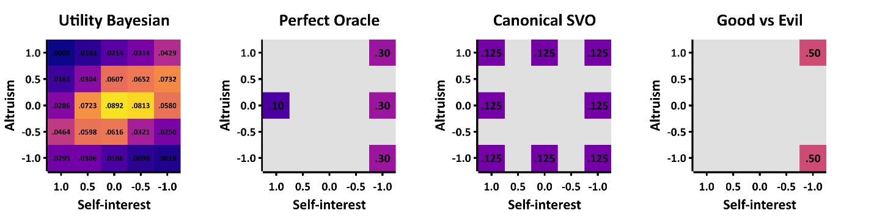
Figure 8: Illustrating Different Resolutions of Social Preference Hypothesis Spaces:
Each square shows a 5×5 parameter grid for 𝑉_{𝑖𝑖} and 𝑉_{𝑖𝑗} ranging from −1 to +1. The color in each cell corresponds to the prior probability assigned to that cell. The leftmost square depicts our high-resolution Utility Bayesian model (here, 5 bins per dimension) with probabilities spread across all 25 cells. Panels B–D display lower-resolution “discrete” models—Perfect Oracle, Canonical SVO, and Good vs. Evil—where only a handful of cells carry nonzero probability (colored), effectively treating the rest as impossible (dark/empty). This demonstrates how simple discrete models can be seen as special cases of the higher-resolution approach, with fewer “bins” (or types) in their hypothesis space. In practice, our “high-resolution” approach uses finer grids (like 21×21) to approximate “continuous” preferences but we also used a 5×5 grid when comparing the UBM to typological models that represent types in somewhere in the 5×5 parameter space so that they UBM would be more comparable to the typological models. Note: The distinction between continuous and discrete Bayesian models pertains to their hypothesis spaces, not how probabilities are updated. Both continuous (UBM) and discrete (typological) models update probabilities continuously (gradually rather than stepwise), but only typological models explicitly forbid certain regions of the parameter space.
    - Searching The Space of Typological Bayesian Models
We next conducted a more extensive search through a broad range of discrete models to test whether any alternative partitioning of the social preference space could rival our Utility-Bayes model. The logic behind these additional comparisons was that each “discrete” hypothesis space can be thought of as a lower-resolution special case of our grid-based, high-resolution approach, where only a handful of parameter “bins” receive nonzero prior probability. To construct these lower-resolution hypothesis spaces, we discretized the two-dimensional parameter space (𝑉_{𝑖𝑖}, 𝑉_{𝑖𝑗}) into a 5 by 5 grid with equally spaced points between −1 and +1 on each dimension. We then generated discrete models by choosing different subsets of these points—ranging from three to six preference “types”—and fitting the prior probabilities over those types to the data. Specifically, we evaluated every combination of three and four types in that 25-point grid ($\left({25 \atop 3}\right)=2300$ combinations and $\left({25 \atop 4}\right)=12,650$ combinations), and we drew a random sample of subsets for five and six types due to computational constraints. For each discrete model, we optimized the prior distribution and calculated total negative log-likelihood (NLL) values based on participants' predictions. We optimized the prior distribution to the entire population for all the models and then fitted the prior distribution participant by participant for the model with the best fit at the population level. Individual-level fitting for every model would have been computationally intractable.
Despite this extensive search, none of the typological models approached the predictive accuracy achieved by our Utility-Bayes Model. The best-performing discrete model had a minimum total NLL slightly above 8,500 at the population level, which improved marginally to approximately 8,470 when priors were individualized per participant. While these adjustments did yield incremental improvements, the overarching result remained robust: typological models omitting large regions (bins) of the hypothesis space failed to capture participants' predictions as effectively as the more granular Utility-Bayes Model (UBM). This suggests that representing social preferences with only a few discrete types overlooks the nuanced, high-resolution inference processes participants actually employed.
Our exhaustive combinational approach inherently included many models with low face validity or minimal differentiation. Nevertheless, systematically evaluating over 15,000 discrete typological models against a continuous Bayesian approach allowed us to present uniquely conclusive evidence supporting quasi-continuous belief representation. This comprehensive evaluation thus constitutes a novel methodological contribution—arguably the largest and most rigorous discrete-versus-continuous Bayesian model comparison within social preference research to date9F. Previous studies comparing continuous and discrete representations typically contrast only a handful of predefined models.
Nonetheless, several directions remain open for future research. First, our analysis is a functional-level description (Marr, 1982), characterizing input-output relationships (choices and predictions) without specifying the cognitive algorithms observers employ. Future studies could explore underlying cognitive or neural processes—for example, determining whether humans approximate Bayesian inference through heuristic algorithms (e.g., sampling-based approximations or particle filters).
Second, our conclusions about discrete versus continuous representations depend on the two parameters (self-interest and altruism) and the utility function we used. While we expect that similar outcomes would generalize to alternative dimensions (e.g., envy and guilt), future empirical work is needed to confirm whether continuous Bayesian inference consistently outperforms discrete typological models across other social preference domains.
Finally, the experimental context provided participants with clear, repeated feedback, which likely facilitated fine-grained belief representation and updating. Future research may address whether participants maintain such granular representations in more information-poor or cognitively demanding environments, or if simpler typological representations would prove more adaptive under these conditions.
Having established the predictive advantage of our relatively granular Bayesian inference framework, we next turn our attention to identifying the optimal form of the utility function that underpins our likelihood calculations.

- Information Criterion Analysis: Determining Optimal Utility Structures
Having demonstrated that a high-resolution Bayesian approach outperforms simpler discrete or non-Bayesian models, we next perform an analysis to determine which utility function our Bayesian approach should employ. The functional form of the utility function determines how social preferences respond to payoff distributions, such as whether they consider payoff differences, payoffs relative to a reference point, or other transformations. Accurately establishing this form is crucial for interpreting the distributions of social preferences we will report, since an incorrect functional form could distort our conclusions about those preferences and even which preferences matter most. To identify the best form, we conduct an Information Criterion (IC) analysis across 476 candidate utility specifications. We base this analysis on the human-human experiment data, which span a large, randomized payoff space and involve participants in both choosing and predicting roles. In contrast to the smaller set of payoff structures from the human-bot experiment, the broader distribution of payoffs in the human-human experiment makes it possible to test the generalizability of each candidate utility function across a larger payoff space and for both chooser and predictor roles.
  - Motivation and Theoretical Justification of Utility Form Variations
Our modeling effort aims to characterize how observers infer and update beliefs about others' social preferences, specifically focusing on outcome-based social preferences. Outcome-based preferences refer to preferences that depend exclusively on final distributions of payoffs, without considering non-outcome elements such as intentions, fairness norms, reciprocity, or responsibility attribution (Falk & Fischbacher, 2006). Non-outcome-based social preferences are important but outside the scope of this study.
We explored a space of utility functions inspired by influential theoretical frameworks and empirical findings. Each variation captures a psychological mechanism hypothesized to influence how individuals represent and evaluate social outcomes.
The following 14 Boolean utility settings determine each model’s functional form. If a setting is set to ‘true’, then it is turned on and it is turned off otherwise. For example, if and only if the setting called ‘conditional welfare mode’ is set to ‘true’, then the utility function will have a conditional welfare form.

(1) Conditional Welfare Mode
Conditional welfare mode captures the tendency to weigh payoffs differently depending on relative social standing—whether one's payoff is ahead (advantageous) or behind (disadvantageous) of others, a concept called conditional welfare (Rabin, 1992).
Example:
$$U_{i}\left(A\right)=\left\{\begin{aligned}V_{ii}\left(π_{i}^{A}-π_{i}^{B}\right)+V_{ij}\left(π_{j}^{A}-π_{j}^{B}\right), &if π_{i}^{A}≥π_{j}^{A} \\ Ʌ_{ii}\left(π_{i}^{A}-π_{i}^{B}\right)+Ʌ_{ij}\left(π_{j}^{A}-π_{j}^{B}\right), &if π_{i}^{A}<π_{j}^{A}\end{aligned}\right.$$

(2) Reference-Dependent Altruism
Reference-dependent altruism introduces the idea that altruistic preferences differ depending on whether the recipient's payoff is above or below a neutral reference point (𝑅 = 3), chosen as the middle payoff in {1, 2, 3, 4, 5}. This aligns with insights from reference-dependent models (Cox, Friedman, & Gjerstad, 2007). This utility setting only applies to conditional welfare models.
Example:
$$U_{i}\left(A\right)=V_{ii}\left(π_{i}^{A}-π_{i}^{B}\right)+\left\{\begin{aligned}V_{ij}\left(π_{j}^{A}-π_{j}^{B}\right), &if π_{i}^{A}≥R \\ Ʌ_{ij}\left(π_{j}^{A}-π_{j}^{B}\right), &if π_{i}^{A}<R\end{aligned}\right.$$

(3) Min-Max Preferences (Rawlsian and Leontief Forms)
Min-max functional forms model fairness considerations that focus on maximizing minimum payoffs, consistent with a desire for equality or fairness as famously advocated by Rawls (1971) and formalized in production economics by Leontief (1941). These forms differ in the placement of preference weights (e.g., self-interest and altruism parameters) relative to the min operator. The Rawlsian form applies a single altruism parameter externally, capturing the principle of maximizing the payoff of the worst-off individual without modulating individual contributions separately. However, the Leontief form incorporates separate parameters internally within the min operator, reflecting an agent-specific weighted consideration of everyone’s outcome. Although neither Rawls nor Leontief originally proposed using the max operator, for completeness and symmetry, we tested both min and max variants.
Rawlsian (external weighting) example:
$$U_{i}\left(A\right)=V_{ij}×{min\left(π_{i}^{A},π_{j}^{A}\right)}^{γ}$$
Leontief (internal weighting) example:
$$U_{i}\left(A\right)=min\left(V_{ii}{\left(π_{i}^{A}\right)}^{γ},V_{ij}{\left(π_{j}^{A}\right)}^{γ}\right)$$

(4 & 5) Use of Exponential Parameters and Single versus Individual Exponents per Term
Exponential parameters model nonlinear subjective utilities, aligning with diminishing marginal utility and Prospect Theory (Kahneman & Tversky, 1979). We explored whether a single exponent across all terms suffices or distinct exponents per term are necessary, reflecting varied nonlinear evaluations for self-interest, altruism, and social comparison.
Single exponent example:
$$U_{i}\left(A\right)=V_{ii}{\left(π_{i}^{A}-π_{i}^{B}\right)}^{γ}+V_{ij}{\left(π_{j}^{A}-π_{j}^{B}\right)}^{γ}-Ƹ_{ij}{\left(π_{i}^{A}-π_{j}^{A}\right)}^{γ}$$
Individual exponents example:
$$U_{i}\left(A\right)=V_{ii}{\left(π_{i}^{A}-π_{i}^{B}\right)}^{γ_{1}}+V_{ij}{\left(π_{j}^{A}-π_{j}^{B}\right)}^{γ_{2}}-Ƹ_{ij}{\left(π_{i}^{A}-π_{j}^{A}\right)}^{γ_{3}}$$

(6) Apply Exponents Directly to Payoffs
When utility functions have exponents and include payoff differences or payoff ratios, the exponents can be applied to the payoffs before or after these transformations. The two placements encode different kinds of nonlinear sensitivity. Assuming γ < 1, curving each payoff before comparison makes a fixed payoff difference feel smaller as both payoffs get larger (Ottone & Ponzano, 2005), while curving the difference itself makes sensitivity diminish with the size of the payoff difference (or ratio) per se, even at the same absolute payoff sizes, which in a social comparison term is akin to inequality aversion with diminishing sensitivity (Hill & Neilson, 2007).
Example of exponents applied inside the payoff difference:
$$U_{i}\left(A\right)=…Ƹ_{ij}\left({\left(π_{i}^{A}\right)}^{γ}-{\left(π_{j}^{A}\right)}^{γ}\right)$$
Example of exponents applied outside the payoff difference:
$$U_{i}\left(A\right)=…Ƹ_{ij}{\left(π_{i}^{A}-π_{j}^{A}\right)}^{γ}$$

(7 & 8) Single Payoffs and Payoff Ratios instead of Differences
Computing utilities from single payoffs may be cognitively simpler than computing utilities from differences (Camerer C. F., 2003) and models the payoff-utility relation as absolute, not relative. Additionally, computing utilities from payoff ratios, not payoff differences, means that a payoff difference becomes less salient as the payoffs grow larger, aligning with nonlinear marginal utility and proportional fairness perspectives (Bolton & Ockenfels, 2000). Note that the social comparison term always uses payoff differences.
Single payoff example:
$$U_{i}\left(A\right)=V_{ii}{\left(π_{i}^{A}\right)}^{γ}+V_{ij}{\left(π_{j}^{A}\right)}^{γ}$$
Payoff ratio example:
$$U_{i}\left(A\right)=V_{ii}{\left(\frac{π_{i}^{A}}{π_{i}^{A}+π_{i}^{B}}-\frac{1}{2}\right)}^{γ}+V_{ij}{\left(\frac{π_{j}^{A}}{π_{j}^{A}+π_{j}^{B}}-\frac{1}{2}\right)}^{γ}$$

(9) Reference-Dependent Utility
Inspired by Prospect Theory, reference-dependent utility evaluates outcomes against a neutral reference point, allowing for modeling of asymmetric perceptions of outcomes as gains or losses (Kahneman & Tversky, 1979).
Ideally, identifying reference-dependent preferences requires outcomes that span true gains and losses relative to a meaningful neutral (often zero or a status-quo allocation). However, because our experimental payoffs were restricted to positive values {1, 2, 3, 4, 5}, we set an artificial reference point at the midpoint of this range (𝑅=3). Conceptually, this is akin to rescaling outcomes around an average midpoint ({-2, -1, 0, 1, 2}), but it is fundamentally different from genuine loss framing around zero or another psychologically meaningful reference.
Example:
$$U_{i}\left(A\right)=V_{ii}{\left(π_{i}^{A}-R\right)}^{γ}+V_{ij}{\left(π_{j}^{A}-R\right)}^{γ}$$

(10) Negativity Parameters (Loss Aversion)
Negativity parameters model distinct sensitivity to negative deviations (losses) relative to positive deviations (gains) from the reference point, capturing the well-documented psychological phenomenon of loss aversion (Kahneman & Tversky, 1979).
As noted in the previous section, our lack of negative payoffs prevent participants from experiencing absolute losses. Instead, in this study, negativity parameters only weight relative losses—losses compared to the alternative payoff or the reference point payoff of 3.
Example:
$$U_{i}\left(A\right)=V_{ii}×max{\left(π_{i}^{A}-π_{i}^{B},0\right)}^{γ}+Ʌ_{ii}{×max\left(π_{i}^{B}-π_{i}^{A},0\right)}^{γ}$$

(11) Negativity in Social Comparison (Envy/Guilt)
Separate negativity parameters within social comparison terms reflect differentiated psychological responses to advantageous versus disadvantageous inequalities, consistent with inequity aversion theories (Fehr & Schmidt, 1999). Here $Ƹ_{ij}$ is envy towards disadvantageous inequality and $Ʒ_{ij}$ is guilt towards advantageous inequality.
Example:
$$U_{i}\left(A\right)=…-Ƹ_{ij}×{max\left(π_{j}^{A}-π_{i}^{A},0\right)}^{γ}-Ʒ_{ij}×{max\left(π_{i}^{A}-π_{j}^{A},0\right)}^{γ}$$

(12) Variable versus Fixed Self-Interest Parameter
We assessed whether self-interest varies across individuals or is universally fixed at 1, simplifying individual heterogeneity assumptions and following common practice (Andreoni & Miller, 2002).
Variable example:
$$U_{i}\left(A\right)=V_{ii}{\left(π_{i}^{A}-π_{i}^{B}\right)}^{γ}+…$$
Fixed example:
$$U_{i}\left(A\right)={\left(π_{i}^{A}-π_{i}^{B}\right)}^{γ}+…$$

(13 & 14) Inclusion of Altruism and Social Comparison Terms
Finally, we explicitly tested the necessity of including altruism and social comparison terms, frequently identified as critical to social behavior (Fehr & Schmidt, 1999; Bolton & Ockenfels, 2000).
These systematic explorations resulted in 476 distinct utility forms. We searched for the best fitting utility form, defined as minimizing the information criterion score, to ensure a robust foundation for our Bayesian cognitive modeling.
  - Methodological Approach
We performed an Information Criterion (IC) analysis to select the optimal utility function among 476 systematically generated alternatives. Using Akaike Information Criterion (AIC) and Bayesian Information Criterion (BIC), we balanced model fit against complexity (Anderson & Burnham, 2002; Akaike, 1973; Schwarz, 1978). For computational feasibility, we conducted this analysis using a static (no updating) version of our cognitive model. Although a fully dynamic Bayesian approach would have been theoretically ideal, the computational demands of fitting individual-level Bayesian belief updating parameters across 73 participants and 476 utility functions proved prohibitive10F.
The total negative log-likelihood (NLL) summed across all participant choices and predictions served as the basis for IC calculations:
$$AIC=2k+2×NLL$$
$$BIC=k×ln\left(n\right)+2×NLL$$
where 𝑘 is the number of free parameters and is the total number of data points.
  - Pairwise Comparison Analysis
Beyond identifying the single best utility form, it is valuable to learn general principles about which design features consistently help or hinder model fit. Such principles can guide researchers who wish to extend this framework to richer settings—e.g., games with more players, strategic reasoning, or belief-based preferences. Because our set of candidate models spans 476 functional forms that differ along 14 Boolean design dimensions, we summarize the average directional contribution of each dimension by averaging the difference in BIC between pairs of models that are identical except for one switched setting.
Table 5 summarizes the results of this pairwise comparison analysis:
Table 5: Pairwise BIC contrasts for each Boolean utility setting:
$∆BIC=BIC\left(setting off\right)-BIC\left(setting on\right).$ Negative values indicate that turning the setting on improves fit on average. “Relation” denotes whether the compared pairs are nested (parent/child), siblings (same k), or neither. Because some settings are only defined with subsets of the model space, the number of eligible pairs differs by row.
Utility Setting | Relation | N Pairs | Mean ΔBIC | Med ΔBIC | Effect on Fit
Use Exponential Parameters | Nested | 118 | -967.38 | -950.51 | Strongly improves
Include Altruism Term | Nested | 158 | -433.46 | -430.77 | Strongly improves
Envy/Guilt in Social Comparison | Nested | 81 | -355.13 | -232.91 | Moderately improves
Include Social Comparison | Nested | 63 | -244.63 | -277.6 | Moderately improves
General Negativity Parameters | Nested | 92 | -51.91 | 1.84 | Slightly improves
Single Exponential Parameter | Nested | 140 | 77.97 | 22.87 | Slightly worsens
Fix Self-Interest Parameter | Nested | 118 | 219.44 | 44.58 | Moderately worsens
Single Payoffs (not differences) | Siblings | 48 | -8.18 | 15.31 | Neutral effect
Reference-Dependent Altruism | Siblings | 37 | 21.42 | 4.92 | Slightly worsens
Reference-Dependent Utility | Siblings | 214 | 313.00 | 358.57 | Moderately worsens
Apply Exponents to Payoffs | Siblings | 164 | 565.27 | 819.96 | Strongly worsens
Payoff Ratios (not differences) | Siblings | 214 | 1548.36 | 1566.04 | Strongly worsens
Conditional Welfare Form | None | 37 | -162.27 | -87.02 | Moderately improves
Min-Max Rawlsian/Leontief | None | 23 | 701.22 | 701.33 | Strongly worsens

Provisional Principles and Recommendations:
Strongly recommended:
- Include exponential parameters and an altruism term.
- Exclude exponents directly on payoffs, payoff ratios, and min-max forms.
Recommended:
- Include a social comparison term, ideally split into sides for disadvantageous (envy) and advantageous (guilt) inequality.
- Allow self-interest to vary, rather than fixing it to one,
- Avoid reference points based on the midpoint payoff (𝑅=3).
- Single payoffs and payoff differences perform about equally well.
- Caution advised: The neutral or weak effects of models that include negativity parameters or use 𝑅 = 3 as a reference point likely reflect our payoff space lacking true losses. These forms might behave differently when outcomes can fall below zero.
These recommendations are provisional. They represent averages across all 476 utility functions rather than the subset of best-fitting ones and ignore potential interactions between settings. Some features that look harmful in aggregate can become beneficial in restricted contexts. For example, “apply exponents to payoffs” worsened fit on average (ΔBIC ≈ +565), but when models using payoff ratios, min-max, and conditional-welfare forms are excluded, the same setting improves fit (mean ΔBIC ≈ -225). Thus, this pairwise analysis should be read as a first-pass, rather than a final verdict. It is a way to identify promising ingredients for future models and to flag areas where richer interaction analyses could reveal context-specific advantages of functional forms.
  - Optimal Utility Functions and Nesting
Our top-performing utility functions were determined by ranking BIC scores, as BIC penalizes model complexity more strongly than AIC. Figure 9 shows the ΔBIC scores for all 476 models and Table 6 shows the top-performing models by 𝑘 parameters.
The optimal utility function is expressed as:
$$U_{i}\left(A\right)=V_{ii}{\left(π_{i}^{A}-π_{i}^{B}\right)}^{γ_{1}}+V_{ij}{\left(π_{j}^{A}-π_{j}^{B}\right)}^{γ_{2}}-Ƹ_{ij}×{max\left(π_{j}^{A}-π_{i}^{A},0\right)}^{γ_{3}}-Ʒ_{ij}×{max\left(π_{i}^{A}-π_{j}^{A},0\right)}^{γ_{3}}$$
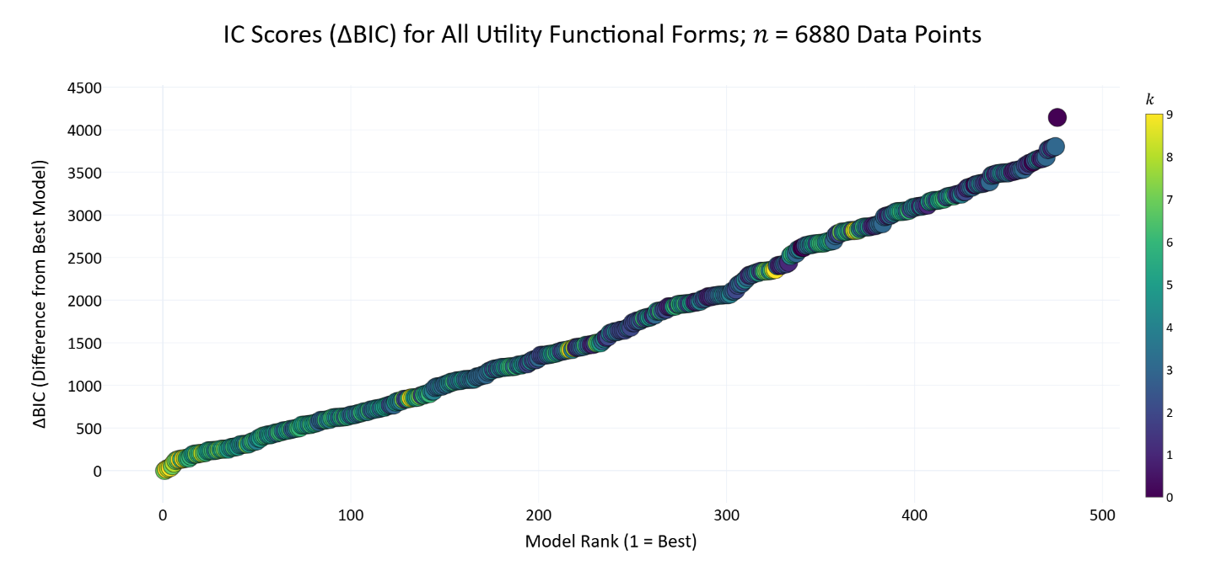
Figure 9: All 476 ΔBIC Scores Per Functional Form from Least to Greatest:
This plot shows ΔBIC for all 476 models from least to greatest, where ΔBIC is the difference between the minimum BIC score and the model's BIC score. Each point is one model. Models are colored by number of parameters (𝑘).
Table 6: Information Criterion Scores and Functional Forms for Top-Performing Utility Functions by Parameter Count.
This table presents the nine best-fitting utility functions from our set of 476 candidate models, organized by the number of free parameters (𝑘). Utility functions are ranked within each 𝑘 on the basis of their Bayesian Information Criterion (BIC), a metric that balances model fit (measured by summed negative log-likelihood) against complexity. The ΔBIC column reports the BIC difference from the best-fitting model across all 476 (the 𝑘 = 5 model with ΔBIC = 0). ΔBIC values greater than 10 indicate significantly worse model performance.
Binary indicators (0/1) in columns S1–S14 denote the inclusion of 14 theoretically motivated utility settings, such as reference dependence, exponent structure, and social comparison terms (see legend below). While the top-performing model includes seven parameters—self-interest, altruism, envy, guilt, and exponents for each term—the broader comparison highlights which features tend to improve fit as model complexity increases.
The equations in the lower panel correspond to the models listed in the upper panel, matched by their 𝑘 values. Due to formatting constraints, the top and bottom halves are separated but aligned row-wise by 𝑘.
While we recommend using the top performing model (𝑘=7), this table allows modelers to select the best utility functions based on the number of parameters they prefer to use, and it reveals general insights into the types of models that tend to fit the data best.
𝑘 | Loss | AIC | BIC | ΔBIC | S_{1_} | S_{2_} | S_{3_} | S_{4_} | S_{5_} | S_{6_} | S_{7_} | S_{8_} | S_{9_} | S₁₀ | S₁₁ | S₁₂ | S₁₃ | S₁₄
1 | 3274.05 | 6550.1 | 6556.94 | 1443.94 | 0 | 0 | 0 | 1 | 1 | 1 | 0 | 0 | 0 | 0 | 0 | 1 | 0 | 0
2 | 2932.19 | 5868.39 | 5882.06 | 769.06 | 0 | 0 | 0 | 1 | 1 | 1 | 0 | 0 | 0 | 0 | 0 | 1 | 0 | 1
3 | 2764.46 | 5534.92 | 5555.43 | 442.43 | 0 | 0 | 0 | 1 | 1 | 1 | 0 | 0 | 1 | 0 | 1 | 1 | 1 | 0
4 | 2657.34 | 5322.68 | 5350.02 | 237.02 | 0 | 0 | 0 | 1 | 1 | 1 | 0 | 0 | 0 | 0 | 0 | 0 | 1 | 1
5 | 2628.47 | 5266.94 | 5301.12 | 188.13 | 0 | 0 | 0 | 1 | 1 | 0 | 1 | 0 | 0 | 0 | 1 | 0 | 1 | 1
6 | 2597.37 | 5206.74 | 5247.75 | 134.76 | 0 | 0 | 0 | 1 | 0 | 0 | 0 | 0 | 0 | 0 | 1 | 1 | 1 | 1
7 | 2525.57 | 5065.14 | 5113 | 0.00 | 0 | 0 | 0 | 1 | 0 | 0 | 0 | 0 | 0 | 0 | 1 | 0 | 1 | 1
8 | 2534.47 | 5084.93 | 5139.62 | 26.63 | 0 | 0 | 0 | 1 | 0 | 0 | 0 | 0 | 0 | 1 | 1 | 1 | 1 | 1
9 | 2525.24 | 5068.48 | 5130.01 | 17.01 | 0 | 0 | 0 | 1 | 0 | 0 | 0 | 0 | 0 | 1 | 1 | 0 | 1 | 1
Column Names:
𝑘: Number of parameters.
loss: Summed Negative Log-Likelihood across all participant responses.
AIC/BIC: Information Criteria balancing fit and complexity (lower values indicate superior models).
ΔBIC: Difference in BIC relative to the best (lowest) scoring model (ΔBIC > 10 considered decisive).
S1 through S14: Utility Settings (1 = true, 0 = false) corresponding to the enumerated settings:
- Conditional welfare mode
- Reference-dependent altruism
- Rawlsian and Leontief min-max
- Use of exponential parameters
- Single versus individual exponents
- Apply exponents directly to payoffs
- Single payoffs (instead of differences)
- Payoff ratios (instead of differences)
- Reference-dependent utility (𝑅 = 3)
- Negativity parameters (loss aversion)
- Negativity within social comparison (envy/guilt)
- Variable versus fixed self-interest parameter
- Inclusion of social comparison
- Inclusion of altruism
𝑘 | Equation
1 | $$U_{i}\left(A\right)={\left(π_{i}^{A}\right)}^{γ}-{\left(π_{i}^{B}\right)}^{γ}$$
2 | $$U_{i}\left(A\right)={\left(π_{i}^{A}\right)}^{γ}-{\left(π_{i}^{B}\right)}^{γ}+V_{ij}\left({\left(π_{j}^{A}\right)}^{γ}-{\left(π_{j}^{B}\right)}^{γ}\right)$$
3 | $$U_{i}\left(A\right)={\left(π_{i}^{A}\right)}^{γ}-{\left(R\right)}^{γ}-Ƹ_{ij}×max\left({\left(π_{j}^{A}\right)}^{γ}-{\left(π_{i}^{A}\right)}^{γ},0\right)-Ʒ_{ij}×max\left({\left(π_{i}^{A}\right)}^{γ}-{\left(π_{j}^{A}\right)}^{γ},0\right)$$
4 | $$U_{i}\left(A\right)=V_{ii}\left({\left(π_{i}^{A}\right)}^{γ}-{\left(π_{i}^{B}\right)}^{γ}\right)+V_{ij}\left({\left(π_{j}^{A}\right)}^{γ}-{\left(π_{j}^{B}\right)}^{γ}\right)-Ƹ_{ij}\left[max\left({\left(π_{j}^{A}\right)}^{γ}-{\left(π_{i}^{A}\right)}^{γ},0\right)+max\left({\left(π_{i}^{A}\right)}^{γ}-{\left(π_{j}^{A}\right)}^{γ},0\right)\right]$$
5 | $$U_{i}\left(A\right)=V_{ii}{\left(π_{i}^{A}\right)}^{γ}+V_{ij}{\left(π_{j}^{A}\right)}^{γ}-Ƹ_{ij}×{max\left(π_{j}^{A}-π_{i}^{A},0\right)}^{γ}-Ʒ_{ij}×{max\left(π_{i}^{A}-π_{j}^{A},0\right)}^{γ}$$
6 | $$U_{i}\left(A\right)={\left(π_{i}^{A}-π_{i}^{B}\right)}^{γ_{1}}+V_{ij}{\left(π_{j}^{A}-π_{j}^{B}\right)}^{γ_{2}}-Ƹ_{ij}×{max\left(π_{j}^{A}-π_{i}^{A},0\right)}^{γ_{3}}-Ʒ_{ij}×{max\left(π_{i}^{A}-π_{j}^{A},0\right)}^{γ_{3}}$$
7 | $$U_{i}\left(A\right)=V_{ii}{\left(π_{i}^{A}-π_{i}^{B}\right)}^{γ_{1}}+V_{ij}{\left(π_{j}^{A}-π_{j}^{B}\right)}^{γ_{2}}-Ƹ_{ij}×{max\left(π_{j}^{A}-π_{i}^{A},0\right)}^{γ_{3}}-Ʒ_{ij}×{max\left(π_{i}^{A}-π_{j}^{A},0\right)}^{γ_{3}}$$
8 | $$U_{i}\left(A\right)=max{\left(π_{i}^{A}-π_{i}^{B},0\right)}^{γ_{1}}+Ʌ_{ii}×{max\left(π_{i}^{B}-π_{i}^{A},0\right)}^{γ_{1}}+V_{ij}{×max\left(π_{j}^{A}-π_{j}^{B},0\right)}^{γ_{2}}+Ʌ_{ij}×{max\left(π_{j}^{B}-π_{j}^{A},0\right)}^{γ_{2}}-Ƹ_{ij}×{max\left(π_{j}^{A}-π_{i}^{A},0\right)}^{γ_{3}}-Ʒ_{ij}×{max\left(π_{i}^{A}-π_{j}^{A},0\right)}^{γ_{3}}$$
9 | $$U_{i}\left(A\right)=V_{ii}×max{\left(π_{i}^{A}-π_{i}^{B},0\right)}^{γ_{1}}+Ʌ_{ii}×{max\left(π_{i}^{B}-π_{i}^{A},0\right)}^{γ_{1}}+V_{ij}{×max\left(π_{j}^{A}-π_{j}^{B},0\right)}^{γ_{2}}+Ʌ_{ij}×{max\left(π_{j}^{B}-π_{j}^{A},0\right)}^{γ_{2}}-Ƹ_{ij}×{max\left(π_{j}^{A}-π_{i}^{A},0\right)}^{γ_{3}}-Ʒ_{ij}×{max\left(π_{i}^{A}-π_{j}^{A},0\right)}^{γ_{3}}$$
Where:
- $U_{i}\left(A\right)$is the utility for player 𝑖 in option 𝐴.
- $π_{j}^{B}$ is the payoff for player 𝑗 in option 𝐵, where $π∈\left[1, 5\right]$.
- 𝑅 is a reference point of 3—the middle payoff in {1, 2, 3, 4, 5}.
- $V_{ii}$ is the self-interest parameter—the amount that player 𝑖 values player 𝑖.
- $V_{ij}$ is the altruism parameter—the amount that player 𝑖 values player 𝑗.
- $Ƹ_{ij}$ is the social comparison parameter activated by disadvantageous inequality.
- $Ʒ_{ij}$ is the social comparison parameter activated by advantageous inequality.
- $Ʌ_{ii}$ and $Ʌ_{ij}$ are the negativity versions of the self-interest and altruism parameters.
- 𝛾 is the exponent parameter, which may or may not be unique to each term.

An important methodological caveat is that our IC analysis fits utility functions at the population level, potentially masking individual differences in preferences and future research may benefit from individual-level modeling to fully capture participant diversity.
  - Robustness Analysis of Model Selection
To ensure that our information criterion (IC) results were robust to the inherently stochastic nature of the optimization process, we conducted a robustness analysis based on repeated iterations of the fitting process. Each iteration attempted to discover better (lower) negative log-likelihood (NLL) losses for each candidate utility function, starting from different randomized initial parameter estimates.
We tracked two complementary metrics:
- Sum of Δ Minimum Loss: This metric quantifies the incremental improvement in model fits across iterations. For each model, we recorded the minimum loss discovered up to each iteration. After every iteration, we calculated how much lower the new minimum loss (if found) was compared to the best minimum loss identified in all previous iterations. Summing these differences across all models yielded a total improvement measure for that iteration. We chose this as our primary robustness metric because diminishing returns in this metric reflect when further iterations no longer substantively improve the stability of our results.
- Ordinal Rank Changes: As a complementary metric, we examined how models' ranks by BIC changed between iterations. Trust in the results of our IC analysis depends on the stability of BIC rank ordering of models across repeated analyses. We measured this by the sum of the absolute differences in rank for all models between consecutive iterations. The results from this metric corroborate those observed with the sum of Δ minimum loss.
We terminated the analysis once the sum of Δ minimum loss improvements fell below a pre-specified threshold (e.g., 10) for two consecutive rounds because this indicates convergence. The sum of Δ minimum loss decreased substantially within the first few iterations and remained below our threshold by iteration 11, triggering the stopping criterion. This convergence provides confidence that our IC-based selection of the optimal utility function is stable and reproducible. Figure 10 illustrates these robustness metrics across iterations.
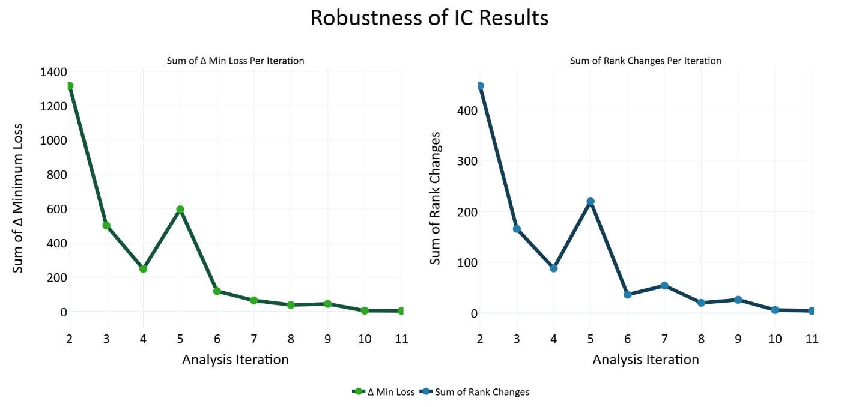
Figure 10: Robustness Analysis of Information Criterion (IC) Results:
The left panel illustrates the sum of Δ minimum loss (negative log-likelihood) discovered across iterations of model fitting, indicating incremental improvements in model fit. Iterations were stopped once the sum of incremental improvements approached minimal practical significance (indicating stability). The right panel shows the sum of ordinal rank changes (by Bayesian Information Criterion; BIC) between consecutive iterations, corroborating the stability suggested by the diminishing returns observed in the sum of Δ minimum loss metric.
  - Nested Models
Many of our utility functions are nested: a child model is a special case of a more flexible parent model, obtained by fixing one or more special parameters, such as setting added exponents to one. For example, Table 7 below presents a small family of nested models. Under identical parameter bounds, a correctly optimized parent must achieve a negative log‑likelihood (NLL) that is less than or equal to its child. Any case where a fitted parent’s best NLL is worse than its child’s is a nesting violation. Our goal is to prevent such violations that arise from optimization artifacts.
Table 7: Example nested family:
Each utility function is a parent of the model in the row below it. 𝑘 = number of free parameters. The special parameters column shows the values these parameters must be set to for the parent to function as the child model in the row below.
𝑘 | Utility Function | Special Parameters
4 | $$U_{i}\left(A\right)=V_{ii}{\left(π_{i}^{A}\right)}^{γ_{1}}+V_{ij}{\left(π_{j}^{A}\right)}^{γ_{2}}$$ | $$γ_{1}=γ_{2}$$
3 | $$U_{i}\left(A\right)=V_{ii}{\left(π_{i}^{A}\right)}^{γ}+V_{ij}{\left(π_{j}^{A}\right)}^{γ}$$ | $$γ=1$$
2 | $$U_{i}\left(A\right)=V_{ii}\left(π_{i}^{A}\right)+V_{ij}\left(π_{j}^{A}\right)$$ | $$V_{ij}=0$$
1 | $$U_{i}\left(A\right)=V_{ii}\left(π_{i}^{A}\right)$$ | $$V_{ii}=1$$
0 | $$U_{i}\left(A\right)=π_{i}^{A}$$

    - Nesting Network and Verification
We formalized a nesting network over all 476 models:
Parent-child relationship: A model is a parent of a child if (1) the parent contains all the parameter of the child, plus at least one additional parameter, (2) exactly one Boolean utility setting differs, and (3) at the child-anchor (the special parameter values), the parent and child produce identical utilities on all possible 625 (54) payoff structures in our dataset. We verified these criteria for all child-parent pairs.
Sibling relationship: Two models are siblings if they have the same number of free parameters and differ in exactly one Boolean utility setting (no strict nesting).
Table 8 below, shows the type of relationship produced between a pair of models when only one boolean utility setting differs between them.
Table 8: Boolean Utility Setting Flips and the Relationships They Produce.
Utility Setting Flip | Relationship
Place exponents on each term | child-parent
Use the same exponent for all terms | child-parent
Include negativity (loss aversion) parameters | child-parent
Include guilt in the social comparison term | child-parent
Fix self-interest parameter to one | child-parent
Include an altruism term | child-parent
Include a social comparison term | child-parent
Use single payoffs, not payoff differences | sibling-sibling
Compute payoff ratios, not payoff differences | sibling-sibling
Apply exponents directly to payoffs | sibling-sibling
Reference-dependent utility (𝑅=3) | sibling-sibling
Reference-dependent altruism | sibling-sibling
Conditional welfare form | None
Min-max Rawlsian-Leontief form | None

    - Parent-Fair L2 Regularization
Many of our models are quasi–scale‑invariant in their weights (e.g., 𝑉_{𝑖𝑖}, 𝑉_{𝑖𝑗},…): multiplying all social preference weights by a constant can leave choice predictions nearly unchanged for a fixed SoftMax temperature. This creates flat directions in the loss surface that can cause gradient‑based local optimizers (especially L‑BFGS‑B) to stop early or wander.
A small L2 penalty adds gentle curvature in these flat directions, stabilizing the search and making local refinement reliable. We keep the weight small. It is used only to help the optimizer, not to change which model wins.
A naïve L2 penalty can bias against parents (they have more free parameters), which could itself produce nesting violations. We therefore design the penalty to be parent‑fair: When a parent is set to the child‑anchor (i.e., the special parameters that collapse it to the child) and the shared parameters match, the parent and child incur the same penalty. So parents are penalized more only when they deviate away from the anchor that makes them behave like their children.
$$Loss=\sum{NLL}+\sum{λ}\left\{\begin{aligned}{\left(w_{+}\right)}^{2} \\ {\left(\frac{\left|w_{+}\right|+\left|w_{-}\right|}{2}\right)}^{2} \\ {\left(\frac{γ_{1}+γ_{2}+…+γ_{n}}{n}-1\right)}^{2}\end{aligned}\right.$$
where:
- λ is the penalty weight, typically 0.05,
- 𝑤₊ are social preference weights: μ(𝑉_{𝑖𝑗}) or μ(Ƹ_{𝑖𝑗}),
- 𝑤₊ are positivity weights, while 𝑤– are negativity weights: μ(Λ_{𝑖𝑖}), μ(Λ_{𝑖𝑗}), or μ(Ʒ_{𝑖𝑗}),
- γ are exponent parameters on one of the three social preference terms,
- Note: self-interest is penalized as ${\left(μ\left(V_{ii}\right)-1\right)}^{2}$.
Equation 1: Penalty Function:
We add a L2 penalty term to stabilize optimization. To not contribute to nesting violations, the penalty is identical for child and parent models if both models use identical parameters and the additional parent parameter(s) are set to the special points that make the parent behave like its child. The social preference weights for altruism and envy are only penalized when they are non-zero, while the self-interest weight is only penalized when it deviates from one. When positivity parameters are paired with negativity parameters: μ(𝑉_{𝑖𝑖}) with μ(Λ_{𝑖𝑖}), μ(𝑉_{𝑖𝑗}) with μ(Λ_{𝑖𝑗}), and μ(Ƹ_{𝑖𝑗}) with μ(Ʒ_{𝑖𝑗}), we penalize the mean of the absolute values of each pair because if a parent model differs from its child only by the exclusion versus inclusion of these negativity parameters, the child and parent are penalized the same when the positivity and negativity parameters are the same. Exponents are penalized as the mean of all exponents minus one because exponents set to one make the parent equivalent to a child without exponents.
    - Optimization Schedule
To avoid nesting violations, we first fit child models and pass their best fitting parameters to their parents as an initial point for optimization, called a warm start. This helps move the optimizer out of local minima in high-dimensional parent parameter spaces. However, warm starts can create path dependence, where a child stuck in a local minima could propagate this suboptimal initialization up the model hierarchy. To mitigate this problem, we fit the models iteratively, using the same iterations within the robustness analysis, where the system progresses from exploration to exploitation. The first four iterations, all models are optimized with simulated annealing, followed by L-BGFS-B, without the help of warm starts. In the next four iterations, children provide their best-fitting parameters to their parents as warm starts but the parents select the child to take the parameters from at random, meaning that parents do not always select their best-fitting child. In the final iterations, parents always exploit the best-fitting parameters of their best-fitting child model.
All model ranking (AIC/BIC) is computed from the best raw NLL attained by each model across all passes. The schedule above eliminated all but trivial (floating‑point) nesting violations in practice.
Overall, these analyses justify our selection of the optimal seven-parameter utility form as a model for observers' outcome-based social preferences. Having identified this optimal structure through our extensive IC analysis, we put it into the Utility Bayesian Model to investigate how participants updated beliefs and inferred social preferences in repeated encounters.
- Results: Joint Parameter Distributions in Human-Human Experiment
Having identified the optimal seven-parameter utility function from our Information Criterion (IC) analysis, we now report the resulting social preference parameters from the human-human experiment. This experiment allowed participants to alternate between chooser and predictor roles, providing data to distinguish between genuine social preferences (chooser parameters) and beliefs about others' social preferences (predictor parameters). Moreover, the use of randomized payoff structures facilitated robust analysis across a multidimensional preference space, enabling meaningful exploration of trade-offs between parameters like self-interest, altruism, envy, guilt, and nonlinear payoff sensitivity.
  - Population-Level Distributions of Social Preference Parameters
    - Self-Interest and Altruism
Participants predominantly exhibited positive self-interest and altruism parameters, with self-interest generally outweighing altruism. Population-level means and standard deviations of chooser parameters were: self-interest [μ(𝑉_{𝑖𝑖}) = 0.67841, σ(𝑉_{𝑖𝑖}) = 0.36920] and altruism [μ(𝑉_{𝑖𝑗}) = 0.04689, σ(𝑉_{𝑖𝑗}) = 0.26501]. Predictors' initial priors showed a similar but exaggerated pattern [μ(𝑉_{𝑖𝑖}) = 0.45530, σ(𝑉_{𝑖𝑖}) = 0.45071; μ(𝑉_{𝑖𝑗}) = 0.14819, σ(𝑉_{𝑖𝑗}) = 0.47929], reflecting participants' accurate belief that self-interest dominates altruism, though they slightly overestimated this dominance.
Additionally, 50.68% of choosers exhibited negative altruism parameters, indicating sadistic or spiteful preferences, and 10.96% of choosers exhibited negative self-interest parameters, indicating masochistic or self-sacrificing behaviors.
After excluding these sadistic and masochistic participants, we computed the ratios between their self-interest and altruism parameters (𝑉_{𝑖𝑖} / 𝑉_{𝑖𝑗}). The average ratio between self-interest and altruism was 8.974 [𝑉_{𝑖𝑖} / (𝑉_{𝑖𝑖} +𝑉_{𝑖𝑗}): mean = 0.755, SD = 0.154, 𝑛 = 30]. This result indicates that, on average, choosers weighted their own payoff roughly nine times more than their counterparts' payoffs.
    - Asymmetric Social Comparison: Envy Versus Guilt
At the population level, choosers’ guilt parameters were larger than their envy parameters ([μ(Ʒ_{𝑖𝑗}) = 0.25591, σ(Ʒ_{𝑖𝑗}) = 0.40912] vs. [μ(Ƹ_{𝑖𝑗}) = 0.01541, σ(Ƹ_{𝑖𝑗}) = 0.35149]), and 68.49% of choosers had Ʒ_{𝑖𝑗} > Ƹ_{𝑖𝑗}. Predictors’ priors were: ([μ(Ʒ_{𝑖𝑗}) = −0.03515, σ(Ʒ_{𝑖𝑗}) = 0.55385] vs. [μ(Ƹ_{𝑖𝑗}) = 0.20265, σ(Ƹ_{𝑖𝑗}) = 0.54697]; 42.47% with Ʒ_{𝑖𝑗} > Ƹ_{𝑖𝑗}).
Figure 11 shows how the distributions of these parameter ratios in the participant population.
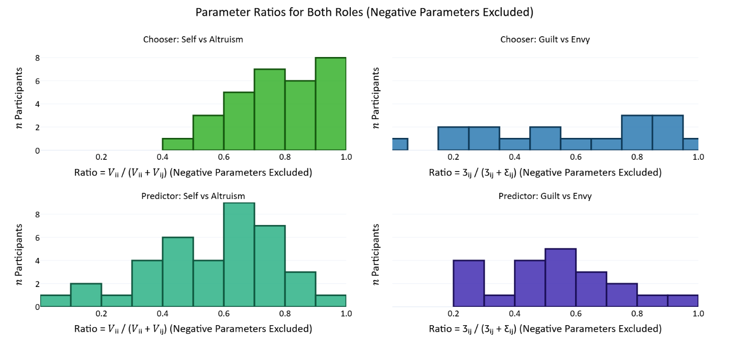
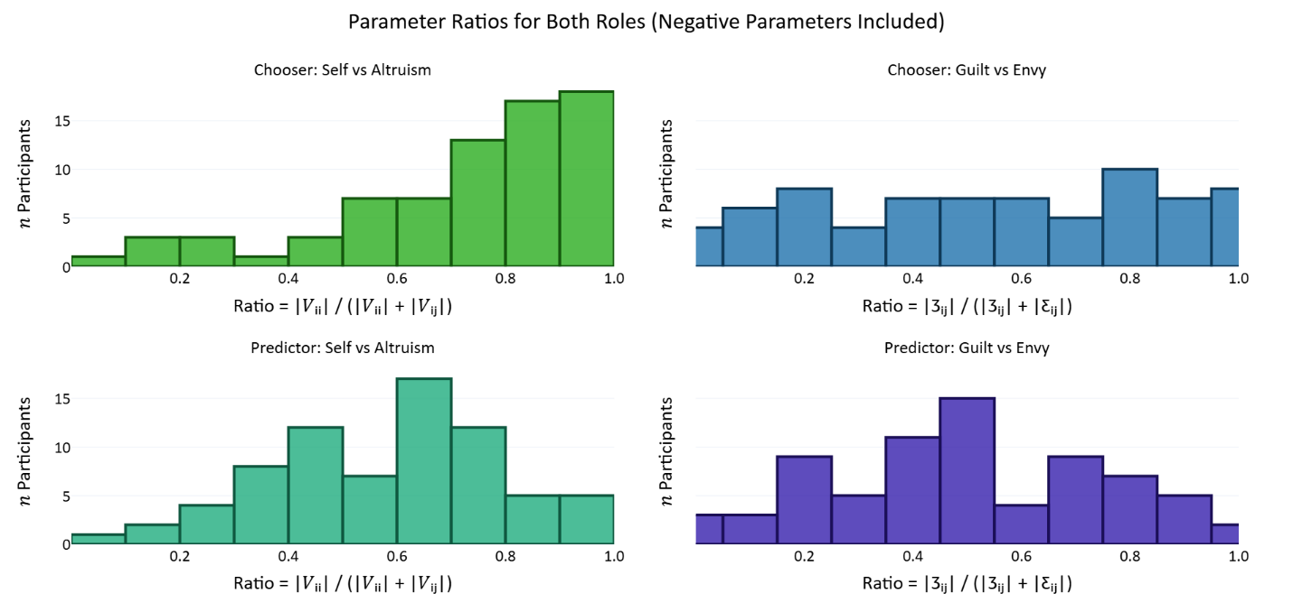
Figure 11: Histograms of Social Preference Parameter Ratios:
For each participant, we computed the ratios of some of their parameters and report the distribution of these ratios in the population. Histograms in the top panel report the distributions only of the subset of participants where both parameters in the ratio were positive (𝑛 participants ∈ [0, 9]), while histograms in the bottom panel report distributions of the ratios of the absolute values of parameters (𝑛 participants ∈ [0, 19]). Within each panel, the top histograms report chooser parameter ratios and the bottom histograms report predictor parameters. Also, the left histograms report ratios between self-interest and altruism, while the right histograms report ratios between guild and envy.
Panels (A) and (B) show distributions of chooser and predictor self-interest/altruism ratios, respectively; panels (C) and (D) display distributions of chooser and predictor envy/guilt ratios. Vertical dashed lines indicate mean ratios, emphasizing the asymmetrical prioritization of self-interest over altruism, and envy over guilt.
    - Nonlinear Payoff Sensitivity
With the seven-parameter model, exponent parameters differ by term. For choosers, μ(𝛾₁)= 0.82552 (σ(𝛾₁) = 0.72610) for self-interest, μ(𝛾₂)=1.33617 (σ(𝛾₂) = 0.67218) for altruism, and μ(𝛾₃)=1.37846 (σ(𝛾₃) = 0.69538). For predictor priors, μ(𝛾₁)= 1.08456 (σ(𝛾₁) = 0.056325) for self-interest, μ(𝛾₂)=0.85037 (σ(𝛾₂) = 0.48445) for altruism, and μ(𝛾₃)= 0.94475 (σ(𝛾₃) = 0.59211).
    - Clarification on Parameter Reporting
Individual-level mean parameters reflect each participant's central social preference tendencies, whereas individual-level standard deviation parameters (used only in predictors' priors) reflect uncertainty about others' preferences. Population-level statistics reported here include the mean and standard deviation across these individual-level mean parameters.
Additionally, choices were likely influenced by the expectation that players would be matched in subsequent rounds, depending on the round number and matching probabilities. Knowledge of these time horizons likely altered the calculation of social preferences. For instance, many choosers may have acted more cooperatively than if they expected to never meet their counterpart again, making these repeated games less of a pure index of altruism than one-shot dictator games.
Figure 12 and Table 9 summarize the distribution of individual-level mean parameters in the population.
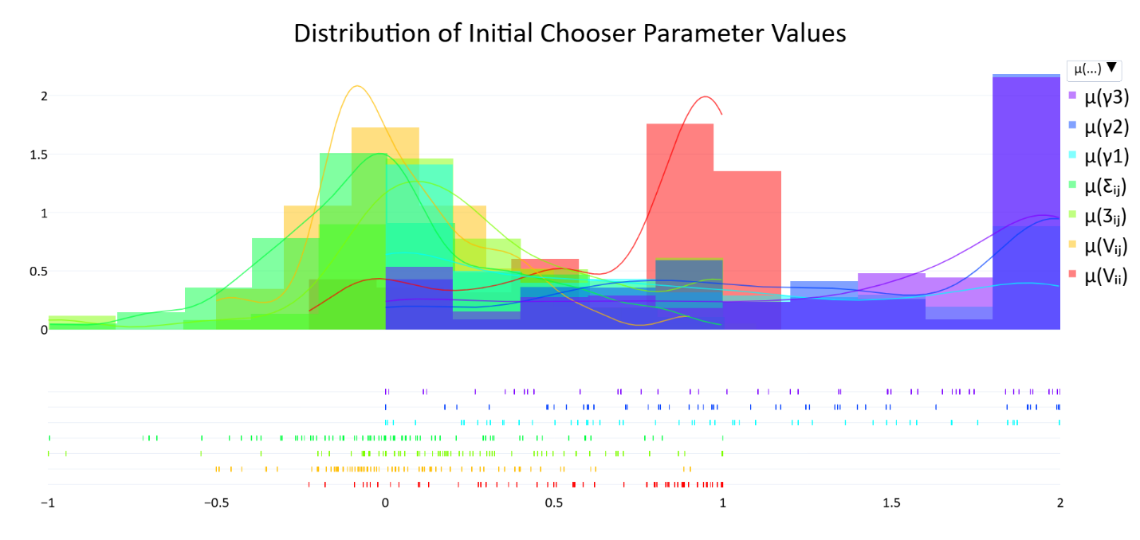
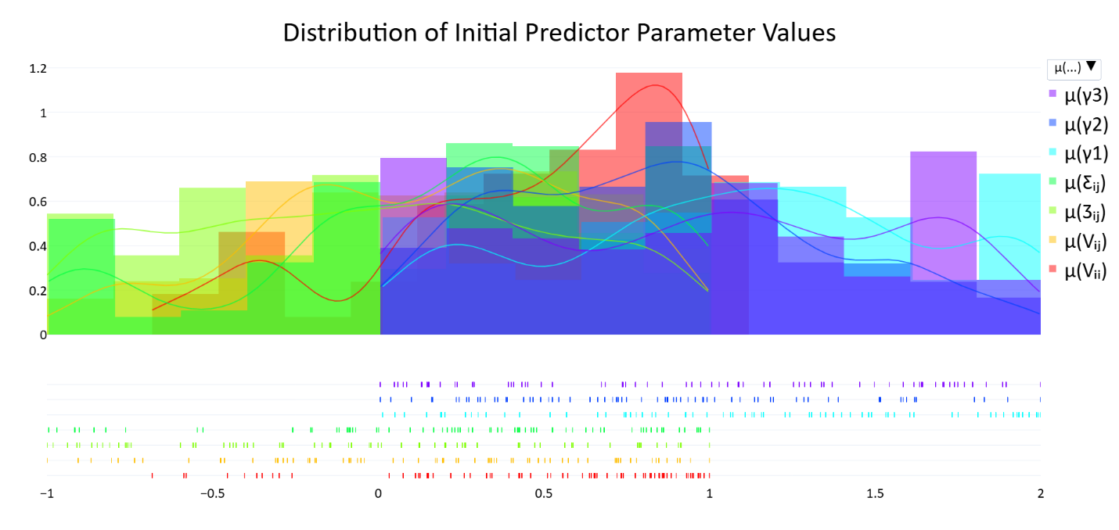
Figure 12: Population-level Distributions of Social Preference Parameters:
Panels display distributions for chooser and predictor parameters (self-interest [𝑉_{𝑖𝑖}], altruism [𝑉_{𝑖𝑗}], envy [Ƹ_{𝑖𝑗}], guilt [Ʒ_{𝑖𝑗}], exponents over the self-interest, altruism, and social comparison terms [𝛾₁, 𝛾₂, 𝛾₃]). Upper histograms show chooser parameters; lower histograms show initial predictor parameters (priors).

Table 9: Population-level averages of individual mean chooser and predictor social preference parameters.
Population Average Chooser and Predictor Parameter Values – Means and Standard Deviations
 | Chooser Parameters; 𝑛 = 73 |  | Predictor Parameters; 𝑛 = 73
Parameter | Mean | Std Dev | Mean | Std Dev
Self-interest 𝑉_{𝑖𝑖} | 0.67861 | 0.36920 | 0.45530 | 0.45017
Altruism 𝑉_{𝑖𝑗} | 0.04689 | 0.26501 | 0.14819 | 0.47929
Envy Ƹ_{𝑖𝑗} | 0.01541 | 0.35149 | 0.20265 | 0.54697
Guilt Ʒ_{𝑖𝑗} | 0.25591 | 0.40912 | −0.03515 | 0.55385
Exponent 𝛾₁ | 0.82552 | 0.72610 | 1.08456 | 0.56325
Exponent 𝛾₂ | 1.33617 | 0.67218 | 0.85037 | 0.48445
Exponent 𝛾₃ | 1.37846 | 0.69538 | 0.94475 | 0.59211
Temperature 𝜏 | 0.97034 | 0.71975 | 1.95989 | 0.62519

    - Correlations Among Social Preference Parameters
Chooser (within‑role). Several theoretically coherent relationships emerged (see Table 10). Self‑interest was strongly negatively associated with 𝛾₁ (𝑟 = −0.445, Holm‑corrected 𝑝_{h} = .0021), indicating that higher weighting of self‑interest co‑occurred with more concave scaling of one’s own payoff differences. Altruism positively correlated with envy (𝑟 = 0.457, 𝑝_{h} = .0013). Among the exponents, we observed negative associations between 𝛾₁–𝛾₃ (𝑟 = −0.409, 𝑝_{h} = .0081) and 𝛾₂–𝛾₃ (𝑟 = −0.475, 𝑝_{h} = .0006). The self-interest exponent 𝛾₁ was negatively correlated with temperature 𝜏 (𝑟 = −0.389, 𝑝_{h} = .0160). All other entries were non‑significant after Holm correction.
Predictor (within‑role). The only robust association after Holm correction was a negative correlation between the altruism exponent 𝛾₂ and temperature 𝜏 (𝑟 = −0.407, 𝑝_{h} = .0099).
Table 10: Pearson correlations coefficients among chooser parameters (upper table) and among predictor parameters (lower table), (𝑛 = 73).
Parameters were normalized so that their absolute values summed to 1 before computing the correlations. Note that these are within-role parameter correlations.
Chooser Parameter Correlations
 | μ(𝑉_{𝑖𝑖}) |  | μ(𝑉_{𝑖𝑗}) | μ(Ƹ_{𝑖𝑗}) | μ(Ʒ_{𝑖𝑗}) | μ(𝛾₁) | μ(𝛾₂) | μ(𝛾₃) | 𝜏
μ(𝑉_{𝑖𝑖})
μ(𝑉_{𝑖𝑗}) | 0.183
μ(Ƹ_{𝑖𝑗}) | 0.081 |  | 0.457**
μ(Ʒ_{𝑖𝑗}) | -0.069 |  | -0.183 | -0.262*
μ(𝛾₁) | -0.445** |  | 0.010 | 0.116 | 0.064
μ(𝛾₂) | 0.022 |  | -0.244* | -0.242* | 0.096 | -0.256*
μ(𝛾₃) | 0.256* |  | -0.050 | 0.050 | -0.246* | -0.409** | -0.479**
𝜏 | -0.135 |  | -0.093 | -0.091 | -0.188 | -0.389** | -0.177 | 0.039 | ---
Predictor Parameter Correlations
 | μ(𝑉_{𝑖𝑖}) |  | μ(𝑉_{𝑖𝑗}) | μ(Ƹ_{𝑖𝑗}) | μ(Ʒ_{𝑖𝑗}) | μ(𝛾₁) | μ(𝛾₂) | μ(𝛾₃) | 𝜏
μ(𝑉_{𝑖𝑖})
μ(𝑉_{𝑖𝑗}) | -0.049
μ(Ƹ_{𝑖𝑗}) | 0.037 |  | -0.115
μ(Ʒ_{𝑖𝑗}) | 0.028 |  | -0.190 | -0.052
μ(𝛾₁) | 0.090 |  | -0.077 | 0.036 | 0.224
μ(𝛾₂) | 0.011 |  | 0.108 | -0.110 | -0.250* | -0.066
μ(𝛾₃) | -0.087 |  | -0.006 | 0.168 | 0.153 | -0.225 | -0.333**
𝜏 | -0.232* |  | -0.077 | -0.057 | 0.156 | -0.334** | -0.407** | -0.055 | ---
*𝑝 < .05, **𝑝 < .01

    - Cross-Role Consistency in Preferences
Because participants alternated between chooser and predictor roles, we examined cross-role consistency to assess preference projection (see Table 11). Correlations were modest and non‑significant after Holm correction, suggesting little projection of preferences onto their counterparts.
Table 11: Cross-role Parameter Correlations.
Correlation between chooser and predictor parameters (𝑛 = 73), illustrating the degree of preference projection. The bottom row reports 𝑝 values.
Correlation Between Chooser and Predictor Parameters
 | μ(𝑉_{𝑖𝑖}) | μ(𝑉_{𝑖𝑗}) | μ(Ƹ_{𝑖𝑗}) | μ(Ʒ_{𝑖𝑗}) | μ(𝛾₁) | μ(𝛾₂) | μ(𝛾₃) | 𝜏
𝑟 | 0.062 | 0.032 | 0.081 | -0.070 | 0.204 | -0.029 | -0.043 | -0.092
𝑝 | 0.605 | 0.791 | 0.494 | 0.554 | 0.084 | 0.810 | 0.721 | 0.440

- Discussion and Conclusion
This research advances our understanding of human social preferences and belief updating dynamics by being the first to integrate four complementary methodological elements: (1) systematic exploration of a broad payoff space, (2) comprehensive testing of diverse utility functions, (3) elicitation of predictions from participants, and (4) continuous Bayesian modeling of belief updating. Each component is essential for the others, forming an interlocking framework necessary for accurately quantifying and modeling social preferences and belief updates. Specifically, exploring an extensive payoff space is required to discriminate between competing utility forms, identifying the optimal utility structure is necessary for accurate Bayesian inference, and eliciting predictions provides unambiguous data to validate the Bayesian model.
  - Scope and Historical Context
This paper focuses only on outcome-based social preferences—preferences about the distribution of payoffs between people, regardless of beliefs, intentions, reciprocity, social norms, self-/social-image, and other non-outcome-based concerns. The binary dictator games we used only involve a single choice made with perfect information, no chance events, and only two players. These games preclude preferences regarding risk and ambiguity, intentionality and accidents, reciprocity, larger groups, and also strategic reasoning. To clarify the meaning of outcome-based preferences, consider some alternatives. Guilt aversion has been defined as a belief-based preference, where an individual's guilt is driven by deviations between their actions and their beliefs about another person's expectations, multiplied by how much the individual cares about the other person (Charness & Dufwenberg, 2006; Battigalli & Dufwenberg, 2009; Battigalli & Dufwenberg, 2022). A husband’s guilt from divorcing his wife depends in part on how surprised and disappointed he expects her to be, not just their financial outcomes. Indeed, in our deterministic and transparent binary dictator games, every outcome is intentional and common knowledge. Thus, we cannot address psychological processes involving attributions of responsibility, intentionality, or moral judgment influenced by accidental versus intentional harm (Falk & Fischbacher, 2006; Cushman, Young, & Hauser, 2006; Young & Saxe, 2009). Likewise, our design does not vary self- or social-image concerns, since the games provided no mechanisms for participants to manage their own self-perception or to control how visible their choices were to third-party observers (Dana, Weber, & Kuang, 2007; Andreoni & Bernheim, 2009).
Regarding reciprocity, preferences for punishment and reward inherently depend on sequences of actions across multiple interactions or multi-step games. Our single-step games preclude reciprocity preferences within each round. However, because players repeatedly encounter the same counterparts across rounds, we acknowledge that reciprocity preferences were probably activated across games (Rand & Nowak, 2013; Falk & Fischbacher, 2006). Although analyzing reciprocity preferences across rounds would be a promising avenue for future research, it is beyond the scope of the current analysis.
Historically, modeling outcome-based preferences converged around canonical utility forms primarily developed between 1992 and 2004: Rabin’s fairness equilibrium (1992), Fehr-Schmidt’s inequity aversion (1999), Bolton-Ockenfels’ ERC model (2000), Andreoni-Miller’s CES warm-glow altruism (2002), Charness and Rabin’s social welfare model (2002), and Engelmann-Strobel’s maximin-efficiency model (2004). Subsequently, innovation largely shifted toward incorporating reciprocity, responsibility, self-image, belief-based and other types of non-outcome-based preferences rather than refining these foundational outcome-based kernels (Capraro, Halpern, & Perc, 2024; Fehr & Charness, 2025). Recent empirical approaches continue to rely on these canonical frameworks or simpler two-dimensional schemes (Kerschbamer, 2015; Nunnari & Pozzi, 2022; Liu & Lange, 2023; Mizuno & Shimizu, 2024; Bakker & Dijkstra, 2021)11F.
  - Limits of Low-Dimensional Utility Models and the Costs of Simplification
Two-dimensional parameterizations of social preferences, originating from Messick and McClintock’s seminal Social Value Orientation model (1968), remain highly influential in the literature. Indeed, traditional Social Value Orientation (SVO) can be conceptualized as a two-dimensional parameter space, with individual preferences represented by vectors whose magnitude indicates consistency (versus stochasticity), and whose direction indicates one’s willingness to sacrifice one’s own interests for the interests of someone else (Murphy, Ackermann, & Handgraaf, 2011). Many contemporary researchers still rely upon or extend these simplified linear utility forms, such as $U_{i}\left(A\right)=π_{i}^{A}+V_{ij}\left(π_{j}^{A}\right)$​ (Wang, et al., 2025).
However, a linear utility function that already includes terms for self-interest and altruism cannot meaningfully incorporate an additional single social comparison term without redundancy. This is because a linear model of two payoffs can support at most two independent preference dimensions12F.
Although two-dimensional schemes are convenient, they are too coarse to separate, self-interest, altruism, the two directions of social comparison, or marginal changes to payoff sizes or differences. Our information criterion analysis favors a seven-parameter utility function, even after penalizing models for the number of parameters. The second-best model trails by roughly 17 BIC points, surpassing the typical threshold of ΔBIC > 10 considered decisive for model comparison (Schwarz, 1978; Anderson & Burnham, 2002). Yet, Figure 9 reveals a roughly constant increase ΔBIC values between a given model and the next best model, rather than a large gap between a set of competitive models and all the rest. Thus, it may be tempting to drop parameters to reduce the winning model to a simpler child model. However, Table 12 shows the costs of doing so. Removing the altruism term incurs a large cost to model fit, prevents sadism from being detected, and conflates altruism with social comparison. Dropping guilt makes it impossible to distinguish reactions to advantageous versus disadvantageous inequality. Fixing self-interest to one, precludes detecting masochism. While forcing all the exponents into one parameter (γ₁ = γ₂ = γ₃) loses specificity and fit, some modelers may consider this an acceptable tradeoff for a more parsimonious five-parameter model.
Table 12: Costs of simplifying the winning seven-parameter model:
The seven-parameter BIC-minimizing model has four child models. This table shows the costs of reducing the winning model to these children in added BIC and theoretically.
Simplification | +ΔBIC | Theoretical Cost
Remove altruism | ~442 | Conflates altruism with social comparison
Symmetrize social comparison | ~233 | Conflates envy and guilt
Force a single exponent | ~193 | Loses specificity
Fix self-interest to one | ~135 | Precludes masochism

The following are reasons that at least five parameters are indispensable:
- Payoff Sensitivity (γ): Although marginal utility and risk attitudes have traditionally been modeled in solitary tasks, individual-level preferences remain operative in social contexts. Social decisions do not suspend solitary economic dynamics, they subsume them.
- Self-interest and altruism: While many traditional utility functions exclude self-interest, assuming it to be a constant of one, including parameters for self-interest and altruism is the only way to identify masochistic and sadistic preferences, which our results demonstrate to be substantial.
- Envy and guilt (social comparison): Inequality aversion is asymmetric; individuals typically exhibit stronger aversion to either disadvantageous inequality (envy) or advantageous inequality (guilt) (Fehr & Schmidt, 1999; Kerschbamer, 2015; Nunnari & Pozzi, 2022; Capraro, Halpern, & Perc, 2024). Combining envy and guilt obscures this reality.
- Psychological Validity: Each parameter corresponds to a conceptually distinct psychological phenomena. For instance, dropping altruism would force us to label anyone who enjoys hurting others as merely "extremely competitive," while dropping social comparison would force us to label anyone who enjoys being superior to others as being "sadistic."13F
In sum, any utility function for outcome-based preferences that omits self-interest, altruism, envy, guilt, and nonlinear payoff sensitivity risks inaccuracy and conceptual confusion. Lower-dimensional models may be expedient and useful when the penalty for model complexity is very high, such as in the human-bot experiment where higher-dimensional payoff exploration was infeasible, these models will nonetheless be an insufficient description of social decision making.
  - Implications of Higher-Dimensional Parameter Estimation
Because our utility function unites these seven preference parameters, we can directly quantify the relative magnitudes of these parameters within and between individuals, something that lower-dimensional frameworks cannot achieve within a single study. Without this unified approach, aggregating results across studies employing simpler models becomes analogous to solving a puzzle from mismatched pieces. While we attempt to compare our parameter distribution results to the results of other studies, we acknowledge that these comparisons tend to be ambiguous because conflating parameter dimensions, especially altruism and social comparison, is so prevalent in the literature.
  - Contributions of Parameter Distributions
We measured the distribution of seven social preference parameters and obtained four notable results: (1) self-interest is roughly seven times stronger than altruism, though altruism remains positive across most individuals; (2) guilt outweighs envy, reaffirming the asymmetry in inequality aversion but in the opposite direction; (3) nonlinear payoff sensitivity was term-specific—self-payoffs were near-linear/slightly concave (γ₁≈0.83), whereas altruism and social-comparison components were super-linear (γ₂≈1.34; γ₃≈1.38), contradicting the typical finding of diminishing marginal utility; and (4) minority negative-preference types (sadism, competitiveness, masochism) occur at substantially higher frequencies than previously recognized.
Participants valued their own payoffs about eight times more strongly than their counterparts', broadly consistent with positive altruism (Falk, et al., 2018) and typical dictator-game allocations averaging approximately 20% of the endowment given away (Engel, 2011). However, this similarity is only approximate, as standard dictator-game giving does not represent a pure measure of altruism. Indeed, linear utility functions such as those discussed in Section 3.2 typically predict extreme allocations—keeping or giving away the entire allotment—unless modified with exponents or inequality aversion parameters (Fehr & Schmidt, 1999; Andreoni & Miller, 2002)14F. In contrast, our method using binary dictator games with varied payoff structures allows us to isolate altruism from social comparison and avoids reliance on these exponents15F or inequality aversion assumptions. Although estimating parameters via binary dictator games requires multiple trials rather than just one standard dictator game, we believe the interpretability and conceptual clarity gained through this method outweigh this logistical cost.
Our finding that aversion to advantageous inequality (“guilt”) exceeded aversion to disadvantageous inequality (“envy”) contrasts with much of the inequality-aversion literature (Fehr & Schmidt, 1999; Loewenstein, Thompson, & Bazerman, 1989; Nunnari & Pozzi, 2022). However, several features of prior experimental designs help explain this discrepancy. Many earlier studies estimated inequality parameters using either constant-sum payoff structures, which make it difficult to distinguish self-interest and altruism from social comparison, or multi-stage strategic games, where strategic reasoning, threats, or reciprocity can masquerade as inequality aversion. In addition, simpler utility forms—often lacking explicit altruism terms or separate parameters for self-interest—force multiple motives to load onto a single inequality term, typically inflating Ƹ_{𝑖𝑗}. Finally, many studies imposed estimation constraints such as Ƹ_{𝑖𝑗} ≥ Ʒ_{𝑖𝑗} or Ʒ_{𝑖𝑗} ≥ 0, effectively preventing guilt-like preferences from emerging even when present in the data. In contrast, our randomized binary dictator design separates self-interest, altruism, disadvantageous inequality, and advantageous inequality, and spans a wide payoff space that allows each of these motives to be identified.
To independently verify that the Ʒ_{𝑖𝑗} > Ƹ_{𝑖𝑗} pattern was not an artifact of our Bayesian fitting pipeline, we conducted a simple model comparison test in which two inequality-aversion agents—one with Ƹ_{𝑖𝑗} > Ʒ_{𝑖𝑗} (“envious”) and one with Ʒ_{𝑖𝑗} > Ƹ_{𝑖𝑗} (“guilt-weighted”)—were evaluated against human choices across a grid of self-interest (V_{𝑖𝑖}) and altruism (V_{𝑖𝑗}) values. As shown in Figure 13, the guilt-weighted agent provided the better fit when self-interest was high and altruism was low (the region matching our participant population), whereas the envious agent dominated only when self-interest was low and altruism was high. This pattern indicates that the relative influence of disadvantageous and advantageous inequality depends critically on the balance between self- and other-directed motives: when V_{𝑖𝑖} is large, Ƹ_{𝑖𝑗} contributes little additional explanatory value, and the motivational role otherwise associated with unconditional altruism is captured instead by Ʒ_{𝑖𝑗}. Although Fehr-Schmidt termed this parameter “guilt,” our data suggest it more closely reflects a form of conditional altruism or compassionate inequality aversion—people mainly care about securing their own payoff and secondarily care about raising others up to their level, but not beyond it. An important direction for future work is to validate this construct directly—identifying the emotions, motives, and physiological responses that map onto Ʒ_{𝑖𝑗}—to clarify how it relates to guilt, empathy, prosocial concern, and fairness motives.
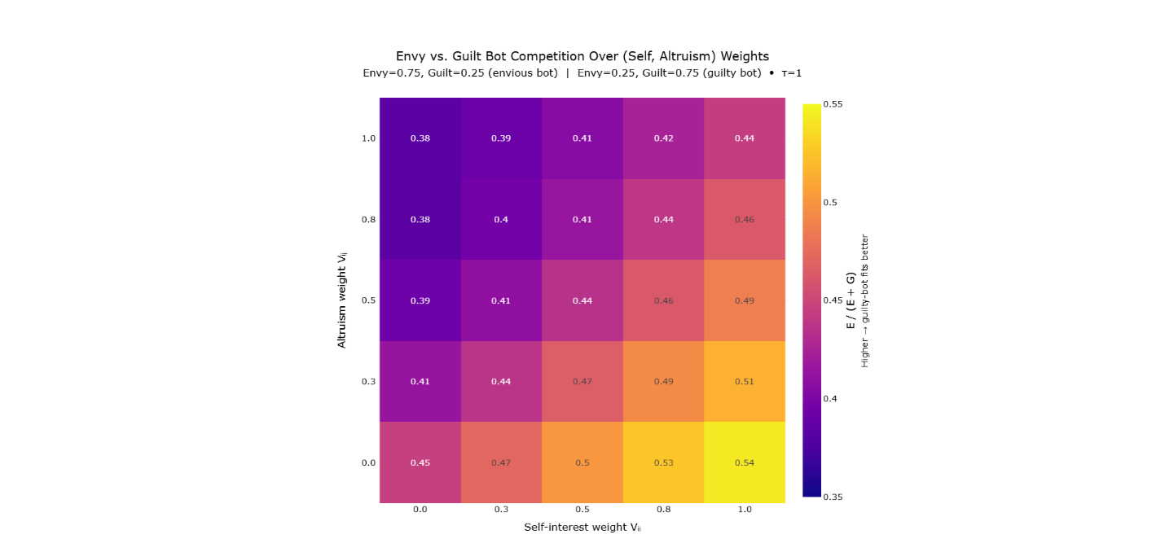
Figure 13: Model Comparison Between Envious (Ƹ_{𝑖𝑗} > Ʒ_{𝑖𝑗}) and Guilt-Weighted (Ʒ_{𝑖𝑗} > Ƹ_{𝑖𝑗}) Agents Across Self-Interest and Altruism:
Cells show the proportion of loss (NLL) attributable to the guilt-weighted agent relative to the total error from both agents (values > 0.5 indicate better performance by the guilt-weighted agent). The guilt-weighted agent fits human behavior more closely when self-interest (V_{𝑖𝑖}) is high and altruism (V_{𝑖𝑗}) is low—the region where most participants’ fitted parameters lie. The envious agent dominates only when V_{𝑖𝑖} is low and V_{𝑖𝑗} is high. This demonstrates that the apparent strength of disadvantageous versus advantageous inequality aversion depends on how attention is allocated across motivational systems: increases in self-interest suppress the behavioral influence of envy (many envy-active contrasts are already explained by V_{𝑖𝑖} alone), whereas increases in altruism suppress the behavioral influence of guilt (concern for the other’s absolute payoff reduces the added need to curb advantageous inequality).
A particularly surprising result is the convex marginal utility (γ > 1) on the altruism and social comparison terms. This finding indicates increasingly intense utility responses as payoffs grow, contradicting traditional assumptions of diminishing marginal utility and concave risk preferences (Kahneman & Tversky, 1979; Andreoni & Miller, 2002; Gossen, 1854; Marshall, 1920). Our result highlights an open question that future research can address.
Our method identified minority negative-preference types—sadistic (negative altruism), competitive (negative guilt), and masochistic (negative self-interest)—at considerably higher rates than previous studies. Negative altruism (sadism) and negative inequality aversion parameters have occasionally been observed before (Abbink & Sadrieh, 2009; Herrmann & Orzen, 2008; Nunnari & Pozzi, 2022), but our data show these preferences to be more prevalent. We acknowledge that these figures may partially reflect strategic punishment, as participants anticipated repeated interactions with the same counterparts.
Our study provided empirical benchmarks for several critical dimensions of human social cognition. We found that participants consistently exhibited dominant self-interest parameters alongside positive, though smaller, altruistic tendencies. This result aligns with and extends previous research (Andreoni & Miller, 2002; Charles & Rabin, 2002; Camerer C. F., 2003), indicating that while humans predominantly prioritize their own interests, genuine concern for others is reliably present across the population.
Additionally, our modeling identified instances of negative altruism (spitefulness) and negative self-interest (masochism). These profiles underscore the importance of nuanced modeling, challenging simpler discrete classifications and revealing the complex range of human motivations (Abbink & Sadrieh, 2009; Herrmann & Orzen, 2008).
Correlations between chooser and predictor parameters were weak and insignificant, which does not support the consensus effect hypothesis (Ross, Greene, & House, 1977; Engelmann & Strobel, 2004), where people tend to project their moral preferences onto others, expecting others to behave like themselves.
There is a critical yet often overlooked theoretical necessity to simultaneously incorporate both altruism and social comparison parameters within a unified utility model. Standard Social Value Orientation (SVO) models (Messick & McClintock, 1968; Van Lange, 1999; Murphy, Ackermann, & Handgraaf, 2011) have traditionally characterized preferences in terms of self-versus other-interest, providing valuable insights into human social decision-making. However, this two-dimensional perspective implicitly treats altruism and competitiveness as opposing ends of a single continuum, conflating conceptually distinct motivations: genuine concern for another’s well-being (altruism) and concern with relative payoffs (social comparison). Our empirical findings reveal substantial individual variation along both altruism and social comparison dimensions independently, suggesting the importance of expanding the dimensionality of utility spaces beyond traditional SVO frameworks.
  - Validation of the Continuous Bayesian Model
Our Bayesian modeling approach demonstrated superior predictive accuracy and cognitive plausibility compared to discrete Bayesian and non-Bayesian alternatives (Gershman, Daw, Rabinovich, Friston, & Varona, 2012; Griffiths, Kemp, & Tenenbaum, 2008). We conducted an unprecedently large-scale comparison, evaluating thousands of discrete typological models against a high-resolution Bayesian model (UBM), showing the UBM to fit the data better than all the typological models. Information Criterion analysis identified the optimal utility functional form, emphasizing the importance of nuanced parameterization for modeling realistic human moral cognition (Akaike, 1973; Schwarz, 1978).
Belief stabilization analyses provided further validation, showing the model’s sensitivity to subtle behavioral cues. Rapid convergence, particularly for parameters aligned with participants' priors, demonstrates the cognitive efficiency and ecological validity of Bayesian inference in human social cognition.
  - Broader Scientific and Philosophical Relevance
This research provides precise empirical measures of fundamental social preferences—selfishness, altruism, and responses to inequality—addressing questions central to moral psychology and philosophy. Knowing exact numerical values for these parameters offers insight into long-standing debates about human nature, such as the extent of inherent altruism versus self-interest and how individuals emotionally react to fairness and inequality. Thus, these findings meaningfully inform broader inquiries into the human condition without overstating their implications.
The identification of consistent altruistic tendencies alongside dominant self-interest also offers cautious optimism about cooperative social interactions. Further, this nuanced understanding of human morality has implications for AI alignment, suggesting that AI systems trained on human interaction data may incorporate foundational cooperative tendencies (Russell, 2019; Dafoe, et al., 2020). However, this optimism must be tempered by recognizing complex factors influencing AI development, including the intentions of AI creators and the dynamic evolution of AI values.
  - Limitations and Future Directions
We acknowledge several methodological limitations. Our primarily unpaid, WEIRD participant sample limits generalizability (Henrich, Heine, & Norenzayan, 2010). Additionally, the exclusion of negative payoffs restricted our ability to fully examine negativity parameters relevant to loss aversion (Kahneman & Tversky, 1979). Our assumption of static social preferences is another simplification, as real-world preferences likely evolve dynamically through reciprocal interactions.
Moreover, our binary dictator games involve only deterministic, two-player, single-choice allocations without negative payoffs. Consequently, we could not explore critical outcome-based preferences including multi-recipient fairness tradeoffs, third-party inequality aversion, or genuine reference-dependent loss aversion. Our use of an artificial reference point at the midpoint (R=3) was practical but fundamentally different from a true loss framing around zero or dynamically evolving reference points. The failure of negativity and reference-dependent parameters in our models thus should be interpreted with caution.
Additionally, our analysis focused exclusively on abstract payoffs (human-bot experiment) or payoffs framed as though they are monetary payoffs. Real-world social preferences may extend beyond monetary outcomes to domains such as health, time, pain, or other intangible outcomes. This work could be extended to see if and how social preferences differ over these non-monetary "currencies".
Future research directions should address these limitations by:
- Conducting experiments with paid16F, non-WEIRD populations to enhance generalizability.
- Introducing temporal discounting, giving greater weight to recent interactions to capture recency effects.
- Incorporating inductive biases, particularly negativity biases, reflecting realistic cognitive heuristics.
- Modeling dynamic parameters and reciprocal updating to examine how individuals' beliefs about others influence their own preferences, facilitating reciprocal altruism.
- Generalizing the model to multi-step, multi-option, and multi-player strategic environments, thereby incorporating non-outcome-based preferences like reciprocity, norms, and intentions (Fudenberg & Levine, 1998; Camerer C. F., 2003; Falk & Fischbacher, 2006; Rand & Nowak, 2013; Charles & Rabin, 2002).
- Include negative payoffs.
  - Conclusion
Ultimately, this study significantly advances our understanding of human social preferences and belief updating dynamics through an integrated methodological framework. The empirical benchmarks established here provide valuable insights into fundamental human motivations and reactions to social outcomes, enriching our understanding of moral psychology and offering practical parameters for future modeling efforts.
These insights set a foundation for future research to explore more dynamic, context-sensitive models, facilitating deeper theoretical understanding and practical applications across psychology, economics, and AI-human interactions. By addressing identified limitations and pursuing the outlined future directions, researchers can further refine our understanding of human social cognition, ultimately supporting more cooperative and beneficial societal and technological outcomes.

References
Abbink, K., & Sadrieh, A. (2009). The pleasure of being nasty. Economics letters, 105(3), 306-308.
Akaike, H. (1973). Maximum likelihood identification of Gaussian autoregressive moving average models. Biometrika, 60(2), 255-265.
Aksoy, O., & Weesie, J. (2014). Hierarchical Bayesian analysis of outcome-and process-based social preferences and beliefs in Dictator Games and sequential Prisoner’s Dilemmas. Social Science Research, 45, 98-116.
Anderson, D. R., & Burnham, K. P. (2002). Avoiding pitfalls when using information-theoretic methods. The Journal of wildlife management, 912-918.
Andreoni, J., & Bernheim, B. D. (2009). Social image and the 50–50 norm: A theoretical and experimental analysis of audience effects. Econometrica, 77(5), 1607-1636.
Andreoni, J., & Miller, J. (2002). Giving According to GARP; An Experimental Test of the Consistency of Preferences in Altruism. Econometrica, 70(2), 737-753.
Bakker, D. M., & Dijkstra, J. (2021). Comparing the slider measure of social value orientation with its main alternatives. Social Psychology Quarterly, 84(3), 235-245.
Balliet, D., Parks, C., & Joireman, J. (2009). Social value orientation and cooperation in social dilemmas: A meta-analysis. Group Processes & Intergroup Relations, 12(4), 533-547.
Battigalli, P., & Dufwenberg, M. (2009). Dynamic psychological games. Journal of Economic Theory, 144(1), 1-35.
Battigalli, P., & Dufwenberg, M. (2022). Belief-dependent motivations and psychological game theory. Journal of Economic Literature, 60(3), 833-882.
Bolton, G. E., & Ockenfels, A. (2000). ERC: A Theory of Equity, Reciprocity, and Competition. American Economic Review, 90(1), 166–193.
Byrd, R. H., Lu, P., Nocedal, J., & Zhu, C. (1995). A limited memory algorithm for bound constrained optimization. SIAM Journal on scientific computing, 6(5), 1190-1208.
Camerer, C. F. (2003). Behavioral Game Theory: Experiments in Strategic Interaction. Princeton: Princeton University Press.
Camerer, C. F., Ho, T.-H., & Chong, J.-K. (2004). A Cognitive Hierarchy Model of Games. The Quarterly Journal of Economics, 861-898.
Camerer, C., & Ho, T. H. (1999). Experience-weighted attraction learning in normal form games. Econometrica, 67(4), 827-874.
Capraro, V., Halpern, J. Y., & Perc, M. (2024). From outcome-based to language-based preferences. Journal of Economic Literature, 62(1), 115-154.
Charles, G., & Rabin, M. (2002). Understanding social preferences with simple tests. The Quarterly Journal of Economics, 117(3), 817-869.
Charness, G., & Dufwenberg, M. (2006). Promises and partnership. Econometrica, 74(6), 1579-1601.
Cosmides, L., Barrett, H. C., & Tooby, J. (2010). Adaptive specializations, social exchange, and the evolution of human intelligence. Proceedings of the National Academy of Sciences, 107(supplement_2), 9007-9014.
Cox, J. C., Friedman, D., & Gjerstad, S. (2007). A tractable model of reciprocity and fairness. Games and Economic Behavior, 59(1), 17-45.
Cushman, F., Young, L., & Hauser, M. (2006). The role of conscious reasoning and intuition in moral judgment: Testing three principles of harm. Psychological science, 17(12), 1082-1089.
Dafoe, A., Hughes, E., Bachrach, Y., Collins, T., McKee, K. R., Leibo, J. Z., & Graepel, T. (2020). Open problems in cooperative AI. arXiv preprint, arXiv:2012.08630.
Dana, J., Weber, R. A., & Kuang, J. X. (2007). Exploiting moral wiggle room: Experiments deomonstrating an illusory preference for fairness. Economic Theory, 33, 67-80.
David A. Pizarro, E. U. (2003). Causal deviance and the attribution of moral responsibility. Journal of Experimental Social Psychology, 1-8.
Devaine, M., Hollard, G., & Daunizeau, J. (2014). The Social Bayesian Brain: Does Mentalizing Make a Difference When We Learn? PLoS Computational Biology, 10(12), e1003992.
Engel, C. (2011). Dictator Games: A Meta Study. Experimental Economics, 583–610.
Engelmann, D., & Strobel, M. (2004). Inequality aversion, efficiency, and maximin preferences in simple distribution experiments. American economic review, 94(4), 857-869.
Erev, I., & Roth, A. E. (1998). Predicting how people play games: Reinforcement learning in experimental games with unique, mixed strategy equilibria. American economic review, 848-881.
Falk, A., & Fischbacher, U. (2006). A theory of reciprocity. Games and economic behavior, 54(2), 293-315.
Falk, A., Becker, A., Dohmen, T., Enke, B., Huffman, D., & Sunde, U. (2018). Global evidence on economic preferences. The quarterly journal of economics, 133(4), 1645-1692.
Fehr, E., & Charness, G. (2025). Social preferences: Fundamental characteristics and economic consequences. Journal of Economic Literature, 63(2), 440–514.
Fehr, E., & Schmidt, K. M. (1999). A Theory of Fairness, Competition, and Cooperation. Quarterly Journal of Economics, 114(3), 817-868.
Fischbacher, U., & Gächter, S. (2010). Social preferences, beliefs, and the dynamics of free riding in public goods experiments. American economic review, 100(1), 541-556.
Fisman, R., Kariv, S., & Markovits, D. (2007). Individual preferences for giving. American Economic, 97(5), 1858-1876.
Fudenberg, D., & Levine, D. K. (1998). The theory of learning in games (Vol. 2). Cambrige, MA: MIT press.
Fudenberg, D., & Levine, D. K. (2009). Learning and equilibrium. Annu. Rev. Econ, 1(1), 385-420.
Gelman, A., Carlin, J. B., Stern, H. S., Dunson, D. B., Vehtari, A., & Rubin, D. B. (2003). Bayesian Data Analysis. New York, NY: Chapman & Hall.
Gershman, S. J., Daw, N. D., Rabinovich, M. I., Friston, K. J., & Varona, P. (2012). Perception, action and utility: The tangled skein. Principles of brain dynamics: Global state interactions, 293-312.
Gossen, H. H. (1854). The Laws of Human Relations and the Rules of Human Action Derived Therefrom. Verlag von R. L. Prager.
Griffiths, T. L., Kemp, C., & Tenenbaum, J. B. (2008). Bayesian Models of Cognition. In S. R., The Cambridge Handbook of Computational Psychology (pp. 59-100). Cambridge, MA: Cambridge University Press.
Hampton, A. N., Bossaerts, P., & O’Doherty, J. P. (2008). Neural correlates of mentalizing-related computations during strategic interactions in humans. Proceedings of the National Academy of Sciences, 105(18), 6741–6746.
Henrich, J., Heine, S. J., & Norenzayan, A. (2010). The weirdest people in the world? . Behavioral and brain sciences, 33(2-3), 61-83.
Herrmann, B., & Orzen, H. (2008). The appearance of homo rivalis: Social preferences and the nature of rent seeking. CeDEx discussion paper series, 1-44.
Hill, S. A., & Neilson, W. (2007). Inequality aversion and diminishing sensitivity. Journal of Economic Psychology, 28(2), 143-153.
Iriberri, N., & Rey-Biel, P. (2013). Elicited beliefs and social information in modified dictator games: What do dictators believe other dictators do? Quantitative Economics, 4(3), 515-547.
Jern, A., Lucas, C. G., & Kemp, C. (2017). People learn other people’s preferences through inverse decision-making. Cognition, 168, 46-64.
Kahneman, D., & Tversky, A. (1979). Prospect theory: An analysis of decision under risk. Econometrica, 47(2), 263-292.
Kerschbamer, R. (2015). The geometry of distributional preferences and a non-parametric identification approach: The Equality Equivalence Test. European economic review, 76, 85-103.
Kerschbamer, R. (2015). The geometry of distributional preferences and a non-parametric identification approach: The Equality Equivalence Test. European economic review, 76, 85-103.
Kirkpatrick, S., Gelatt Jr, C. D., & Vecchi, M. P. (1983). Optimization by simulated annealing. Science, 220(4598), 671-680.
Krupp, D. B., Debruine, L. M., & Barclay, P. (2008). A cue of kinship promotes cooperation for the public good. Evolution and Human Behavior, 29(1), 49-55.
Lee, M. D., & Wagenmakers, E.-J. (2014). Bayesian cognitive modeling: A practical course. Cambridge, England: Cambridge University Press.
Leontief, W. W. (1941). The Structure of American Economy, 1919–1929: An Empirical Application of Equilibrium Analysis. Harvard University Press.
Liu, Y. B., & Lange, P. A. (2023). The development of social value orientation: Attachment styles, number of siblings, age, and a comparison of measures. European Journal of Personality, 37(4), 402-417.
Loewenstein, G. F., Thompson, L., & Bazerman, M. H. (1989). Social utility and decision making in interpersonal contexts. Journal of Personality and Social psychology, 57(3), 426.
Luce, R. D. (1959). Individual Choice Behavior: A Theoretical Analysis. Mlneola, New York: Dover Publications, Inc.
Marr, D. (1982). Vision: A computational investigation into the human representation and processing of visual information.
Marshall, A. (1920). Principles of Economics (8th ed.). Macmillan and Co.
McFadden, D. (1974). Conditional Logit Analysis of Qualitative Choice Behavior. Frontiers in Econometrics, 105–142.
Messick, D. M., & McClintock, C. G. (1968). Motivational bases of choice in experimental games. Journal of experimental social psychology, 4(1), 1-25.
Mizuno, K., & Shimizu, H. (2024). Measuring social value orientation by model-based scoring. Behaviormetrika, 51(1), 211-236.
Murphy, R. O., & Ackermann, K. A. (2014). Social value orientation: Theoretical and measurement issues in the study of social preferences. Personality and Social Psychology Review, 18(1), 13-41.
Murphy, R. O., Ackermann, K. A., & Handgraaf, M. J. (2011). Measuring Social Value Orientation. Judgment and Decision Making, 6(8), 771-781.
Nagel, R. (1995). Unraveling in Guessing Games: An Experimental Study. The American Economic Review, 85(5), 1313-1326.
Nunnari, S., & Pozzi, M. (2022). Meta-analysis of inequality aversion estimates (No. 9851). CESifo Working Paper.
Ottone, S., & Ponzano, F. (2005). An extension to the model of inequity aversion by Fehr and Schmidt. POLIS department's Working Papers, 51.
Rabin, M. (1992). Incorporating fairness into game theory and economics. University of California at Berkeley, Department of Economics, 1281-1302.
Rand, D. G., & Nowak, M. A. (2013). Human cooperation. Trends in cognitive sciences, 17(8), 413-425.
Rawls, J. (1971). An egalitarian theory of justice. Philosophical Ethics: An Introduction to Moral Philosophy, 365-370.
Ross, L., Greene, D., & House, P. (1977). The “false consensus effect”: An egocentric bias in social perception and attribution processes. Journal of experimental social psychology, 13(3), 279-301.
Russell, S. J. (2019). Human Compatible: Artificial Intelligence and the Problem of Control. United States: Viking.
Schwarz, G. (1978). Estimating the dimension of a model. The annals of statistics, 461-464.
Stahl, D. O., & Wilson, P. W. (1995). On players′ models of other players: Theory and experimental evidence. Games and Economic Behavior, 10(1), 218-254.
Van Lange, P. A. (1999). The pursuit of joint outcomes and equality in outcomes: An integrative model of social value orientation. Journal of personality and social psychology, 77(2), 337.
Van Lange, P. A., Joireman, J., Parks, C. D., & Dijk, E. V. (2013). The psychology of social dilemmas: A review. Organizational Behavior and Human Decision Processes, 120, 125-141.
Wang, Q.-H., Wei, Z.-H., Chen, W.-N., Na, Y., Gou, H.-M., & Liu, H.-Z. (2025). The impact of inequality on social value orientation: an eye-tracking study. Frontiers in Psychology, 16, 1521101.
Yoshida, W., Dolan, R. J., & Friston, K. J. (2008). Game Theory of Mind. PLoS Computational Biology, 4(12), e1000254.
Young, L., & Saxe, R. (2009). Innocent intentions: A correlation between forgiveness for accidental harm and neural activity. Neuropsychologia, 47(10), 2065-2072.

Future research is needed to analyze social preferences, like reciprocity, that occur between games.
Using dots instead of numbers allows the method to be more easily adapted to studies involving nonhuman animals and non-literate populations. Payoffs were switched back to numbers on the Morality Game (human-human experiment) to avoid crowding the user-interface.
This feedback was withheld in the human-bot experiment to avoid imposing the researcher’s model upon the participants. Instead, we were interested in investigating the moral schemas that participants would spontaneously apply to the games.
The gaussian prior is truncated within parameter bounds for the mean parameters, which is between -1 and 1 for self-interest, altruism, envy, and guilt and is 0.02 – 2 for the exponent and 0.02 – 4 for temperature.
Throughout this paper, the Utility-Bayes Model submits responses using a SoftMax temperature parameter set arbitrarily at 1.5. This response temperature controls the stochasticity of simulated choices and predictions, setting a theoretical minimum achievable loss. By contrast, the likelihood function employs a separate SoftMax temperature parameter (𝜏) fitted individually to participants. This parameter reflects participants' beliefs regarding chooser randomness, directly influencing the Bayesian updating of beliefs. Despite both using SoftMax functions, these two temperatures serve fundamentally different purposes: the response temperature standardizes model-generated predictions, while the likelihood temperature characterizes participants’ inferred uncertainty about chooser behavior.
Updates were skipped whenever participants failed to respond within the allotted time, mitigating potential contamination from inattentive responses.
We implemented a nonlinear penalty on parameter values during the estimation process, calculated by squaring each mean parameter, multiplying by a penalty weight of 0.05, and adding these values to the loss function. This penalty was essential because most utility functions exhibit scale invariance in their parameters, meaning infinitely many parameter sets differing by a constant multiplier could produce identical predicted behavior (e.g., parameters {.1, .2, .4} versus {.2, .4, .8}). Without this penalty, the L-BFGS-B optimization algorithm frequently failed to converge to stable solutions, terminating prematurely. The penalty itself was subtracted from the final reported loss values, thereby minimally impacting the primary analyses or conclusions. Nonetheless, this method slightly biases parameter estimates toward zero, marginally compressing extreme parameter values and subtly affecting the shape of parameter distributions.
Temperature parameters (τ) are fitted individually although they remain stable across all rounds (they do not themselves update), reflecting a constant assumption regarding how diagnostic each choice is of the counterpart’s preferences.
To ensure a fair comparison between the typological models and our Utility-Bayes Model (UBM), we conducted two separate analyses: one where the UBM used a high-resolution 21×21 grid to approximate fully continuous preferences, and another using a coarser 5×5 grid matching the discrete models' resolution. Results were substantively similar, confirming that the superior performance of the UBM was not merely due to higher resolution. The typological models were thus evaluated against a comparable-resolution continuous model.
We acknowledge that we could have tested discrete models with types (bins) at irregular intervals within the parameter space, but we expect that any improvements to model fit would be marginal and not worth the computation expense.
Utility functions were fit separately to chooser and predictor decisions. Chooser parameters directly express pure social preferences without incorporating belief updates and thus are inherently non-Bayesian. Predictor parameters, by contrast, reflect beliefs about the chooser’s preferences and ideally would employ dynamic Bayesian updating. Here, for computational tractability, we evaluated both chooser and predictor parameters using a static model.
This pairwise comparison analysis is preferable to running a regression, which would have been misleading due to utility settings that are logically interdependent (creating multicollinearity).
Self-interest is penalized as ${\left(μ\left(V_{ii}\right)-1\right)}^{2}$ because the relevant Boolean utility setting determines if the utility function fixes the self-interest parameter to one, meaning that a child model could look like $U_{i}\left(A\right)=π_{i}^{A}+…$ while the parent could look like $U_{i}\left(A\right)=V_{ii}\left(π_{i}^{A}\right)+…$. By contrast, the other relevant utility settings determine if altruism terms or social comparison terms should be included at all, which is why the penalty for altruism and social comparison should bias those parameters towards zero, not one.
We use only local refinement in the warm‑start steps because standard simulated/dual annealing APIs do not accept an explicit initial guess.
Additions such as Kerschbamer’s Equality-Equivalence Test (2015), Cappelen et al.’s (2007) fairness ideals, moral wiggle room, merit biases, stake effects, or reference dependence represent important elaborations but do not substantially alter this overall historical narrative.
Consider a linear utility function with two payoffs $π_{i}^{A}$, and $π_{j}^{A}$, such as $U_{i}\left(A\right)=V_{ii}\left(π_{i}^{A}\right)+V_{ij}\left(π_{j}^{A}\right)$. Adding a social comparison term based on the payoff difference, $-Ƹ_{ij}\left(π_{i}^{A}-π_{j}^{A}\right)$, does not add a genuinely independent dimension. This is because the new term can be re-expressed by simply regrouping the existing terms: $$U_{i}\left(A\right)=\left(V_{ii}-Ƹ_{ij}\right)π_{i}^{A}+\left(V_{ij}-Ƹ_{ij}\right)π_{j}^{A}$$ Any adjustment to $Ƹ_{ij}$​ can be offset exactly by adjusting $V_{ii}$​ or $V_{ij}$​, leaving the predictions unchanged. Thus, the gap parameter is always redundant unless the utility function is made nonlinear or decomposed into distinct parameters for envy and guilt.
The altruism-social comparison distinction is roughly analogous to the division between the morality of harm and the morality of fairness in moral foundations theory (Haidt, 2007), although it is worth acknowledging that there are many forms of fairness, such as outcome equality, procedural fairness, and reciprocity.
A linear two-term utility function such as $U_{i}\left(A\right)=V_{ii}\left(π_{i}^{A}\right)+V_{ij}\left(π_{j}^{A}\right)$ always prefers one extreme allocation (keep all or give all). Standard dictator-game data show interior splits only after the utility is modified—either by adding a social-comparison penalty (e.g., $-Ƹ_{ij}\left(π_{i}^{A}-π_{j}^{A}\right)$) or by raising each pay-off to a concave exponent $U_{i}\left(A\right)=V_{ii}{\left(π_{i}^{A}\right)}^{γ}+V_{ij}{\left(π_{j}^{A}\right)}^{γ}$. Also, because utilities alone do not produce choices, researchers embed them in a choice-probability rule (e.g., a soft-max).
While our seven-parameter utility function includes exponents, we are saying that exponents are not necessary to quantify altruism with binary dictator games in general.
Specifically, it would be worth incentivizing correct predictions, not just assigning dollar amounts to payoffs won. We did not create extrinsic incentives for correction prediction because this could have been a confound. For instance, paying participants for correct predictions could incentivize them to nudge their counterparts to be predictable, such as by choosing in more trustworthy ways, not because of genuine social preferences but out of the desire to make more money when in the predictor role if stable trustworthy choices were reciprocated. Nonetheless, paid predictors would likely invest more energy into their predictions and produce more reliable data. Thus, it might be worth finding ways to mitigate such confounds.

