&amp; set up document

THE OVERVIEW
- Welcome! This document was created with the aim to guide you through the set up of &amp;. If you are interested in reading about how to use &amp; please consult the User Guide. If you have any further questions or encounter any problems with the installation please do not hesitate to contact us at info@teacupinastorm.com, quoting &amp; in the subject line. Please be as detailed as you possibly can when describing any issues you may encounter. We’ll respond as quickly as possible.
- We appreciate your taking time to work through the install. Should you wish we can also for a small fee ($60.00, i.e. one man hour) we can carry out the installation for you.
- Finally we would like to thank you for your interest in &amp; and do hope you will find the CMS both useful and productive. Any feedback or comments you’d like to share will be gladly heard.

PRE-REQUESITES
- In order for &amp; to be installed properly you will need to complete the following steps:
- Extract the contents of the &amp; CMS zip file in a folder on your web server.
- You will need to have access to a MySQL server
- You will need to be able to create a database on that server that will hold all the CMS related tables
- You will need to create or use an existing user account with privileges to SELECT, INSERT, UPDATE, DELETE, CREATE and DROP permissions for the set up process to complete successfully. [For the CMS to run you will need a user account with permissions to SELECT, INSERT, UPDATE and DELETE, so you can remove the CREATE and DROP permissions once the set up has completed].
- You will need to run the database creation script, which is located in the set up folder and is called dbStruct.sql. You can run this script in a variety of ways and in Appendix A we talk you through using our preferred way of meeting all of the above pre-requisites.
- Once you have met these pre-requisites, you’ll be able to complete the set-up of &amp;. We’ll be introducing two ways in which to accomplish this.

SET-UP A
- As indicated above by browsing to a URL such as this one http://yourDomain/yourInstallPath/setup/index.php (please note you’ll have to make the necessary adjustments based on your install path and domain).
- Using the browser allows you to simply complete a form, providing the information you set up in the pre-requisites. Please note you’ll have to provide the following:
  - Url = http://test.yourdomain.com/amp/
  - Path = c:/yourPath/yourInstallFolder/
  - Site Name = WhateverNameYouChoose
  - Database Name = yourDatabase
  - Database Host = localhost
  - Database Username = yourDbUsername
  - Database Password = yourDbPassword
- On submitting the form the configuration file will be written to, so please make sure that before you submit the form it is set to: write.
- Once completed, you’ll be prompted to re-set the _config_info.php file permissions to read-only and delete the set up folder. Please DO NOT forget to do this or you’ll compromise the security of your CMS.

SET-UP B
- The second method is a manual process.
- Go to the global folder, locate the _config_info.php template and now open it in your favorite editor
- You should be presented with the following information
<?php
// check if array exists
if(!isset($config)) {
global $config;
$config = array();
}
// populate the array with config settings
$config['siteID'] = 'f926b87567d4affc6618d83f73c2cc87';
$config['url'] = '';
$config['path'] = '';
$config['siteName'] = '';
$config['dBName'] = '';
$config['dBHost'] = '';
$config['dBUsername'] = '';
$config['dBPassword'] = '';
?>
- Now simply take a moment to provide the information requested and that you should have previously set up when completing the pre-requisites. Below is a sample configuration
<?php
// check if array exists
if(!isset($config)) {
global $config;
$config = array();
}
// populate the array with config settings
$config['siteID'] = 'f926b87567d4affc6618d83f73c2cc87';
$config['url'] = 'http://test.yourdomain.com/amp/';
$config['path'] = 'c:/yourPath/yourInstallFolder/';
$config['siteName'] = 'WhateverNameYouChoose';
$config['dBName'] = 'yourDatabase';
$config['dBHost'] = 'localhost';
$config['dBUsername'] = 'yourDbUsername';
$config['dBPassword'] = 'yourDbPassword';
?>
- Once completed re-set the _config_info.php file permissions to read-only and delete the set up folder. Please DO NOT forget to do this or you’ll compromise the security of your CMS.

THE END
- That’s it you have reached the end. Hopefully everything is configured and running smoothly. Please do let us know your thoughts and experiences we are forever attempting to improve our products and services.

APPENDIX A
- Our preferred method for MySQL administration is by using phpMyAdmin, which is a web based interface for administering our MySQL servers. Installation and configuration of this product is beyond the scope of this document, however if you go here you should find the necessary information to get up and running [if you require assistance with this, please feel free to contact us and we’ll be happy to help you out].
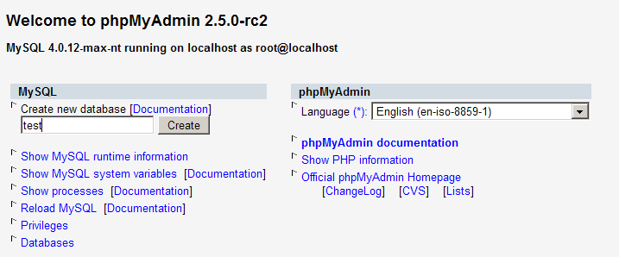
- First you’ll need to create a database to hold all of your &amp; information. To do so, from the opening screen enter the name for the aforementioned database. In this example we’ll create one called test, but really you can call it whatever you wish.
Figure 1.
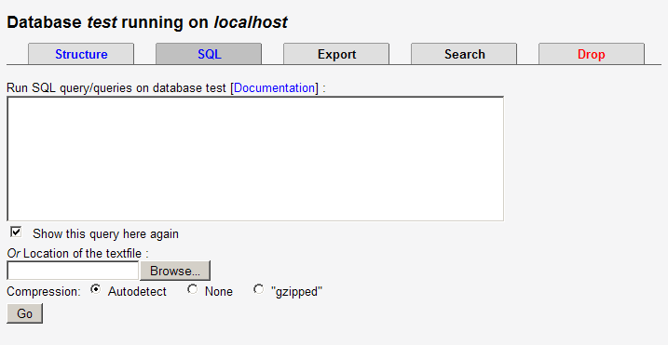
- On clicking create the database will be created and you’ll be taken to the admin interface for the selected database [that is the database you created to hold the &amp; application, in this example we have called it: test], click on the SQL tab and you should be presented with an interface just like in Figure 2.

Figure 2.
- Click on the browse button, and from the dialogue select the dbStruct.sql file, which should be found in the setup folder of your installation.
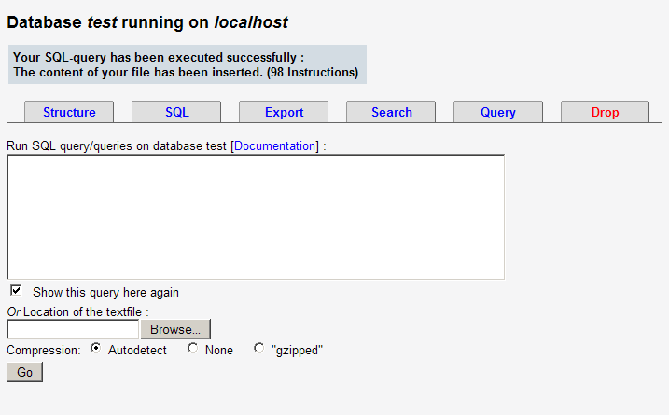
- Then click on go

Figure 3.
- If all went well the script will have been run, the tables that will hold all of the CMS data created, some data inserted and user accounts set up.
- Next you will need to set up the account privileges. To do select Databases…from the drop down menu and then from the following screen [the same you saw when you first accessed phpMyAdmin] and select the link labeled Privileges. You will presented with Figure 4

Continued on next page
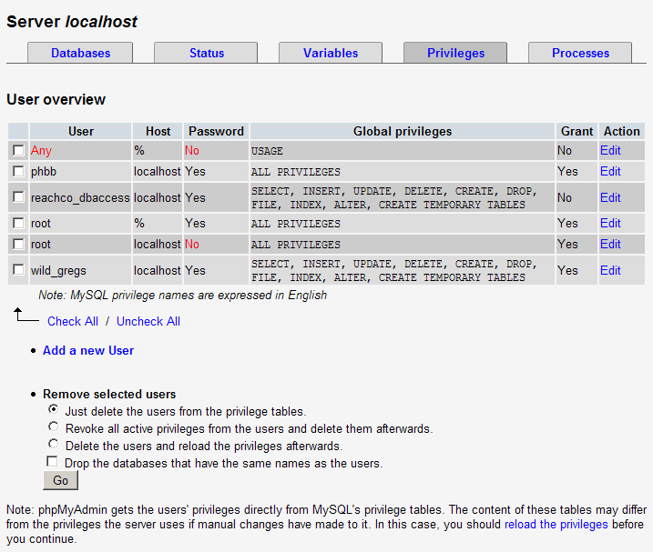

Figure 4.
- On that screen you choose the Add new user option and complete the form with your login credentials similar to the one shown in Figure 5.

Continued on next page
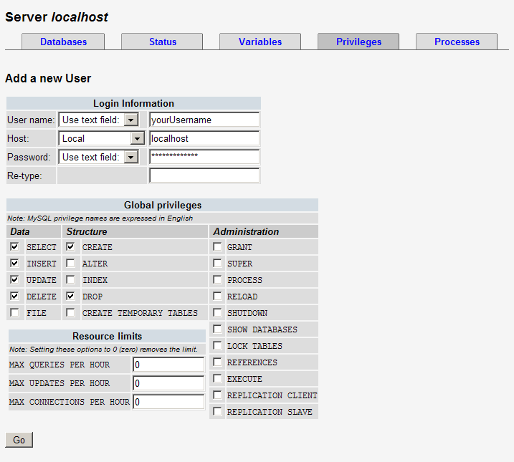
Figure 5.
- And that’s it you are done, the database has been created, the table structure applied and a user account with the appropriate privileges has been set up.

