

Mardevdm2 Proposal Response for:

Dyson Commercial Global Lead Nurturing Strategy & Implementation Program

**Introduction**

Our parent company, Reed Elsevier is a world leading provider of professional information solutions in the Science, Medical, Risk, Legal and Business sectors. mardevdm2, a division of Reed Business Information, are a global b2b marketing data and services provider, offering a suite of marketing solutions, from data provision, demand generation, lead nurturing and marketing automation; services that maximize your ROI.

mardevdm2’s Client Solutions Team provides technical and analytical support for demand generation programs through marketing automation, from planning through implementation and analysis, to better leverage and scale integrated marketing communications to maximize return on investments.

* + address customer needs based on where they are in the buying cycle
  + use a broad range of media channels to fill the funnel
  + don’t push the prospect down a predefined path allow them to pick the route
  + focus on increasing/improving ROMI
  + ensure measurability and accountability
  + utilize technology to ensure we produce reactive, transparent, fully optimised campaigns

Mardevdm2 is the right **strategic and operational partner** to help Dyson build and develop a professional, automated, demand generation program

Mardevdm2’s definition of best practice lead generation is:

‘The development & delivery of effective dialogue with individuals (both prospects and customers) via integrated, relevant, personalised, timely & engaging content based upon their specific profile, behaviour & identified needs. The aim is to establish lasting & valuable relationships that result in greater revenue, profitability & a superior Return on Marketing Investment.’

**mardevdm2 will meet the objectives by…**

* Addressing customer needs based on their online behaviour and where they are in the buying cycle
* Allowing prospects to pick their route based on activity, not pushing them down a predefined path
* Ensuring measurability and accountability
* Utilizing technology to ensure we produce reactive, transparent, fully optimised campaigns

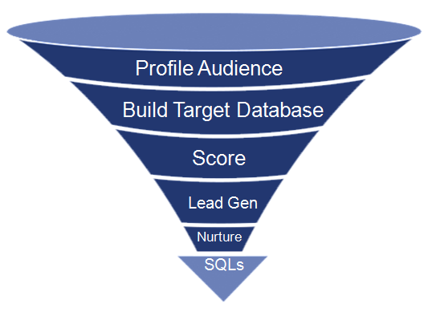

* Define cold leads as “push” and Warm leads as “pull”

To determine what prospects to go after by performing:

* Segmentation Analyses
* Targeting
* Social Media Monitoring (“Listening”)

**Who?**

Target Audience based on:

* Profiled Dyson Airblade Customer list
* 3rd Party Target Audience

**What?**

**Stage 1 – Segmentation, Targeting, Positioning**

**How?**

* Cluster Analyses
* Social Media Analyses using a Monitoring Platform
* Propensity Modeling

**Why?**

1. To develop a persona for each target segment:
   1. Understand Pain points
   2. Gauge Brand Loyalty
2. Identify Preferred Marketing Channels with appropriate positioning for each target segment
3. Optimize ROI on 3rd Party Data Usage

**Added Value Services**

**Data-Sourcing**

As well as mardevdm2 ‘s own multi-channel product; Decisionmaker Global Database with 65 million contacts globally, mardevdm2 have a dedicated list brokerage division which is able to source and supply any dataset on the open market, globally, utilizing local intelligence from our global network of offices. Brokerage services include results analysis and full profitability calculations for each media source. Our ability to source data on Dyson Airblade’s behalf will drive efficiency and add value to the cold lead generation process, by minimizing the need for Dyson Airblade to retain a roster of third party suppliers.

**Suppression Files**

Mardevdm2 have created a bespoke European Suppression File – commonly known as The Robinson File, a pre-merged single source providing access to European MPS/TPS/EPS files compiled from 40 countries suppression files. Robinson provides marketers the ability to be ‘country compliant’ when running multi-national campaigns – recommended as best practice.

The wastage costs, regulatory risk and negative effects on your company’s reputation are at stake when you mail to individuals who have opted-out of commercial communications. Use of Robinson pro-actively minimizes the risk of data protection contravention, resulting legal action and negative publicity – which could impact Dyson Airblade’s brand and revenues.

**Stage 2 – Cold Lead Generation**

**Engagement:**

* Communications sent to targeted audience to drive them to a bespoke dynamic hypersite dedicated to engaging prospects

**Stage 2 – Cold Lead Generation**

Objective: Lead Generation through List Rental

Methodology:

* Based on the personas created in Step 1, Mardevdm2 will create a custom journey for each target segment per country (Refer to Figure 1 below)
  + Entails a series of online communications that map the prospect’s buying cycle to the Dyson Airblade’s in-house asset library using the persona’s preferred marketing channel
  + Uses dynamic content and personalization
* Real-time online tracking to ascertain each prospect’s position in the buying cycle
* Triggered communications/lead flow based on scoring

Target Universe: *Data to be Included based on counts*

Expected Outcome/Benefits:

The end-user experience will promptly identify short-term sales-ready opportunities and funnel those not ready to buy into the “Nurture” program. This approach will create a resonating campaign that will most definitely impact response rates and add structure and depth to Dyson Airblade’s positioning in the targeted marketplace.

**Figure 1: Sample Lead Generation Flow**

**(**

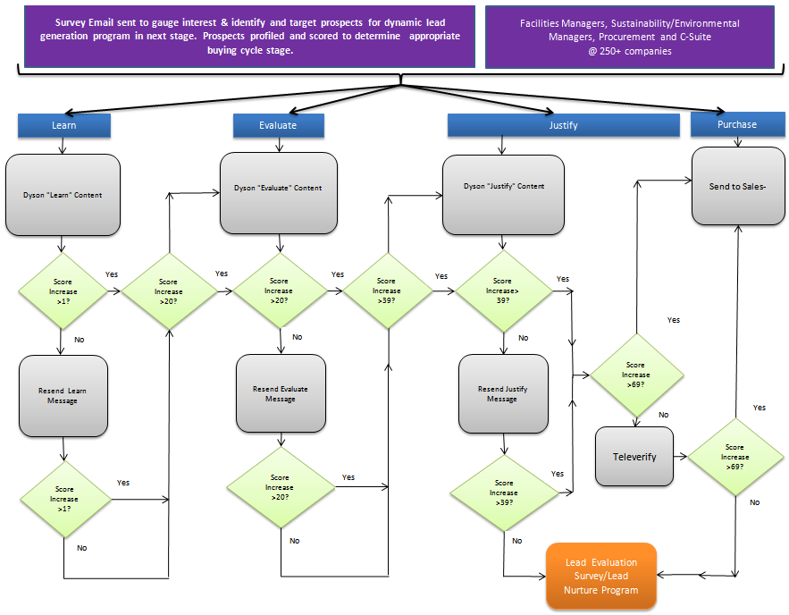

Objective:

* Create a database of all engaged prospects generated in Stage 2

**Stage 3 – Lead Nurture**

* Engage and further educate this prospect database to help expedite their buying process
* Generate a steady/predictable lead flow based on engagement content across a plethora of marketing channels

Prospect Database:

**Warm-lead generation:**

* **Website Optimization/SEO/SEM** will increase the amount and quality of traffic to the Dyson Airblade™ website
* **Vendor Partners** – Using website content syndication, newsletter ads, social engagement...targeted at key decision makers to promote various Dyson whitepapers warm leads interested in Dyson will fill out a form and submit their contact data to be fed into the demand generation platform
* **Website tracking** - lead traffic activity will flow into the demand generation platform and will be matched to a prospect once they submit a form on the Dyson website and their contact data is automatically fed into the demand generation platform
* **Face-to-Face Opportunities** - automated Lead pull from SFDC into lead gen platform (once opportunities are entered by Dyson team) or simple lead form to fill out onsite at tradeshows...
* **List Rental Leads** – warm leads generated via online communications to 3rd party lists

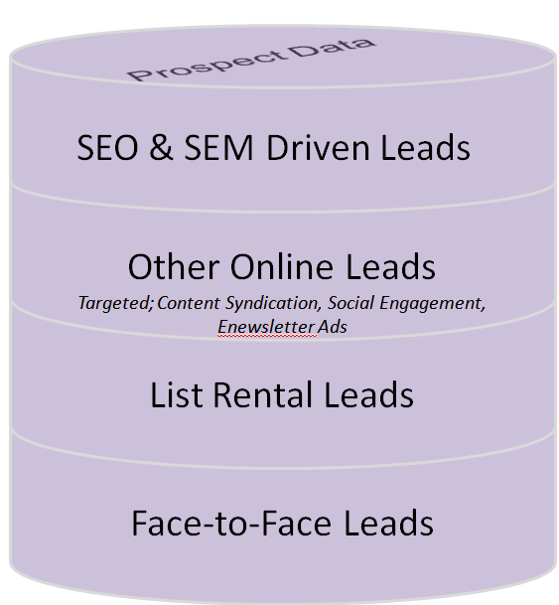

Methodology:

* Leads generated via multiple online channels will funnel through a custom lead nurture process.
  + Entails a series of online communications that map the prospect’s buying cycle to the Dyson Airblade’s in-house asset library using the persona’s preferred marketing channel (Refer to Figure 2)
  + Uses dynamic content and personalization
* Real-time online tracking to ascertain each prospect’s position in the buying cycle
* Triggered communications/lead flow based on scoring
* Figure 3 Exhibits a sample lead nurture flow for a unique target segment within a country

**Figure 2: Customer Buying Process**

**(**

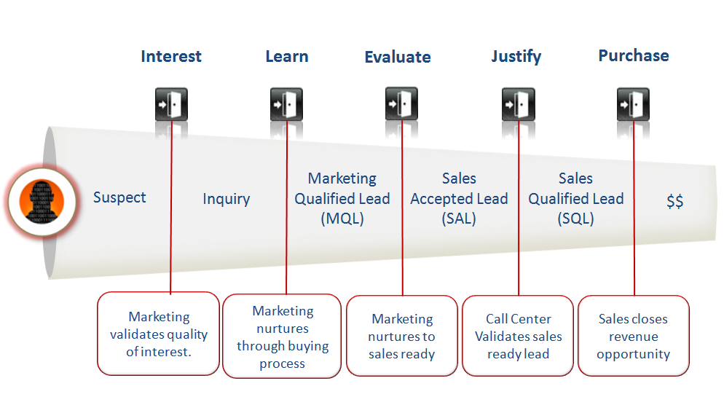

**Figure 3: Sample Lead Nurture Flow**

**(**

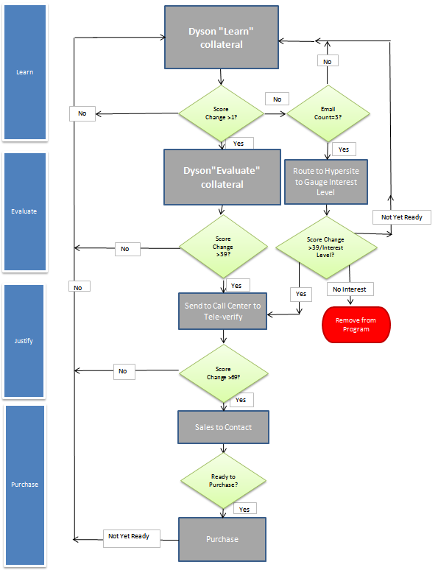

Expected Outcome/Benefits:

Nurture leads by continuing to drive demand and capture interest over a period of time with future prospects, by observing the detailed digital footprint of the non responder and nurture their interest via targeted communications.

Objective: All engagement activities will be routed through a Lead Scoring Model to determine their interest level and position in the buying cycle.

Methodology: Understand whether they are the right person (explicit scoring) and/or are showing the right level of interest (implicit scoring). A lead scoring model will be developed based on mutually agreeable parameters to ensure sales efficiencies. All leads will be scored in real time based upon the action taken online. (Refer to

**Stage 4 – Lead Scoring**

**Profile Fit/Evaluating Explicit Scores**

Information that we know about a prospect (through forms…)

The demographics that tell us we want to do business with this person.

**Information that we know about a prospect (through forms…)**

**The demographics that tell us we want to do business with this person.**

**Information that we know about a prospect (through forms…)**

**The demographics that tell us we want to do business with this person.**

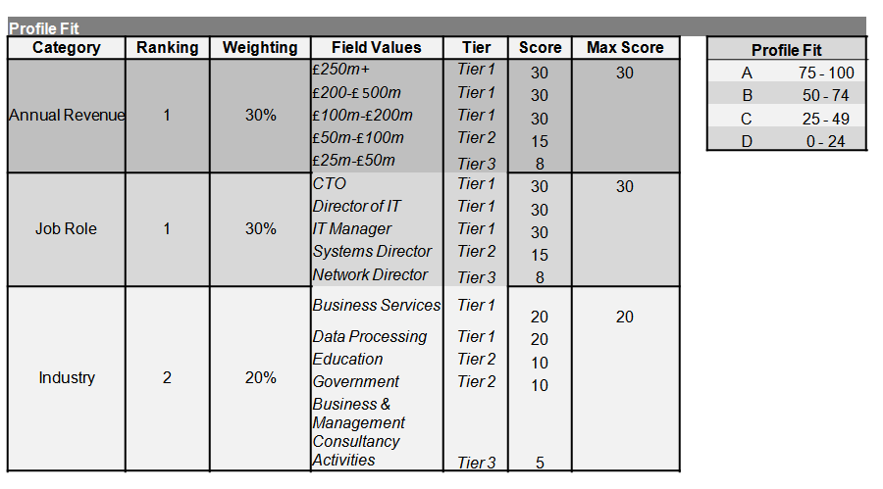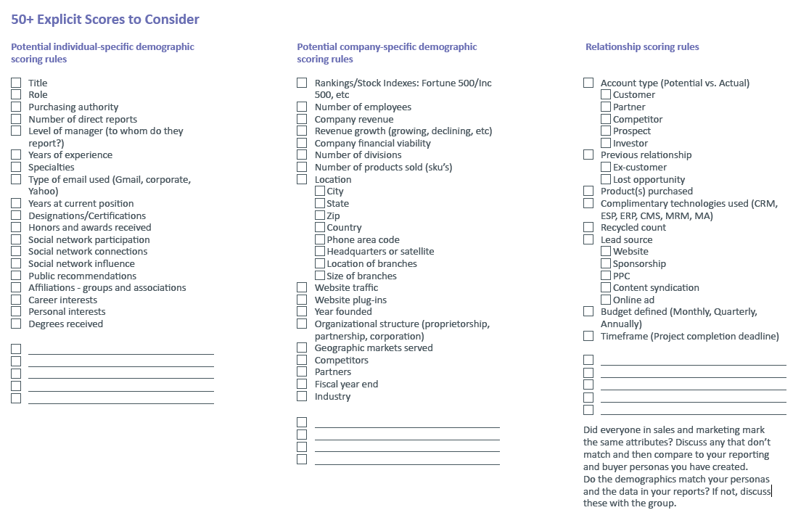

**Engagement/Evaluating Implicit Scores (Activity)**:

Behavior such as web visits and responsiveness to promotions, etc.

The activity that tells us this person may want to do business with us.

Key Elements in Evaluating Activity:

* Recency
* Activity Type

**Information that we know about a prospect (through forms…)**

**The demographics that tell us we want to do business with this person.**

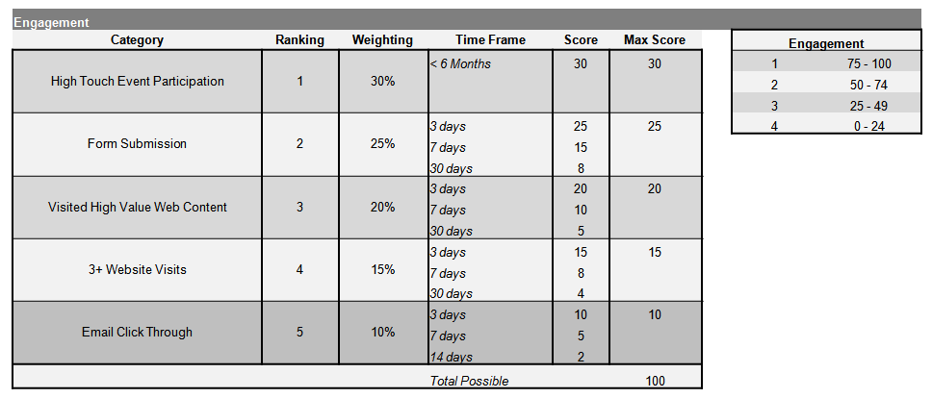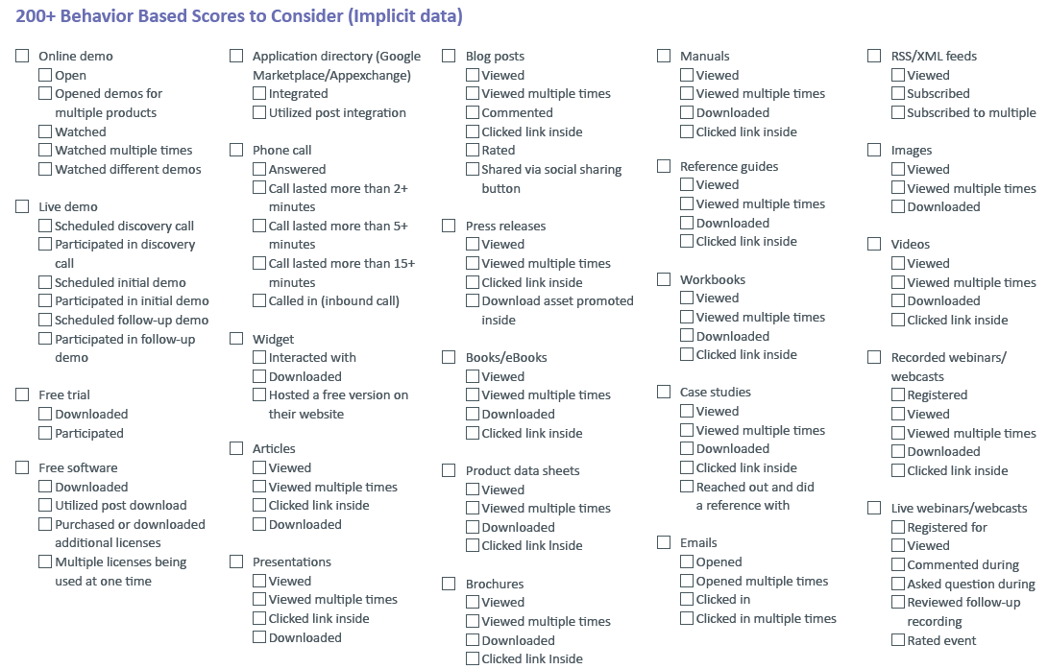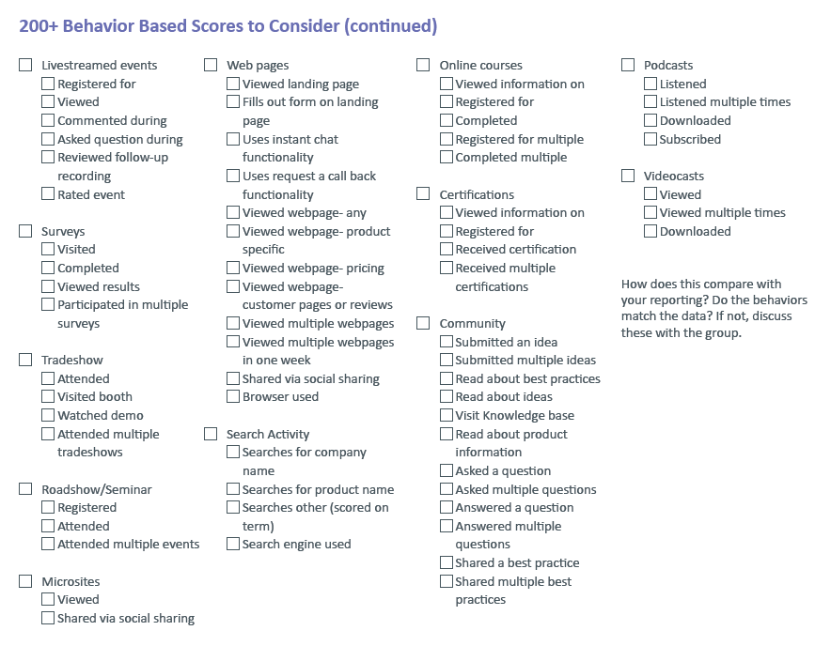

**Lead Scoring Process Steps**

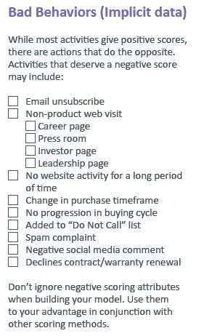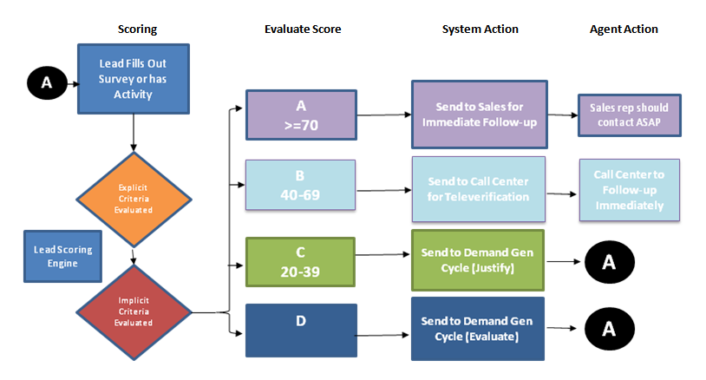

All Sales Qualified Leads will be fed into SFDC via automated process (Mardevdm2 will configure Demand Generation platform and integrate with Dyson’s SFDC platform (given the appropriate access is granted)

Expected Outcome/Benefits:

* Optimize Sales Energy to Active Sales Ready Leads
* Prevent Lead Fall-out
* Increase Conversion Rates
* Control Lead Flow to Sales while enhancing marketing credibility by forwarding sales ready leads

**Implementation Strategy**

Objective: Use Dyson’s existing infrastructure to minimize costs while automating processes to add efficiencies to the initiative.

Methodology:

Mardevdm2 will utilize Dyson’s SilverPop Engage instance to meet the needs of the proposed program including the set-up and configuration of the Dyson’s Sales Force integration.

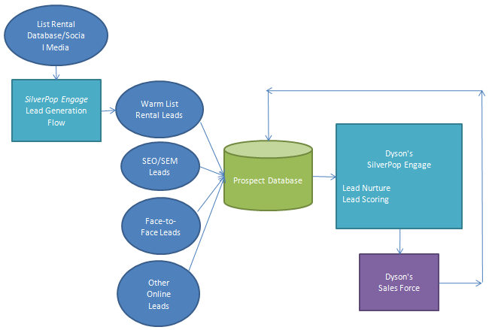

Expected Outcome:

US, UK, FR, GR

Based on average conversion rates we have seen in the US/UK we estimate that we will need a monthly prospect pool of approximately 8,000 leads in order to generate 120 SQLs/month.

CH, HL, BL

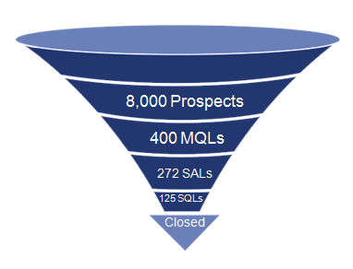

IT, AUS, SP

Based on average conversion rates we estimate that we will need a monthly prospect pool of approximately 4,000 leads in order to generate 60 SQLs/month.

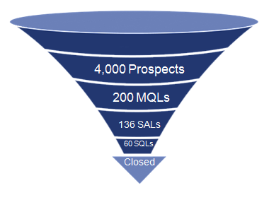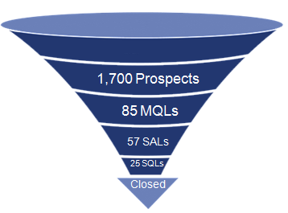

Based on average conversion rates we estimate that we will need a monthly prospect pool of approximately 1,700 leads in order to generate 25 SQLs/month.

Marketing Effectiveness Measurement:

**Reporting & Dashboards**

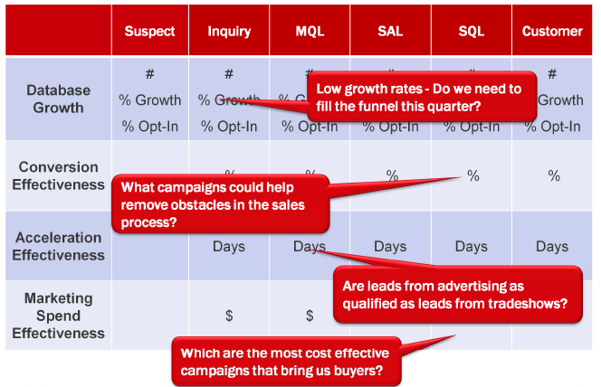

Propensity Model Example:



Propensity Model Example:

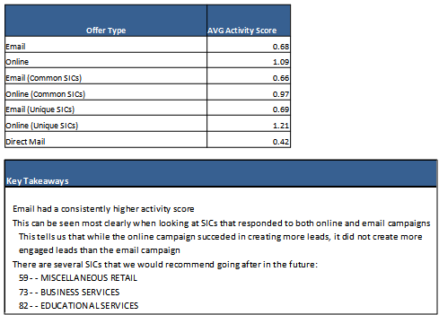

Attribution Model: ROI by Channel:

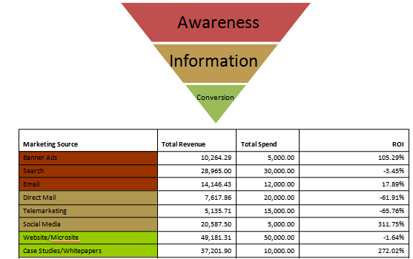

ROI: Best Performing Campaigns:

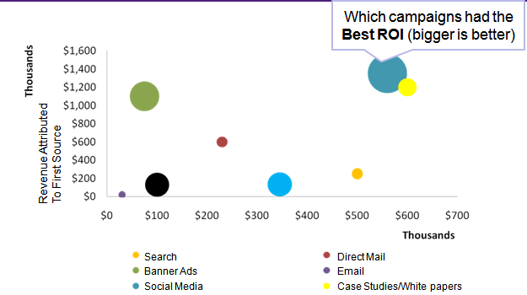

ROI: Best Performing Campaigns

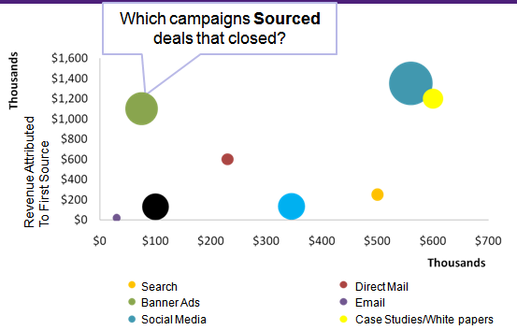

Attribution Model: ROI by SIC



Attribution Model: ROI by Job Title



**Why This Approach?**

This proposed approach is based on best practise B2B marketing. Targeted data together with this type of intelligence led campaigning can result in sales increasing by up to 40% over time, marketing qualified leads increasing up to 60% and a 15% increase in visitors to your campaign website to response.[1] This will help to improve response rates and enquiry conversions. The approach is about quality of leads for better sales conversion, not quantity.

In addition,

1. Dyson Airblade will be provided with more engaged prospects, which are more likely to convert to opportunities, thereby optimising the marketing budget to deliver leads that sales can actively follow up on. This in turn will improve Sales efficiency and productivity by not calling those that are just seeking information and are not in the buying cycle.
2. With the ability to track prospects throughout the campaign in real time, we are able to tweak the campaign quickly if we feel that the results are not coming through rather than waiting to the end of the campaign period to find we have not hit the results mark.
3. Lastly, our approach allows Dyson to leverage existing vendor platform Infrastructure to eliminate additional vendor costs .

**Account Management Support**

Dyson Airblade will be supported by an Account Management team consisting of:

Mardevdm2 is an integrated marketing services provider that is headquartered in the UK with offices in Chicago, New York, Singapore and Sydney, Australia.

**Johanna Higgleton**

**Mardevdm2 Account Director**

Johanna is a professional and versatile Account Director with over 20 years of expertise within the Direct Marketing arena. Highly experienced at delivering complex marketing results whilst ensuring high standards of data protection and compliance,Johanna’s wealth of experience has enabled her to counsel clients from initial idea formation through to execution and the successful delivery of results. Clients include large blue chip companies, agencies and suppliers worldwide. Her tenure at the Direct Marketing Association enhanced her knowledge regarding regulatory and compliance issues client’s benefit greatly from that experience.

**Parin Mody**

**Mardevdm2 Global Director, Business Development**

Parin Mody has more than 15 years of experience in International product development, business development and corporate strategy. His experience spans industries including technology, retail, gaming, financial services, hospitality and B2B marketing services.

In his role with mardevdm2, Parin is responsible for the global business development and product roadmap strategies. He holds an MBA from Kellogg School of Management with emphasis in Business Strategy, Marketing & Technology & Ecommerce.

**Bridgid Johnson**

**Mardevdm2 Global Manager, Client Solutions**

Bridgid Johnson has more than 10 years of experience in Email and Online marketing strategies and technology. Her online marketing expertise includes strategy, planning, project management, implementation/programming, compliance, best practices, and emerging technologies.

In her role with mardevdm2, Bridgid is responsible for global demand generation client solutions. She manages a global team that provides technical and analytical support for demand generation programs through marketing automation, from planning through implementation and analysis, to better leverage and scale integrated marketing communications to maximize return on investments.

**Rizwana Qureshi**

**Mardevdm2 Project Executive, Client Solutions Team**

Rizwana Qureshi is experienced within the marketing industry and her 6 year experience stems from sales, logistics and project management within the IT, Financial Services and Higher Education industry.

In her role with mardevdm2, Rizwana is responsible for providing dedicated support for demand generation campaigns, which ranges from client set-up/programming to ongoing reporting and analytical advice. She holds a BSc (Hons) in Multimedia Technology and Design with a focus on Business and Technology modules from Brunel University, Middlesex.

**Elizabeth Baione**

**Mardevdm2 Senior List Broker**

With over 13 years of experience in multinational list brokerage and management, Elizabeth is one of the international marketing community’s most knowledgeable list experts. With a strong background in both international and domestic list brokerage and management, Liz has continued to provide unparalleled service to her many clients. A few of these include The National Geographic Society, American Association for the Advancement of Science, The New England Journal of Medicine, IEEE, Marquis Who’s Who, and others.

**Timeline**

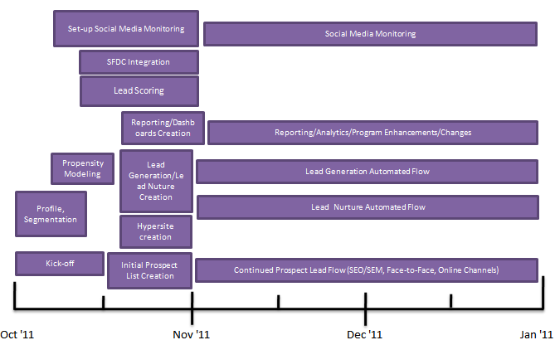

|  |
| --- |
| **Pricing** |
| See attachment Dyson_Pricing_Final.xls |

**Terms & Conditions**

**Non-Disclosure & Confidentiality**

All information contained in this brief is proprietary and confidential to Mardevdm2 and all information and rights to the information shall be held in confidence. The recipient of this document by its retention and use agrees to the foregoing restrictions and shall protect the document and the information contained herein from loss, theft, and misuse. Further, the recipient agrees not to disclose as such to any third party without the prior written consent of Mardevdm2.

1.