Homework 11&12

MSDS 6306 DOING DATA SCIENCE

Section 403

Instructor: Thomas Tibbett

Gregory Asamoah

DOING DATA SCIENCE

Date: 11/13/2017

Github Url

Url: <https://github.com/gregxmarfo/Doing-Data-Science-Time-Series>

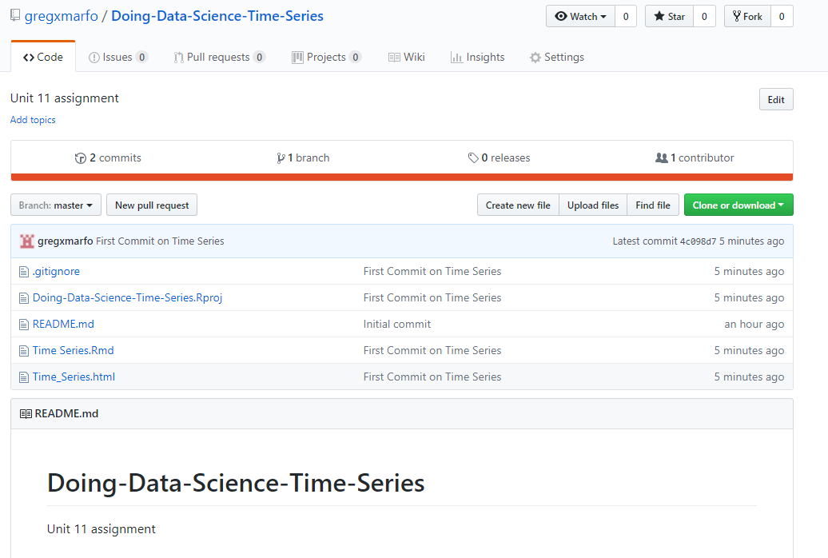

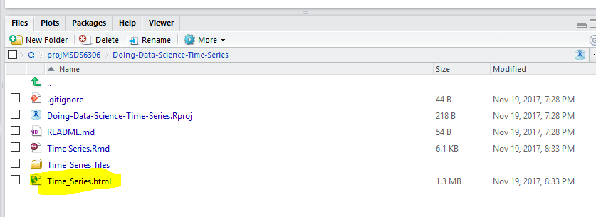

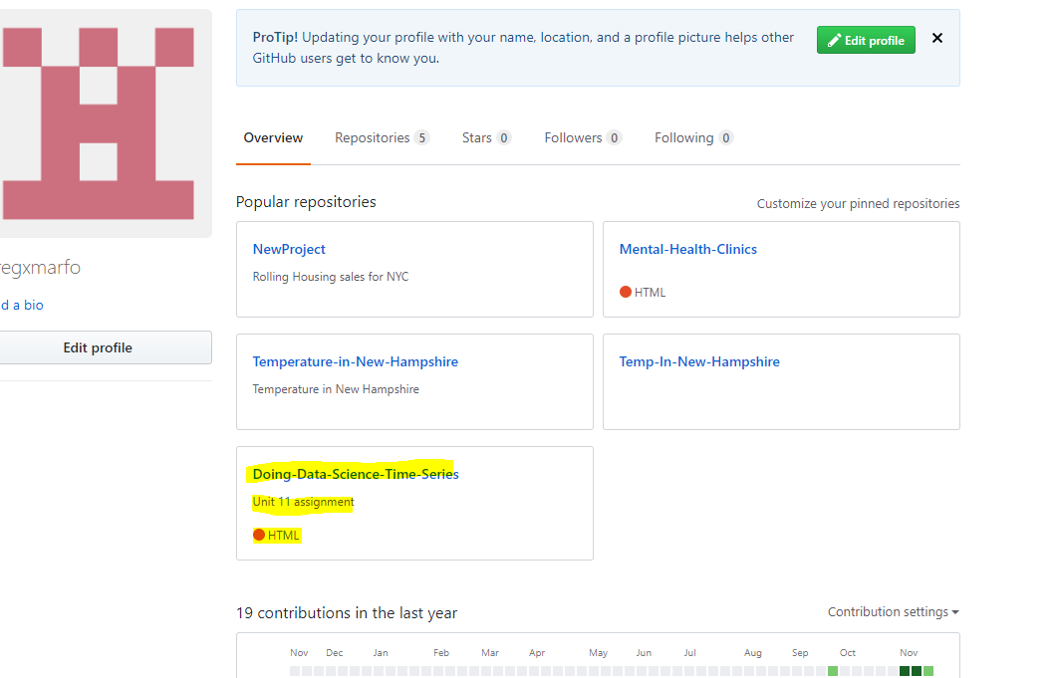

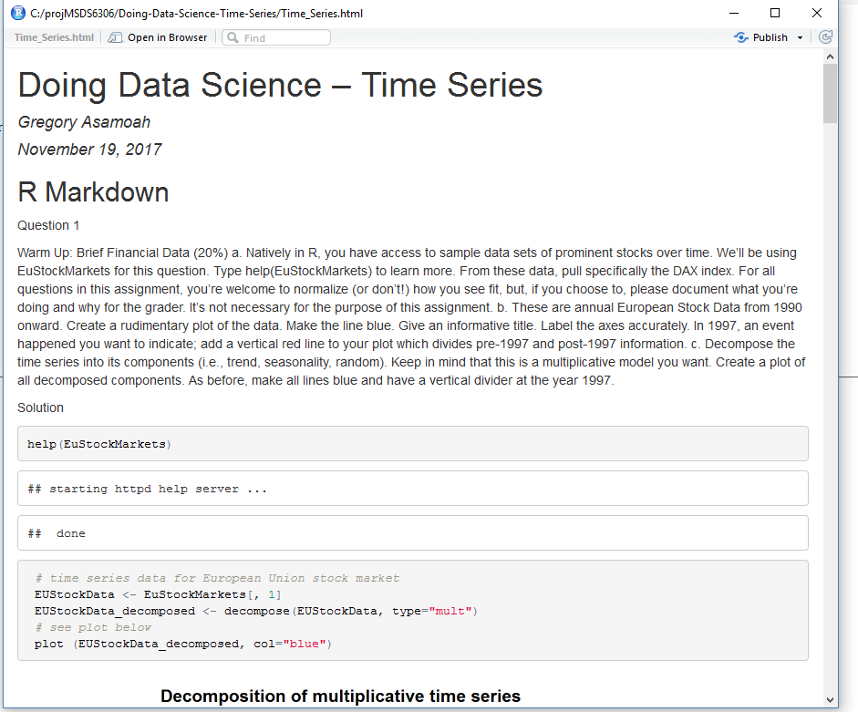

1 a

help(EuStockMarkets)

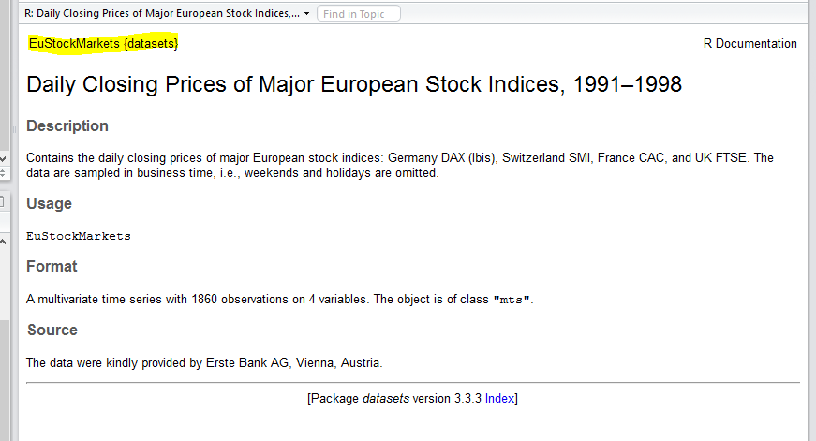

b

> help(EuStockMarkets)

> EUStockData <- EuStockMarkets[, 1] # time series data for European Union stock market

> EUStockData_decomposed <- decompose(tsData, type="mult")

> plot (EUStockData_decomposed, col="blue")

> stlEUStockData <- stl(tsData, s.window = "periodic")

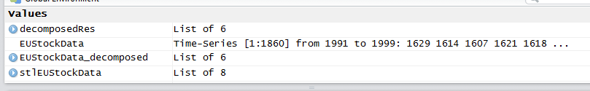

C

plot (EUStockData_decomposed, col="blue")

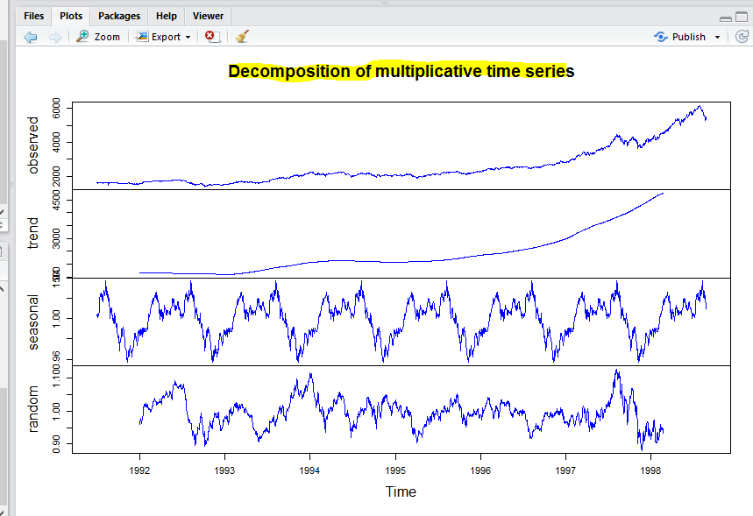

2.

library(fpp2)

help(maxtemp)

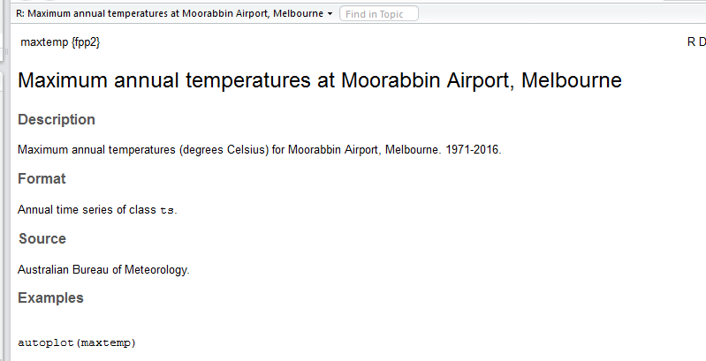

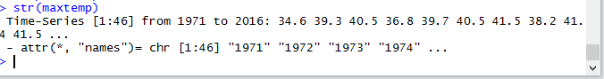

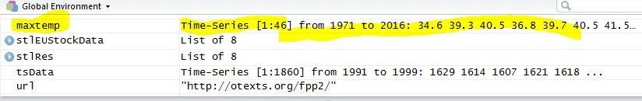

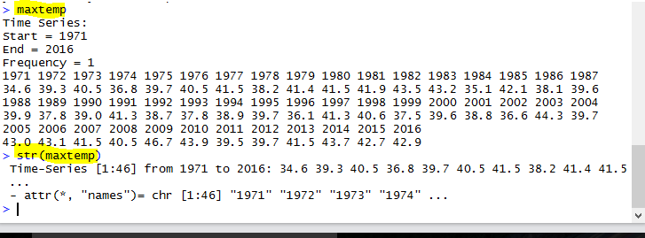

b. Subset the dataset from 1990 to 2016

sub_maxtemp <- maxtemp[20:46]

> head(sub_maxtemp)

> sub_maxtemp

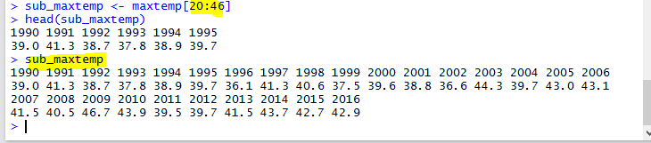

ts.plot(sub_maxtemp,col="blue",main="Maximum Temperature in Melbourne, Australia 1990 to 2016")

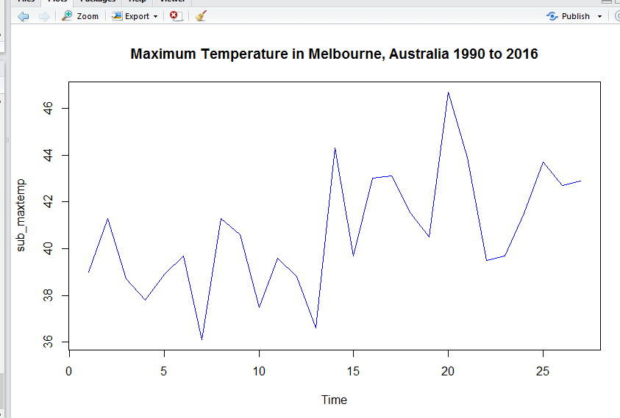

3.

a

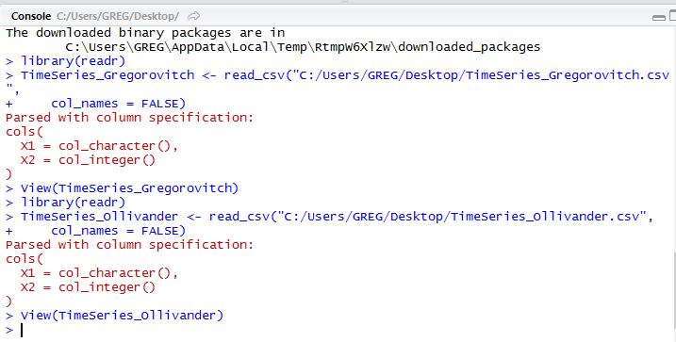

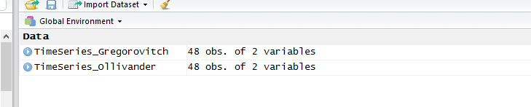

b.

TimeSeries_Ollivander$X1 <- as.Date(TimeSeries_Ollivander$X1,"%d/%m/%Y")

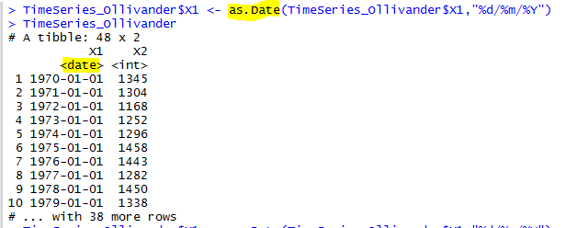

TimeSeries_Gregorovitch$X1 <- as.Date(TimeSeries_Gregorovitch$X1,"%d/%m/%Y")

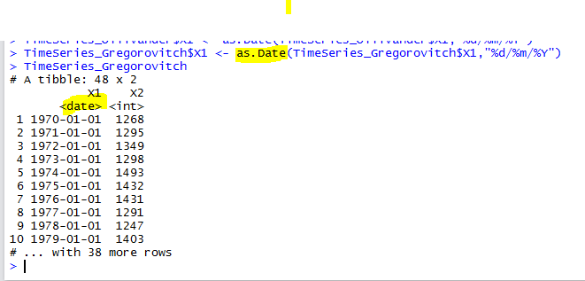

c.

TimeSeries_Gregorovitch_order <- xts(TimeSeries_Gregorovitch, order.by = TimeSeries_Gregorovitch$X1) #make xts

dygraph(TimeSeries_Gregorovitch_order,main="TimeSeries_Gregorovitch",xlab="Year", ylab="Wand Sold") #now plot

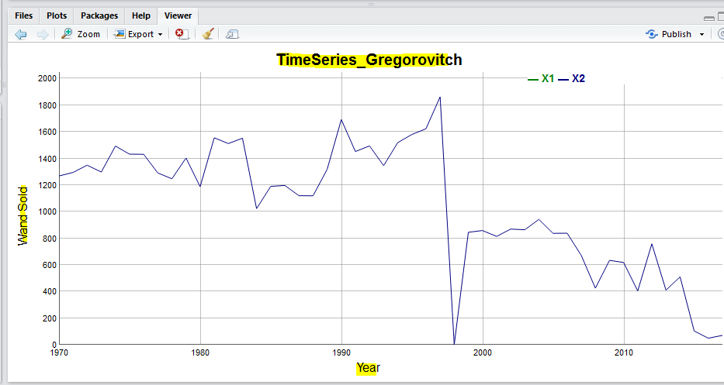

TimeSeries_Ollivander_order <- xts(TimeSeries_Ollivander, order.by = TimeSeries_Ollivander$X1) #make xts

dygraph(TimeSeries_Ollivander_order,main="TimeSeries_Ollivander",xlab="Year", ylab="Wand Sold") #now plot

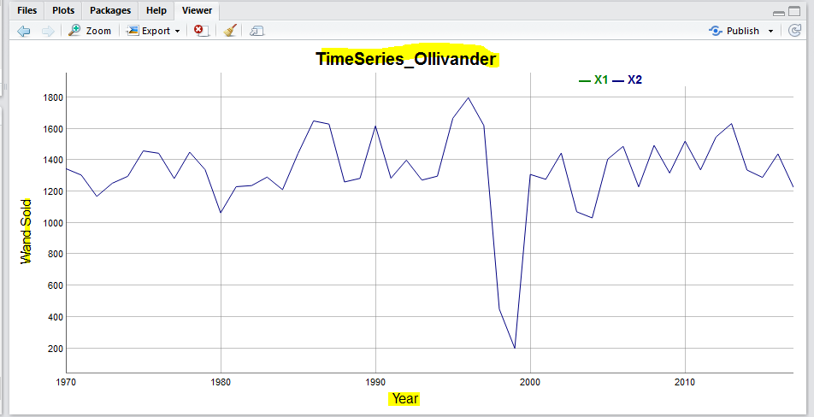

d. #The two dataframe combined using Cbind

Gregorovitch_Ollivander <- cbind(TimeSeries_Ollivander_order, TimeSeries_Gregorovitch_order)

dygraph(Gregorovitch_Ollivander, main="TimeSeries_Ollivander_Gregorovitch combined",xlab="Year", ylab="Wand Sold")

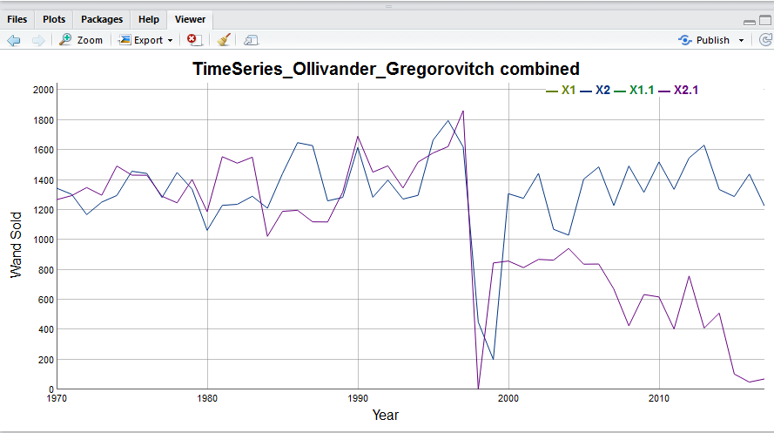

dygraph(Gregorovitch_Ollivander) %>%

dySeries("X1", label = "Gregorovitch") %>%

dySeries("X2", label = "Gregorovitch") %>%

dySeries("X1.1", label = "Ollivander") %>%

dySeries("X2.1", label = "Ollivander") %>%

dyOptions(stackedGraph = TRUE) %>%

dyRangeSelector(height = 250)

