Homework 4

MSDS 6306 DOING DATA SCIENCE

Section 403

Instructor: Jongwook Woo

Gregory Asamoah

DOING DATA SCIENCE

Date: 09/23/2017

1.

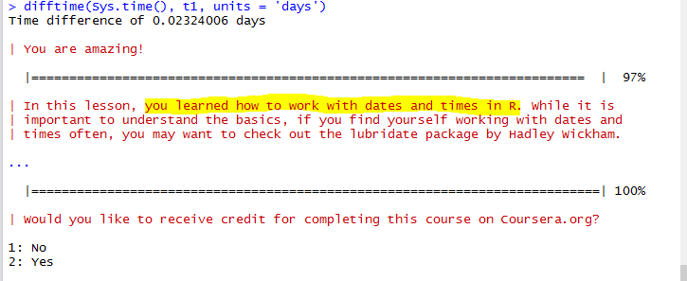

2.

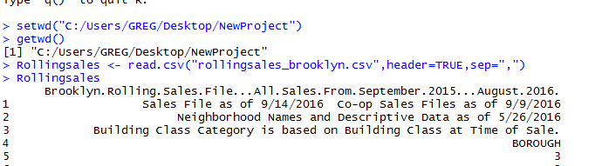

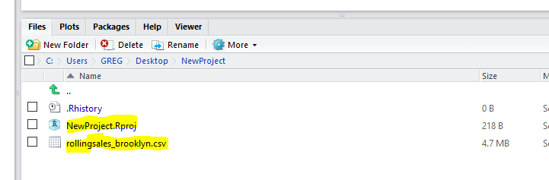

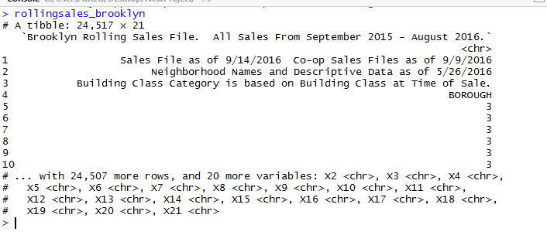

> rb <- rollingsales_brooklyn$X20

> rb

> count(is.na(rb$sale.price.n))

> rb$SALE.PRICE.N <- as.numeric(gsub("[^[:digit:]]","",rollingsales_brooklyn$X20))

> rb$SALE.PRICE.N

> names(rb) <- tolower(names(rb))

> names(rb)

> rb$x17 <- as.numeric(as.character(rb$x17))

> rb$x16 <- as.numeric(rb$x16)

rb$x15 <- as.numeric(rb$x15)

> plot(log10(rb$x16),log10(rb$sale.price.n))

