# Online-Yard-Sale

1 Start the Website:

yarn install

yarn start

2 technical specifications:

HTML, CSS, React, JavaScript

3 Technical Requirements Checkout:

HTML

* Have at least 3 pages, keep the grid system consistent as much as possible ?

* Use at least 10 different HTML tags ?

* Use HTML tables ?

* Implement at least two uses for forms ?

* Dropped Down Menu ?

* Use web fonts ?

* Use different types of content in the form of text, images, videos, and GIFs ?

* Use regex validation ?

CSS

* Inline, internal, and external styling ?

* Use five different CSS selectors ?

* Don’t use too many fonts ?

* Use colors that complement each other ?

* Use Flexbox (Optional) ?

* Use SASS/SCSS (Optional)

* Use animations (Optional)

JavaScript

* External scripts ?

* Use variables, if statements, loops, at least one form of collections, functions/call back, and events ?

* Use AJAX (Optional)

* Use JSON or XML (Optional)

* Use JQuery (Optional)

Description of Website

Every time I move from one city to another city, I have to throw away many used belongings since I cannot carry all of them with me. And I know many people have trouble dealing with used stuff they no longer want. The inadequate processing of waste doesn't just create pollution; it's also the cause of significant waste. So, I want to create a website to help people sold stuff.

There are currently 3 pages. This one is the homepage. I try to use React for the front end. This homepage is built to react. It does not look very well at this time since I just start learning to react for two days. As I go deeper with react, I will make it looks better!

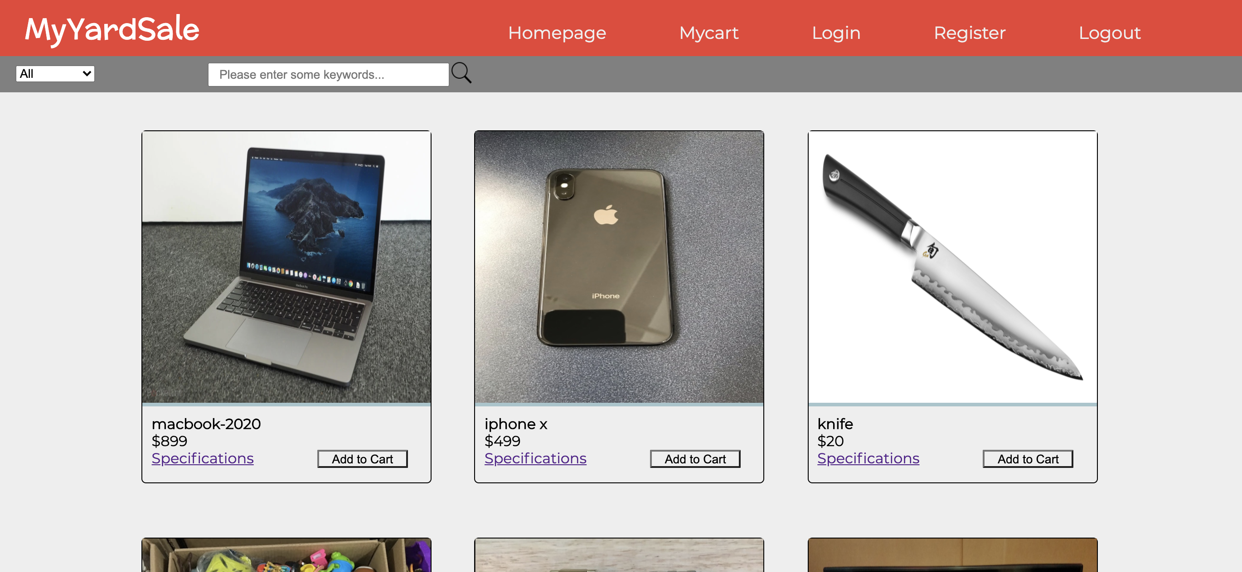

The second page is login page. I built this page with HTML, CSS and JavaScript.

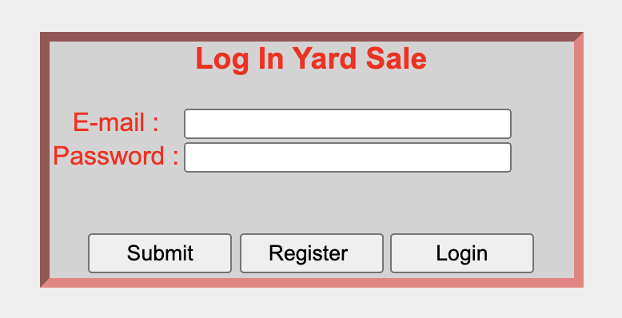

JavaScript will help us to verify the Email format by using regex.

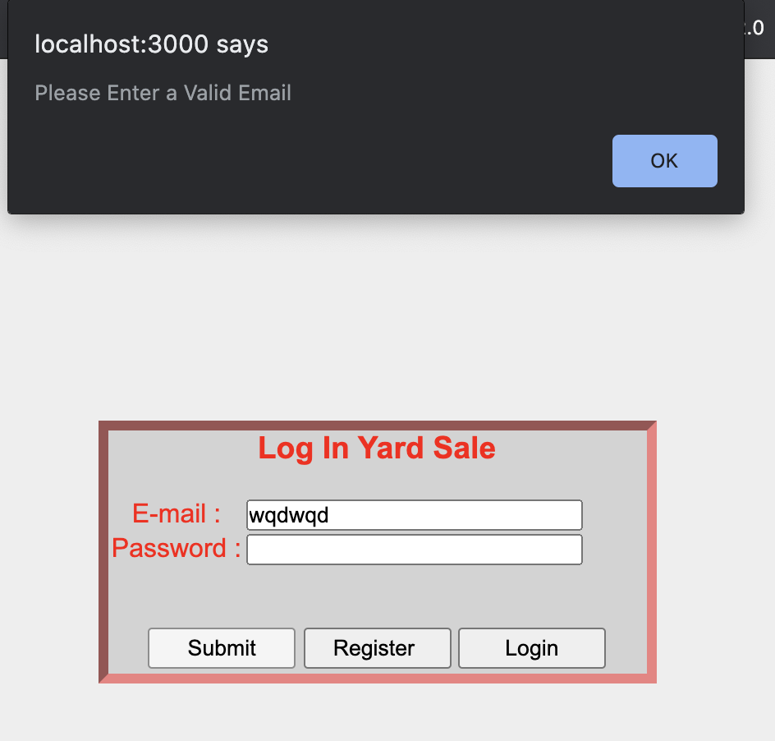

The third page is the register page. It is built with HTML and CSS. When the input last name and first name do not satisfy the requirement, the border will have yellow to alert the user.

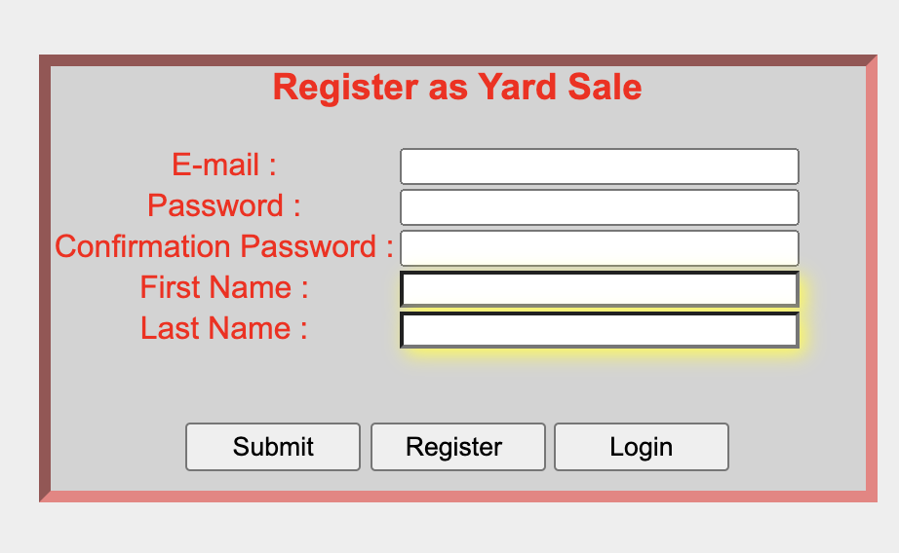

I will keep working on this website as my case study. I believe it will become much better in the end!