Security Policies and Procedures Lab 1

Miranda Gress

4/12/23

Summary: I used VSC instead of Eclipse. I didn’t particularly have any technical challenges or errors, but it was a little tricky at first looking up directions for each step for Visual Studio Code instead of following the tutorial that was provided in the lab description for Eclipse.

1. Create GitHub repository.

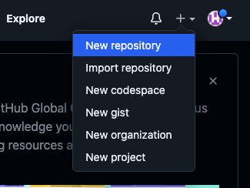

1. Clone repository in VSC - click “clone git repository” and select the “SPP” repository that I created on github in step 1

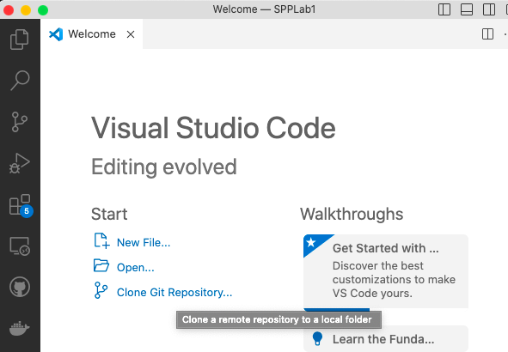

-For repository destination, use folder that I created for the purpose of this lab:

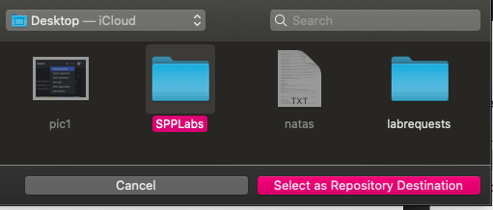

1. Add VSC project to GitHub repository.

-Create the project: I titled mine index.html, and put a basic html structure inside

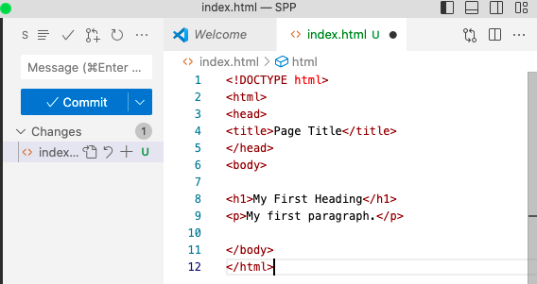

1. Commit, push, and pull the changes.

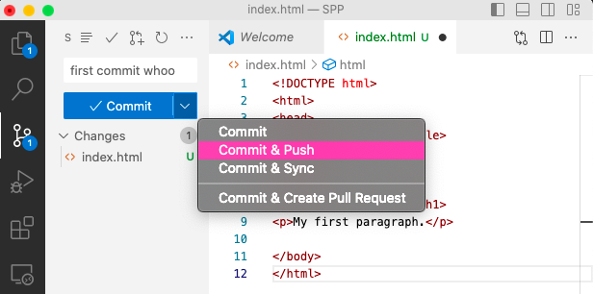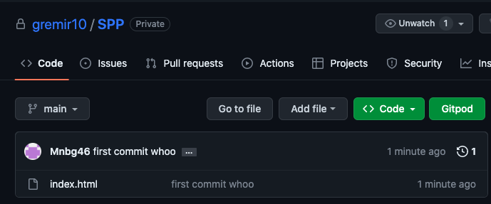

The project is now visible inside my github repository.