**Maleeza Mayrose Nicholas**

17418673

Gremlin95.github.io

Assignment 1: Web Development

15 January 2017

**Acknowledgement**

Upon the successful completion of the project, special gratitude goes to the lecturer, Mr. Kasun Kosala for all the guidance and advice given throughout the project. Special thanks goes out to Isuru for his assistance with the design of the personal logo and to Tharaka for proofreading and editing all the content.

**Personal portfolio web project**

The following document will focus on the design and development process of making a personal portfolio. The READ ME concentrates on the concept of ‘self-branding’ the author to make her work more attractive in terms of employability and state that she is quite capable of handling fully integrated projects in the corporate sector. All elements from designing to developments, testing, and the challenges faced have been explained. The document will give the reader a thorough knowledge of the webpage from the errors in implementation to the people without whom the project would have not been successful.

**Design**

At the first stage of developing the webpage much thought was given to designing the wireframe for the website. All elements in the webpage were ordered in a manner as to which anyone visiting the site would have a pleasant user experience. An approximate of 3 hours was spent on conceptualizing and designing the following wireframe.

The webpages follow a uniform theme which manifest simplicity and elegance. The colors used in the website are Black for font and blue-green for all highlighting elements with a clean white background, to stick with the theme all images have been gray-scaled. The Google ‘[Material Design’ UI Style guide](https://material.google.com/) was used as reference when designing the website and all its elements.

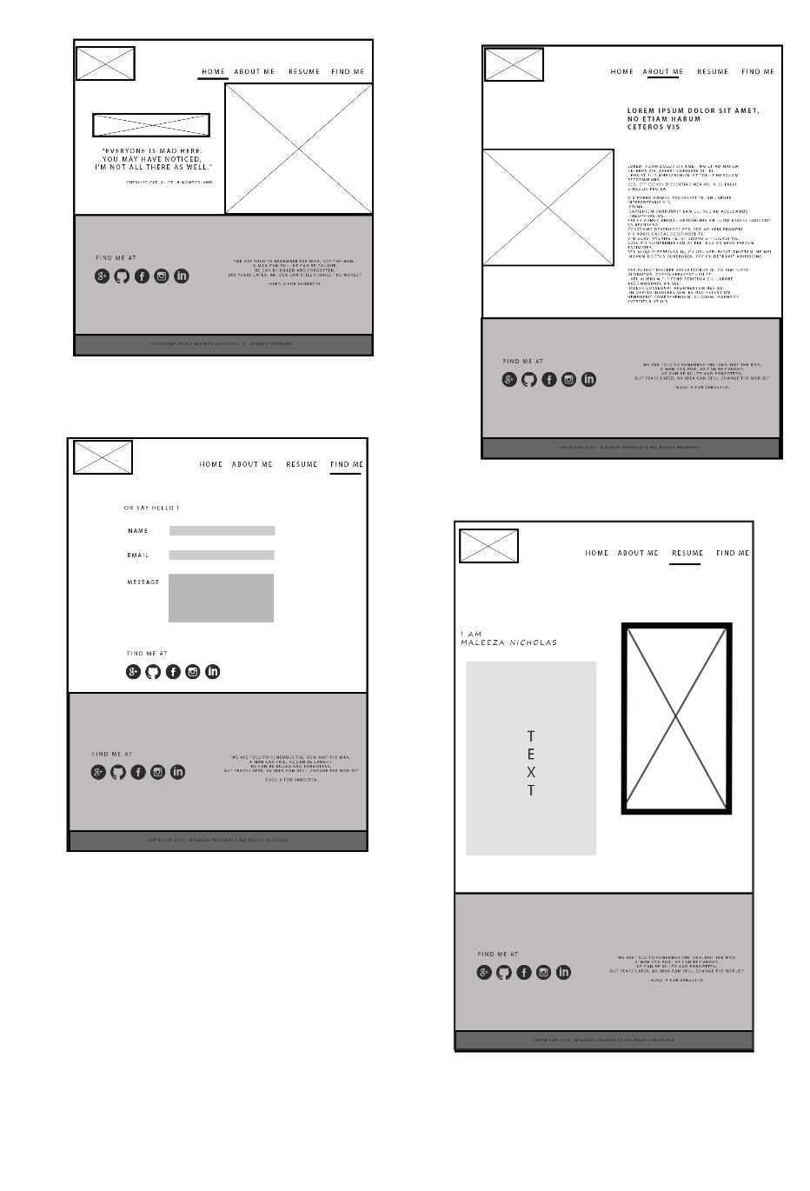

**Development**

CSS – more than 5 CSS rules were implemented.

The webpage has been developed using only HTML5 and CSS and an approximation of 30 hours was spent in the process. It contains 4 HTML5 files index.html, bio.html, resume.html and contact.html. To which all formatting is done using a single CSS master style sheet. The development environment used to code the website was notepad++ and GITHUB.

**Testing**

After thorough testing on different platforms the following were present in the website:

* Navigation bar works perfectly with all links (navigation and social media) responding.
* Images are properly optimized. They expand and compress on different devices screen with no errors.
* Mobile screen – Not fully mobile responsive. All the components are out of alignments.
* Desktop 21 – Too much spacing on different components. The reason is that there is too less components and correct space ratio is not maintained. This give an unattractive appearance.
* Laptop 15.6 – Properly optimized. Works without any issues

All pages however successfully pass the official CSS and HTML5 validations with no warnings.

**Challenges faced**

* To understand and familiarize with GITHUB was quite a time consuming challenge. Many other difficulties such as unfamiliar jargon was faced throughout.
* Issues were faced with the CSS file, as only one was used and different formatting for every page was time consuming and difficult.
* The fact of having to use only CSS and not BOOTSTRAP to make it mobile responsive was problematic due to the time constraint.

**Conclusion**

To conclude, the following Read Me consists of the author’s personal portfolio web project with all elements of it analyzed and discussed. Upon the completion of the project and overcoming all the challenges in the process, the author learned how to use HTML5 and CSS in a more effective and efficient manner. The author also found out better ways to research on problems and find methodical solutions.