

Internet & Web Programming

Project Report

Medical Information & Symptoms Analysis Website

“MedicInfo”

Team members: Submitted To:

Siddharth Chandra 15BCE1286 Dr. G. Malathi

Kanishk Sankpal 15BCE1368

Kunal Kasodekar 15BCE1045

* Introduction/Motivation:

Aim of project is to develop a medical website which could operate for the analysis of symptoms seen in patient (user); moreover it is also helpful to get information about diseases and their respective medicines, with help of which user can get knowledge of medicines about when and at what situation it can be used.

* Abstract:

For the development of this project languages used are:

* PHP
* HTML
* AJAX
* JAVASCRIPT
* CSS (Designing)

Front-hand is handled using html and JavaScript, by the use of which user-interface is handled like navigation bar for navigating between different webpages, content handling and its display is also done by same. Creating pop-up forms, validation and different functions and are handled by JavaScript and php. Ajax is used for search implementation and hints provided during searching. Database is managed by MySQL using php commands. Data fetching and storing and handling of data is done by php commands.

Firstly navigation bar contains’ Diseases’,’ Medicines’ pages for information, quizzes, home and symptom checker for analysing symptoms. Information of medicines and diseases are stored in table in database from which it is fetched and displayed, specifically in these two pages vertical navigation is given to navigate between stack of medicines and diseases. Other than these’ Quizzes’ are just for enhancing the interaction with user by showing score and knowledge awareness of particular information. As commonly followed ‘About us‘ page is also included which gives overall short introduction of ours and our specialities.

In ‘Home’ page also our extra features like BMI calculation and symptoms checking are mentioned which are designed by css. Apart from these for ‘Symptom checking’ page is operated by image mapping concept, which is helpful for searching for diseases and connected to database accordingly.

* Methodology:

Here in this project we used HTML for the base structure of the pages, CSS for styling them, JavaScript for dynamic working of the page, PHP for the server side and AJAX a technique of JavaScript for implementing ‘Search’ and ‘Symptom Checker’.

1. HOME- PAGE:

Starting with the Home Page, we included two CSS file named ‘Header.css’ and ‘homepage.css’ these files contain the code for the styling of the page’s top. Class ‘border’ defines border, ID ‘hints’ is used for the Search implementation that becomes visible when the user type something on the Search bar, ‘medictab’ defines the MedicInfo’s header, then the classes ‘dropdown’, ‘dropbtn’, ‘dropctn’ are all used to perform hover over the tabs.

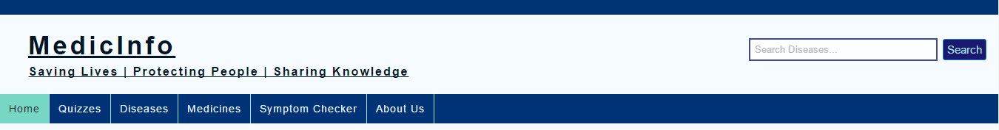

1. SEARCH IMPLEMENTATION

<form action="SearchResults.php" method="GET" autocomplete="off">

<input type="text" name="search" placeholder="Search Diseases..." size="30" onkeyup="showHints(this.value)"/>

<input type="submit" value="Search" />

</form>

This part of HTML code is used in every page where it requests to the SearchResults.php to perform the action of finding the related query. Here on some selected names can be searched that are in our database other than that all queries will result in NOT FOUND. Each disease is given an ID, once the user press enter that particular disease if exists in the database will get retrieved from the database. Some Search suggestions will be given using AJAX that works on behind of the page without reloading it for AJAX to occur we included ‘onkeyup’ event of JavaScript so whenever user presses a key and releases it the suggestion appears in front of the user. Here AJAX send a XML Http Request to the server which works on the responses coming from the server side, when a response is ready to be given to the client readyState changes from 0 to 4 at 4 it prints the result. Here status has to be 200 for loading the server page on back side signifying page is present.

AJAX:

<!-- JAVASCRIPT FOR SEARCH SUGGESTIONS -->

<script type="text/javascript">

function showHints(str){

if(str.length == 0 || str == ""){

document.getElementById("hints").innerHTML="";

document.getElementById("hints").style.border="none";

document.getElementById("navigation").style.marginTop = "14px";

return;

}

else{

var xmlhttp = new XMLHttpRequest();

xmlhttp.onreadystatechange = function(){

if(this.readyState == 4 && this.status == 200){

document.getElementById("hints").innerHTML = this.responseText;

document.getElementById("hints").style.border = "1px solid blue";

document.getElementById("navigation").style.marginTop = "36px";

}

};

xmlhttp.open("GET", "SearchHints.php?q="+str, true);

xmlhttp.send();

}

</script>

PHP gets the result from AJAX and store it in $q then $q is converted to lower string and then compared with the sub-string to the length of $q if a match is found then it shows those matches otherwise prints ‘No Suggestion!’.

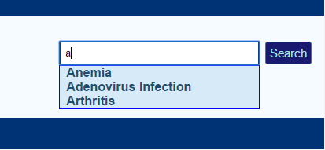

When the user press the Search button it sends the request to SearchResults.php whose search works according to the code below:

function validate($x){

$x = trim($x);

$x = str_replace(' ', '', $x);

$x = stripslashes($x);

$x = htmlspecialchars($x);

return $x;

}

$name=$desc=$symp=$cure="";

if($id>0 and $id<=20){

$conn = mysqli_connect('localhost','root', '15bce1286','medicinfo');

if(!$conn){

die("Connection Error ".mysqli_error($conn));

}

$sql = "SELECT * FROM disease where Did=$id";

$result = mysqli_query($conn, $sql);

if(!$result){

die("Connection error ".mysqli_error($conn));

}

while($row = mysqli_fetch_assoc($result)){

$name = $row['Dname'];

$desc = $row['Ddesc'];

$symp = $row['Dsymp'];

$cure = $row['Dcure'];

}}

else{

$name=$desc=$symp=$cure=$res;

}

?>

First of all the text goes to the validate() function for server side validation and then id will get computed according to an if-else system, then after identifying the id it checks whether id is less than 0 or greater than 20 if not then it allows the server to perform the action for finding data in the database with a simple SQL command ‘SELECT * FROM disease WHERE id=$id’ then the data collected is fetched from the table in the form of an associated array by simple SQL PHP function ‘mysqli_fetch_assoc()’ then parenthesis contains the result of the SQL query. Once data gets fetched it stores in variable $name, $desc, $symp, $cure. If the id does not match the required conditions then a variable $res get the message which replaces all variable $name, $desc, $symp, $cure with a single variable $res and shows ‘NO RESULT FOUND’.

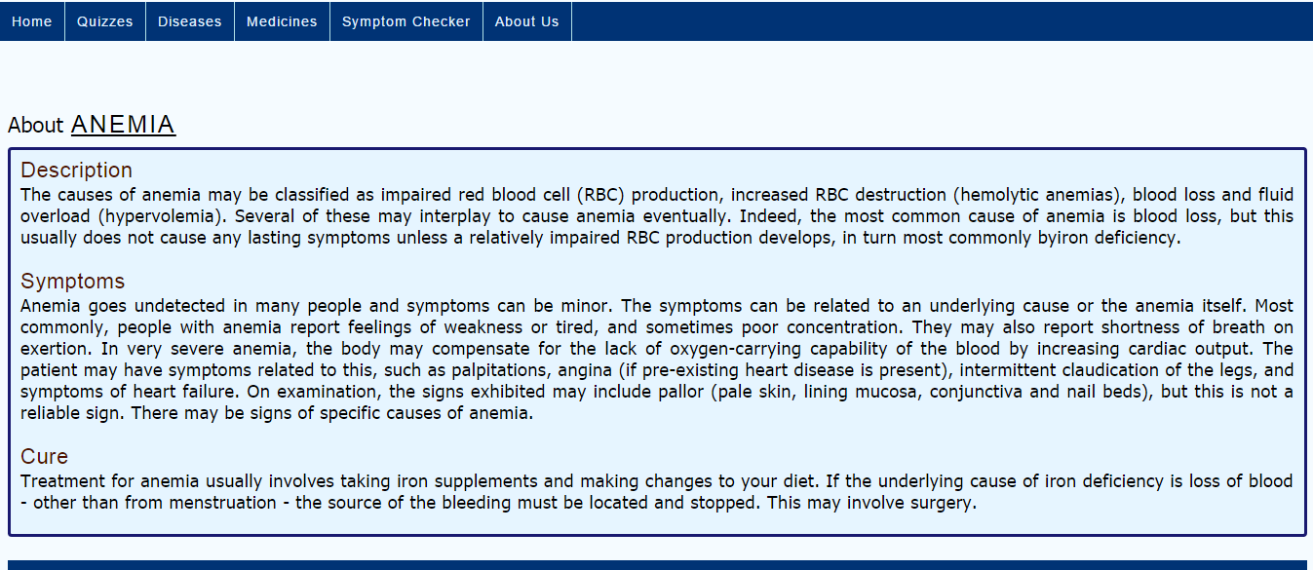

1. DISEASE PAGE

Disease page deals with the 10 diseases listed on the page and using a frame for displaying the result marking/highlighting the disease that is being displayed on the frame. This is done using the frame name and 10 HTML pages that are all linked to the frame as a target through its name. When someone clicks the vertical tabs, it links that page being called and displayed on the frame rather loading a new page. The tabs on the left side gets highlighted showing the current frame that is displaying on the page. This is done with the help of java script that changes color when a link a pressed and keep all other thing same as before. So for doing this it requires 10 such cases where this changes happens therefore 10 times we have copy each thing then only changing the required link color. This same goes for the Medicines page.

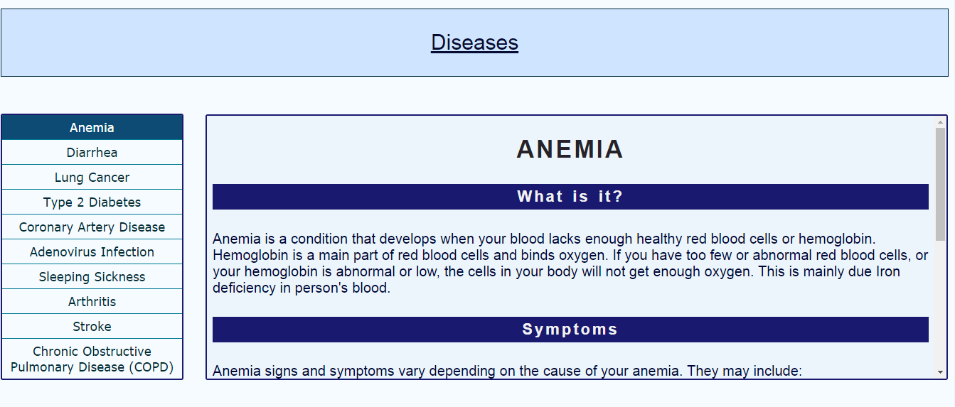

1. FEEDBACK FORM

We have included a feedback form for the users to rate our website, the details given by the user will be recorded in a file. Data is send to the file through PHP file handling and a person can easily view that file for references. Data from the form will be entered (date will be generated by the server side independent of the user’s position by using date() object) and PHP will take them as a POST method so that it remains private. Name, Email, Age, Sex, Rating to our website are all included in the form.

The Result in the file will look like:

Date: 2016-10-19

Name: a a

Email id: a@c.com

Sex: male

Blood Group: B+

Experience: good

Rate: 6

Comments: abc