**Diagram of executing a Linux command:**

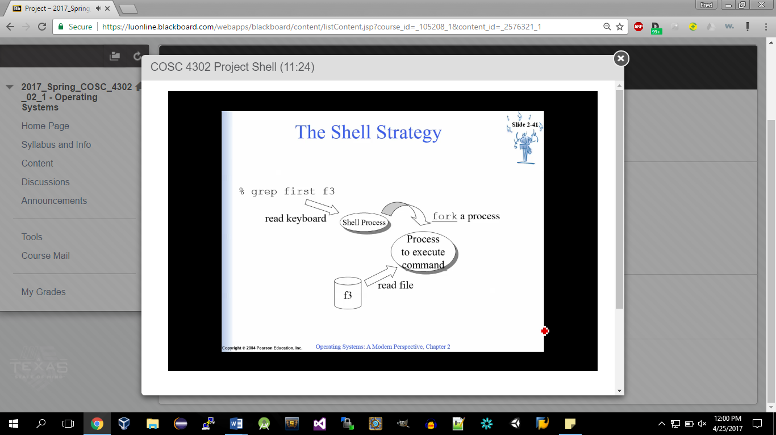

**Diagram of Shell:**

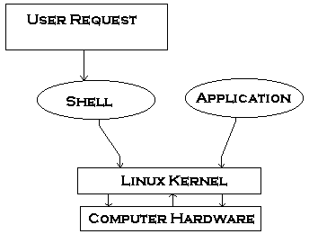

User Commands