Notes for car08, car89new and car04new

These notes are designed to be used with car08.jmp, and to describe revised car89.jmp and car04.jmp files.

Beginning with model year 2008, the EPA has revised its methods for estimating mileage. The new methods take into account more aggressive driving (higher speeds and faster acceleration), air conditioner usage and operation in cold temperatures. For details see www.epa.gov/fueleconomy. The new methods result in miles per gallon figures which are lower than those obtained using the previous estimation techniques.

In view of the new methods, the EPA has revised mileage estimates for the years 1985-2007. The new estimates can be obtained at www.fueleconomy.gov/feg/findacar.htm. Each of the new files car89new.jmp and car04new.jmp contains two columns with the revised estimates, MPG_City_New and MPG_Hwy_New, and also revised columns for GP1000M. In addition some errors and omissions in the car89 and car04 files have been fixed. I believe some errors remain.

The file car08.jmp contains approximately twice as many vehicles as car04.jmp. Unlike in car04.jmp, for many models both automatic and manual transmissions, and different engine sizes, have been included in car08.jmp. Furthermore, there are more entries for four-wheel drive vehicles than in car04.jmp.

The EPA defines a number of vehicle classes and uses two categories, cars and trucks. The categories for cars are defined using passenger plus cargo volume, in cubic feet.

Category Cubic Footage

Two-seater
Minicompact < 85
Subcompact 85–99
Compact 100–109
Midsize 110–119
Large ≥ 120

Small station wagon < 130
Midsize station wagon 130–159
Large station wagon ≥ 160

Minivans and sport utility vehicles are classified as trucks by the EPA. Only those vehicles with gross vehicle weight rating (vehicle weight plus carrying capacity) less than 8,500 pounds are included among the evaluated vehicles. For example, the Ford Excursion (no longer produced) and the Hummer H2 are not included.

The file car08.jmp contains a column titled Fuel, and the entries are gas and E85. The purpose of this column is to identify fuel flexible vehicles. The following remarks are in the 2008 Economy Guide (www.fuel.economy.gov/feg/FEG2008.pdf):

Ethanol is an alcohol fuel made by fermenting and distilling starch crops, such
as corn. It may also be made from “cellulosic biomass’ such as trees and
grasses in the near future.

…E10 or “gasohol” is a blend of 10% ethanol and 90% gasoline sold in many
parts of the country. All auto manufacturers approve the use of blends of
10% ethanol or less in their gasoline vehicles.

E85, a blend of 85% ethanol and 15% gasoline, can be used in flexible fuel
vehicles (FFVs), which are specially designed to run on gasoline, E85, or
any mixture of the two. FFVs are offered by several vehicle manufacturers.

…There is no noticeable difference in vehicle performance when low-level
ethanol blends are used. However, FFVs operating on E85 usually experience
a 20–30% drop in miles per gallon due to ethanol’s lower energy content.

As of March 2008 about 1500 filling stations in the U.S. were selling ethanol. The
price varies among the stations, but for most tends to be 5–10% lower per gallon than that
for gasoline.

There are two separate lines in car08.jmp for each FFV vehicle. Thus, the E85 lines should be excluded from some calculations.

The file car08.jmp does not include any diesel vehicles. These typically get 30–35% more miles per gallon than comparable gasoline vehicles. Diesel engines are more energy efficient, and diesel contains 10% more energy per gallon than gasoline.

The abbreviations in the Transmission column are as follows:

A Automatic

A-S Automatic transmission-select shift

AV Continuously variable transmission

M Manual

There is a column in car08.jmp for presence of a turbocharger. A turbocharger is a forced-induction compressor powered by the engine's exhaust gas. The purpose of a turbocharger is to increase the mass of air entering the engine to create more power. Essentially, the presence of a turbocharger allows the use of a smaller engine to achieve the horsepower level of a larger engine.

The column HEV in car08.jmp identifies hybrid-electric vehicles.

Example. This model fit includes the Fuel and HEV variables. If the Fuel variable is not included in a model, then all the E85 lines should be excluded. (Recall there are two lines in the data table for each FFV vehicle, one for use of gas and one for use of E85.) If the HEV variable is not included in a model, it is probably best to exclude all the hybrid vehicles.

For this analysis the vehicles on lines 10, 27, 54, 288 and 289 have been excluded.

Response GP1000M_City
Whole Model
Actual by Predicted Plot
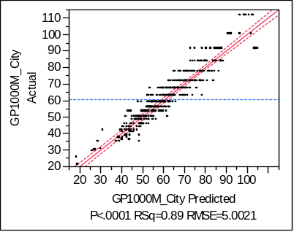

Summary of Fit
RSquare | 0.893004
RSquare Adj | 0.891319
Root Mean Square Error | 5.002078
Mean of Response | 60.50005
Observations (or Sum Wgts) | 517

Effect Tests
Source | Nparm | DF | Sum of Squares | F Ratio | Prob > F
Weight(lb) | 1 | 1 | 9902.305 | 395.7632 | <.0001
Horsepower | 1 | 1 | 11217.887 | 448.3427 | <.0001
Transmission | 3 | 3 | 686.770 | 9.1493 | <.0001
Length | 1 | 1 | 594.832 | 23.7735 | <.0001
Fuel | 1 | 1 | 13354.594 | 533.7400 | <.0001
HEV | 1 | 1 | 4024.099 | 160.8302 | <.0001

Expanded Estimates
Term | Estimate | Std Error | t Ratio | Prob>|t|
Intercept | 32.120059 | 4.121694 | 7.79 | <.0001
Weight(lb) | 0.0093962 | 0.000472 | 19.89 | <.0001
Horsepower | 0.0701275 | 0.003312 | 21.17 | <.0001
Transmission[A] | 2.1919083 | 0.437142 | 5.01 | <.0001
Transmission[A-S] | 0.3141276 | 0.47454 | 0.66 | 0.5083
Transmission[AV] | -3.444254 | 0.896731 | -3.84 | 0.0001
Transmission[M] | 0.9382179 | 0.496565 | 1.89 | 0.0594
Length | -0.126503 | 0.025945 | -4.88 | <.0001
Fuel[E85] | 12.987279 | 0.562151 | 23.10 | <.0001
Fuel[gas] | -12.98728 | 0.562151 | -23.10 | <.0001
HEV[no] | 9.7693225 | 0.770337 | 12.68 | <.0001
HEV[yes] | -9.769323 | 0.770337 | -12.68 | <.0001

Residual by Predicted Plot
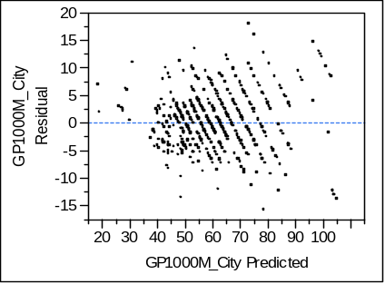

Residual GP1000M_City
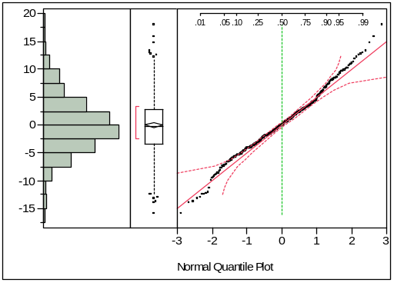

Paul Shaman
30 June 2008

