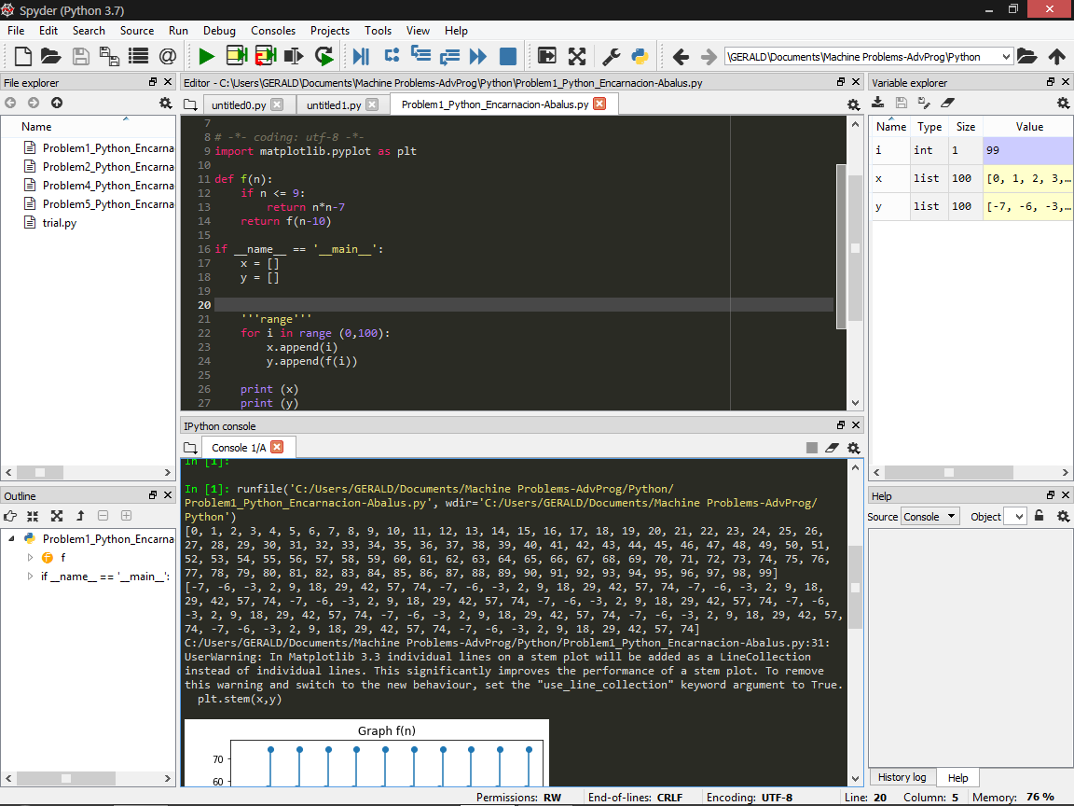

Problem 1 (Python)

import matplotlib.pyplot as plt

def f(n):

if n <= 9:

return n*n-7

return f(n-10)

if __name__ == '__main__':

x = []

y = []

'''range'''

for i in range (0,100):

x.append(i)

y.append(f(i))

print (x)

print (y)

'''stem()'''

plt.stem(x,y)

'''labels'''

plt.xlabel('X Axis')

plt.ylabel('Y Axis')

plt.title('Graph f(n)')

*In print (x,y)*

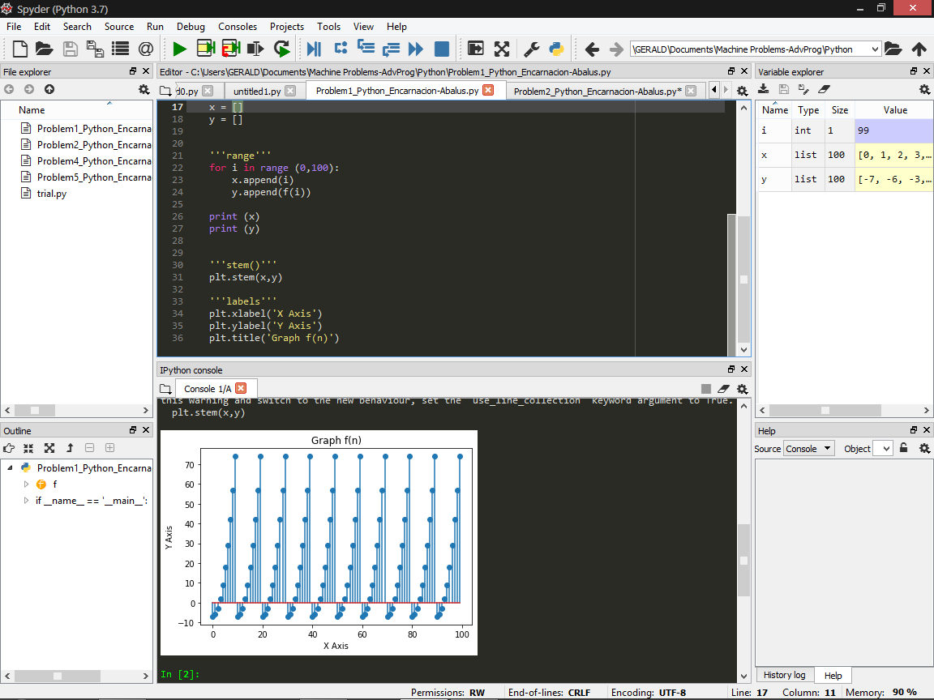

*The graph in console*