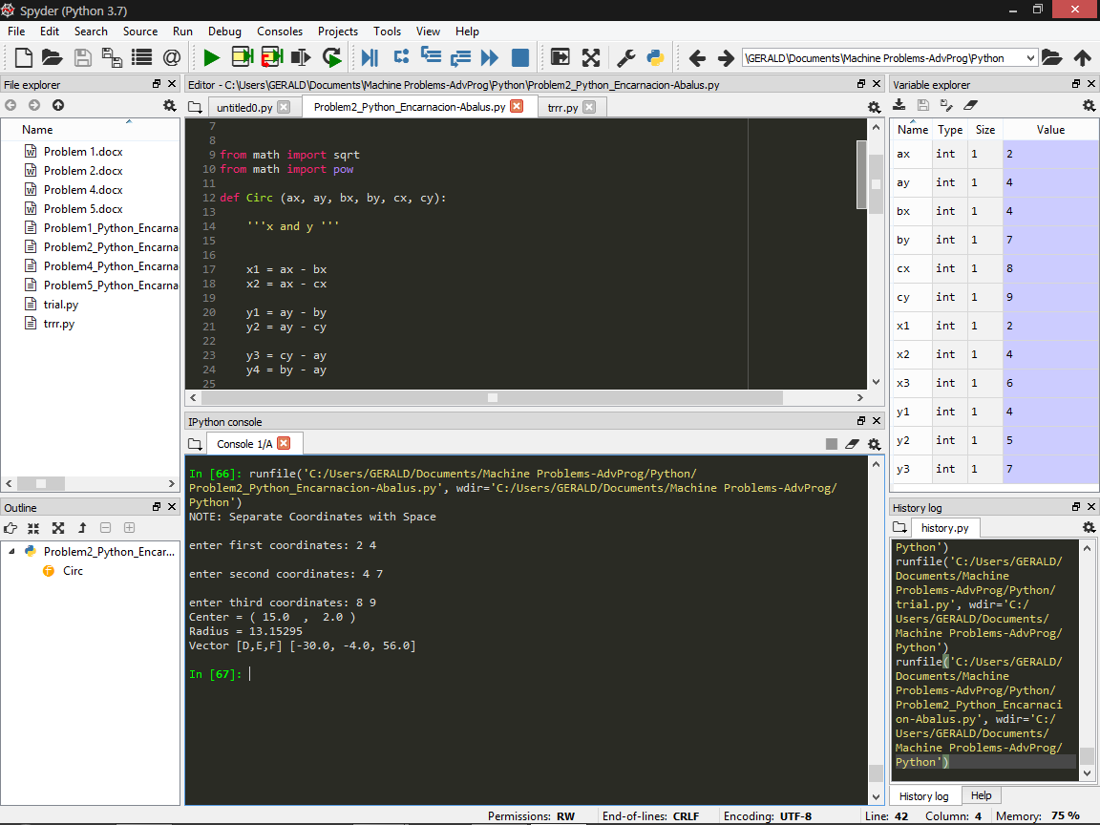

Problem 2 (Python)

from math import sqrt

from math import pow

def Circ (ax, ay, bx, by, cx, cy):

x1 = ax - bx

x2 = ax - cx

y1 = ay - by

y2 = ay - cy

y3 = cy - ay

y4 = by - ay

x3 = cy - ay

x4 = bx - ax

xac = pow (ax,2) - pow(cx,2)

yac = pow (ay,2) - pow (cy,2)

xba = pow (bx,2) - pow (ax,2)

yba = pow (by,2) - pow (ay,2)

f = (((xac) \* (x1) + (yac) \* (x1) + (xba) \* (x2) + (yba) \* (x2)) // (2 \* ((y3) \* (x1) - (y4) \* (x2))))

g = (((xac) \* (y1) + (yac) \* (y1) + (xba) \* (y2) + (yba) \* (y2)) // (2 \* ((x3) \* (y1) - (x4) \* (y2))))

c = (-pow(ax, 2) - pow(ay, 2) - 2 \* g \* ax - 2 \* f \* ay)

h = -g

k = -f

sqrr = h \* h + k \* k - c

r = round (sqrt(sqrr), 5)

l = [2\*g, 2\*f, c]

print("Center = (", h, " , ", k, ")")

print ("Radius =", r)

print ("Vector [D,E,F]", l)

print ('NOTE: Separate Coordinates with Space')

ax,ay = map (int, input ('enter first coordinates: ').split())

bx,by = map (int, input ('enter second coordinates: ').split())

cx,cy = map (int, input ('enter third coordinates: ').split())

Circ (ax, ay, bx, by, cx, cy)

*Screeshot of example*