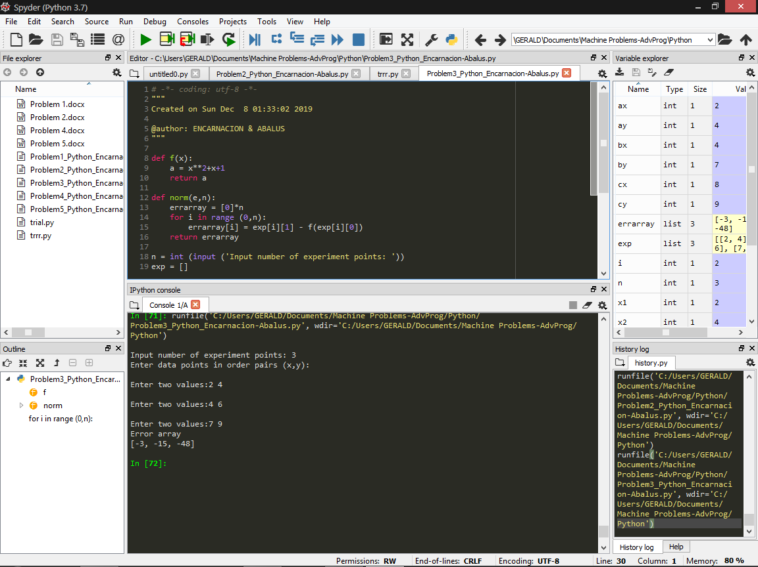

Problem 3 (Python)

def f(x):

a = x\*\*2+x+1

return a

def norm(e,n):

errarray = [0]\*n

for i in range (0,n):

errarray[i] = exp[i][1] - f(exp[i][0])

return errarray

n = int (input ('Input number of experiment points: '))

exp = []

print ('Enter data points in order pairs (x,y): ')

for i in range (0,n):

exp.append([int(j) for j in input("Enter two values:" ).split()])

errarray = norm(exp,n)

print ("Error array")

print (errarray)

*Screenshot of an example*